Appendix A:
Safety Element Information

Table of Contents
A.1 Introduction A-3
A.2 Existing Conditions A-5
A.3 Past Wildfires in Siskiyou County A-9
A.4 Fire Hazard Severity Zone Maps A-17
A.5 Flood Hazard Maps for Local Communities A-26
A.6 Institutional and Regulatory Framework A-48
A.7 Incorporation of the LHMP and CWPP A-52
A.8 Primary Evacuation Routes A-53
A.9 Areas with One Evacuation Route A-73

- Introduction
Siskiyou County’s location, geography, and seasonal climate, all contribute to its natural beauty, economy, and quality of life. To preserve these resources from the increasing risk of wildfire and other hazards, the county prepares for disasters to maintain a safe, enjoyable, and resilient community. The Safety Element is one of the seven mandatory elements (Land Use, Circulation, Housing, Conservation, Open Space, Noise and Safety) of the General Plan. The principal purpose of the Safety Element is to identify potential risks posed by natural and human made hazards to the people of Siskiyou County.
Relationship to Other General Plan Elements

The Safety Element is closely related to the other General Plan elements, particularly the Housing Element. The Housing Element is the county’s strategy and commitment for how it intends to meet the community’s current and future housing needs. The Housing Element seeks to make quality housing available to residents, workers, and visitors, while addressing systemic housing inequality. The Safety Element, on the other hand, aims to protect these same residents, workers, and visitors from natural and human made hazards.
Relationship to the LHMP and the CWPP
Though written as a standalone document, the Safety Element is meant to be utilized in coordination with, and is complementary to, the Local Hazard Mitigation Plan (LHMP) and other local area emergency plans, such as the Community Wildfire Protection Plan (CWPP). Developed through collaboration with local, state, federal, and tribal partners, the LHMP and CWPP are incorporated by reference into the Safety Element. While the Safety Element provides an overview of potential hazards, the LHMP and CWPP are meant to provide deeper analysis, context, and mitigation strategies for these hazards.
Section 5.2, Existing Conditions, is a discussion of the county’s population data and how it impacts evacuation planning and natural hazard mitigation. The County’s FEMA National Risk Index Scores are also discussed.
Section 5.3, The Fire Hazard, The Klamath National Forest, covering much of the western part of the county, has been the site of some of the largest wildfires in the county’s history. The Butte Valley National Grasslands, in the eastern part of the county, has also experienced significant wildfire challenges.
Section 5.4, The Flood Hazard, outlines the flood danger. Some areas of the county, like the community of Callahan, are in the 100-year floodplain, while other communities, like the town of Dorris, have almost zero flood risk. The Box Canyon Dam on Lake Siskiyou is rated Extremely High for downstream hazards.
Section 5.5, Geologic & Seismic Hazards, examines the dangers of geologic and seismic hazards such as landslides, earthquakes and volcanic activity.
Section 5.6, Hazardous Materials, discusses how hazardous materials incidents impact local waterways and public health and safety.
Section 5.7, Wildlife Hazards, summarizes possible wildlife disease transmission and predator hazards.
Section 5.8, Adaptation & Community Resilience, discusses rising temperatures. It is expected that abnormally dry conditions, increased forest stand density, and excessive fuel load will continue to result in extreme fire events.
Section 5.9, Emergency Management, includes information about the county’s emergency alert programs, agencies, and operations. Lack of reliable cellular telecommunication service is a noted concern.
Section 5.10, Evacuation Planning, looks at the anticipated evacuation routes that would be utilized during an emergency. Most residential areas in the county have at least two emergency evacuation routes.
Section 5.11, Goals, Policies, & Actions, is a list of the county’s Goals, Policies, and Actions for mitigating against the potential hazards discussed in the Safety Element.
Section 5.12, Implementation Programs, details the programs the county will implement to mitigate against the hazards identified in the Safety Element.
Section 5.13, Past Wildfires in Siskiyou County is a visual depiction of past wildfires along with fire statistics from 2006 to 2024.
Section 5.14, Fire Hazard Severity Zone Maps contains fire hazard severity maps for local cities and the unincorporated county.
Section 5.15, Flood Hazard Maps for Local Communities provides flood mapping and emergency routes for different areas of the county.
Section 5.16, Institutional & Regulatory Framework by Hazard is a summary of the institutions, laws, and regulations that are relevant to hazard mitigation.
Section 5.17, Incorporation of the LHMP and CWPP incorporates the Local Hazard Mitigation Plan and the Community Wildfire Protection Plan into the Safety Element.
Section 5.18, Evacuation Routes for Selected Communities provides mapping of evacuation routes for different areas of the county.
Section 5.19, Residential Areas with One Evacuation Route is a list of residential areas with only one evacuation route. For the most recent list, please email planning@co.siskiyou.ca.us.

- Existing Conditions

Population Statistics
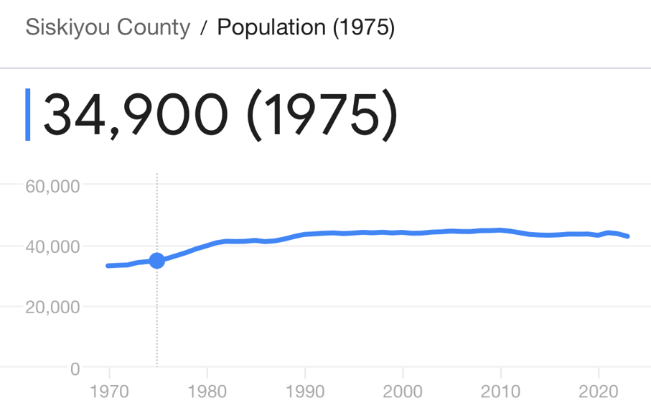
Siskiyou County’s population has not grown significantly since the last major Safety Element update. Population data comes from the 2020 U.S. Census. There are approximately 44,076 people living in the county. It is estimated that 81.3% of all households have at least 2 motor vehicles.
Based on this high ownership percentage, it is expected that the primary mode of transportation during an evacuation will be by private motor vehicle.
Children. Children (defined as individuals under 18 years of age) make up 19.7% of the county’s population and it is expected that during an evacuation they will be accompanied by an adult caretaker.
An Aging Population. 28.7% of the county population is 65 years or older. Pre-existing medical conditions and potential mobility issues will need to be considered in any evacuation planning.
Individuals with Disabilities. 18.1% of the county population has a medically recognized disability. Individuals with disabilities and individuals with functional or access needs may require specialized assistance during an evacuation. Given the high percentage of individuals in this category, consideration of this population segment must be included in any emergency planning that occurs.
Limited Income Population. 16.7% of the population is listed as below the federal poverty threshold. Individuals in this population segment may not have access to a reliable motor vehicle during an evacuation.
The Unhoused Population. For 2022 and 2023, Partnership HealthPlan of California listed 2,204 individuals as lacking adequate shelter in Siskiyou County. The Point in Time count conducted by the County for the same period which estimated that there are about 507 individuals in the county lacking adequate shelter. The actual number of unhoused persons in the county is likely to be somewhere between 507 to 2,204 people.

Based on the County’s population characteristics, a significant portion of the community may require additional or specialized assistance during a large-scale evacuation. For individuals without access to a private motor vehicle, public buses operated by the Siskiyou Transit and General Express (STAGE), and any available school buses could be an option for relocating people to safety.

FEMA National Risk Index
The National Risk Index created by the Federal Emergency Management Agency (FEMA) summarizes the risks posed by natural hazards in Siskiyou County. The national index tracks 18 hazard types, 14 of which are relevant to the county. Siskiyou County is most at risk from Drought, Wildfire, Earthquake, Landslide, Riverine Flooding, and Volcanic Activity.
Risk Index Scores
Very High | Relatively High | Relatively Moderate | Relatively Low | Low
Siskiyou County Risk Index Scores
Hazard Type | Risk Index Rating | Risk Index Score | National Percentile
Avalanche | Very Low | 10.1 | 100
Cold Wave | Relatively Low | 55.2 | 100
Drought | Relatively High | 99.5 | 100
Earthquake | Relatively Moderate | 94.6 | 100
Hail | Very Low | 3.9 | 100
Heat Wave | Relatively Low | 43.5 | 100
Landslide | Relatively Moderate | 92.1 | 100
Lightning | Relatively Low | 31.7 | 100
Riverine Flooding | Relatively Moderate | 88.6 | 100
Strong Wind | Very Low | 4.0 | 100
Tornado | Very Low | 1.9 | 100
Volcanic Activity | Relatively Moderate | 78.7 | 100
Wildfire | Relatively High | 98.1 | 100
Winter Weather | Relatively Low | 35.6 | 100

The Maximum Risk Index Score is 100. Siskiyou County's Risk Index Score is represented by its percentile ranking compared to all other US counties. For example, the county’s Drought score of 99.5 means that its Risk Index Score is greater than 99.5% of all other US counties. Put another way, 99.5% of all US counties have a lower Risk Index Score for Drought than Siskiyou County.
FEMA National Risk Index
An Expected Annual Loss score and rating represent a community's relative level of expected losses each year when compared to all other communities at the same level.
Expected Annual Loss
Very High | Relatively High | Relatively Moderate | Relatively Low | Low

Siskiyou County Expected Annual Loss
Hazard Type | EAL Rating | EAL Value | EAL Score
Avalanche | Very Low | $36,967 | 12.0
Cold Wave | Relatively Low | $58,958 | 52.1
Drought | Relatively High | $14,895,728 | 99.5
Earthquake | Relatively Moderate | $6,190,981 | 93.4
Hail | Very Low | $1,956 | 5.6
Heat Wave | Relatively Low | $43,095 | 43.1
Landslide | Relatively Moderate | $147,424 | 88.7
Lightning | Relatively Low | $44,473 | 28.1
Riverine Flooding | Relatively Moderate | $2,677,010 | 87.7
Strong Wind | Very Low | $9,402 | 6.1
Tornado | Very Low | $2,181 | 1.9
Volcanic Activity | Relatively Moderate | $1,146,557 | 81.1
Wildfire | Relatively High | $8,898,099 | 97.7
Winter Weather | Relatively Low | $26,663 | 36.5

The Maximum EAL Score is 100. Expected Annual Loss (EAL) represents the average economic loss in dollars resulting from natural hazards each year. EAL scores are calculated independently for buildings, population, and agriculture. Building and agriculture values are measured in dollars while population is measured in fatalities and injuries. When population is monetized each fatality or 10 injuries is treated as equivalent to $11.6 million of economic loss. In In Siskiyou County, the highest expected annual losses are from Drought and Wildfire.

FEMA National Risk Index
Social vulnerability is the susceptibility of social groups to the adverse impacts of natural hazards, including disproportionate death, injury, loss, or disruption of livelihood. Community resilience is the ability of a community to prepare for anticipated natural hazards, adapt to changing conditions, and withstand and recover rapidly from disruptions.

Social Vulnerability
Very High | Relatively High | Relatively Moderate | Relatively Low | Low

Social Vulnerability Score: 74.92
The maximum score is 100. The lower the score the better. A high Social Vulnerability Score indicates that a community is more susceptible to the negative impacts posed by natural hazards. With a high score of 74.92, social groups in Siskiyou County have a Relatively High susceptibility to the negative impacts of natural hazards compared to other US counties.

- 74.92 National Percentile and 51.70 Percentile in California.
- 75% of US counties and 52% of counties in California have a lower Social Vulnerability Score than Siskiyou County.

Community Resilience
Very High | Relatively High | Relatively Moderate | Relatively Low | Low

Community Resilience Score: 40.17
The maximum score is 100. The higher the score the better. A low Community Resilience Score indicates that a community is less able to prepare for and recover from the negative impacts posed by natural hazards. Communities in Siskiyou County have a Relatively Moderate ability to prepare for and recover quickly from emergency disasters compared to other US counties.

- 40.17 National Percentile and 39.70 Percentile in California.

- 60% of US counties and 60% of counties in California have a higher Community Resilience Score than Siskiyou County.

- Past Wildfires in Siskiyou County

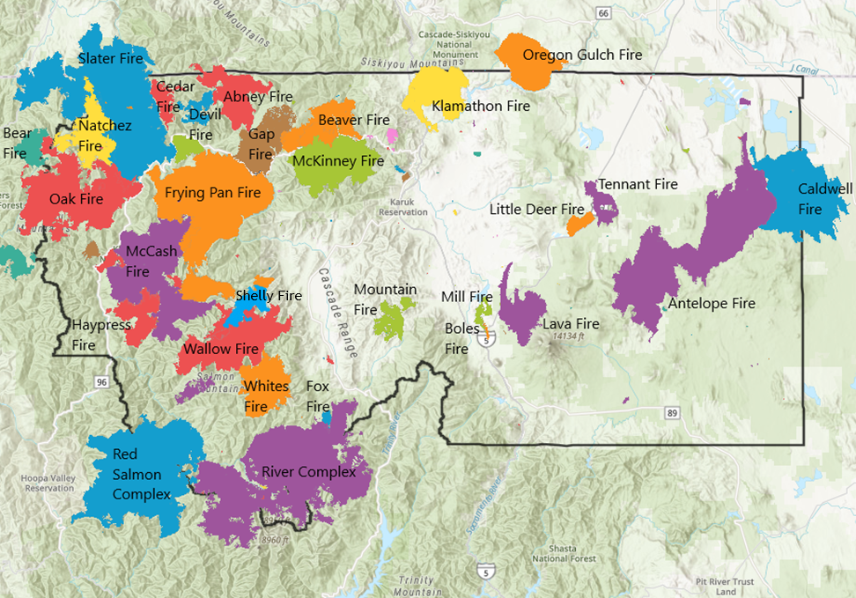
Largest Wildfires in Siskiyou County from 2006 – 2024
Year | Name | Start Date | Acreage
2022 | McKinney Fire | July 29 | 60,138
2021 | River Complex | July 30 | 199,359
2021 | Antelope Fire | August 1 | 145,632
2021 | McCash Fire | August 18 | 94,962
2020 | Slater Fire | September 8 | 157,429
2020 | Red Salmon Complex | July 27 | 143,835
2020 | Caldwell Fire | July 24 | 83,261
2017 | Klamath River Complex | August 10 | 91,125
2017 | Salmon-August Complex | August 11 | 63,785
2017 | Eclipse Complex | August 15 | 78,698
2014 | Happy Camp Complex | August 11 | 134,056
2008 | Klamath River Complex | June 21 | 192,038

2024 Wildfires in Siskiyou County – 16,240 Acres
Fire Name | Cause | Acres | Date
Hambone | Unknown | 15 | 10/6/2024
Harry | Unknown | 10 | 7/23/2024
Donomore | Unknown | 35 | 7/16/2024
Paradise | Unknown | 101 | 7/15/2024
Dewey | Unknown | 109 | 7/14/2024
Bogus | Unknown | 411 | 7/8/2024
Shelly | Unknown | 15,520 | 7/3/2024
Cod | Unknown | 28 | 6/10/2024
Springs | Unknown | 11 | 6/7/2024

2023 Wildfires in Siskiyou County – 22,563 Acres
Fire Name | Cause | Acres | Date
Happy Camp Complex | Unknown | 21,725 | 8/16/2023
August Complex | Unknown | 838 | 8/15/2023

2022 Wildfires in Siskiyou County – 86,110 Acres
Fire Name | Cause | Acres | Date
97 | Unknown | 30 | 8/27/2022
Eliza | Unknown | 20 | 9/8/2022
Coyote | Unknown | 297 | 9/7/2022
Mountain | Unknown | 13,440 | 9/2/2022
Mill | Mill Operations | 3,939 | 9/2/2022
Smokey | Unknown | 34 | 8/4/2022
Meamber | Unknown | 63 | 7/31/2022
Kelsey | Unknown | 85 | 7/30/2022
Shackleford | Unknown | 31 | 7/30/2022
Yeti | Lightning | 7,886 | 7/29/2022
McKinney | Power Line | 60,138 | 7/29/2022
Ridge | Unknown | 12 | 6/26/2022
Whitlow | Unknown | 10 | 3/25/2022
Gulch | Unknown | 113 | 3/12/2022
Evergreen | Unknown | 12 | 3/12/2022

2021 Wildfires in Siskiyou County – 478,345 Acres
Fire Name | Cause | Acres | Date
McCash | Lightning | 94,962 | 8/18/2021
Hambone | Unknown | 55 | 8/6/2021
Antelope | Lightning | 145,632 | 8/1/2021
River Complex | Lightning | 199,359 | 7/30/2021
Bradley | Unknown | 357 | 7/11/2021
Tennant | Unknown | 10,580 | 6/28/2021
Beswick | Unknown | 118 | 6/28/2021
Lava | Lightning | 26,409 | 6/24/2021
Refuge | Unknown | 873 | 3/27/2021

2020 Wildfires in Siskiyou County – 396,237 Acres
Fire Name | Cause | Acres | Date
Fox | Campfire | 2,188 | 9/16/2020
Shackleford | Unknown | 50 | 9/11/2020
Schoolhouse | Unknown | 45 | 9/9/2020
Slater | Power Line | 157,429 | 9/8/2020
Devil | Unknown | 8,871 | 9/8/2020
Red Salmon Complex | Lightning | 143,835 | 7/27/2020
Caldwell | Lightning | 83,261 | 7/24/2020
Badger | Unknown | 557 | 7/18/2020

2019 Wildfires in Siskiyou County – 2,557 Acres
Fire Name | Cause | Acres | Date
Bar | Unknown | 91 | 9/15/2019
Lime | Unknown | 1,872 | 9/7/2019
Kidder 2 | Unknown | 227 | 9/7/2019
Duzel | Unknown | 15 | 9/7/2019
Tree | Unknown | 83 | 7/27/2019
Community | Unknown | 35 | 7/27/2019
Lumgrey | Unknown | 207 | 6/17/2019
Iron Gate | Unknown | 10 | 6/16/2019
Rocky | Unknown | 17 | 6/14/2019

2018 Wildfires in Siskiyou County – 76,862 Acres
Fire Name | Cause | Acres | Date
Iron Gate | Unknown | 15 | 10/10/2018
Natchez | Lightning | 38,134 | 7/15/2018
Steamboat | Unknown | 224 | 7/15/2018
Klamathon | Debris Burning | 38,008 | 7/5/2018
Petersburg | Unknown | 215 | 7/1/2018
Cherry | Unknown | 63 | 6/27/2018
Meamber | Unknown | 12 | 6/4/2018
Martin | Unknown | 37 | 6/3/2018
Ager | Unknown | 27 | 5/19/2018
Shastina | Unknown | 127 | 5/9/2018

2017 Wildfires in Siskiyou County – 301,521 Acres
Fire Name | Cause | Acres | Date
Owens | Unknown | 55 | 8/29/2017
Bradley | Unknown | 54 | 8/28/2017
Eclipse Complex * | Lightning | 78,698 | 8/15/2017
Miller Complex * | Lightning | 39,715 | 8/14/2017
Ward | Unknown | 41 | 8/13/2017
Salmon-August Complex * | Lightning | 63,785 | 8/11/2017
Klamath River Complex * | Lightning | 91,125 | 8/10/2017
Hill | Unknown | 155 | 7/29/2017
Orleans | Lightning | 27,276 | 7/26/2017
Fay | Unknown | 496 | 7/5/2017
King | Unknown | 19 | 6/26/2017
Bogus | Unknown | 56 | 6/18/2017
Whitepine | Unknown | 46 | 6/6/2017
- The Eclipse Complex includes the Young, Clear, and Cedar fires.
- The Miller Complex includes the Abney, Knox, and Burnt Peak fires.
- The Salmon-August Complex includes the Wallow fire.
- The Klamath River Complex includes the Oak Fire.

2016 Wildfires in Siskiyou County – 37,574 Acres
Fire Name | Cause | Acres | Date
Moffett | Unknown | 32 | 9/12/2016
Gap | Arson | 33,867 | 8/26/2016
Grade | Unknown | 710 | 8/24/2016
Table/Bailey | Unknown | 49 | 7/19/2016
Pony | Unknown | 2,860 | 6/7/2016
Mill | Unknown | 56 | 5/19/2016

2015 Wildfires in Siskiyou County – 12,148 Acres
Fire Name | Cause | Acres | Date
Military | Unknown | 58 | 10/10/2015
Prairie | Unknown | 69 | 8/20/2015
Bear | Lightning | 11,616 | 7/30/2015
Dorris | Unknown | 24 | 7/21/2015
Cooley | Unknown | 181 | 7/13/2015
Stephens | Unknown | 200 | 2/24/2015

2014 Wildfires in Siskiyou County – 257,915 Acres
Fire Name | Cause | Acres | Date
Boles | Arson | 516 | 9/14/2014
Oregon Gulch | Lightning | 35,302 | 8/12/2014
Happy Camp Complex * | Lightning | 134,056 | 8/11/2014
Little Deer | Lightning | 5,503 | 8/11/2014
July Complex * | Lightning | 50,042 | 8/2/2014
Beaver | Lightning | 32,496 | 7/30/2014
- The Happy Camp Complex includes the Frying Pan fire.
- The July Complex includes the Whites fire.

2013 Wildfires in Siskiyou County – 14,844 Acres
Fire Name | Cause | Acres | Date
Cottonwood | Unknown | 50 | 8/15/2013
Salmon River Complex * | Unknown | 14,754 | 7/31/2013
Trout | Unknown | 40 | 7/13/2013
- The Salmon River Complex includes the Butler, Boulder, and Shelly fires.

2012 Wildfires in Siskiyou County – 24,163 Acres
Fire Name | Cause | Acres | Date
Fort Complex * | Unknown | 23,653 | 8/5/2012
Dillon | Unknown | 318 | 8/3/2012
Oak | Unknown | 192 | 6/28/2012
- The Fort Complex includes Goff, Lick and Hello fires.

2011 Wildfires in Siskiyou County – 120 Acres
Fire Name | Cause | Acres | Date
Hawkinsville | Unknown | 120 | 9/11/2011

2010 Wildfires in Siskiyou County – 371 Acres
Fire Name | Cause | Acres | Date
Dutch | Unknown | 371 | 7/31/2011

2009 Wildfires in Siskiyou County – 4,589 Acres
Fire Name | Cause | Acres | Date
Black | Unknown | 103 | 9/2/2009
Red Rock | Unknown | 1,364 | 8/21/2009
Tennant | Unknown | 3,225 | 7/19/2009

2008 Wildfires in Siskiyou County – 192,038 Acres
Fire Name | Cause | Acres | Date
Klamath River Complex * | Lightning | 192,038 | 6/21/2008
- The Klamath River Complex includes the Blue 2, Bear Wallow, Panther, and Siskiyou Complex fires.

2007 Wildfires in Siskiyou County – 20,685 Acres
Fire Name | Cause | Acres | Date
Cherry | Unknown | 95 | 8/29/2007
Elk Complex | Unknown | 17,684 | 7/10/2007
China & Back Complex | Unknown | 2,906 | 7/10/2007

2006 Wildfires in Siskiyou County – 38,321 Acres
Fire Name | Cause | Acres | Date
Lakin | Unknown | 450 | 7/25/2006
Hoy | Unknown | 1,283 | 7/26/2026
Uncles Complex * | Lightning | 36,588 | 7/23/2006
- The Uncles Complex includes the Titus and Happy Camp fires.
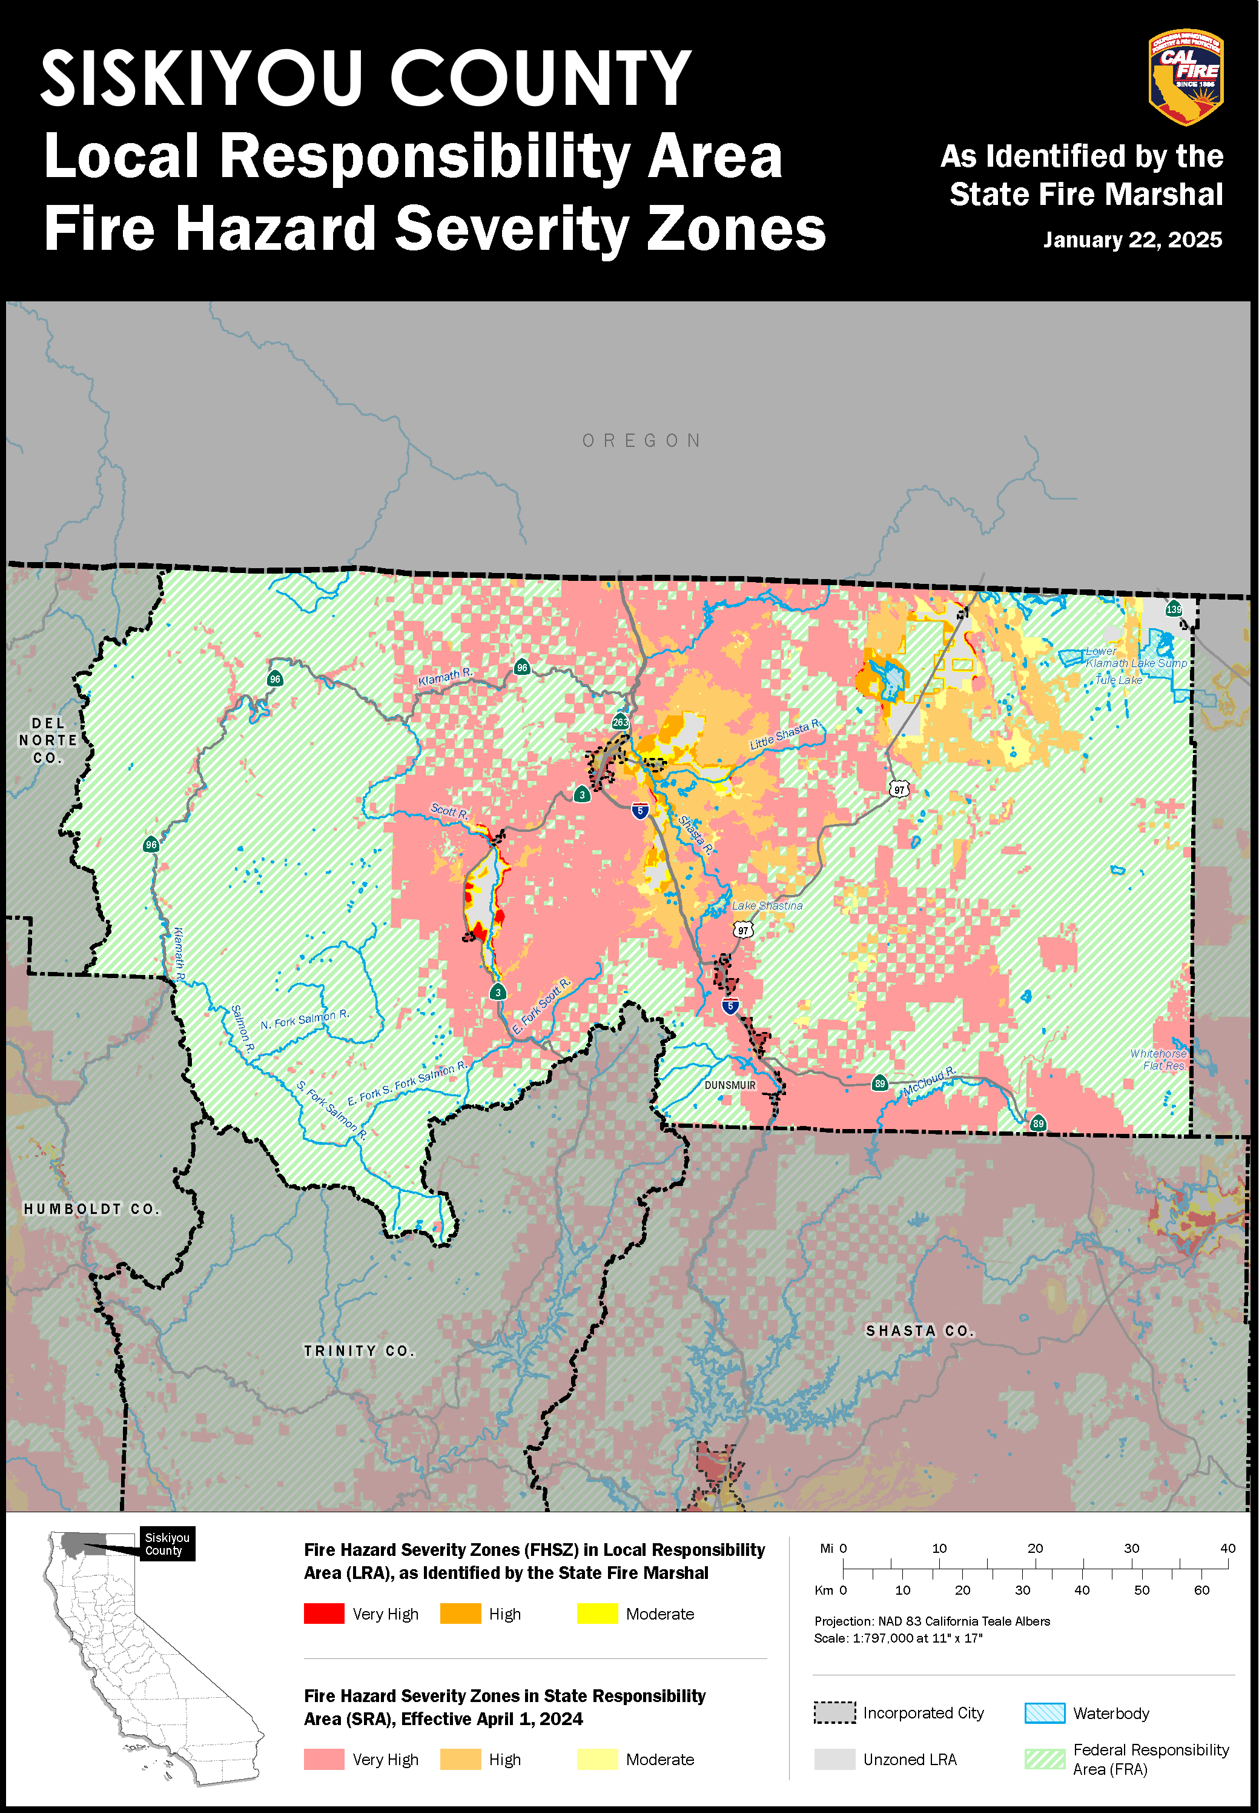
- Fire Hazard Severity Zone Maps

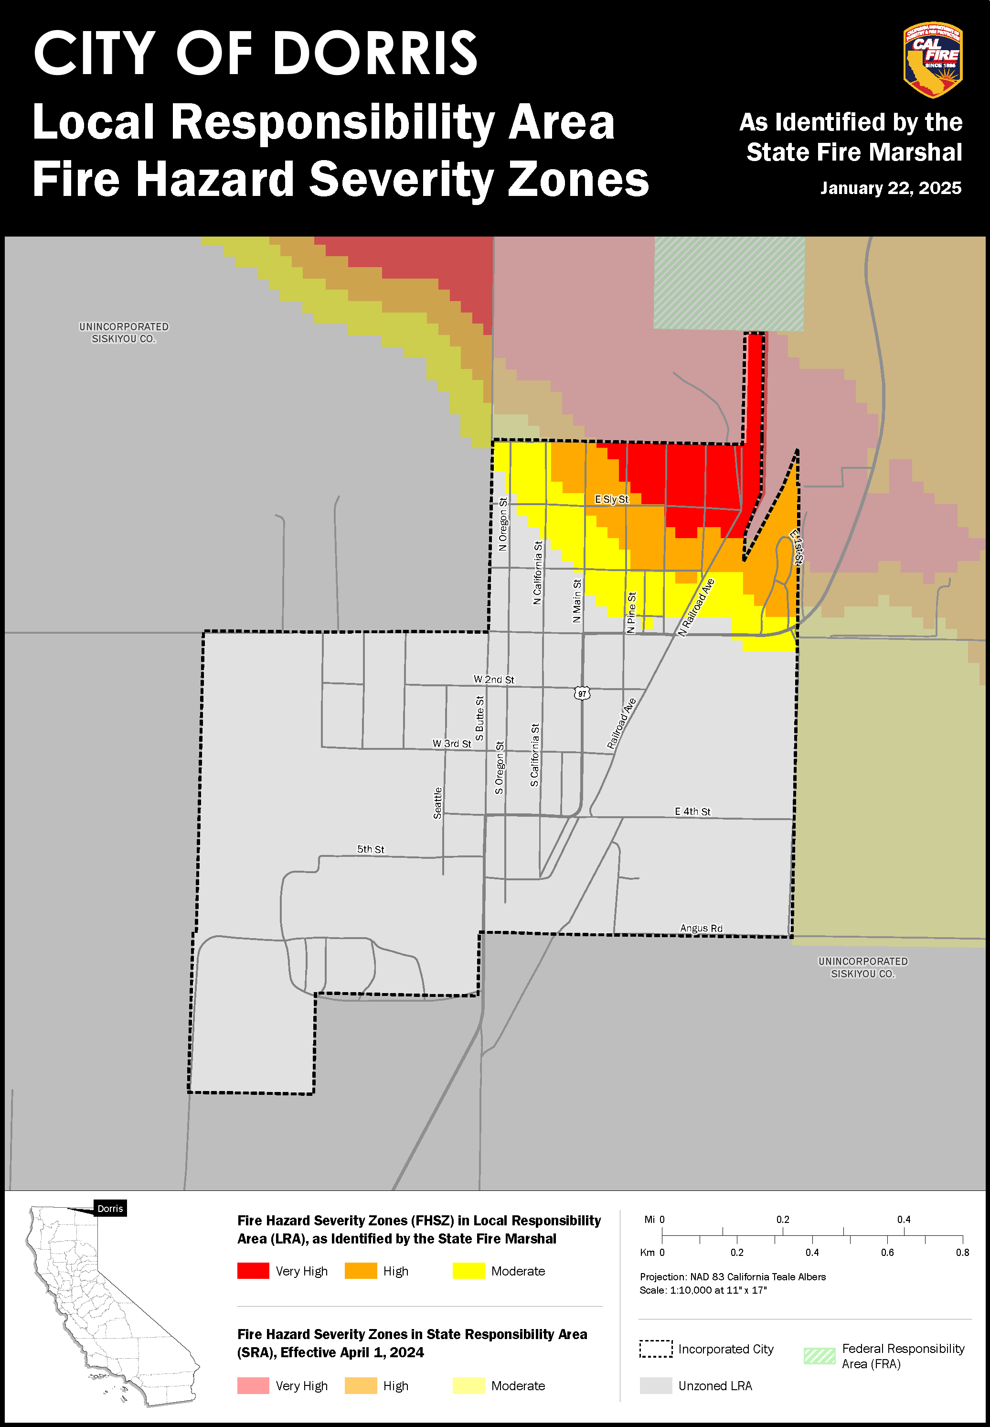

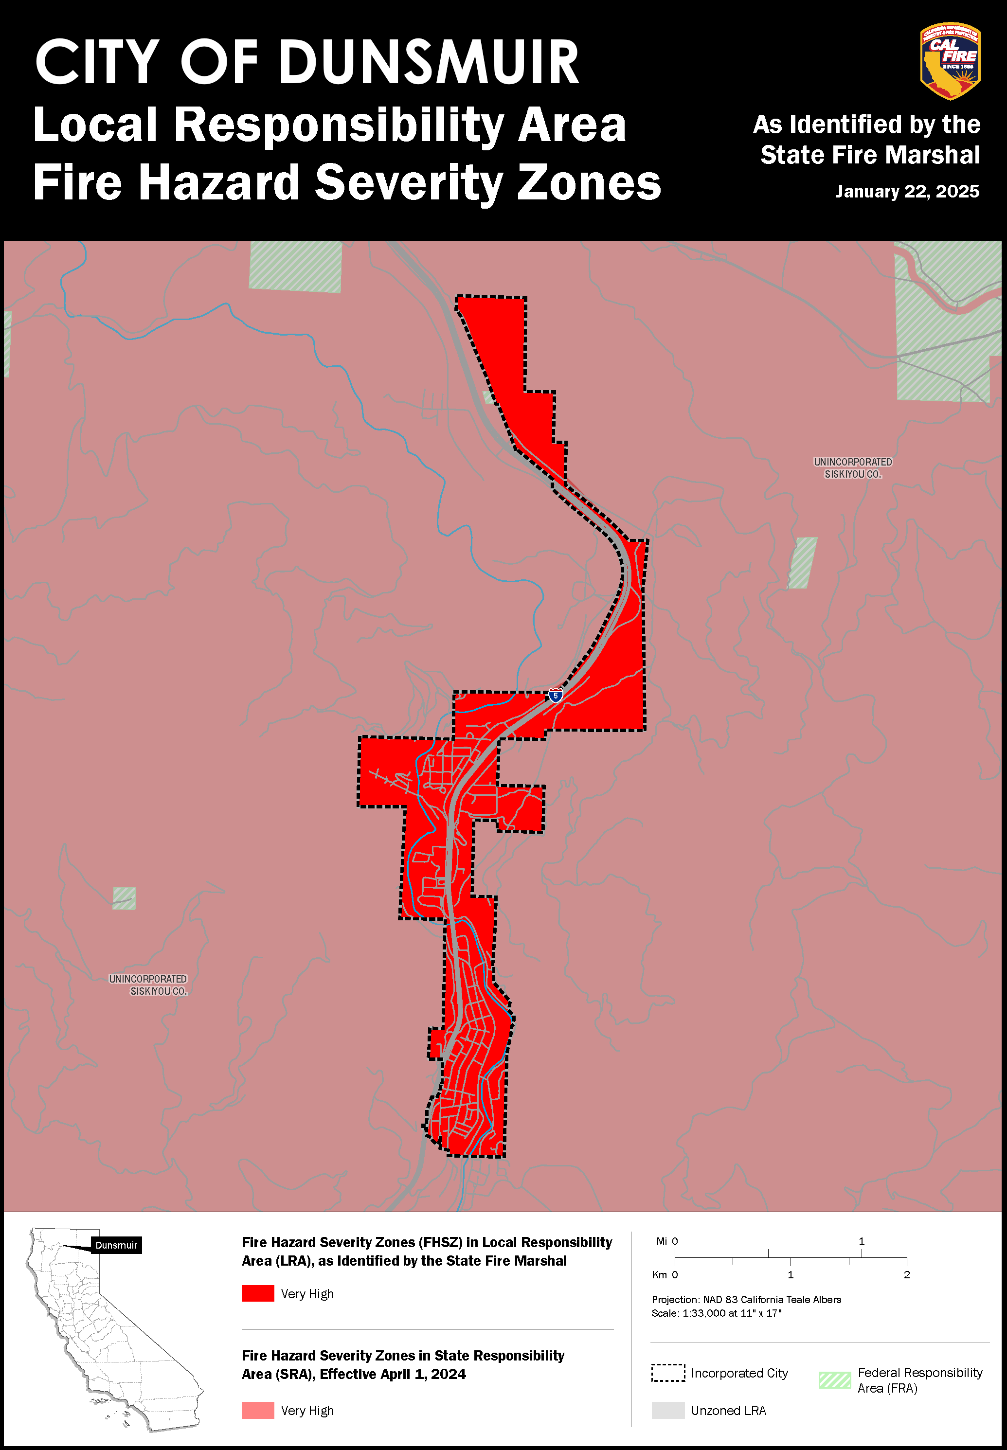
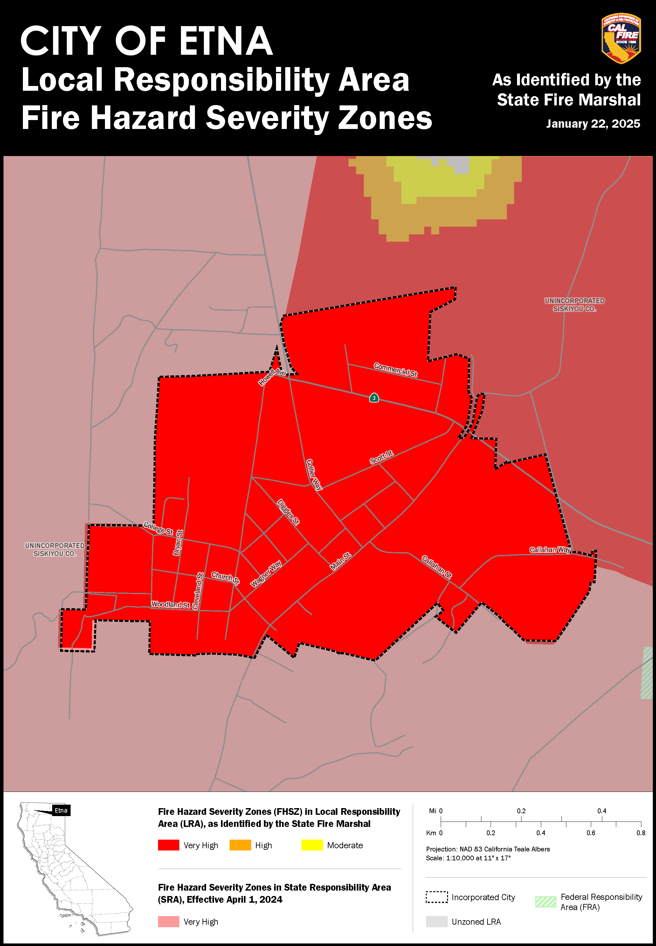
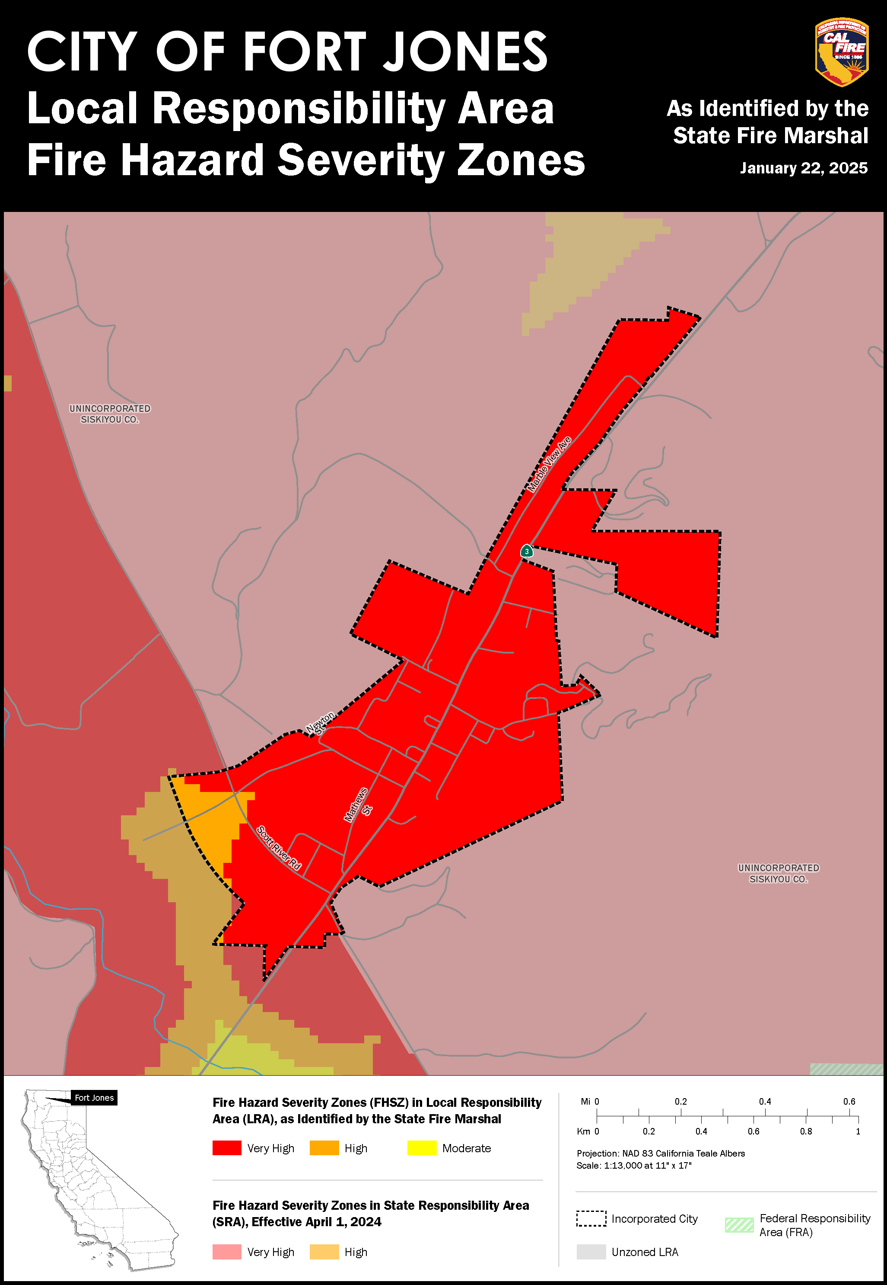
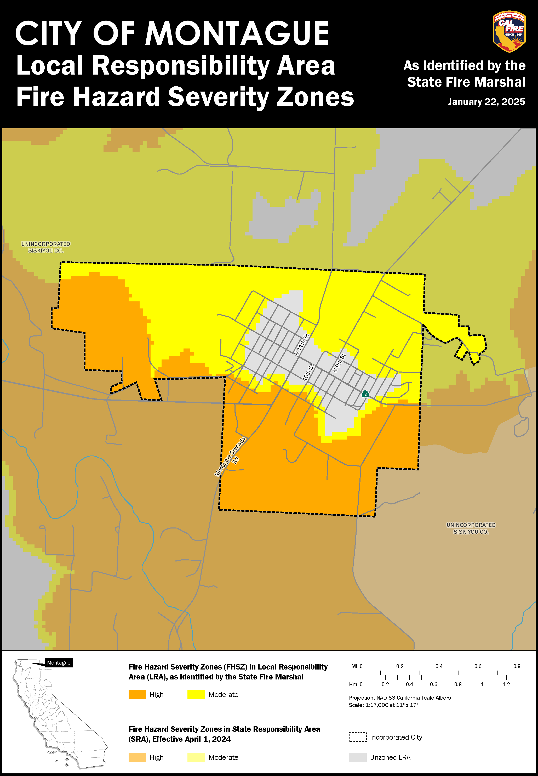
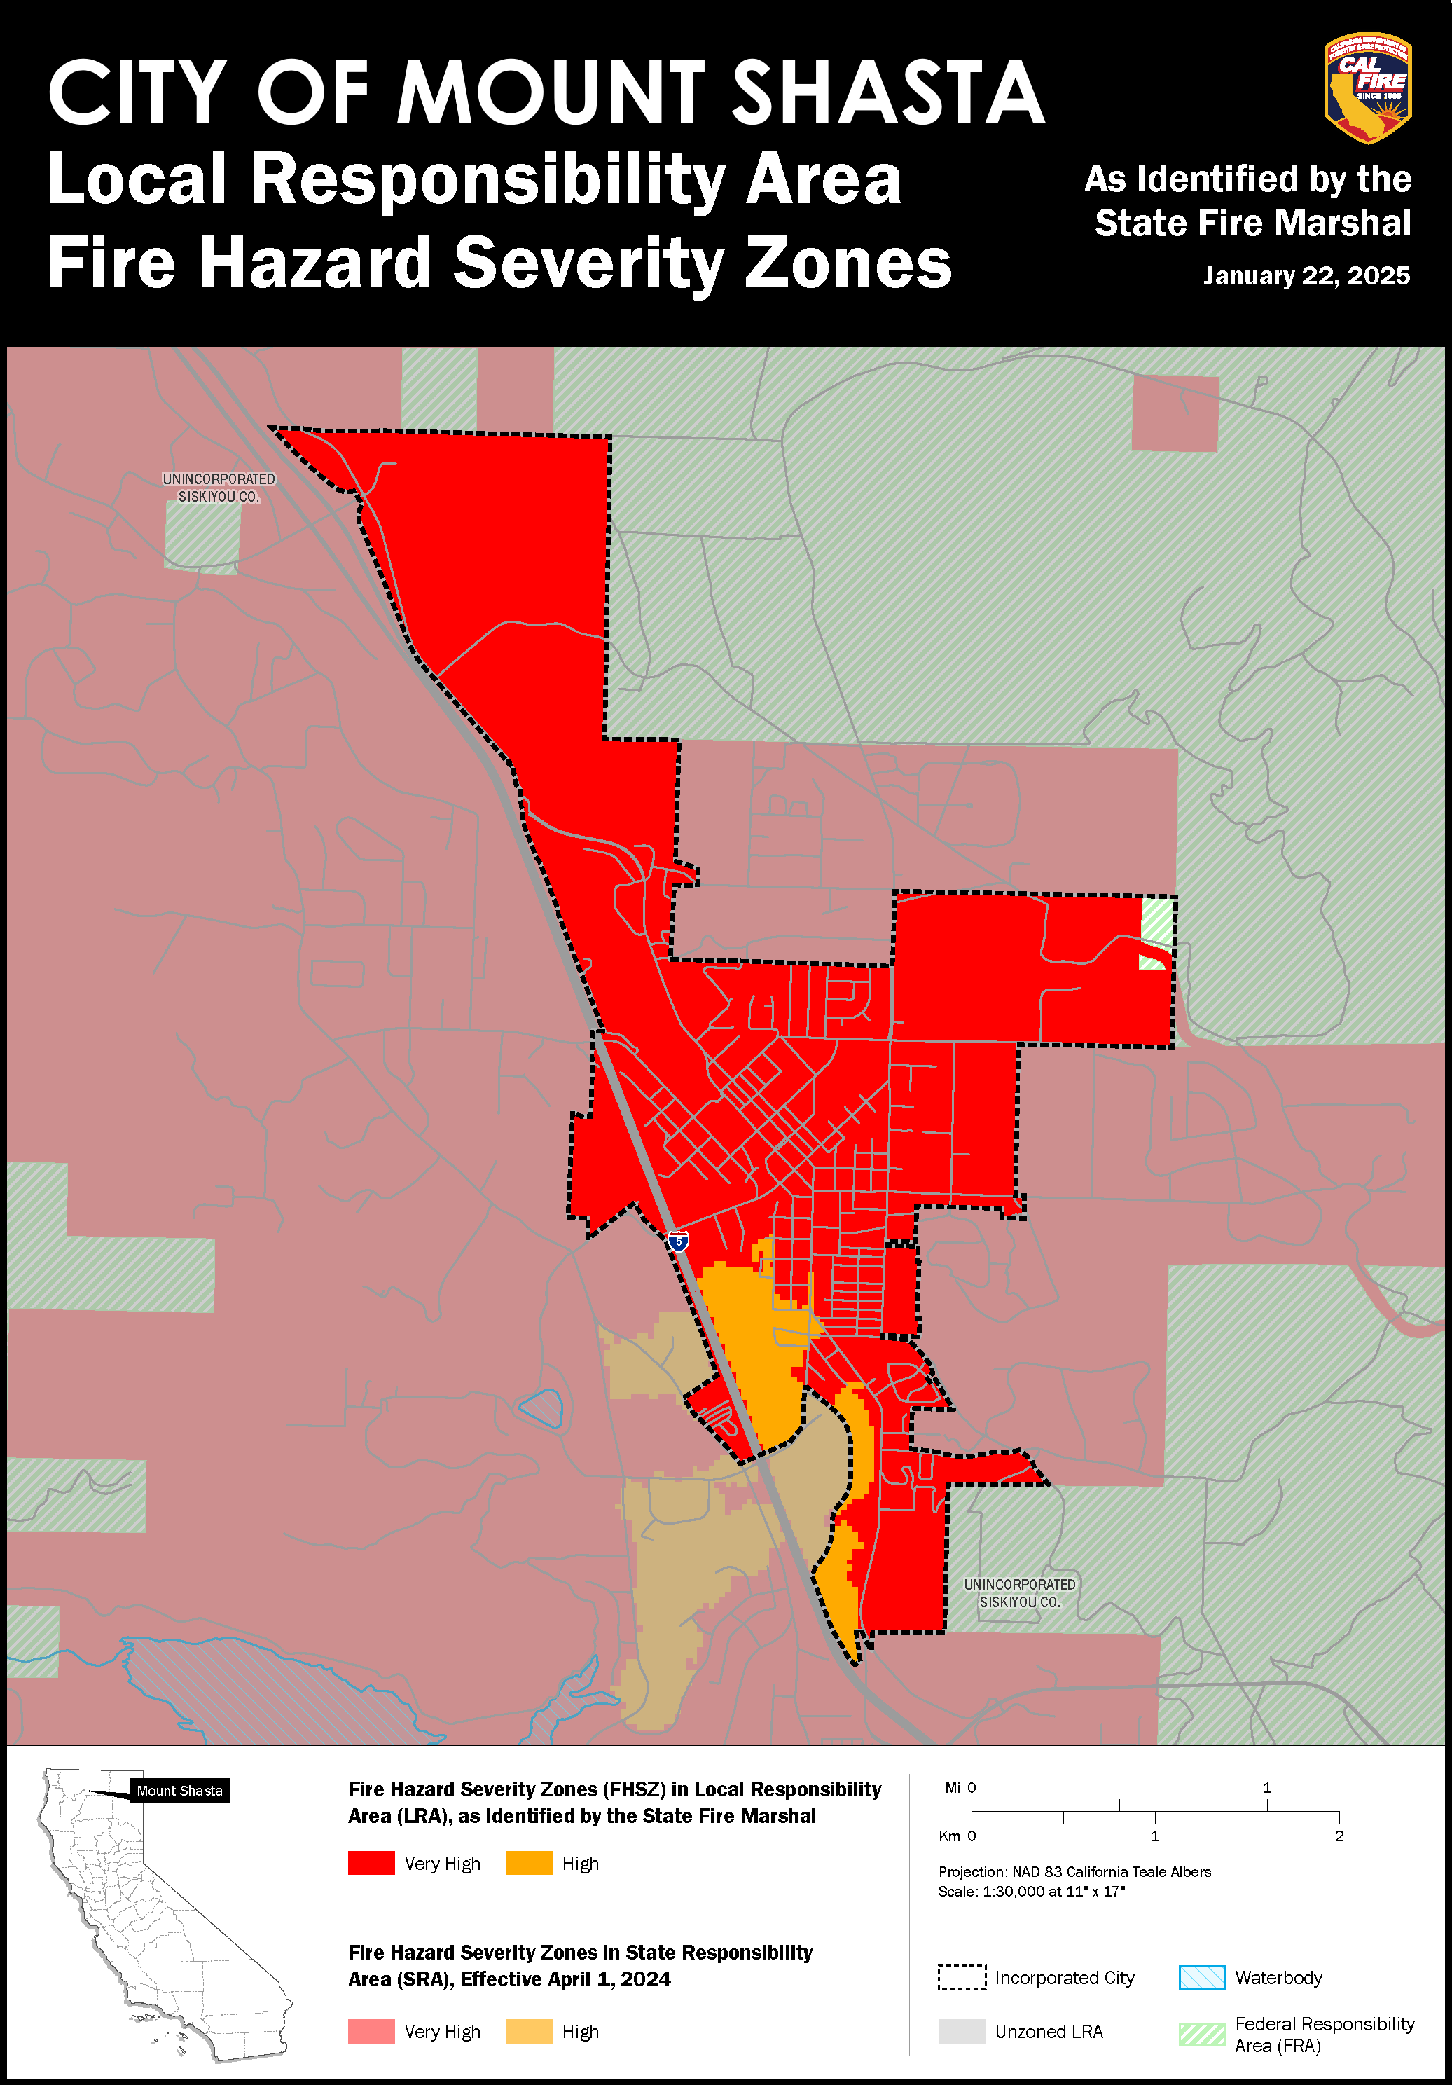
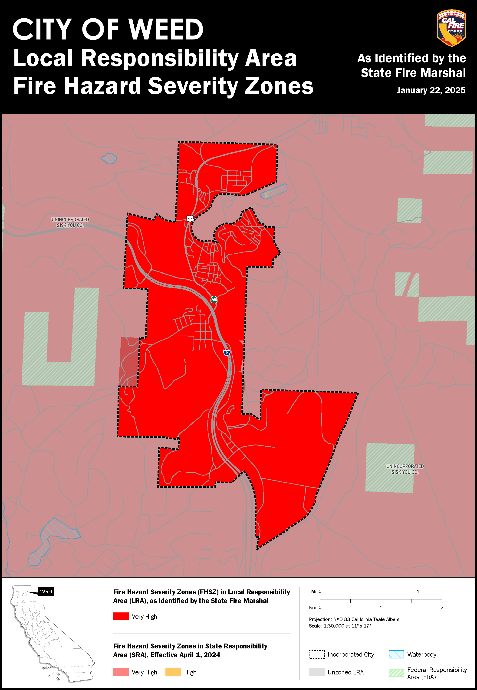
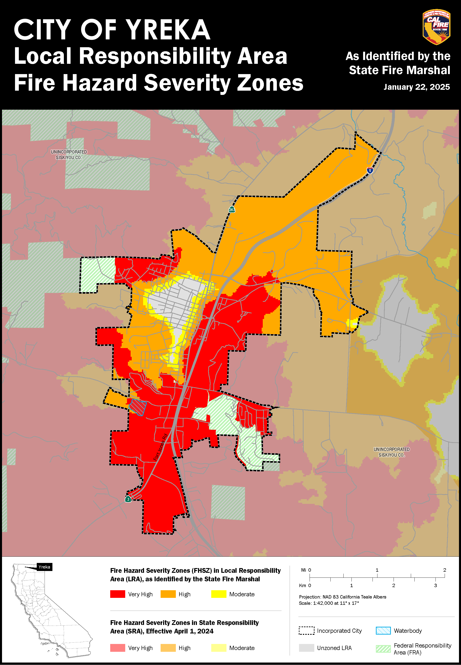
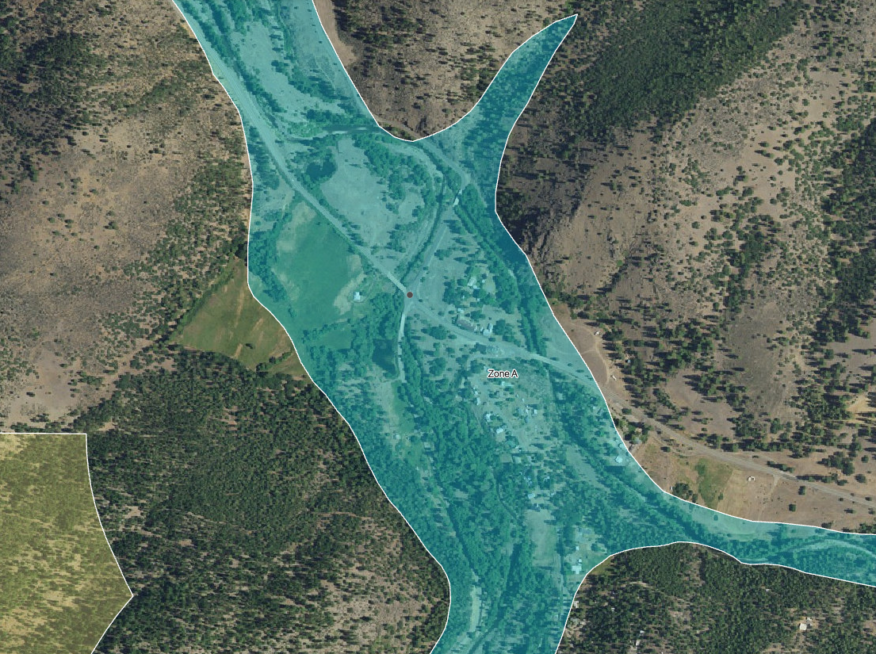
- Flood Hazard Maps for Local Communities

East Callahan Road

Callahan
Highway 3 to Etna

Callahan Emporium

Highway 3 to Gazelle
Cecilville Road

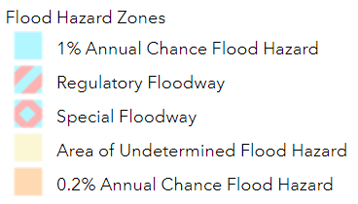

Flood Map – Callahan
The community of Callahan (Population less than 100) is located at the intersection of Highway 3 and Cecilville Road, near the south end of Scott Valley, where the south and east fork of the Scott River meet. Callahan’s location along the banks of the Scott River places the community within the 100 Year Floodplain. All primary evacuation routes in the Callahan area are in the 100 Year Floodplain.

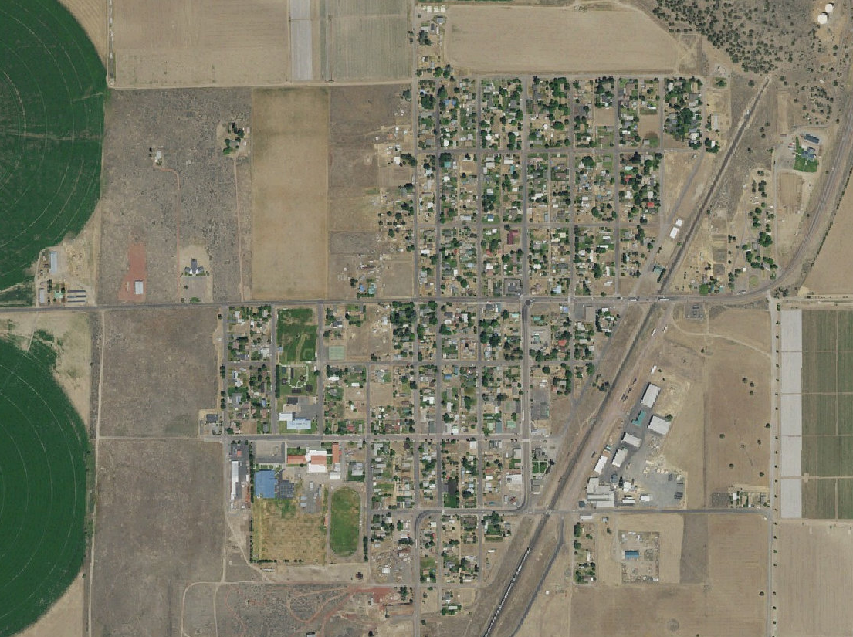
Highway 97 to Weed
Dorris
City Hall
Highway 97 to Klamath Falls
Dorris Elementary School

Flood Map – Dorris
The town of Dorris (Population 822) is in the northeastern portion of Butte Valley, slightly south of the Oregon border, along Highway 97. The nearest surface water is approximately 2 miles away. No portion of the town is within the 100 Year Floodplain. Minor localized flooding is possible due to ponding or diversion of water onto town streets during a storm event. Dorris has very little flood risk.

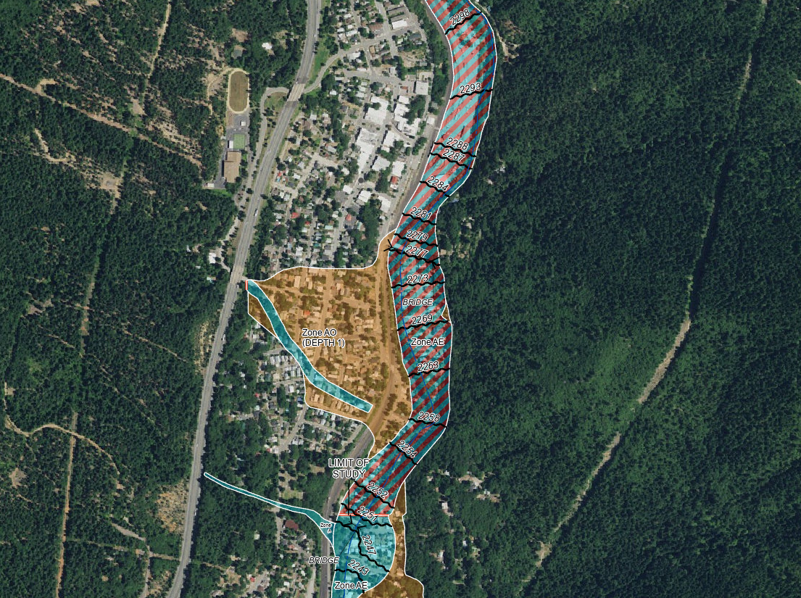
Dunsmuir High School
Interstate 5
to Mount Shasta
Interstate 5
to Redding
Dunsmuir
City Hall
Sacramento River

Flood Map – Dunsmuir
The town of Dunsmuir (Population 1,642) is located along Interstate 5, near the county’s southern border. There is a significant history of flooding in this area. The Sacramento River runs through the middle of town with development on both sides of the river. Several creeks and temporary channels flow through town and feed into the Sacramento River. Large portions of the town are within the 100 Year and 500 Year Floodplain. The town is located downstream from the Box Canyon dam, which is classified as Extremely High for downstream hazards. Major flood events in the past resulted in extensive damage to structures located along the Sacramento River.
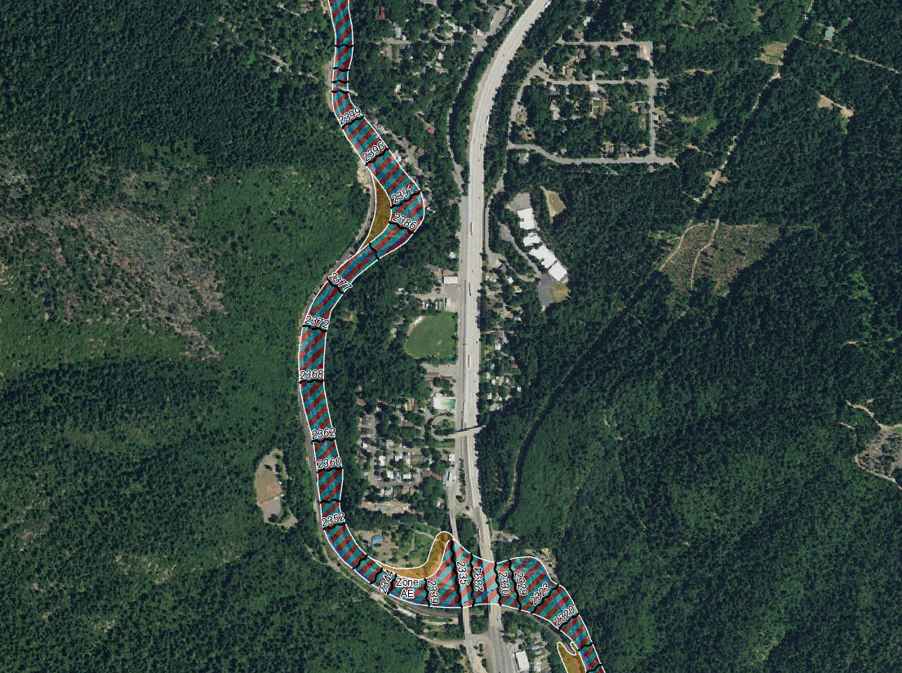
Interstate 5 to Mount Shasta
North Dunsmuir
Interstate 5 to Redding
Dunsmuir Elementary School
City Park

Flood Map – North Dunsmuir
There is significant development adjacent to the Sacramento River. The Southern Pacific Railroad line runs parallel to the river as it passes through the river canyon. Flooding of Hedge Creek or the Sacramento River would have adverse impacts on all development along the Sacramento River, including the railroad. In 1964 and 1974, flooding in Dunsmuir resulted in steel bridges and large sections of rail line being washed downstream.

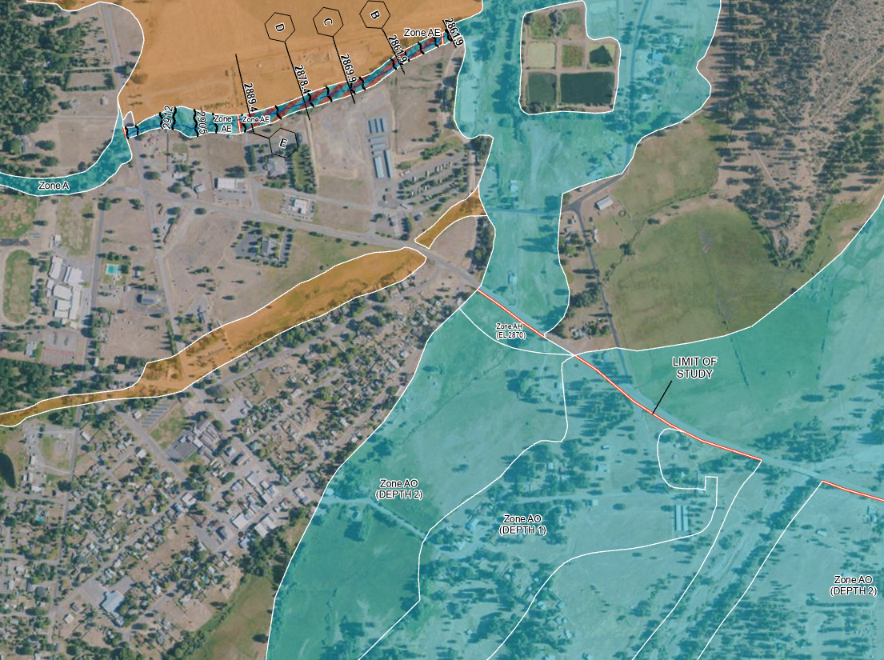
Highway 3 to Callahan
Highway 3 to Fort Jones
Etna
City Hall
Etna High School
Island Road

Flood Map – Etna
The town of Etna (Population 653) is located on the west side of Scott Valley, 13 miles north of Callahan along Highway 3. The nearest surface water is Etna Creek located to the southeast. The 100 Year Floodplain is located southeast of Main Street, spreading across the valley floor. In this area, Island Road, Highway 3, and Horn Lane are all in the 100 Year Floodplain. Development near Etna Creek and the low-lying areas southeast of town would be most affected during a flood. In the past, flooding of Island Road has prevented vehicle travel to Etna via Island Road for weeks at a time.
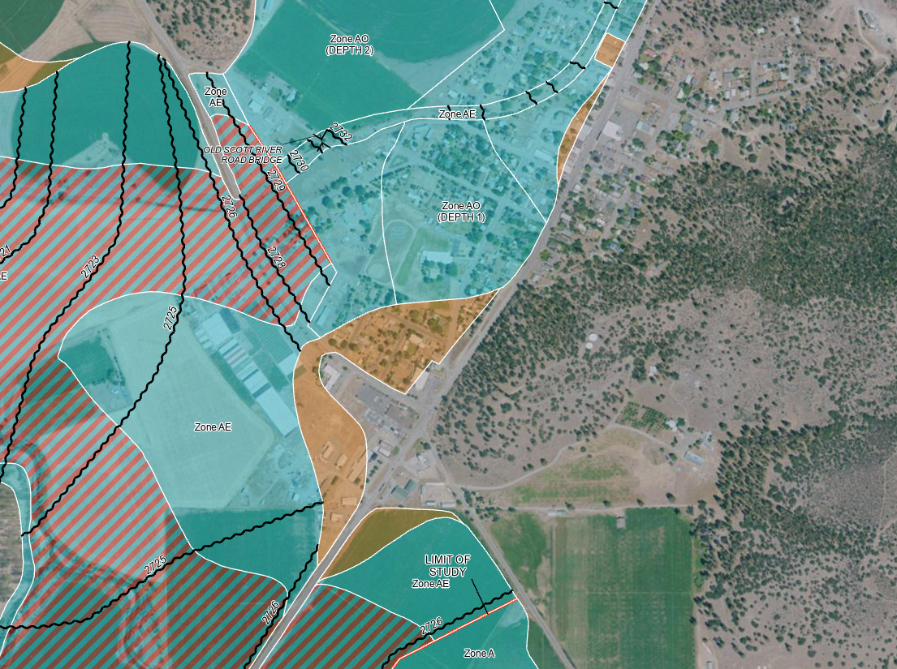
Highway 3 to Yreka
Highway 3 to Etna
Fort Jones
City Hall
Scott River Road
Scott Valley
Junior High
Eastside Road

Flood Map – Fort Jones
The town of Fort Jones (Population 673) is in Scott Valley, 12 miles north of Etna along Highway 3. The nearest surface water is the Scott River located to the southwest. The 100 Year Floodplain is located west of Main Street, spreading west, north, and south, across the valley floor. Scott River Road and Highway 3 are both in the 100 Year Floodplain. Eastside Road sits above the floodplain, heading east towards Etna.

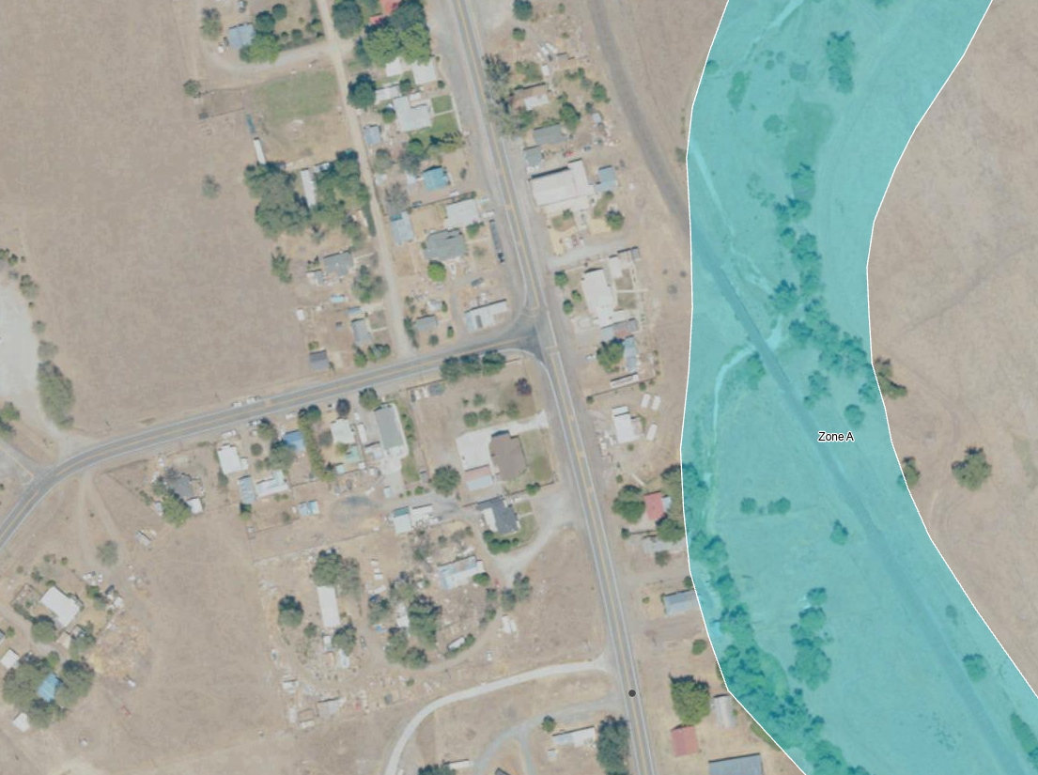
Old Highway 99 to Weed
Old Highway 99 to Yreka
Gazelle
Gazelle Callahan Road

Flood Map – Gazelle
The community of Gazelle (Population 120) is located west of Interstate 5 along Old Highway 99 South, between Yreka and Weed. The nearest surface water is Willow Creek. The 100 Year Floodplain is south of town, along Willow Creek and extending northeast up to West Louie Road.

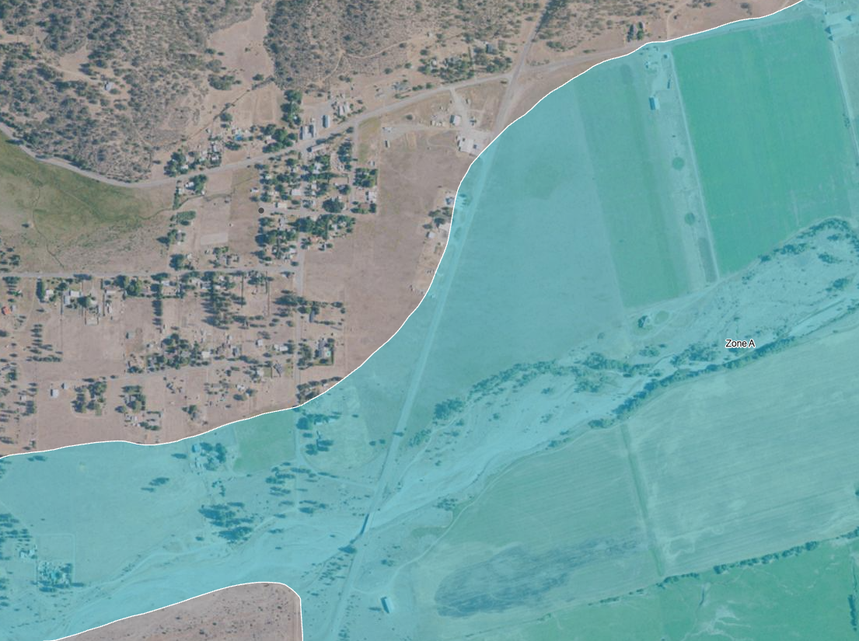
Highway 3 to Etna
Highway 3 to Fort Jones
Greenview
Kidder Creek
Quartz Valley Road

Flood Map – Greenview
The community of Greenview (Population 208) is in Scott Valley, midway between Fort Jones and Etna on Highway 3. The nearest surface water is Kidder Creek located south of town. The 100 Year Floodplain covers the southern part of town and Highway 3 between South Kidder Creek Loop continuing up to Glendenning Road. Flooding is likely to restrict vehicle travel between Greenview and Etna along Highway 3.

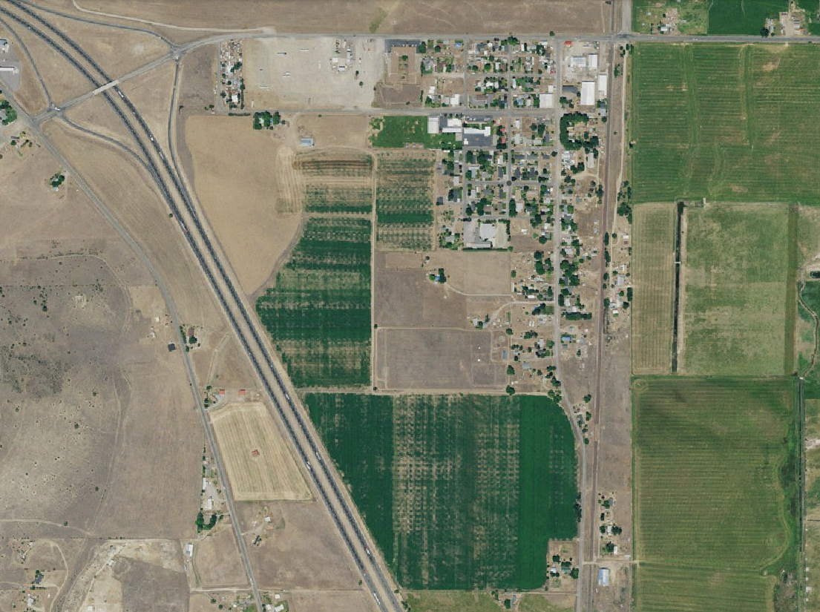
Interstate 5 to Weed
Interstate 5 to Yreka
Old High 99 to Yreka
Old High 99 to Weed
Grenada
99-97 Cut off
Siskiyou Boulevard

Flood Map – Grenada
The community of Grenada (Population 314) is located along Interstate 5 and covers the land area between County Road A12, Montague Grenada Road, and Interstate 5. The nearest surface water is Willow Creek east of Grenada. The community is not in the 100 Year Floodplain and flood risk is minimal.

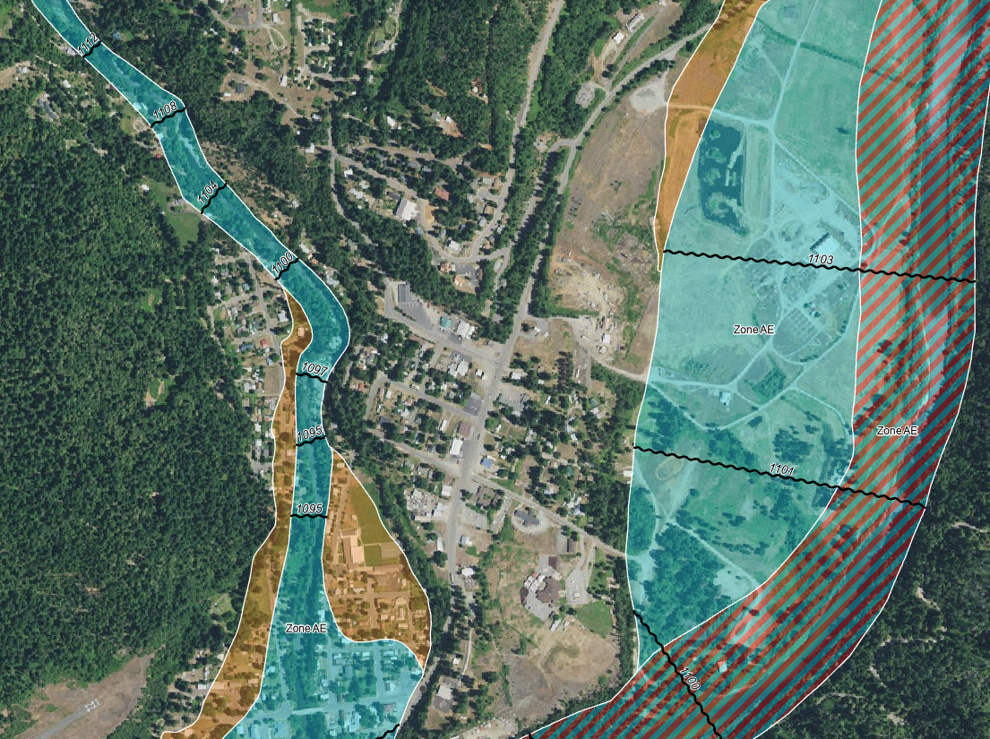
Grayback Road to Oregon
Highway 96 to Yreka
Highway 96 to Orleans
Happy Camp
Karuk Tribe Administration

Flood Map – Happy Camp
The community of Happy Camp (Population 907) is located on Highway 96, approximately 70 miles west of Interstate 5. The 100 Year Floodplain covers large areas of the town and parts of Highway 96. Happy Camp is home to one of three Karuk Tribe administrative centers. The Tribe has invested heavily into Happy Camp and a flood event is likely to cause extensive damage to tribal property.

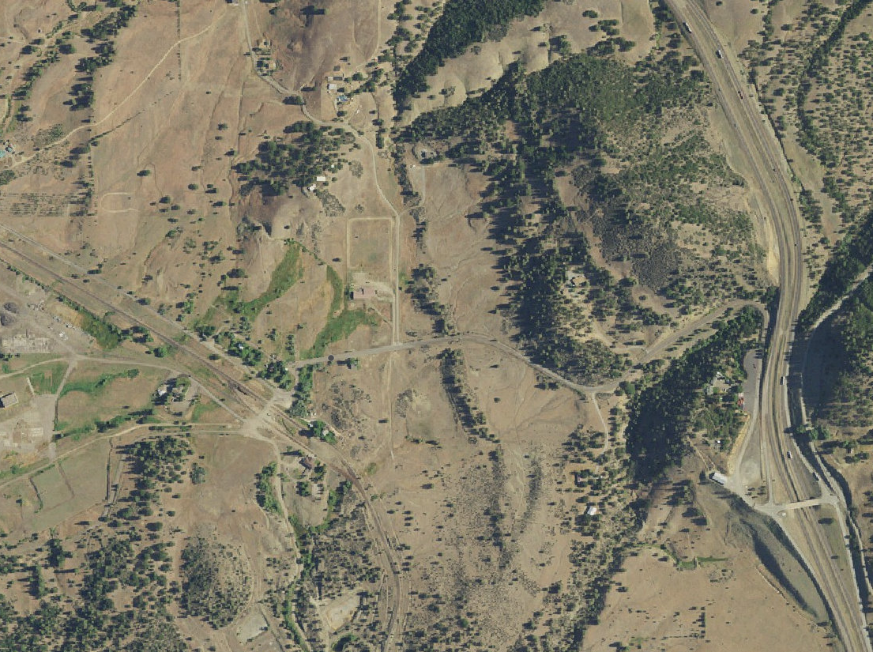
Interstate 5 to Yreka
Interstate 5 to Ashland
Hilt
Hilt Road
Hilt Church

Flood Map – Hilt
The community of Hilt (Population 9) is located west of Interstate 5, near the Oregon border. The nearest surface water is Cottonwood Creek located west of town. The 100 Year Floodplain is located far from any development and there is minimal flood risk.

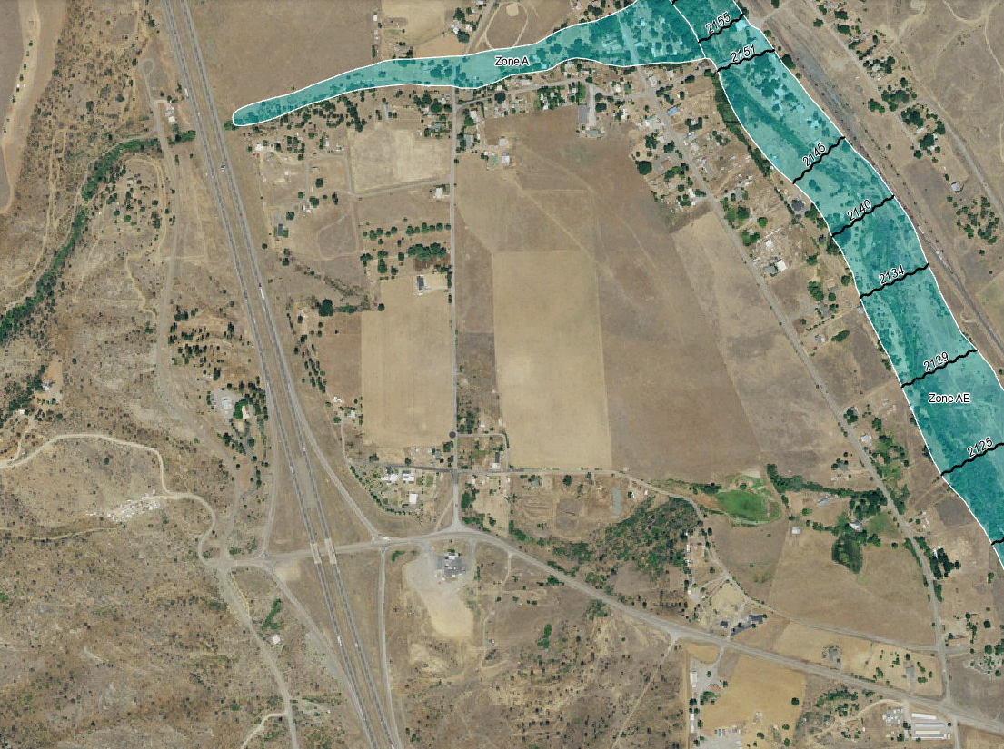
Interstate 5 to Ashland
Interstate 5 to Yreka
Hornbrook
Hornbrook Road
Copco Road
Oregon Road

Flood Map – Hornbrook
The community of Hornbrook (Population 381) is located east of Interstate 5, approximately 15 miles north of Yreka. The nearest surface water feature is Cottonwood Creek. The 100 Year Floodplain is located near developments and there is moderate flood risk.

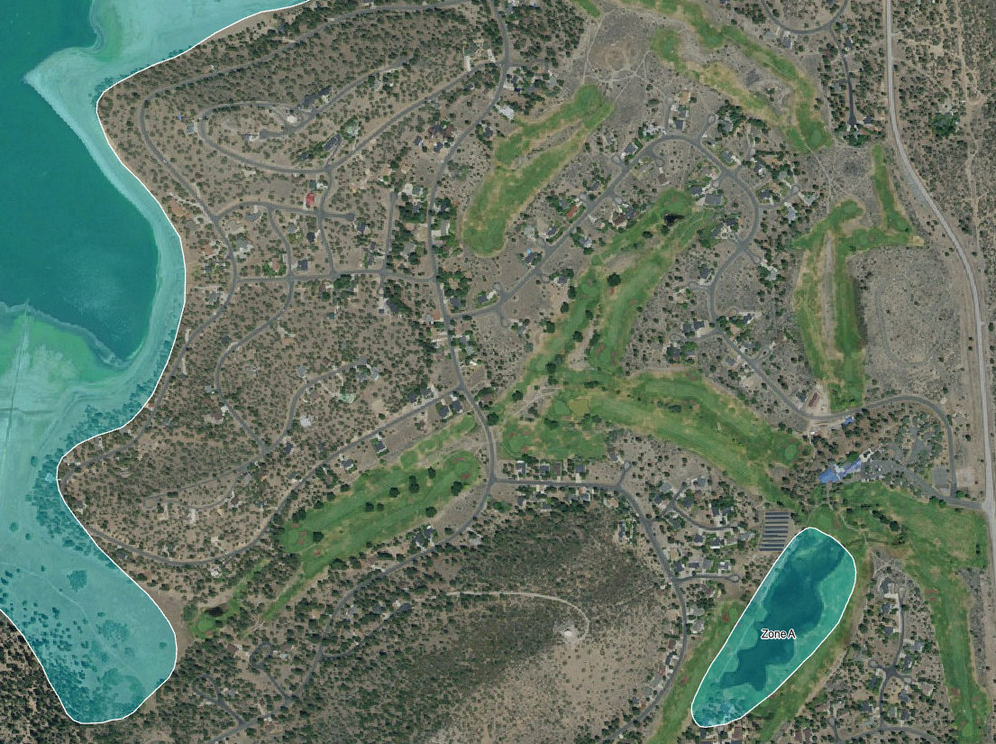
Lake Shastina
Lake Shastina
Golf Resort
Tony Lema Drive
Big Springs Road

Flood Map – Lake Shastina
The community of Lake Shastina (Population 3,008) is located north of Weed along Highway 97. The nearest surface water features are Lake Shastina and the Shasta River. The 100 Year Floodplain is located far from most development. Low lying areas near the lake are most at risk. Parts of Dwinnell Way, Dwinnell Road, and Spear Point Road are in the 100 Year Floodplain.

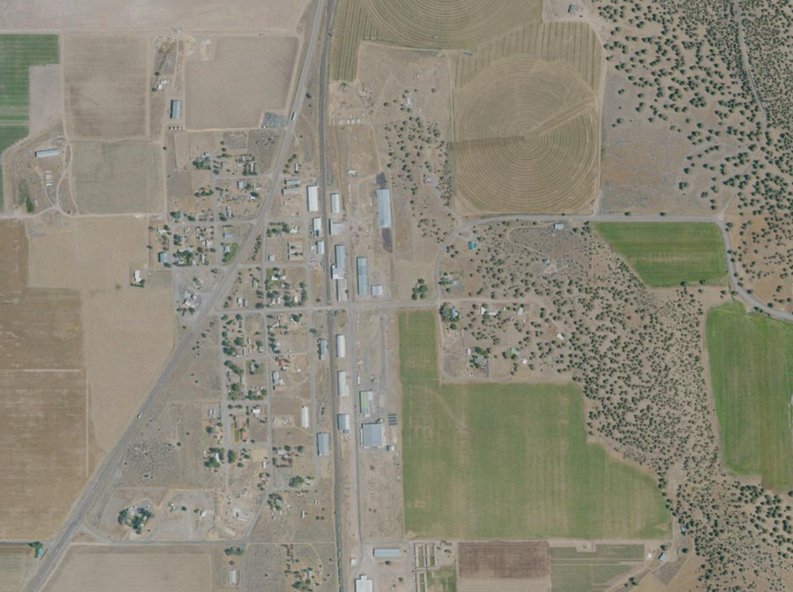
Highway 97
to Weed
Highway 97 to Klamath Falls
Macdoel
Juniper Knoll Road
Meiss Lake Road
Railroad Avenue

Flood Map – Macdoel
The community of Macdoel (Population 143) is located on Highway 97, approximately 40 miles north of Weed, CA. The nearest surface water is Meiss Lake to the northwest. The 100 Year Floodplain is approximately half a mile to the southeast of most development and there is minimal risk of flooding.

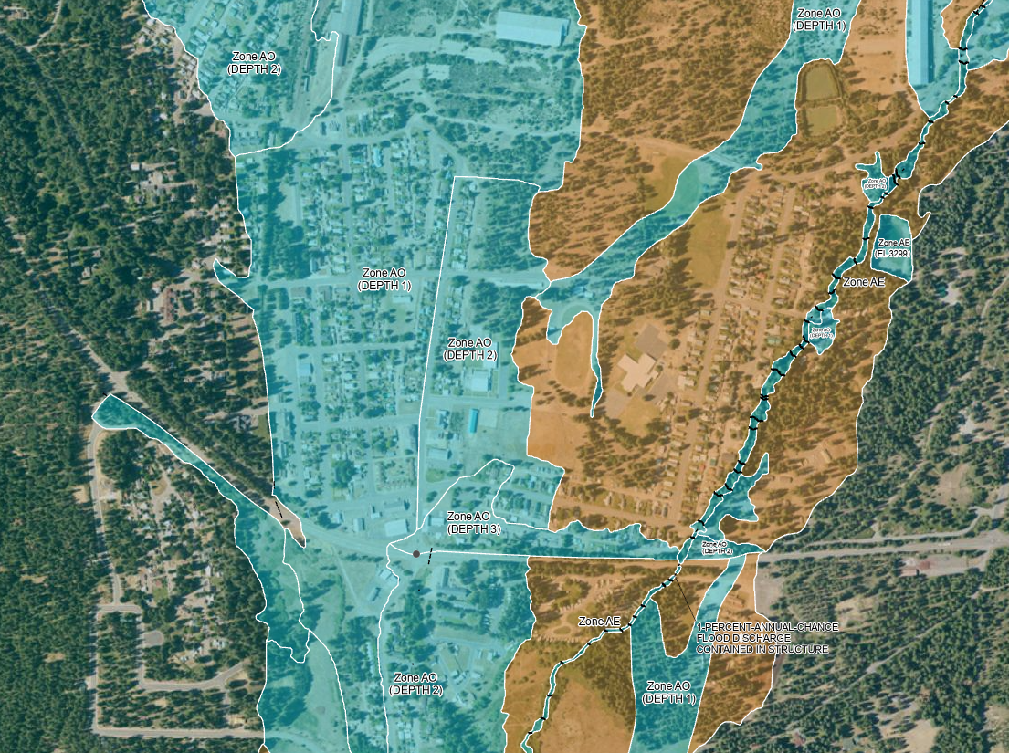
Highway 89 to Reno
McCloud
Highway 89 to Mount Shasta
Broadway Avenue
Shasta Avenue
Mill Road
Tucci Avenue
McCloud High School

Flood Map – McCloud
The community of McCloud (Population 959) is located east of Interstate 5, on Highway 89, 13 miles east of Mount Shasta. The nearest surface water is Panther Creek located to the northwest and Yét Atwam Creek, on the east side of town. Large parts of the community are in the 100 Year and 500 Year Floodplain. Annual flooding of Mud Creek, due to glacier melt from Mt. Shasta, often results in the closure of Highway 89 east of McCloud.

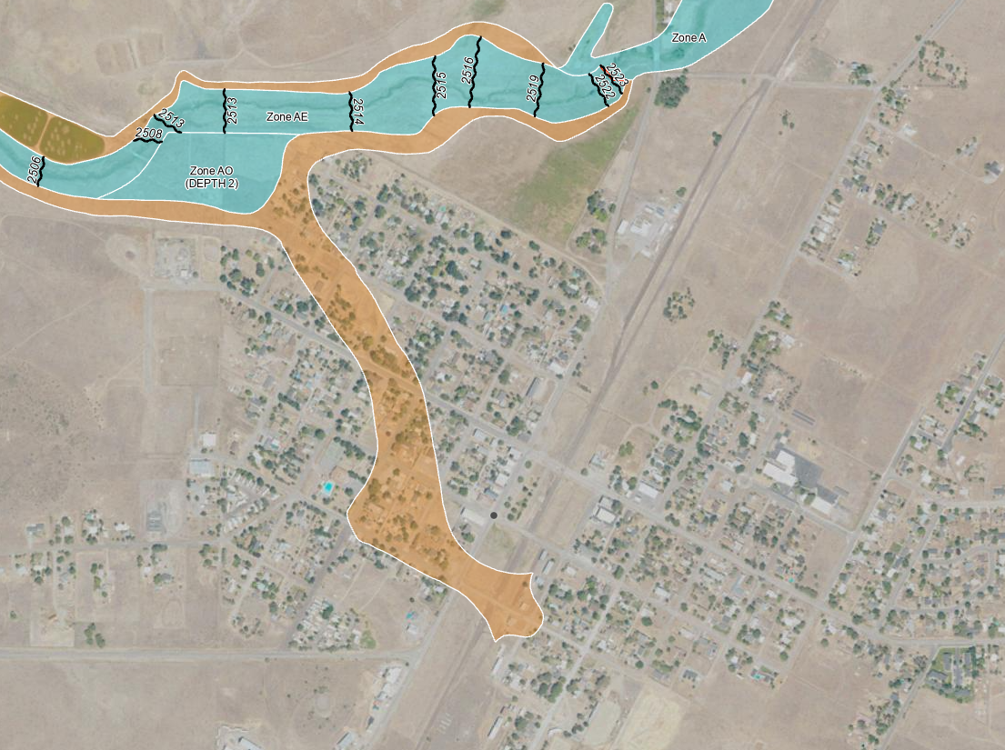
Montague
Montague Ager Road
East Webb Street
Montague Elementary School
Highway 3 to Yreka
Montague Grenada Road

Flood Map – Montague
The town of Montague (Population 1,182) is located east of Interstate 5, six miles east of Yreka on Montague Road. The nearest surface water is the Shasta River located west of town, past the airport, and the Oregon Slough, to the north. The 100 Year Floodplain is located far from town along the banks of the Shasta River. While parts of Montague are in the 500 Year Floodplain there is minimal risk of flooding.

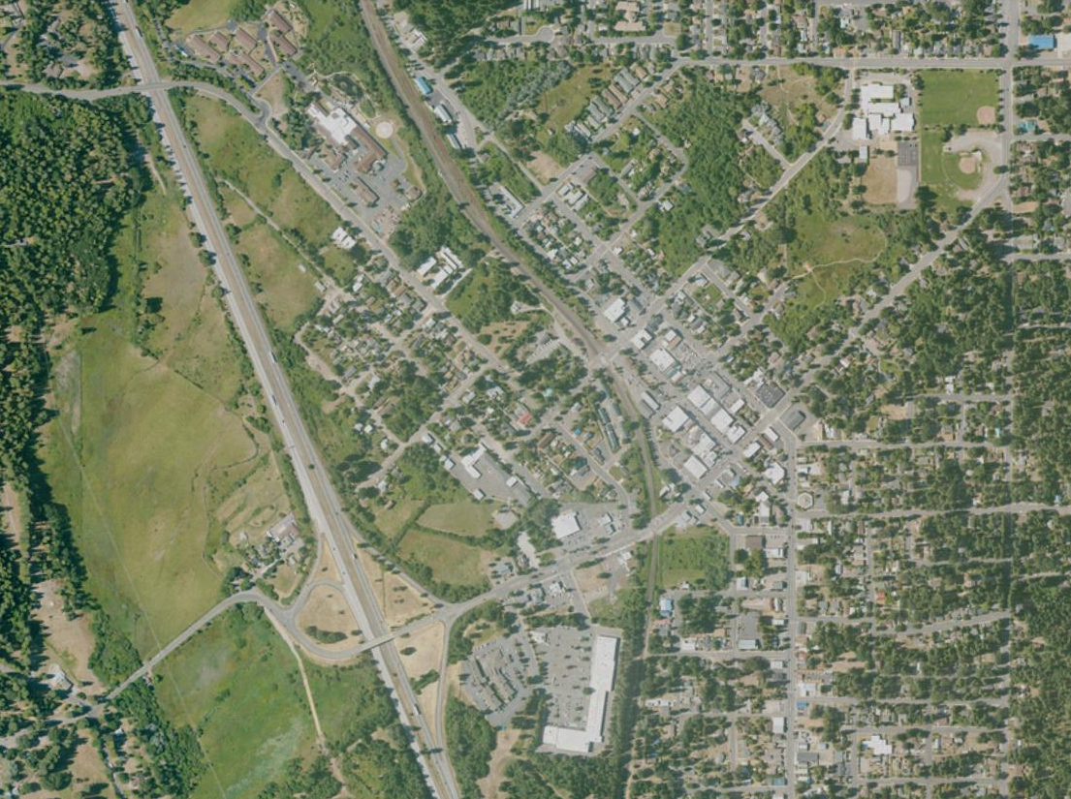
Mount Shasta
Interstate 5 to Yreka
Sisson School
City Hall
Hospital
Interstate 5 to Redding
West Lake Street
North Mt. Shasta Boulevard
East Lake Street

Flood Map – Mount Shasta
The town of Mount Shasta (Population 3,179) is located 8 miles north of Dunsmuir on Interstate 5. The nearest surface water is Lake Siskiyou, located to the west. Also present are Wagon Creek, Big Springs Creek, and Cold Creek. The 100 Year Floodplain is located along the shores of Lake Siskiyou. Box Canyon Dam is a concrete gravity dam impounding Lake Siskiyou. The Upper Sacramento River flows from Lake Siskiyou, starting at the foot of the Box Canyon Dam. Low lying areas nearest to the lake are most at risk. Parts of WA Barr Road are in the 100 Year Floodplain and are susceptible to flooding.

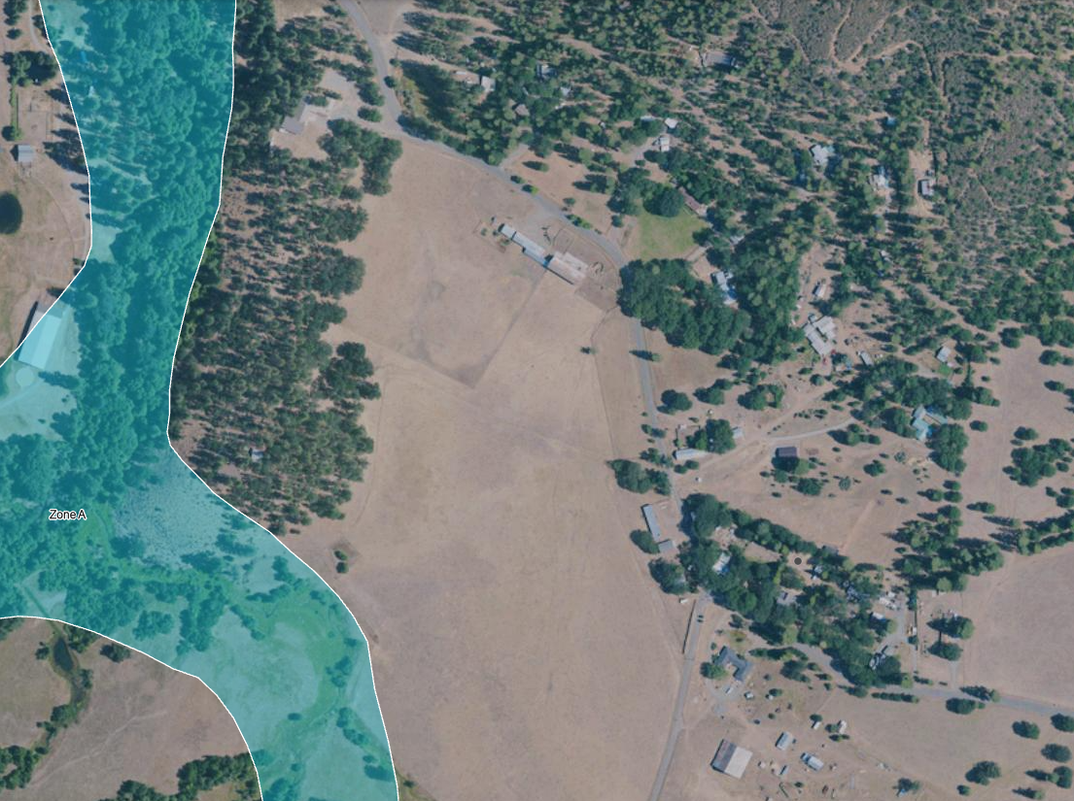
Mugginsville
Emigrant Creek
Mill Creek
Mill Creek Road
Quartz Valley Road
Quartz Valley Road

Flood Map – Quartz Valley
The community of Quartz Valley (Population 202) is located west of Greenview and Highway 3 on Quartz Valley Road. The nearest surface water feature is Scott River to the north, Sniktaw Creek to the west and Shackleford Creek to the south. The 100 Year Floodplain spans the area between Scott River Road and Quartz Valley Road. Emergency evacuation during a flood event may be impacted as large sections of Scott River Road and Quartz Valley Road are in the 100 Year Floodplain.

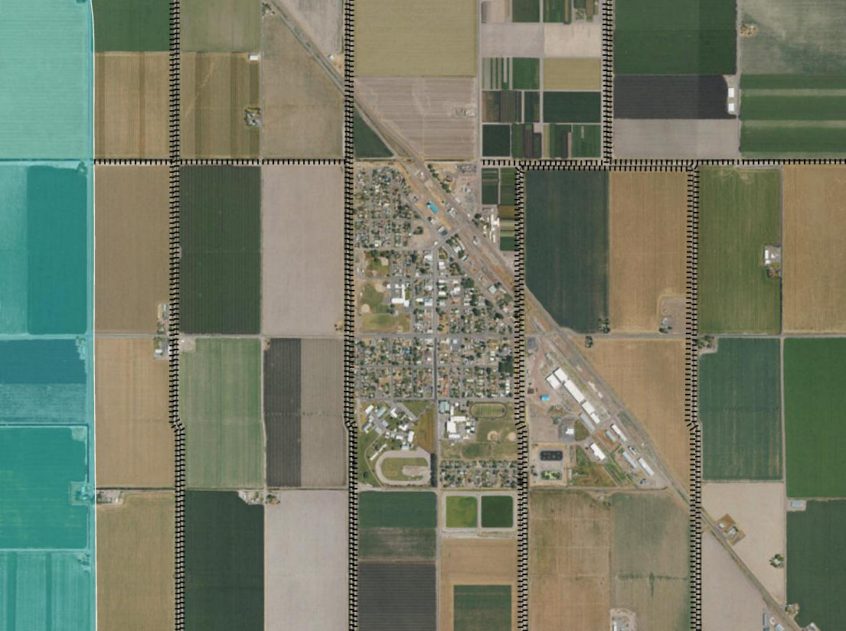
Tulelake
City Hall
Highway 139 North to Oregon
Highway 139 South
Tulelake High School

Flood Map – Tulelake
The town of Tulelake (Population 867) is in the northeast corner of the county on Highway 139, near the Oregon border. The nearest surface water is Tule Lake located southwest of town. The 100 Year Floodplain is located far from town and there is minimal flood risk. In addition, there are a series of levees that surround the town.

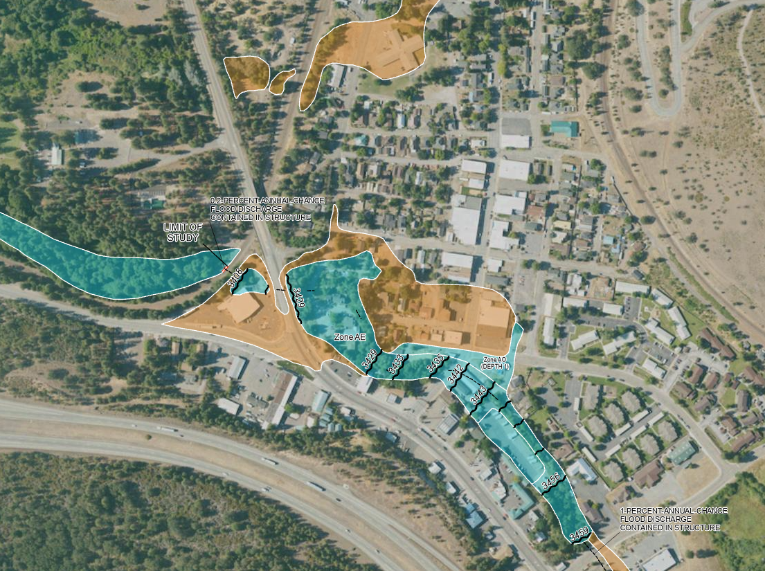
Weed
City Hall
North Weed Boulevard
Main Street
High 97 to Dorris
Interstate 5 South
Interstate 5 North

Flood Map – Weed
The town of Weed (Population 2,574) is located at the interchange of Interstate 5 and Highway 97, 10 miles north of Mount Shasta. The nearest surface water is Boles Creek, flowing east to west through town. Developments near the intersection of Weed Boulevard and Highway 97 are in the 100 Year Floodplain.

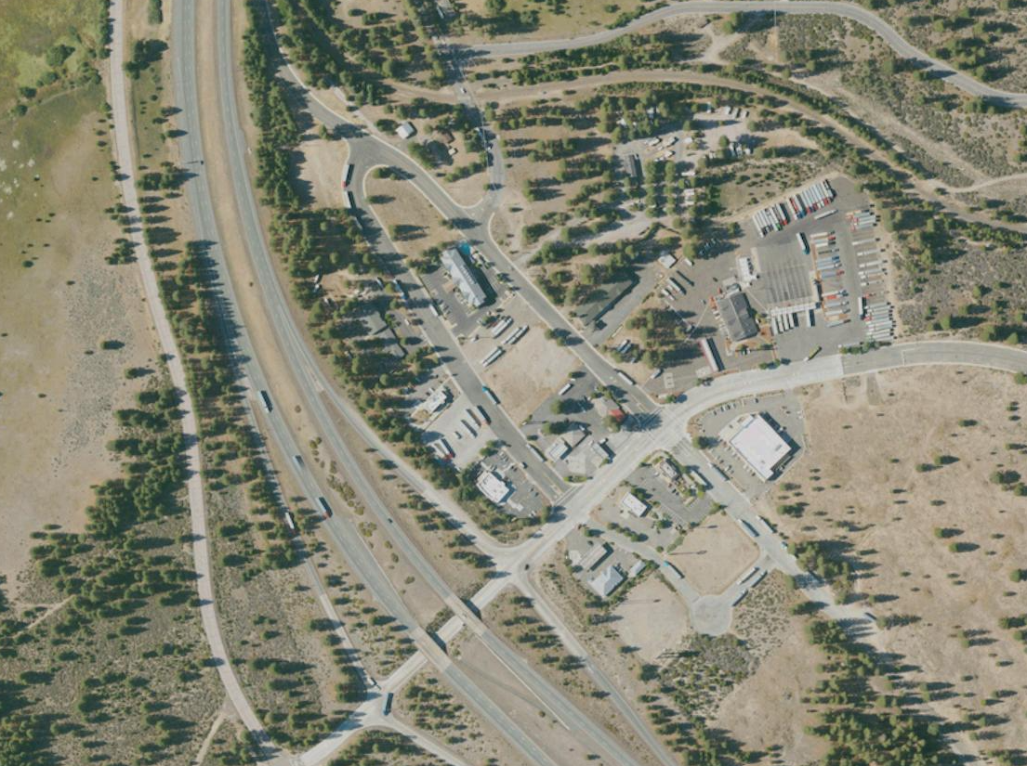
South Weed
Interstate 5 to Dunsmuir
Black Butte Drive
Interstate 5 to Yreka
East Vista Drive

Flood Map – South Weed
South Weed has minimal flood risk. The only areas in the 100 Year Floodplain are located along Interstate 5 towards the College of Siskiyous.

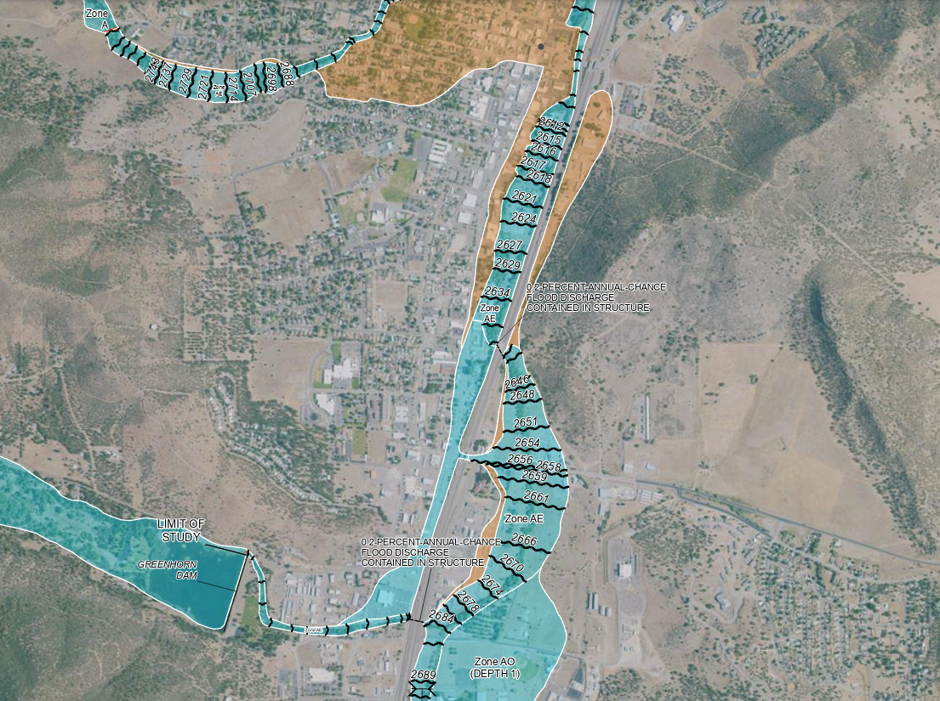
Yreka
Main Street
Greenhorn Park
Hospital
City Hall
Greenhorn Road
East Oberlin Road
Interstate 5 South to Weed
Interstate 5 North to Ashland

Flood Map – Yreka
The town of Yreka (Population 7,808) is located on Interstate 5, approximately 22 miles south of the Oregon Border. The nearest surface water feature is the Greenhorn Reservoir at the south end of town and Yreka Creek, which runs parallel to Interstate 5, the length of the town. The 100 Year Floodplain covers large areas of the town along the I-5 corridor. The 500 Year Floodplain covers the area between South West Street and Interstate 5.

- Institutional and Regulatory Framework

Fire Hazard Institutional Framework
The U.S. Geological Survey has additional information about wildfire hazard areas in Siskiyou County on the agency’s website at:

https://www.usgs.gov/fire-danger-forecast

The Department of Forestry and Fire Protection (CAL FIRE) is the primary agency responsible for fighting wildfires within the state responsibility area. The department oversees enforcement of state forest protection regulations, implements fuel management projects, and participates in forest conservation and management.

Fire Safe Council of Siskiyou County is a coalition of community groups organized around wildfire prevention and mitigation to protect communities.

Siskiyou Prescribed Burn Association (SPBA) includes landowners, tribes, and local organizations and agencies that work together to safely conduct prescribed burns as a fire hazard mitigation tool.

Fire Hazard Regulatory Framework
Public Resources Code 4290 includes minimum standards for development in the State Responsibility Area. The law addresses emergency access, signage and building numbering, private water supply reserves for emergency fire use, and vegetation modification.

Public Resources Code 4291 requires property owners in mountainous areas, forest covered lands, or any land that is covered with flammable material to create at a minimum a 100-foot defensible space (or to the property line) around their homes and other structures.

The California State Building Code requires minimum standards for new buildings in fire hazard severity zones. Most housing in the county was built prior to this code requirement (Pre 1991). Any new development in the VHFHSZ must comply with state and county requirements for building standards, vegetation management, points of egress, and other measures.

The California Fire Code establishes regulations regarding fire safety and fire prevention in buildings and structures throughout the state. Under the Fire Code, all portions of a building shall be within 150 feet of a serviceable fire access road. Fire apparatus access roads shall be all weather roads with a minimum width of 20 feet.

Flood Hazard Institutional Framework
California Department of Water Resources developed the Flood Emergency Response Information Exchange to improve flood emergency preparedness, response, and recovery. The Department also implements the Sustainable Groundwater Management Act and administers the California Statewide Groundwater Elevation Monitoring Program.

Division of Safety of Dams, a part of the California Department of Water Resources, provides oversight of the design, construction, and maintenance of over 1,200 dams in California.

North Coast Regional Water Quality Control Board (RWQCB) enforces waterway protection and pollution control regulations for most of the county. The North Coast RWQCB contains the majority of county’s watersheds under its jurisdiction, except for the Sacramento River headwaters.

Central Valley Regional Water Quality Control Board (RWQCB) enforces waterway protection and pollution control regulations in the southeastern portion of the county. The Central Valley RWQCB has authority over waters used for irrigating the Central Valley, including much of the Sacramento River.

Geologic & Seismic Hazards Institutional Framework
The US Geological Survey conducts studies and provides information on geological and seismic hazards in the county, including volcanic activity.

The California Geological Survey provides scientific products and services about the state’s geology, seismicity, forests and watersheds, and mineral resources.

Geologic & Seismic Hazards Regulatory Framework
The Alquist-Priolo Act was passed following the San Fernando earthquake in 1971 (Magnitude 6.6). This act established regulatory zones surrounding the surface traces of active faults so that a structure for human occupancy cannot be placed or built on active faults with potential for surface rupture and must be sited at a minimum distance from the fault.

The Seismic Hazards Mapping Act (SHMA) directs the California Geological Survey to identify and map areas prone to earthquake hazards.

Hazardous Materials Institutional Framework
Siskiyou County Agriculture Department is the local enforcement agency for state pesticide regulations. The Department protects people and the environment through environmental and natural resource protection, consumer and industry protection and animal control programs.

The U.S. Environmental Protection Agency (EPA) tracks six common air pollutants, called “criteria air pollutants” that are found all over the U.S. and have been shown to harm human and environmental health as well as cause property damage. These include ground-level ozone, particulate matter, carbon monoxide (CO), lead, sulfur dioxide (SO2), and nitrogen dioxide (NO2).

California Air Resources Board (CARB) is a state agency that establishes emission standards for mobile air pollution sources in conjunction with federal agencies. CARB has developed programs to encourage cleaner cars and cleaner fuels such as California’s cleaner-burning gasoline.

Department of Resources Recycling and Recovery (CalRecycle) is a department within the California Environmental Protection Agency that coordinates the state’s recycling and waste management programs. CalRecycle also provides assistance with fire cleanup.
The Department of Toxic Substances Control (DTSC) tracks facilities that are authorized to handle hazardous waste such as federal Superfund and state Superfund sites, military facilities, voluntary cleanup sites, and school sites being evaluated for possible contamination.

The State Water Resources Control Board (SWRCB) regulates Leaking Underground Storage Tanks (LUSTs), Department of Defense facilities, and manages the Spills, Leaks, Investigations & Cleanup Program (SLIC), and landfills.

Hazardous Materials Regulatory Framework
The Resource Conservation and Recovery Act (RCRA) is a federal law that gives the Environmental Protection Agency (EPA) the authority to manage hazardous waste from "start to finish". This means the EPA controls the generation, transportation, treatment, storage, and disposal of hazardous waste. In 1992, the State received authorization from the EPA to oversee and regulate the federal RCRA in California.

Evacuation Planning Regulatory Framework
Government Code §65302 (Senate Bill 99). An update of the Safety Element must include identification of residential developments in any hazard area that do not have at least two emergency evacuation routes. This is intended to assist the County in identifying opportunities to improve the connectivity and resiliency of the transportation system.

Government Code §65302.15 (Assembly Bill 747) states that the county must identify evacuation routes and their capacity, safety, and viability under a range of emergency scenarios as well as identifying evacuation locations. The Safety Element may incorporate reference material from the LHMP to comply with this requirement.

- Incorporation of the LHMP and CWPP

INCORPORATION
In compliance with Assembly Bill 2140 (2006), the Siskiyou County 2025 Local Hazard Mitigation Plan (2025 LHMP) is herein incorporated and made a part of the Siskiyou County General Plan Safety Element.


2025 LOCAL HAZARD MITIGATION PLAN
The 2025 Local Hazard Mitigation Plan (2025 LHMP) for the County of Siskiyou Planning Area was developed in accordance with the Disaster Mitigation Act (2000) and followed FEMA’s Local Hazard Mitigation Plan guidance. The 2025 LHMP incorporates a process where hazards are identified and profiled, the people and facilities at risk are analyzed, and mitigation actions are developed to reduce or eliminate hazard risk. The implementation of these mitigation actions, which include both short and long-term strategies, involve planning, policy changes, programs, projects, and other activities.

To view the 2025 LHMP in its entirety please visit:
https://www.siskiyoucounty.gov/emergencyservices/page/local-hazard-mitigation-plan

2019 Community Wildfire Protection Plan for Siskiyou County
The Community Wildfire Protection Plan (CWPP) is a countywide effort that was collaboratively developed by interested residents, local fire agencies, city and county leadership, and state and federal fire suppression agencies. It is designed to help communities identify and prioritize areas for hazardous fuel reduction treatments and recommends the types and methods of treatment that will protect the communities of Siskiyou County.

To view the 2019 CWPP in its entirety please visit:
https://www.siskiyoucounty.gov/planning/page/general-plan
- Primary Evacuation Routes

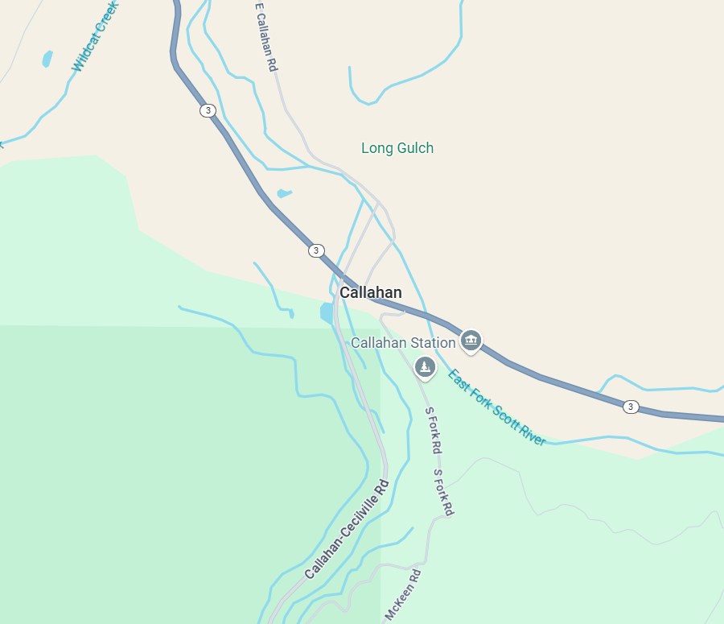
Southbound Highway 3
Northbound
East Callahan Road
Callahan
Southbound
Cecilville Road
Northbound Highway 3

Evacuation Routes – Callahan
The community of Callahan (Population less than 100) is located at the intersection of Highway 3 and Cecilville Road, where the south and east fork of the Scott River meet. Primary evacuation routes for Callahan are Highway 3, East Callahan Road, and Callahan-Cecilville Road, all of which are in the 100 Year Floodplain. Schools, churches, and the Etna rodeo grounds could serve as safe locations for evacuees during a hazard event.

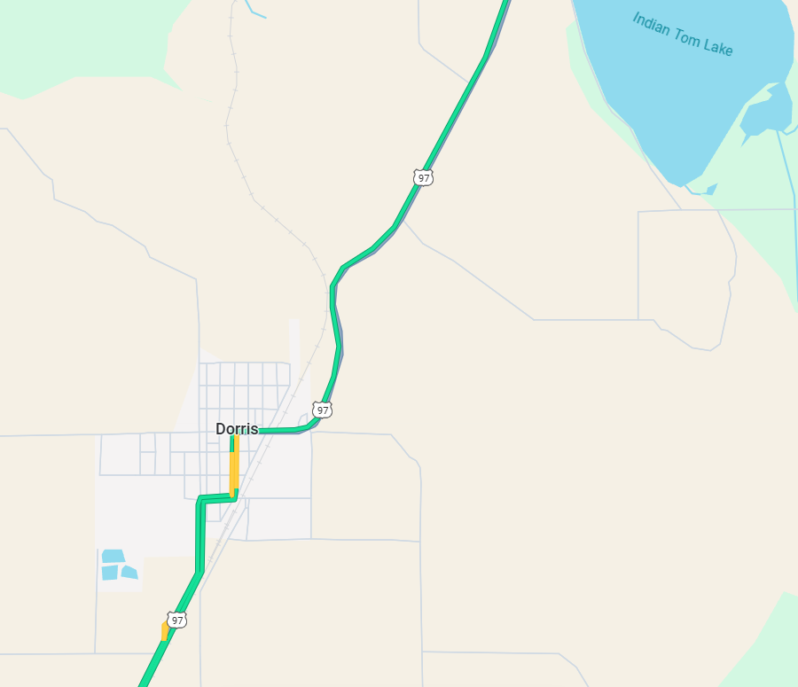
Dorris
Northbound Highway 97
Southbound Highway 97

Evacuation Routes – Dorris
The town of Dorris (Population 822) is in the northeastern portion of Butte Valley, slightly south of the Oregon border, along Highway 97. The primary evacuation route out of Dorris is Highway 97, north to Oregon, and south to the town of Weed. Schools, churches, and community centers in Weed and Tulelake could serve as safe locations for evacuees during a hazard event.

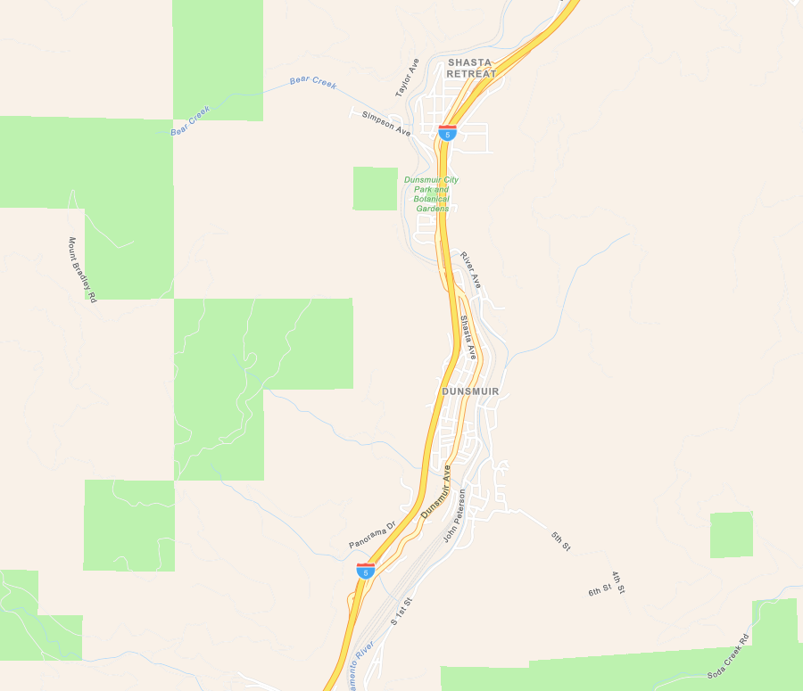
Dunsmuir
Southbound Interstate 5
Northbound Interstate 5

Evacuation Routes – Dunsmuir
The town of Dunsmuir (Population 1,642) is located on Interstate 5, near the County’s southern border. The primary evacuation route out of the area is Interstate 5, northbound to the town of Mount Shasta and southbound to the town of Redding and Shasta County. Schools, churches, and community centers in Mount Shasta could serve as safe locations for evacuees during a hazard event. Given Dunsmuir’s proximity to Shasta County, it is likely that many evacuees will instead choose to transit south towards Castella and Redding, California.

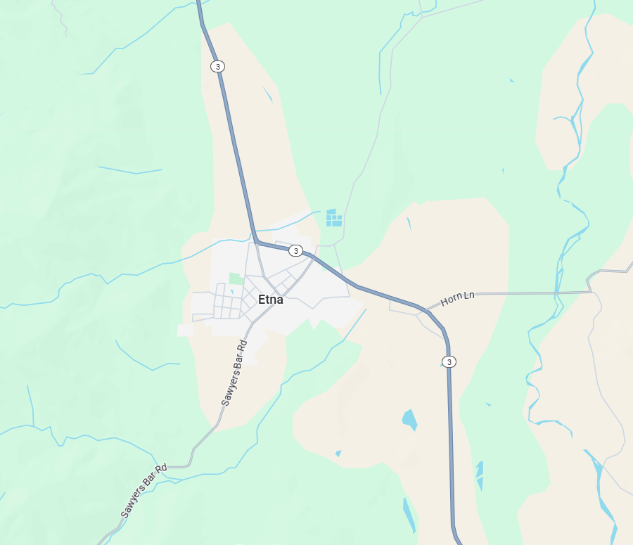
Etna
Southbound
Sawyers Bar Road
North on Island Road to Fort Jones
Northbound Highway 3
Horn Lane towards Eastside Road
Southbound Highway 3

Evacuation Routes – Etna
The town of Etna (Population 653) is located on the west side of Scott Valley, 13 miles north of Callahan on Highway 3. The primary evacuation route is Highway 3, northbound to Fort Jones and Yreka, southbound towards the Community of Gazelle and the town of Weed. An alternative route, south on Sawyers Bar Road is available, which will take you over Etna Summit and towards the Communities of Sawyers Bar, Forks of Salmon and Somes Bar. Schools, churches, and community centers in Fort Jones could serve as safe locations for evacuees during a hazard event.

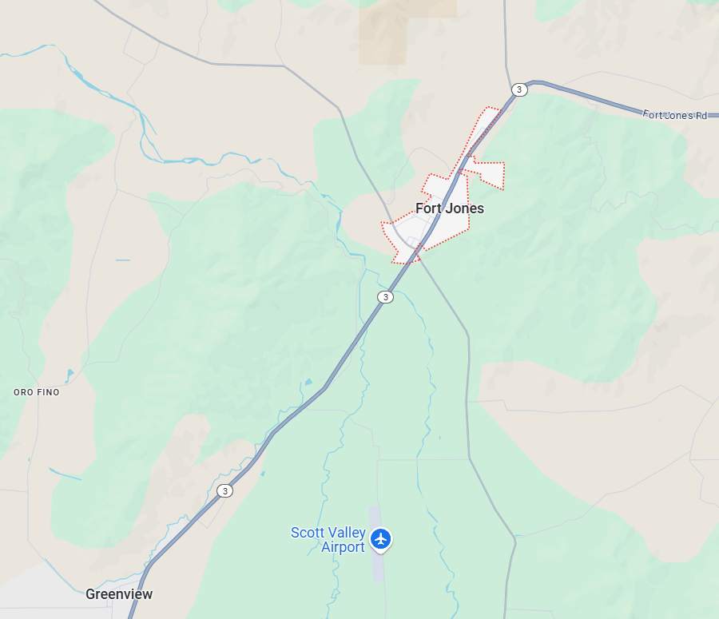
Fort Jones
Southbound Highway 3
North on Scott River Road
Northbound Highway 3
South on Eastside Road to Etna

Evacuation Routes – Fort Jones
The town of Fort Jones (Population 673) is in Scott Valley, 12.5 miles north of Etna on Highway 3. The primary evacuation route out of Fort Jones is Highway 3, northbound to Yreka and southbound towards the town of Etna. Scott River Road and Eastside Road could also serve as evacuation routes. Schools, churches, and community centers in Yreka and Etna, and the Siskiyou County Fairgrounds in Yreka, could serve as safe locations for evacuees during a hazard event.

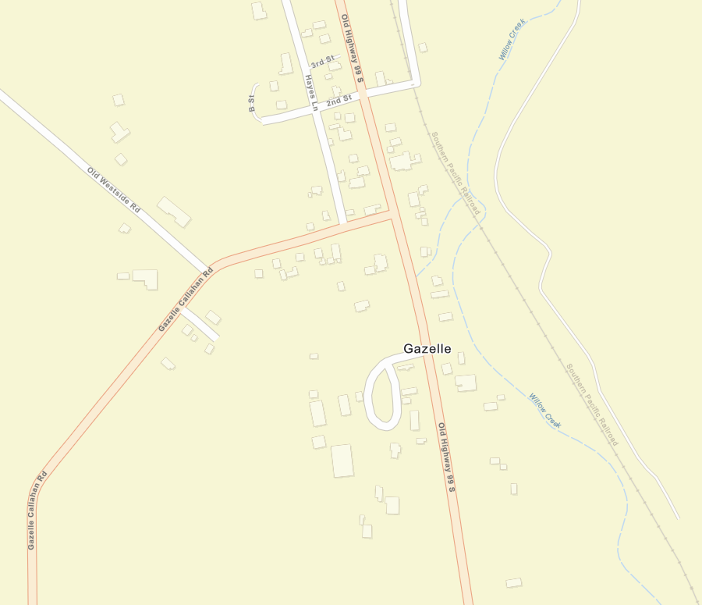
Gazelle
Southbound
Old Highway 99
Northbound
Old Highway 99
Eastbound on
Gazelle Callahan Road

Evacuation Routes – Gazelle
The community of Gazelle (Population 120) is located west of Interstate 5 on Old Highway 99, between the Cities of Yreka and Weed. The main evacuation route is Old Highway 99, northbound to Yreka, southbound to Weed, or west along Gazelle-Callahan Road towards Callahan and the Scott Valley area. Schools, churches, and community centers in Yreka, Weed, and Montague, and the Siskiyou County Fairgrounds in Yreka, could serve as safe locations for evacuees during a hazard event.

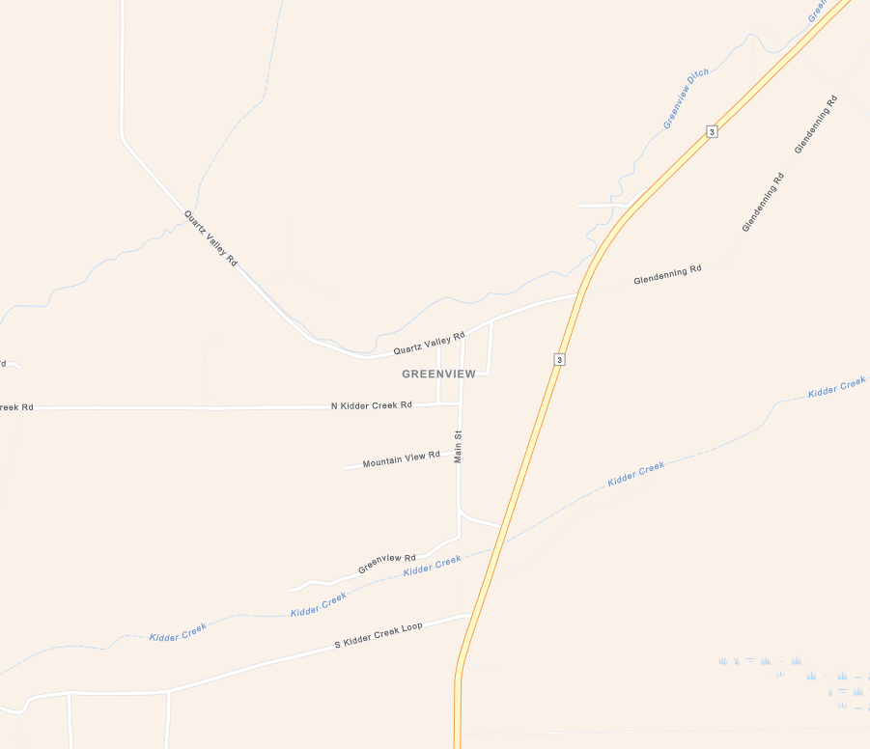
Greenview
Southbound Highway 3
Westbound
Quartz Valley Road
Northbound Highway 3

Evacuation Routes – Greenview
The community of Greenview (Population 208) is in Scott Valley, midway between Fort Jones and Etna on Highway 3. The main evacuation route for this area is Highway 3, northbound towards Fort Jones, and southbound towards Etna. Quartz Valley Road is an alternative route which will take you towards the Quartz Valley Indian Reservation and eventually to Scott River Road towards Fort Jones. Schools, churches, and community centers in Fort Jones and Etna could serve as safe locations for evacuees during a hazard event.

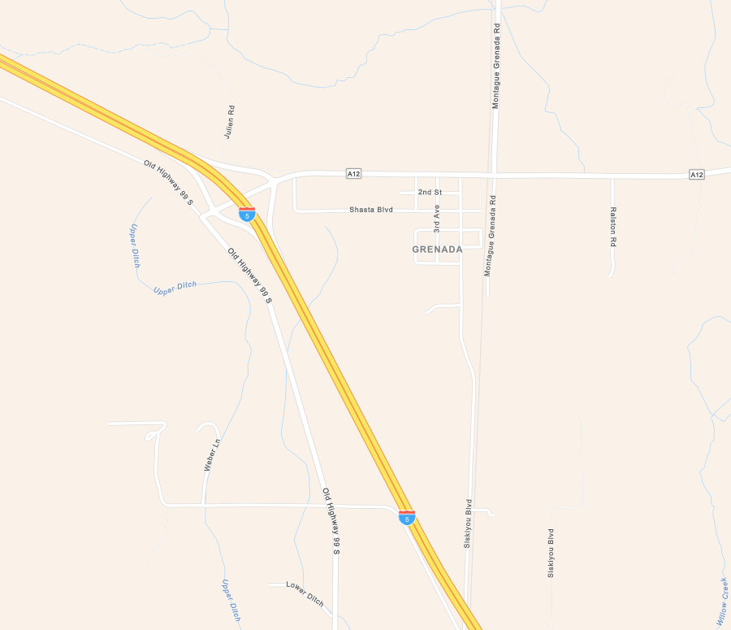
Northbound
Montague Grenada Road
Grenada
Northbound Interstate 5
Southbound Interstate 5
Eastbound
County Road A12

Evacuation Routes – Grenada
The community of Grenada (Population 314) is located along Interstate 5 and covers the land area between County Road A12, Montague Grenada Road, and Interstate 5. The primary evacuation route for this area is Interstate 5, northbound to Yreka and southbound to Weed. County Road A12 and Montague Grenada Road are alternative routes if I-5 is not accessible. Schools, churches, and community centers in Yreka, Weed, and Montague, and the Siskiyou County Fairgrounds in Yreka, could serve as safe locations for evacuees during a hazard event.

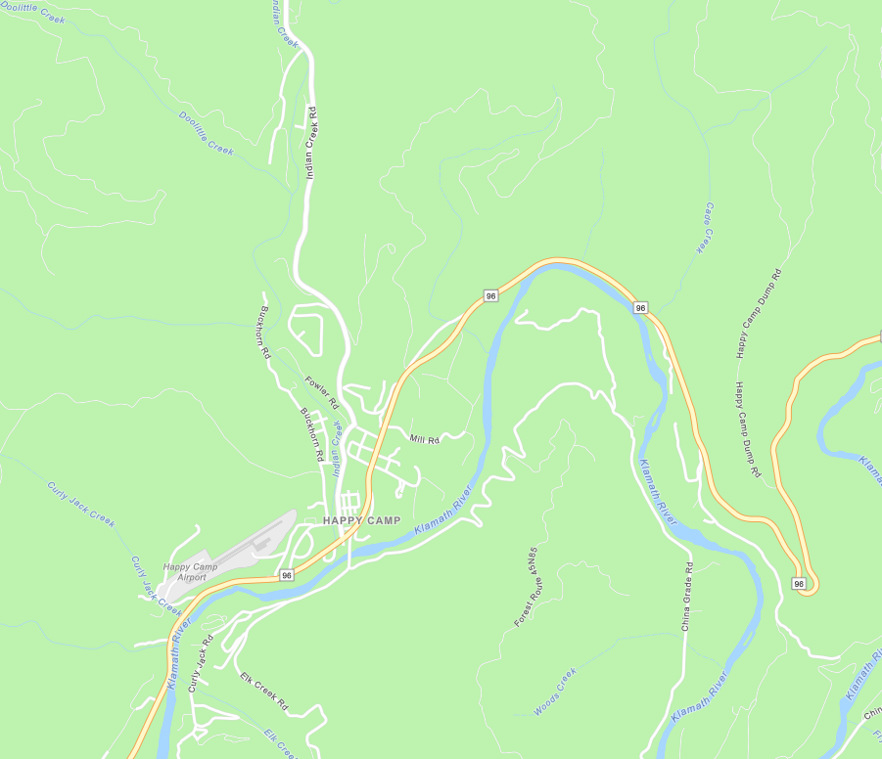
Eastbound Highway 96
Karuk Tribe
Happy Camp
Westbound Highway 96
Indian Creek Road to Grayback Road

Evacuation Routes – Happy Camp
The community of Happy Camp (Population 907) is located on Highway 96, 70 miles west of Interstate 5. Primary evacuation routes are Highway 96, Elk Creek Road, Indian Creek Road, and Buckhorn Road. When Highway 96 is restricted, the only route out of the area is Indian Creek Road continuing to Grayback Road, up into Oregon. Forest Routes (unpaved roads) between Orleans and Happy Camp are available as a last resort. Schools, churches, and community centers in Orleans and Yreka and the Siskiyou County Fairgrounds in Yreka, could serve as safe locations for evacuees during a hazard event.

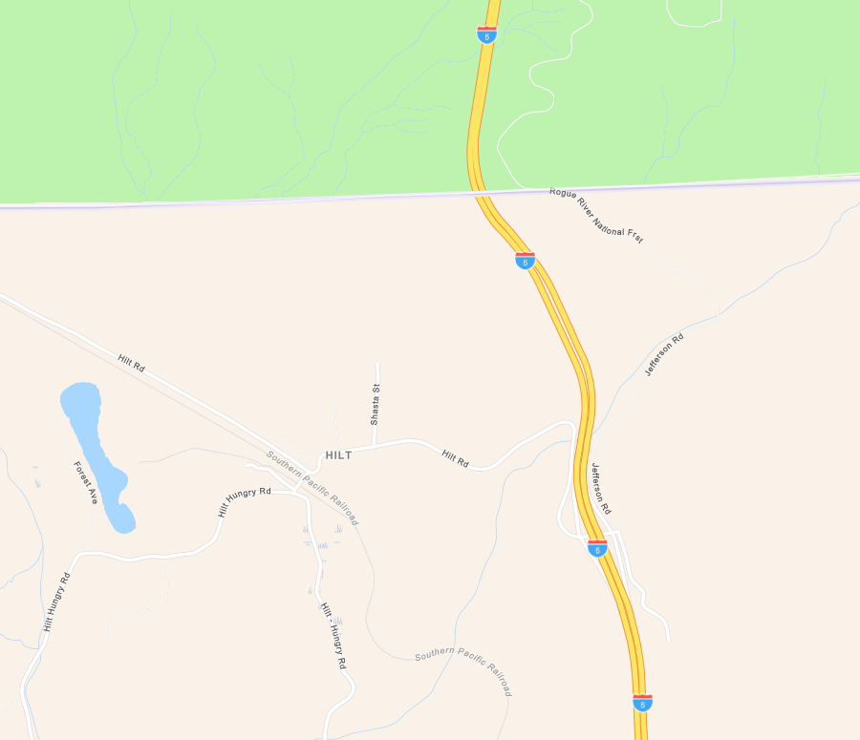
Hilt
Northbound Interstate 5
Southbound Interstate 5

Evacuation Routes – Hilt
The community of Hilt (Population 9) is located west of Interstate 5, near the Oregon border. The sole evacuation route is Hilt Road to Interstate 5. Schools, churches, and community centers in Yreka and Montague, and the Siskiyou County Fairgrounds in Yreka, could serve as safe locations for evacuees during a hazard event. Given Hilt’s proximity to Oregon, it is possible that evacuees will instead choose to transit north towards Ashland.

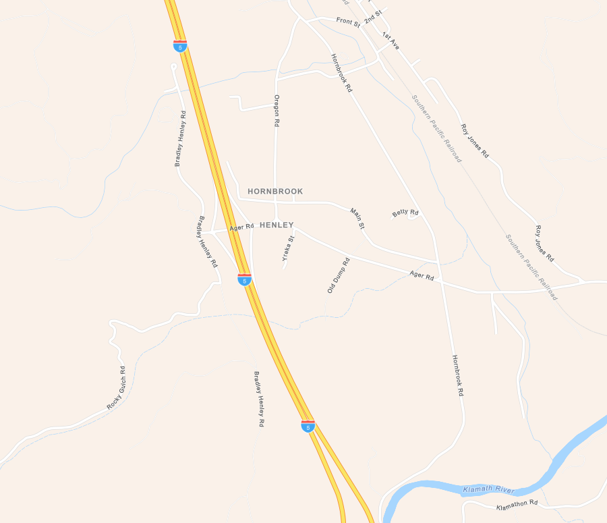
Hornbrook
Northbound Interstate 5
Southbound Interstate 5

Evacuation Routes – Hornbrook
The community of Hornbrook (Population 381) is located east of Interstate 5, approximately 15 miles north of Yreka. The primary evacuation route is Ager Road out to Interstate 5. Schools, churches, and community centers in Yreka and Montague, and the Siskiyou County Fairgrounds in Yreka, could serve as safe locations for evacuees during a hazard event. Given Hornbrook’s proximity to Oregon, it is possible that evacuees will instead choose to transit north towards Ashland.

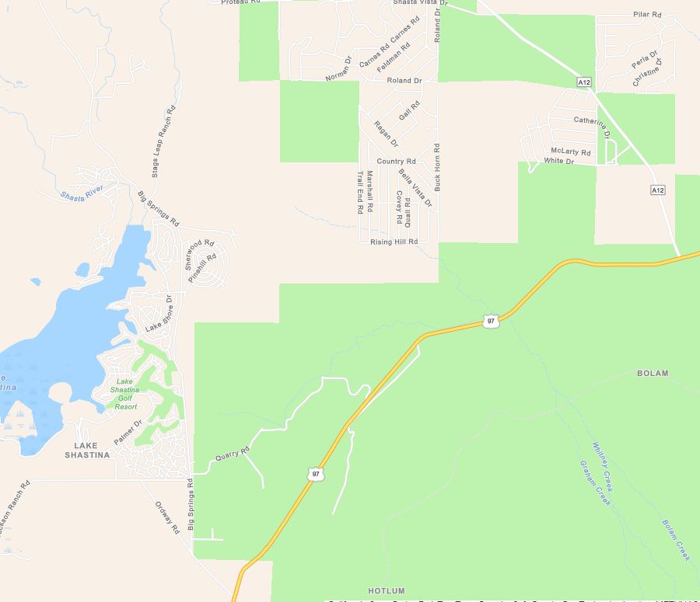
Eastbound Highway 97
Big Springs Road
Lake Shastina
County Road A12
Westbound Highway 97
Jackson Ranch Road

Evacuation Routes – Lake Shastina
The community of Lake Shastina (Population 3,008) is located north of Weed along Highway 97. The primary evacuation routes are Jackson Ranch Road westbound to Interstate 5 and Big Springs Road southbound to Highway 97. County Road A12 is also available, northbound to Grenada, and southbound to Highway 97. Schools, churches, and community centers in Yreka, Montague, and Weed, and the Siskiyou County Fairgrounds in Yreka, could serve as safe locations for evacuees during a hazard event.

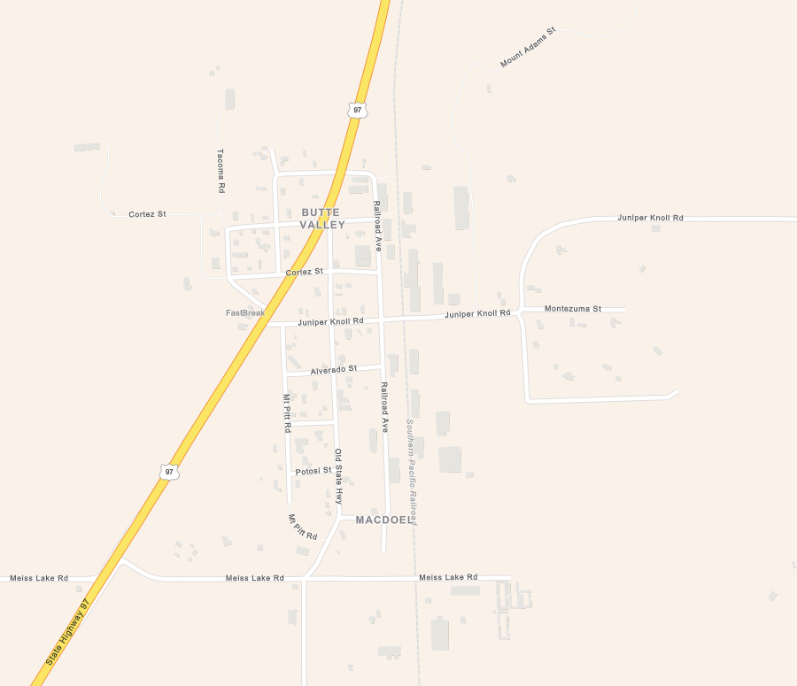
Macdoel
Southbound Highway 97
Northbound Highway 97

Evacuation Routes – Macdoel
The community of Macdoel (Population 143) is located on Highway 97, approximately 40 miles north of Weed, CA. The primary evacuation route is Highway 97 north to Dorris and Klamath Falls and south to Weed, CA. Collector roads such as Meiss Lake Road and Juniper Knoll Road are alternate routes if Highway 97 is inaccessible. Schools, churches, and community centers in Yreka, and the Siskiyou County Fairgrounds, could serve as safe locations for evacuees during a hazard event. Given the community’s proximity to Oregon, it is possible evacuees will instead choose to transit north towards Klamath Falls.

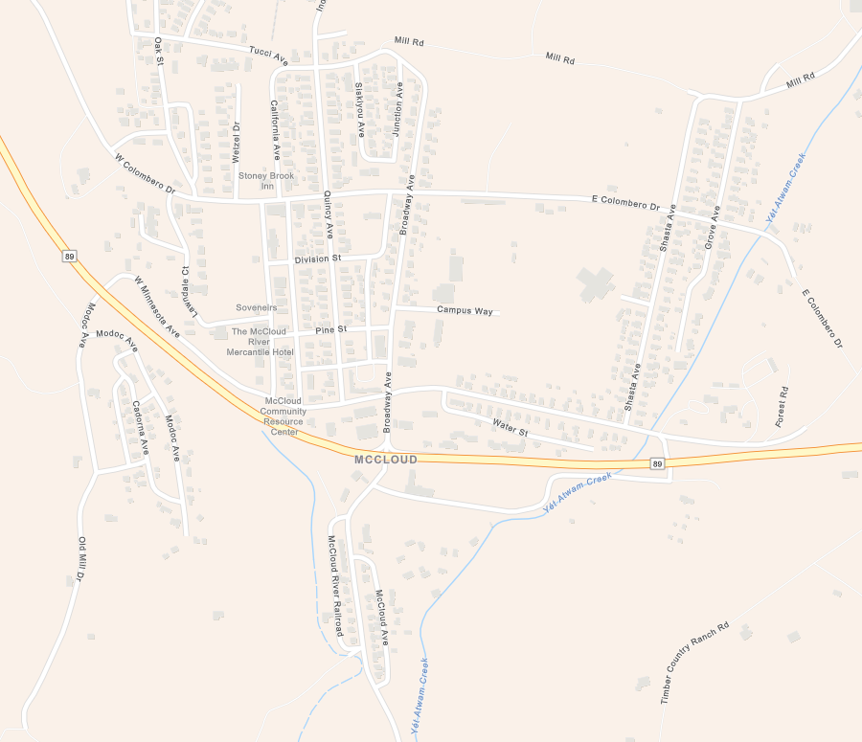
McCloud
Westbound Highway 89
Eastbound Highway 89

Evacuation Routes – McCloud
The community of McCloud (Population 959) is located east of Interstate 5, along Highway 89, 13 miles east of Mount Shasta. The primary evacuation route is Highway 89, westbound to the town of Mount Shasta and eastbound towards Shasta County. Schools, churches, and community centers in Mount Shasta, Weed, and Dunsmuir, could serve as safe locations for evacuees during a hazard event. Evacuees may likely also choose instead to transit into neighboring Modoc and Shasta Counties.

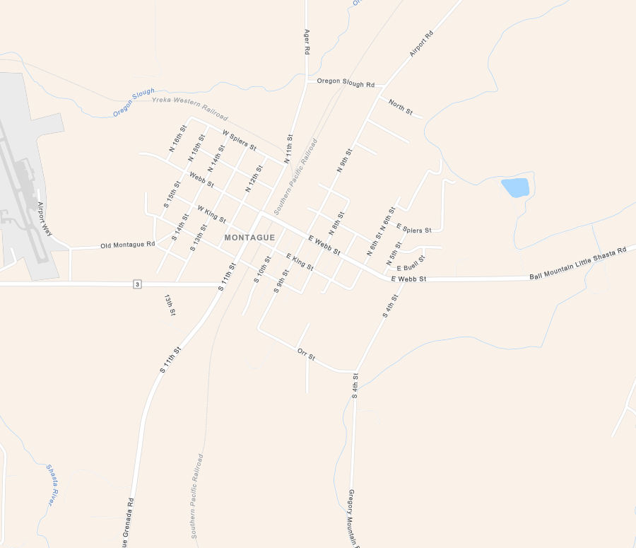
Montague
North on Montague Ager Road
West on Highway 3
South on Montague
Grenada Road
East on Ball Mountain
Little Shasta Road

Evacuation Routes – Montague
The town of Montague (Population 1,182) is located east of Interstate 5, six miles east of Yreka on Highway 3, also referred to as Montague Road. The primary evacuation routes are Highway 3 westbound to Interstate 5, Montague Ager Road heading north, Ball Mountain Little Shasta Road heading east, and Montague Grenada Road heading south. Schools, churches, and community centers in Yreka, and the Siskiyou County Fairgrounds, could serve as safe locations for evacuees during a hazard event.

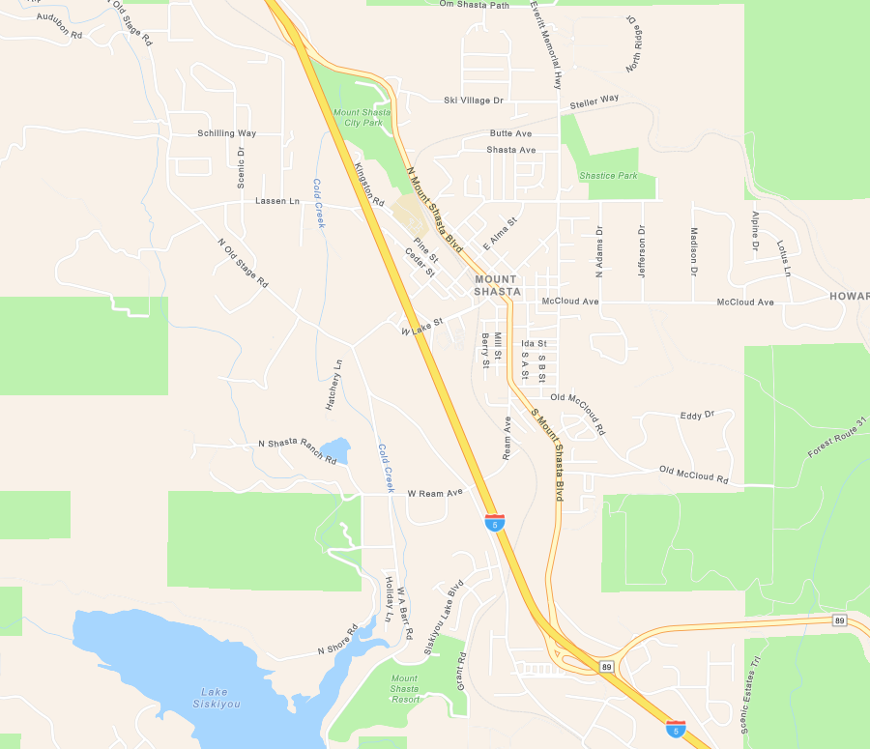
Eastbound Highway 89
Mount Shasta
Southbound Interstate 5
Northbound Interstate 5

Evacuation Routes – Mount Shasta
The town of Mount Shasta (Population 3,179) is located 8 miles north of Dunsmuir along Interstate 5. The primary evacuation route is Interstate 5, north to the town of Weed and south to the town of Dunsmuir. Highway 89 towards McCloud is also possible. The major collector roads for this area are North Mount Shasta Boulevard and South Mount Shasta Boulevard, which both lead to Interstate 5. Schools, churches, and community centers in Weed, Dunsmuir, and McCloud could serve as safe locations for evacuees during a hazard event.

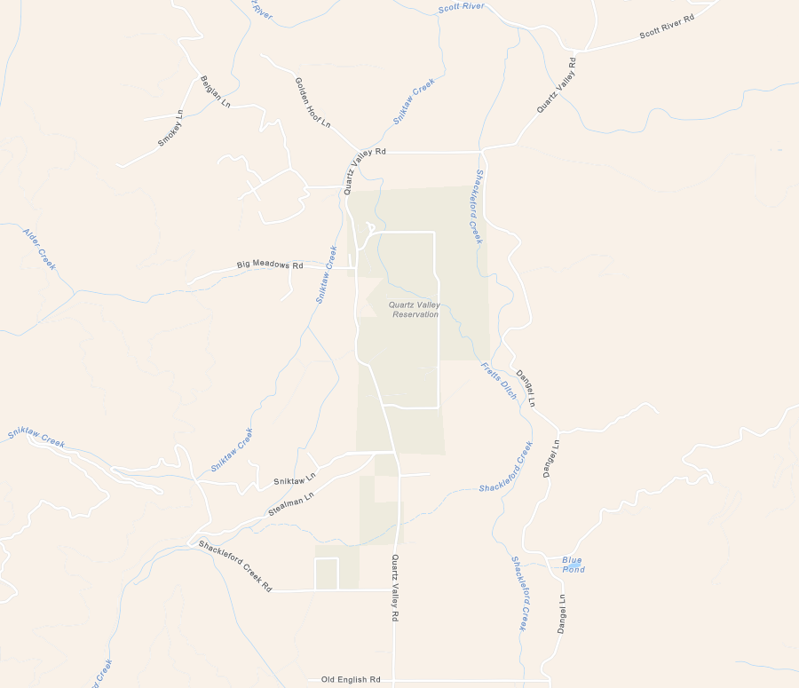
Quartz Valley
Quartz Valley Reservation
Quartz Valley Road to
Highway 3
Quartz Valley Road to
Scott River Road

Evacuation Routes – Quartz Valley
The community of Quartz Valley (Population 202) is located northwest of Greenview along Quartz Valley Road. Primary evacuation routes for this area are Quartz Valley Road to Highway 3 and Quartz Valley Road to Scott River Road and Fort Jones. Schools, churches, and community centers in Fort Jones, Etna, and possibly Happy Camp could serve as safe locations for evacuees during a hazard event.

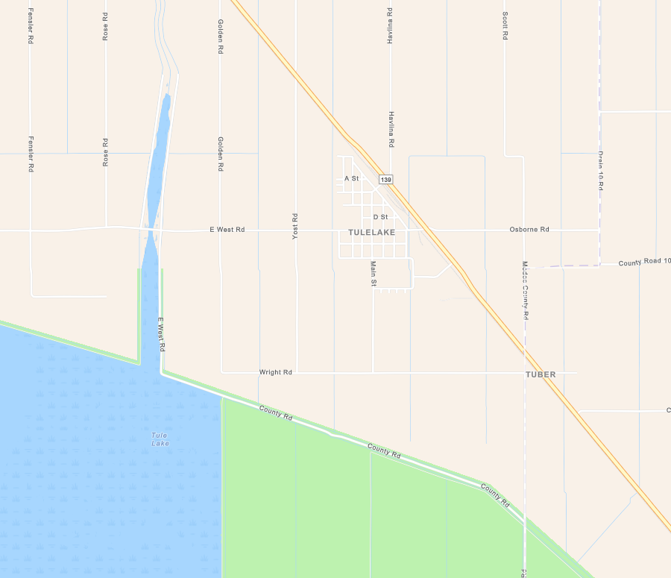
Southbound Highway 139
Tulelake
Northbound Highway 139

Evacuation Routes – Tulelake
The town of Tulelake (Population 867) is in the northeast corner of Siskiyou County along Highway 139, near the Oregon border. The primary evacuation route is Highway 139 north towards the state of Oregon and south towards Modoc County. Schools, churches, and community centers in Yreka and Dorris, and the Siskiyou County Fairgrounds in Yreka, could serve as safe locations for evacuees during a hazard event. Given Tulelake’s proximity to Oregon, it is possible that evacuees will instead choose to transit north towards Klamath Falls.
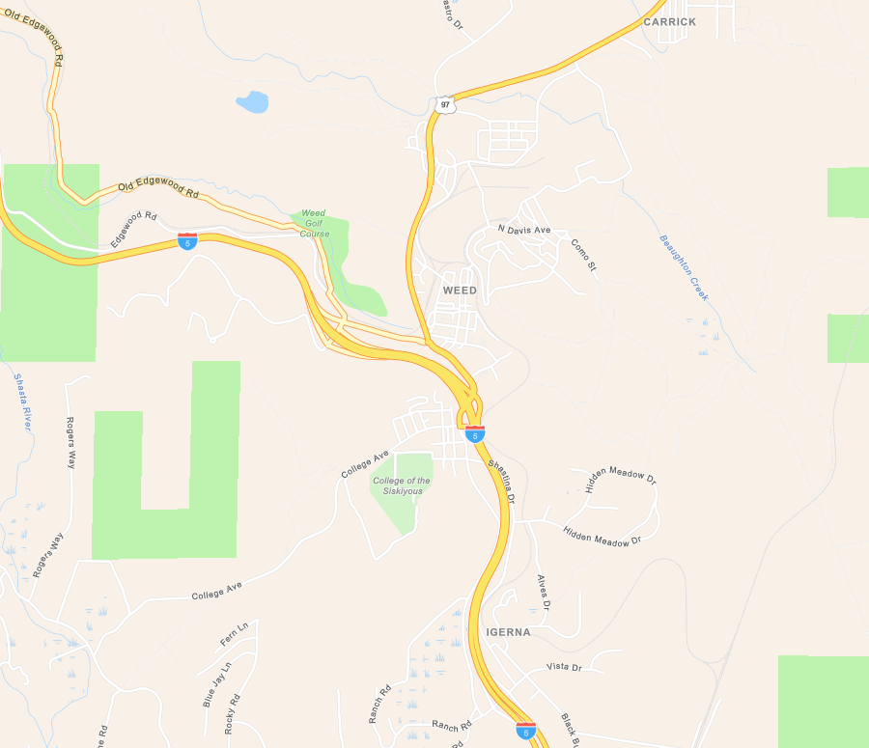
Weed
Eastbound Highway 97
Northbound Interstate 5
Southbound Interstate 5

Evacuation Routes – Weed
The town of Weed (Population 2,574) is located at the interchange of Interstate 5 and Highway 97, 10 miles north of Mount Shasta, CA. The primary evacuation routes are Highway 97 and Interstate 5. Schools, churches, and community centers in Yreka, Montague, Lake Shastina, Mount Shasta, and Dunsmuir, and the Siskiyou County Fairgrounds in Yreka, could serve as safe locations for evacuees during a hazard event.

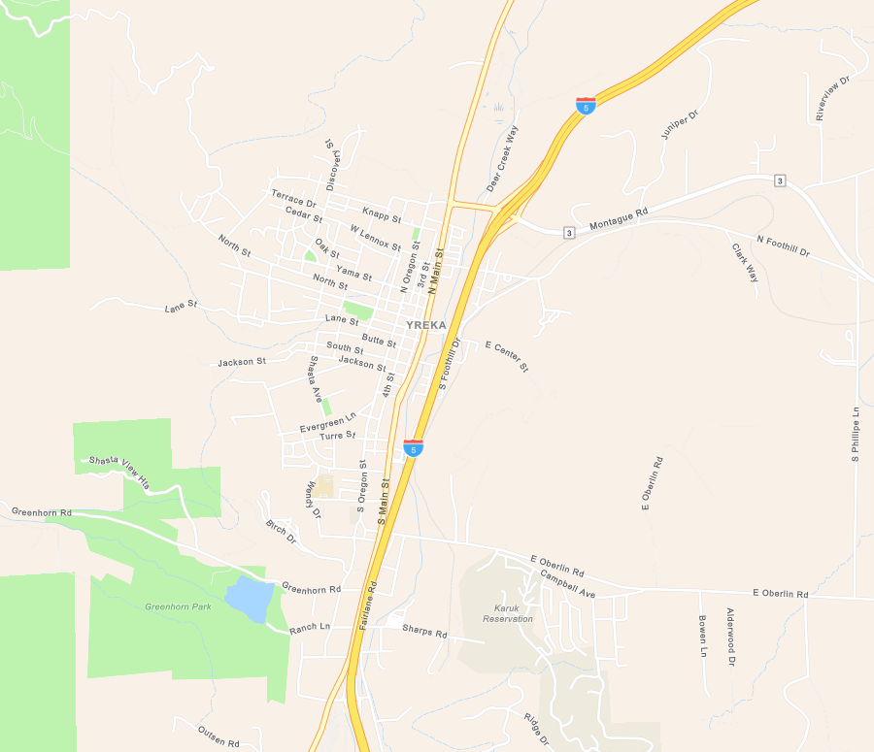
East Highway 3 Montague Road
East on Oberlin Road
Yreka
Karuk Tribe
Interstate 5 South
Interstate 5 North

Evacuation Routes – Yreka
The town of Yreka (Population 7,808) is located on Interstate 5, approximately 22 miles south of the Oregon Border. The Primary evacuation route is Interstate 5. Alternative routes are North and South Main Street, running north and south through the town. East Oberlin Road and Montague Road (Highway 3) running eastbound. Greenhorn Road heading west and southbound on Highway 3 towards Fort Jones. Given Yreka’s proximity to Oregon, it is possible that evacuees will transit north towards Ashland, Oregon, or south on I-5 towards Lake Shastina, Weed, Mount Shasta, and Dunsmuir.

- Areas with One Evacuation Route
To view mapping for a specific location, click on the link in the description. For the most recent list email planning@co.siskiyou.ca.us.
No. | Area | Description | Latitude | Longitude
1 | Dunsmuir | Intersection of 4th Street and Hilltop Drive. | 41°12'09.4"N | 122°16'12.1"W
2 | Dunsmuir | Intersection of Katherine Street and South Francis Street. | 41°12'07.6"N | 122°16'29.8"W
3 | Dunsmuir | Intersection of Dunsmuir Avenue and Elizabeth Street. | 41°11'46.8"N | 122°16'50.3"W
4 | Dunsmuir | Intersection of Bush Street and Mountain Avenue. | 41°12'29.6"N | 122°16'11.7"W
5 | Dunsmuir | Intersection of River Avenue and Upper River Avenue. | 41°13'01.1"N | 122°16'17.1"W
6 | Dunsmuir | Intersection of Linda Place and Dunsmuir Avenue. | 41°14'07.7"N | 122°16'18.3"W
7 | Dunsmuir | Intersection of Pinewood Road and Prospect Avenue. | 41°14'05.0"N | 122°16'31.5"W
8 | Dunsmuir | Intersection of Wells Avenue and Hart Avenue. | 41°13'52.5"N | 122°16'39.8"W
9 | Dunsmuir | Intersection of Scarlet Way and Dunsmuir Avenue. | 41°13'42.4"N | 122°16'33.1"W
10 | Dunsmuir | Intersection of Shasta Terrace and Willow Street. | 41°12'42.8"N | 122°16'31.2"W
1 | Etna | Intersection of Esther Warren Road and Sawyers Bar Road. | 41°26'33.8"N | 122°54'09.4"W
2 | Etna | West on unnamed road, starting at 1389 Sawyers Bar Road. | 41°26'48.4"N | 122°54'02.2"W
3 | Etna | Intersection of Pleasure Park Road and Callahan Street. | 41°27'21.2"N | 122°53'19.7"W
1 | Lake Shastina | Intersection of Solus Court and Highway 97. | 41°27'35.9"N | 122°21'23.3"W
2 | Lake Shastina | Intersection of Solus Drive and Highway 97. | 41°27'57.7"N | 122°21'15.0"W
3 | Lake Shastina | Intersection of Solus Place and Big Springs Road. | 41°28'32.5"N | 122°21'21.8"W
4 | Lake Shastina | Intersection of Big Rock Road and Big Springs Road. | 41°28'59.7"N | 122°21'44.1"W
5 | Lake Shastina | West on Dwinnell Way. | 41°30'16.6"N | 122°23'33.3"W
6 | Lake Shastina | Intersection of Mount Blanch Drive and Cottonwood Drive. | 41°30'01.1"N | 122°23'19.7"W
7 | Lake Shastina | Intersection of Hill Drive and Antler Way. | 41°30'37.7"N | 122°22'53.3"W
8 | Lake Shastina | Intersection of Stag Mountain Road and Doe Way. | 41°30'55.8"N | 122°22'47.9"W
9 | Lake Shastina | Intersection of Indian Island Road and Lake Shore Drive. | 41°31'12.0"N | 122°22'33.0"W
10 | Lake Shastina | Intersection of Link Road and Lake Shastina Drive. | 41°31'41.7"N | 122°22'17.7"W
11 | Lake Shastina | Intersection of Gallop Place and Lake Shore Drive. | 41°31'34.0"N | 122°22'01.9"W
12 | Lake Shastina | Intersection of Lake Shore Drive and Silver Spur Road. | 41°32'32.1"N | 122°22'09.2"W
13 | Lake Shastina | Intersection of McDonald Lane and Big Springs Road. | 41°33'51.7"N | 122°23'11.6"W
14 | Lake Shastina | Intersection of Sunset Place and Big Springs Road. | 41°35'01.6"N | 122°23'58.6"W
15 | Lake Shastina | Intersection of Sunset Road and Sunset Avenue. | 41°35'03.3"N | 122°24'34.0"W
16 | Lake Shastina | Intersection of Stoney Ridge Lane and Big Springs Road. | 41°35'37.4"N | 122°23'46.9"W
1 | Macdoel | Intersection of Juniper Knoll Road and Montezuma Street. | 41°49'39.9"N | 121°59'58.9"W
2 | Macdoel | Intersection of McKinley Road and Sheep Mountain Road. | 41°51'04.1"N | 121°56'33.5"W
3 | Macdoel | Intersection of Homeland Road and Sheep Mountain Road. | 41°51'04.3"N | 121°56'15.8"W
4 | Macdoel | Intersection of Juniper Knoll Road and Montezuma Street.
5 | Macdoel | Intersection of Juniper Knoll Road and Montezuma Street.
1 | McCloud | Intersection of Quail Court and West Colombero Drive. | 41°15'36.2"N | 122°08'43.7"W
2 | McCloud | Intersection of Wetzel Drive and West Colombero Drive. | 41°15'21.4"N | 122°08'24.1"W
1 | Montague | Intersection of East Orr Street and Locust Lane Drive. | 41°43'15.4"N | 122°31'28.1"W
2 | Montague | Intersection of Unnamed Street and East Orr Street. | 41°43'18.6"N | 122°31'35.7"W
3 | Montague | Intersection of Rabbit Brush Road and Yreka Ager Road. | 41°46'06.8"N | 122°33'07.8"W
4 | Montague | Intersection of Unnamed Road and Montague Road. | 41°43'31.2"N | 122°33'10.3"W
5 | Montague | Intersection of Golf Course Road and Montague Road. | 41°43'44.2"N | 122°33'51.2"W
6 | Montague | Intersection of Montair Drive and Montague Road. | 41°43'43.8"N | 122°34'10.7"W
7 | Montague | Intersection of Calamity Lane and Montague Road. | 41°43'50.2"N | 122°34'39.0"W
8 | Montague | Intersection of Collier Lane and Montague Road. | 41°43'51.1"N | 122°34'42.9"W
9 | Montague | Intersection of Fiock Road and Montague Road. | 41°43'55.1"N | 122°35'00.6"W
10 | Montague | Intersection of South Scala Lane and Oberlin Road. | 41°42'20.2"N | 122°32'58.8"W
11 | Montague | Intersection of Zanotto Lane and Oberlin Road. | 41°42'20.5"N | 122°33'34.4"W
12 | Montague | Intersection of Delphic Road and Oberlin Road. | 41°42'20.4"N | 122°33'50.7"W
1 | Mt. Shasta | Intersection of Lotus Lane and Shasta Acres Road. | 41°18'51.9"N | 122°17'01.4"W
2 | Mt. Shasta | Intersection of Matthew Court and Villa Road. | 41°17'07.7"N | 122°17'29.1"W
3 | Mt. Shasta | Intersection of Lone Pine Drive and Villa Road. | 41°17'01.9"N | 122°17'39.7"W
4 | Mt. Shasta | Intersection of Cantara Loop Road and South Old Stage Road. | 41°16'28.4"N | 122°17'55.3"W
5 | Mt. Shasta | Intersection of Remour Lane and South Old Stage Road. | 41°16'35.7"N | 122°18'03.0"W
6 | Mt. Shasta | Intersection of Aiello Road and South Old Stage Road. | 41°16'45.8"N | 122°18'13.5"W
7 | Mt. Shasta | Intersection of Dusty Lane and Azalea Drive. | 41°16'57.8"N | 122°18'05.6"W
8 | Mt. Shasta | Intersection of Old Stage Court and South Old Stage Road. | 41°17'00.6"N | 122°18'33.2"W
9 | Mt. Shasta | Intersection of Irene Lane and South Old Stage Road. | 41°17'04.1"N | 122°18'36.4"W
10 | Mt. Shasta | Intersection of Twin View Court and South Old Stage Road. | 41°17'11.5"N | 122°18'39.9"W
11 | Mt. Shasta | Intersection of Wagon Wheel Road and South Old Stage Road. | 41°17'14.8"N | 122°18'41.2"W
12 | Mt. Shasta | Intersection of Deas Way and Christian Way. | 41°17'27.5"N | 122°18'53.6"W
13 | Mt. Shasta | Intersection of Conan Court and Siskiyou Lake Boulevard. | 41°17'25.6"N | 122°19'01.0"W
14 | Mt. Shasta | Intersection of Paul’s Place and Siskiyou Lake Boulevard. | 41°17'32.7"N | 122°18'52.2"W
15 | Mt. Shasta | Intersection of Holiday Lane and Holiday Court. | 41°17'23.8"N | 122°19'22.4"W
16 | Mt. Shasta | Intersection of Unnamed Road and WA Barr Road. | 41°16'36.7"N | 122°21'12.5"W
17 | Mt. Shasta | Intersection of Shasta Ranch Road and WA Barr Road. | 41°17'52.8"N | 122°19'22.6"W
18 | Mt. Shasta | Intersection of Melo Road and North Old Stage Road. | 41°18'40.7"N | 122°19'54.7"W
19 | Mt. Shasta | Intersection of Lombardi Road and North Old Stage Road. | 41°18'48.9"N | 122°20'07.1"W
20 | Mt. Shasta | Intersection of Torrey Road and North Old Stage Road. | 41°18'56.5"N | 122°20'18.3"W
21 | Mt. Shasta | Intersection of Hill Road and North Old Stage Road. | 41°19'05.7"N | 122°20'28.8"W
22 | Mt. Shasta | Intersection of Wyehka Way and North Old Stage Road. | 41°19'27.0"N | 122°20'40.6"W
23 | Mt. Shasta | Intersection of Weston Lane and Davis Place Road. | 41°20'04.2"N | 122°21'54.2"W
24 | Mt. Shasta | Intersection of Rainbow Ranch Court and Davis Place Road. | 41°20'27.8"N | 122°21'42.8"W
25 | Mt. Shasta | Intersection of Pony Trail and North Old Stage Road. | 41°20'40.5"N | 122°21'26.0"W
26 | Mt. Shasta | Intersection of Upton Road and Abrams Lake Road. | 41°20'32.4"N | 122°20'58.2"W
27 | Mt. Shasta | Intersection of Brooks Ridge Drive and Pony Trail. | 41°20'53.3"N | 122°21'13.9"W
28 | Mt. Shasta | Intersection of Trinity Lane and Cricket Road. | 41°21'26.7"N | 122°21'52.8"W
29 | Mt. Shasta | Intersection of Freeman Lane and North Old Stage Road. | 41°21'29.1"N | 122°22'33.1"W
30 | Mt. Shasta | Intersection of Deetz Road and North Old Stage Road. | 41°21'48.7"N | 122°22'36.4"W
1 | Scott Valley | Intersection of Eastside Road and Hurds Gulch Road. | 41°32'54.3"N | 122°49'44.5"W
2 | Scott Valley | Intersection of Azalea Drive and French Creek Road. | 41°21'23.2"N | 122°54'03.4"W
3 | Scott Valley | Intersection of French Creek Court and French Creek Road. | 41°21'29.3"N | 122°54'07.1"W
4 | Scott Valley | Intersection of Facey Bingham Road and East Callahan Road. | 41°22'28.8"N | 122°49'20.5"W
5 | Scott Valley | Intersection of Wildcat Creek Road and Highway 3. | 41°19'21.9"N | 122°48'47.2"W
6 | Scott Valley | Intersection of Hartstrand Road and Eastside Road. | 41°28'58.6"N | 122°49'43.0"W
7 | Scott Valley | Intersection of Shell Gulch Road and Eastside Road. | 41°30'05.0"N | 122°49'50.4"W
1 | Weed | Intersection of Oregon Street and Siskiyou Way. | 41°24'50.8"N | 122°23'05.9"W
2 | Weed | Intersection of Walnut Street and Siskiyou Way. | 41°24'50.8"N | 122°23'09.1"W
3 | Weed | Intersection of Terrace Street and Sullivan Avenue. | 41°25'03.3"N | 122°23'20.8"W
4 | Weed | Intersection of Walnut Street and Sullivan Avenue. | 41°25'04.1"N | 122°23'09.6"W
5 | Weed | Intersection of Unnamed Street and College Avenue. | 41°24'14.8"N | 122°24'31.2"W
6 | Weed | Intersection of Unnamed Street and College Avenue. | 41°24'11.7"N | 122°24'57.3"W
7 | Weed | Intersection of Running Springs Lane and College Avenue. | 41°24'09.3"N | 122°25'01.0"W
8 | Weed | Intersection of Meadow Creek Road and North Old Stage Road. | 41°24'07.7"N | 122°25'26.6"W
9 | Weed | Intersection of Shadowwood Lane and North Old Stage Road. | 41°24'13.1"N | 122°25'36.8"W
10 | Weed | Intersection of Burley Drive and North Old Stage Road. | 41°24'20.9"N | 122°25'44.7"W
11 | Weed | Intersection of Nighthawk Lane and North Old Stage Road. | 41°24'32.3"N | 122°26'01.0"W
12 | Weed | Intersection of China Mountain Road and North Old Stage Road. | 41°24'40.6"N | 122°26'02.8"W
13 | Weed | Intersection of Shasta Valley Road and North Old Stage Road. | 41°25'13.7"N | 122°26'10.0"W
14 | Weed | Intersection of Shire Lane and North Old Stage Road. | 41°25'16.7"N | 122°26'10.8"W
15 | Weed | Intersection of Keryl Lane and North Old Stage Road. | 41°25'23.4"N | 122°26'12.2"W
16 | Weed | Intersection of Sabankaya Lane and North Old Stage Road. | 41°25'51.6"N | 122°26'13.8"W
17 | Weed | Intersection of Woodridge Court and South Davis Avenue. | 41°25'46.7"N | 122°22'49.6"W
18 | Weed | Intersection of Columbus Way and Florence Drive. | 41°25'40.1"N | 122°23'17.5"W
19 | Weed | Intersection of Lombardi Avenue and Florence Drive. | 41°25'42.3"N | 122°23'15.7"W
20 | Weed | Intersection of Church Avenue and West Lincoln Avenue. | 41°26'13.0"N | 122°23'16.6"W
21 | Weed | Intersection of Evergreen Lane and Highway 97. | 41°26'44.3"N | 122°22'06.8"W
22 | Weed | Intersection of 2nd Avenue and Center Street. | 41°26'51.6"N | 122°21'31.7"W
23 | Weed | Intersection of 3rd Avenue and Center Street. | 41°26'51.7"N | 122°21'26.0"W
24 | Weed | Intersection of Rainbow Way and Highway 97. | 41°26'59.6"N | 122°21'45.8"W
1 | Yreka | Intersection of Melinda Way and Donna Drive. | 41°39'12.8"N | 122°35'43.7"W
2 | Yreka | Intersection of Sturgis Road and South Old Highway 99. | 41°39'41.6"N | 122°35'56.5"W
3 | Yreka | Intersection of Memory Lane and Easy Street. | 41°39'41.9"N | 122°36'19.5"W
4 | Yreka | Intersection of Deer Meadows Road and Schulmeyer Road. | 41°39'30.0"N | 122°37'32.1"W
5 | Yreka | West on Oak Valley Drive from location. | 41°39'55.7"N | 122°37'56.2"W
6 | Yreka | Intersection of Oakwood Lane and Travis Heights Road. | 41°40'35.5"N | 122°38'21.5"W
7 | Yreka | Intersection of Westside Court and Pruett Drive. | 41°40'51.0"N | 122°38'05.3"W
8 | Yreka | Intersection of Orchard Court and Pruett Drive. | 41°40'54.3"N | 122°38'06.4"W
9 | Yreka | Intersection of Oak View Court and Easy Street. | 41°40'59.9"N | 122°38'10.3"W
10 | Yreka | Intersection of Laura Lane and Highway 3. | 41°41'31.4"N | 122°39'13.8"W
11 | Yreka | Intersection of Wicklow Woods Drive and Highway 3. | 41°41'25.4"N | 122°39'26.7"W
12 | Yreka | Intersection of Eastman Lane and Highway 3. | 41°41'17.2"N | 122°39'42.7"W
13 | Yreka | Intersection of Outsen Road and Burton Avenue. | 41°42'02.3"N | 122°39'11.4"W
14 | Yreka | Intersection of Bennett Drive and Greenhorn Road. | 41°42'53.6"N | 122°39'29.2"W
15 | Yreka | Intersection of Douglas Lane and Greenhorn Road. | 41°43'11.1"N | 122°41'08.1"W
16 | Yreka | Intersection of Maryhill Circle and Meadowlark Lane. | 41°43'28.6"N | 122°39'01.8"W
17 | Yreka | Intersection of Roundtree Road and Meadowlark Lane. | 41°43'36.1"N | 122°39'04.7"W
18 | Yreka | West on Jackson Street from location. | 41°43'42.9"N | 122°39'11.2"W
19 | Yreka | Intersection of Lane Street and South Lange Way. | 41°43'55.5"N | 122°39'14.8"W
20 | Yreka | Intersection of Discovery Street and Northridge Drive. | 41°44'07.9"N | 122°39'13.6"W
21 | Yreka | Intersection of Melinda Way and Donna Drive. | 41°44'30.4"N | 122°38'41.6"W
21 | Yreka | Intersection of Vanessa Way and North Main Street. | 41°45'02.1"N | 122°37'46.9"W
22 | Yreka | Intersection of Rocky Gulch Road and Highway 263. | 41°45'52.2"N | 122°37'04.2"W
23 | Yreka | Intersection of Jasper Place and Montague Road/Highway 3. | 41°44'18.2"N | 122°37'13.0"W
24 | Yreka | Intersection of South Foothill Drive and East Center Street. | 41°43'49.3"N | 122°37'56.6"W
25 | Yreka | Intersection of Sierra Vista Drive and Foothill Drive. | 41°44'05.2"N | 122°37'28.5"W
26 | Yreka | Intersection of Clark Way and North Foothill Drive. | 41°44'18.1"N | 122°36'22.3"W

This page is intentionally left blank.

