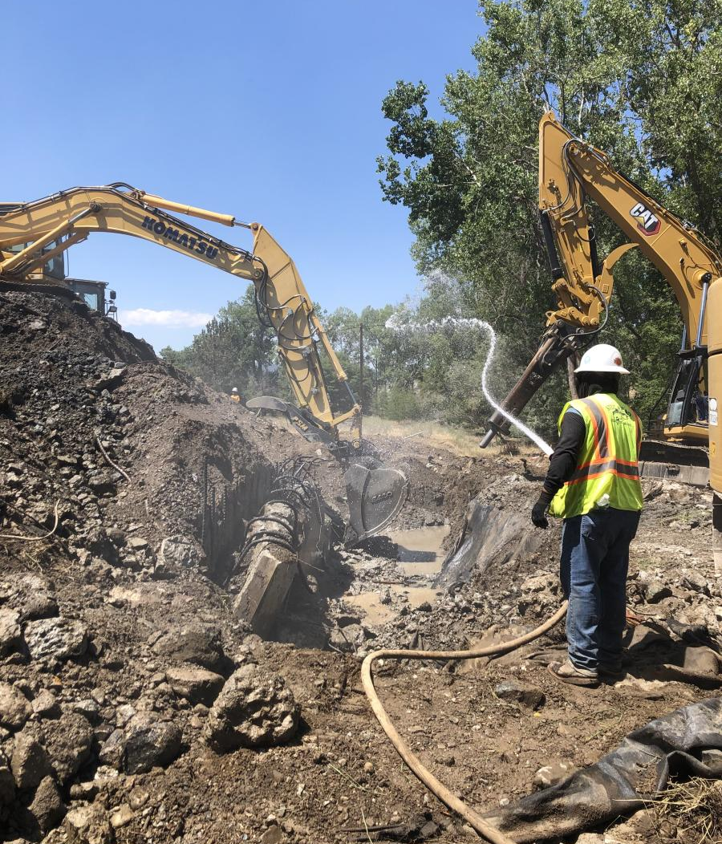
6. Noise Element

The Noise Element outlines the County’s strategy for managing and mitigating noise exposure to ensure a safe and healthy environment for all community members. The goals, policies, and implementation programs focus on establishing guidelines for ensuring noise compatible land uses, addressing noise from transportation and construction activities.

Table of Contents
6.1 Introduction NOI-3
6.2 Noise Measurement NOI-4
6.3 Noise in Siskiyou County NOI-5
6.4 Goals and Policies NOI-10
6.5 Implementation Programs NOI-13
- Introduction
Noise is recurring or ongoing unwanted or intrusive sound, usually generated by vehicular, rail, or airplane traffic; construction, commercial, agricultural, or industrial activity; or disturbances, such as barking dogs, home maintenance activities, livestock, special events, or parties. Although most activities will result in some noise, noise that affects people’s well-being or the nature of an area is detrimental to a community. State law requires that a General Plan identify and address the impacts of noise on residents from the following sources:
- Highways and freeways
- Primary arterials and major local streets
- Passenger, freight, and ground rapid transit systems
- Airport operations
- Industrial plants
- And other stationary noise sources such as emergency backup generators.
The main sources of noise in Siskiyou County are traffic on roadways, industrial and commercial uses such as lumber mills, and aircraft from county airports and local airfields. Some land uses are more impacted by noise concerns than others because of population density, health-related risks, wildlife impacts, or the type of permitted uses, such as agricultural operations. Noise-sensitive uses in Siskiyou County include residences, assisted living facilities, motels and hotels, schools, libraries, places of worship, community centers, hospitals, local parks, and open space areas. This Element sets forth policies and programs to protect the continued quiet and rural nature of the county as it evolves in the future.

- Noise Measurement
Noise is generally described in terms of the loudness (amplitude) and frequency (pitch) of the sound. Noise loudness is measured in decibels (dB) which are based on a logarithmic scale that condenses the range in sound pressure levels to a more usable number range. This number range is shown in Table 6.1. A weighted decibel (dBA) is an additional measure of sound that adjusts the sound rating scale to levels consistent with the sensitivity range of the human ear. For example, people perceive a sound 10 dBA higher than another sound as being twice as loud, and 20 dBA higher as being four times as loud. Everyday sounds normally range from 30 dBA (very quiet) to 100 dBA (very loud). Noise in communities is often described with the Community Noise Equivalent Level (CNEL), which is a weighted average of noise levels over time to illustrate the impact of noise on residential neighborhoods.
- Typical Noise Levels and Decibel Scale
Source | Intensity level
Instant Perforation of Eardrum | 160 dB
Military Jet Takeoff | 140 dB
Threshold of Pain | 130 dB
Front Rows of Rock Concert | 110 dB
Walkman at Maximum Level | 100 dB
Vacuum Cleaner at 3 feet | 80 dB
Busy Street Traffic | 70 dB
Normal Conversation | 60 dB
Whisper | 20 dB
Rustling Leaves | 10 dB
Threshold of Hearing (TOH) | 0 dB
Source: Caltrans. Typical Noise Levels. Available online at: https://dot.ca.gov/programs/maintenance/pavement/noise-levels
- Noise in Siskiyou County
Transportation Noise
Noise in Siskiyou County is primarily caused by traffic along major roadways such as Interstate 5, U.S. Route 97, and State Routes 3, 96, and 89. Interstate 5 runs north-south for 1,381 miles, connecting southern California to Oregon and Washington while connecting several major metropolitan areas. U.S. Route 97 is a major north-south route that starts in Weed and runs for 670 miles to Washington along the eastern side of the Cascade Mountains. State Routes 3, 96, and 89 cover a combined distance of 535 miles through Siskiyou and Trinity Counties. According to the Yreka Area California Highway Patrol, an average of 20,000 vehicles travel through Siskiyou County per day, contributing significant noise pollution to the communities near major transportation routes.
Siskiyou County owns and operates Butte Valley Airport, Happy Camp Airport, Scott Valley Airport, Siskiyou County Airport, and Weed Airport. The Dunsmuir-Mott Airport and Montague-Yreka Rohrer Field are also operated within the county and contribute to aviation-related noise.
Three railroad companies serve Siskiyou County. The largest operator is Southern Pacific Railroad, which operates from south of Dunsmuir to the Oregon border. This railroad operates up to 24 on-line trips per day in Siskiyou County, including 15 daytime trips and nine nighttime trips from Weed to Klamath Falls, Oregon. The towns of Macdoel and Mt. Hebron are most affected by these operations and frequently experience noise levels between 60 and 65 dBA.
Noise Contour Maps
Noise contour maps are used as guides for making land use decisions that minimize exposure of people to excessive noise near roadways. Existing noise contours and noise contours projected for the buildout of Siskiyou County in 2050 are shown in Figure 6.1 and Figure 6.2.
- Figure Placeholder – Existing Noise Contours

Noise contour maps are generated using traffic data, which is still being collected. This figure will be updated once the traffic data is available through the Environmental Impact Report.
- Figure Placeholder – Projected noise contours

Noise contour maps are generated using traffic data, which is still being collected. This figure will be updated once the traffic data is available through the Environmental Impact Report.

Stationary Noise
Other sources of noise throughout the county include stationary sources such as general construction, roadway improvements, and industrial activity from the regular operation of equipment such as generators, fans, chillers, compressors, boilers, pumps, and air conditioning systems. Gas stations and commercial mechanical equipment can also generate noise during times of high use.
Noise Sensitive Land Uses
Noise-sensitive land uses are generally considered to include those uses where noise exposure could result in health-related risks to individuals, as well as places where quiet is an essential element of their intended purpose. These uses include, but are not limited to residences; schools; historic sites; cemeteries; parks and open space areas; hospitals and care facilities; hotels and other short-term lodging (e.g., bed and breakfasts, and motels); places of worship; and libraries.
Land Use Compatibility
In addition to using Figure 6.1 to guide land use decisions regarding noise, Table 6.2 provides guidance on which types of land uses are generally considered compatible with ambient decibel levels on a site. This guidance is intended to guide the Planning Commission and Board of Supervisors in determining if a proposed noise-sensitive use is compatible with the existing noise environment experienced on site.
The table indicates the levels at which noise from roadways and nearby uses will likely be incompatible with new noise-sensitive uses. For example, a site with ambient noise level of 80 dB has significant noise impacts equivalent to the sound of a vacuum at three feet (Table 6.1). Table 6.2 indicates that a site with that level of ambient exterior noise is clearly unacceptable for residential development but may be appropriate for office, commercial, or industrial uses if noise insulation features are included in the proposed design. A existing noise environment of 60 dB or less is considered to be normally acceptable for new residential uses.
Where ambient noise levels exceed the normally acceptable category, design features or site planning such as additional noise insulation or setbacks may be required for new projects. Acoustical studies may also be required for proposed new development projects in areas that exceed the normally acceptable category to show these features effectively reduce noise to acceptable levels.
- Community Noise and Land Use Compatibility
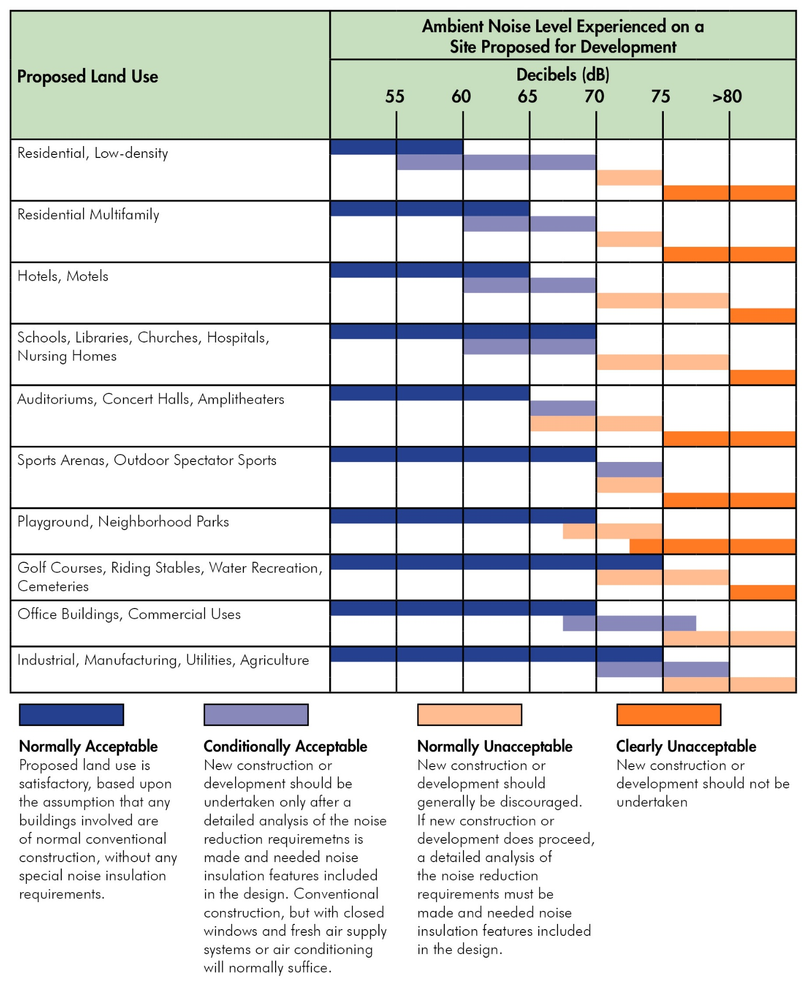
Source: General Plan Guidelines, California Office of Planning and Research 2017; Mintier Harnish, 2026.
- Goals and Policies
- Compatible Land Uses

To provide a harmonious environment by considering the noise compatibility of adjacent uses in all land use planning efforts. [Source: New Goal]

Policies
  - Project Review. The County shall review public and private development proposals to determine consistency with the policies of this Noise Element. [Source: New Policy]
  - Noise Compatibility Standards. The County shall review discretionary development for noise compatibility with surrounding uses based on the following standards:
      - New noise sensitive uses proposed to be located within 1,000 feet of highways, truck routes, heavy industrial activities and other relatively continuous noise sources shall incorporate noise control measures so that indoor noise levels in habitable rooms do not exceed Community Noise Equivalent Level (CNEL) 45 dB and outdoor noise levels do not exceed CNEL 65 dB during any hour.
      - New noise sensitive uses proposed to be located near railroads and airports shall incorporate noise control measures so that indoor noise levels in habitable rooms do not exceed CNEL 45 dB and outdoor noise levels do not exceed L10 of 65 dB(A)
      - New noise generators, proposed to be located near any noise sensitive use, shall incorporate noise control measures so that ongoing outdoor noise levels received by the noise sensitive receptor, measured at the exterior wall of the building, does not exceed any of the following standards:
        - Leq1H of 55dB(A) or ambient noise level plus 3 dB(A), whichever is greater, during any hour from 6:00 a.m. to 7:00 p.m.;
        - Leq1H of 50dB(A) or ambient noise level plus 3 dB(A), whichever is greater, during any hour from 7:00 p.m. to 10:00 p.m.; and
        - Leq1H of 45dB(A) or ambient noise level plus 3 dB(A), whichever is greater, during any hour from 10:00 p.m. to 6:00 a.m. [Source: New Policy]
  - Acoustical Analysis. The County shall require an acoustical analysis by a qualified acoustical engineer for discretionary development involving noise exposure or noise generation in excess of noise compatibility standards (Policy NOI-1.2) or an adopted noise ordinance. The analysis shall provide documentation of existing and projected noise levels at on-site and off-site receptors and shall recommend noise control measures for mitigating adverse impacts. [Source: New Policy]
  - Noise Compatible Land Uses. The County shall avoid locating noise sensitive land uses such as housing, schools, and parks in areas where they may be adversely affected by noise. [Source: New Policy]
  - Location of Noise-generating Uses. The County shall require commercial development applicants to locate noise-generating components such as loading areas, parking lots, driveways, trash enclosures, mechanical equipment, and other similar facilities away from on-site residential units or adjacent residential uses. [Source: New Policy]
  - Stationary Noise Sources. The County shall require outdoor machinery and other noise generating devices to be located away from noise sensitive uses and mitigated to reduce exposure to intrusive noise. [Source: New Policy]
  - Buffering. To reduce intrusive noise, the County shall require additional noise buffering of industrial or commercial machinery potentially including, but not limited to, acoustic paneling, sound-absorbing materials, and enclosures. [Source: New Policy]
- Transportation Noise

To minimize and mitigate noise impacts from traffic and other transportation-related activities. [Source: New Goal]

Policies
  - Airport Noise Mitigation. The County shall require navigation easements and noise mitigation measures in new residential developments near airports in the 60+ dB CNEL contour. [Source: New Policy]
  - Flight Path Noise Attenuation. The County shall support the attenuation of noise generated by existing and future flight paths and promote available funding for attenuation measures to improve the existing noise environment. [Source: New Policy]
  - Railroad Noise Mitigation. The County shall require future development adjacent to railroad routes to implement feasible noise mitigation measures. [Source: New Policy]
- Temporary and Construction Noise

To minimize noise from temporary sources and construction activities without discouraging development. [Source: New Goal]

Policies
  - Construction Noise Mitigation. The County shall limit construction noise in residential areas to the hours of 7am and 7pm on weekdays, 9am and 5pm on weekends. [Source: New Policy]
  - Noise from Special Events. The County shall require the use of siting and design measures to reduce noise from special events. [Source: New Policy]

- Implementation Programs
 | Implements Which Policy(ies) | Responsible Department | Funding Source | Timeframe
 | Implements Which Policy(ies) | Supporting Department(s) | Funding Source | Timeframe
- Noise Ordinance  The County shall develop and adopt a noise ordinance. In developing the ordinance, the County shall ensure compliance with legal standards. [Source: New Program] | NOI-1.1: | Planning Division | General Fund | 2030-2035
- Proactive Mitigation of Truck Noise  The County shall evaluate and identify traffic noise mitigation for industrial and commercial truck traffic, and pursue partnerships with local businesses to coordinate implementation of mitigation measures. [Source: New Program] | NOI-2.1: | Planning Division | General Fund | Every five years
- Attenuating Unacceptable Noise Levels  The County shall complete an evaluation of existing and planned flight paths to identify areas impacted by unacceptable aviation noise levels, as well as potential attenuation measures to improve the area’s existing noise environment. The County shall seek funding to facilitate the implementation of attenuation measures. [Source: New Program] | NOI-2.3: | Planning Division | General Fund, State and Federal grant funding | 2027

This page is intentionally left blank.

Typical noise-sensitive land uses include residences, senior facilities, schools, hospitals, retail, and guest lodging.

