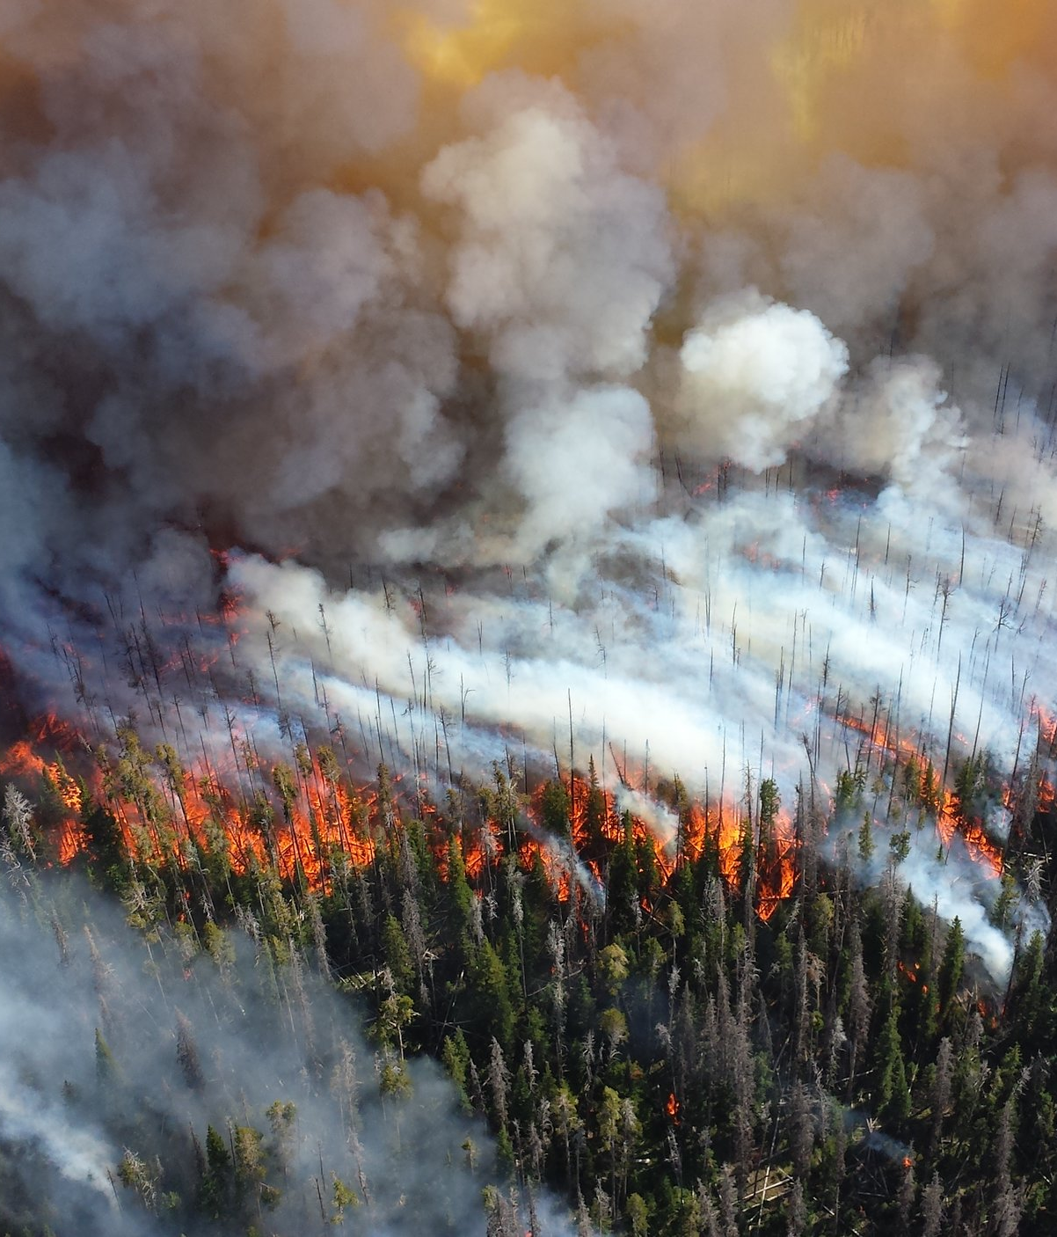

5. Safety Element

Siskiyou County’s location, geography, and seasonal climate, all contribute to its natural beauty, economy, and quality of life. To preserve these resources from the increasing risk of wildfire and other hazards, the county prepares for disasters to maintain a safe, enjoyable, and resilient community.

Table of Contents
5.1 Introduction SAF-3
5.2 The Fire Hazard SAF-5
5.3 The Flood Hazard SAF-15
5.4 Geologic and Seismic Hazards SAF-19
5.5 Hazardous Materials SAF-29
5.6 Wildlife Hazards SAF-31
5.7 Adaptation and Community Resilience SAF-37
5.8 Emergency Management SAF-43
5.9 Evacuation Planning SAF-47
5.10 Goals and Policies SAF-50
5.11 Implementation Programs SAF-54

- Introduction
The Safety Element is one of the seven mandatory elements (Land Use, Circulation, Housing, Conservation, Open Space, Noise and Safety) of the General Plan. The principal purpose of the Safety Element is to identify potential risks posed by natural and human made hazards to the people of Siskiyou County.
Relationship to Other General Plan Elements
The Safety Element is closely related to the other General Plan elements, particularly the Housing Element. The Housing Element is the County’s strategy and commitment for how it intends to meet the community’s current and future housing needs. The Housing Element seeks to make quality housing available to residents, workers, and visitors, while addressing systemic housing inequality. The Safety Element, on the other hand, aims to protect these same residents, workers, and visitors from natural and human made hazards.

Relationship to the LHMP and the CWPP
Though written as a standalone document, the Safety Element is meant to be utilized in coordination with, and is complementary to, the Local Hazard Mitigation Plan (LHMP) and other local area emergency plans, such as the Community Wildfire Protection Plan (CWPP). Developed through collaboration with local, state, federal, and tribal partners, the LHMP and CWPP are incorporated by reference into the Safety Element. While the Safety Element provides an overview of potential hazards, the LHMP and CWPP are meant to provide deeper analysis, context, and mitigation strategies for these hazards.
Safety Element Appendix
In developing the Safety Element, the County analyzed existing conditions and hazards with the potential to impact the county. This Element includes a summary of the existing conditions analyses, followed by goals, policies, and programs to address safety in the county. The full analyses and associated diagrams have been incorporated into the General Plan Update as an appendix to the General Plan Policy Document. Please see Appendix A: Safety Element Information. The appendix is organized under the following headings.
- Section A.1, Introduction.
- Section A.2, Existing Conditions, is a discussion of the county’s population data and how it impacts evacuation planning and natural hazard mitigation. The County’s FEMA National Risk Index Scores are also discussed.
- Section A.3, Past Wildfires in Siskiyou County is a visual depiction of past wildfires along with fire statistics from 2006 to 2024.
- Section A.4, Fire Hazard Severity Zone Maps contains fire hazard severity maps for local cities and the unincorporated county.
- Section A.5, Flood Hazard Maps for Local Communities provides flood mapping and emergency routes for different areas of the county.
- Section A.6, Institutional & Regulatory Framework by Hazard is a summary of the institutions, laws, and regulations that are relevant to hazard mitigation.
- Section A.7, Incorporation of the LHMP and CWPP incorporates the Local Hazard Mitigation Plan and the Community Wildfire Protection Plan into the Safety Element.
- Section A.8, Evacuation Routes for Selected Communities provides mapping of evacuation routes for different areas of the county.
- Section A.9, Residential Areas with One Evacuation Route is a list of residential areas with only one evacuation route. For the most recent list, please email planning@co.siskiyou.ca.us.

- The Fire Hazard
A wildfire is defined as an uncontrolled fire on undeveloped land requiring fire suppression. Wildfires can be ignited by naturally occurring events like lightning or by human activity such as smoking, campfires, equipment use, or arson. Most large fires in the county have been wind driven fires. Lightning, followed by equipment use, downed power lines, and debris burning were the lead ignition sources for these fires. From 2014 to 2024, seventy six percent of all wildfires in Siskiyou County were the result of lightning strikes.
Siskiyou County Annual Burn Probability
Figure 5.1 depicts the county’s annual burn probability, the darker the color, the higher the annual burn probability. The snow on Mt. Shasta is colored white, indicating a zero percent burn probability. Most wildfires occur in the western part of the county in or near the Klamath National Forest.
The county’s total land area is approximately 4 million acres. From 2006 to 2024, wildfires burned the equivalent of 49% of the total land area, or approximately 1.9 million acres.
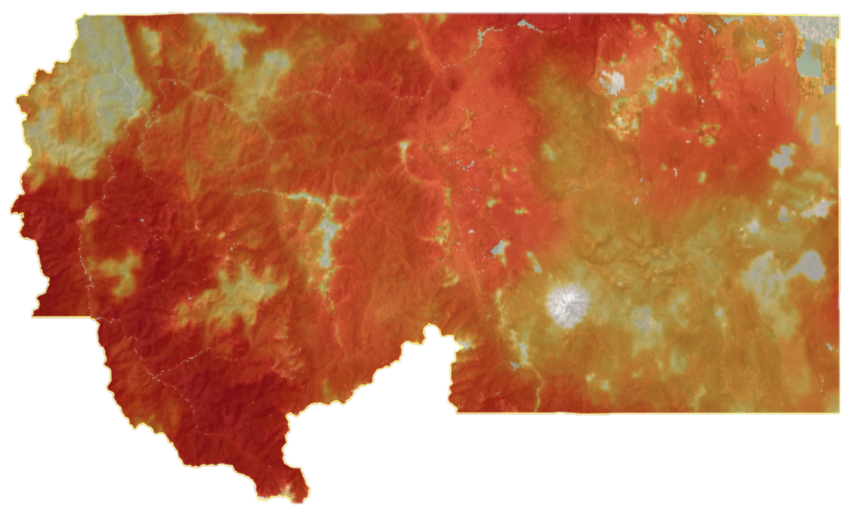
- Siskiyou County Annual Burn Probability
Source: USFS, 2025.

Wildland-Urban Interface
The term wildland-urban interface (WUI) refers to the area where human development meets with the natural environment. Figure 5.2 below shows Siskiyou County’s WUI areas marked in (red). Most people in the county live in or near a fire prone area. The location of residential communities in high-risk areas increases the chances of catastrophic wildfire. The McKinney Fire (2022) burned 60,138 acres, destroyed 185 structures and had a suppression cost of 75.4 million dollars. The Mill Fire (2022) burned 3,939 acres, destroyed 115 structures and cost 7 million dollars to suppress.
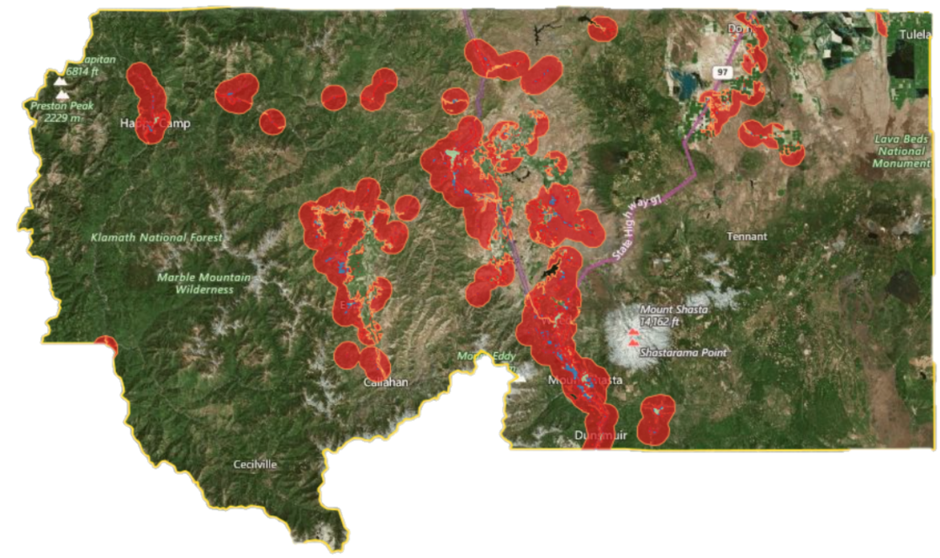
- Wildland-Urban Interface
Source: Mintier Harnish, 2023.

Ignition Sources
When a fire flares up in the WUI, it can spread rapidly, as flames jump to neighboring structures, damaging and destroying businesses and homes. Smoking in bed, ash from woodburning fireplaces, faulty wiring, children playing with matches, and appliance malfunctions are common causes of structure fires.
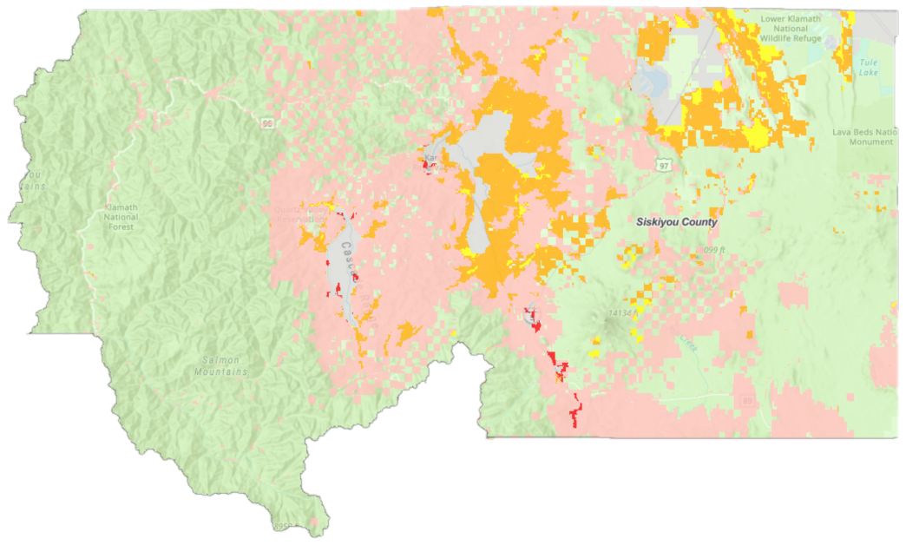
- Fire Protection Responsibility Areas
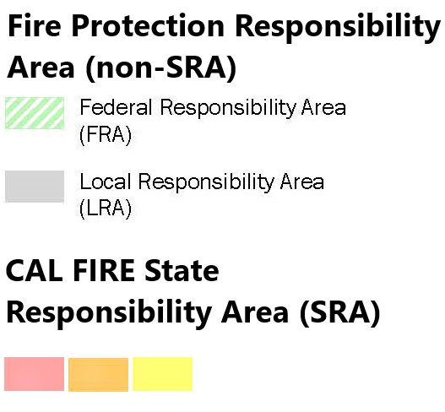
Source: CAL FIRE, 2025.
Fire Prevention
Everyone is responsible for helping prevent forest fires. In remote areas, due to the lack of immediate water sources and long emergency response times, measures such as defensible space clearing are extremely important. USFS has primary firefighting responsibility for the green areas above. Local fire stations have primary responsibility for the gray areas.

CAL FIRE has responsibility for the rest of the county not colored green or gray.
Who is Responsible?
Fire protection responsibility is shared between local, state, and federal agencies. Emphasizing multi-agency cooperation results in a rapid, effective, and coordinated fire response. The following is a listing of local fire protection agencies in Siskiyou County.
- Local Fire Protection Agencies
Etna town Fire Department | Happy Camp Fire District | Scott Valley Fire Protection District
Hilt Fire  Protection District | Fort Jones Fire Department | Gazelle Fire  Protection District
Coco Lake  Fire District | Hammond Ranch  Fire Zone | Grenada Fire  Protection District
Hornbrook Fire  Protection District | Klamath River  Fire Company | Mayten Fire  Protection District
Montague Fire  Protection District | Mt. Shasta Vista  Fire Zone | Salmon River Fire Company
South Yreka Fire  Protection District | Yreka town  Fire Department | Butte Valley Fire  Protection District
Dorris town  Fire Department | Seiad Valley  Fire Company | Tennant Community  Services District
Tulelake  Fire Department | Weed town  Fire Department | Lake Shastina Comm.  Services District
Castella Fire  Protection District | Dunsmuir  Fire Department | McCloud Community  Services District
Pleasant Valley  Fire Zone | Mt. Shasta town  Fire Department | Mount Shasta Fire  Protection District
Source: Siskiyou County, 2025.
CAL FIRE and the US Forest Service cooperate in maintaining a series of fire lookouts throughout the county to scout for lightning strikes and other fire ignition sources. With advance warning firefighters have a better chance to prevent small ignitions from becoming catastrophic wildfires.

Fire Hazard Severity Zones (FHSZs)
The California Department of Forestry and Fire Protection (CAL FIRE) has created fire maps identifying areas of high fire danger. These Fire Hazard Severity Zones (FHSZs) are mapped and identified based on fuel loading, slope, fire history, and other relevant factors, including areas where winds have been identified as a major cause of wildfire spread.
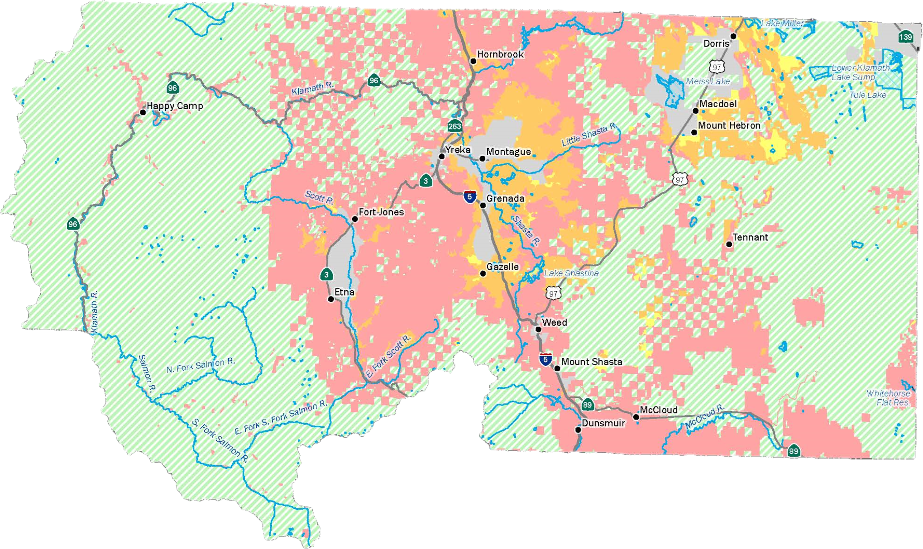
In Siskiyou County, the state responsibility area covers 1.06 million acres of land classified as very high for fire danger. An additional 282,023 acres are classified as high, and another 38,849 acres are classified as moderate.
- Fire Hazard Severity Zones
Source: CAL FIRE, 2025.
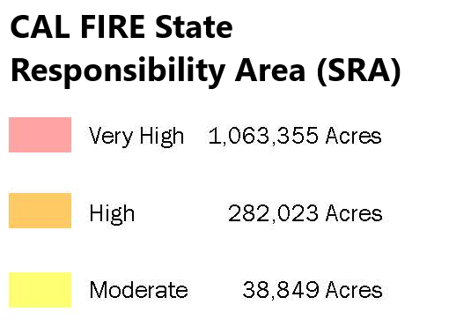
Fire Hazard Severity Zone maps
use the following classifications:
(Moderate, High, Very High)

Distribution of Land Uses in VHFHSZs and SRAs
The Klamath National Forest is zoned Rural Residential (R-R). The R-R district is intended to provide an area where rural residential uses can be compatibly mixed with commercial agricultural activities. This zoning often results in people working or living in the middle of the forest. Excluding the Klamath National Forest and the Butte Valley National Grasslands, the State Responsibility Area (SRA) covers large areas of the county, including very high fire hazard severity zones (VHFHSZs), where most people live and work.
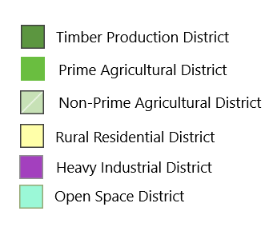
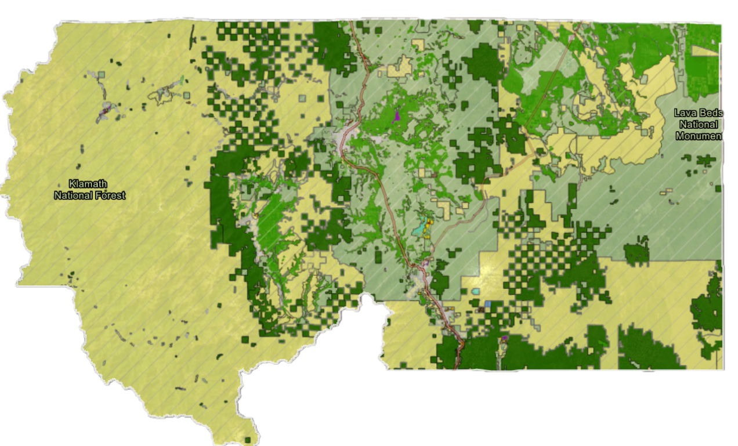

Forest Density Management
Forest density management is a viable fire hazard mitigation tool. It involves thinning overly dense forests to reduce fire susceptibility. Past forest management policies, particularly those emphasizing suppression over prevention, have contributed to a buildup of forest fuels, leading to larger, more destructive wildfires. A legacy of fire suppression, coupled with changes in forest composition due to density and age structure, has created conditions where wildfires are more likely to spread rapidly and with greater intensity.
Prescribed Burning
A prescribed burn (also known as a controlled burn) is the intentional application of fire to a specific area to achieve specific land management objectives. These burns are carefully planned and executed under carefully controlled conditions, with the goal of reducing wildfire risk, improving habitat, or promoting ecological restoration.
Surviving a Wildfire
When an evacuation route is compromised, or becomes impractical, alternative measures may need to be taken. Knowing the location of areas of relative safety can improve survivability. Individuals should become familiar with potential refuge locations such as large water bodies and water ways of a size and depth that will provide protection, large open spaces such as ball fields and parks, irrigated fields, and large parking lots away from trees and flammable materials. These types of refuge locations should only be considered as a last resort.
Fire Hazard Vulnerability Assessment
Background
The county has an extensive fire history due to the abundance of fuel sources combined with the local climate and topography. Wildfires are occurring on a more frequent basis. The county experiences frequent mixed-severity fires approximately every 2 to 3 years. The Klamath National Forest has been the site of many large fires over the last 25 years.
FEMA Wildfire Hazard Risk Index. The Risk of Wildfire is Relatively High. Siskiyou County’s Risk Index Score is 98.1 out of a possible 100. The county’s wildfire risk is greater than 98.1% of all US counties. FEMA projects estimated Expected Annual Loss from wildfire in the county to be $8,898,099.
Population at Risk
Even if a wildfire occurs in a remote area, the entire county population can be affected by the resulting smoke and air pollution fallout. Individuals at greater risk of health effects from wildfire smoke include those with cardiovascular or respiratory disease, older adults, children, pregnant women, outdoor workers, and limited income individuals.

An Aging Population. Physical limitations and cognitive decline can make it difficult to maintain adequate defensible space around homes and can slow the ability to evacuate in an emergency. Preexisting medical conditions and potential mobility issues need to be considered when formulating evacuation plans. In the McKinney Fire (2022), all four fatalities were over the age of 72.
The Unhoused Population. This population segment generally lacks the resources needed to mitigate against wildfire. Lacking adequate shelter, these individuals are often unable to remain indoors to avoid prolonged exposure to smoke and air pollution.
Individuals with Disabilities. People with disabilities or functional or access needs often require additional assistance during an evacuation. Additional resources may be needed to facilitate safe transport. Third party assistance may be required to create defensible space around structures. Early alert and public warning systems must account for a population that may have visual and/or audio impairments.
Limited Income Population. This population segment will likely lack the financial resources needed to mitigate wildfire. Low-cost housing in fire prone areas can often lack adequate defensible space buffers. During an evacuation limited income individuals may not have access to a motor vehicle in which to evacuate.
Property Damage
In Siskiyou County, most private homes and buildings are of wood frame construction. The McKinney Fire (2022) destroyed over 185 structures, including much of the Community of Klamath River. The fire burned for a total of 41 days, however much of the structural damage occurred in the first few days.
Critical Facilities and Infrastructure
Significant damage to critical infrastructure is possible. Most roads would be without damage except in the worst scenarios. Power lines, communication lines, and railroads are the most at risk because their supporting structures are made primarily of wood and are susceptible to burning. In recent years, the power company has installed nonwooden fire resistant utility poles in areas of the county. Local water systems throughout the county often include wooden structural components making them highly susceptible to fire damage. Fire can also impact bridges, especially those with wood construction or decking. Bridges in areas of high to moderate fire risk are important because they often provide the only ingress and egress route into the affected area.
Mitigation Measures
Mitigation measures should be encouraged and implemented to reduce the impact of wildfires.
- Creating Defensible Space Around a Home
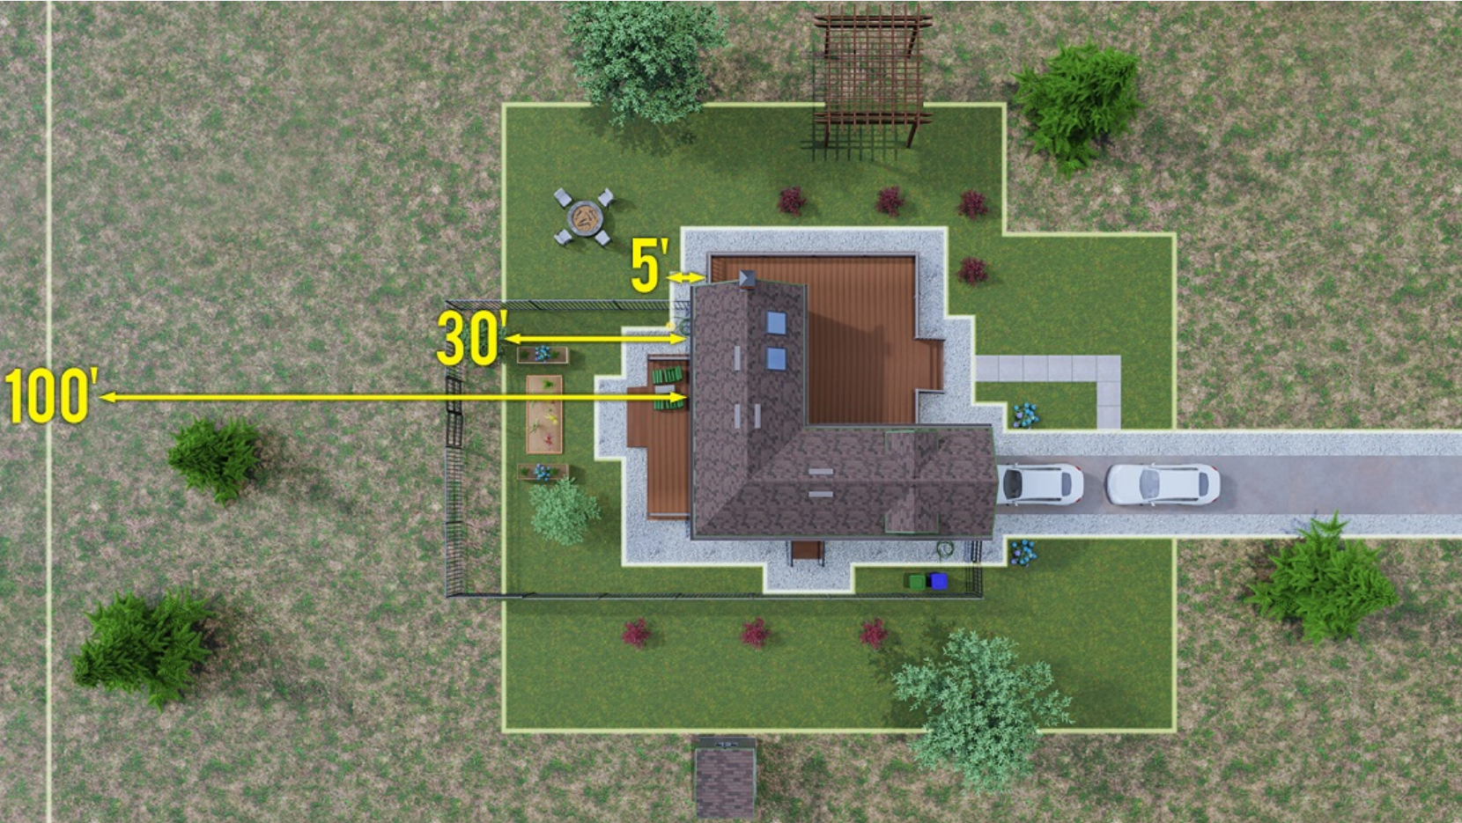
Source: CAL FIRE, 2025.
Defensible Space. Creating buffers around structures and using fire resistant building materials are essential requirements in mitigating against wildfire, as shown in Figure 5.5 above. It is recommended to keep the first 5 feet around a home clear to prevent embers from igniting, this area is called (Zone 0). Keep the area within 30 feet of the home clear of dry vegetation to create a buffer area, (Zone 1). Reduce fuel load within 100 feet of the home, (Zone 2). To learn more about protecting your home please visit the CAL FIRE website.
Fuel Reduction. Reducing forest stand density and removal of dead wood and debris help to reduce fuel load. Controlled burns, firebreaks, and vegetation gaps can help to disrupt a wildfire’s progress when it occurs.
Environmental Impacts
The Klamath National Forest, covering much of the western portion of the county, is home to a variety of endangered species. This area is highly susceptible to wildfire.
Salmon Habitat. Salmon populations can suffer from increased water temperatures, excessive sedimentation, and changes in water quality. Rainy season landslides and debris flows can create new habitats for salmon by providing shelter and gravel for spawning. However, excessive sedimentation can also smother eggs, bury spawning areas, or spark a microbial bloom, depleting oxygen levels in the water. Flash flooding after the McKinney Fire (2022) caused excessive sedimentation in the Klamath River which resulted in a devastating fish kill.
Soil Erosion. After a wildfire, the protective covering provided by foliage and dead organic matter is removed, leaving the soil fully exposed to wind and water erosion. Accelerated soil erosion can result in mudslides which can impact aquatic species and public safety.
Invasive Plant Species. Non-native woody plant species frequently invade burned areas, inhibiting the return of native plants and animals.
Disease and Insect Infestations. Unless diseased or insect-infested trees are quickly removed, infestations and diseases from wildfire areas can spread to healthy forests and private lands.
Additional Information Available
To view fire hazard severity zone maps for local communities and the unincorporated county please see Appendix A: Safety Element Information, Section A.4, Page A-17.
- The Flood Hazard
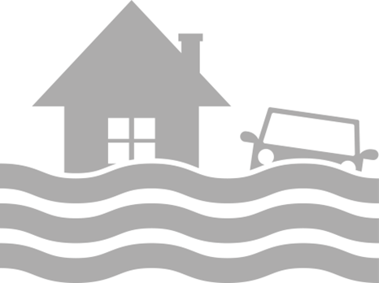
Flooding is the overwhelming of dry land due to a rise in the level of surface waters or the rapid accumulation of stormwater runoff. The two primary types of floods that occur in Siskiyou County are riverine flooding and flash flooding.
Riverine flooding. This type of flooding occurs when streams and rivers exceed the capacity of their channels to accommodate the flow of water and are overwhelmed. Riverine flooding can occur at any time of the year but is most common in the late winter and early spring due to snowmelt and heavy rainfall.
Flash flooding. Flash flooding is a rapid and extreme flow of water into a normally dry area, or a rapid rise in a waterway above a predetermined level, beginning within six hours of the causal event. Flash floods can move rapidly, end suddenly, and occur in areas not generally associated with flooding. Flash floods cannot be predicted accurately and can occur whenever there are heavy storms.
Road Closures. Most flood hazards in the county are transportation related. During a storm, railroad, highway, and canal embankments can form temporary barriers, resulting in ponding or diversion of water. In extreme conditions, due to high levels of runoff and erosion from intense precipitation, roads and bridges can become damaged if the road runs parallel to a flooding river.
Dam Failure
Dam failure can be caused by a mechanical failure or structural damage resulting from a major event such as an earthquake. Internal erosion, improper design and maintenance, and negligent operation can also cause dam failure.
There are currently 19 active dams in the county.
Four dams in the county are listed as being High or Extremely High for downstream hazards, meaning these areas would experience flooding, damage, loss of property, and injury during a dam failure.

- Siskiyou County Dams
Name | Acre Feet | Hazard Rating
Barton | 160 | Low
Bass Lake | 223 | Low
Box Canyon | 26,000 | Extremely High
Campbell Lake | 350 | Low
Cloak Lake | 123 | Low
Dwight Hammond | 348 | Low
East Boulder | 200 | Low
Fiock #1 | 223 | Low
Fiock #2 | 318 | Low
Greenhorn | 251 | High
Juanita Lake | 348 | Low
Kangaroo Lake | 168 | Low
Montague #2 | 160 | Low
Ray Soule Reservoir | 132 | Significant
Shasta River | 50,000 | High
Shelley | 364 | High
Steamboat Lake | 2,700 | Significant
Lake Suzanne | 89 | Low
Trout Lake | 2,108 | Significant
Source:
Box Canyon Dam (Lake Siskiyou)
The Box Canyon Dam is a concrete hydroelectric gravity dam impounding Lake Siskiyou. It was completed in 1969 and holds back approximately 26,000 acre feet of water. The Box Canyon Dam has a hazard classification of Extremely High for potential damage. The dam is located 8 miles north of the town of Dunsmuir near the start of the Sacramento River. A dam failure could reach Dunsmuir within 15 minutes of collapse.
California Dam Hazard Classifications
Significant | No probable loss of human life but can cause economic loss, environmental damage, impacts to critical facilities, or other significant impacts.
High | Dam failure is expected to cause the loss of at least one human life.
Extremely High | Expected to cause considerable loss of human life or would result in an inundation area with a population of 1,000 or more.

Floodplain Areas
A floodplain is a low-lying area of land next to a river, lake, or waterway that is prone to flooding. The 100 Year Floodplain in (blue) includes river areas and other low-lying areas that have a 1 percent or greater chance of flooding each year. The 500 Year Floodplain in (yellow) is an area of minimal flood danger, having a 0.2 percent or 1 in 500 chance of flooding each year.
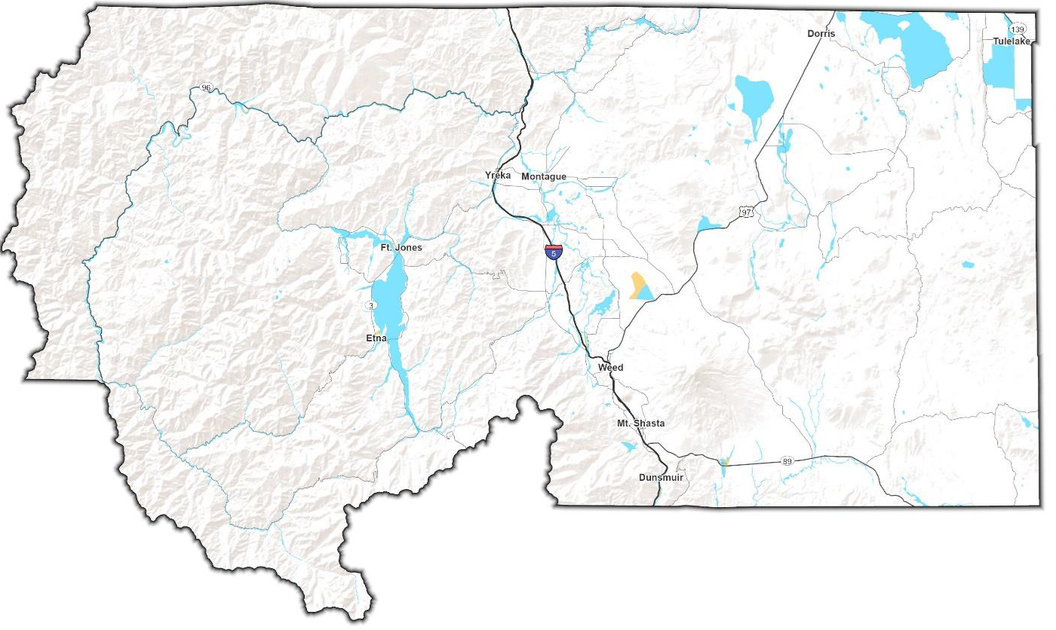

- Floodplain Mapping
Source: Mintier Harnish 2023.
Flood History
Specific areas of the county are more susceptible to the flood hazard than others. In Scott Valley, localized flooding is possible in areas adjacent to the Scott River. The City of Dunsmuir has experienced substantial flood damage in the past due to its location along the banks of the Sacramento River. The Dunsmuir floods in 1964 and 1974 resulted in damaged and destroyed homes, washed out bridges, roads and railroad tracks. At the same time, other areas of the county have minimal flood risk.
Mitigation Measures. Floodplain and wetland restoration help reduce the flood hazard while also providing environmental and economic benefits. Areas of restoration act like sponges that absorb and slowly release excess water while also providing critical habitat for animal species. These areas are particularly useful in countering the water runoff that comes from pavement and buildings.

Vulnerability Assessment
Specific areas of the county are more susceptible to the flood hazard than others. In Scott Valley, localized flooding is possible in areas adjacent to the Scott River. The town of Dunsmuir has experienced substantial flood damage in the past due to its location along the banks of the Sacramento River. At the same time, other areas of the county have minimal flood risk.
Flood Hazard Mapping. To view flood hazard maps and evacuation routes for the communities below please see Appendix A: Safety Element Information, Section A.5, Page A-26.
• Callahan • Gazelle • Lake Shastina • Tulelake
• Dorris • Greenview • Macdoel • Weed
• Dunsmuir • Grenada • McCloud • South Weed
• North Dunsmuir • Happy Camp • Montague • Yreka
• Etna • Hilt • Mount Shasta
• Fort Jones • Hornbrook • Quartz Valley

- Geologic and Seismic Hazards
Siskiyou County is home to a variety of geologic and seismic hazards, including volcanoes.
Landslide Hazard
Landslides and mudslides, including rockfalls, usually strike without warning. The force of rocks, soil, and other debris moving down a slope can devastate anything in its path. Figure 5.7 below depicts areas of the county in (red) with slopes greater than 15 percent that are especially prone to landslide and mudslide events.
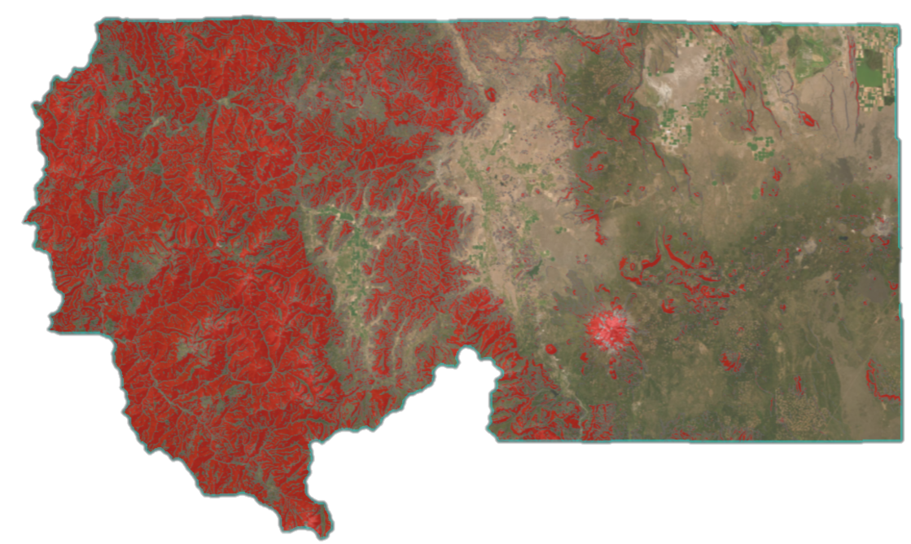
- Areas with Excessive Slope
Source: Siskiyou County, 2025.
The risk of a landslide is greatest when factors such as excessive slope, weak loose soils, water saturation, prior history of landslides, active earthquake faults, and improper grading are present. Wildfire burn scars are especially susceptible to landslides during subsequent rain events. During the winter months, rockfalls on Highway 96, can often result in road closures.
While efforts have been taken by the county through the development process to minimize landslide potential, some hillside development predates the imposition of grading and zoning requirements. For this reason, older homes built on a slope may be more susceptible.

Earthquake Hazard

An earthquake is caused by a sudden slip between tectonic plates. In Siskiyou County few earthquakes will exceed a magnitude of 2.5 (meaning they are not felt but can be captured by a seismograph) and even fewer will exceed a magnitude of 4.5 (meaning they are often felt but only cause minor damage.)
What Happens During an Earthquake?
Surface Rupture occurs when movement on a fault deep within the earth breaks through to the surface. Not all earthquakes result in surface rupture.
Fault creep is the slow, constant slippage that can occur on active faults absent an earthquake. Surface rupture may occur suddenly during an earthquake or slowly in the form of fault creep. This slow surface creep offsets and deforms curbs, streets, buildings, and other structures that lie near the fault.
Land Subsidence is a gradual settling or sudden sinking of the Earth’s surface due to removal or displacement of subsurface earth materials.
Liquefaction takes place when loosely packed, water-logged sediments at or near the ground surface lose their strength in response to strong ground shaking. Liquefaction beneath buildings and other structures can cause major damage during earthquakes.
Ground shaking describes the vibration of the ground during an earthquake. The extent of ground shaking depends on the magnitude and intensity of the earthquake and distance from the epicenter.
Tectonic Plates and You
The Pacific and North American Plates
In California there are two tectonic plates, the Pacific Plate and the North American Plate. The Pacific Plate consists of most of the Pacific Ocean floor and the California Coastline. The North American Plate comprises most of the North American Continent and parts of the Atlantic Ocean floor. The major boundary between these two plates is the 650 mile long San Andreas Fault. Siskiyou County sits on the edge of the North American Plate.
Cascadia Subduction Zone
The Cascadia Subduction Zone is an area where the Explorer, Juan de Fuca, and Gorda plates are moving eastward, sliding beneath the much larger North American Plate. The North American Plate itself is moving slowly in a southwest direction, sliding over these smaller plates as well as the larger oceanic Pacific Plate, which moves in a northwest direction.

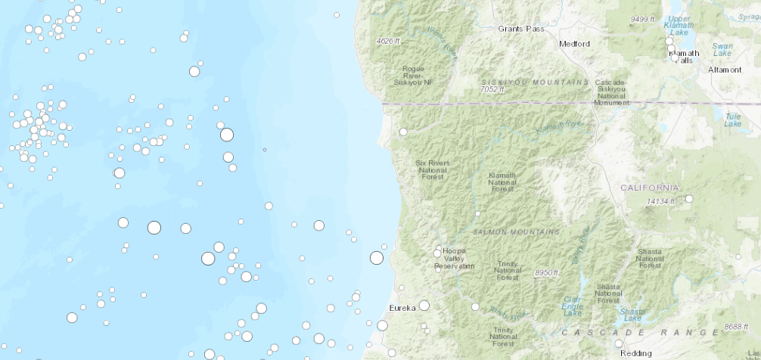
- Earthquake Distribution in the Pacific Northwest
Source: USGS, 2025.
Earthquakes in the Pacific Northwest
Most earthquakes in the Pacific Northwest occur in the Pacific Ocean as shown in Figure 5.8 above. Earthquake epicenter locations are marked by a white circle. Size differences between the white circles indicate the magnitude of the earthquake, with larger circles representing larger magnitude (more powerful) earthquakes.
Earthquake Fault Zones in Siskiyou County
The California Geological Survey (CGS) has mapped minor earthquake fault zones (EFZs) in Dorris, MacDoel, Sams Neck, Porcupine Butte, Indian Spring Mountain, East of Pondosa, Timbered Crater, Rainbow Mountain, Tennant, Garner Mountain, Bray, Sharp Mountain, Red Rock Lakes, and Sheep Mountain. Even with earthquake fault zones located in the eastern part of the county, there is an extremely low chance of a damaging earthquake occurring.
Earthquake Zones of Required Investigation
Earthquake Zones of Required Investigation (EZRIs) are specific areas, where potential earthquake hazards, beyond strong ground shaking, warrant detailed geological and geotechnical investigations before new construction or significant renovations can begin. These zones highlight areas with a higher risk of ground failures like liquefaction, landslides, or fault rupture. Earthquake Zones of Required Investigation Mapping can be viewed at the California Geological Survey website:
https://maps.conservation.ca.gov/cgs/informationwarehouse/regulatorymaps/

- Earthquake Intensity
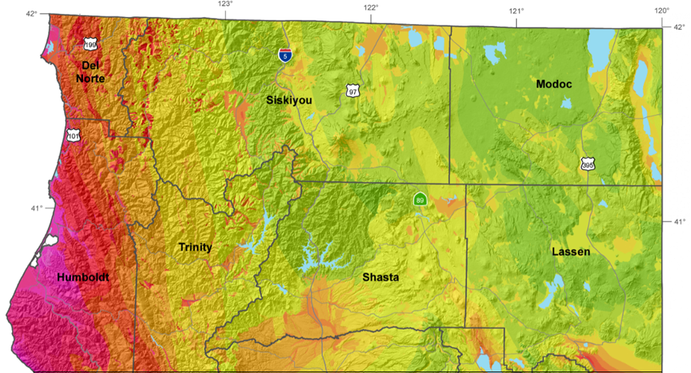
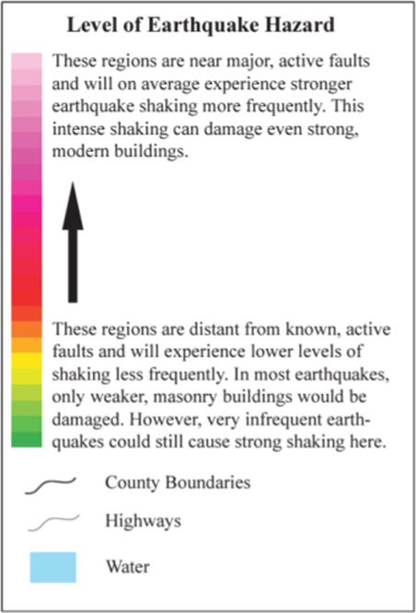
Source: California Geological Survey, 2025.
Alquist-Priolo Fault Zones
Alquist-Priolo earthquake fault zones are regulatory zones surrounding the surface traces of active faults in California. A trace is a line on the earth's surface defining a fault. Wherever an active fault exists, if it has the potential for surface rupture, a structure for human occupancy cannot be placed over the fault and must be a minimum distance from the fault (generally 50 feet). An active fault, for the purposes of the Alquist-Priolo Act, is one that has ruptured in the last 11,000 years. Alquist-Priolo Fault Zone Mapping can be viewed here:

https://cadoc.maps.arcgis.com/home/item.html?id=29d2f0e222924896833b69ff1b6d2ca329d2f0e222924896833b69ff1b6d2ca3

Intensity is a subjective measure of the effects of an earthquake as measured by the Modified Mercalli Intensity Scale (MMI).
- Modified Mercalli Intensity Scale (MMI)
Intensity | Shaking | Description/Damage
I | Not felt | Not felt except by very few under especially favorable conditions.
II | Weak | Felt only by a few persons at rest, especially on upper floors of buildings.
III | Weak | Felt quite noticeably by persons indoors, especially on upper floors of buildings. Many people do not recognize it as an earthquake. Vibrations similar to a passing truck.
VI | Light | Felt indoors by many, outdoors by a few during the day. At night, some awakened. Dishes, windows, doors disturbed; walls make crackling sound. Sensation like heavy truck striking building.
V | Moderate | Felt by nearly everyone, many awakened. Some dishes, windows broken. Unstable objects overturned. Pendulum clocks may stop.
VI | Strong | Felt by all, many frightened. Some heaving furniture moved; a few instances of fallen plaster. Damage slight.
VII | Very Strong | Damage negligible in buildings of good design and construction; slight to moderate in well-built ordinary structures; considerable damage in poorly built or designed structures; some chimneys broken.
VIII | Severe | Damage slight in specially designed structures; considerable damage in ordinary substantial buildings with partial collapse. Damage great in poorly built structures. Fall of chimney stacks, factory stacks, columns, monuments, walls. Heavy furniture overturned.
IX | Violent | Damaged considerable in specially designed structures; frame structures thrown out of plumb. Damage great in substantial buildings, with partial collapse. Buildings shifted off foundations.
X | Extreme | Some well-built wood structures destroyed; most masonry structures destroyed with foundations.

Moment Magnitude Scale (Mw)
Magnitude | Earthquake Effects
2.5 or less | Usually not felt but can be recorded by seismograph.
2.5 to 5.4 | Often felt and causing only minor damage.
5.5 to 6.0 | Slight damage to buildings and other structures.
6.1 to 6.9 | May cause a lot of damage in very populated areas.
7.0 to 7.9 | Major earthquake. Serious damage.
8.0 or greater | Great earthquake. Can destroy communities near the epicenter.

Magnitude is an objective measure of an earthquake’s size at its release, as reported by the Moment Magnitude Scale (Mw), which looks at the distance a fault moves, and the force required to move it. Most earthquakes in the county are 2.5 or less in magnitude.


Volcano Hazard
Home to the Lava Beds National Monument, Mt. Shasta Volcano, and the Medicine Lake Volcano, Siskiyou County has significant volcano hazard exposure.
At the county level, Shasta and Siskiyou counties have the largest daily populations in the volcano hazard zone (approximately 61,425 and 42,163, respectively).
FEMA National Risk Index
Siskiyou County’s Volcanic Activity Risk Index Score is 78.7. According to FEMA, there is a Relatively Moderate risk of volcanic activity in the county. Should property damage occur, expected annual loss from volcanic activity is estimated to be approximately 1.1 million dollars.
The National Volcanic Threat Assessment provides threat assessment rankings for 161 US volcanoes with the greatest potential for eruptions based on objective measures of volcano hazards and the exposure of people and infrastructure to those hazards.
National Volcanic Threat Assessment
Very High | High | Moderate | Low | Very Low

Rank | Volcano | State | Threat Group | Latitude | Longitude
5 | Mt. Shasta | CA | Very High | 41.3099° N | 122.3106°W
45 | Medicine Lake | CA | High | 41.6108° N | 121.5535°W

Mt. Shasta is ranked No. 5 (Very High Threat) on the National Volcanic Threat Assessment list for US volcanoes. Medicine Lake Volcano is ranked No. 45 (High Threat).

Mt. Shasta Volcano
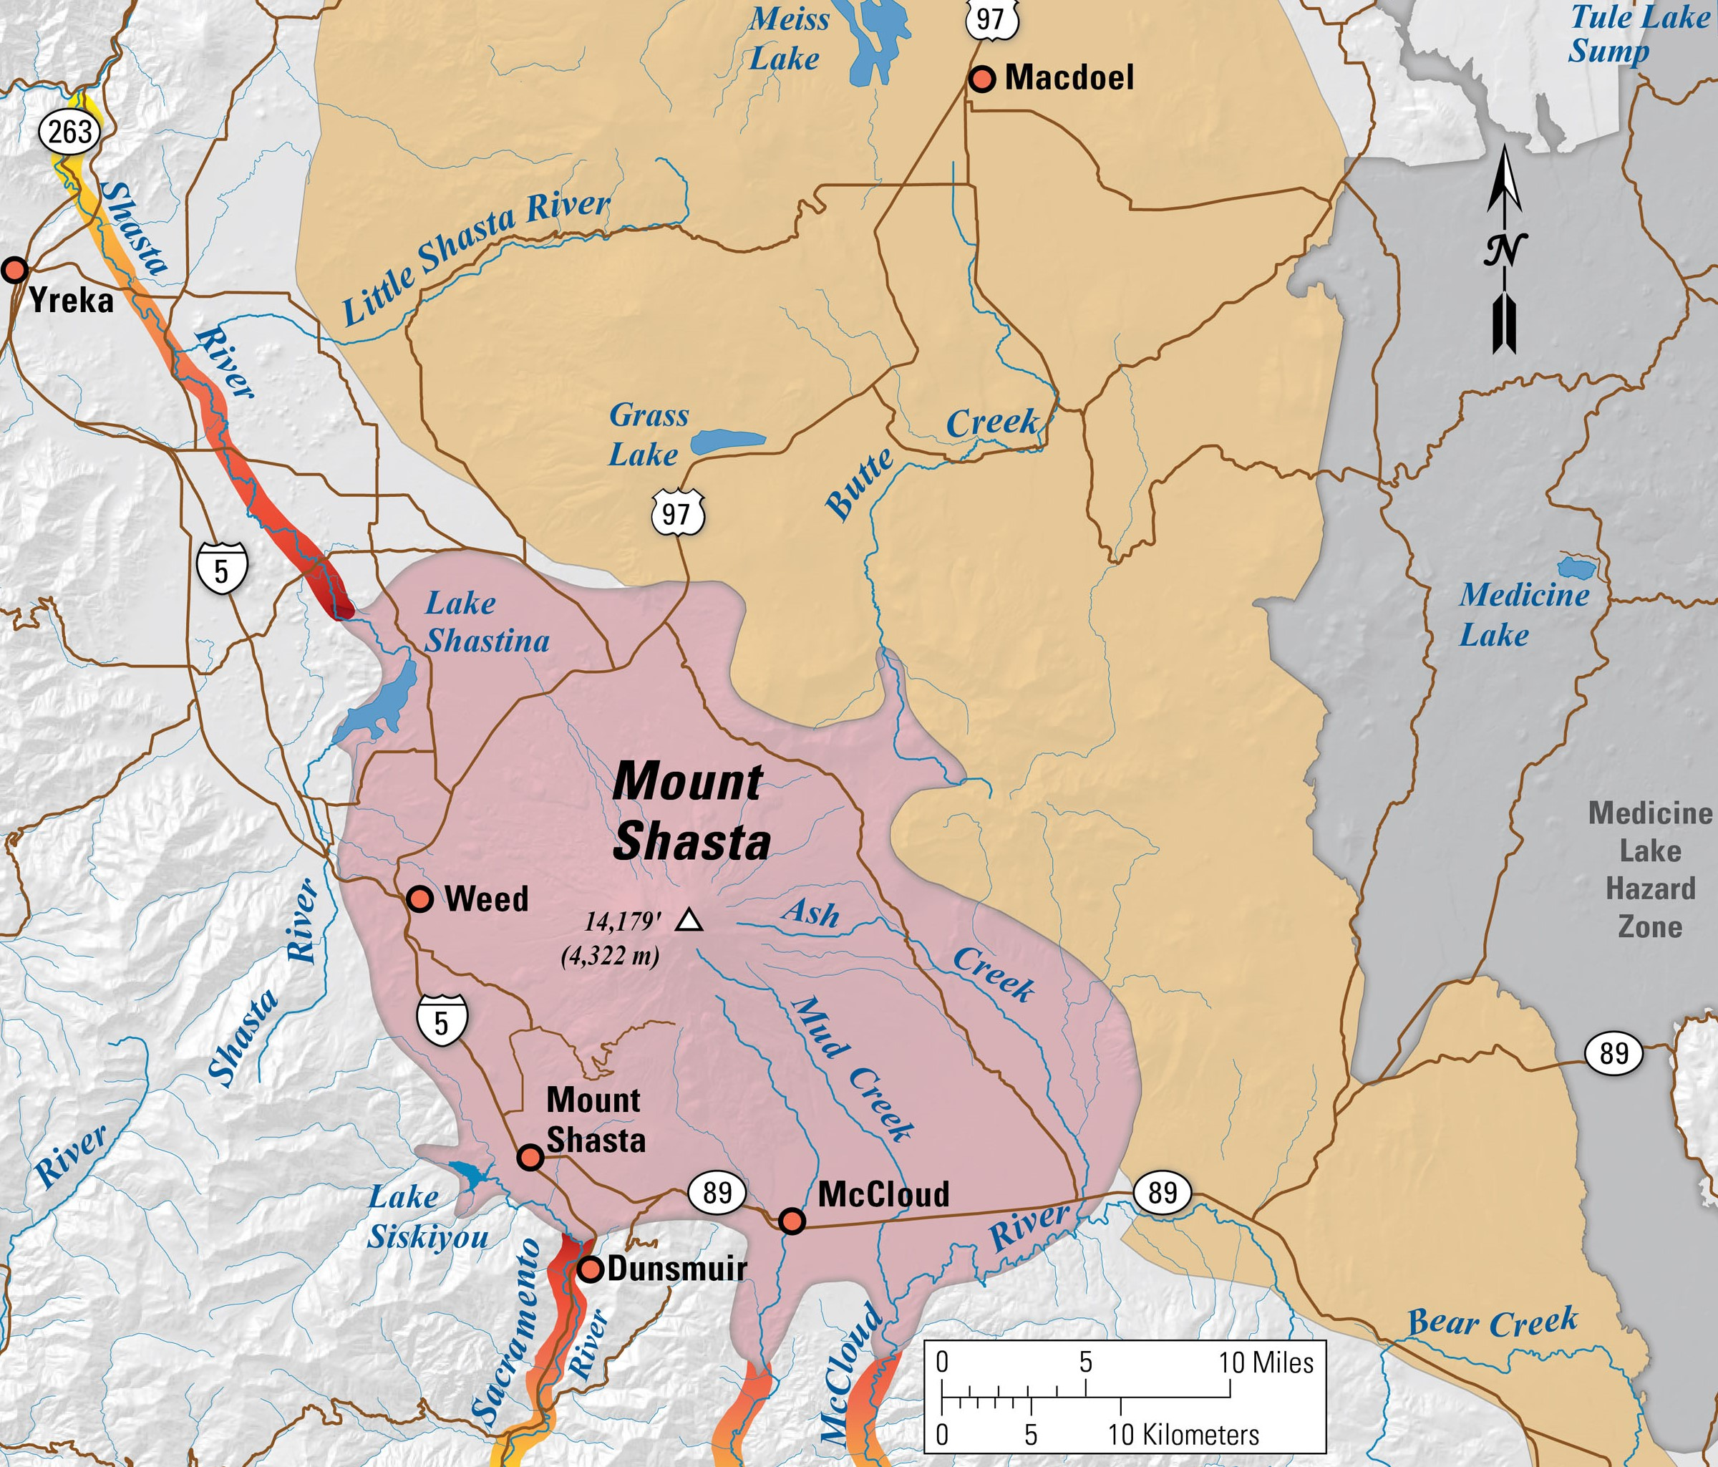
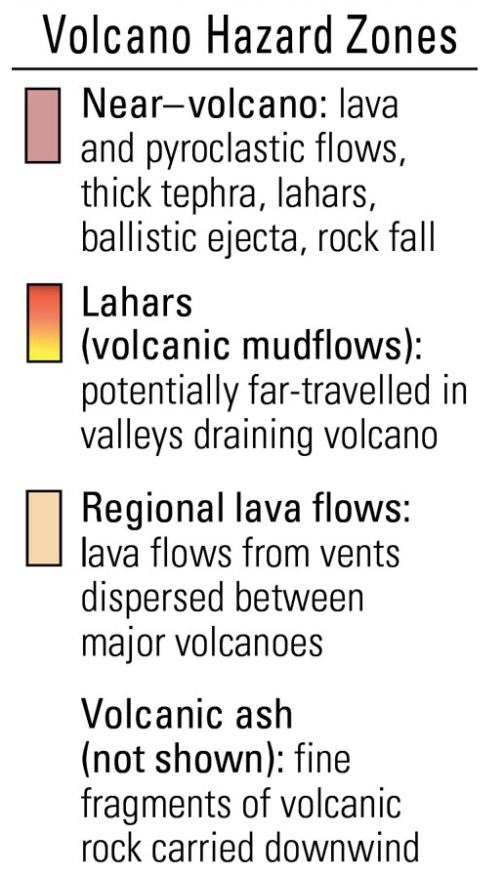
- Mount Shasta Eruption Analysis
Source: USGS, 2025.
Mt. Shasta is a steep-sided volcano (stratovolcano) located along the Interstate 5 corridor. The towns of Weed, Mount Shasta, and McCloud lie at the base of this 14,162 foot high snow covered volcano. Mt. Shasta began forming on the remnants of an older volcano that collapsed sometime between 500,000 to 300,000 years ago. The collapse created one of the largest landslides known on Earth, covering more than 170 square miles of the Shasta Valley to the northeast.
Eruptions around 11,000 years ago formed Black Butte and the Shastina dome on the west flank of the volcano. In the last few thousand years, eruptions have broken out at the volcano’s summit and from vents on its upper east flank.

Medicine Lake Volcano
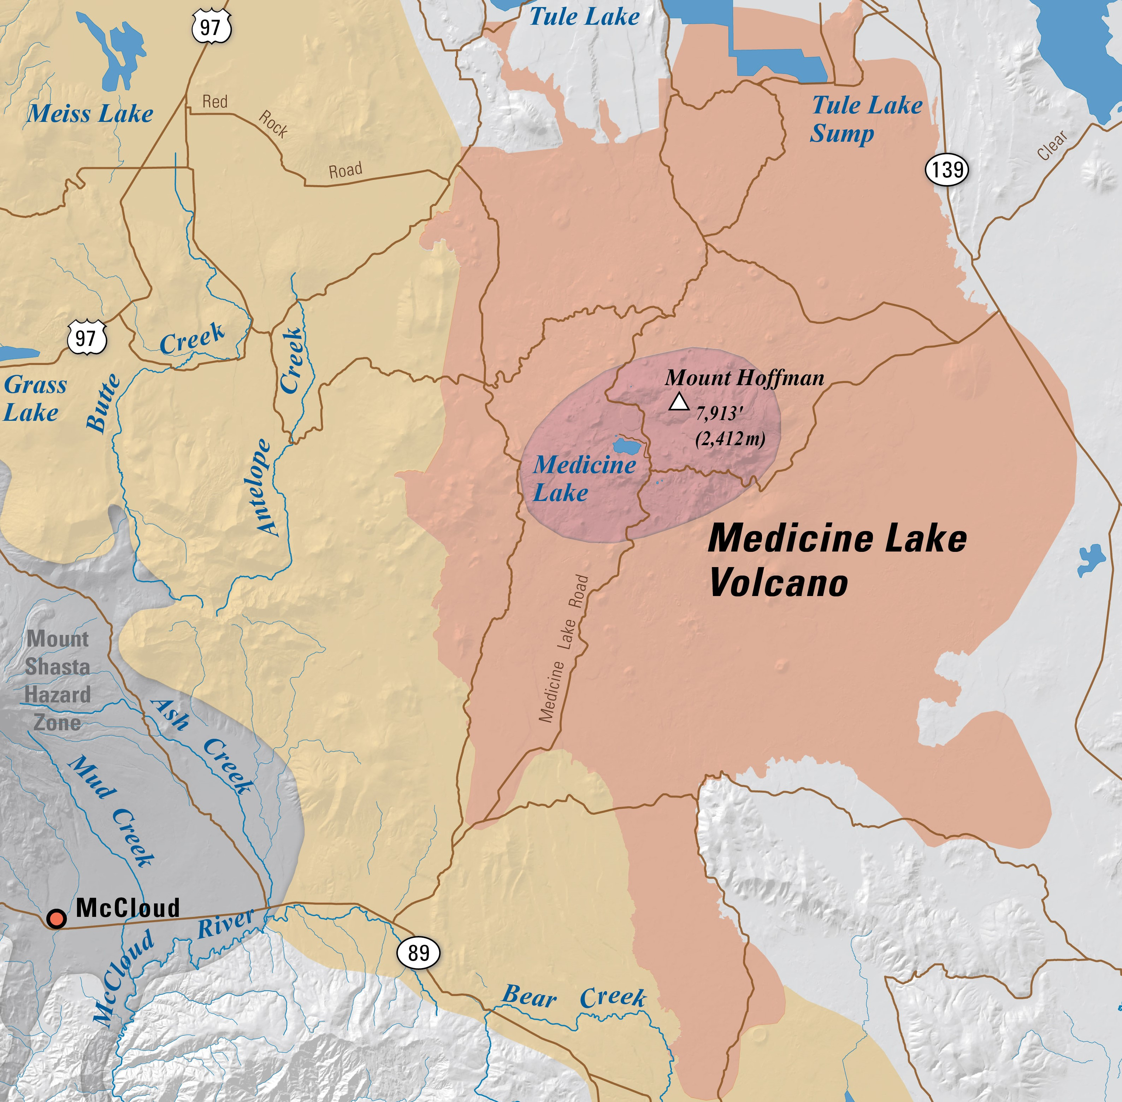
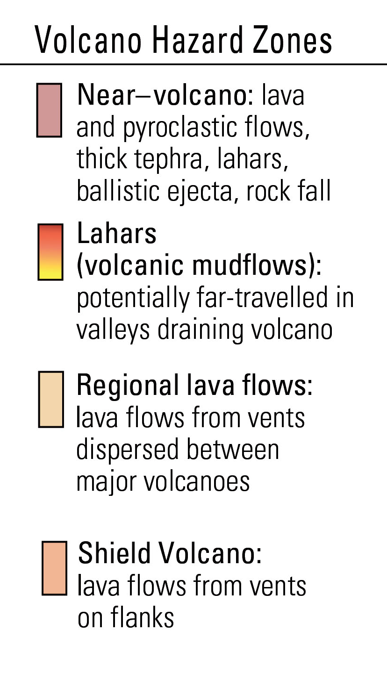
- Medicine Lake Eruption Analysis
Source: USGS, 2025.
Medicine Lake Volcano is a large, broad volcano (shield volcano) located in eastern Siskiyou County. The Lava Beds National Monument lies on the north side of the volcano. Located at the summit of the volcano is a water-filled collapsed basin, or caldera. The caldera is 8 miles wide and 14 miles across.
The volcano has erupted nine times during the past 5,200 years, and seven of those eruptions began with an explosive phase. The two youngest eruptions produced Little Glass Mountain (1,000 years ago) and Glass Mountain (950 years ago).

Geologic and Seismic Hazards Vulnerability Assessment
Landslides
Much of western Siskiyou County consists of slopes greater than 15 percent. These areas are susceptible to the landslide hazard. Erosion of wildfire burn scars due to wind and heavy rain can result in landslides and debris flows in these areas. Most landslides in the county occur in remote locations so incidents often go unnoticed and unreported. When they impede major travel routes, landslides and rockfalls can isolate local communities from the rest of the county.
Earthquakes
While Siskiyou County is in a seismically active area, the chance of a catastrophic earthquake resulting in substantial damage is low. Earthquake fault zones within the county are in sparsely populated areas. When they do occur, few earthquakes within the county will exceed a magnitude of 2.5, meaning they are not felt but can be captured by scientific instruments.
Volcanic Activity
Mt. Shasta Volcano
The next eruption will likely involve weeks or months of precursory earthquakes and ground deformation followed by a series of steam explosions blasting a deep crater at the summit of the volcano. Such a scenario would provide ample warning for residents to evacuate. Although geophysically quiet, periodic geochemical surveys indicate that volcanic gas emanates from an opening at the summit of Mt. Shasta from a deep-seated reservoir of partly molten rock.
If Mt. Shasta erupted, modeling indicates that large volcanic mudflows could engulf the Shasta, Sacramento and McCloud Rivers. The towns of Weed, Mount Shasta, and McCloud would be subjected to ballistic ejecta and rock fall, while volcanic ash would blanket most of the county.
Research published by the US Geological Survey (USGS) suggests there is a 3.5 percent chance that Mt. Shasta erupts in the next 30 years.
Mt. Shasta Glaciers. Mudslides generally occur in areas that are also vulnerable to the landslide hazard after heavy precipitation events. During the summer months, glacier melt from Mt. Shasta has the potential to result in large mudslides and debris flows which can impact roads and critical infrastructure. Highway 89, east of the town of McCloud is experiencing this phenomenon on an annual basis.
Electrical Grid Vulnerability
With over 1,223 miles of high-voltage transmission lines and 86 substations in the Mt. Shasta Volcano Hazard Area, an eruption of Mt. Shasta has the potential to knock out electrical power for a significant portion of the county.

- High-Voltage Transmission Lines in the Volcano Hazard Area
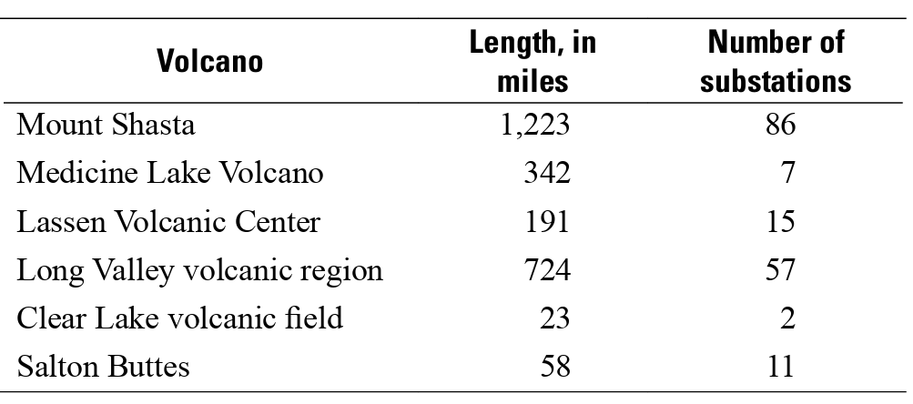
Source: USGS, 2025.
Medicine Lake Volcano
Similar to Mt. Shasta, the eruption of the Medicine Lake Volcano would be preceded by weeks or months of heightened earthquake activity and ground deformation. Given the long advance warning time, loss of life during an eruption event is expected to be minimal. Property loss in affected areas, however, could be significant. Due to its nonexplosive nature, an eruption would likely result in lava flows rather than ballistic ejecta and rock fall being scattered across the county. This area is sparsely populated, and property damage is expected to be minimal, although volcanic ash could be a county-wide problem.
Research by the US Geological Survey (USGS) suggests there is a 1 percent chance that Medicine Lake Volcano erupts in the next 30 years.

- Hazardous Materials

Mishandling of hazardous materials can threaten environmental quality and result in soil and groundwater contamination.
Hazardous materials are defined as those materials that pose a significant present or potential threat to human health and safety or to the environment if released into the workplace or the environment. These materials include chemicals, radioactive waste, explosives, natural gas, petroleum, pesticides, agricultural chemicals, and household cleaning products.
Exposure to hazardous materials can result in lung damage, cancer, cardiovascular disease, low birth weight infants, and other negative health outcomes that reduce life expectancy.
Most fuels, lubricants, solvents, and paints are considered hazardous materials. Businesses and institutions that use substantial quantities of hazardous materials are required to adhere to strict regulations regarding the handling, transport, and storage of such materials.
Hazardous Materials Incidents
Improper handling, storage, and disposal of hazardous materials can have negative effects on people and the environment.
In 1991, a Union Pacific Railroad train derailment occurred below Box Canyon Dam, upstream from the town of Dunsmuir. A railroad car fell into the Sacramento River spilling 19,000 gallons of the herbicide Metam sodium into the river. Referred to as the Cantara Loop Spill this hazardous materials incident killed nearly all aquatic life and affected the entire river ecosystem.
In 2006, a truck overturned on Highway 96, dumping its cargo, a toxic petroleum-based asphalt emulsion, into the Klamath River, creating an eight-mile plume downriver. Most of the spill did not reach the river due to the quick thinking of a retired US Forest Service employee, Ed Masonheimer, who got a shovel from his pickup truck and began building a sand and gravel dam that managed to impede much of the 7,000 gallons of road sealant. While only a small amount of emulsion reached the water’s edge, it was enough to cause a significant fish kill.
In 2021, a Union Pacific Railroad train derailment involving 18 train cars occurred near the site of the 1991 Cantara Loop Spill. No injuries or hazardous material releases were reported at the time.
In 2022, a Union Pacific Railroad train derailment involving 9 train cars occurred near the site of the 1991 Cantara Loop Spill. No injuries or hazardous material releases were reported at the time.

Vulnerability Assessment
Railroad Incidents
Union Pacific Railroad is the primary rail operator in Siskiyou County, transporting a variety of commercial and industrial products. The company’s railyard in the town of Dunsmuir, has existed since the early 1900s. Since that time, unknown amounts of fuel has seeped into the soil, groundwater, and the Upper Sacramento River. Current efforts to stop contamination from entering the river include excavation of impacted material along the surface of the riverbank and installation of oil barriers in the river. The Central Valley Regional Water Quality Control Board has issued a Cleanup and Abatement Order for the Dunsmuir site. In addition, the US Environmental Protection Agency has issued a Clean Water Act Order for the location. Clean up commenced in 2022 and is expected to be completed by the end of 2025.
Motor Vehicle Incidents
Interstate 5 is the main transportation corridor within Siskiyou County. Over 6,000 commercial trucks use the road on a daily basis. All other major routes in the county connect to Interstate 5. Starting at the county’s southern border and ending north of Weed Airport, Interstate 5 experiences winter weather conditions on an annual basis. Road closures due to snow are not uncommon. The other major traffic routes in the county can also experience icy conditions making travel difficult. Rock falls on Highway 96 occur on a regular basis.

- Wildlife Hazards
The proximity of wildlife to people and livestock can lead to a range of issues, including disease transmission, predation, and resource competition.
Siskiyou County is a rural community where land development occurs in wildlife areas. When this happens, human activity can alter normal wildlife behavior, including diet, activity times, and movement patterns. Over time animals start to develop a preference for human provided food and lose their natural fear of people.
Disease Transmission
Some wildlife species can become ill with zoonotic diseases, or diseases that are transmitted between animals and humans. These diseases are caused by a variety of pathogens (e.g. bacteria, viruses, fungi) that can cause fatal infections in people. Examples of zoonotic diseases include rabies (from bites or scratches from an infected animal), hantavirus (from exposure to rodent urine, droppings, saliva, bites or scratches), and tularemia (from tick and fly bites or contact with infected animals).
Chronic Wasting Disease (CWD)
Chronic Wasting Disease is a degenerative prion disease similar to ‘Mad Cow Disease’. While Mad Cow Disease affects cattle, Chronic Wasting Disease affects deer, elk, moose, and other cervids. CWD is an always fatal disease that affects the brain, spinal cord, and other tissues. The name for CWD comes from its most noticeable symptom, dramatic weight loss. There is no cure or vaccine for Chronic Wasting Disease. The Centers for Disease Control and Prevention (CDC) has advised against consuming infected meat due to the potential risk to people. To limit possible exposure, hunters should only harvest and eat healthy looking animals. The brain, eyes, tonsils, spine, spleen, and lymph nodes should always be avoided as these are where the prions accumulate in high density. An infected carcass should be buried at least 4 feet deep or disposed of at an approved landfill to prevent exposure to other cervids.
Studies conducted by the National Institutes of Health (NIH), indicated there is a substantial species barrier preventing transmission of CWD from cervids to humans. CWD cannot be transmitted to livestock or humans. While confirmed cases have been detected in central and southern California, there have been no reported cases in Siskiyou County.
Avian Influenza (Bird Flu/H5N1)
Bird Flu is a highly contagious and often fatal disease in birds. The viral spread is passed by migratory wild birds, such as ducks and geese, but many other wild bird species can also be a source of spread. The disease spreads through contact with infected wild and domestic birds or contact with the virus on surfaces such as hands, shoes, clothing, and the fur of other animals, such as pets. The virus can be transmitted to dairy cows, so precautions should be taken for farms that have both cows and poultry or are in the vicinity of a dairy cow farm.
As of May 2025, there were 70 confirmed human cases of Bird Flu in the US (38 in California), with one fatality. California and Washington state had the most reported cases. Studies show that the virus cannot be passed from person to person. While it has been detected in California there have been no reported cases of Bird Flu in Siskiyou County.
West Nile Virus (WNV)
West Nile Virus is a mosquito-borne virus that causes disease in humans, horses, and birds. The virus spreads to people through the bite of an infected mosquito. Since 2003, 8,000 human cases and nearly 400 deaths have been reported in California. WNV cannot be spread through coughing, sneezing, or casual contact, such as touching or kissing a person who has the virus.
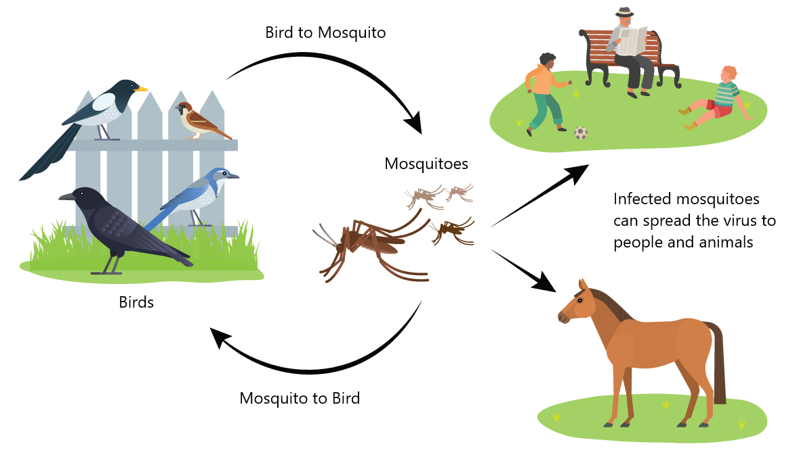
- How West Nile Virus is Spread
Source: Westnile.ca.gov
There is no vaccine. The best way to avoid getting WNV is to prevent mosquito bites. While the virus has been detected in California there have been no reported cases in Siskiyou County.
Predator Hazard
Siskiyou County is home to a variety of animal predators such as fishers, martens, bobcats, coyotes, black bears, mountain lions, and gray wolves. Among these predator species, black bears, mountain lions, and gray wolves pose the most risk to people, domesticated animals, and livestock.

Gray Wolves
The last native gray wolf in California was killed in 1924. After nearly a century with no confirmed wolf sightings, the species has returned to California through dispersal migration of wolves from other states. Dispersal occurs when a wolf leaves its natal pack to form a new pack in a different area. As of May 2025, California has 10 confirmed wolf packs along with an undetermined number of dispersing wolves.
Siskiyou County is currently home to the Whaleback Wolf Pack, which was formed when a male wolf identified as OR-85 dispersed from Oregon’s Mount Emily Pack in 2020 and paired with a female wolf, WHA01F, from Oregon’s Rogue Pack.
The pair settled in Siskiyou County and produced a litter of 7 pups in 2021 and 8 pups in 2022. In 2023, the pack produced another 8 pups, and in 2024 the pack produced at least 6 pups.
The actual size of the Whaleback Wolf Pack is not publicly known, but it is believed to consist of at least 10 wolves.
In March 2023, the breeding male, OR-85, was captured and fitted with a satellite tracking collar. In January 2025, the breeding female, WHA01F, was captured and fitted with a satellite tracking collar.
The California Department of Fish and Wildlife (CDFW) operates a gray wolf tracking map that can be viewed at: https://wildlife.ca.gov/Conservation/Mammals/Gray-Wolf/Location-Map
As of May 2025, the Whaleback Wolf Pack is not displayed on the CDFW wolf tracking map. Lack of activity on the tracking map does not mean that a wolf pack is no longer present in a specific area. Gray wolves have their young and use den sites in early spring. After leaving the den, gray wolves switch to using rendezvous sites, where young are kept until they can safely travel with the pack. While denning and rendezvous site behavior is occurring (typically April through August), certain areas in the immediate vicinity will not be activated on the wolf tracking map. However, if a gray wolf, that has been satellite collared, moves outside of the protected area, its collar will again show up on the tracking map.
Livestock predation by gray wolves usually increases during the fall and winter months, at a time when deer fawns are scarce. According to the Wolf Management Update Report published by the CDFW, the Whaleback Wolf Pack was responsible for the deaths of four calves, one heifer, and one steer in Siskiyou County from October to December 2024. Livestock predation incidents are expected to increase if the Whaleback Wolf Pack grows in size and disperses to other areas of Siskiyou County.
Past history indicates that gray wolves generally do not pose a direct threat to human health and safety. However, it must be remembered that gray wolves have been functionally extinct in California for almost 100 years, so that past interactions between gray wolves and people may not accurately reflect the current situation.
Mountain Lions
Mountain lion sightings are an annual, albeit rare, occurrence in Siskiyou County, with confirmed sightings near the towns of Dunsmuir, McCloud, Mount Shasta, and Yreka. In February 2025, the CDFW issued a predation permit for the taking of a mountain lion responsible for the killing of a pet dog in the town of McCloud. Mountain lions have also been observed in the area of Greenhorn Park in the town of Yreka. In 2021, a mountain lion was photographed resting in a patch of manzanita outside a home in the town of Mount Shasta. In 2024, a mountain lion was captured on a doorbell camera standing on a back porch in the town of Dunsmuir.
The Siskiyou Deer-Mountain Lion Study (2015-2020), conducted by UC Santa Cruz and the CDFW, involved the capture and electronic collaring of 14 mountain lions, ranging from 2 to 7 years of age. Eight of the 14 collared mountain lions are known to have died during the study period. Three of the mountain lions were illegally killed, 3 were killed by other mountain lions, and 2 were killed due to accidents (one vehicle and one train collision, respectively).
The Siskiyou Deer-Mountain Lion Study estimated an overall adult mountain lion density of 0.22 to 0.36 lions per 100 km².
Based on the County’s land area (16,260 km²), a very rough estimate indicates there could be at least 36 to 59 adult mountain lions in Siskiyou County.
In the last 100 years, there have been no confirmed mountain lion attacks on humans in Siskiyou County.
Black Bears
Black bears are omnivores, and their teeth are adapted for feeding on both plant and animal matter. They are highly opportunistic and will eat nearly anything edible. The opportunistic foraging behavior of black bears often brings them into conflict with people, as black bears can damage homes and property, including vehicles, while seeking out human food and garbage.
A food-conditioned black bear is one that has become accustomed to human-associated food sources and has learned to associate humans and human developments with food. Food-conditioned black bears may be dangerous to humans and domestic animals. The first ever reported human fatality caused by a black bear in California occurred in 2023 in Downieville, Sierra County.
Black bear interactions with gray wolves can be lethal or kleptoparasitic. A Kleptoparasite is an animal that steals food or prey from another animal (scavenging or usurping behavior). Packs of gray wolves are known to displace black bears from carcasses or even prey on black bears themselves.
According to the CDFW, California has the largest black bear population in the United States, with Humboldt, Mendocino, Shasta, Trinity, and Siskiyou Counties, having the highest black bear densities.
The CDFW Black Bear Conservation and Management Plan (2025) estimates black bear densities for Siskiyou County at 38 to 96 black bears per 100 km².
Based on the county’s l and area (16,260 km²), a very rough estimate indicates there could be approximately 6,178 to 15,609 black bears in Siskiyou County.
Wildlife Hazard Vulnerability Assessment
Disease Transmission
Chronic Wasting Disease, Bird Flu, and West Nile Virus are all present in California, but not in Siskiyou County. There is no vaccine for West Nile Virus. The best way to avoid contracting the disease is to not be bitten by an infected mosquito. There is no vaccine for Chronic Wasting Disease. However, a strong species barrier prevents transmission of CWD from animals to humans. People are advised not to consume animals that may be infected with CWD. There is currently no Bird Flu vaccine for humans. At this time bird flu cases in humans appears to be limited to people who work regularly with poultry or dairy cows. Preventative measures should be taken by individuals who come into regular close contact with poultry or dairy cows.
Predator Hazard
Never feed wild animals. Don’t do it. Wild animals should have a natural fear of humans. To limit negative interactions with wildlife, people should secure their garbage and never try to make a pet out of a wild animal. Deer-proofing property is a good idea to avoid attracting a mountain lion’s main food source. Removing dense vegetation around homes helps to reduce possible hiding spaces for predators. Installation of outdoor lighting makes it difficult for predators to approach unseen. If feasible, secure livestock and outdoor pets in sturdy, covered shelters at night. When out in nature, avoid hiking, biking, or jogging alone, or at dawn, dusk, or at night.
If you see a baby wolf, mountain lion, or black bear, do not touch it. It is likely that the mother is nearby and will attack you to protect her young.
Gray Wolves
Gray wolves rarely pose a direct threat to human health and safety and will generally depart the area when people are present. Gray wolves are listed as an endangered species under state and federal law. It is illegal to “take” a gray wolf, which is defined as hunting, pursuing, harassing, catching, capturing, or killing them. If wolves are present, non-injurious harassment is allowed to protect people and livestock.
In addition, confirmed or probable wolf depredations of livestock may be eligible for compensation through the CDFW Wolf Livestock Compensation Grant Program.
Mountain Lions
Mountain lion attacks on humans are rare. Since 1890, there have been less than 50 verified mountain lion attacks on humans in California; of that, only six have been fatal.
Fish and Game Code Section 4807 states that any mountain lion that is encountered while in the act of pursuing, inflicting injury to, or killing livestock, or domestic animals, may be taken immediately by the owner of the property or the owner's employee or agent.
Black Bears
Black bears are highly food-motivated, particularly during hyperphagia, the period prior to hibernation. The best way to prevent conflict is to eliminate what is attracting the bear. If a black bear becomes food conditioned or habituated to humans, it may become increasingly bold or destructive. Cubs that are food conditioned by their mothers will grow up to become conflict adults, continuing the cycle. Relocation is not an option, as a relocated bear can travel hundreds of miles to return “home”. Even if the bear does not return “home”, it may end up becoming a problem for the community where it was relocated to. Bears who have become habituated to humans will often need to be euthanized.
Fish and Game Code Section 4181.1 states that any bear that is encountered while in the act of inflicting injury to, molesting, or killing, livestock may be taken immediately by the owner of the livestock or the owner’s employee.
Proper Handling and Disposal of Carcasses
Proper disposal of dead animals is critical to prevent exposure of other wildlife, livestock, and humans to disease. Three effective methods of carcass dispose are incineration, burying, and rendering. Incineration is the preferred method when the carcass is diseased, however this can be expensive. An acceptable alternative is to bury the carcass. If burying, the carcass should be buried at least 4 feet deep and covered with lime to discourage scavengers.
Food and Agriculture Code Section 19348 states for a routine livestock death the owner can choose to bury the animal on the owner’s property if the burial is within 3 miles of where the animal died. However, if it is to be disposed of offsite, the carcass must be transported by a licensed dead animal hauler to a licensed rendering plant.
California Code of Regulations 14 CCR 17855.2 prohibits the composting of unprocessed mammalian tissue (cattle, goats, sheep). In Siskiyou County, due to the financial cost, dead animals are often disposed of in open bone pits, rather than transported to a rendering plant, which can attract gray wolves and other predators.

- Adaptation and Community Resilience
While increasing temperatures and extreme weather conditions are happening on a global scale, different areas are affected in different ways.
Increasing Temperatures
Siskiyou County’s historical average temperature is 50.3 degrees Fahrenheit (1960 – 2000). By 2099, under a low emissions scenario, which refers to a projected future where action is taken to reduce GHG emissions, the average temperature would still increase by 3.4 degrees to 53.7 ° Fahrenheit. By 2099, under a high emissions scenario, which assumes that GHG levels in the atmosphere continue to increase at current rates (meaning no action is taken to cut emissions or reduce consumption), Siskiyou County’s average temperature would increase by 6.0 degrees to 56.3 ° Fahrenheit.
Scenario | Average Temperature | Change
Historical (1960 - 2000) | 50.3 °F | +0.0 °F
Low Emissions (2000 - 2099) | 53.7 °F | +3.4 °F
High Emissions (2000 - 2099) | 56.3 °F | +6.0 °F

According to the National Aeronautics and Space Administration (NASA), July 22, 2024, was the hottest day on record, with an average global temperature of 62.87 ° Fahrenheit. 2024 was the warmest year on record and the ten warmest years on record have all occurred in the last ten years (from 2015 – 2024).
Drought Impacts
In 2024, the county experienced its 28th wettest year to date over the past 130 years. Precipitation was up 4.64 inches from normal. However, this was preceded by years of exceptional drought and water curtailments.
Drought conditions can change rapidly from one year to the next. After experiencing extreme drought conditions between 2021 to 2023, as of May 2025, Siskiyou County is no longer experiencing drought.
These oscillating (on again, off again) drought conditions are expected to persist and increase in severity, year to year, due to changing weather patterns.
Figure 5.14 below is a county-wide map of drought conditions from the year 2000 to 2025. The map uses four drought categories, from D1, the least intense to D4, the most intense.
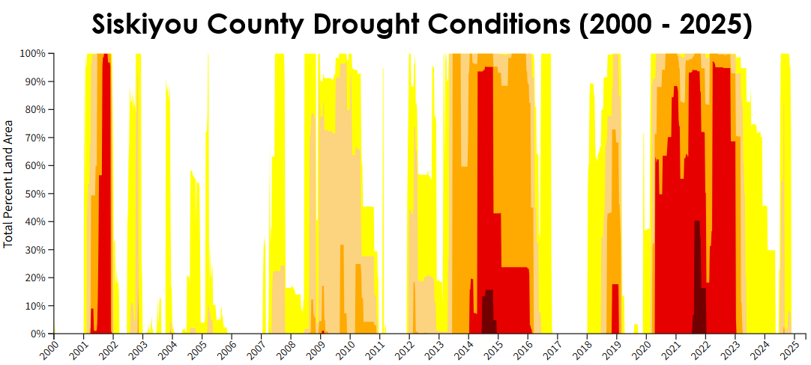
- Siskiyou County Drought Mapping
Source: USDM, 2025.
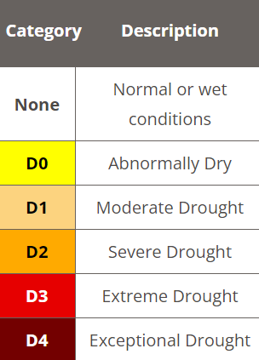
Agricultural production in the county has been impacted by drought. The cover page of the last published Siskiyou County Annual Crop & Livestock Report (2022) reads “Tulelake Dried Up After a Million Years Underwater”.
According to the report, 24,000 acres of agricultural land in Siskiyou County were fallowed in 2022 as a result of drought, compared to 12,000 acres in 2021. For the Tulelake Irrigation District, 7,100 acres were fallowed as a result of drought for 2022, compared to 2,620 acres in 2021.
US Drought Monitor Data Sources
The US Drought Monitor is a partnership between the United States Department of Agriculture (USDA), the National Oceanic and Atmospheric Administration (NOAA), and the National Drought Mitigation Center (NDMC). Each week, staff from USDA, NOAA, and NDMC generate updated flood mapping based on current data from local observations. Data inputs are obtained at the local level and transmitted to the US Drought Monitor for interpretation. Recent precipitation totals across individual regions are compared to their long-term averages. Variables such as temperatures, soil moisture, water levels in streams and lakes, snow cover, meltwater runoff, reported water shortages and business interruptions are all included in the drought condition analysis.
Extended Growing Season
Increasing temperatures have resulted in warmer winters leading to earlier snowmelt and longer frost-free seasons. The last spring frost is occurring earlier in the season and the first fall frost is occurring later in the season which has resulted in a longer overall growing season. According to federal government statistics, California experienced nearly 50 more growing days in 2020 than in 1895. Agricultural experts in Siskiyou County also report that the growing season is shifting and occurring later in the year.
Drought Task Force
In recognition of the threat posed by drought conditions to people and the environment the County has created the Siskiyou County Drought Taskforce. The taskforce is responsible for developing the Siskiyou County Drought Resilience Plan (DRP). The goal of the DRP is to facilitate drought and water shortage preparedness for state small water systems (SSWS) and domestic wells in the county’s jurisdiction.
SSWS systems are defined as systems that provide water for at least five and up to 14 service connections and provide drinking water to fewer than 25 people on a regular basis.
Reducing GHG Emissions
Fossil fuels – coal, oil and gas – are all associated with increasing temperatures. It is estimated that fossil fuels account for over 75 percent of all GHG emissions and nearly 90 percent of all CO2 emissions. Increasing temperatures are associated with long-term changes in weather patterns which will pose serious risks to human life, property, and the environment.
In Siskiyou County, the main sources of GHG emissions are stationary sources, area-wide sources, and mobile sources. Stationary sources include fuel combustion, waste disposal, cleaning and surface coating, petroleum production, and industrial processes. Area-wide sources include solvent evaporation from activities such residential fuel combustion, pesticide and fertilizer application, asphalt paving, refrigerants, and waste burning and disposal. Mobile sources such as transportation and wildfire smoke are the largest contributors to GHG emissions in the county.
Siskiyou County is dedicated to reducing GHG emissions through sustainable land use and transportation planning. In 2016, Senate Bill 32 was passed, which codifies a 2030 GHG emissions reduction target of 40 percent below 1990 levels. The Siskiyou County Regional Transportation Plan and the Siskiyou County General Plan both include language supporting deceasing GHG emissions by reducing vehicle miles traveled, switching to certified wood stoves, and encouraging alternative forms of transportation.

Adaptation & Community Resilience
Adaptation and Resilience are often discussed together, but it is helpful to distinguish between them.
Adaptation is an action or set of actions that reduces physical risk to the community. In the public safety context, adaptation involves taking steps to modify behavior or physical conditions to adjust to a changing environment. For example, creating defensible space around existing structures to mitigate against increased wildfire risk is a physical adaptation. On the other hand, discouraging future development in very high fire hazard severity zones is a behavioral adaptation.
Community Resilience describes a community’s state of readiness to face potential risks. Improving community resilience (a community’s ability to withstand and recovery from disaster) involves identifying risks to the community.
Risk is a function of two related concepts: threat and vulnerability.
Threats are events that can negatively impact a community, and vulnerability is the degree of potential damage to the community.
Vulnerability is determined by the sensitivity, exposure, and adaptive capacity of the community.
Managing Risk requires addressing either the Threat or the Vulnerability, or both, depending on the situation. The vulnerability assessment on the next few pages is a discussion of the risks and impacts that result from increasing temperatures.
Adaptation and Community Resilience Vulnerability Assessment
It is expected that increasing temperatures will exacerbate natural and human made hazards such as wildfire, flooding, and extreme heat. Transmission of vector-borne and waterborne diseases are also expected to pose an increasing risk to public safety.
Hazards Related to Rising Average Temperatures
Hazards resulting from long-term changes in weather patterns include:
• Drought • Rainfall flooding • Extreme heat
• Extreme cold • Severe Storms • High winds

Expected Future Impacts
Impacts of rising average temperatures include:
• Increased wildfire • Poor air quality • Power outages
• Biodiversity loss • Infrastructure failure • Increased erosion
• Water insecurity • Disease outbreak • Invasive species

Other Factors to Consider
Rising average temperatures will result in secondary stresses such as:
• Increased migration • Food insecurity • Drug/alcohol abuse
• Displaced populations • Economic crisis • Economic inequality
• Increased homelessness • Inadequate educational systems
• Inadequate health systems • Inadequate infrastructure

Population at Risk
Rising average temperatures will affect everyone in the county, regardless of income, with many weather-related impacts projected to worsen. However, not all individuals will experience these effects equally.
The Work Force
Rising average temperatures disproportionately impacts workers because they often work outdoors, in fields such as agriculture, forestry, logging, construction, transportation and emergency response. This makes workers more exposed to temperature and weather extremes, poor air quality, and disease. While inside, workers may often be subjected to hot indoor environments that lack adequate air conditioning, such as manufacturing plants, warehouses, and lumber mills.
An Aging Population
Older adults are more likely to have health conditions that make them more sensitive to hazards such as heat and air pollution, which can often worsen their existing illnesses. Many older adults may also have compromised immune systems, which makes them more prone to severe illness from insect and water related diseases that may become more common with increasing temperatures. Limited mobility also increases risk before, during, and after an extreme weather event.
The Unhoused Population
This population segment lacks the necessary resources to mitigate against the risks posed by increasing temperatures. Without adequate shelter, these individuals are more likely to experience prolonged exposure to extreme weather conditions such as severe heat and winter storms. This population segment is expected to increase as more people are displaced due to natural disasters such as flooding and wildfire.
Individuals with Disabilities
Individuals with disabilities or functional needs will be more vulnerable to the impacts of increasing temperatures. This population segment faces the same challenges experienced by older adults. Increasing temperatures are expected to result in more heat related illnesses and deaths among vulnerable groups, including people with disabilities. This is especially true for individuals with mental health issues, those who depend on others for assistance in daily living, and those with limited mobility or access to transportation.
Limited Income Population
This population segment often lacks the financial resources needed to adequately mitigate against the risks posed by increasing temperatures. These individuals are likely to live in areas that are prone to flooding and extreme weather. They are also less likely to have insurance to compensate for losses in the event of a disaster.
Children are not the primary cause of increasing temperatures however they are the ones who are and will be most affected by it. Children breathe at a faster rate than adults and their bodies are still developing, which can make them more vulnerable to extreme heat and poor air quality. Children also tend to spend more time outdoors than adults, which increases their exposure to heat and cold, rain and snow, outdoor allergens, and vector-borne disease. Displacement and disruptions to home life and schooling are expected due to increasing temperatures.

Property Damage and Economic Impact
All property located within the county would be impacted by the secondary effects of rising temperatures (wildfire, flooding, extreme heat, etc.).
The Local Economy
Increasing temperatures and extreme weather will impact the local economy. For example, the Mount Shasta Ski Park did not open for the 2013-2014 season and had an limited season in 2014-2015 due to a lack of snow in the winter months. The ski park's closure led to a steep decrease in regional tourism.
Wildfires also have a negative impact on tourism as visitors are deterred by the smoke and air quality. Future projections of severe heat and drought will lead to decreasing crop yields and reduced workforce productivity in outdoor occupations.
Critical Facilities and Infrastructure
Secondary effects of increasing temperatures, such as wildfires, can damage physical infrastructure and disrupt services. A disruption to critical facilities and infrastructure often creates cascading impacts that can heighten the severity of a hazard event.
Environmental Impact
Increasing temperatures will affect the survivability of all species as long-term changes in weather patterns result in reduced habitat and biodiversity.
Future environmental threats resulting from rising temperatures are projected to consist of more rain and less snow, a dwindling snowpack, drought, flooding, melting glaciers, increased erosion, wildfire, warming rivers, pest infestation, invasive species, forest morbidity, reduced crop yields, and keystone species extinction.
Forest management practices that reduce stand density and fuel load will be essential to improving community resilience.



- Emergency Management
Siskiyou County encourages interagency cooperation to better prepare for and respond to public emergencies.
Responsible Agency Listing
The following agencies are responsible for ensuring an effective coordinated response whenever there is a threat to public health or safety.
California Highway Patrol

The California Highway Patrol (CHP) enforces traffic laws on state roads and highways in the county. CHP works together with local authorities to ensure that traffic moves quickly and safely out of the hazard area during an emergency.
Siskiyou County Sheriff’s Office
The Siskiyou County Sheriff’s Office (SCSO) is the primary law enforcement agency for the unincorporated county. Agency headquarters are in the town of Yreka, with satellite offices in other towns across the county. The SCSO determines when and where evacuation warnings or orders should be issued. It is also responsible for securing the perimeter of the affected area to prevent looting and unauthorized entry. Sheriff deputies play a crucial role in communicating information to residents regarding the need to evacuate or shelter in place. Deputies may also be called on to conduct welfare checks to ensure that residents who need assistance are safely evacuated.
Local Police Departments
Local police departments, in coordination with the Sheriff’s Office, communicate evacuation warnings and orders to residents in their jurisdictions. Police officers help to ensure an orderly withdrawal along designated evacuation routes and have primary responsibility for conducting welfare checks within their service area.
Local Fire Departments
The primary role of local fire departments is to defend properties and structures. However, if residents do not heed evacuation orders, firefighters will prioritize saving people first and property second. Local fire departments have a better chance of extinguishing fires when residents comply with evacuation orders.


Yreka Interagency Command Center
CAL FIRE operates an emergency command center known as the Yreka Interagency Command Center (YICC). The YICC is located at the CAL FIRE Siskiyou Unit headquarters in Yreka and is a collaboration of CAL FIRE, US Forest Service, and county staff. YICC provides dispatching services for CAL FIRE, USFS, local government fire departments, and ambulance companies. YICC is responsible for emergency call taking, dispatching, and tracking of resources on a 24-hour basis.
Siskiyou County Office of Emergency Services
Siskiyou County Office of Emergency Services (OES) coordinates with various local agencies, organizations, and community groups to develop and implement countywide plans for emergency management. OES also provides public education and training on emergency preparedness.
Siskiyou County Public Health Department
Siskiyou County Public Health Department is responsible for providing support and information to the public during public health emergencies such as wildfire and disease outbreaks. During an ongoing emergency this could include arranging for temporary shelters, cooling centers, and medical or financial assistance to evacuees.
Siskiyou County Agricultural Department
Siskiyou County Agricultural Department is charged with protecting the agricultural industry and the people of Siskiyou County. The department is responsible for enforcing safe and responsible handling of pesticides in the county and may be called upon to provide technical assistance in the event of a hazardous materials incident.
Local Hospitals
Emergency medical services are provided by two area hospitals. Hospital trauma centers are classified as Level I, II, III, IV, or V. Level I trauma centers have the most services and are able to handle complex cases and injuries. Level V trauma centers have the least services and are more focused on patient stabilization prior to transfer to a higher-level of care trauma center.
Mercy Medical Center – Level III
Mercy Medical Center, Mount Shasta is the only hospital in south Siskiyou County. It is a 25-bed hospital with a Level III trauma center. Level III facilities do not require in-hospital trauma surgeons or surgical specialists; however, a trauma surgeon and anesthesia and operating room personnel must be available within 30 minutes of being called. Level III facilities focus on stabilization prior to transfer to a higher-level trauma center such as a Level II or Level I.

Fairchild Medical Center – Level IV
Fairchild Medical Center, Yreka is the only hospital in north Siskiyou County. It is a 25-bed hospital with a Level IV trauma center. Level IV facilities are generally located in underserved or sparsely populated areas. Level IV facilities do not have trauma surgeons or surgical specialists. These centers have 24/7 emergency services with a physician or a mid-level provider such as physician assistants (PAs), nurse practitioners (NPs), or advanced practice registered nurses. Level IV facilities focus on patient stabilization prior to transfer to a Level III, II, or I trauma center.
Emergency Alerts & Community Resources
The County emphasizes fast and accurate communication to keep the community informed. Evacuations are most effective when residents are aware of the emergencies that are likely to affect them and have ample time to prepare their own emergency plans. Emergency alert and assistance systems should include fire and law enforcement vehicle loudspeakers, emergency response phone numbers such as 911, agency websites, and other digital tools.
ReadySiskiyou – Alerts is the county-wide emergency alert system which provides alerts about hazards and emergencies, including severe weather, unexpected road closures, missing people, and evacuations of buildings or neighborhoods. Participants who have opted-in will receive time sensitive messages in their preferred format, such as an email, text message, or telephone phone call to a home, cell, or business number. Registration is voluntary. Community members will not receive an alert unless they sign up for this free service.
The Access and Functional Needs Registry (AFN Registry) is a database designed to identify individuals who may require additional assistance during an emergency evacuation due to their access and functional needs. The registry serves as a tool for emergency management agencies, first responders, and service providers to proactively identify and prioritize resources for those who require specialized assistance. Participation in the AFN Registry is completely voluntary. Information submitted is strictly confidential and is only used in the event of an emergency.
Designated Shelter Sites
These community serving facilities support and coordinate resource distribution and services before, during, or after a hazard event. Designated shelter sites are often utilized during heat waves, wildfire, floods, and earthquakes.
Community Safety Concerns
Limited Wireless Communication Coverage
Public information messaging systems are most effective when emergency notifications are actually received. However, many rural areas of the county have weak or no cellular service. Such areas should be identified by the County for future improvement of the communication system.
Diversion of Resources
During the winter season, there is an increased safety risk for people in the Scott Valley area as Caltrans diverts equipment and resources to prioritize snow removal on Interstate 5 instead of Highway 3. It is important to ensure that adequate resources remain in the Scott Valley area sufficient to support the needs of the community during winter weather conditions.

- Evacuation Planning
Evacuation is the process of moving people from a place of immediate danger to a place of safety where appropriate temporary shelter can be provided. When the threat to health and safety is gone evacuees can return to their normal activities or make suitable alternative arrangements. The primary goal of evacuation planning is to maximize preservation of life while reducing the number of people that must evacuate and the distance they must travel to seek refuge.
The most likely evacuation scenario for the county is a forced evacuation due to a natural disaster such as a wildfire, flood, landslide, earthquake, or volcanic activity.
Accounting for Vulnerable Populations
Evacuation planning must account for at-risk or special needs groups, including individuals with physical, cognitive, and emotional disabilities, those without access to transportation, as well as plans for feeding the evacuees.
Accounting for Pets and Service Animals
To comply with the Americans with Disabilities Act (1990) and the Pets Evacuation and Transportation Standards Act (2006), accommodations need to be made for the evacuation of service animals and household pets, during and following an emergency event.
Ensuring the evacuation, transportation, care, and sheltering of animals is extremely important. Many people will refuse to evacuate their homes if they cannot take their pets with them. It is estimated that 25 percent of pet owners will refuse to evacuate without their animals.
Furthermore, about 30-50 percent of pet owners will accidentally leave pets behind, and approximately 50-70 percent of individuals who leave animals behind will attempt to re-enter an evacuated area to rescue their animals. Pets left behind in the evacuation area may pose a danger to first responders. It is essential that evacuation plans address pet evacuation and sheltering procedures to protect both people and animals during an emergency.
Livestock Pass Program
Because of the size of their operations and the fact that many ranches run on a variety of leased and owned land that may or may not be contiguous, evacuating livestock from commercial ranching operations may not be possible during a disaster. Sheltering in place may be the best and safest alternative. Access to disaster areas by ranch personnel is critical to livestock welfare, firefighter safety, and public safety.
In coordination with local agencies, the Siskiyou County University of California Cooperative Extension (UCCE) and the Siskiyou County Agricultural Department have established a livestock pass program, through the issuance of a Livestock Access Pass, which may permit commercial livestock operators to gain entrance to evacuation zones or other restricted areas to care for livestock during a disaster.
The Livestock Pass is a permit issued by the Siskiyou County Agricultural Commissioner to a Commercial Livestock Operator, upon submission and approval of an application for registration, which must be presented to law enforcement, fire personnel, or other emergency personnel at the point of entry in order to gain entrance to an evacuation zone, or other restricted area, for the purpose of providing feed, water, medical treatment, and other care to livestock, subject to the discretion of emergency personnel.
Livestock Passes are issued to approved commercial livestock operators before a disaster strikes. The Livestock Pass must be renewed annually. Each year, a Commercial Livestock Operator is required to participate in a 1-hour continuing education class prior to pass renewal.

Conducting Evacuations
With advanced warning, evacuation can be effective in reducing injury and loss of life. Evacuation routes should be developed with the intent of directing traffic toward the nearest highway. Due to vehicle carrying capacity, highways are logical routes by which to move people away from danger. Most evacuees will use their own vehicle. Evacuation assistance should instead focus on individuals with disabilities or access and functional needs, and individuals without a vehicle.
Although most primary roads are of sufficient width to allow for passage of emergency vehicles and evacuating residents, many of the secondary roads within the county are narrow or may have few if any ingress and egress options. This makes it exceedingly difficult for engines, tankers, and other firefighting equipment to enter the hazard area during the time that residents are supposed to be evacuating.
Known or expected evacuation routes should be regularly maintained to ensure availability during an emergency event.
Evacuation Route Analysis
During an evacuation, the routes utilized will depend on the type, location, and extent of the emergency. While it is impossible to identify a set of evacuation routes which will apply to all situations, it is expected that the existing county road system will be the most suitable option for carrying out mass evacuations.
Six major highways run through the county and are the primary evacuation routes for the community.
• Interstate 5 • Highway 89 • Highway 97
• Highway 3 • Highway 96 • Highway 161
Of these six major traffic corridors, Interstate 5, Highway 89, and Highway 97 are the only major transportation routes in and out of the county.

Additional Information Available
In compliance with Govt. Code §65302.15 (Assembly Bill 747), the Safety Element identifies evacuation routes and locations under a range of emergency scenarios. The listed anticipated evacuation routes and designated shelter locations for the communities below are applicable to all emergency scenarios likely to be encountered.
To review anticipated evacuation routes and safe locations for the following communities please see Appendix A: Safety Element Information, Section A.8, Page A-53.
• Callahan • Gazelle • Lake Shastina • Tulelake
• Dorris • Greenview • Macdoel • Weed
• Dunsmuir • Grenada • McCloud • South Weed
• North Dunsmuir • Happy Camp • Montague • Yreka
• Etna • Hilt • Mount Shasta
• Fort Jones • Hornbrook • Quartz Valley

- Goals and Policies
- The Fire Hazard

Protection from the Fire Hazard.

Policies
  - Structure Fires. Continue, enhance, or implement programs that seek to reduce the risk of structure fires.
  - Vegetation and Forest Management. Continue to recommend that building owners in high-risk areas maintain defensible space and implement fire prevention measures. Build partnerships with and consult indigenous groups on traditional burning and other fire suppression techniques.
  - Water Infrastructure. Work with local agencies to plan for the ongoing maintenance and long-term integrity of planned and existing firefighting water supply infrastructure, including peak load water supply.
  - New Developments in Fire Hazard Severity Zones. Promote development in areas with existing adequate road networks, evacuation routes, and water infrastructure and encourage the following actions, as applicable:
    - Assessing site specific characteristics such as topography, slope, vegetation type, and wind patterns, during the development process.
    - Determining local fire protection coverage and capacity.
    - Locating and designing development to avoid high fire risk areas if feasible.
    - Maintaining defensible space around structures as recommended by CAL FIRE.
    - Using fire resistant building materials and design features, such as visible signage, consistent with the most recent California Fire Code and Building Code as adopted and amended.
    - Using fire resistant native plant species in landscaping.
    - Requiring street improvements to comply with minimum fire road access standards.
    - Allowing new residential development in areas with only one evacuation route, if a development is able to provide additional connections to mitigate the risk.
    - Require fire protection plans for new developments in VHFHSZs.
  - Financial Assistance. Encourage programs to provide financial assistance for defensible space maintenance, home hardening, and situation specific evacuation training.
  - Agency Coordination. Participate in mutual aid agreements with local jurisdictions and other agencies to respond to wildfires.
  - Protect Against Wildfire Smoke. Improve access to better indoor air quality by identifying additional clean air centers in populated areas.
  - Location of Essential Public Facilities. Require new essential public facilities be located outside high fire risk areas, such as VHFHSZs, when feasible.
  - Maintaining adequate evacuation and emergency vehicle access in VHFHSZs. Encourage programs to maintain adequate evacuation and emergency vehicle access in VHFHSZs.
- The Flood Hazard

Protection from the Flood Hazard.

Policies
  - Minimize Storm Induced Flooding. Continue or develop county programs that seek to minimize storm induced flooding.
  - Compliance with the National Flood Insurance Program. Ensure compliance with the National Flood Insurance Program (NFIP).
- Geologic and Seismic Hazards

Protect Life and Property from the Dangers of Geologic and Seismic Hazards

Policies
  - Seismic Hazards. Enforce regulations and programs to reduce geologic and seismic hazard vulnerability.
  - Development in Hazardous Areas. Minimize risk by limiting development in areas subject to known geologic & seismic hazards.
- Hazardous Materials

Minimize Impacts Related to the Use, Storage, Manufacture, and Transport of Hazardous Materials.

Policies
  - Hazardous Materials Inspections. Continue to conduct required inspections of facilities that produce or store hazardous materials, gas, natural gas, or other fuels.
  - Hazardous Materials Incidents. Seek to prevent hazardous materials incidents and increase the county’s ability to respond to incidents.
- Wildlife Hazards

Minimize the Risks Posed by Wildlife Hazards.

Policies
  - Limiting Disease Transmission. Recommend procedures to limit disease transmission to include containment and proper disposal of dead animals.
  - Limiting Wildlife Predator Hazards. Recommend procedures to minimize wildlife predator hazards.
- Adaptation and Community Resilience

Minimize the Effects of Increasing Temperatures by Implementing Adaptation and Resiliency Strategies.

Policies
  - Adaptation. Consider implementing county specific adaptation strategies to deal with increasing temperatures.
  - Community Resilience. Ensure that the needs of all population segments are considered in the hazard mitigation process.
- Emergency Management

Maintain and Emergency Preparedness and Response System that keeps Everyone Informed, Connected, and Safe, Before, During, and After an Emergency.

Policies
  - Interagency Coordination. Continue to encourage and support interagency coordination.
  - Designated Shelter Sites. Identify public facilities such as libraries, senior centers, fairgrounds, and other locations for possible use as designated shelter sites.
  - Local Hazard Mitigation Plan (LHMP). Update the LHMP prior to the 5 year expiration period. Incorporate the LHMP into the Safety Element.
- Evacuation Planning

Identify Residential Areas with Only One Evacuation Route.

Policies
  - Evacuation Routes. Identity residential areas with only one evacuation route for possible future improvement.

- Implementation Programs
None. The policies included in Section 5.10 will guide County actions in implementing the Safety Element.

