

4. Circulation Element

The Circulation Element guides the planning of Siskiyou County’s transportation system, ensuring the safe and efficient movement of people, goods, and services. It addresses challenges such as aging infrastructure and natural hazards, while also emphasizing the need to increase access for rural and underserved communities. Looking forward, the Element seeks to promote a transportation network that is resilient, equitable, and aligned with the County’s long-term goals.

Table of Contents
4.1 Introduction CIR-3
4.2 Existing Conditions CIR-3
4.3 Challenges and Opportunities CIR-9
4.4 Policy & Planning Framework CIR-10
4.5 Goals, Policies, and Implementation Programs CIR-12
4.6 Implementation Programs Table CIR-15
4.7 Maps and Figures CIR-18
4.8 Incorporation of the Regional Transportation Plan (RTP) CIR-29

- Introduction
Purpose
The Circulation Element establishes the policy framework for the planning, development, operation, and maintenance of Siskiyou County’s circulation system. Consistent with Government Code section 65302(b), it identifies the general location and extent of major thoroughfares, transportation routes, terminals, and related public utilities and facilities necessary to support countywide access and movement.
Recognizing that agriculture, timber production, and other working lands are foundational to the County’s economy, the Circulation Element balances community access and safety and focuses on maintaining and improving goods movement, rural connectivity, and emergency response to support long term economic productivity.
Relationship to Other General Plan Elements
The Circulation Element supports and is informed by the policies of other General Plan elements. Together, these elements guide how circulation infrastructure is planned, operated, and maintained across the County.
- Land Use Element. Coordinates circulation infrastructure with planned growth patterns to improve accessibility, manage congestion, and support compact, center based development, while maintaining access to agricultural lands, timber resources, and other working landscapes.
- Housing Element. Supports housing availability by improving connections between residential areas and employment centers, schools, and essential services, with particular attention to rural communities and underserved areas.
- Safety Element. Supports emergency preparedness and response through the identification and improvement of evacuation routes, lifeline corridors, and circulation facilities critical to wildfire, flood, and seismic hazard response.
- Conservation and Open Space Element. Coordinates circulation planning to minimize conflicts with sensitive lands and wildlife corridors while supporting the continued use and productivity of agricultural and resource lands.
- Noise Element. Identifies circulation facilities as a primary source of community noise. Roadway and rail networks provide the basis for noise contour mapping and land use compatibility policies.
Together, these relationships ensure the circulation system supports countywide goals related to safety, housing access, economic vitality, and the long term viability of rural communities and working lands.
  - Existing Conditions
Overview
Siskiyou County’s circulation system reflects its rural character, expansive geography, and role as a regional gateway between California and the Pacific Northwest. The system includes highways, county roads, local streets, transit, rail, airports, and nonmotorized facilities that support community access, goods movement, emergency response, and regional connectivity.
Agriculture, timber production, and other working lands rely heavily on this network for farm to market access, freight movement, and day to day operations. Residents also depend on the network for access to employment, services, and essential destinations. The circulation system faces challenges related to aging infrastructure, limited funding, constrained multimodal options, and exposure to natural hazards.
Roadway Network and Functional Classification
Siskiyou County’s roadway network is organized by functional classification and serves a wide range of roles, including local access, goods movement, regional travel, and emergency response. Together, these roadways support rural communities, agriculture, timber production, recreation, and regional connectivity.
- Interstate. Interstate 5 carries the highest traffic volumes in Siskiyou County and serves as the primary north south corridor connecting California and Oregon. It accommodates long distance commercial freight, regional travel, and tourist traffic while providing essential access for local travel, goods movement, emergency response, and evacuation.
- Other Principal Arterial. U.S. Highway 97 serves as the primary north south route through the eastern portion of the County, linking Siskiyou County to markets and destinations in Oregon and Washington. The corridor supports timber, livestock, and farm to market activity and provides essential access for rural communities.
State Route 89 functions as the principal east west corridor through the southern portion of the County, connecting communities, recreation areas, and national forest lands.
- Minor Arterial. Minor arterial routes include two lane State highways and major County roads that connect smaller towns, agricultural valleys, Tribal lands, and recreation areas to the principal arterial network.
State Route 3 links Yreka, Fort Jones, and Etna through Scott Valley and serves as an important agricultural and regional travel corridor.
State Route 96 follows the Klamath River corridor, providing access to Tribal lands, remote communities, and working landscapes.
State Route 263 connects State Route 3 to State Route 96 and is the primary route for travel between Yreka and Happy Camp.
State Route 161 is an east west roadway running along the California Oregon border, starting at U.S. Highway 97 north of Dorris and ending at State Route 139.
State Route 139 is located near Tulelake and provides northbound access to State Route 161 towards Klamath Falls, Oregon.
- Major Collector. Major collector roads gather traffic from rural neighborhoods, farms, timberlands, and recreation areas and distribute it to the arterial highway system. Examples include Old Highway 99 south of Yreka, which parallels Interstate 5 and provides access to local industry and residential areas, and Sawyers Bar Road, which connects communities along the Salmon River to State Route 96.
- Minor Collector. Minor collector roads provide community level connections between rural neighborhoods, agricultural lands, and local service areas, linking them to the larger collector and arterial network. Examples include Gazelle Callahan Road, which connects agricultural lands and foothill residences to State Route 3 and nearby towns.
- Local Roads. Local roads provide direct access to homes, farms, businesses, recreation areas, and public facilities and connect rural properties to the collector network. Examples include Miner Street in Yreka, which supports local downtown circulation, and Everitt Memorial Highway above Mount Shasta, which provides access to forest recreation sites and trailheads. These roads are essential for daily travel and emergency response, particularly in rural and remote areas.
Collectively, these roadways function as lifeline and evacuation corridors during emergencies. Interstate 5 and United States Highway 97 provide primary evacuation and supply routes, while State Routes 96 and 89 serve as critical access connections for isolated mountain and river communities. Segments of these routes experience safety challenges related to roadway geometry, limited passing opportunities, winter conditions, and wildlife crossings.
Table 4.2-1. Total Centerline Road Miles by Functional Classification
Functional Classification | Centerline Road Miles
Interstate | 166
Other Principal Arterial | 196
Minor Arterial | 384
Major Collector | 307
Minor Collector | 339
Local Road | 7,041
Total: | 8,433

Pavement Condition Index (PCI)
The Pavement Condition Index (PCI) is a numerical scale from 0 to 100 used to determine the existing condition of a pavement segment. A score of 0 represents extremely poor pavement health, while 100 indicates new or excellent condition. PCI ratings are influenced by surface age, traffic loads, climate, and maintenance history.
Table 4.2-2. Pavement Condition Index (PCI)
PCI Range | Condition Rating | General Description
85–100 | Very Good/Excellent | New or recently resurfaced pavement with little or no distress.
70–84 | Good | Minor surface wear; routine maintenance is adequate.
50–69 | Fair | Noticeable cracking and roughness; increasing need for rehabilitation.
25–49 | Poor | Significant distress; frequent patching; nearing reconstruction.
0–24 | Very Poor/Failed | Severely distressed; structural failure likely; full rebuild needed.
As of 2023, Siskiyou County arterial and collector roads have weighted PCI scores above 70, which are considered to be in “Good” condition. Residential and local roads have a weighted PCI of 58.65, categorized as “Fair”, reflecting a higher risk of deterioration due to deferred maintenance and limited rehabilitation funding.
Public Transportation
Public transportation in Siskiyou County is limited but provides an essential mobility option for residents without reliable automobile access.
- Siskiyou Transit and General Express (STAGE): Provides fixed route and demand response service between Yreka, Weed, Mount Shasta, Dunsmuir, and Happy Camp. Service is infrequent due to long distances and low density.
- Intercity Connections: Amtrak Thruway buses and private carriers connect residents to Redding, Medford, and Klamath Falls for long distance rail and air service.
- Access Challenges: STAGE routes may only operate on specific days limiting usefulness for daily commuting or frequent appointments. Rural ridership continues to remain low and requires subsidy.

Rail System
The region’s rail service provides freight and passenger connections but is limited in reach and capacity.
- Union Pacific Railroad: The north south mainline parallels Interstate 5, serving as a major freight corridor connecting California and Oregon.
- Short-Line Service: The Central Oregon & Pacific Railroad provides local connections for timber, agriculture, and aggregates. However, infrastructure is aging and service is constrained by variable demand.
- Passenger Rail: Siskiyou County has a single Amtrak station in Dunsmuir, served by the Coast Starlight, which runs daily between Seattle and Los Angeles. Most residents rely on Amtrak Thruway buses to connect to Redding or Klamath Falls.
Airports
Although Siskiyou County does not have scheduled commercial airline passenger service, several local general aviation airports provide important business, recreational, firefighting, and emergency access throughout the County. The County owns and maintains five general aviation airports distributed across the region, while the Cities of Montague and Dunsmuir operate smaller municipal facilities. Together, these facilities form a critical part of the County’s emergency response and economic development infrastructure.
County Owned Airports
- Siskiyou County Airport (KSIY/SIY): A nontowered general aviation facility located three miles northeast of Montague in the Shasta Valley. The airport features a single paved runway and is one of the few facilities in far northern California capable of supporting large airtanker operations, with a U.S. Forest Service tanker base that operates seasonally between June and October. The airport also supports business, medical, and law enforcement flights, serving as the County’s primary general aviation and emergency response airport.
- Weed Airport (O46): A nontowered general aviation facility located on the west side of the City of Weed, adjacent to Interstate 5. The airport features a single paved runway and provides fuel, aircraft tiedowns, hangars, and basic pilot amenities. Weed Airport serves as a secondary base to Siskiyou County Airport for aerial firefighting and emergency operations. While the facility accommodates general aviation and smaller firefighting aircraft or helicopters, it is not suited for large air tanker operations because of its limited runway length, width, and pavement capacity.
- Scott Valley Airport (A30): A nontowered general aviation facility located approximately five miles south of Fort Jones and eight miles north of Etna on Island Road, east of Highway 3. The airport features a single paved runway aircraft tiedowns, hangars, restroom facilities, and a pilots’ lounge. The airport supports general aviation, agricultural, and emergency response operations serving the Scott Valley area. It houses a seasonal CAL FIRE helitack base that operates between June and October, with activity levels increasing during wildfire events.
- Happy Camp Airport (36S): A nontowered general aviation facility located in western Siskiyou County, adjacent to State Route 96. The airport is closed to public use and supports seasonal U.S. Forest Service and CAL FIRE helicopter operations between June and October for wildfire suppression, crew transport, and emergency response activities along the Klamath River corridor.
- Butte Valley Airport (A32): A nontowered general aviation facility located approximately three miles southeast of Dorris. The airport includes a single paved runway but does not have the U.S. Forest Service or CAL FIRE tanker base infrastructure, such as fueling, retardant mixing, or loading facilities, that are available at Siskiyou County Airport. Despite these limitations, Butte Valley Airport provides important aviation access for one of the County’s more remote areas, supporting local economic activity, agricultural operations, and emergency response.
City Owned Airports
- Montague-Yreka Airport (1O5): A nontowered general aviation facility located within the City of Montague, approximately six miles east of Yreka in the Shasta Valley. The airport features a single paved runway, self-serve fueling, aircraft tiedowns, and hangars.
- Dunsmuir Municipal–Mott Airport (1O6): A nontowered general aviation facility located approximately two miles north of Dunsmuir. The airport features a single paved runway, aircraft tiedowns, hangars, and basic pilot amenities.
Active Transportation
Walking and bicycling facilities exist throughout the County but remain fragmented and can be perceived as unsafe by many users. Key conditions include the following:
- Sidewalks: Sidewalks are concentrated in town centers and near schools but are often incomplete or in poor condition. Many residential streets lack sidewalks entirely.
- Bikeways: Dedicated bike lanes are rare and typically disconnected. Rural roads often lack paved shoulders, making bicycling hazardous.
- Trails: Regional assets include the Pacific Crest Trail and Great Shasta Rail Trail, which offer recreation but limited local connectivity. Trail to town connections continue to be underdeveloped.
- Crossing Safety: Large highways and arterials bisect local towns and lack safe, frequent pedestrian crossings. Winter weather and snow removal challenges can further reduce pedestrian and bicycle access.
Improving active transportation facilities such as completing sidewalk networks, adding paved shoulders, and creating safer highway crossings will improve safety, accessibility, and connectivity within communities.
Freight and Goods Movement
Freight movement underpins Siskiyou County’s timber, agriculture, and resource based economy and is essential to the viability of working lands.
- I-5 Corridor: Truck lanes, rest areas, and bridge infrastructure need upgrades to meet current and projected freight volumes.
- US 97 Corridor: Needs include shoulder widening, safety upgrades, and pavement rehabilitation to accommodate increasing heavy vehicle use.
- Last-Mile Connectivity: Challenges exist where local access roads may be weight restricted, unpaved, or seasonally impassable.
Freight reliant industries depend on reliable access to I-5 and US 97, making investment in bridge rehabilitation, roadway maintenance, and grade separation projects a high priority.
Utilities and Supporting Infrastructure
In addition to traditional roadways and transit facilities, the County recognizes that broadband networks, electric vehicle charging infrastructure, and Intelligent Transportation Systems constitute supporting circulation infrastructure. These systems directly enable the safe and efficient movement of people and goods by enhancing emergency communications, supporting changes in vehicle technology, and improving traffic management and traveler safety.
- Bridges and Culverts: Many are aging, with load restrictions and vulnerability to flood or seismic events.
- Broadband and Cellular: Coverage gaps are widespread outside the I-5 corridor, reducing access to emergency alerts, 911 services, and digital mobility tools.
- ITS: Road Weather Information Stations (RWIS), CCTV, and dynamic message signs are concentrated along the I-5 corridor.
- EV Charging: Clustered along the I-5 corridor, with no coverage on US 97 and remote areas.
  - Challenges and Opportunities
Overview
Siskiyou County’s transportation system faces persistent challenges tied to its rural geography, dispersed population, and dependence on freight movement. At the same time, state funding, new technologies, and regional partnerships create opportunities to enhance mobility, resilience, and economic vitality.
Key Challenges
The County’s circulation system must contend with structural, environmental, and social barriers to safe and efficient mobility.
- Aging Infrastructure: County roads and bridges are deteriorating due to deferred maintenance and heavy truck traffic.
- Natural Hazards: Wildfires, snowstorms, flooding, and debris flows regularly disrupt travel and threaten safety, particularly in remote communities with limited evacuation routes.
- Limited Transit Options: Low density and long distances make frequent fixed route transit infeasible, leaving many seniors, youth, and low-income households reliant on automobiles.
- Equity and Access: Disadvantaged and tribal communities face longer travel distances to jobs, schools, and health care. Broadband gaps restrict access to telecommuting and telehealth.
- Freight Constraints: Heavy reliance on I-5 and US 97 creates vulnerability to closures and bottlenecks. Last-mile access roads are often weight-restricted or deteriorated.
- Funding Limitations: Local funding is insufficient, requiring dependence on competitive state and federal programs that often favor urban areas.
Key Opportunities
Despite these constraints, Siskiyou County can leverage its geography, partnerships, and policy environment to improve transportation outcomes.
- Strategic Location: As a gateway between California and the Pacific Northwest, Siskiyou is well-positioned to attract freight, tourism, and infrastructure investment.
- State and Federal Programs: Resources such as SB 1, the Active Transportation Program, and federal infrastructure funding can address local maintenance and multimodal needs.
- Sustainable Mobility: Expanding bicycle, pedestrian, and transit facilities, along with EV infrastructure, supports state greenhouse gas reduction goals while improving local access.
- Resilient Infrastructure: Incorporating slope stabilization, culvert upgrades, and fire-resistant design extends asset life and improves emergency readiness.
- Regional and Tribal Partnerships: Collaboration with Caltrans, the Siskiyou County Local Transportation Commission (SCLTC), tribal governments, and neighboring counties strengthens funding eligibility and project coordination.
- GIS and Data Integration: Developing a countywide GIS system will enhance hazard planning, improve transparency, and strengthen competitiveness for state and federal transportation funding.
- Tourism and Recreation: Enhancing access to trails, parks, and scenic byways supports outdoor recreation and tourism, which continue to be major contributors to the local economy.
  - Policy & Planning Framework
Overview
Siskiyou County’s circulation planning is shaped by State law, regional strategies, and local priorities. This framework ensures that transportation investments are legally compliant, regionally coordinated, and reflective of community needs. Together, these mandates and principles provide the foundation for the goals, policies, and programs of this Element.
State Mandates
The following statutes and guidelines provide the primary legal framework for circulation planning and CEQA transportation analysis in Siskiyou County:
- Government Code §65302(b): Requires circulation elements to identify the general location and extent of major transportation routes, terminals, and supporting public utilities.
- SB 375 (Sustainable Communities and Climate Protection Act): Integrates transportation and land use planning through Regional Transportation Plans and Sustainable Communities Strategies to reduce greenhouse gas emissions.
- SB 743 (CEQA Transportation Impacts): The County will use VMT as the CEQA transportation metric and may use LOS as an operational design tool outside of CEQA. The use of vehicle miles traveled in this Element is intended solely for transportation impact analysis under CEQA for discretionary projects and does not establish a Countywide requirement to reduce vehicle miles traveled.
- AB 1358 (Complete Streets Act): Directs local governments to design circulation systems that serve all users, including pedestrians, bicyclists, transit riders, motorists, reflecting urban, suburban, and rural contexts.
- SB 1000 (Environmental Justice in General Plans): Requires consideration of mobility and access barriers in disadvantaged and underserved communities.
- AB 52 (Tribal Consultation): Requires early and meaningful tribal consultation for projects subject to CEQA review.
Regional and Local Coordination
Transportation planning in Siskiyou County does not occur in isolation. It relies on coordination across agencies, jurisdictions, and communities to ensure consistency and efficiency.
The Circulation Element is formally aligned with the Siskiyou County Regional Transportation Plan (RTP, 2021). Projects and priorities identified in the RTP are adopted as part of this Element, ensuring consistency between land use policy and transportation investment. While Siskiyou County is not required to adopt a Sustainable Communities Strategy (SCS), the County’s circulation policies support statewide greenhouse gas reduction goals consistent with SB 375.
- Siskiyou County Regional Transportation Plan (RTP, 2021): Establishes countywide transportation needs, priorities, and funding strategies, prepared by the Siskiyou County Local Transportation Commission (SCLTC).
- Caltrans Planning and Concept Reports: Provide long-range strategies for I-5, US 97, and State routes that serve as lifeline and freight corridors.
- Interagency and Tribal Partnerships: Collaboration with Caltrans, tribal governments, neighboring counties, and Federal agencies strengthens funding eligibility and ensures cultural and regional priorities are addressed.
- County and City General Plans: Local land use and circulation elements are coordinated across jurisdictions to ensure internal consistency and avoid conflicts.
  - Goals, Policies, and Implementation Programs
The following goals and policies establish Siskiyou County’s vision for a safe, resilient, equitable, and economically sustainable circulation system.
- A Safe and Reliable Transportation System

Maintain and improve the County roadway and bridge network to ensure safety, reliability, and emergency readiness. (Source: New Goal)

Policies
  - County Road Maintenance. Prioritize maintenance, rehabilitation, and preservation of County roads, bridges, and culverts to extend service life and improve safety. [Source: New Policy]
  - Lifeline Routes and Emergency Access. Identify and maintain County roads that function as lifeline routes to support emergency response, evacuation, and access to remote communities. [Source: New Policy]
  - Natural Hazard Considerations. Consider wildfire, flooding, snow, and slope conditions in the planning, maintenance, and improvement of County transportation facilities. [Source: New Policy]
- Access and Mobility within Rural Contexts

Support reasonable access to essential services and destinations for residents of rural, underserved, and tribal communities. (Source: New Goal)

Policies
  - Rural Access Considerations. Consider rural travel distances, limited alternatives to automobile travel, and community needs when evaluating transportation related land use decisions. [Source: New Policy]
  - Public Transportation Services. Consider public transportation service needs for seniors, youth, and persons with disabilities in County transportation planning, recognizing service and funding constraints. [Source: New Policy]
  - Community Based Active Transportation. Support pedestrian and bicycle improvements within community areas, town centers, and near schools and public facilities where safety benefits can be achieved. [Source: New Policy]
- Goods Movement and Working Lands Access

Support transportation access that sustains agriculture, timber production, and other working lands. (Source: New Goal)

Policies
  - Freight Corridor Coordination. Coordinate with State and regional agencies on the maintenance and improvement of major freight corridors serving Siskiyou County. [Source: New Policy]
  - Access for Emergency and Economic Functions. Consider transportation access needs related to emergency response, rural connectivity, and economic activity when planning and prioritizing County transportation investments. [Source: New Policy]
  - County Owned Airports. Support operation and maintenance of County owned airports to serve emergency response, business activity, agriculture, and regional connectivity. [Source: New Policy]
- Transportation Supporting Infrastructure

Support transportation related infrastructure that improves safety, communication, and system efficiency. (Source: New Goal)

Policies
  - Complete Streets Consideration. Consider Complete Streets principles in County transportation projects where appropriate to roadway function, safety needs, and rural conditions. [Source: New Policy]
  - Communications Infrastructure Support. Support expansion of broadband and cellular infrastructure that enhances emergency communications and access to services, in coordination with service providers. [Source: New Policy]
  - Electric Vehicle Infrastructure Coordination. Support coordination with utilities and other agencies to expand electric vehicle charging infrastructure where feasible. [Source: New Policy]
- Coordination and Consistency

Coordinate County transportation planning with regional, State, and tribal partners. (Source: New Goal)

Policies
  - Regional Transportation Plan Consistency. Coordinate County transportation priorities with the Siskiyou County Regional Transportation Plan. [Source: New Policy]
  - Interagency and Tribal Coordination. Coordinate with State agencies, tribal governments, cities, and neighboring counties on transportation planning and project development. [Source: New Policy]
  - CEQA Transportation Review. Apply Vehicle Miles Traveled as the transportation impact metric for discretionary projects under CEQA, consistent with State law. [Source: New Policy]
- Use of General Plan Program EIR for Future Projects

The County intends to use the General Plan Program Environmental Impact Report as a foundational environmental review document for future discretionary projects where appropriate and consistent with CEQA. The Program EIR is intended to streamline subsequent environmental review, avoid unnecessary duplication, and support efficient decision making, while ensuring that project specific impacts and changed circumstances are adequately evaluated. (Source: New Goal)

Policies
  - Tiering From the Program EIR. Future discretionary projects may tier from and rely upon the certified General Plan Program Environmental Impact Report pursuant to Public Resources Code section 21094 and CEQA Guidelines sections 15152 and 15168, where appropriate. For projects determined to be consistent with the General Plan and where the Program EIR adequately analyzed the relevant environmental impacts, subsequent environmental review shall focus on:
1. Applying applicable mitigation measures adopted in the Program EIR;
2. Evaluating project specific environmental impacts not addressed in the Program EIR; and
3. Analyzing any new or substantially more severe significant impacts resulting from changes in the project, surrounding conditions, or applicable regulations. [Source: New Policy]

  - Implementation Programs Table
 | Implements Which Policy(ies) | Responsible Department | Funding Source | Timeframe
- Pavement and Asset Management. The County shall implement Policies CIR 1.1 by maintaining and periodically updating pavement and asset management information for County roads, bridges, and culverts to support maintenance prioritization, service life planning, and funding applications. [Source New Program] | CIR 1.1 County Road Maintenance | Public Works | SB 1, General Fund | Ongoing
- Lifeline Route Identification and Planning. The County shall implement Policy CIR 1.2 by identifying County roads that function as lifeline routes for emergency response and evacuation and by considering these routes in maintenance prioritization and emergency planning efforts. [Source New Program] | CIR 1.2 Lifeline Routes and Emergency Access | Public Works, OES | Grants, General Fund | Ongoing
- Natural Hazard Considerations in Transportation Planning. The County shall implement Policy CIR 1.3 by considering wildfire, flooding, snow, and slope conditions in planning and review of County transportation maintenance and improvement activities, in coordination with emergency management and public safety agencies. [Source New Program] | CIR 1.3 Natural Hazard Considerations | Public Works, OES | Grants, General Fund | Ongoing
- Rural Access Considerations in Land Use Review. The County shall implement Policy CIR 2.1 by considering rural travel distances, limited transportation alternatives, and community access needs during discretionary land use review where transportation access is a relevant consideration. | CIR 2.1 Rural Access Considerations | Planning Division | General Fund | Ongoing
- Public Transportation Service Planning. The County shall implement Policy CIR 2.2 by considering service needs for seniors, youth, and persons with disabilities in planning and evaluation of County public transportation services, recognizing funding availability and service constraints. | CIR 2.2 Public Transportation Services | Public Works, Planning Division | General Fund | Ongoing
- Community Area Active Transportation Improvements. The County shall implement Policy CIR 2.3 by supporting pedestrian and bicycle safety improvements within community areas, town centers, and near schools and public facilities through planning, grant applications, and coordination with partner agencies. | CIR 2.3 Community Based Active Transportation | Planning Division | General Fund | Ongoing
- Freight Corridor Coordination. The County shall implement Policy CIR 3.1 by coordinating with State and regional agencies regarding planning and investment priorities for major freight corridors serving Siskiyou County. | CIR 3.1 Freight Corridor Coordination | Public Works, SCLTC | Grants, General Fund | Ongoing
- Emergency and Economic Access Considerations. The County shall implement Policy CIR 3.2 by considering transportation access needs related to emergency response, rural connectivity, and economic activity when planning and prioritizing County transportation investments. | CIR 3.2 Access for Emergency and Economic Function | Public Works | General Fund | Ongoing
- County Airport Planning and Maintenance. The County shall implement Policy CIR 3.3 by planning for the operation and maintenance of County owned airports to support emergency response, agricultural operations, business activity, and regional connectivity, consistent with available funding and regulatory requirements. | CIR 3.3 County Owned Airports | Public Works, County Airports | Grants, General Fund | Ongoing
- Complete Streets Consideration in County Projects. The County shall implement Policy CIR 4.1 by considering Complete Streets principles in County transportation projects where appropriate to roadway function, safety needs, and rural conditions. | CIR 4.1 Complete Streets Consideration | Planning Division | General Fund | Ongoing
- Communications Infrastructure Coordination. The County shall implement Policy CIR 4.2 by coordinating with service providers and partner agencies to support expansion of broadband and cellular infrastructure that enhances emergency communications and access to services. | CIR 4.2 Communications Infrastructure Support | Planning Division | General Fund | Ongoing
- Electric Vehicle Infrastructure Coordination. The County shall implement Policy CIR 4.3 by coordinating with utilities and other agencies to support expansion of electric vehicle charging infrastructure where feasible and consistent with County authority. | CIR 4.3 Electric Vehicle Infrastructure Coordination | Public Works, Planning Division | State and Federal Funds | Ongoing
- Regional Transportation Plan Coordination. The County shall implement Policy CIR 5.1 by coordinating County transportation planning and capital priorities with the Siskiyou County Regional Transportation Plan. | CIR 5.1 Regional Transportation Plan Consistency | Public Works, Planning Division | RTP Funding | Ongoing
- Interagency and Tribal Coordination. The County shall implement Policy CIR 5.2 by coordinating transportation planning and project development with State agencies, tribal governments, cities, and neighboring counties. | CIR 5.2 Interagency and Tribal Coordination | Public Works, Planning Division | General Fund | Ongoing
- CEQA Transportation Review Procedures. The County shall implement Policy CIR 5.3 by applying Vehicle Miles Traveled as the transportation impact metric for discretionary projects under CEQA, consistent with State law and adopted guidance. | CIR 5.3 CEQA Transportation Review | Planning Division | General Fund | Ongoing
- Program EIR Tiering Procedures. The County shall implement Policy CIR 6.1 by using the General Plan Program Environmental Impact Report as a foundational environmental review document for future discretionary projects where appropriate and by evaluating project specific impacts and changed circumstances consistent with CEQA. | CIR 6.1 Tiering From the Program EIR | Planning Division | General Fund | Ongoing

  - Maps and Figures
The Circulation Element includes a series of maps and figures illustrating Siskiyou County’s multimodal transportation system. These maps satisfy the statutory requirement under Government Code §65302(b) to show the general location and extent of major thoroughfares, transportation routes, terminals, and supporting public utilities and facilities.
Figures
- Figure 4.7.1 – Roadway Circulation and Functional Classification
- Figure 4.7.2 – Public Transit – Siskiyou Transit and General Express (STAGE)
- Figure 4.7.3 – Airports in Siskiyou County
- Figure 4.7.4 – Railroad Lines and Freight Corridors
- Figure 4.7.5 – Public Electric Vehicle Charging Locations
- Figure 4.7.6 – Wildfire Hazard Zones and Evacuation Corridors
- Figure 4.7.7 – Active Transportation and Trails, Happy Camp*
- Figure 4.7.8 – Active Transportation and Trails, Lake Shastina*
- Figure 4.7.9 – Active Transportation and Trails, McCloud*
- Figure 4.7.10 – Active Transportation and Trails, Seiad Valley*

*Due to limitations in County mapping data, active transportation and trails are shown using diagrams of existing bike and pedestrian infrastructure from the 2025 Siskiyou County Active Transportation Plan, prepared by Alta Planning + Design.

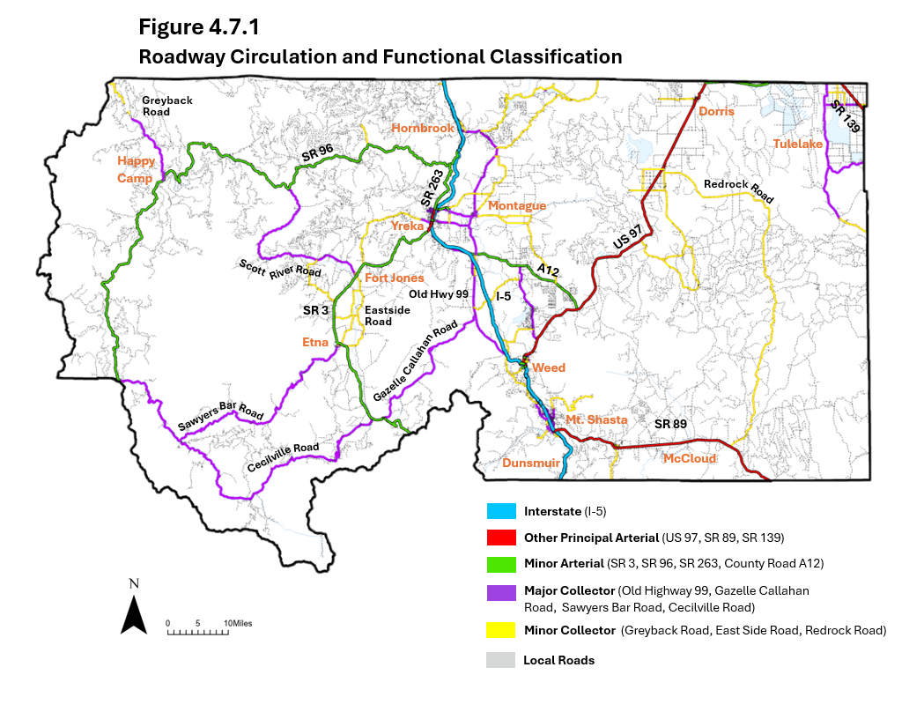

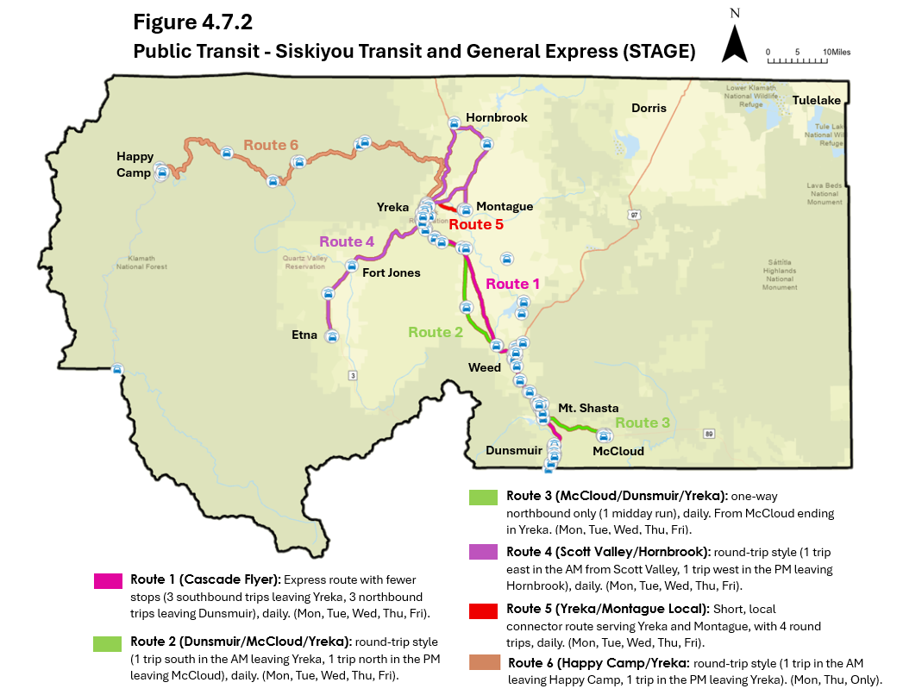

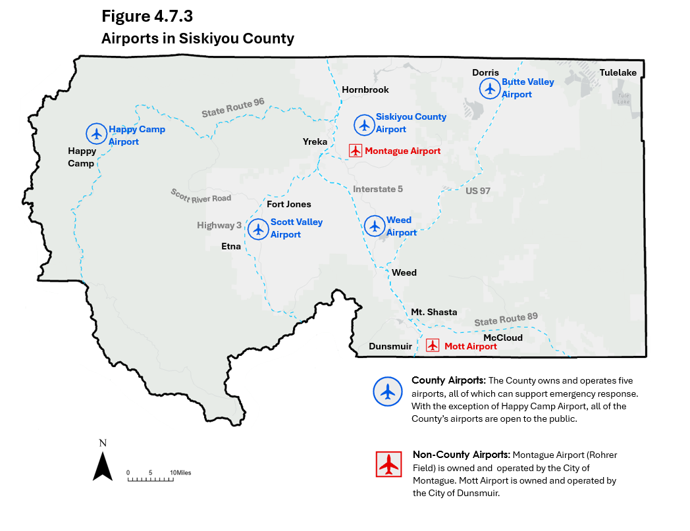
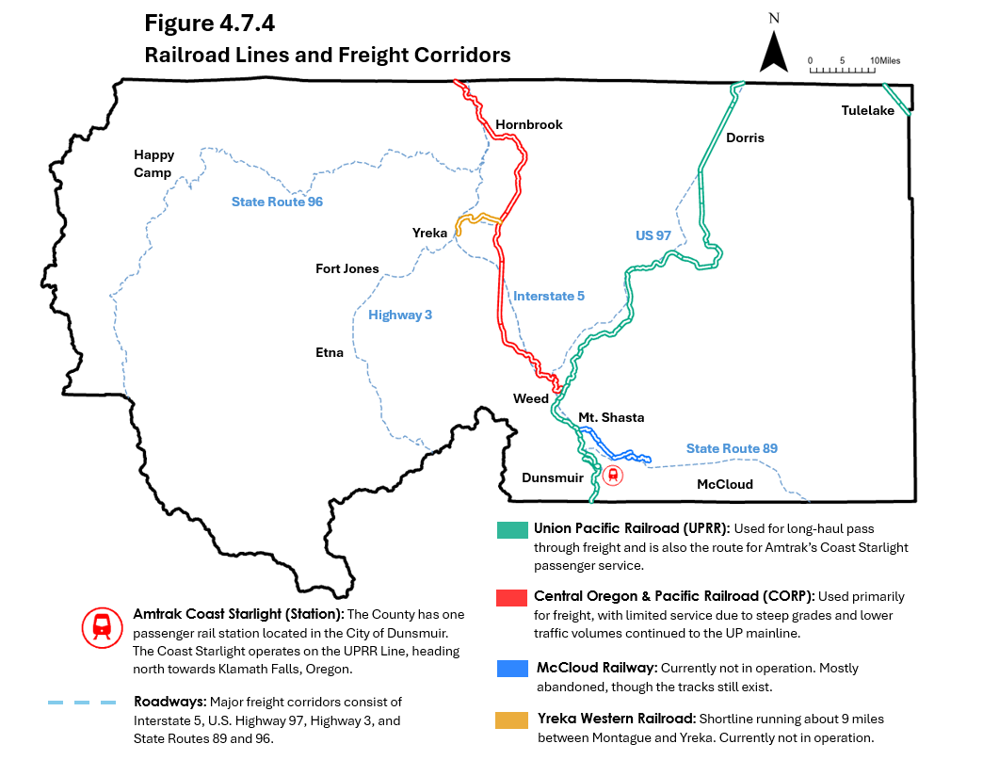
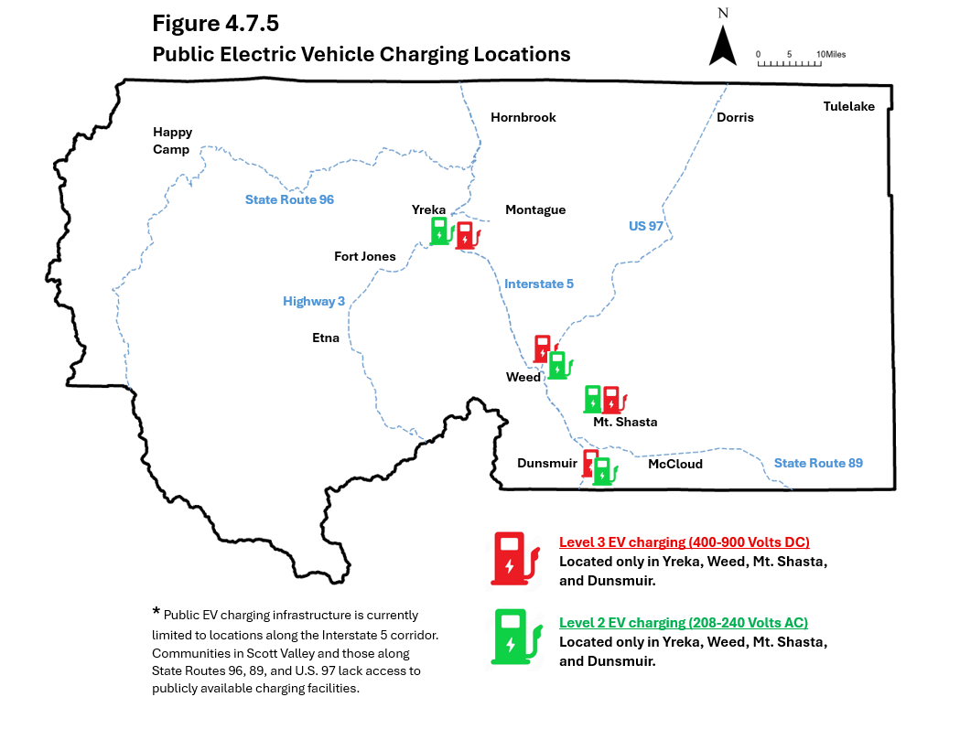
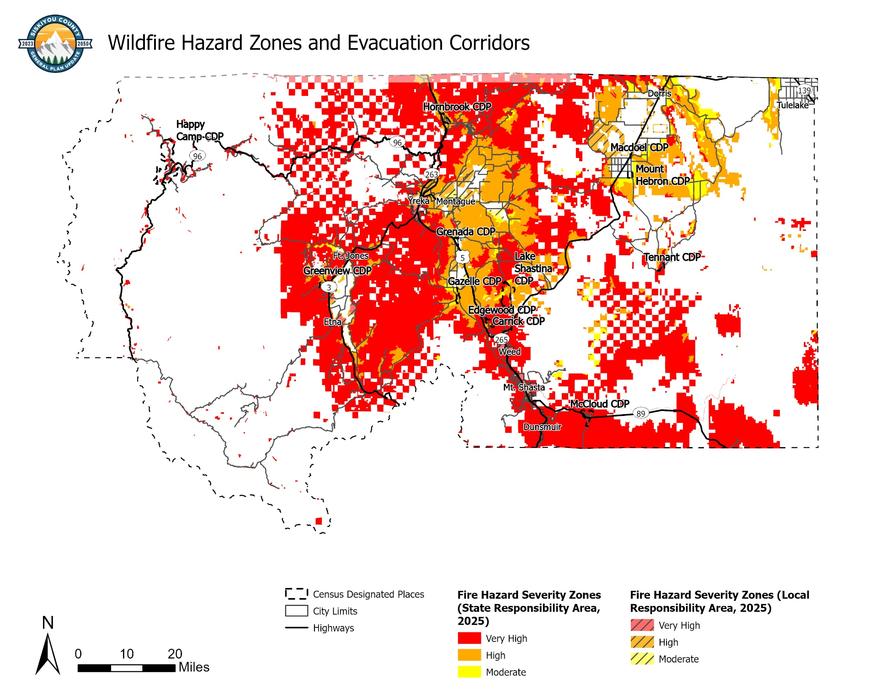
Figure 4.7.6 – Wildfire Hazard Zones and Evacuation Corridors

Figure 4.7.7 – Active Transportation and Trails, Happy Camp
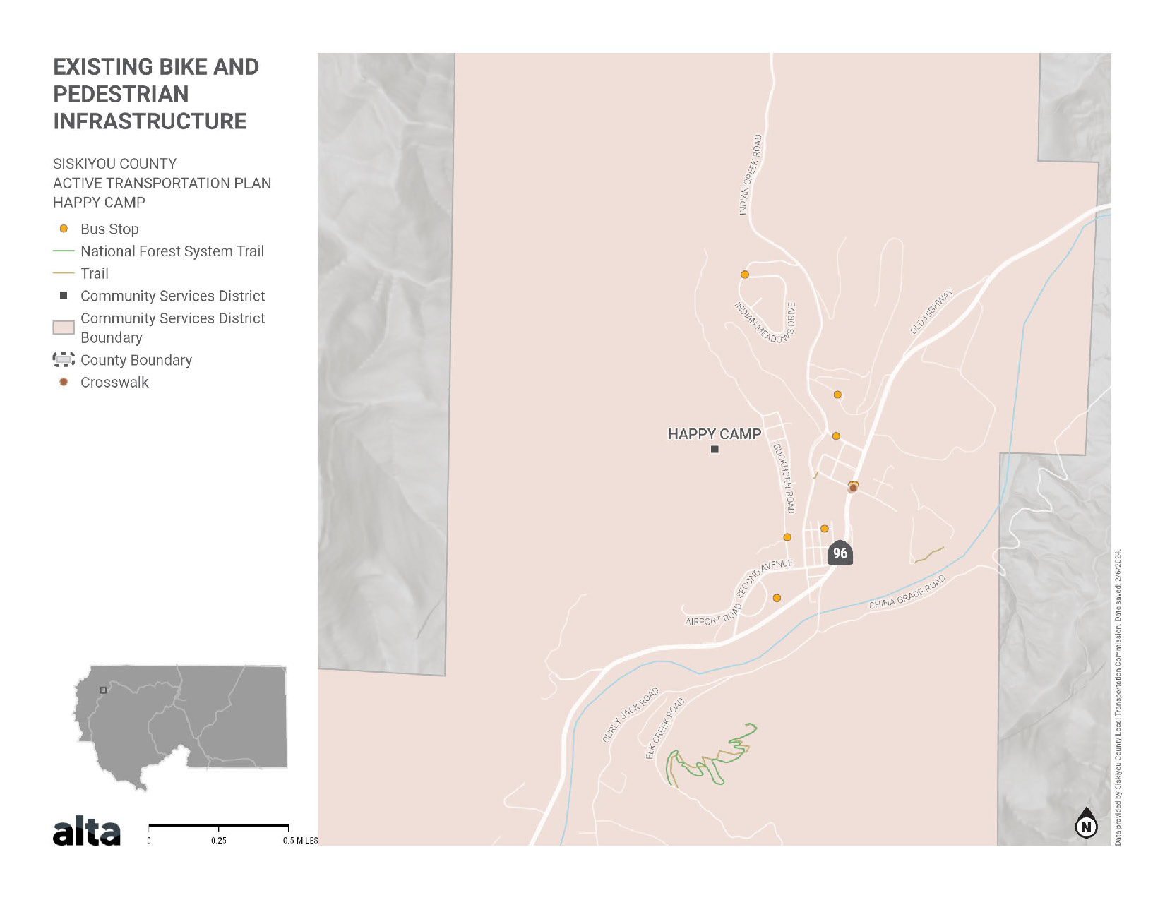
Source: Siskiyou County Active Transportation Plan, 2025.

Figure 4.7.8 – Active Transportation and Trails, Lake Shastina
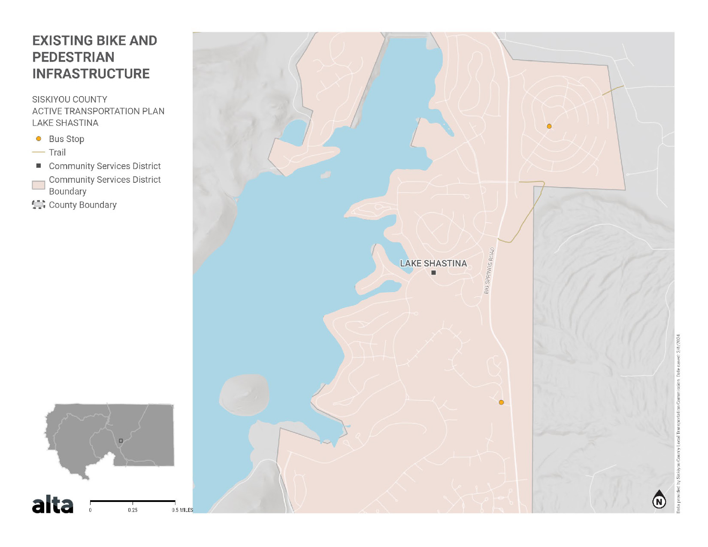
Source: Siskiyou County Active Transportation Plan, 2025.

Figure 4.7.9 – Active Transportation and Trails, McCloud
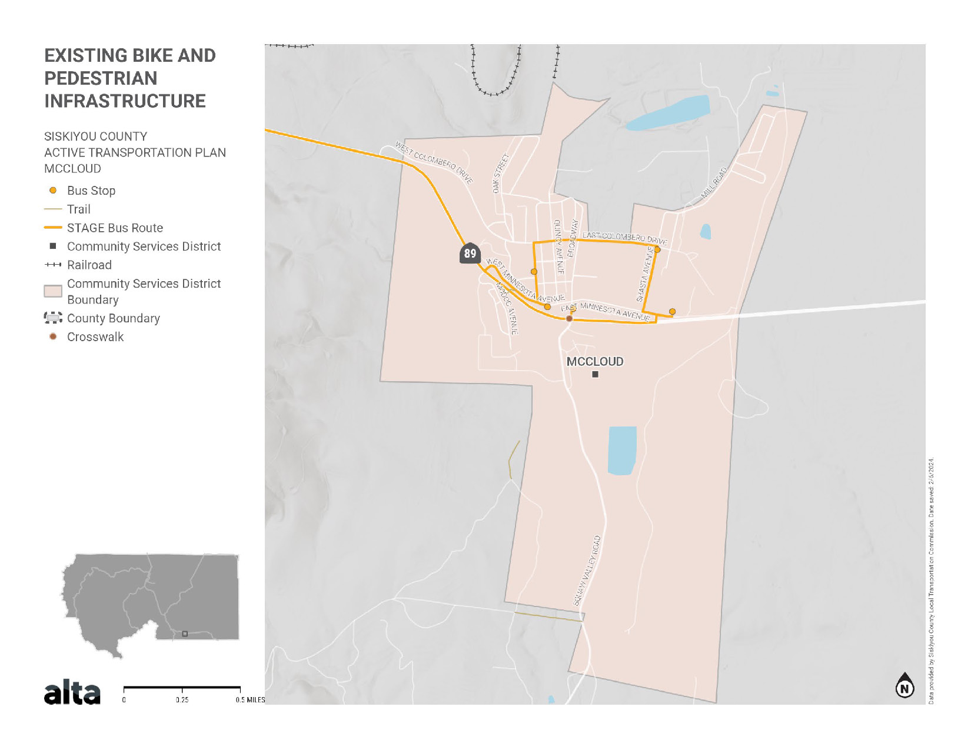
Source: Siskiyou County Active Transportation Plan, 2025.

Figure 4.7.10 – Active Transportation and Trails, Seiad Valley
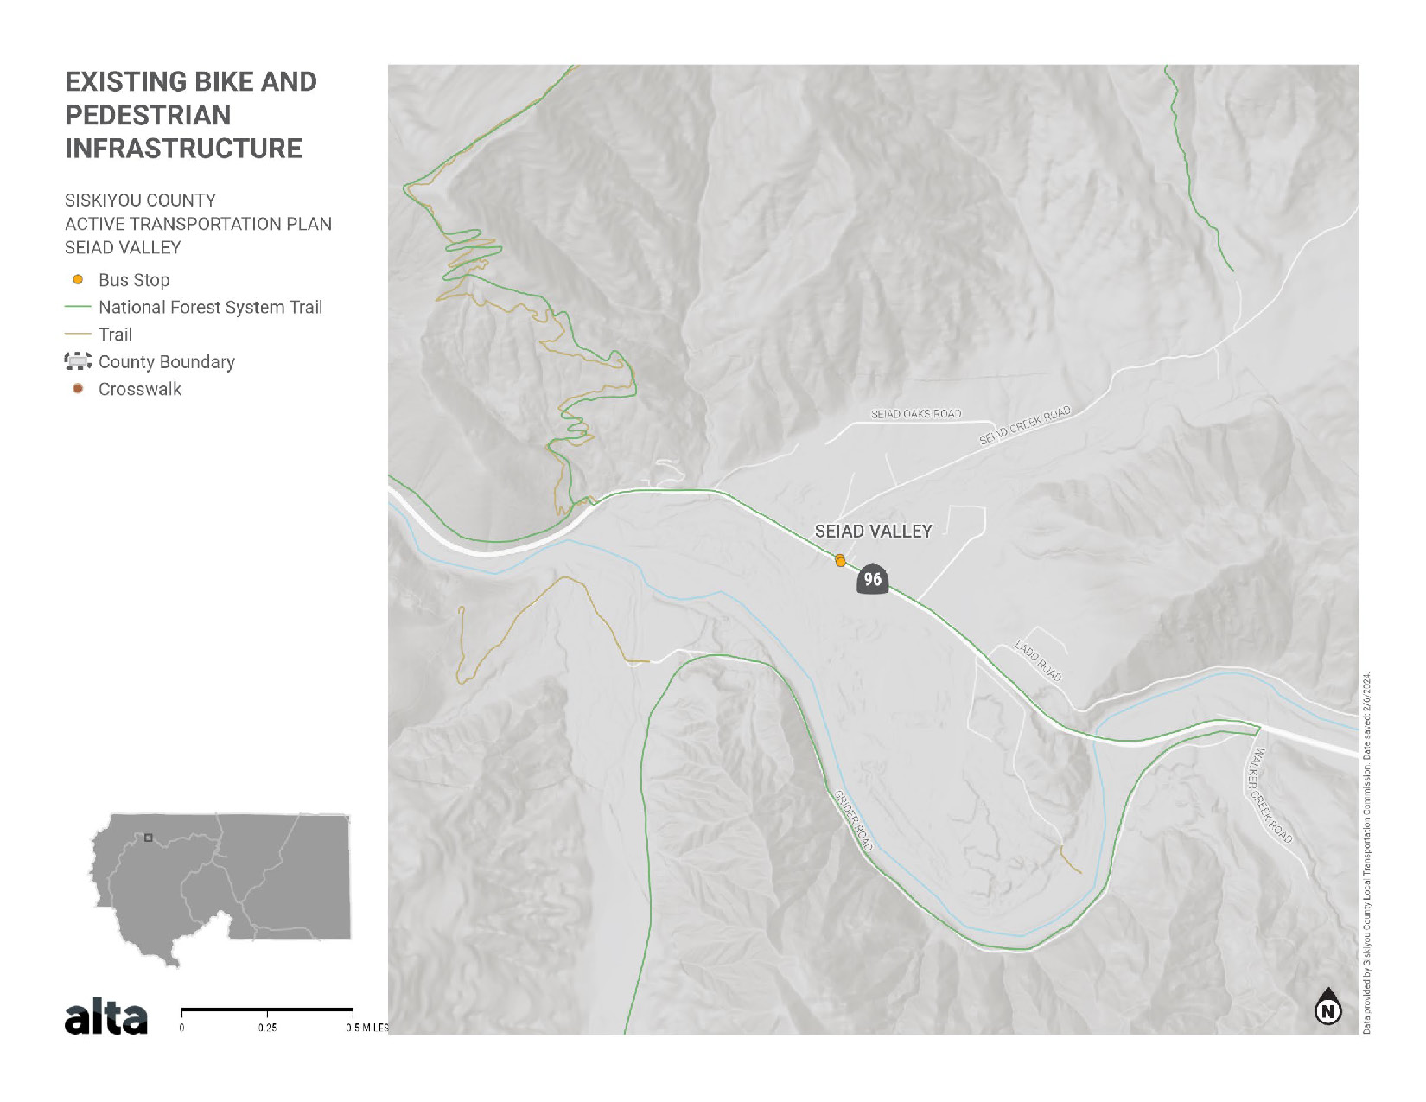
Source: Siskiyou County Active Transportation Plan, 2025.
  - Incorporation of the Regional Transportation Plan (RTP)
This Element incorporates by reference the Siskiyou County Regional Transportation Plan (RTP, 2021). Projects identified in the RTP are hereby adopted as the County’s capital improvement priorities, consistent with Government Code §65302(b). In the event of a conflict, the RTP governs funding and programming, while the Circulation Element governs land use and policy consistency. This coordination ensures that transportation investments are prioritized and delivered in a manner that aligns local land use decisions with regional and state mobility goals.
The Regional Transportation Plan is published separately with its own Table of Contents and pagination.

This page is intentionally left blank.

