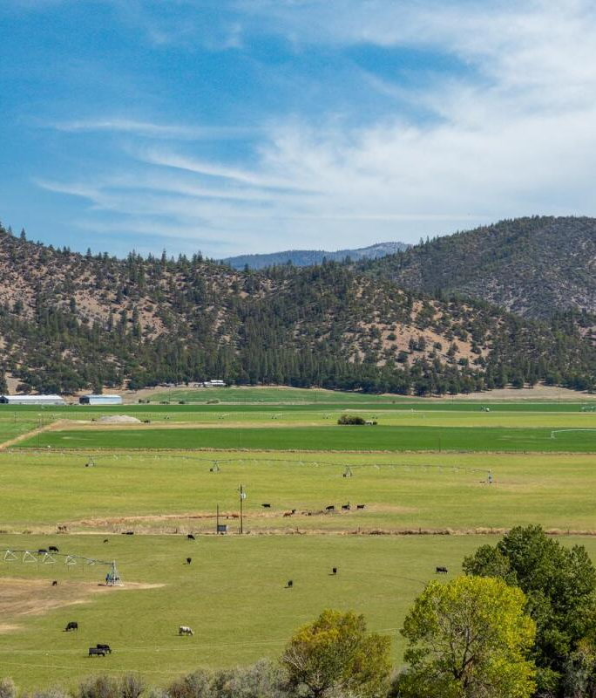

3. Open Space and Conservation Element

The Open Space and Conservation Element provides a land use policy framework to guide the conservation and management of Siskiyou County’s natural, agricultural, and cultural resources. The Element establishes goals and policies related to open space, water resources, agricultural lands, and biological and cultural resources to inform land use planning and discretionary decision making.

Table of Contents
3.1 Introduction OS-3
3.2 Water Resources OS-4
3.3 Natural and Biological Resources OS-6
3.4 Cultural, Historical, Paleontological, and Archaeological Resources OS-12
3.5 Goals and Policies OS-13
3.6 Implementation Programs OS-18

- Introduction
Siskiyou County contains extensive natural and open space resources, including mountains, forests, rivers, lakes, and valleys, that contribute to environmental quality, rural character, economic activity, and overall quality of life. These resources support a wide range of functions, including agriculture and forestry, water supply and water quality protection, wildlife habitat, recreation, and scenic values.
The County’s primary role in open space and conservation is to guide land use patterns and discretionary decision making in a manner that supports resource stewardship, working lands viability, public safety, and regulatory compliance. Many natural resource systems including water supply, groundwater sustainability, forest management, and water quality regulation are administered by private landowners, service providers, and State and federal agencies. Consistent with its land use authority, the County will emphasize compatibility, coordination, and information sharing to support responsible resource management without assuming operational control of these systems.
The Open Space and Conservation Element provides goals, policies, and implementation programs to guide the conservation and management of open space, natural resources, and working lands. The Element recognizes that many of these resources are actively managed for agricultural, forestry, and recreational purposes and that conservation objectives can often be achieved through responsible use and stewardship.
This Element establishes a framework for balancing resource protection with compatible land uses and infrastructure requirements, while supporting the long term viability of the County’s natural resource based economy. The Element also addresses the protection of recreational, scenic, cultural, historical, archaeological, and paleontological resources, recognizing their importance to community identity, education, tourism, and intergenerational stewardship.
Please note: The elements of the 2050 General Plan, such as this Open Space and Conservation Element, provide goals, policies, and implementation programs that respond to existing conditions in the county, community input, and the General Plan Vision and Guiding Principles. For an in depth analysis of existing conditions related to conservation and open space, please review the Siskiyou County 2050 General Plan Background Report, Chapter 6: Biological Resources, Chapter 7: Cultural Resources, and Chapter 10: Hydrology and Water Quality. To review a summary of community input, please download the June 2024 Visioning Workshop Series Summary. Finally, to review the County’s vision for the 2050 General Plan and guiding principles for policy creation, download the 2050 General Plan Vision and Guiding Principles.

- Water Resources
Siskiyou County contains twelve distinct watersheds, which provide the primary geographic framework for understanding surface water and groundwater resources in the County. These watersheds collect and convey rainfall and snowmelt through interconnected surface water and groundwater systems that support rivers, lakes, springs, aquifers, and downstream uses.
Water in the Upper and Lower Klamath watersheds, located in the northern and western portions of the County, flows into the Klamath River and then to the Pacific Ocean. In 2024, as part of the Klamath River dam removal project, three of the four major dams on the Klamath River system located in Siskiyou County (Copco No. 1, Copco No. 2, and Iron Gate Dams) were removed. Dam removal has supported river restoration efforts, including improved fish passage and habitat conditions for anadromous fisheries, such as coho salmon.
Other major watersheds, including the Scott River, Shasta River, Lost River, and Butte Valley watersheds, are integral to the County’s agricultural economy. Lands within these watersheds are managed by a combination of private landowners and public agencies, including the U.S. Forest Service (USFS) and the Bureau of Land Management (BLM), depending on ownership and jurisdiction.
Numerous rivers, creeks, and springs traverse Siskiyou County, with the Klamath, Scott, and Shasta Rivers among the most prominent. The County is also home to approximately 272 lakes and reservoirs that provide wildlife habitat, recreational opportunities, and surface water storage functions. Following the 2024 dam removal, Lake Siskiyou and Lake Shastina remain among the County’s most prominent surface water bodies and continue to serve recreational and water storage functions.
Water Quality
Siskiyou County falls within the jurisdiction of the North Coast Regional Water Quality Control Board (NCRWQCB) and the Central Valley Regional Water Quality Control Board (CVRWQCB), which are responsible for water quality regulation and protection of designated beneficial uses.
Water Quality Control Plans adopted for each region establish water quality objectives, discharge requirements, and monitoring programs. These plans address water quality concerns associated with a range of land uses, including agricultural, residential, and industrial activities.
Water resources within Siskiyou County are subject to management and oversight by multiple entities, including State and federal agencies, irrigation districts, special districts, and the Siskiyou County Superior Court through water rights adjudications for the Scott River, Shasta River, Shackleford Creek, and French Creek systems.
The Siskiyou County Flood Control and Water Conservation District oversees aspects of countywide water management related to drainage, flood and stormwater management, water conservation, and groundwater recharge.
Public water systems within Siskiyou County include municipal water departments, community services districts, mutual water companies, and irrigation districts. In unincorporated areas, residents typically rely on private domestic wells for groundwater supply.
Onsite wastewater treatment systems in unincorporated areas are regulated through the County’s Local Agency Management Program (LAMP), which provides oversight of onsite wastewater treatment systems in areas with higher system densities, including Greenview, Edgewood, Carrick, South Yreka, and Macdoel. The County’s LAMP is subject to review and approval by the State Water Resources Control Board.
Water Supply
Siskiyou County is located upstream of the headwaters of both the State Water Project (SWP) and the federal Central Valley Project (CVP). The County receives surface water runoff from the Klamath Mountains, Shasta Cascade Range, Trinity Mountains, and Scott Mountains. In addition to surface water sources, groundwater serves as a critical component of the County’s water supply.
The County does not own, operate, or control a centralized water supply system. Water service within Siskiyou County is provided by a combination of irrigation districts, mutual water companies, community services districts, and municipal water departments. In unincorporated areas, water supply is typically provided through private domestic wells.
Water availability and reliability vary by watershed, groundwater basin, water right, and infrastructure capacity. Periodic drought conditions have resulted in water use restrictions and curtailments in some areas, affecting agricultural and domestic users. Long term weather variability, including fluctuations in temperature and precipitation, may place additional pressure on water supplies over time, particularly in areas without long term storage or diversified supply sources.
Groundwater Resources
In 2014, the California Legislature enacted the Sustainable Groundwater Management Act (SGMA) to achieve long term sustainability of the State’s high- and medium-priority groundwater basins.
Siskiyou County does not contain any high-priority groundwater basins. The County includes four medium-priority groundwater subbasins: Butte Valley, Scott Valley, Shasta Valley, and Tulelake.
The Siskiyou County Flood Control and Water Conservation District serves as the Groundwater Sustainability Agency (GSA) for the Butte Valley, Scott Valley, and Shasta Valley subbasins. The Tulelake subbasin is managed by a multiagency GSA consisting of the City of Tulelake, Modoc County, Siskiyou County, and the Tulelake Irrigation District.
Each groundwater basin is managed through an adopted Groundwater Sustainability Plan (GSP) that establishes sustainable management goals, measurable objectives, and implementation actions to address undesirable results, including chronic groundwater level declines, reductions in groundwater storage, degraded water quality, land subsidence, and impacts to interconnected surface waters.
The policies and implementation programs in this Element are intended to be consistent with adopted Groundwater Sustainability Plans and to support coordination between land use planning and groundwater sustainability efforts.
- Natural and Biological Resources
Agricultural Land
Agricultural lands are a foundational component of Siskiyou County’s economy, rural character, and scenic landscape. The County contains extensive working lands used for crop production, livestock grazing, and associated agricultural activities, many of which have been continuously farmed or ranched for generations. These lands support local employment, contribute to regional food systems, and reinforce the County’s agricultural heritage.
Agricultural uses in Siskiyou County vary widely by geography, soil type, water availability, and elevation. Valley floors and low lying basins support irrigated pasture, hay, and row crops, while upland and foothill areas are commonly used for grazing and rangeland operations. The viability of these working lands depends on continued access to water, soil productivity, infrastructure, and the ability of landowners to adapt to changing economic conditions.
The County recognizes that agricultural lands often provide additional open space benefits, including scenic values, wildlife habitat, groundwater recharge, and floodplain functions. These benefits are generally a result of continued agricultural use rather than land set aside exclusively for conservation. Maintaining active agricultural operations is therefore a key strategy for preserving open space and rural landscapes.
Siskiyou County participates in the California Land Conservation Act of 1965 (Williamson Act), which provides property tax incentives to landowners who voluntarily commit their land to long term agricultural use. Williamson Act contracts are an important tool for supporting agricultural viability and limiting the premature conversion of farmland to nonagricultural uses. In Siskiyou County, Williamson Act contracts are primarily applied to support active agricultural operations and long term agricultural land use, rather than as a tool for general open space preservation.
Agricultural lands in the County are influenced by a range of factors, including water supply variability, groundwater sustainability requirements, market conditions, and long term weather patterns. Periodic drought, changes in precipitation patterns, and groundwater management actions may affect cropping decisions and land use over time. The County’s land use planning framework seeks to support agricultural operations by promoting compatible land uses, minimizing conflicts between agricultural and nonagricultural activities, and coordinating, where appropriate, with water management agencies and other jurisdictions.
Forested Land
Forested lands are a defining feature of Siskiyou County and represent a significant economic, environmental, and cultural resource. The County contains extensive working forests that support timber production and related industries, while also contributing to watershed protection, wildlife habitat, and scenic landscapes.
Forests in Siskiyou County occur across a wide range of elevations, environmental conditions, and ownership patterns. Large areas of forestland are managed by federal agencies, including the U.S. Forest Service and the Bureau of Land Management, while other forested lands are privately owned and actively managed for timber production, grazing, and other resource uses. Management practices vary based on ownership, forest type, site conditions, and applicable regulatory frameworks.
The continued viability of forested working lands depends on market conditions, regulatory certainty, access to processing facilities, and the ability of landowners to implement forest management activities. Over the past several decades, timber production in Siskiyou County has declined; however, the County remains among the leading timber producing counties in California. Looking forward, timber harvest levels on public lands may change in response to federal forest management policies and regulations.
In addition to their economic role, forested lands provide important ecological benefits, including wildlife habitat, protection of water quality and watersheds, groundwater recharge, and contributions to regional biodiversity. Many forested areas also provide recreational opportunities and scenic values that are important to the County.
Siskiyou County recognizes the importance of balancing forest resource use with long term sustainability and public safety considerations. The County’s land use planning role related to forested lands is focused on supporting continued forest management and resource production, promoting compatibility with adjacent land uses, reducing land use conflicts, and coordinating, where appropriate, with State and federal agencies responsible for forest management and environmental protection.
Recreational Land
Recreational lands and facilities contribute to Siskiyou County’s quality of life, public health, and local economy by providing opportunities for outdoor recreation, tourism, and community activities. Recreational uses in the County occur across a wide range of settings, including parks, trails, rivers, lakes, reservoirs, forests, and open landscapes. Recreation in Siskiyou County is closely connected to the County’s natural and working lands. Agricultural and forested landscapes, rivers and reservoirs, and scenic open spaces often support recreational uses while remaining in active production or resource management. These recreational uses depend on continued land stewardship and compatibility with primary land uses. Most recreational opportunities in the County are provided on lands managed by federal and State agencies, along with cities, special districts, and other local entities. The County’s land use planning role related to recreational lands is primarily focused on ensuring compatibility between recreational uses and surrounding land uses, infrastructure capacity, environmental resources, and ongoing agricultural and forest management activities. The County does not operate or manage most recreational lands.
Figure 3.1 National Forests
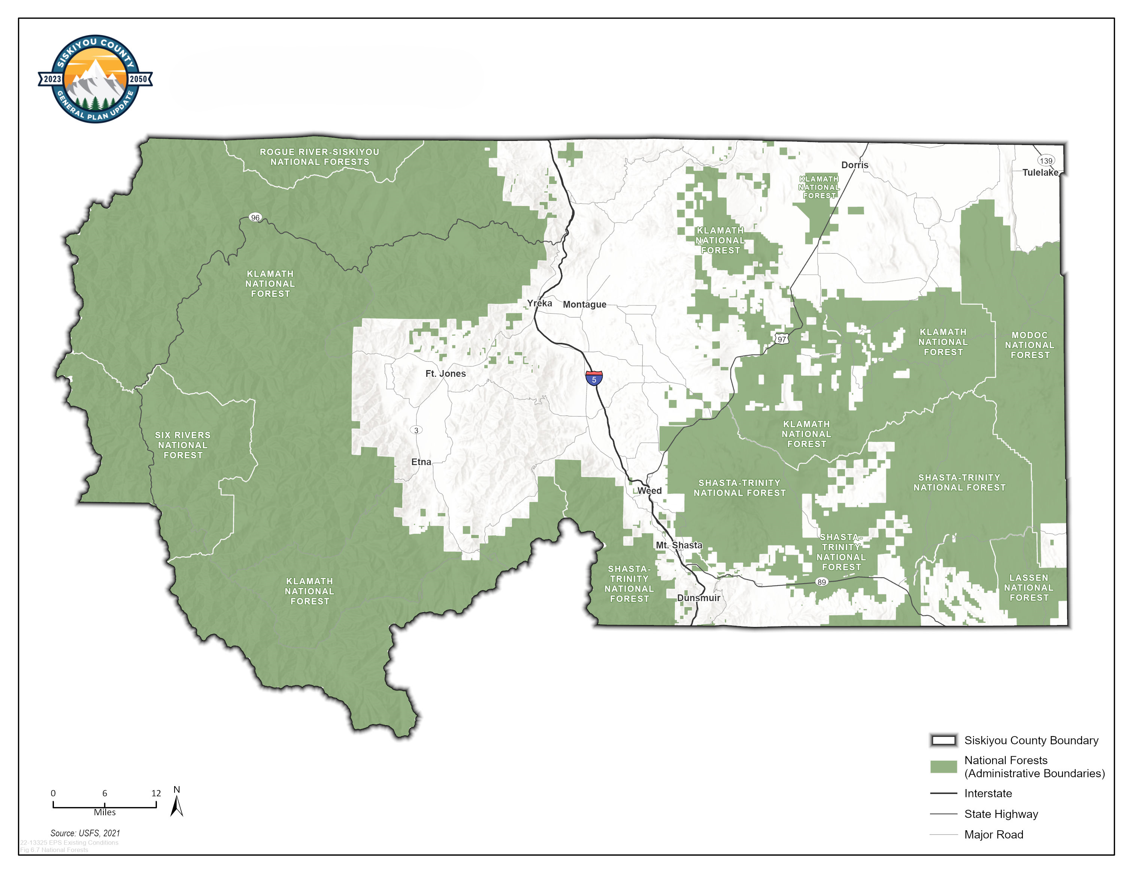
Wildlife Habitat
Siskiyou County supports a wide range of wildlife habitats due to its diverse geography, which includes mountains, valleys, rivers, forests, chaparral, and open landscapes. Major river systems such as the Klamath, McCloud, Salmon, and Sacramento River headwaters, along with associated riparian corridors, provide important habitat for fish and wildlife species. Forested areas span a range of elevations and vegetation communities, including mixed conifer forests, oak woodlands, and shrublands.
Wildlife habitat in the County is closely associated with working lands and managed landscapes. Agricultural and forested lands often provide forage, cover, migration pathways, and seasonal habitat while remaining in active production or resource management. Habitat values in these areas generally depend on land stewardship practices and compatibility with primary land uses.
The County contains habitat for a variety of wildlife species, including species designated as sensitive or of special concern at the State or federal level. These habitats occur on both public and private lands and may be affected by land use activities. Development in or near sensitive habitat areas can result in habitat loss or fragmentation and may require additional consideration during land use and environmental review, consistent with applicable regulations.
Wildlife movement corridors and habitat connectivity areas play an important role in supporting species movement and ecological function across the landscape. Several connectivity areas have been identified within Siskiyou County by agencies such as the California Department of Fish and Wildlife and Caltrans, particularly in the northern and northeastern portions of the County. These areas are considered during planning and project review, where applicable, to support coordination between land use decisions and existing habitat resources.
Scenic Resources
Siskiyou County’s scenic resources include a diverse range of natural landscapes, rural vistas, and visual corridors that contribute to the County’s identity, sense of place, and quality of life. These resources include mountains, forests, valleys, rivers, agricultural landscapes, and open spaces visible from public roads, trails, communities, and recreation areas.
Scenic resources in the County are closely tied to rural landscape patterns shaped by agriculture, forestry, and other long standing land uses. These landscapes define much of the County’s visual character and reflect established land management and development patterns across both public and private lands.
Land use decisions related to development location and scale can influence scenic character. The County’s land use planning role is to consider scenic context as part of its review of development proposals, consistent with applicable regulations and with recognition of private property rights and existing land use patterns.

Figure 3.2 Vegetation and Land Cover Types
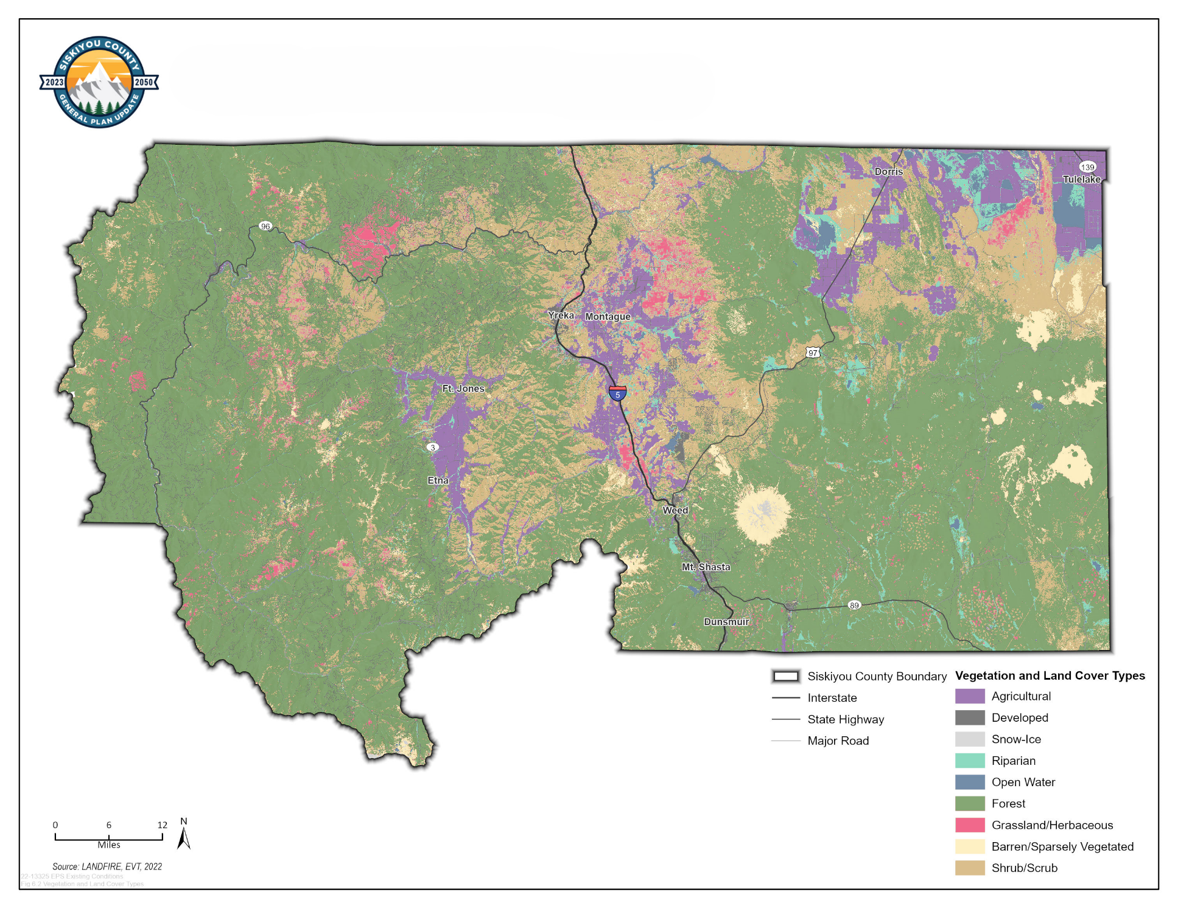
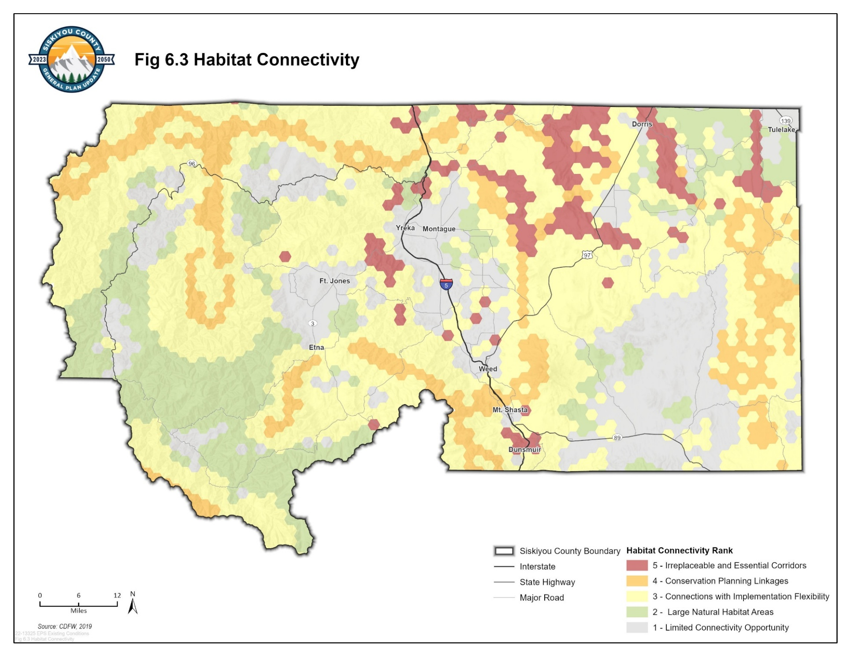
Figure 3.3 Habitat Connectivity

- Cultural, Historical, Paleontological, and Archaeological Resources
Siskiyou County contains a wide range of cultural, historical, paleontological, and archaeological resources that reflect a long history of human settlement and land use. These resources contribute to local identity and provide insight into past activities, traditions, and historical events that have shaped the County’s landscapes and communities.
Cultural and historical resources may include historic buildings and structures, districts, landscapes, transportation corridors, and features associated with early settlement, agriculture, forestry, mining, and community formation. Such resources occur on both public and private lands and vary widely in age, condition, and visibility.
Archaeological resources consist of material remains associated with past human activity, including artifacts, features, and subsurface deposits. These resources provide information about historical land use, environmental adaptation, and changes in social and cultural practices over time, and may hold cultural significance for Native American Tribes and other communities.
Siskiyou County includes the traditional homelands of the Achomawi, Karuk, Modoc, Shasta, and Wintu Tribes. Cultural and archaeological resources of importance to Tribes may be present throughout the County on both public and private lands. The County recognizes the importance of consultation with California Native American Tribes, as required by applicable State law, during discretionary land use and environmental review processes.
Paleontological resources may be present in areas containing fossil bearing geologic formations and can provide information about the County’s prehistoric environments. These resources are generally not visible at the surface and may be encountered during ground disturbing activities.
The identification, evaluation, and treatment of cultural, historical, paleontological, and archaeological resources are primarily governed by State and federal law, including the California Environmental Quality Act (CEQA) and the California Public Resources Code. The County’s land use planning role is to recognize the potential presence of such resources, coordinate with appropriate agencies and Tribes as required, and ensure compliance with applicable regulations during project review, while recognizing private property rights.

- Goals and Policies
- Water Quality

Support water quality protection for beneficial uses, including agricultural, domestic, commercial, industrial, and environmental uses. [Source: New Goal]

Policies
  - Water Quality Protection Programs. The County shall support water quality protection by encouraging participation in established regulatory and voluntary programs that reduce pollution from agricultural, commercial, industrial, and domestic sources, consistent with applicable regulations. [Source: New Policy]
  - Wastewater System Review. In evaluating proposals for onsite wastewater treatment systems and public wastewater facilities, the County shall identify potential risks to water quality and require compliance with applicable local and State standards prior to project approval. [Source: New Policy]
- Water Supply

Support long term water supply planning and coordination to meet agricultural, domestic, commercial, industrial, and environmental needs. [Source: New Goal]

Policies
  - Water Storage Planning. The County shall support coordination with water providers and State and federal agencies to evaluate water storage opportunities, including surface storage, groundwater storage, and groundwater recharge, consistent with applicable regulations. [Source: New Policy]
  - Wastewater Reclamation and Recycling. The County shall support wastewater reclamation and recycling efforts by encouraging coordination among wastewater service providers and applicable regulatory agencies, where feasible and consistent with applicable regulations. [Source: New Policy]
  - Interagency Coordination. The County shall support coordination and information sharing between local, regional, State, and federal water agencies to better understand water supply conditions and infrastructure capacity to inform County land use decisions, where applicable, including consideration of long term variability in water availability and reliability. [Source: New Policy]
  - Water Efficient Irrigation Practices. The County shall support efforts by irrigation districts, resource conservation districts, and other relevant agencies to promote water efficient irrigation practices. [Source: New Policy]
- Groundwater Management

Support sustainable groundwater management by coordinating with Groundwater Sustainability Agencies and ensuring consistency of County land use planning actions with adopted Groundwater Sustainability Plans. [Source: New Goal]

Policies
  - Groundwater Sustainability Plan Consistency. The County shall ensure that discretionary land use planning decisions are consistent with the applicable adopted Groundwater Sustainability Plans. [Source: New Policy]
  - Sustainable Groundwater Management. The County shall support the long term sustainability of groundwater resources by encouraging water conservation management practices and other groundwater management activities identified in the adopted Groundwater Sustainability Plans. [Source: New Policy]
  - Groundwater Use Limitations. The County shall support applicable Groundwater Sustainability Agency efforts to establish groundwater extraction limits for nonagricultural land uses, consistent with the adopted Groundwater Sustainability Plans. [Source: New Policy]
  - Well Permitting Coordination. The County shall coordinate with the Siskiyou County Flood Control and Water Conservation District and other relevant agencies to ensure that new well permits are reviewed for consistency, where applicable, with the applicable adopted Groundwater Sustainability Plans. [Source: New Policy]
- Agricultural Lands

Establish agriculture as a priority long term land use while discouraging the conversion of productive agricultural lands to permanent nonagricultural uses, including permanent nonagricultural open space. [Source: New Goal]

Policies
  - Agricultural Viability and Land Use Decisions. The County shall consider the continued viability of agricultural operations in land use planning and discretionary decisions affecting agricultural lands, including decisions related to the approval of Williamson Act contracts, particularly where proposed actions would result in the conversion of productive agricultural land to permanent nonagricultural open space. [Source: New Policy]
  - Agricultural Land Use Priority. The County shall preserve agricultural land for agricultural use by limiting approvals that convert agricultural lands to nonagricultural uses, particularly permanent nonagricultural open space. Where proposals involve permanent nonagricultural open space or conservation uses, the County shall consider whether continued agricultural use can be reasonably maintained or integrated, and whether the proposed conversion would adversely affect surrounding working lands. [Source: New Policy]
  - Working Lands as Open Space. The County shall recognize and support continued agricultural use of agricultural lands as a preferred form of open space that sustains Siskiyou County’s rural landscape and agricultural economy. This recognition shall include consideration of whether proposed land uses, parcel configurations, or conservation actions would allow for agricultural uses to be maintained at a scale and configuration consistent with surrounding working lands. [Source: New Policy]
  - Prioritization of Working Lands. The County shall discourage conservation or open space proposals that would permanently remove productive agricultural lands from agricultural use unless continued agricultural use is demonstrated to be impracticable. [Source: New Policy]
  - Agricultural Diversification and Related Uses. The County shall allow consideration of a broad range of agriculturally related uses on agricultural lands that support continued agricultural use and economic viability. Such uses may include onsite sales, storage, processing and value added activities, agritourism, farm stays, agricultural services, and other complementary uses, where consistent with applicable County policies, rural character, and environmental constraints. [Source: New Policy]
- Forested Lands

Recognize forested lands as working landscapes when making County discretionary land use decisions. [Source: New Goal]

Policies
  - Clustered Development. The County shall encourage clustered development patterns, where feasible, to retain large contiguous areas of forest land. [Source: New Policy]
  - Forested Lands as Open Space. The County shall recognize that forested lands are working landscapes that support active forest management and forest based economic activity while also providing scenic, ecological, and other resource related open space benefits. In reviewing development, subdivision, or conservation proposals on forested lands, the County shall consider whether such proposals maintain forest lands in large, connected areas with sufficient access to support long term forest management and minimize conflicts with nearby working forest uses. [Source: New Policy]
  - Wildfire Risk and Forested Lands. The County shall consider wildfire risk when reviewing land use proposals affecting privately managed forest lands, consistent with applicable state and federal forest management laws. [Source: New Policy]
- Recreational Land

Recognize recreational uses as a secondary land use consideration in County land use planning, where compatible with agriculture, working lands, surrounding uses, resource protection, and public safety. [Source: New Goal]

Policies
  - Private Recreational Uses. The County shall consider the location, intensity, and operational characteristics of private commercial recreational uses to ensure compatibility with primary land uses, infrastructure capacity, and public safety. [Source: New Policy]
  - River-Oriented Recreational Uses. The County shall consider river-oriented recreational uses where compatible with water quality protection, flood hazard constraints, riparian resources, surrounding land uses, and public safety. [Source: New Policy]
  - Recreation on Multi-purpose Lands. The County shall consider recreational uses on multi-purpose lands—such as reservoirs, floodplains, and forest lands—where such uses are compatible with the primary function of the land, resource protection objectives, and public safety. [Source: New Policy]
  - Equitable Recreational Facility Siting. The County shall consider equitable access in the siting of recreational facilities, prioritizing locations near disadvantaged communities and underserved areas, including areas where residents live more than one half mile from an existing park, where feasible and consistent with surrounding land uses and resource protection. [Source: New Policy, SB 1425 compliance]
- Wildlife Habitat

Recognize the importance of wildlife habitat and habitat connectivity while balancing resource protection with working lands and other compatible land uses. [Source: New Goal, AB 1889 Compliance]

Policies
  - Wildlife Habitat and Connectivity. The County shall consider wildlife habitat and habitat connectivity when reviewing land use proposals, including available information regarding identified wildlife corridors, connectivity areas, and existing wildlife passage locations, and shall seek to minimize fragmentation and avoid, where feasible, land use patterns that would substantially impede wildlife movement, consistent with working lands, resource protection, and public safety. [Source: New Policy, AB 1889]
- Scenic Resources

Acknowledge scenic resources as components of Siskiyou County’s natural and working landscapes to be considered in land use planning and discretionary decision making. [Source: New Goal]

Policies
  - Consideration of Scenic Resources. The County shall consider scenic resources in relation to project location, scale, and visibility within the surrounding landscape. [Source: New Policy]
- Cultural, Historical, Paleontological, and Archaeological Resources

Address cultural, historical, paleontological, and archaeological resources as considerations in land use planning and discretionary decision making. [Source: New Goal]

Policies
  - Cooperation for Resource Preservation. The County shall consider potential impacts to cultural, historical, paleontological, and archaeological resources when reviewing discretionary land use and development proposals. [Source: New Policy]
  - Tribal Consultation. The County shall conduct tribal consultation for discretionary land use actions where required by State law. [Source: New Policy]
- Extreme Weather Conditions and Open Space Functions

Integrate extreme weather resilience considerations into land use planning and open space conservation. [Source: New Goal]

Policies
  - Open Space Functions. The County shall consider the role of open space areas in supporting flood control, groundwater recharge, habitat connectivity, and protection from extreme weather conditions. [Source: New Policy, SB 1425]
- Implementation Programs
 | Implements Which Policy(ies) | Responsible Department | Funding Source | Timeframe
- Water Quality Program Coordination  The County shall implement Policy OS-1.1 during discretionary land use planning and project review by coordinating, where applicable, with Environmental Health and relevant State and regional agencies regarding regulatory and voluntary water quality protection programs applicable to proposed land uses, consistent with applicable regulations. [Source: New Program] | OS-1.1 Water Quality Protection Programs | Community Development | General Fund | Ongoing
- Onsite Wastewater and Public Facility Review Coordination  The County shall implement Policy OS-1.2 during discretionary land use planning and project review by coordinating, where applicable, with Environmental Health regarding proposed onsite wastewater treatment systems and public wastewater facilities to identify potential risks to water quality and ensure compliance with applicable local and State standards prior to project approval. [Source: New Program] | OS-1.2 Wastewater System Review | Community Development | General Fund | Ongoing
- Water Storage and Recharge Coordination  The County shall implement Policy OS-2.1 during discretionary land use planning and long range planning by coordinating, where applicable, with water providers, Environmental Health, and relevant State and federal agencies regarding surface water storage, groundwater storage, and groundwater recharge considerations that may inform land use decisions, consistent with applicable regulations. [Source: New Program] | OS-2.1 Water Storage Planning | Community Development | General Fund | Ongoing
- Wastewater Reclamation and Recycling Coordination  The County shall implement Policy OS-2.2 during discretionary land use planning and project review by coordinating, where applicable, with wastewater service providers, Environmental Health, and applicable regulatory agencies regarding wastewater reclamation and recycling considerations that may inform land use decisions, consistent with applicable regulations. [Source: New Program] | OS-2.2 Wastewater Reclamation and Recycling | Community Development | General Fund | Ongoing
- Interagency Water Supply Information Sharing  The County shall implement Policy OS-2.3 during discretionary land use planning and project review by coordinating, where applicable, with local, regional, State, and federal water agencies to share information regarding water supply conditions, infrastructure capacity, and supply reliability that may inform County land use decisions, consistent with applicable regulations. [Source: New Program] | OS-2.3 Interagency Coordination | Community Development | General Fund | Ongoing
- Water Efficient Irrigation Support  The County shall implement Policy OS-2.4 during discretionary land use planning and project review by coordinating, where applicable, with irrigation districts, resource conservation districts, and other relevant agencies to support consideration of water efficient irrigation practices that may inform land use decisions affecting agricultural operations, consistent with applicable regulations. [Source: New Program] | OS-2.4 Water Efficient Irrigation Practices | Community Development | General Fund | Ongoing
- Groundwater Sustainability Plan Consistency Review  The County shall implement Policy OS-3.1 during discretionary land use planning and project review by reviewing proposed actions for consistency, where applicable, with the adopted Groundwater Sustainability Plans, recognizing that groundwater management authority rests with the applicable Groundwater Sustainability Agencies and that the County role is limited to land use planning considerations. [Source: New Program] | OS-3.1 Groundwater Sustainability Plan Consistency | Community Development | General Fund | Ongoing
- Groundwater Sustainability Coordination  The County shall implement Policy OS-3.2 during discretionary land use planning and project review by coordinating, where applicable, with the appropriate Groundwater Sustainability Agencies regarding water conservation practices and groundwater management actions identified in the adopted Groundwater Sustainability Plans that may inform land use decisions, recognizing that groundwater management authority rests with the applicable Groundwater Sustainability Agencies. [Source: New Program] | OS-3.2 Sustainable Groundwater Management | Community Development | General Fund | Ongoing
- Groundwater Use Limitation Support  The County shall implement Policy OS-3.3 during discretionary land use planning and project review by coordinating, where applicable, with the appropriate Groundwater Sustainability Agencies regarding groundwater extraction limitations for nonagricultural land uses identified in the adopted Groundwater Sustainability Plans that may inform land use decisions, recognizing that groundwater management authority rests with the applicable Groundwater Sustainability Agencies. [Source: New Program] | OS-3.3 Groundwater Use Limitations | Community Development | General Fund | Ongoing
- Well Permitting and Interagency Coordination  The County shall implement Policy OS-3.4 during discretionary land use planning and project review by coordinating, where applicable, with the Siskiyou County Flood Control and Water Conservation District and other relevant agencies to review new well permits associated with discretionary land use actions for consistency with the applicable adopted Groundwater Sustainability Plans, recognizing that groundwater management authority rests with the applicable Groundwater Sustainability Agencies. [Source: New Program] | OS-3.4 Well Permitting Coordination | Community Development | General Fund | Ongoing
- Agricultural Viability Consideration in Land Use Decisions  The County shall implement Policy OS-4.1 during discretionary land use planning and project review by considering the continued viability of existing agricultural operations in decisions affecting agricultural lands, including, where applicable, applications related to Williamson Act contracts, consistent with applicable County policies and regulations. [Source: New Program] | OS-4.1 Agricultural Viability and Land Use Decisions | Community Development | General Fund | Ongoing
- Agricultural Land Conversion Review  The County shall implement Policy OS-4.2 during discretionary land use planning and project review by evaluating whether proposed actions affecting agricultural lands would result in the permanent conversion of productive agricultural land to nonagricultural uses, including permanent nonagricultural open space, and whether continued agricultural use has been demonstrated to be impracticable, consistent with applicable County policies and regulations. [Source: New Program] | OS-4.2 Agricultural Land Use Priority | Community Development | General Fund | Ongoing
- Recognition of Working Lands as Open Space  The County shall implement Policy OS-4.3 during discretionary land use planning and project review by recognizing continued agricultural use of agricultural lands as a preferred form of open space and by considering whether proposed land uses, parcel configurations, or conservation actions would allow agricultural operations to be maintained at a scale and configuration comparable to surrounding working lands, in accordance with applicable County policies and regulations. [Source: New Program] | OS-4.3 Working Lands as Open Space | Community Development | General Fund | Ongoing
- Conservation and Open Space Proposal Evaluation  The County shall implement Policy OS-4.4 during discretionary land use planning and project review by evaluating conservation and open space proposals affecting productive agricultural lands to determine whether such proposals would permanently remove land from agricultural use and whether continued agricultural use has been demonstrated to be impracticable, in accordance with applicable County policies and regulations. [Source: New Program] | OS-4.4 Prioritization of Working Lands | Community Development | General Fund | Ongoing
- Agricultural Diversification and Related Uses Review  The County shall implement Policy OS-4.5 during discretionary land use planning and project review by considering a range of agriculturally related and complementary uses on agricultural lands, including onsite sales, storage, processing, agritourism, and agricultural services, where such uses support continued agricultural operations and economic viability and are appropriate in relation to rural character and applicable environmental constraints. [Source: New Program] | OS-4.5 Agricultural Diversification and Related Uses | Community Development | General Fund | Ongoing
- Clustered Development Review on Forested Lands  The County shall implement Policy OS-5.1 during discretionary land use planning and project review by encouraging clustered development patterns on forested lands in order to retain large contiguous areas suitable for long term forest management and to reduce potential conflicts with surrounding working forest uses. [Source: New Program] | OS-5.1 Clustered Development | Community Development | General Fund | Ongoing
- Recognition of Forested Lands as Working Open Space  The County shall implement Policy OS-5.2 during discretionary land use planning and project review by recognizing forested lands as working landscapes and as a form of open space, and by considering whether proposed land uses, subdivisions, or conservation actions would maintain forest lands in large, connected areas with sufficient access to support long term forest management and forest based economic activity. [Source: New Program] | OS-5.2 Forested Lands as Open Space | Community Development | General Fund | Ongoing
- Wildfire Risk Consideration for Forested Lands  The County shall implement Policy OS-5.3 during discretionary land use planning and project review by considering wildfire risk in proposals affecting privately managed forest lands, including site conditions, access, and proximity to existing development, in coordination with applicable State and federal forest management and public safety requirements. [Source: New Program] | OS-5.3 Wildfire Risk and Forested Lands | Community Development | General Fund | Ongoing
- Private Recreational Use Compatibility Review  The County shall implement Policy OS-6.1 during discretionary land use planning and project review by evaluating the location, intensity, and operational characteristics of proposed private commercial recreational uses to ensure compatibility with primary land uses, available infrastructure capacity, and public safety considerations. [Source: New Program] | OS-6.1 Private Recreational Uses | Community Development | General Fund | Ongoing
- River-Oriented Recreational Use Review  The County shall implement Policy OS-6.2 during discretionary land use planning and project review by evaluating proposed river oriented recreational uses for compatibility with water quality protection, flood hazard constraints, riparian resources, surrounding land uses, and public safety considerations. [Source: New Program] | OS-6.2 River-Oriented Recreational Uses | Community Development | General Fund | Ongoing
- Recreation on Multi-Purpose Lands Review  The County shall implement Policy OS-6.3 during discretionary land use planning and project review by evaluating proposed recreational uses on multi purpose lands, including reservoirs, floodplains, and forest lands, to determine whether such uses are compatible with the primary function of the land, applicable resource protection objectives, and public safety considerations. [Source: New Program] | OS-6.3 Recreation on Multi-purpose Lands | Community Development | General Fund | Ongoing
- Equitable Recreational Facility Siting Consideration  The County shall implement Policy OS-6.4 during discretionary land use planning and project review by considering equitable access in the siting of recreational facilities, including proximity to disadvantaged communities and underserved areas, while also evaluating compatibility with surrounding land uses, infrastructure capacity, and applicable resource protection objectives. [Source: New Program, SB 1425 compliance] | OS-6.4 Equitable Recreational Facility Siting | Community Development | General Fund | Ongoing
- Wildlife Habitat and Connectivity Review  The County shall implement Policy OS-7.1 during discretionary land use planning and project review by considering available information regarding wildlife habitat, identified wildlife corridors, habitat connectivity areas, and existing wildlife passage locations, and by evaluating whether proposed land use patterns would substantially impede wildlife movement, while balancing working lands, resource protection objectives, and public safety considerations. [Source: New Program] | OS-7.1 Wildlife Habitat and Connectivity | Community Development | General Fund | Ongoing
- Scenic Resource Consideration in Land Use Review  The County shall implement Policy OS-8.1 during discretionary land use planning and project review by considering scenic resources in relation to project location, scale, and visibility within the surrounding landscape, while recognizing existing land use patterns and private property rights. [Source: New Program] | OS-8.1 Consideration of Scenic Resources | Community Development | General Fund | Ongoing
- Cultural and Historical Resource Consideration  The County shall implement Policy OS-9.1 during discretionary land use planning and project review by considering potential impacts to cultural, historical, paleontological, and archaeological resources and by ensuring that project review and approval processes address applicable State and federal requirements. [Source: New Program] | OS-9.1 Cooperation for Resource Preservation | Community Development | General Fund | Ongoing
- Tribal Consultation Coordination  The County shall implement Policy OS-9.2 during discretionary land use planning and project review by conducting tribal consultation where required by State law and by coordinating, as appropriate, with California Native American Tribes during land use planning and project review processes. [Source: New Program] | OS-9.2 Tribal Consultation | Community Development | General Fund | Ongoing
- Open Space Functions and Extreme Weather Consideration  The County shall implement Policy OS-10.1 during discretionary land use planning and project review by considering the role of open space areas in supporting flood control, groundwater recharge, habitat connectivity, and protection from extreme weather conditions, while evaluating compatibility with surrounding land uses and applicable resource protection objectives. [Source: New Program] | OS-10.1 Open Space Functions | Community Development | General Fund | Ongoing

