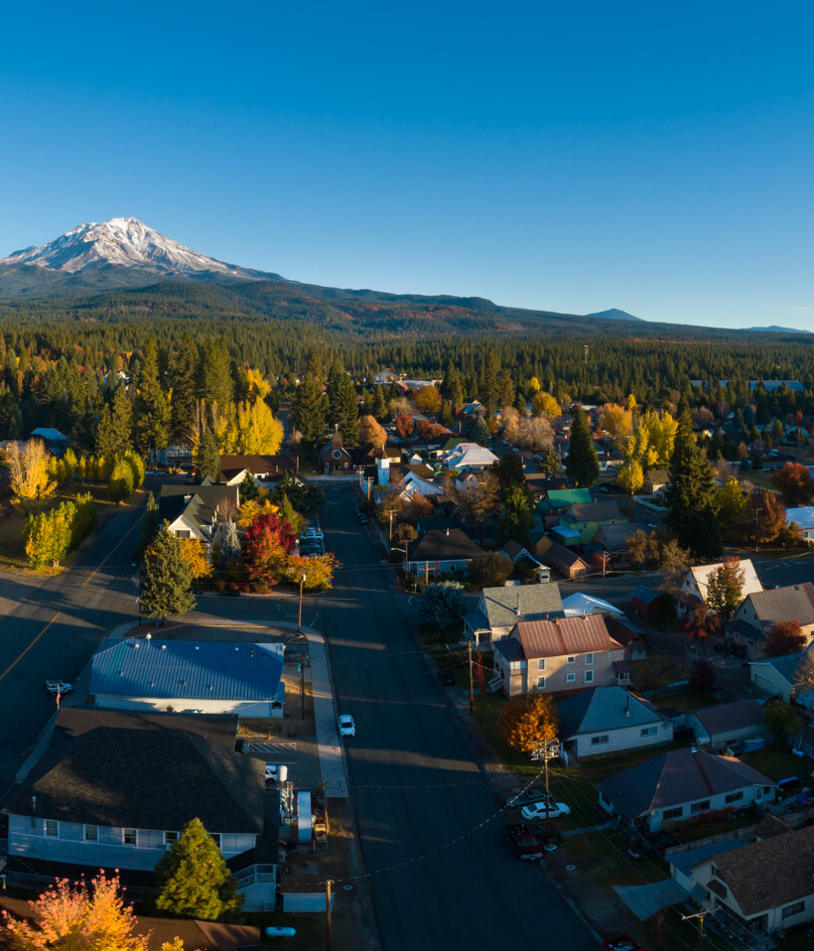
2. Land Use Element

The Land Use Element establishes the framework for regulating the general type, location, and intensity of development within the County. It sets forth goals, policies, and implementation programs that guide land use and development decisions. Of all General Plan elements, the Land Use Element has the most direct influence on existing and future residents, as it determines the distribution and pattern of residential, commercial, industrial, agricultural, and open space uses. This Element is intended to achieve a balanced and orderly land use pattern that reflects the unique environmental conditions, economic base, rural character, and community values of Siskiyou County.

Table of Contents
2.1 Land Use Designations and Standards LU-3
2.2 Goals and Policies LU-23
Goal LU-1 Land Use Balance LU-23
Goal LU-2 Development Patterns LU-24
Goal LU-3 Flexible Development Framework LU-25
Goal LU-4 Economic Development LU-26
Goal LU-5 Prime Agricultural Land LU-28
Goal LU-6 Agriculture Based Economy LU-29
Goal LU-7 Timber Production LU-30
Goal LU-8 Coordination and Engagement LU-30
Goal LU-9 Land Use and Environmental Justice LU-31
Goal LU-10 General Plan Maintenance LU-31
Goal LU-11 Scott Valley Planning Area LU-32
2.3 Implementation Programs LU-33

- Land Use Designations and Standards
The Land Use Element is organized around two primary components. First, it establishes land use designations that classify and distinguish the range of uses needed throughout Siskiyou County and define the corresponding levels of density, intensity, and allowable activities, consistent with Government Code Section 65302(a). Second, it includes goals, policies, and programs that guide the County’s long-term land use decisions and implementation efforts.
The General Plan Land Use Diagram (Figure 2.1) illustrates the distribution of land use designations within the County and provides direction for where and what type of development may occur.
Land Use Designations and Standards
State planning law requires general plans to establish “standards of population density and building intensity” for each land use designation (Government Code Section 65302(a)). To meet this requirement, this General Plan establishes development standards for every designation shown on the Land Use Diagram.
- Residential standards are expressed in terms of density, measured in dwelling units per net acre.
- Non-residential standards are expressed in terms of intensity, measured by maximum lot coverage and floor area ratio.
Each land use designation is described by its typical uses and corresponding development standards.
How are land use designations enforced?
The Land Use Element includes a Land Use Map that identifies land use designations and general standards for development density and intensity, reflecting the County’s long-term vision for growth. These designations are implemented through the County’s Zoning Code.
The Zoning Code establishes zoning districts corresponding to each General Plan land use designation and regulates development through specific standards, including lot size, setbacks, height, and allowable uses. The zoning districts are shown on the Zoning Map.
Amendments to the Zoning Map must be consistent with the General Plan Land Use Map. All development must comply with both the General Plan and the Zoning Code, including the Land Use Map and the adopted goals and policies of this Element. Proposed amendments to the Zoning Map that are not consistent with the General Plan Land Use Diagram require a General Plan Amendment to ensure consistency between the Land Use Diagram and Zoning Map.
Density

Residential Density Examples

1 dwelling unit per acre
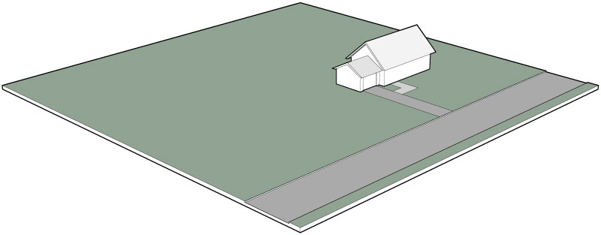

4 dwelling units per acre
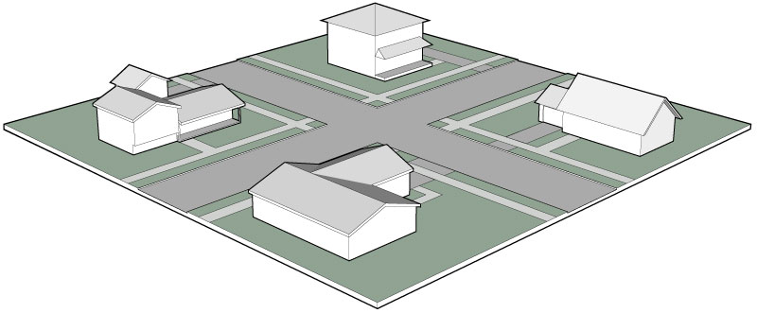

8 dwelling units per acre
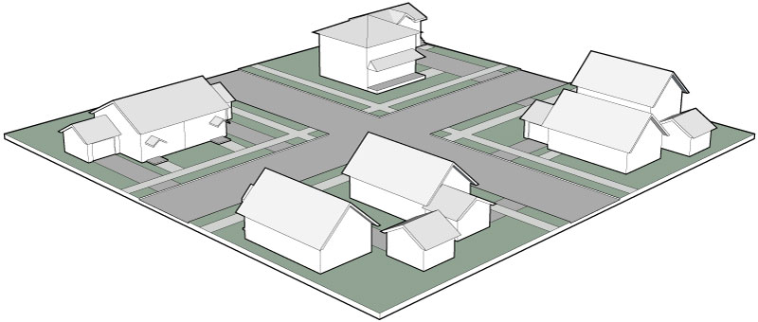

12 dwelling units per acre
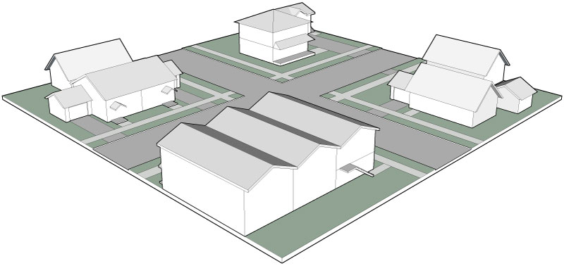

20 dwelling units per acre

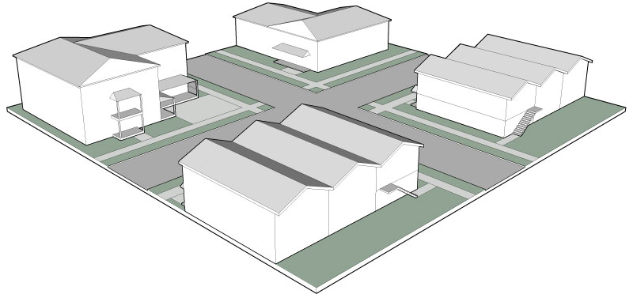
Residential development is categorized by an allowed density range (minimum and maximum), measured in dwelling units per acre (du/ac). Residential density is calculated by dividing the number of dwelling units on a site (excluding accessory dwelling units) by the net acreage of the site. Net acreage excludes public or private streets, rights-of-way, and easements that restrict development.
State planning law requires general plans to establish standards for measuring population density. Population density is determined by multiplying the maximum number of dwelling units allowed within a land use designation by the average number of persons per household, as determined by the California Department of Finance.
Accessory dwelling units are permitted pursuant to the Zoning Code and applicable State law and do not count toward the allowable residential density. The illustrations to the right demonstrate examples of residential density for one-acre properties.

Gross versus Net Acreage (Lot Area)
The term “gross acreage” refers to all land within the boundaries of a lot, including easements, streets, and rights-of-way. Gross acreage is measured on a horizontal plane within the lot lines.
“Net lot area” means the lot area minus any existing or proposed public or private streets, roads, or easements for ingress or egress, and minus any easement area where the surface of the land is restricted from development.
For subdivision purposes, minimum lot area is expressed as net area for parcels less than 10 acres and as gross area for parcels of 10 acres or more.
In commercial and industrial areas, net acreage may be 20 to 25 percent less than gross acreage due to required access and infrastructure. In rural areas, the difference between net and gross acreage may be as little as five percent because parcels are generally larger and devote a smaller proportion of land to non-buildable areas such as roads and access easements.

Gross versus Net Acreage Examples

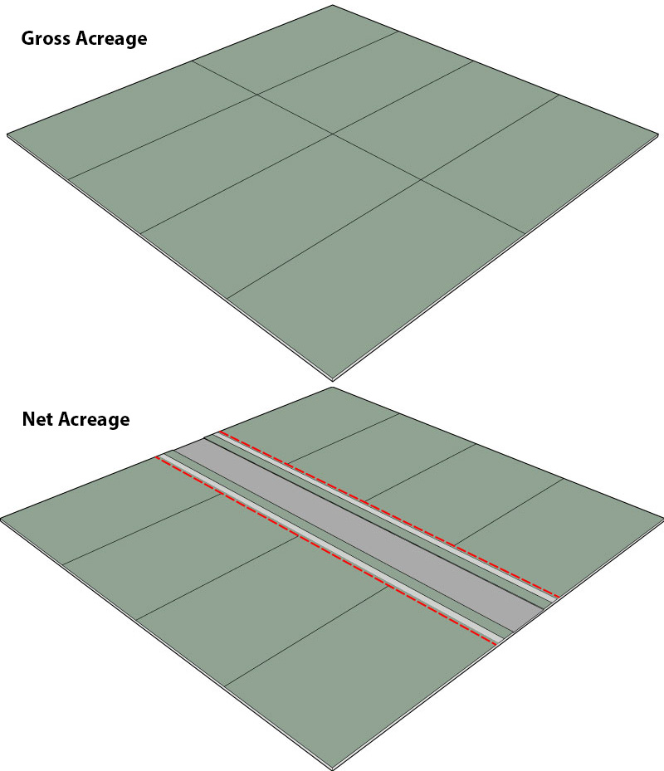

Intensity
Standards of building intensity for non-residential uses (e.g., agricultural, open space, commercial, and industrial) are based on the intensity of use, expressed as the maximum allowable lot coverage and floor area ratio.
Lot Coverage

Lot Coverage Examples

100% lot coverage

50% lot coverage
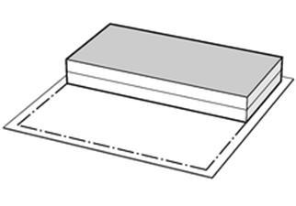
25% lot coverage
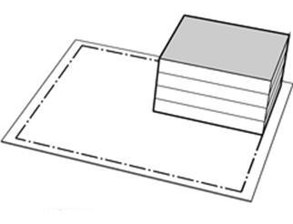
Lot coverage is the percentage of a lot covered by the building footprint (the area covered by the first floor of a structure) relative to the net square footage of the lot. For example, a lot coverage of 100 percent allows 10,000 square feet of building footprint to be constructed on a lot with 10,000 net square feet of land area, regardless of the number of stories in the building. On the same lot, a lot coverage of 50 percent would allow 5,000 square feet of building footprint, and a lot coverage of 25 percent would allow 2,500 square feet. These development standards are described on the following pages and summarized in Table 2.1.

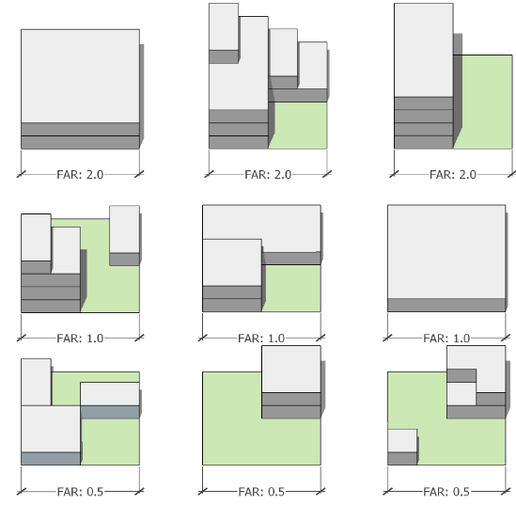

Floor Area Ratio (FAR)
The intensity of development, which can be regulated by total building size and lot coverage, may also be measured by Floor Area Ratio (FAR). FAR is calculated as the gross floor area of a building or buildings on a parcel divided by the area of the parcel. The maximum FAR standard limits the overall size of development on a parcel. For example, a maximum FAR of 0.75 would allow 75,000 square feet of total floor area on a 100,000 square foot lot. The 75,000 square feet could be developed in one building or multiple buildings and may consist of one or more stories.

- General Plan Land Use Designations
Designation | Description | Standards | Compatible Zoning
Rural Residential | The Rural Residential designation identifies areas appropriate for rural residential uses and compatible commercial agricultural activities on large single lots including low-density residential uses, family day care homes, vacation rentals, feed stores, retail nurseries, bed and breakfasts, agricultural enterprises, guest ranches, campgrounds and recreational facilities, recreational and educational agricultural uses, and public or government uses. The minimum lot size is 10 acres. | Density:  - 0-6 du/ac  Maximum FAR:  n/a  Minimum Lot Size:  - 10 acres | RR
Low Density Residential | The Low Density Residential designation identifies areas for low-density single-family residential neighborhoods and compatible uses at a neighborhood scale, including home enterprises, day care centers, and small-scale housing types in compliance with State law. Limited agricultural uses such as greenhouses and grazing may be allowed if compatible with the property and surrounding land uses. The minimum lot size is 2.5 acres. | Density:  - 0-6 du/ac (with water and sewer)  Maximum FAR:  n/a  Minimum Lot Size:  - 2.5 acres | RL
Mixed Density Residential | The Mixed Density Residential designation identifies areas that can accommodate a wider range of housing types. Allowed uses include, but are not limited to, single-family homes, duplexes, triplexes, multifamily housing, mobile home parks. Limited neighborhood-scale commercial uses, such as restaurants or professional offices may be allowed if they are compatible with and serve the surrounding residential land uses. The minimum lot size is 7,200 square feet. | Density:  6-20 du/ac  Maximum FAR:  n/a  Minimum Lot Size:  7,200 sf. | RM
Commercial | The Commercial designation identifies areas for a mix of commercial, educational, and public assembly, light industrial, and limited residential uses. This designation supports high-intensity commercial uses along major transportation corridors, including hotels and vehicle service stations, as well as less intensive commercial uses that are compatible with residential neighborhoods, including restaurants and laundromats. Schools, community centers, and places of worship, as well as light industrial uses such as medical laboratories and wholesale storage and sales, are also supported. Multifamily residential uses are allowed in compliance with State law. The minimum lot size is 2,000 square feet; however, all lots requiring an on-site septic tank system shall have a minimum lot size of 2.5 acres. | Density:  10-21 du/ac  Maximum FAR:  1.5  Minimum Lot Size:  - 2,000 sf (with water and sewer)  - 2.5 acres (on septic) | C
Industrial | The Industrial designation identifies areas for light and heavy manufacturing and industrial activities, as well as low-impact industrial uses where activities are conducted and confined within a structure. Allowed land uses include manufacturing, assembly, and packaging; distilleries and wineries; repair garages; storage facilities; medical and dental laboratories; contractor’s yards; lumberyards; creameries; and food processing. The minimum lot size is 7,200 square feet; however, all lots requiring an on-site septic tank system shall have a minimum lot size of 2.5 acres. | Density:  n/a  Maximum FAR:  1.5  Minimum Lot Size:  - 2,000 sf. (with water and sewer)  - 2.5 acres (on septic) | IN
Agricultural | The Agricultural designation identifies areas for commercial agriculture and related agricultural activities, as well as low-density residential uses mixed with agricultural uses. Allowed agricultural uses include nurseries, crop harvesting, livestock farming, and animal husbandry. Allowed residential uses include farm labor housing, single-family homes, and accessory dwelling units. The minimum lot size is 40 acres in Prime Agricultural (AG1) Districts and 10 acres in Non-Prime Agricultural (AG2) Districts. | Density:  1 du/10ac  Maximum FAR:  n/a  Minimum Lot Size:  40 acres (AG1)  10 acres (AG2) | AG1  AG2
Open Space | The Open Space designation identifies areas to be reserved for natural and scenic resources, wildlife habitat, or resource rehabilitation, and to support public, quasi-public, and private open space lands for the health, safety, and welfare of the public. Limited uses are allowed, including crop and tree farming, grazing, riding and hiking trails, wildlife refuges and game preserves, and scientific study sites. The minimum lot size is one acre. | Density:  n/a  Maximum FAR:  n/a  Minimum Lot Size:  1 acre | OS
Timberland Production | The Timberland Production designation identifies areas for the purpose of growing and harvesting timber and protecting timberland production areas from incompatible uses. The minimum lot size is 40 acres. | Density  n/a  Maximum FAR:  n/a  Minimum Lot Size:  40 acres | TPZ
State and Federal Public Lands | This designation applies to State or Federally owned land, generally including forests, parks, and recreation areas. The County has no land use authority in these areas. Areas so designated include land under federal or state ownership on which governmental facilities may be located. Principal uses include open space; public recreational facilities; support for fire suppression, fuel management, and forest health activities; and coordination of state, federal, and local facilities and programs. | Density  n/a  Maximum FAR:  n/a  Minimum Lot Size:  n/a | -
¹ Accessory dwelling units are allowed pursuant to the Zoning Code and applicable State law and do not count toward the allowable density.
² Single-family includes:
- A building containing one dwelling unit.
- A mobile home when placed upon a foundation system pursuant to Section 18551 of the Health and Safety Code of the State. (Source: Sec. 10-6.3602.53)

- General Plan Land Use Diagram
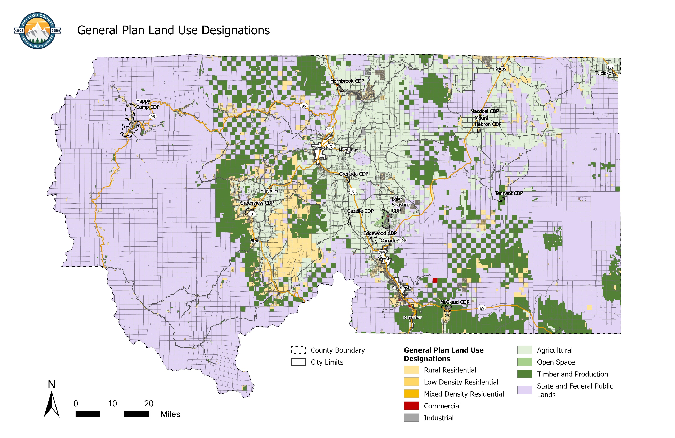

This page is intentionally left blank.

- Edgewood General Plan Land Use Diagram
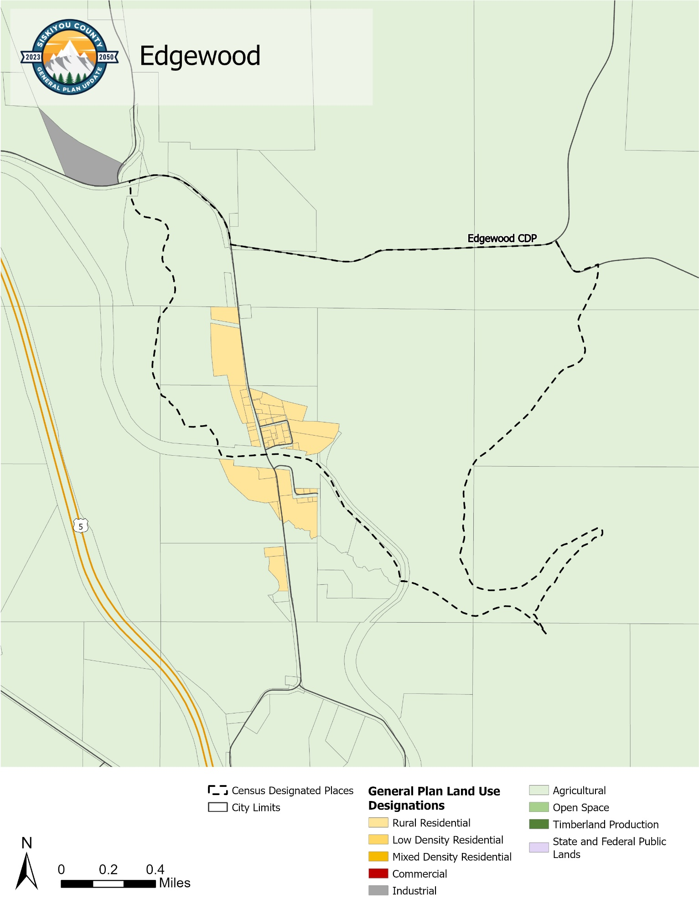
- Gazelle General Plan Land Use Diagram
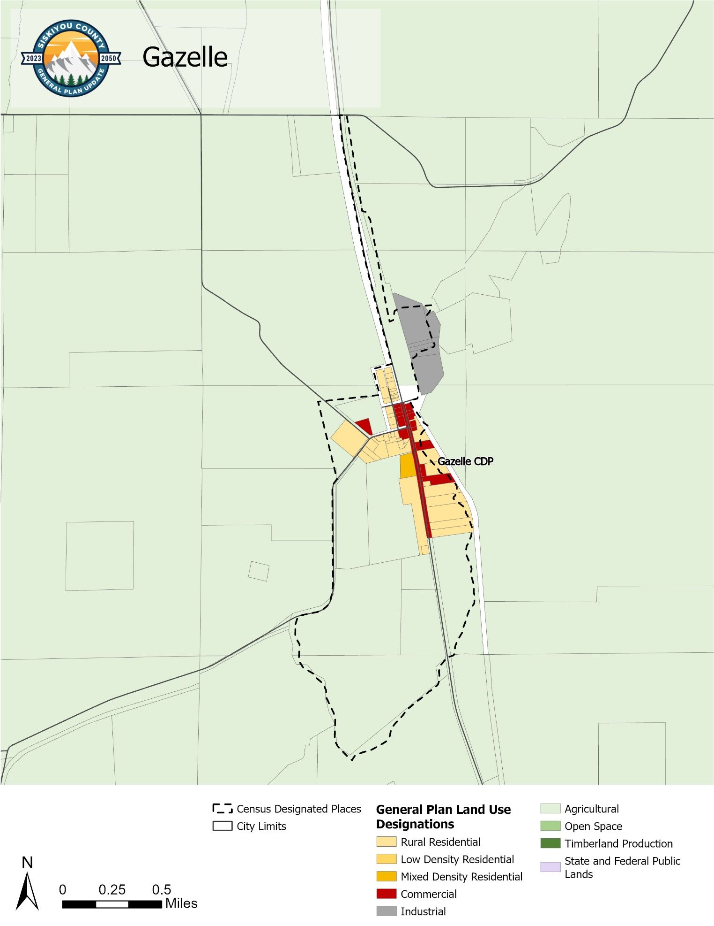
- Greenview General Plan Land Use Diagram
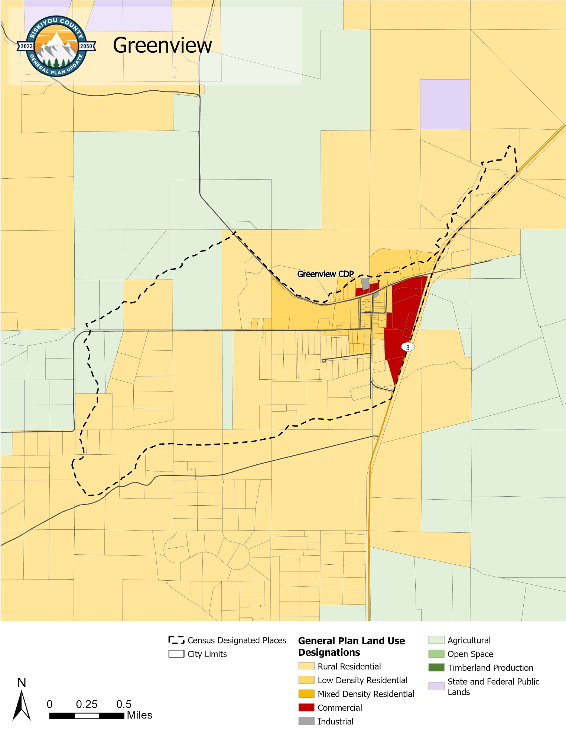
- Grenada General Plan Land Use Diagram
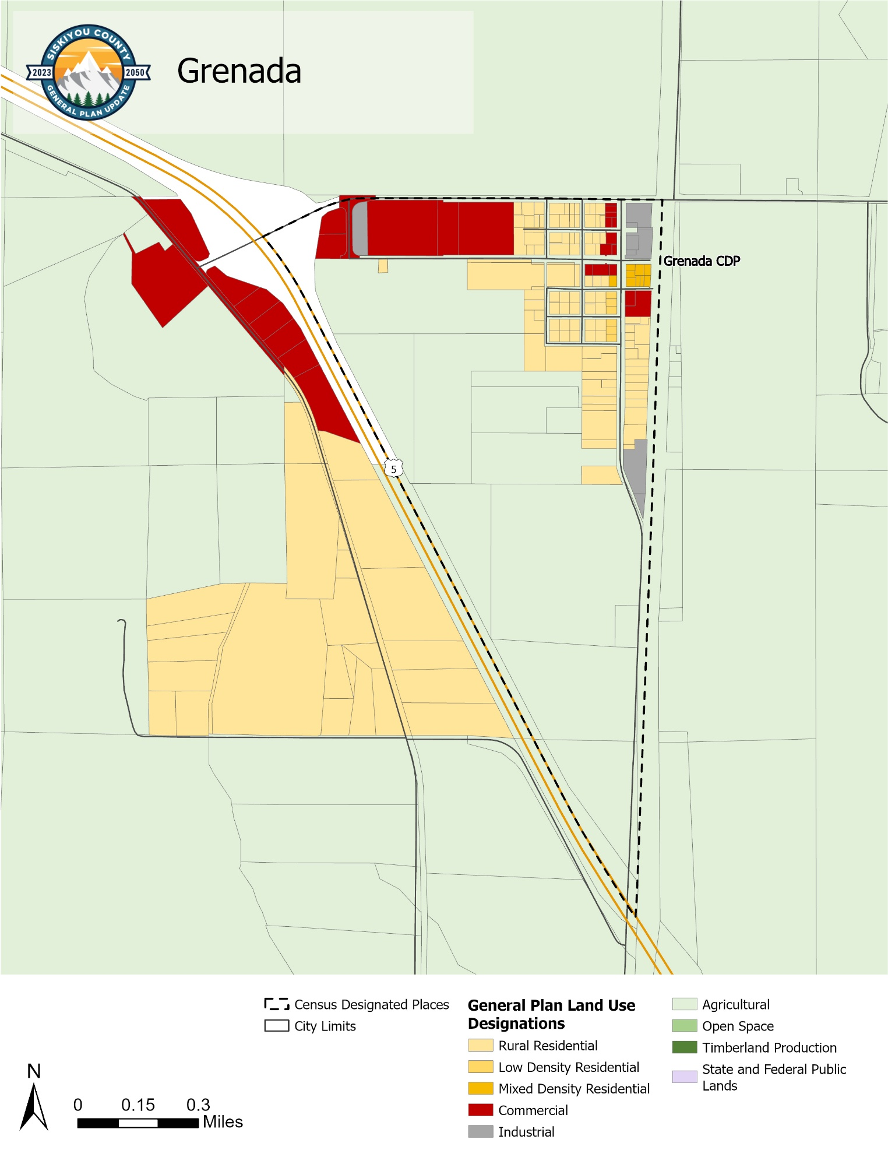
- Happy Camp General Plan Land Use Diagram
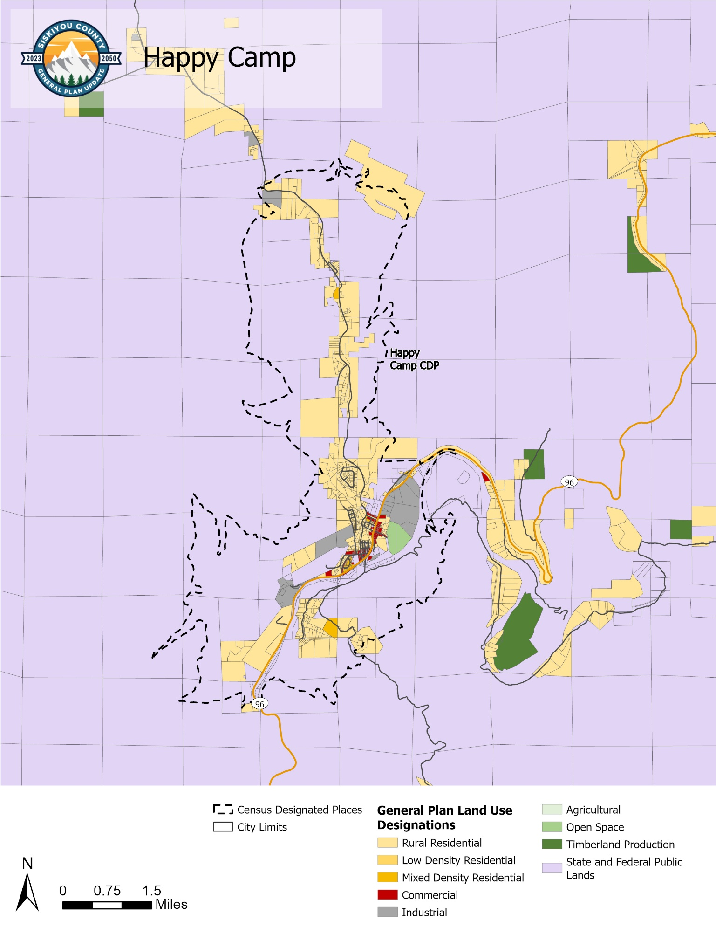
- Hornbrook General Plan Land Use Diagram
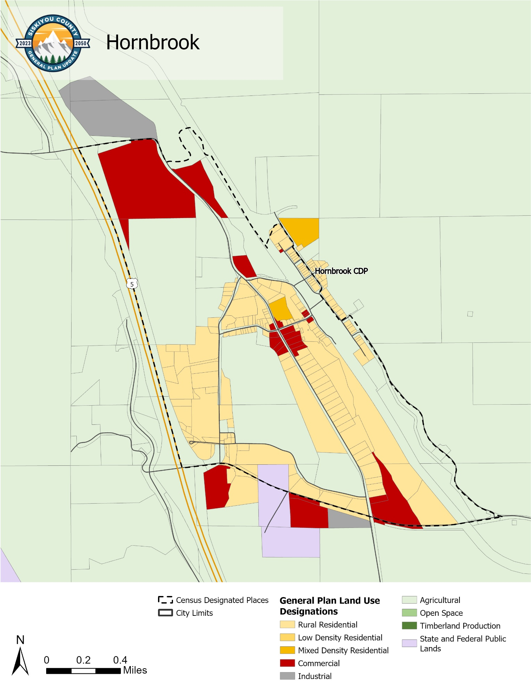
- Lake Shastina General Plan Land Use Diagram
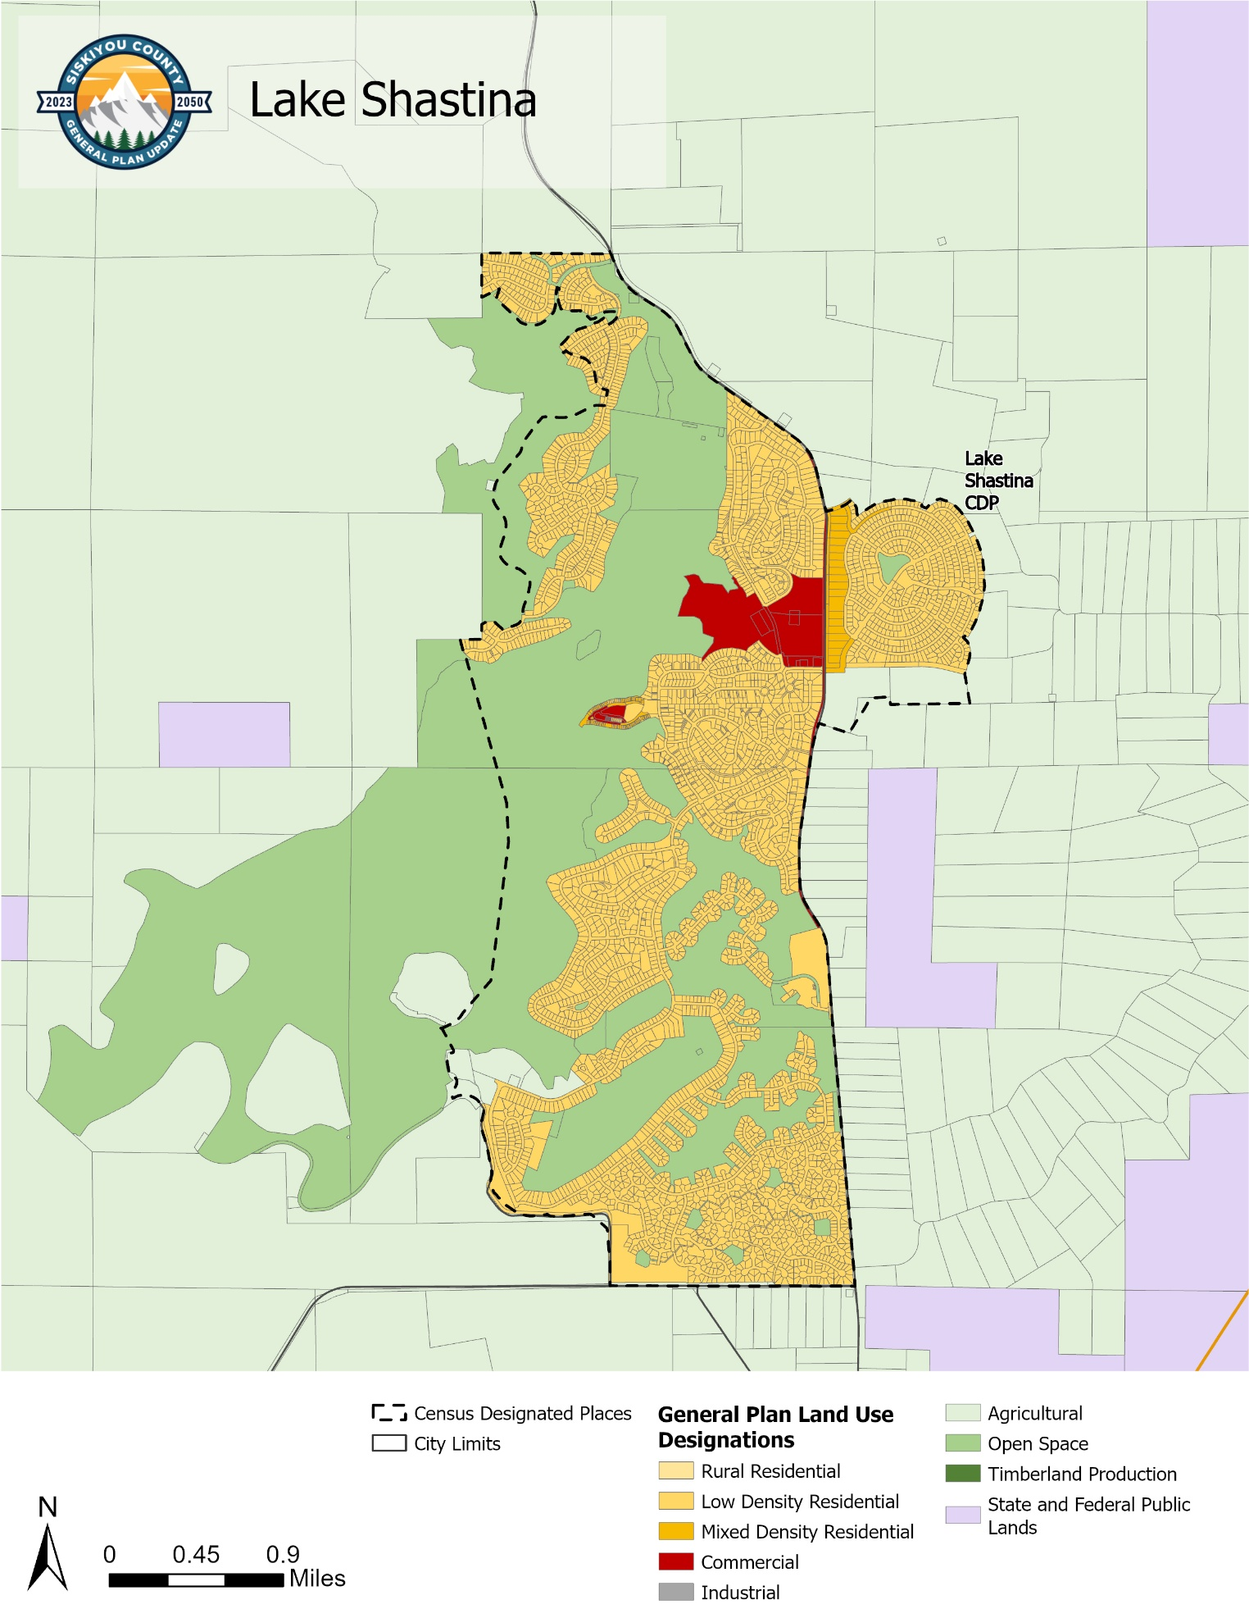
- Macdoel General Plan Land Use Diagram
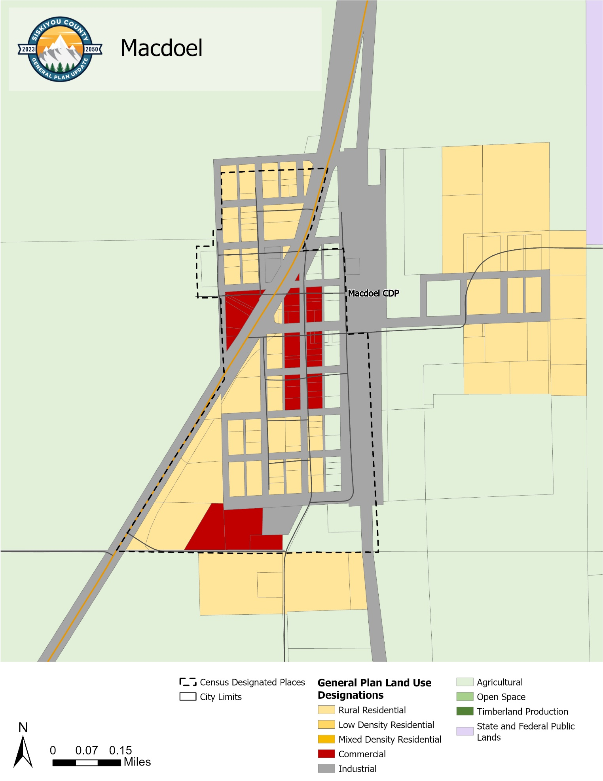
- McCloud General Plan Land Use Diagram
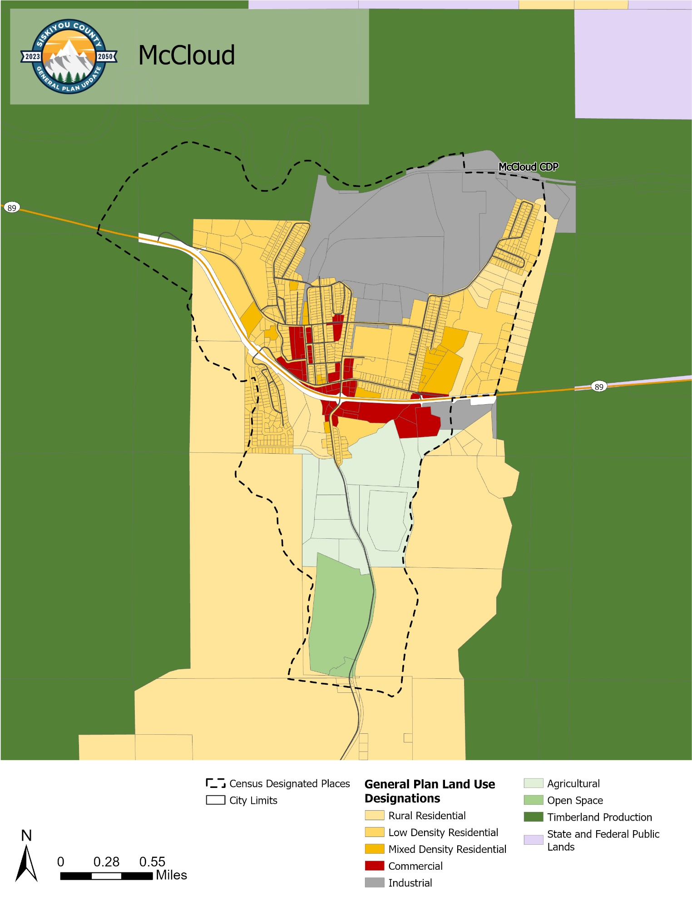
- Mount Hebron General Plan Land Use Diagram
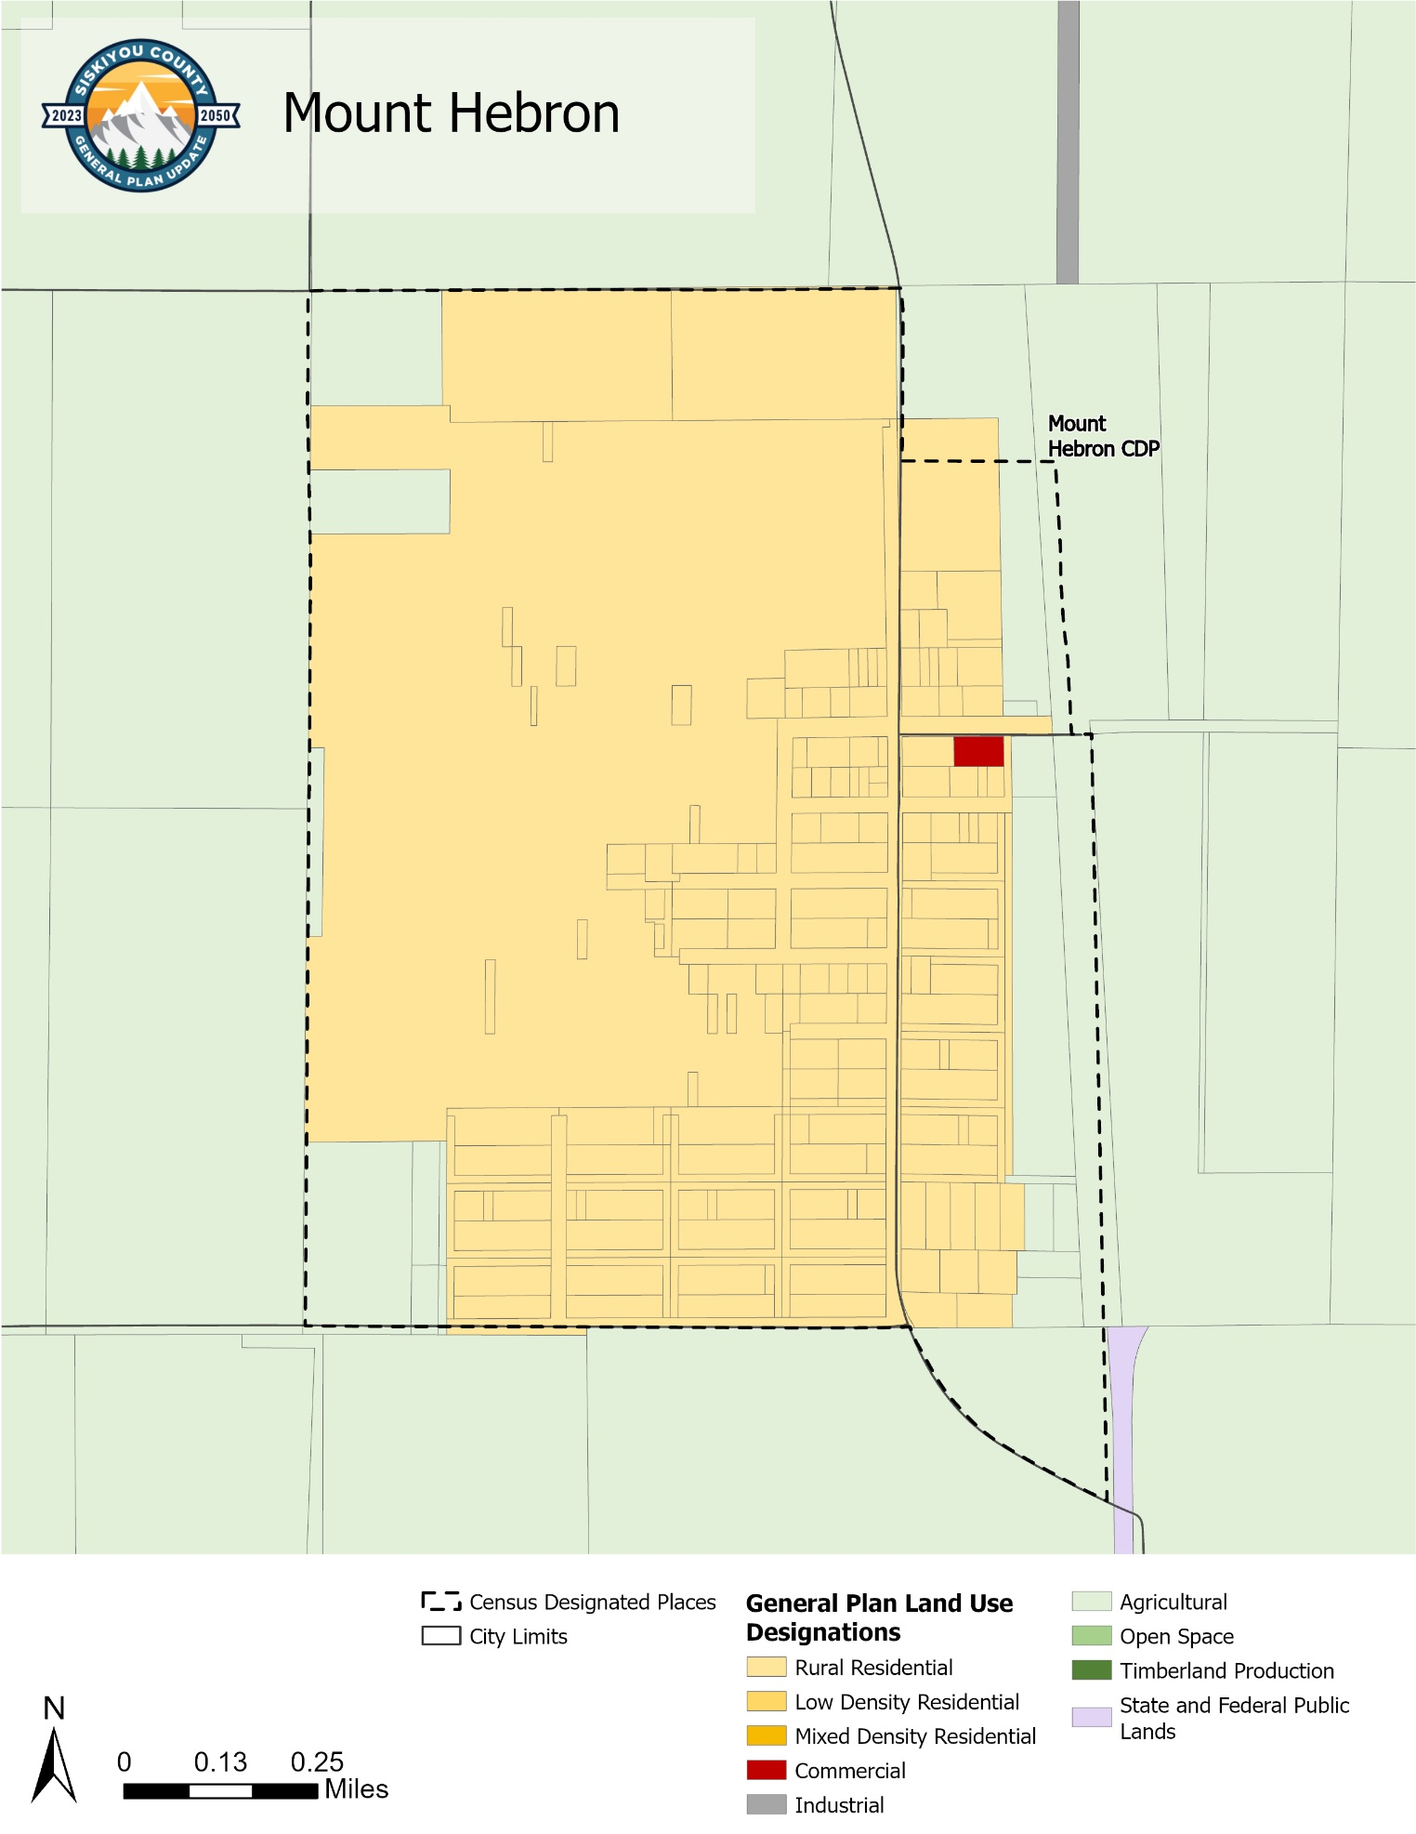
- Tennant General Plan Land Use Diagram
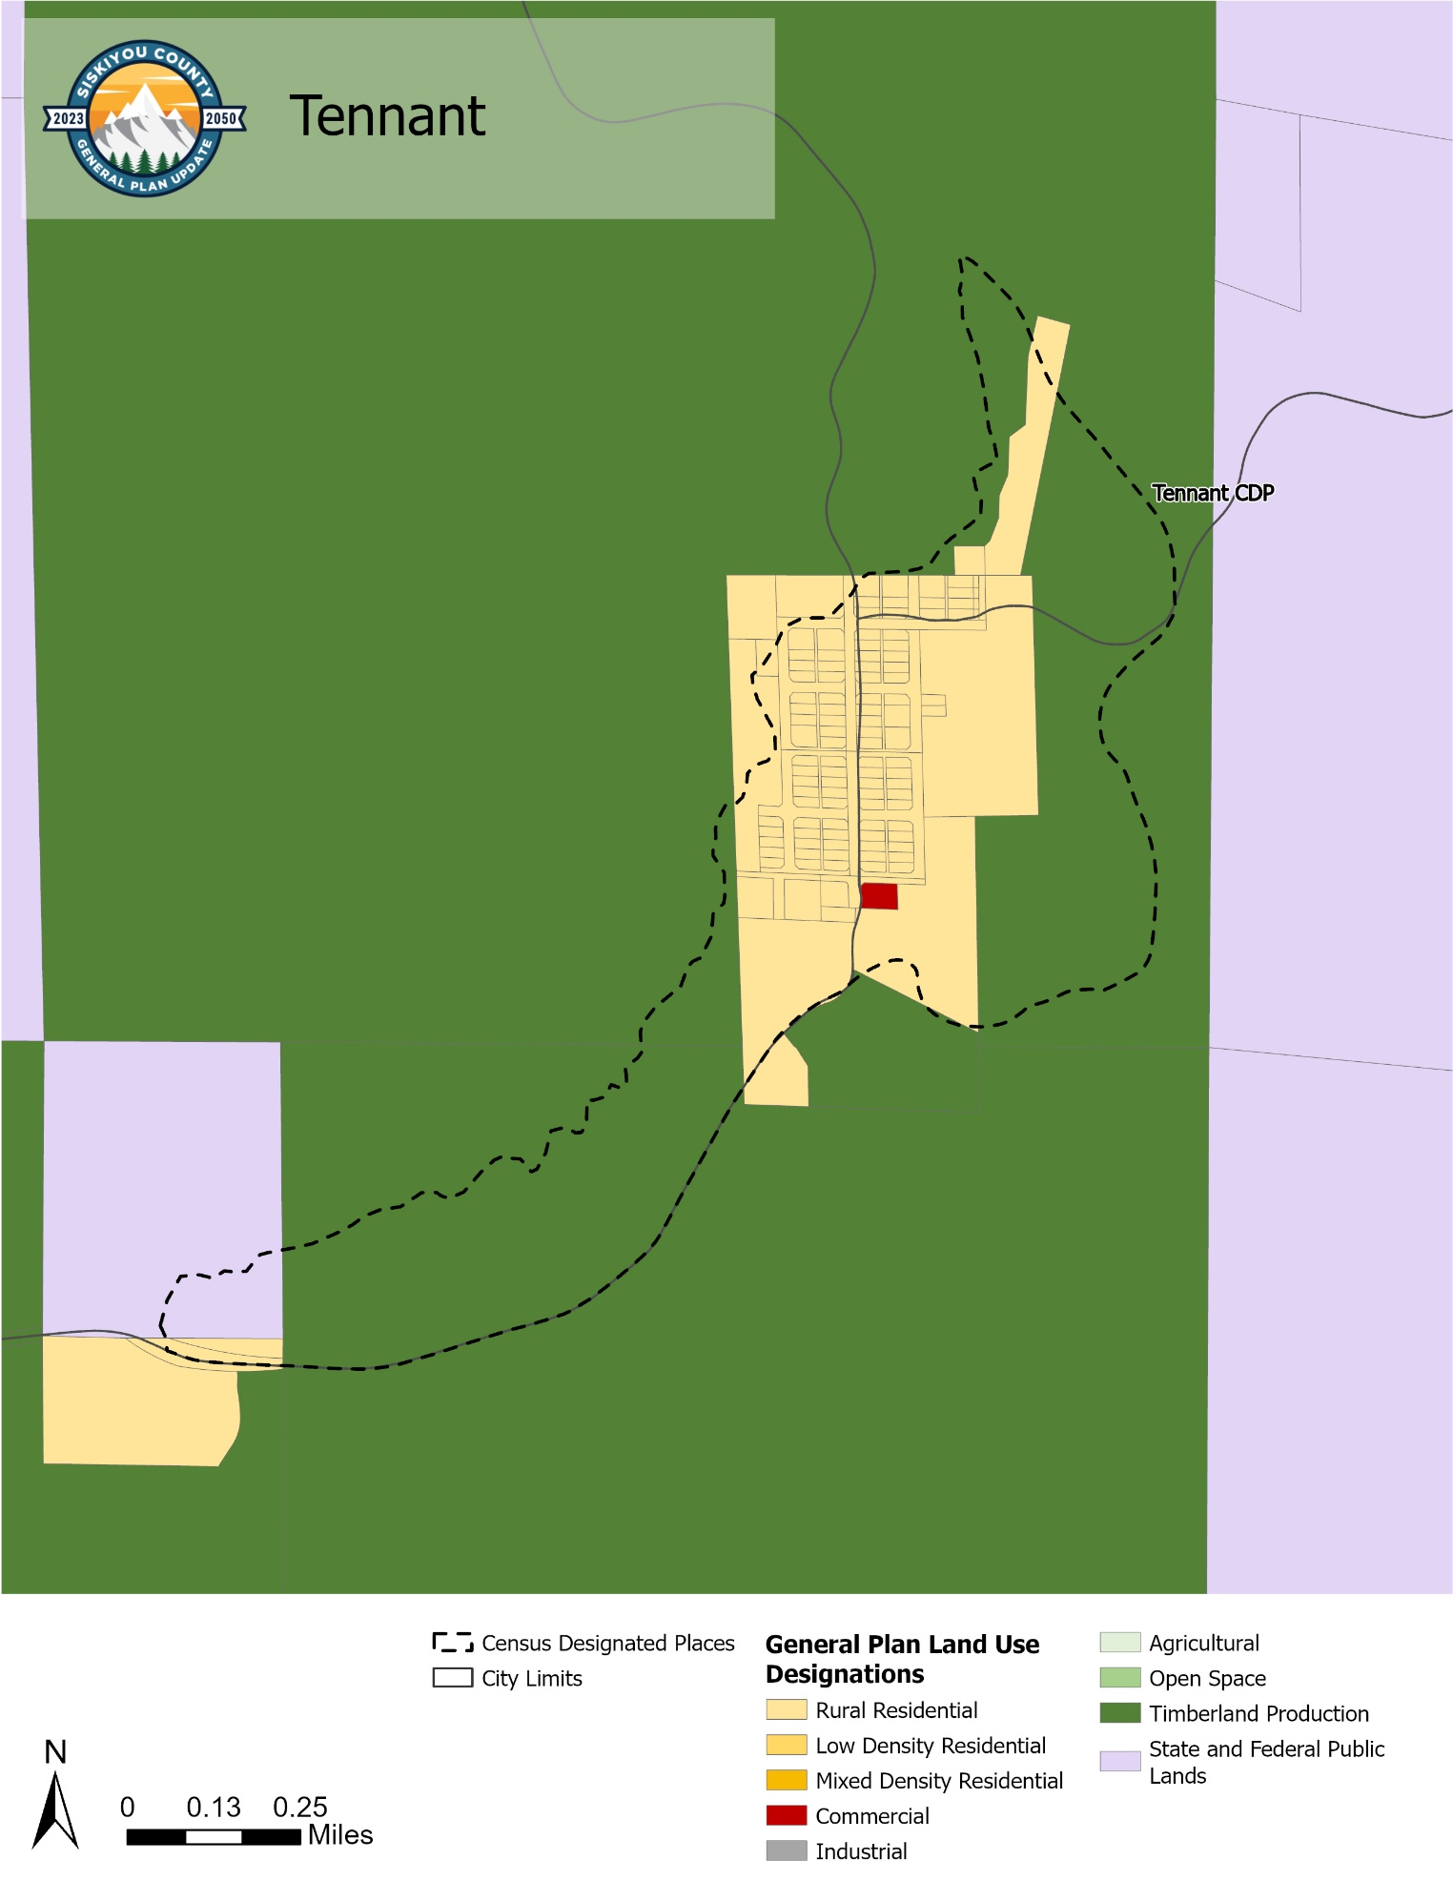

- General Plan and Allowable Zoning Districts
Zoning District | General Plan Land Use Designation |  |  |  |  |  |  |  | Minimum Lot Size  (on septic) | Maximum Lot Coverage | Density¹ | FAR
Zoning District | Rural Residential | Low Density Residential | Mixed Density Residential | Commercial | Industrial | Agricultural | Open Space | Timberland Production
Rural Residential Zone (RR) | X |  |  |  |  |  |  |  | 10 acres | 40% | 0-6  du/ac | -
Residential-Low Zone (RL) |  | X |  |  |  |  |  |  | 2.5 acres | 50% | 0-6  du/ac | -
Residential-Mixed Zone (RM) |  |  | X |  |  |  |  |  | 7,200 sq ft | 75% | 6-20 du/.ac | -
Commercial Zone (C) |  |  |  | X |  |  |  |  | 2,000 sq ft  (2.5 acre) | 75% | 10-24  du/ac | 1.5
Industrial Zone (IN) |  |  |  |  | X |  |  |  | 7,200 sq ft  (2.5 acre) | 75% | - | 1.5
Prime Agricultural Zone (AG1) |  |  |  |  |  | X |  |  | (40 acres) | 10% | - | -
Non-Prime Agricultural Zone (AG2) |  |  |  |  |  | X |  |  | (10 acres) | 20% | - | -
Open Space Overlay Zone (OS) |  |  |  |  |  |  | X |  | 1 acre | 35% | - | -
Timberland Production Zone (TPZ) |  |  |  |  |  |  |  | X | 40 acres | N/A | - | -

- Goals and Policies
How are goals and policies used?
Goals and policies direct future actions and decisions. When an application for development is received, County staff must complete a consistency review to ensure the project is consistent with the goals and policies of the General Plan and the standards and requirements of the County’s Zoning Code.
- Applications for uses allowed by right are approved through a staff-level process and must be consistent with the General Plan and the Zoning Code.
- Applications for projects found to be inconsistent with one or more aspects of the General Plan or Zoning Ordinance Code may be considered for approval by the Planning Commission and Board of Supervisors but may require amendment of the General Plan or Zoning Code to achieve consistency.
- Community planning efforts and long-range plans must also be consistent with the goals and policies of the General Plan, though they can provide additional detail.
- Land Use Balance

To allow for adequate growth and development to meet the needs of residents and visitors while sustainably managing natural resources. [Source: New Goal, based on existing text]
Policies
  - Guidance for New Development. The County shall structure zoning and development standards to support higher-intensity development within areas served by public services or located within existing urbanized or non-resource areas, while maintaining applicable development standards in resource and hazard areas. [Source: Existing text, modified].
  - Intensity. The County shall encourage development in areas served by existing public services at densities and intensities that make efficient use of public infrastructure and are consistent with applicable land use designations. [Source: New Policy]
  - Connectivity. The County shall encourage new subdivisions and commercial development to be located where adequate public services and infrastructure are available or can be provided, and to be planned in a manner that supports connectivity with existing communities. [Source: New Policy]
  - Efficient Use of Land. The County shall require new development to demonstrate adequate site area and access to necessary utilities and infrastructure, consistent with applicable zoning standards and public health and safety requirements. [Source: Existing Policy 41.5, modified]
  - Adequate Sewage. The County shall require all proposed new development to demonstrate compliance with applicable Environmental Health standards by providing evidence of adequate on-site wastewater disposal or the ability to connect to an existing public sewer system with sufficient capacity to serve the development. [Source: Existing Policy 41.8, modified]
  - Solid Waste Disposal Facilities. The County shall encourage the development of adequate solid waste and hazardous materials management facilities and services. [Source: New Policy]
  - Sufficient Land for Septic Systems. The County shall require minimum lot sizes for development utilizing on-site wastewater systems sufficient to protect public health and groundwater quality, including a minimum of 2.5 acres for residential, commercial, and industrial uses, consistent with applicable Environmental Health standards. [Source: New Policy, standards shown for each designation in Table 2.2]
- Development Patterns

To promote land use patterns that support compatible development, efficient infrastructure use, and long-term community sustainability. [Source: New Goal]
Policies
  - Compatible Uses. The County shall require new development to be compatible with surrounding existing uses and with the land use designations and policies of this General Plan. [Source: Existing Policy 41.3, modified]
  - Commercial and Industrial Development. The County shall encourage the development and expansion of commercial and industrial uses in areas designated and zoned for such uses, consistent with applicable infrastructure and public service capacity. [Source: New Policy]
  - Industrial Land. The County shall support the identification of additional land suitable for industrial development through this General Plan and zoning processes and may allow compatible, low-impact industrial uses within commercial areas, consistent with applicable zoning standards. [Source: New Policy]
  - Streamline Commercial and Industrial Development Approval. The County shall streamline the review and approval of commercial and industrial development consistent with the General Plan to foster economic development. [Source: New Policy]
  - Healthy Communities. The County shall encourage new development that supports and enhances the health and well-being of all residents, including health care options, access to healthy foods, active living, and aging in place. [Source: New Policy]
  - Location of Heavy Commercial and Heavy Industrial Uses. The County shall encourage the development of heavy commercial and heavy industrial uses near Interstate 5 and incorporated cities and in locations that minimize impacts on nearby residential and agricultural uses. [Source: Existing Policy 41.3, partial, modified]
  - Floodways and Water Bodies. The County shall manage development within designated floodways and within or adjacent to water bodies in accordance with applicable federal, state, and local laws and shall maintain setback requirements as established by ordinance to protect public safety, water quality, and property. [Source: Existing Policy 22, modified]
  - Public and Quasi-public Uses. The County shall encourage new County government buildings and other public and quasi-public uses to locate in central, accessible locations that serve the greatest number of residents. Density and minimum parcel size requirements shall not apply to land divisions required to accommodate public or quasi-public projects. [Source: New Policy]
- Flexible Development Framework

To provide a flexible land use framework that allows communities to address local needs and support appropriate development consistent with Countywide standards. [Source: New Goal, based on existing text]
Policies
  - Remove Regulatory Constraints. The County shall improve its land use permitting processes, including the use of administrative-level review where appropriate, to provide efficient, predictable, and cost-effective development review while ensuring consistency with this General Plan and applicable regulations. [Source: New Policy]
  - Standards for New Development. The County shall maintain clear, objective, and consistent development standards within the Zoning Code to provide predictability for applicants and the public. [Source: New Policy]
  - Efficient Review. The County shall use administrative review processes, where appropriate, to facilitate timely and cost-effective development review for projects consistent with this General Plan and the Zoning Code. [Source: New Policy]
  - CEQA Streamlining. The County shall apply the streamlining provisions of CEQA Guidelines Section 15183 to development projects that are consistent with this General Plan and applicable zoning regulations for which an Environmental Impact Report (EIR) has been certified. Environmental review for such projects shall be limited to project-specific significant effects that are peculiar to the project or its site, were not previously analyzed, or are more severe than previously analyzed in the prior EIR. [Source: New Policy]
  - Review Processes. The County shall maintain a clear and streamlined process for reviewing applications for new development, with defined review authority by permit type, including, but not limited to:
    - Allowed uses. Allowed uses shall be reviewed and approved at the staff level to ensure consistency with this General Plan and the Zoning Code.
    - Administrative Use Permit. Uses requiring an Administrative Use Permit shall be reviewed and approved by the Planning Director to ensure consistency with this General Plan, the Zoning Code, and applicable findings of approval.
    - Conditional Use Permit. Uses requiring a Conditional Use Permit shall be reviewed and approved by the Planning Commission based on required findings. The Planning Commission may exercise discretion in determining consistency with this General Plan and the Zoning Code and may impose reasonable conditions of approval.
    - Minor Deviations. The County shall provide a streamlined process for minor deviations and similar adjustments, which shall be reviewed and approved by the Planning Director. [Source: New Policy]
  - Water Storage Infrastructure. The County shall support the development and improvement of water storage capacity infrastructure and facilities, where consistent with state and federal law, to enhance water supply reliability for residents, agriculture, economic development, the environment, and other biological needs, such as aquatic spawning and movement. [Source: New Policy]
  - Public Access and Assistance. The County shall maintain and improve public access to clear information regarding development regulations, application requirements, and applicable fees, and shall provide reasonable guidance to applicants to promote transparency, predictability, and ease of use in the entitlement process. [Source: New Policy]
- Economic Development

To support a healthy, diverse, and resilient economy through appropriate land use designations, zoning, and development patterns that accommodate business and employment opportunities. [Source: New Goal]
Policies
  - Sustainable Economic Development. The County shall strive to optimize the mix, amount, types, and location of land uses to maximize fiscal and economic health for local residents and businesses. [Source: New Policy]
  - Supporting Local Communities. The County shall encourage the economic development of unincorporated community centers, inclusive of both census designated places and tribal communities. [Source: New Policy]
  - Home-based Businesses. The County shall allow home-based and small-scale business activities where such activities are compatible with surrounding uses and permitted under the Zoning Code. [Source: New Policy]
  - Multi-Use Parcels. The County shall allow compatible secondary and accessory uses on residential and agricultural parcels, including agricultural enterprises, small-scale commercial activities, and visitor-serving or event-related uses, where such uses are consistent with the Zoning Code and remain subordinate to the primary residential or agricultural use of the property. [Source: New Policy]
  - Commercial and Industrial Land. The County shall ensure that its land use designations and zoning provide opportunities for commercial and industrial development, including within established unincorporated community centers and tribal communities, to meet current and future business needs. [Source: New Policy]
  - Full Range of Services. The County shall encourage a full range of commercial and recreational services to meet the needs of local residents and visitors and reduce leakage of sales to areas outside the county. [Source: New Policy]
  - Construction Yards. To support development, the County shall allow for temporary on- and off-site construction yards in all agricultural, residential, commercial, and industrial areas. [Source: New Policy]
  - Economic Development Coordination. The County shall coordinate its economic development efforts with local groups, such as chambers of commerce, municipalities, Siskiyou Economic Development Council, and other organizations invested in supporting economic development in Siskiyou County. [Source: New Policy]
  - Historic Districts. The County shall coordinate with historic districts to promote county historic assets and encourage increased tourism. [Source: New Policy]
  - Job Training. The County shall encourage the development of education and job training programs to enhance existing skill levels and provide for job advancement. [Source: New Policy]
  - Tourism and Recreation. The County shall work with local jurisdictions to explore opportunities to preserve and promote well known landmarks and popular visitor destinations in the county while reducing the impact of tourism on the local community.
  - Visitor-Serving Uses. To further encourage economic development and tourism, the County shall encourage the private development of visitor-serving uses, such as campgrounds, hotels, restaurants, RV parks, and resorts. [Source: New Policy]
  - Temporary Uses. The County shall allow for a variety of temporary uses, including, but not limited to, events, seasonal sales lots, construction yards, temporary offices or residences, garage or rummage sales, and emergency facilities. [Source: New Policy]
  - Events. The County shall support the development of temporary events, including sporting events, festivals, community gatherings, agricultural enterprises, weddings, trade shows, conferences, and similar business, recreational, and tourism-related events. [Source: New Policy]
  - Activities for Youth. The County shall support the development of activities for youth near schools, parks, and entertainment/recreational uses. [Source: New Policy]
- Prime Agricultural Land

To protect prime agricultural land from fragmentation and incompatible development and support its long-term agricultural use. [Source: New Goal]
Policies
  - Prime Agricultural Land Defined. The County shall consider all Class I, II and III soils, and soils that become Class III or better under irrigation, with the exception of Class III soils determined to be non-irrigable, as prime agricultural land. [Source: Existing Policy 34]
  - Minimum Parcel Size for Prime Agricultural Land. The County shall require a minimum parcel size of forty (40) acres for lands designated as prime agricultural land, except where a different parcel size is established through an adopted area plan, community plan, or specific plan. [Source: Existing Policy 35, modified]
  - Minimum Parcel Size for Lands Adjacent to Prime Agricultural Land. The County shall require a minimum parcel size of twenty (20) acres for lands adjacent to prime agricultural land to maintain compatibility with agricultural operations and reduce land use conflicts. [Source: Existing Policy 36]
  - Allowed Uses on Prime Agricultural Land. The County shall only allow accepted agricultural uses and non-agricultural activities that are secondary to the primary agricultural use of the property on prime agricultural land. Accepted agricultural uses are those uses which are lawful, inherent, customary, necessary, reasonable, normal, safe and typical to the agricultural industry. A conditional use permit shall be required for all major non-agricultural activities. An administrative use permit shall be required for all minor non-agricultural activities. The determination of whether a non-agricultural activity is a major or minor activity shall rest with the Planning Director subject to appeal to the Planning Commission. [Source: Existing Policy 37, modified]
  - Alternative Uses of Agricultural Land. On lands mapped as prime agricultural land, but proven not to be prime agricultural land, the County shall allow non-agricultural uses upon issuance of all necessary permits, provided that the proposed non-agricultural uses are determined to be compatible with existing agricultural operations in the surrounding area. [Source: Existing Policy 38, modified]
  - Disproving a Prime Agricultural Land Designation. The County may redesignate land mapped as prime agricultural land where substantial evidence demonstrates that the land does not meet the definition of prime agricultural land established in LU-5.1. Such evidence may include, but is not limited to, soil studies, authoritative mapping corrections, documented irrigation infeasibility or lack of water, or other credible technical information. Economic infeasibility alone shall not constitute sufficient evidence that land is not prime agricultural land. [Source: Existing Policy 39, modified]
  - Prime Agricultural Land Homestead Exception. Notwithstanding LU-5.2, the County shall allow a one-time division of prime agricultural land to create a residential parcel not exceeding 2.5 acres for an existing or proposed single-family dwelling, provided that:
    - The remaining parcel continues to meet the forty (40) acre minimum parcel size requirement for prime agricultural land;
    - No more than one such division is permitted per original legal parcel existing as of the effective date of this General Plan; and
    - The property is not subject to a Williamson Act contract.
The newly created parcel shall be redesignated consistent with its residential use. [Source: Existing Policy 35.1, modified]
- Agricultural Viability and Diversification

To support the long-term viability of agriculture through land use policies that maintain agricultural production and allow for compatible secondary uses that are subordinate to the primary agricultural use. [Source: New Goal]
Policies
  - Williamson Act Participation. The County shall use Williamson Act contracts as a land use tool to support the continued use of agricultural lands for commercial production.
  - Support for Local Products. The County shall support opportunities to promote legal agricultural products grown or processed in Siskiyou County. [Source: New Policy]
  - Support for Agricultural Businesses. The County shall encourage the retention, expansion, and development of legal agricultural businesses including small businesses such as nurseries, small animal and equestrian activities, and specialty product production. [Source: New Policy]
  - Value-Added Agricultural Activities. The County shall encourage development of food processing and other facilities that could support production of “value-added” agriculture¹ products from Siskiyou County. [Source: New Policy]
  - Compatible Secondary Uses on Agricultural Land. The County shall allow compatible secondary uses, including event-related activities, on lands designated for agricultural use, provided such uses remain secondary to the primary agricultural use, do not preclude continued agricultural production, and comply with applicable zoning standards. [Source: New Policy]
- Timber Production

To manage and protect timberlands for long-term timber production. [Source: Existing text, modified]
Policies
  - Timberland Production. The County shall utilize appropriate land use designations and zoning, including the Timberland Production Zone (TPZ), to retain lands suitable for long-term timber production and prevent incompatible non-resource development. [Source: Existing Policy 33, modified]
  - Parcel Integrity. The County shall maintain minimum parcel sizes and discourage fragmentation of timberlands to support continued timber production. [Source: New Policy]
- Coordination and Engagement

To coordinate land use planning efforts with local communities and regional partners. [Source: New Goal]
Policies
  - Area Plans. The County may prepare and adopt area plans for defined geographic areas, provided such plans are consistent with this General Plan and adopted as amendments to the Land Use Element. [Source: Existing Policy 41.10, modified]
  - Interagency Coordination and Public Participation. The County shall coordinate planning efforts with cities, special districts, tribal governments, other public agencies, community-based organizations, and state and federal agencies, as appropriate, and shall provide reasonable opportunities for public participation in planning processes consistent with applicable law. [Source: New Policy]
  - Public Engagement. The County shall provide public notice and engagement opportunities through multiple communication methods to promote broad community participation in land use planning processes. [Source: New Policy]
- Environmental Justice

To promote fair treatment in land use planning and reduce disproportionate environmental impacts consistent with Government Code §65302(h). [Source: New Goal]
Policies
  - Equitable Access to Public Facilities. The County shall consider equitable access to public facilities and infrastructure when making land use decisions and planning community development. [Source: New Policy]
  - Disproportionate Impact Review. The County shall consider potential disproportionate health and safety impacts when reviewing land use decisions involving hazardous materials, industrial uses, or other activities that may adversely affect nearby communities. [Source: New Policy]
  - Food Access. The County shall ensure that zoning regulations allow food retail and related uses in appropriate districts to improve access to fresh food. [Source: New Policy]
  - Solid Waste and Recycling Facilities. The County shall ensure that land use designations and zoning provide appropriate locations for solid waste and recycling facilities consistent with applicable standards and in a manner that minimizes potential impacts on nearby residential communities. [Source: New Policy]
  - Wastewater Capacity and Development Intensity. The County shall not approve higher-density or higher-intensity development in areas where public sewer or on-site wastewater systems lack the capacity to safely serve the proposed use. [Source: New Policy]
  - Childcare Facilities. The County shall ensure that zoning regulations allow licensed childcare facilities in appropriate zoning districts consistent with State law. (Source: New Policy)
- General Plan Administration and Maintenance

To provide a clear framework for the administration, periodic review, and implementation of this General Plan. [Source: New Goal]
Policies
  - Periodic Review. The County shall periodically review this General Plan and update its elements as necessary to reflect changing conditions and State law. [Source: New Policy]
  - Implementation Monitoring. The County shall monitor and update General Plan implementation programs as needed to ensure continued relevance, feasibility, and consistency with available resources. [Source: New Policy]
  - General Plan Maintenance. The County shall support the establishment of a General Plan maintenance fee sufficient to ensure funding to complete annual General Plan progress reports, five-year General Plan reviews, and future technical or comprehensive General Plan updates. [Source: New Policy]
- Scott Valley Planning Area

To guide growth in the Scott Valley Planning Area in a manner that protects agricultural resources and maintains the area’s scenic and natural character, consistent with the Scott Valley Area Plan. [Source: New Goal]
Policies
  - Prime Agricultural Land – Scott Valley Planning Area. Within the Scott Valley Planning Area, lands designated as prime agricultural land shall be maintained for agricultural use and protected from incompatible development consistent with the Scott Valley Area Plan. [Source: Existing Scott Valley Plan text, modified].
    - The minimum parcel size for lands designated as prime agricultural land in the Scott Valley Planning Area shall be eighty (80) acres. [Source: Existing Scott Valley Plan text]
    - For agricultural lands within the Scott Valley Planning Area that are not designated as prime agricultural land, the minimum parcel size shall be forty (40) acres. [Source: Existing Scott Valley Plan text]
  - Location of Commercial and Industrial Uses. The County shall provide for commercial and industrial uses within or adjacent to the established communities of Fort Jones, Greenview, Etna, and Callahan consistent with adopted land use designations and zoning standards. [Source: Existing Scott Valley Plan text, modified]
  - Residential Development Patterns. The County shall provide for higher residential densities within or adjacent to the established communities of Fort Jones, Greenview, Etna, and Callahan consistent with infrastructure capacity and applicable zoning standards. [Source: Existing Scott Valley Plan text, modified]

- Implementation Programs
 | Implements Which Policy(ies) | Responsible Department | Funding Source | Timeframe
 | Implements Which Policy(ies) | Supporting Department(s) | Funding Source | Timeframe
- Expedited Review  The County shall adopt an expedited development application review process for projects that are consistent with this General Plan and applicable zoning regulations. The process shall clearly identify application submittal requirements, review procedures, responsible County departments, applicable local, State, and Federal agency coordination, and target processing timelines. The procedure shall streamline review where legally permissible and reduce unnecessary public meetings while maintaining compliance with CEQA and other applicable law. Where appropriate, the County shall utilize applicable CEQA exemptions or streamlined environmental review consistent with this General Plan Program EIR and State law. (Source: New Program) | LU-3.3:  LU-3.4:  LU-3.5:  LU-3.7: | Community Development | General Fund | 2026-2030
- Prepare a Grading Ordinance  The County shall prepare and adopt a grading ordinance. (Source: New Program) | LU-1.1:  Goal LU-2  LU-3.2: | Community Development | General Fund | 2026-2030
- Zoning Code and Map Update  The County shall update the Zoning Code for consistency with the 2050 General Plan Update and for compliance with State law. (Source: New Program) | LU-10.2: | Community Development | General Fund | 2026
- Annual General Plan Implementation Review  The County shall conduct an annual review of this General Plan focused on the status of implementation programs. A report shall be prepared for the Board of Supervisors summarizing progress, identifying constraints, and recommending any necessary policy or program amendments. (Source: New Program) | LU-10.1:  LU-10.2: | Community Development | General Fund | Annually
- General Plan Maintenance Fund.  The County shall establish a General Plan Maintenance Fund to ensure funding to complete annual General Plan progress reports and future technical or comprehensive updates. [Source: New Program] | LU-10.3: | Community Development | General Fund | 2026-2030
- Disadvantaged Communities  The County shall incorporate environmental justice considerations into General Plan implementation and land use decision-making processes, consistent with State law. The County shall utilize available CalEPA and other relevant data sources to identify disadvantaged communities and consider appropriate policy responses where applicable. (Source: New Program) | LU-9.2:  LU-9.3: | Community Development | General Fund | 2030

Value-added agriculture entails changing a raw agricultural product into something new through packaging, processing, cooling, drying, extracting or any other type of process that differentiates the product from the original raw commodity. Source: Oregon State University.

