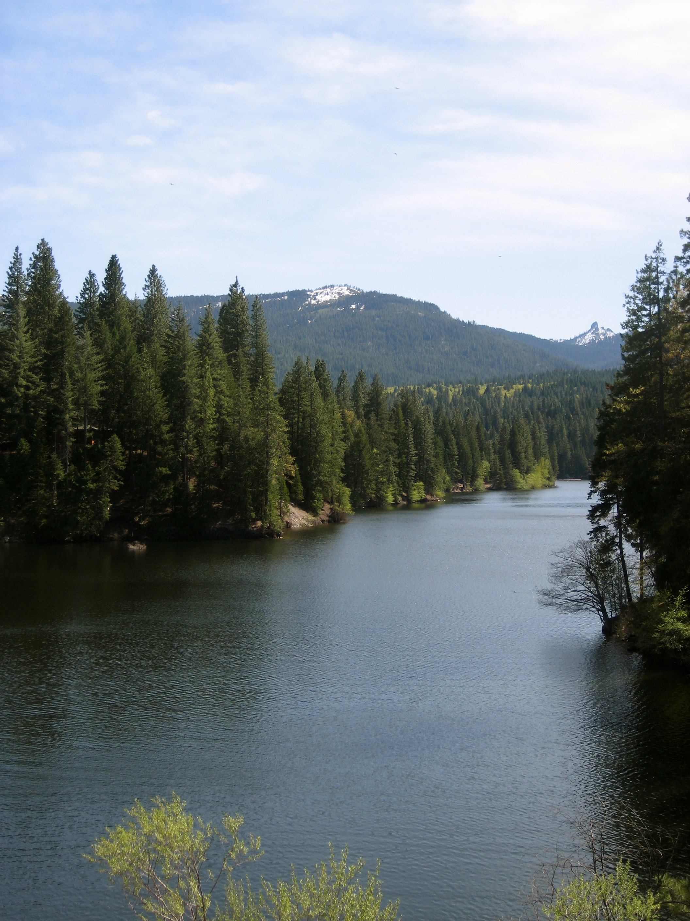

1. Introduction

The Siskiyou County General Plan is a long-range plan that guides decision-making and establishes rules and standards for new development and county improvements. This chapter describes the purpose and organization of the Siskiyou County General Plan, including an overview of the General Plan, why it is prepared, and why it is important. The Introduction also describes the process to prepare the update, as well as to maintain and amend the General Plan during the planning period.

Table of Contents
1.1 Purpose of the General Plan INT-3
1.2 Analyses Informing the General Plan INT-5
1.3 Regional Setting INT-7
1.4 Community Engagement INT-9
1.5 Using the General Plan INT-11

  - Purpose of the General Plan
What is a General Plan?
Every city and county in California is required by law to adopt and maintain a general plan, which is the local government’s long-term framework or “blueprint” for future growth and development. The general plan represents a city, county, or community’s vision of its future and outlines and expresses community goals and policies. All specific plans, subdivisions, public works projects, and zoning decisions must be consistent with the general plan. The Siskiyou County General Plan includes the goals and policies upon which the Board of Supervisors and Planning Commission base their land use decisions. Typically, the time horizon for general plans ranges from 15 to 25 years. The horizon year for Siskiyou County’s General Plan Update is 2050. A general plan has four defining features:
- General. A general plan provides general guidance for future land use, transportation, environmental, and resource decisions.
- Comprehensive. A general plan addresses a broad range of social, economic, infrastructure, and natural resource topics. These include land use, urban development, housing, transportation, public facilities and services, recreation, agriculture, biological resources, safety, and many other topics. See Section 1.6 for a list of the topics addressed in the Siskiyou County General Plan Background Report.
- Long-Range. A general plan provides guidance on achieving a long-range vision for a community’s future. To achieve this vision, general plans include goals, policies, and implementation programs that address both near-term and long-term needs.
- Integrated and Coherent. A general plan’s goals, policies, and implementation programs present a comprehensive, unified program for future development. A general plan implements consistent assumptions and projections to assess future demands for housing, employment, and public services or infrastructure. A general plan has a coherent set of policies and implementation programs that enable a community’s citizens to understand the vision of the General Plan, and businesses, landowners, and industry to be more certain about the standards and priorities of Siskiyou County and how they will be implemented.
General plans are the basis for a variety of regulatory measures and administrative procedures. California planning law requires consistency between general plans and their implementing programs, such as zoning, subdivision ordinances, specific plans, area plans, environmental impact assessment procedures, capital improvement programs, and building codes. That said, a general plan should not be confused with zoning. Although both general plans and zoning ordinances designate how land may be developed, they do so in different ways. General plans have a long-term outlook and identify the types of development that will be allowed, the spatial relationships among land uses, and the general pattern of future development. Zoning ordinances regulate development through specific standards such as lot size, building setback, and allowable uses. The land uses shown on general plan diagrams or maps will, however, typically be reflected in local zoning maps as well, as State law requires that they be consistent with one another. Development must not only meet the specific requirements of a zoning ordinance, but also the broader policies set forth in a general plan.
Over time, the county's population will increase, its goals will evolve, and the physical environment will change. For a general plan to be a useful document, it must be monitored and periodically revised to respond to and reflect changing conditions, needs, and priorities. A general plan should be reviewed annually, with a more comprehensive and thorough review and revision being done every five to ten years to assess whether it needs to be refined to reflect changes in local conditions, new local priorities, or State law. State law permits a general plan to be amended up to four times in any calendar year unless special conditions apply as defined by Government Code Sections 65358(c) and (d). Each amendment may include more than one change to the general plan.
Why Update the General Plan?
Siskiyou County adopted its current General Plan starting in 1972. While the existing General Plan is serving the community well, the County has undertaken this update to refine the Plan, address emerging trends and recent State laws, consider new issues, and remove completed implementation measures. The Update is a fine-tuning of the existing General Plan, rather than a comprehensive overhaul of the document. The purpose of the General Plan Update is to implement best practices in planning to ensure that Siskiyou County is resilient to future risks while also improving quality of life.
Who Prepared the General Plan Update?
The General Plan Update is being prepared by the County Community Development Department with direction from the Board of Supervisors and input from the Planning Commission and the community. The General Plan Team includes Siskiyou County Community Development staff and a consulting team consisting of a core group of planners, urban designers, and technical specialists:
- Mintier Harnish (lead consultant) (Land Use Planning, Zoning Code, community engagement)
- Rincon Consultants (Environmental Resources, CEQA)
- DKS Associates (Transportation Planning)
- The Natelson Dale Group (TNDG) (Economic and Market Analysis)
Maintaining the General Plan
Over time, the County’s population will likely increase, its goals will evolve, and the physical environment in which its residents live and work will change. In order for the General Plan to be a useful document, it must be monitored and periodically revised to respond to and reflect changing conditions and needs.
The General Plan should be reviewed annually to evaluate the progress in achieving its goals. A more comprehensive and thorough review should be done every five to 10 years to assess whether the plan needs to be refined or updated to reflect changes in local conditions, local priorities, or state law. State law permits the General Plan to be amended up to four times in any calendar year unless special conditions apply as defined by Government Code Sections 65358(c) and (d). Each amendment may contain more than one change to the General Plan.
General Plan Amendments can be initiated by the County or at the request of a property owner. Each General Plan Amendment goes through a public review process with review and hearings. Each Amendment is also subject to review under the California Environmental Quality Act (CEQA).

  - Analyses Informing the General Plan
Existing Conditions Background Report
The Existing Conditions Background Report provides a clear understanding of current trends and conditions in the county. The Report provides a detailed description of a range of topics within the county, such as economic and demographic conditions, housing, land use, natural resources, and public facilities, services, and infrastructure. Unlike the Policy Document, the Existing Conditions Background Report is policy neutral. The Background Report also serves as the “Environmental Setting” section of the Environmental Impact Report (EIR) prepared for the General Plan.
Vision and Guiding Principles
The Vision and Guiding Principles are designed to reflect what community members value most about their community and the shared aspirations of what they envision their community being in the future. They are intended to be inspirational and set the key values and aspirations for the General Plan. All goals, policies, and implementation programs in the General Plan must be consistent with the Vision and Guiding Principles.
The following Vision and Guiding Principles were developed in direct response to feedback collected at the first community workshop series, the second Technical Advisory Committee meeting, the second Planning Commission and Board of Supervisors joint study session, comments from the Karuk Tribe, and final comments from the Board of Supervisors. The Vision and Guiding Principles were presented to the Board of Supervisors on April 15, 2025, and were subsequently approved.
Vision Statement
The Vision Statement is an aspirational description of what the community would like to be in the future. It is a summary of high-level goals to be achieved by the updated General Plan and provides the foundation for all subsequent goals, policies, and programs. Siskiyou County’s vision for the future is as follows:
“To build a sustainable, prosperous future for all, Siskiyou County strives to improve the lives of workers and residents alike by focusing on the following priorities:
- Maintaining the County’s rural heritage, including the right to farm, the right to gather traditional foods, and open range.
- Diversifying new and emerging industries and expanding business opportunities based on agriculture, the natural resources economy, outdoor recreation, and local tourism.
- Increasing housing stock while preserving the unique character of our communities.
- Emphasizing and preserving private property rights while encouraging sound stewardship of renewable resources and working landscapes.
- Continuing coordination and collaboration with tribal partners.
- Increasing support for local schools and creating educational opportunities for rural communities.
- Prioritizing local community interests, including wildfire and natural hazard mitigation, while providing efficient, cost-effective government services.”
Guiding Principles
Guiding Principles are central ideas that articulate the County’s commitment to achieving the Vision Statement. They establish key values and aspirations for Siskiyou County’s future and act as guideposts for the goals, policies, and implementation measures contained within the General Plan. These principles expand on the main ideas contained in the vision statement so that important concepts are given appropriate weight. Guiding principles are purposefully broadly stated to guide the County throughout development of the updated General Plan.
The Guiding Principles are organized around five topic areas:
1. Hazards, Safety, and Wildfire Preparedness
- Protecting communities from natural hazards.
- Maintaining community health and safety through disaster preparedness and hazard mitigation.
- Fostering community resilience.
2. Natural Resources and Scenery
- Responsibly managing natural resources and open spaces.
- Maintaining public access to recreational opportunities.
- Promoting sustainable water resource management practices to encourage agriculturally based economic development, conservation of fish and wildlife habitat, and recreation.
3. Economic Development
- Incentivizing economic development.
- Expanding employment and educational opportunities, including workforce development.
- Boosting local tourism.
- Supporting renewable energy.
- Expanding the natural resource economy.
- Encouraging locally owned businesses.
4. Sense of Community and Unique Lifestyle
- Prioritizing rural communities and lifestyles.
- Fostering the unique characteristics of our communities.
5. Land Use, Housing, and Infrastructure
- Incentivizing development to meet current and future housing needs.
- Providing efficient, competent, and cost-effective government services.
- Encouraging development near cities and employment centers.
- Continuing to support local schools and health facilities.
- Investing in local infrastructure.

Environmental Impact Report (EIR)
An environmental impact report (EIR) presents detailed information about a proposed project’s environmental effects, includes options for minimizing a project’s significant environmental impacts, and presents reasonable alternatives that would result in fewer environmental impacts than the proposed project. The analysis presented in the EIR must comply with the requirements of the California Environmental Quality Act (Sections 15126, 15175, and 15176 of the CEQA Guidelines). The Planning Commission and Board of Supervisors will review the EIR to understand potential environmental implications associated with implementation of the General Plan and to identify feasible mitigation measures.
  - Regional Setting
Siskiyou County covers approximately 6,347 square miles and is located in the northernmost part of California, along the California-Oregon border. The county is made up of high mountain peaks, heavily forested areas, deep river canyons, and valleys. The county includes numerous mountain ranges including the Klamath Mountains, Cascade Range, and Siskiyou Mountains, and many valleys, including Shasta Valley, Scott Valley, and Butte Valley. The rugged terrain is sparsely populated, with 44,076 people, according to the 2020 Census. A vast majority of the land within the county is Federally or State owned. Siskiyou County has nine incorporated cities, 12 Census Designated Places (CDPs), and 17 unincorporated communities.
Siskiyou County was formed from parts of Shasta and Klamath Counties and was officially established on March 22, 1852. The county got its name from the Siskiyou Mountain range. Siskiyou County includes parts of Shasta-Trinity National Forest, Rogue River-Siskiyou National Forest, Klamath National Forest, and Butte Valley National Grassland. The county is bordered by the State of Oregon to the north, Humbodlt, Trinity, and Shasta counties to the south, Modoc County to the east, and Del Norte County to the west.
The basins of northeastern Siskiyou County, including Butte Valley, Lower Klamath and Tulelake basins, have some of the deepest and richest soils in the State, producing alfalfa, potatoes, horseradish, and brewing barley. The Scott River, Shasta River, and Klamath River as well as their tributaries and riparian corridors contain important habitats for a wide range of animal species. Figure 1.1 shows the regional context map of Siskiyou County.

- Regional Context
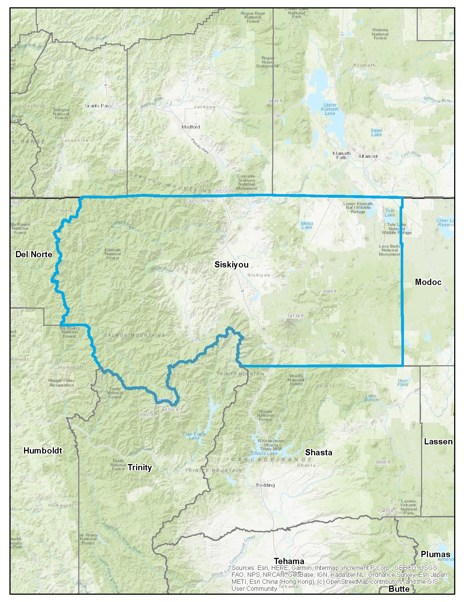

OREGON
CALIFORNIA

  - Community Engagement
The Siskiyou County 2050 General Plan Update was prepared over the course of four years, with various forms of public engagement planned at each step of the update process. Engagement events included workshops, public meetings, and online exercises and surveys. Siskiyou County Community Development staff and the consultants (General Plan Team) also hosted a dedicated project website, sent emails throughout the project to a project email list, and posted updates to social media. Feedback gathered throughout the community engagement process helped identify existing community needs and challenges to consider in the update, informed the development of the community vision and guiding principles, and guided the goals, policies, and implementation programs included in the General Plan.
Project Website
To engage and inform residents online, the County created a project website, www.siskiyou2050.com that has served as the central hub for information related to the General Plan Update. The website includes an overview of the basics of a general plan and the overall update process, links to all project documents, notifications about events, and online exercises and surveys. The website also allowed residents to sign up for email notifications about the project and submit comments at any time.
Community Workshops
The County held six community workshops to gather community input regarding assets, issues, opportunities and to help establish a long-term vision for the county’s future. These workshops also served as a forum for community members to discuss and learn about the General Plan update process and the findings from the County’s Background Report. Held in June 2024 these, initial workshops were held in six communities: Fort Jones, Dunsmuir, Gazelle, McCloud, Dorris, and Happy Camp. All workshops included various activities to solicit input, including several topic-specific exercises and general comment cards, as well as educational posters about the overall project purpose, timeline, and process.
Online Exercises and Surveys
The General Plan Team developed a variety of online exercises and surveys following in-person workshops to collect additional input from community members who were unable to attend an in-person event. These exercises and surveys engaged community members on their vision for the future, community assets, issues, and opportunities the General Plan should address, and specific topics such as housing, land use, open space, and community design. All online exercises and surveys were open to input from the public for a minimum of four weeks.
Public Review Draft
The Public Review Draft General Plan will be released on the project website and available for public comment for a minimum of 30 days. Over this period, community members will be encouraged to provide their feedback on the draft document.

Office Hours
Following the release of the Public Review Draft General Plan and Zoning Code, the County will host virtual “office hours” at different days and times to capture a wide range of community members. These office hours will provide an opportunity for participants to ask questions about the Public Review Draft General Plan and Zoning Code Update.
Board of Supervisors and Planning Commission Meetings
Throughout the process, the Board of Supervisors and Planning Commission held several study sessions and public meetings regarding a variety of topics, including a project overview, the Background Report, countywide vision and guiding principles, the Zoning Code Update, and the upcoming reviews of the Public Review Draft General Plan and associated Environmental Impact Report. The Planning Commission also held a series of meetings to review each element of the General Plan prior to public review. These meetings were open to the public, and residents were encouraged to participate in the discussions.
Email
A project email list was created to announce project updates throughout the duration of the project, including notifications about meetings, workshops, and all published documents. As of May 2026, the project email list had a membership of 102 individuals and a total of 18 email blasts have been sent.
Newsletters
The General Plan Update Team prepared three newsletters at key milestones in the project to keep the community up-to-date on the development of the General Plan, covering topics such as an overview of the General Plan Update, a summary of the Existing Conditions Background Report, and an overview of the adopted County vision and guiding principles. All newsletters were sent to the project email list and posted to the project website.
Social Media
To advertise community engagement opportunities, the County also posted notifications to their Facebook page and prepared periodic press releases which were distributed to various news outlets in the county.

  - Using the General Plan
The Siskiyou County General Plan is used by the Board of Supervisors, Planning Commission, and County staff to inform decisions that have direct or indirect land use implications. Additionally, the General Plan provides a structure for inter-jurisdictional coordination of planning efforts among officials and staff of Federal, State, and local agencies. County residents, property owners, businesses, and industries also use the General Plan for guidance on County policies for particular geographic areas or for particular subjects of interest to them. (Source: Siskiyou County General Plan Background Report)
Organization
The General Plan is organized into eight chapters, including an introduction, six elements, and a glossary, as well as an appendix.
- Elements of the Siskiyou County General Plan
General Plan Elements | State Mandated Elements
General Plan Elements | Land Use | Circulation | Housing | Conservation | Noise | Open Space | Safety | Environmental Justice
Introduction
Land Use Element | ◾ |  |  |  |  | ◾ |  | ◾
Open Space and Conservation Element |  |  |  | ◾ |  | ◾
Circulation Element |  | ◾
Safety Element |  |  |  |  |  |  | ◾
Noise Element |  |  |  |  | ◾
Housing Element* |  |  | ◾
* Produced on a separate schedule and published under separate cover.
1. Introduction
This chapter describes the purpose and organization of the Siskiyou County General Plan, including an overview of the General Plan, why it is prepared, and why it is important.
2. Land Use Element
The Land Use Element regulates the general type and intensity of development and includes goals, policies, and programs that guide land development and land use decisions. Of all the elements of the General Plan, the Land Use Element has the most significant impact on existing and future residents because it determines the general location of residential, commercial, industrial, agricultural, and open space uses.
3. Open Space and Conservation Element
The Open Space and Conservation Element aims to preserve, protect, and enhance the natural and historical resources that make Siskiyou County a unique place. The Element includes goals, policies, and programs related to natural, biological, and cultural resources, as well as air and water quality in Siskiyou County.
4. Circulation Element
The Circulation Element focuses on providing a balanced, multimodal transportation network that meets the needs of all users.
5. Safety Element
The Safety Element establishes a policy framework for protecting people and property from unreasonable risks from hazards, natural disasters, and other events. The Element also addresses adaptation and community resilience, emergency management, and evacuation planning.
6. Noise Element
The Noise Element outlines the County’s strategy for managing and mitigating noise exposure to ensure a safe and healthy environment for all community members. The goals, policies, and implementation programs focus on establishing guidelines for ensuring noise compatible land uses, addressing noise from transportation and construction activities, and limiting impacts of ground-borne vibration caused by temporary and construction operations.
7. Housing Element (published under separate cover)
The 6th cycle Housing Element update covers the eight-year period from November 2022-November 2030. It is intended to provide Siskiyou County with a comprehensive strategy to promote the production of safe, decent, and affordable housing for all residents. The Housing Element was adopted on November 14, 2023, and certified by the California Department of Housing and Community Development on January 8, 2024.
8. Glossary
This chapter provides definitions for key terms used in the Policy Document.
Appendix A: Safety Element Information
This appendix includes existing conditions background information and maps related to the Safety Element.

Readers Guide
Goals and Policies
Each element contains the goals and policies that the County will use to guide future land use, development, resource management, and environmental protection decisions. Figure 1.2 explains the standard format for goals and policies, using a sample goal and policy.
Goal
A goal is a statement that describes in general terms a desired future condition or “end” state. Goals describe ideal future conditions for a topic and tend to be very general and broad.
Policy
A policy is a clear and unambiguous statement that guides a specific course of action for decision-makers to achieve a desired goal.
- How to Read Goals and Policies
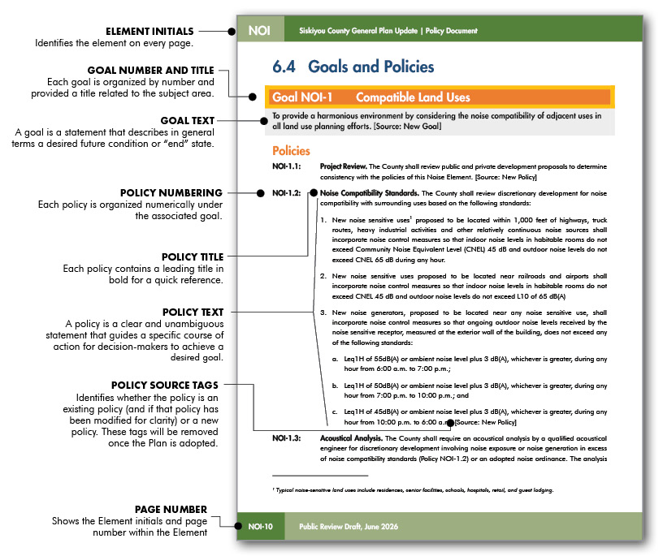

Implementation Programs
While many policies can be implemented as part of standard County operations, some policies require specific programs to assure their implementation. These implementation programs are included as the last section in each element in a format illustrated in Figure 1.3.
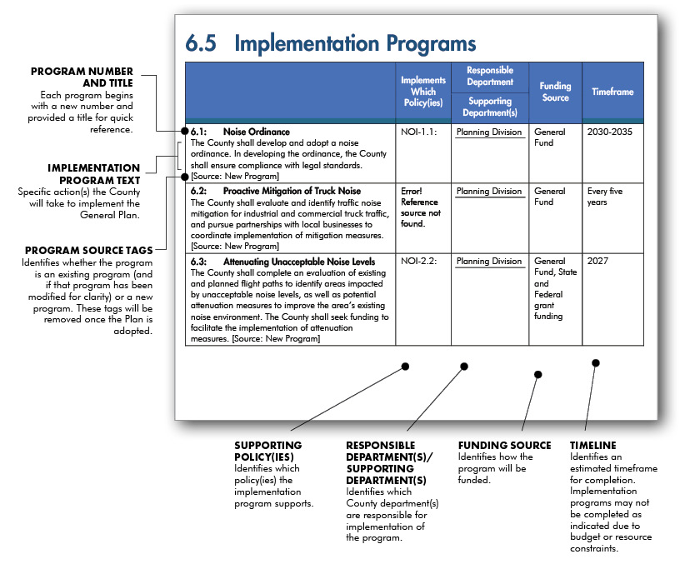
- How to Read Implementation Programs

