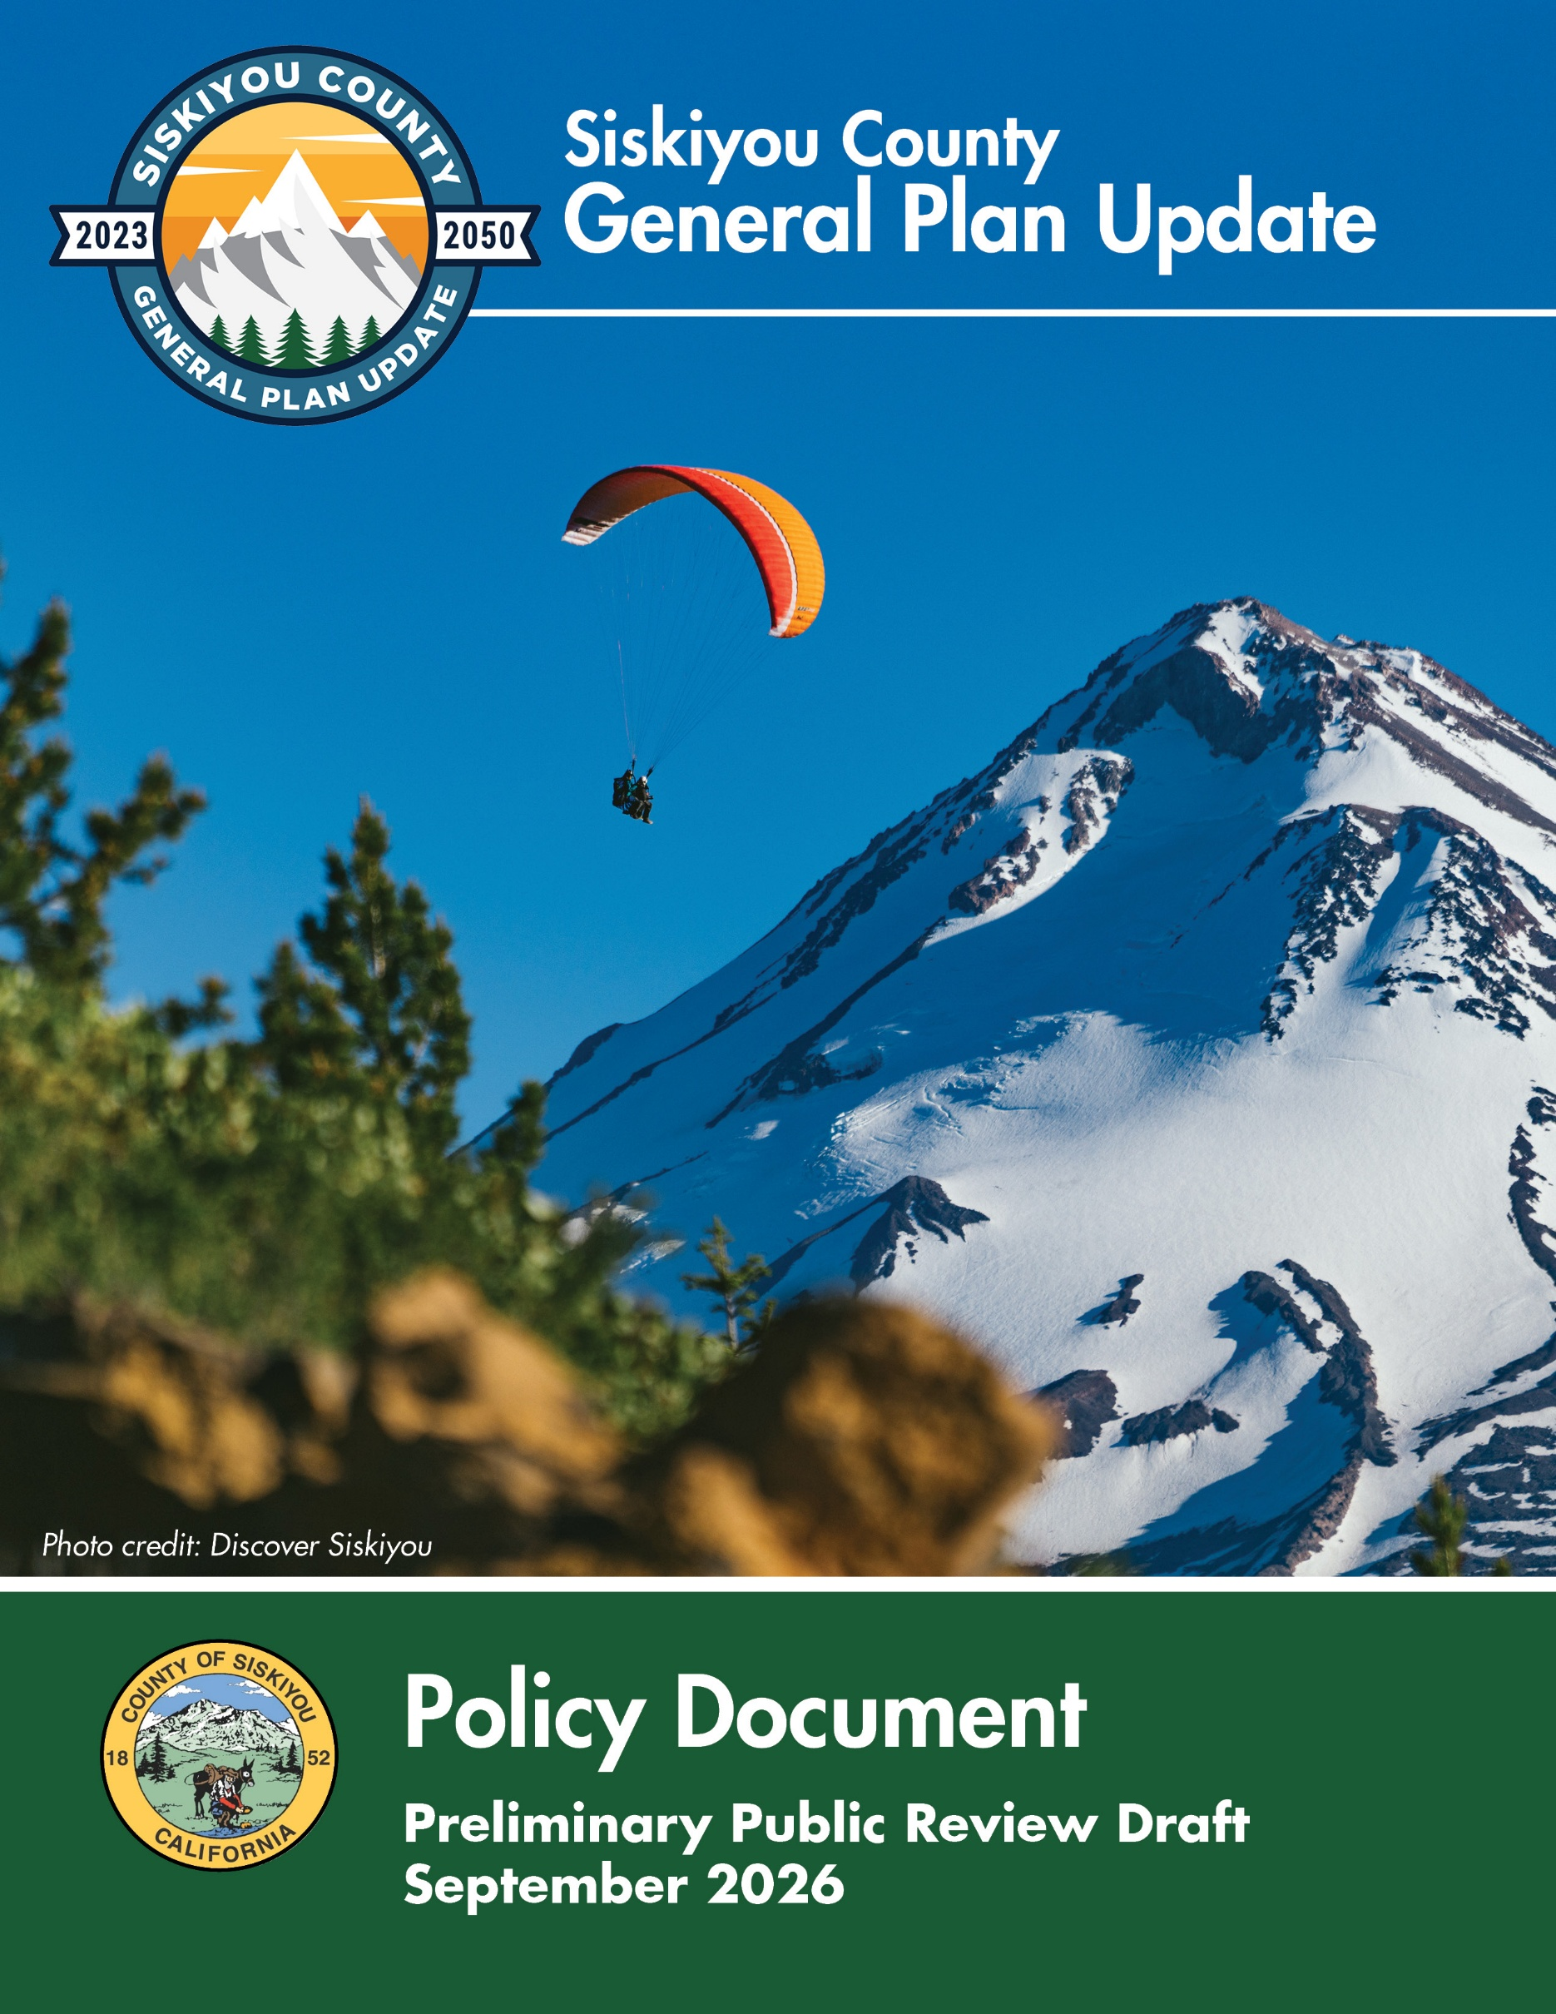

This page is intentionally left blank.
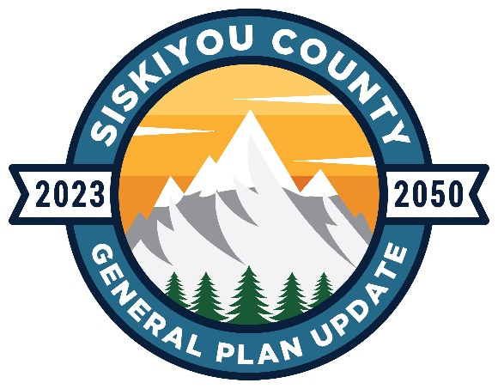

Siskiyou County
General Plan Update
Policy Document

Preliminary Public Review Draft
September 2026

Acknowledgements

Siskiyou County Community Development Department
Hailey Lang, Director

Siskiyou County Planning Division

James Phelps, Deputy Director

Siskiyou County Board of Supervisors
Jess W. Harris, Supervisor - District 1
Ed Valenzuela, Supervisor - District 2
Michael N. Kobseff, Supervisor, Chair -District 3
Nancy Ogren, Supervisor, Vice-Chair - District 4
Ray A. Haupt, Supervisor -District 5

Siskiyou County Planning Commission
Blair Hart - District 1
Tony Melo - District 2
Danielle Lindler - District 3
Dusty Veale - District 4
Jeff Fowle - District 5

Mintier Harnish
Jim Harnish, JD, Principal/Owner, Project Director
Brent Gibbons, AICP, Principal Planner, Project Manager
Ryan Lester, Project Manager, Assistant Project Manager
Hannah Woolsey, Planner

Rincon Consultants
Matt Maddox MESM, AICP, Environmental Task Manager
Denise Vo, Senior Planner
Kay Real, AICP, Planner

Table of Contents
1. Introduction INT-1
1.1 Purpose of the General Plan INT-3
1.2 Analyses Informing the General Plan INT-5
1.3 Regional Setting INT-7
1.4 Community Engagement INT-9
2. Land Use LU-1
2.1 Land Use Designations and Standards LU-3
2.2 Goals and Policies LU-23
2.3 Implementation Programs LU-33
3. Open Space and Conservation OSC-1
3.1 Introduction OS-3
3.2 Water Resources OS-4
3.3 Natural and Biological Resources OS-6
3.4 Cultural, Historical, Paleontological, and Archaeological Resources OS-12
3.5 Goals and Policies OS-13
3.6 Implementation Programs OS-18
4. Circulation CIR-1
4.1 Introduction CIR-3
4.2 Existing Conditions CIR-3
4.3 Challenges and Opportunities CIR-9
4.4 Policy & Planning Framework CIR-10
4.5 Goals, Policies, and Implementation Programs CIR-12
4.6 Implementation Programs Table CIR-15
4.7 Maps and Figures CIR-18
4.8 Incorporation of the Regional Transportation Plan (RTP) CIR-29
5. Safety SAF-1
5.1 Introduction SAF-3
5.2 The Fire Hazard SAF-5
5.3 The Flood Hazard SAF-15
5.4 Geologic and Seismic Hazards SAF-19
5.5 Hazardous Materials SAF-29
5.6 Wildlife Hazards SAF-31
5.7 Adaptation and Community Resilience SAF-37
5.8 Emergency Management SAF-43
5.9 Evacuation Planning SAF-47
5.10 Goals and Policies SAF-50
5.11 Implementation Programs SAF-54
6. Noise NOI-1
6.1 Introduction NOI-3
6.2 Noise Measurement NOI-4
6.3 Noise in Siskiyou County NOI-5
6.4 Goals and Policies NOI-10
6.5 Implementation Programs NOI-13
7. Housing Under Separate Cover
8. Glossary G-1
Appendix A: Safety Element Information A-1

