CDBG/HOME Shutdown
Attachment B – Revision to County of Siskiyou Community Development Block Grant Housing Rehabilitation Guidelines (adopted by Resolution 20-157)

On October 20, 2020 the Board of Supervisors approved the County of Siskiyou Community Development Block Grant Housing Rehabilitation Guidelines by Resolution No. 20-157, as required for an application to the State’s CDBG program to use cash-on-hand Program Income for CDBG eligible projects, programs and general administration.

The County does not have the resources to continue administering CDBG programs. Staff met with the State CDBG Representative and they advised updating Guidelines to include loan forgiveness with the caveat that the loans need to meet the National Objective for 5 years. While reviewing the Guidelines, staff noted other sections that needed updating. The following are the proposed revisions shown in redline format:

[Page 25]

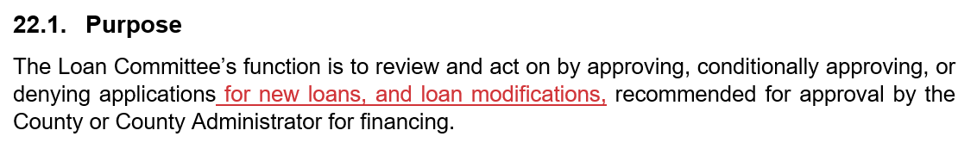

[ Page 26]

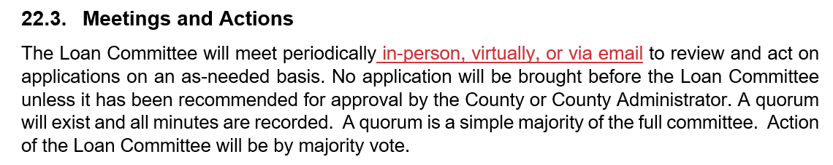
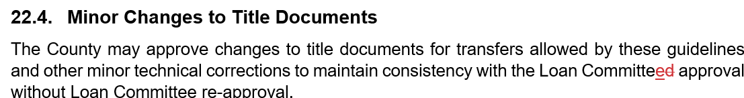

[Page 45]

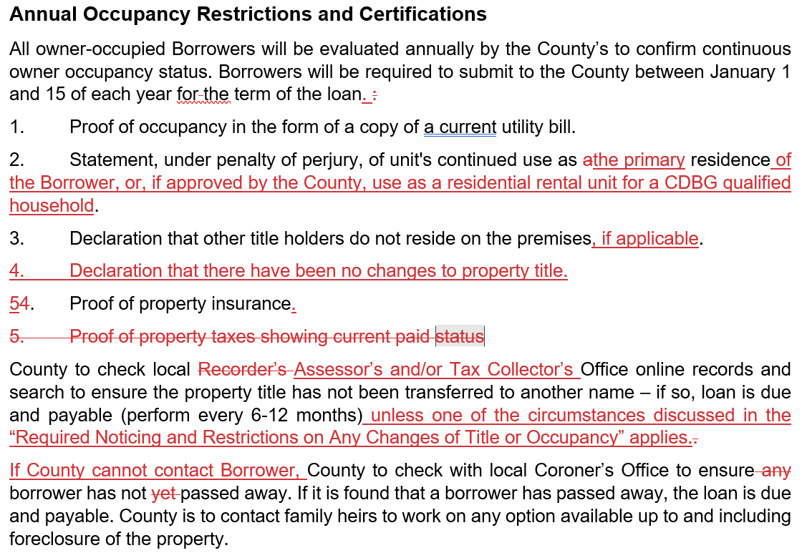

[Page 48]

