Allen Baradar Zone Change (Z-26-01)
Exhibit “A”
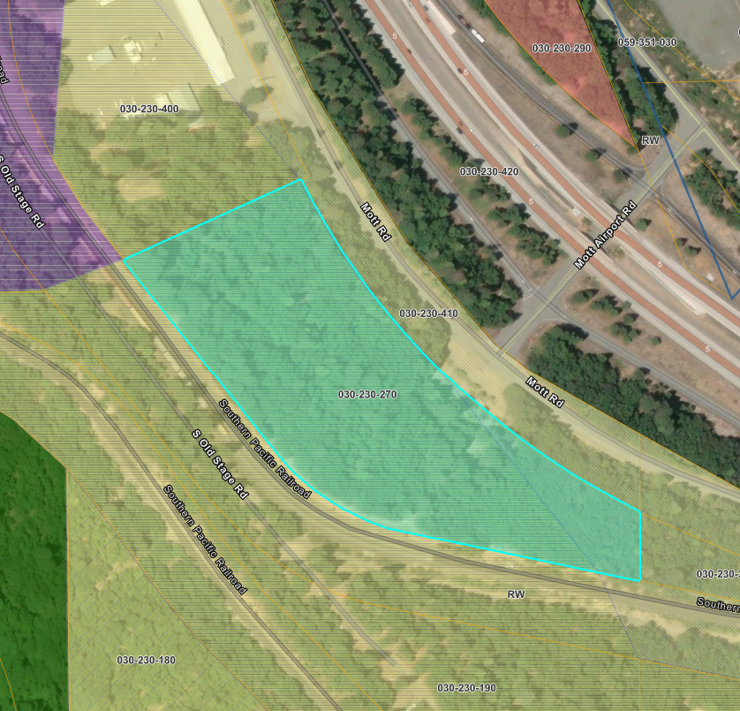
APN 030-230-270
R-R-B-10
C-H

