Shasta Casdcades Zone Change (Z-24-04)
Exhibit “A”
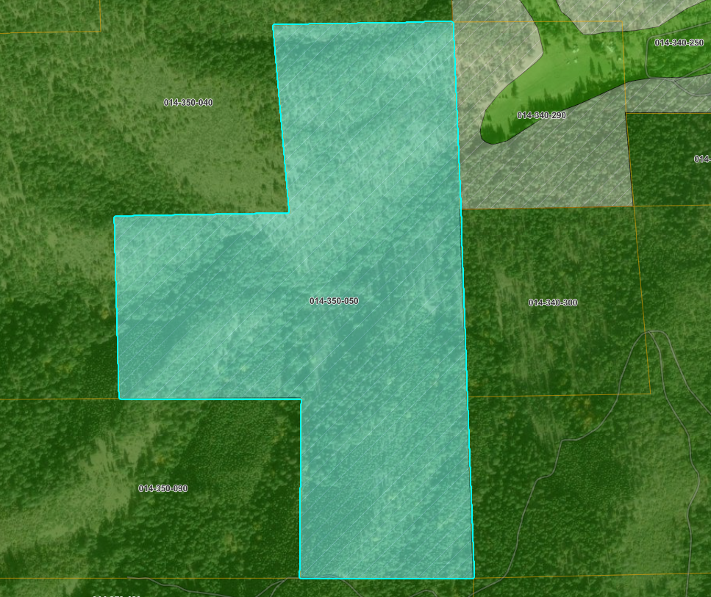
APN 014-350-050
TP
AG-2-B-40

