Owner | APN | Acreage | Contract No.
Emmerson Investments Inc (to SPI HQ) | 022-250-070 (por) | 147.92 | 20003A
Emmerson Investments Inc (to Humanity for Horses) | 022-250-740 | 117.11 | 20003A
Emmerson Investments Inc (to Humanity for Horses) | 022-250-770 (por) | 16.63 | 20003A
DeOme | 022-221-400 | 156.00 | 20003A
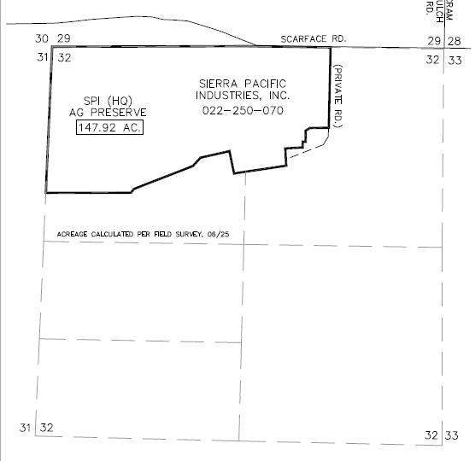
SPI HQ Parcel
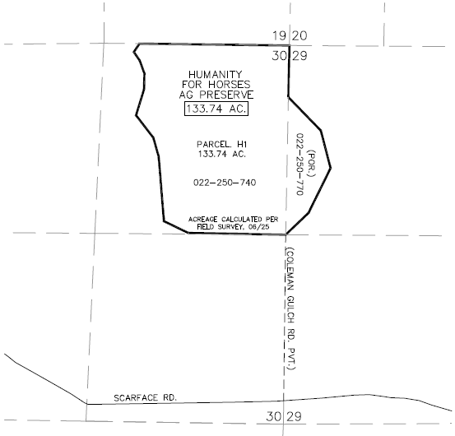
Humanity for Horses Parcel
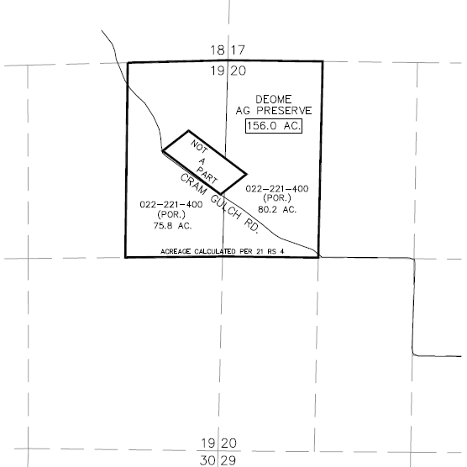
DeOme Parcel

