Staff Report
Meeting Date: April 7, 2026
To: Siskiyou County Board of Supervisors
From: Bernadette Cizin, Associate Planner
Subject: Proposed Emmerson Williamson Act Rescission with Re-entry, Agricultural Preserve Amendment (APA-24-08) and CEQA Determination

Background and Discussion
On June 7, 2024, the County received an application for a Tentative Parcel map to reconfigure 1302.1 acres of land. The tentative map would reconfigure eleven parcels into ten ranging in size from 61 to 182.3 acres. The map was reviewed and conditionally approved by the Planning commission on May 21, 2025. In order to facilitate the tentative map, the application also proposed to amend the existing Williamson Act Contracts and Agricultural Preserves accordingly.
Additionally, the applicants propose to increase the acreage in Agricultural Preserve and under contract by 0.2 acres and include additional property that is already incumbered by Williamson Act Contract but not part of the Tentative Map portion of the project. This proposal is necessary as property under their ownership is under multi-owner contracts or portions of parcels are under different contracts.
During the review of each of the proposed contracts it was found that resultant DeOme contract (Figure 2) does not meet the minimum requirement of 40 acres of Class I or II equivalent soils. Also, the resultant SPI (HQ) contract (Figure 3) does not have commercial agricultural uses occurring. The property owners were notified that these two contracts would be recommended for denial. Additionally, the resultant Humanity for Horses parcel is not proposed to receive a new contract but should be addressed as Humanity for Horses does not have a commercial agricultural operation on this property.
These three properties should be issued a notice of non-renewal.

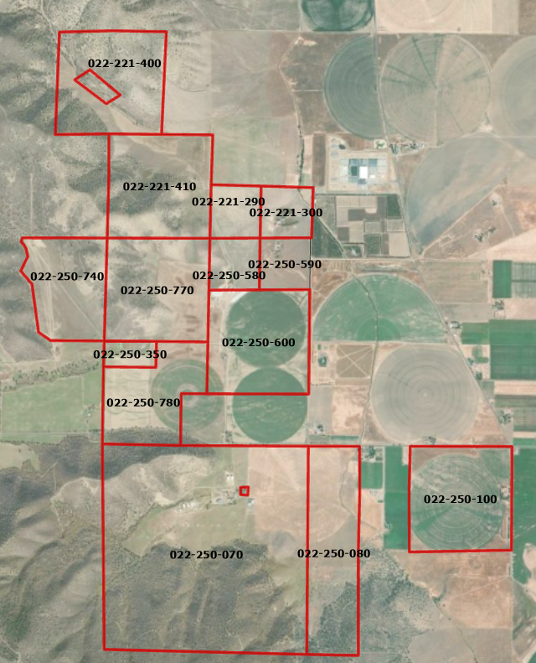
Figure 1: Subject Property

Agricultural Preserve Administrator Review
Staff prepared a detailed report (Exhibit C) for review and recommendation by the Agricultural Preserve Administrator. Based on the report, the Administrator found the applicant’s request is consistent with the County Rules for the Establishment and Administration of Agricultural Preserves and Williamson Act Contracts and recommends the Board rescind and reissue the contracts as proposed and amend the existing preserves to remove the subject property and establish a new agricultural preserves with the exception of the proposed DeOme and SPI (HQ) contracts.

Environmental Review
Staff is proposing that the proposed project be considered categorically exempt from the California Environmental Quality Act (CEQA) pursuant to CEQA Guidelines Section 15317, Open Space Easements or Contracts. A Categorical Exemption implies that the project will not result in any significant adverse environmental effects. CEQA Guidelines Section 15317 specifically exempts the making and renewing of open space contracts under the Williamson Act, which is applicable to the subject action.
The Board of Supervisors must consider the proposed CEQA exemption together with any comments received during the public review process. Further, the exemption can only be approved if the Board finds, based on the whole record before it, that there is not substantial evidence that the project will have a significant effect on the environment. Accordingly, a finding to this effect has been incorporated into both draft resolutions prepared for the Board’s consideration.

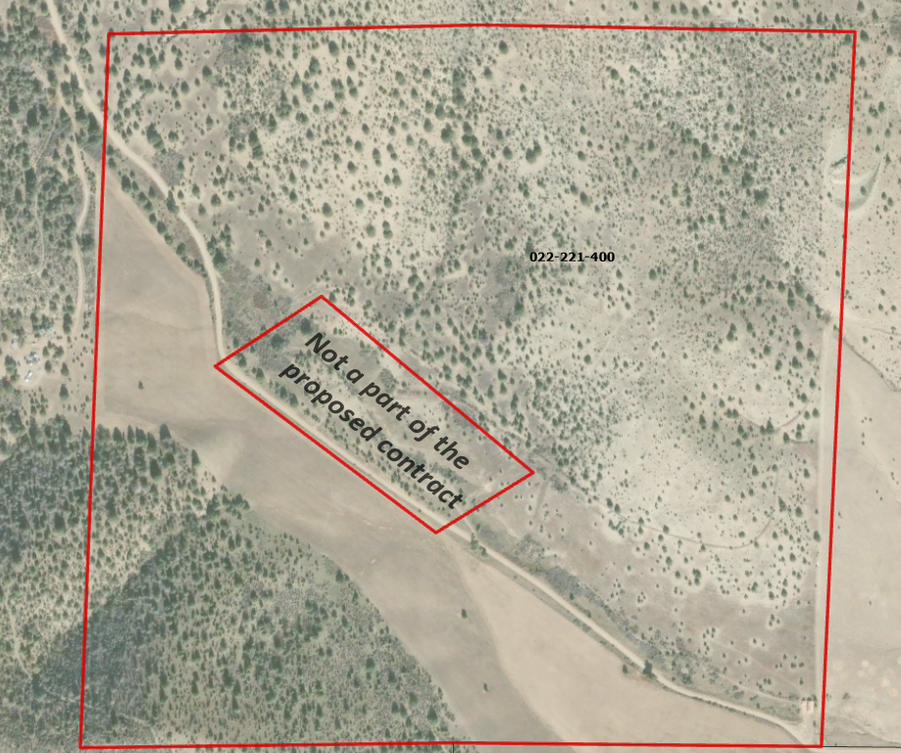
Figure 2: Proposed DeOme Contract

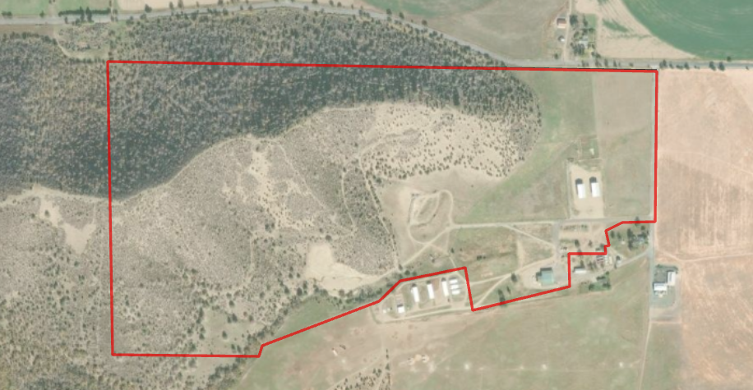
Figure 3: Proposed SPI (HQ) Contract

Comment
Public Comments
Notice of the project was published and posted as required prior to the Board of Supervisors meeting and no public comment was received as of the preparation of this staff report.

Recommended Action
Should the Board of Supervisors concur with staff’s analysis, staff recommends that the Board of Supervisors find that the proposed modifications to the Williamson Act contract and Agricultural Preserve are exempt from CEQA and approve said modifications.
A draft motion to this effect is provided below.

Recommended Motions
I move to take the following actions:
- Determine the project exempt from CEQA in accordance with Section 15317, Open Space Easements or Contracts; and
- Adopt the attached resolution approving amendment to the existing Agricultural Preserves and establishment of four new preserves; and
- Adopt the attached resolution approving the rescission and reentry of the applicable Williamson Act contracts.
- Adopt the attached resolution directing staff to process the Notice of Non-Renewal for the substandard parcels, with any changes directed by the Board.

Exhibits to the Staff Report
- Draft Resolution amending the existing Agricultural Preserves and establishing four new preserves
- Draft Resolution Approving the Rescission of the subject property from the existing contracts and Reentry into new Williamson Act Contracts
- Exhibit A-1 within Draft Resolution: Emmerson #1 Williamson Act Contract – Draft
- Exhibit A-2 within Draft Resolution: Emmerson #2 Williamson Act Contract – Draft
- Exhibit A-3 within Draft Resolution: Mickelson Williamson Act Contract – Draft
- Exhibit A-4 within Draft Resolution: SPI Williamson Act Contract – Draft
- Draft Resolution directing staff to issue a Notice of Non-Renewal for the substandard parcels.
      - Exhibit A-1 within Draft Resolution: List of Parcels and Map
      - Exhibit A-2 within Draft Resolution: Notice of Non-Renewal – Draft
- Agricultural Preserve Administrator Staff Report with Recommendation

