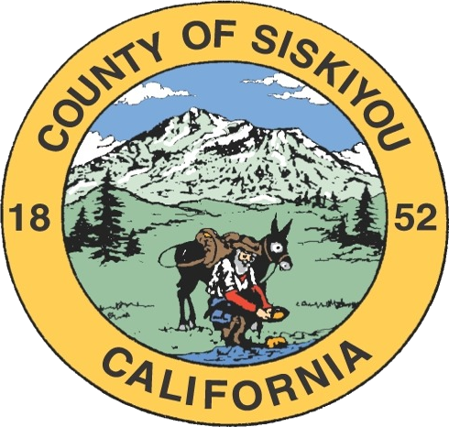
Siskiyou County Health & Human Services Agency Social Services Division
Caseload Statistics – Q2 FY 2025/2026

Ongoing Quarterly Cases

Program | Case Count | Person Count | Expenses
CalWORKs | 1346 | 3469 | $1,439,175
CalFresh | 16,483 | 27,034 | $5,033,840
Medi-Cal | 26,987 | 48,956 | N/A
General Assistance | 139 | 139 | $42,860
Foster Care | 250 | 250 | $667,719
Adoptions | 717 | 717 | $1,366,210
Adult Protective Services | 323 | 323 | N/A
IHSS | 1,569 | 6,205 | $2,057,446
CMSP | 0 | 0 | N/A
Public Guardian/Conservator | 12 | 12 | N/A

New Cases

Program | New Case Count
CalWORKs | 29
CalFresh | 404
Medi-Cal | 486
General Assistance | 12
Foster Care | 11
Adoptions | 9
Adult Protective Services | 132
IHSS | 30
CMSP | 0
Public Guardian/Conservator | 0

Fraud Activity

Program | Early Fraud | Ongoing Fraud | Trafficking | Prosecutions | Convictions
CalFresh | 1 | 13 | 0 | 1 | 1
CalWORKs | 0 | 13 | 0 | 0 | 0

Siskiyou County Health & Human Services Agency Social Services Division
Caseload Statistics – Q2 FY 2025/2026

October Ongoing Counts

Program | Case Count | Person Count | Expenses
CalWORKs | 452 | 1,157 | $493,941
CalFresh | 5,574 | 9,125 | $1,701,296
Medi-Cal | 9,106 | 16,366 | N/A
General Assistance | 39 | 39 | $12,213
Foster Care | 88 | 88 | $247,314
Adoptions | 236 | 236 | $456,244
Adult Protective Services | 110 | 110 | N/A
IHSS | 515 | 515 | $691,298
CMSP | 0 | 0 | N/A
Public Guardian/Conservator | 4 | 4 | N/A

November Ongoing Counts

Program | Case Count | Person Count | Expenses
CalWORKs | 449 | 1,152 | $478,867
CalFresh | 5,454 | 8,933 | $1,663,575
Medi-Cal | 8,856 | 16,308 | N/A
General Assistance | 48 | 48 | $14,680
Foster Care | 82 | 82 | $203,279
Adoptions | 247 | 247 | $468,105
Adult Protective Services | 110 | 110 | N/A
IHSS | 529 | 529 | $672,044
CMSP | 0 | 0 | N/A
Public Guardian/Conservator | 4 | 4 | N/A

Siskiyou County Health & Human Services Agency Social Services Division
Caseload Statistics – Q2 FY 2025/2026

December Ongoing Counts

Program | Case Count | Person Count | Expenses
CalWORKs | 445 | 1,160 | $466,367
CalFresh | 5,455 | 8,976 | $1,668,969
Medi-Cal | 9,025 | 16,282 | N/A
General Assistance | 52 | 52 | $15,967
Foster Care | 80 | 80 | $217,126
Adoptions | 234 | 234 | $441,861
Adult Protective Services | 103 | 103 | N/A
IHSS | 525 | 525 | $694,104
CMSP | 0 | 0 | N/A
Public Guardian/Conservator | 4 | 4 | N/A

