Recorded at the request of the Siskiyou County Planning Department

When recorded mail to:  Siskiyou County Clerk  311 Fourth Street, Room 201  Yreka, CA 96097 | (FOR RECORDER’S USE ONLY)
DOCUMENT TITLE(S)

NOTICE OF NON-RENEWAL OF

THAT CERTAIN LAND DESCRIBED HEREIN UNDER

LAND CONSERVATION CONTRACT NO. 71051 and 72062
NOTICE IS HEREBY GIVEN:
WHEREAS, Mark and Cyndi Baird, Trustees, the owners of land described herein that is subject to Land Conservation Contract No. 71051, established pursuant to Siskiyou County Board of Supervisors as recorded on May 5, 1971 in the Siskiyou County Records in Volume 620 at Page 406; and
WHEREAS, Mark and Cyndi Baird, Trustees, the owners of land described herein that is subject to Land Conservation Contract No. 72062, established pursuant to Siskiyou County Board of Supervisors as recorded on February 25, 1972 in the Siskiyou County Records in Volume 653 at Page 210; and
WHEREAS, the County desires non-renewal said property from Land Conservation Contract No. 71051 and 72062; and
WHEREAS, Land Conservation Contracts must meet certain criteria in order to remain compliant; Specifically, that the commercial agricultural use be maintained.
NOW, THEREFORE, the County declares the intent not to renew 518.60 acres under Land Conservation Contract No. 71051 and 160 acres under Land Conservation Contract No. 72062 as it applies to the real property described in the Legal Description, attached hereto as Exhibit A and incorporated by this reference.

COUNTY OF SISKIYOU

Dated: By: __________________________________
James V. Phelps, Deputy Director of Planning
A notary public or other officer completing this certificate verifies only the identity of the individual who signed the document to which this certificate is attached, and not the truthfulness, accuracy, or validity of that document.

State of California

County of Siskiyou

On _____________________, 2026, before me, ________________________________, Notary Public, personally appeared James V. Phelps, who proved to me on the basis of satisfactory evidence to be the person(s) whose name(s) is/are subscribed to the within instrument and acknowledged to me that he/she/they executed the same in his/her/their authorized capacity(ies), and that by his/her/their signature(s) on the instrument the person(s) or the entity upon behalf of which the person(s) acted, executed the instrument.

I certify under PENALTY OF PERJURY under the laws of the State of California that the foregoing paragraph is true and correct.

WITNESS my hand and official seal

__________________________________
Signature of Notary Public
Exhibit “A”
Land Conservation Contract AGN-26-02
Notice of Non-Renewal
(Baird)

Assessor’s Parcels Numbers and Pre-rescission Contract Numbers listed below:

Assessor’s Parcel Number | Assessor Contract Number | Recordation Number | Acreage
024-383-110 | 71051 | Vol. 620 Page 406 | 379.10
024-383-170 | 71051 | Vol. 620 Page 406 | 46.40
024-383-200 | 71051 | Vol. 620 Page 406 | 40
024-410-400 | 71051 | Vol. 620 Page 406 | 13.10
024-450-060 | 71051 | Vol. 620 Page 406 | 40
024-383-210 | 72062 | Vol. 653 Page 210 | 160

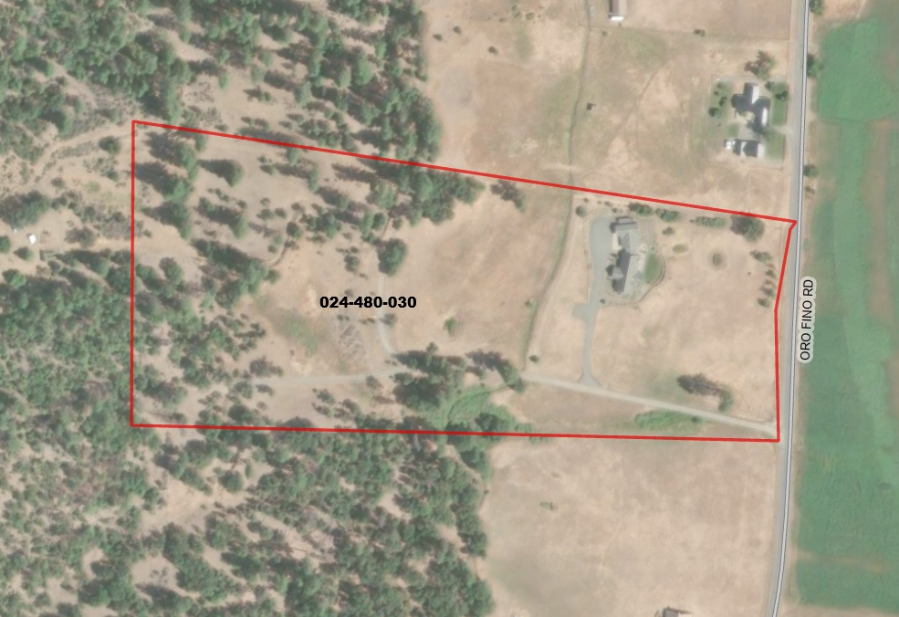

The following described property in the unincorporated area of the County of Siskiyou, State of California:
Insert Legal Description
APN:024-480-030

