Staff Report
Meeting Date: May 5, 2026
To: Siskiyou County Board of Supervisors
From: Bernadette Cizin, Associate Planner
Subject: AGN-26-02 Baird - Intention to Serve Notice of Non-Renewal of property under Williamson Act Contract 71051 and 72062 and CEQA Determination

Background
On October 21, 2025, at the Board of Supervisors Meeting, staff recommended the Board issue a Notice of Non-Renewal for property owned by the Baird’s as they had not returned a complete survey or declaration of commercial agricultural use form. Mr. Baird attended the meeting and provided comment. The board did not take action at that time and directed the owner and staff to discuss further.
Staff was to provide information on compliance and potential rezoning to Timber Production Zoning.
The owners have not provided a completed survey or declaration form, nor have they responded to a request to set up a meeting.
Staff is now bringing the recommendation back to the board as the owner has not applied for a contract amendment or returned requested information regarding uses occurring on the property.
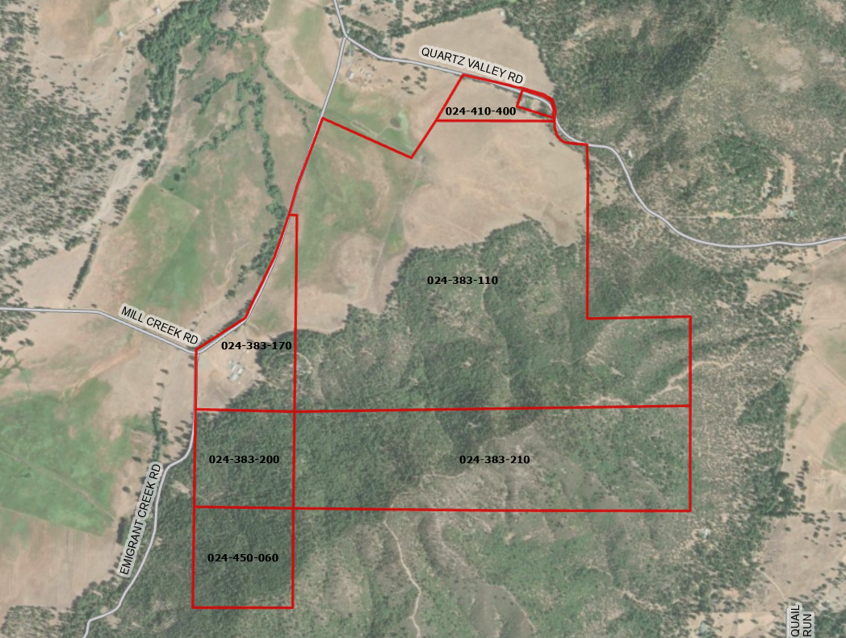
Figure 1 – Subject Property

Potential Next Steps

Should the Board agree with staff’s recommendation and authorize staff to issue the notices of non-renewal, the Planning Department will file a Notice of Non-Renewal of Williamson Act Contract with the Assessor’s Office. Under Government Code Section 51245, if a local government desires not to renew a Williamson Act contract, it shall serve written notice of non-renewal of the contract upon the contracted party(ies) in advance of the annual renewal date of the contract. A city or county shall serve written notice of non-renewal at least 60 days prior to the renewal date, which would require Siskiyou County to serve the Notice of Non-Renewal by no later than November 1, 2026.
The recordation will trigger property tax reassessment of the affected 678.6 acres, and a nine-year period contract phase out will commence. Pursuant to Government Code Section 51246(a), development restrictions on non-renewed contracted parcels will remain in effect for the balance of the period remaining since the original execution or the last renewal of the contract.
Notice of the project was published and posted as required prior to the Board of Supervisors meeting and no public comments were received as of the preparation of this staff report.

Environmental Review

Staff recommends the proposed issuance of a notice of non-renewal for a Williamson Act contract be determined categorically exempt from the California Environmental Quality Act (CEQA) pursuant to CEQA Guidelines Section 15317, Open Space Contracts or Easements. The Class 17 exemption applies as this project does not propose to alter or expand the existing Williamson Act contract, which will remain in effect for the nine-year roll out period. Additionally, staff further recommends also, therefore, also be exempt from CEQA pursuant to Guidelines Section 15061(b)(3), the “commonsense” exception, as no changes in current use of the properties are proposed.
The proposed CEQA exemptions must be considered together with any comments received during the public review process. Further, the exemptions can only be approved if the finding is made, based on the whole record before it, that there is not substantial evidence that there are unusual circumstances (including future activities) which might reasonably result in the project having a significant effect on the environment.

Recommended Motion
I move to adopt the Resolution Directing staff to Issue a Notice of Non-Renewal to Williamson Act Contract No. 71051 and 72062 which hereby taking the following actions:
- The Board of Supervisors determines that the proposed issuance of a Non-Renewal of a Williamson Act contract is categorically exempt under Sections 15317 and 15061(b)(3) of the CEQA Guidelines; and

Authorize staff to process the Notice of Non-Renewal with any changes directed by the Board.

Exhibits to the Staff Report
A. Draft Resolution, a Resolution of the County of Siskiyou, State of California, Directing Staff to Issue a Notice of Non-Renewal for Contract No. 71051 and 72062.
  - Exhibit A-1 within Draft Resolution: List of recommended properties
  - Exhibit A-2 within Draft Resolution: Notice of Non-Renewal - DRAFT
- Agricultural Preserve Administrator Staff Report with Recommendation

