Staff Report
Meeting Date: May 5, 2026
To: Siskiyou County Board of Supervisors
From: Bernadette Cizin, Associate Planner
Subject: AGN-26-01 Lutz - Intention to Serve Notice of Non-Renewal of property under Williamson Act Contract 24007and CEQA Determination

Background
0.57 acres of Williamson Act Contract encumbered property was transferred by Boundary Line Adjustment to a parcel that is not under contract. A Williamson Act Contract amendment was approved on June3, 2025 which reflects the new property boundaries.
The issue of 0.57 acres that is now part of an unencumbered parcel was not addressed. A notice of non-renewal should have been recommended at the time of the contract amendment.
Staff is now bringing the 0.57-acre portion of a contract back to the board for recommendation of issuance of a notice of non-renewal to address this issue.
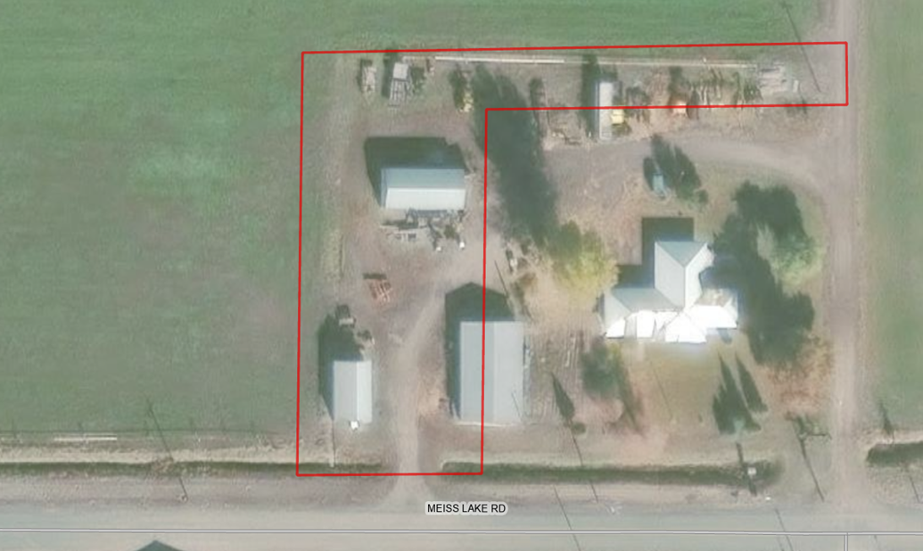
Figure 1 – Subject Property

Potential Next Steps

Should the Board agree with staff’s recommendation and authorize staff to issue the notices of non-renewal, the Planning Department will file a Notice of Non-Renewal of Williamson Act Contract with the Assessor’s Office. Under Government Code Section 51245, if a local government desires not to renew a Williamson Act contract, it shall serve written notice of non-renewal of the contract upon the contracted party(ies) in advance of the annual renewal date of the contract. A city or county shall serve written notice of non-renewal at least 60 days prior to the renewal date, which would require Siskiyou County to serve the Notice of Non-Renewal by no later than November 1, 2026.
The recordation will trigger property tax reassessment of the affected 0.57 acres, and a nine-year period contract phase out will commence. Pursuant to Government Code Section 51246(a), development restrictions on non-renewed contracted parcels will remain in effect for the balance of the period remaining since the original execution or the last renewal of the contract.
Notice of the project was published and posted as required prior to the Board of Supervisors meeting and no public comments were received as of the preparation of this staff report.

Environmental Review

Staff recommends the proposed issuance of a notice of non-renewal for a Williamson Act contract be determined categorically exempt from the California Environmental Quality Act (CEQA) pursuant to CEQA Guidelines Section 15317, Open Space Contracts or Easements. The Class 17 exemption applies as this project does not propose to alter or expand the existing Williamson Act contract, which will remain in effect for the nine-year roll out period. Additionally, staff further recommends also, therefore, also be exempt from CEQA pursuant to Guidelines Section 15061(b)(3), the “commonsense” exception, as no changes in current use of the properties are proposed.
The proposed CEQA exemptions must be considered together with any comments received during the public review process. Further, the exemptions can only be approved if the finding is made, based on the whole record before it, that there is not substantial evidence that there are unusual circumstances (including future activities) which might reasonably result in the project having a significant effect on the environment.

Recommended Motion
I move to adopt the Resolution Directing staff to Issue a Notice of Non-Renewal to Williamson Act Contract No. 24007 which hereby taking the following actions:
- The Board of Supervisors determines that the proposed issuance of a Non-Renewal of a Williamson Act contract is categorically exempt under Sections 15317 and 15061(b)(3) of the CEQA Guidelines; and

Authorize staff to process the Notice of Non-Renewal with any changes directed by the Board.

Exhibits to the Staff Report
A. Draft Resolution, a Resolution of the County of Siskiyou, State of California, Directing Staff to Issue a Notice of Non-Renewal for Contract No. 72064.
  - Exhibit A-1 within Draft Resolution: List of recommended properties
  - Exhibit A-2 within Draft Resolution: Notice of Non-Renewal - DRAFT
- Agricultural Preserve Administrator Staff Report with Recommendation

