Recording Requested By:
Siskiyou County Board of Supervisors

When Recorded Return To:
Siskiyou County Clerk
311 Fourth Street, Room 201
Yreka, CA 96097

Land Conservation Contract No. APA-25-27
(W. Criss – Ranch)
Preamble to Land Conservation Contract

Whereas, the hereinafter referred to OWNER possesses certain real property located within the hereinafter referred to COUNTY, which property is presently devoted to Agricultural and compatible uses.
Whereas, said property is located in Agricultural Preserve established by COUNTY on March 3, 2026; and
Whereas, both OWNER AND COUNTY desire to limit the use of said property to agricultural and compatible uses in order to discourage premature and unnecessary conversion of such lands from agricultural uses, recognizing that such agricultural land has definite public value as Open Space and that the preservation of such land in agricultural production constitutes an important physical, social, aesthetic and economic asset to COUNTY to maintain the agricultural economy of COUNTY and the State of California; and
Whereas, the County enters into this Contract with OWNER on the express condition that funds be annually appropriated by the State of California, and that the annual payments continue to be made to County by the State Controller, under the provisions of the Open Space Subvention Act (California Government Code section 16140, et. seq.), and that if said funds are not appropriated or dispersed the County may terminate the Contract.
The following agreement is prepared and entered into by the parties to accomplish the above-stated purposes.
Land Conservation Contract No. APA-25-27
(W. Criss - Ranch)

This Land Conservation Contract, Made And Executed This 3rd day of March 2026, by and between Wayne T. Criss and Erin M. Criss, as Trustees of the Criss Revocable Trust dated December 14, 2012, hereinafter referred to as the “OWNER”, and the County of Siskiyou, a political subdivision of the State of California, hereinafter referred to as the “COUNTY”, hereby agree as follows:

New Land Conservation Contract

Section 1. Contract. This is a “Contract” made pursuant to the California Land Conservation Act of 1965, amended as of the date first above written, including amendments enacted at the 1969 Regular Session of the California Legislature (hereinafter referred to as the “Act”) and is applicable to the premises described in Exhibits “A” and “B” attached hereto.

Section 2. Term. This Contract shall take effect on the January 1 following its recordation with the County Recorder and shall remain in effect for a period of ten years therefrom and during any renewals of this Contract.

Section 3. Renewal. Notice of Non-Renewal. This Contract shall be automatically renewed for a period of one year on the first day of each year, and on the first day of each January thereafter unless a written Notice of Non-Renewal is served by the OWNER on the COUNTY at least 90 days prior to said date or written Notice of Non-Renewal is served by the COUNTY on the OWNER at least 60 days prior to said date. Under no circumstances shall a Notice of Non-Renewal to either party be required to effectuate the automatic renewal of this Contract.

Section 4. Authorized Uses. During the term of this Contract, and any and all renewals thereof, the premises shall not be used for any purpose other than the production of agricultural commodities for commercial purposes and for compatible uses as specified by State law, the Resolution Establishing the applicable Agricultural Preserve, the County’s most current resolution establishing the Rules for the Establishment and Administration of Agricultural Preserves and Williamson Act Contracts, and this Williamson Act contract. No buildings or structures shall be erected upon the premises, except such buildings and structures as are directly related to authorized uses of the premises as specified by State law, the Resolution Establishing the applicable Agricultural Preserve, the County’s most current resolution establishing the Rules for the Establishment and Administration of Agricultural Preserves and Williamson Act Contracts, and this Williamson Act contract.

Section 5. Addition or Elimination of Authorized Uses.

(a) The OWNER agrees that the primary use of the property is for Rangeland and pasture for livestock production and forage. Upon a proposed change in the primary use by the Owner, or if a change in primary use has been determined by the County, the proposed change shall require a new contract and shall be processed as a Williamson Act contract recession and simultaneous reentry.
(b) The Board of Supervisors of the County, by resolution, may from time to time during the term of this Contract, or any renewals thereof, amend the Resolution establishing the uniform Rules for the Establishment and Administration of Agricultural Preserves and Williamson Act Contracts to add or eliminate authorized uses at the sole discretion of the Board of Supervisors. This contract is subject to all such provisions as they now exist and as may hereafter be amended. An OWNER reserves the right to not to consent to any future amendment by filing a Notice of Non-Renewal as detailed herein in which case the existing rules shall apply during the term of the non-renewal.
Section 6. Police Power. Nothing in this Contract shall be construed to limit the exercise by the Board of Supervisors of the police power or the adoption or re-adoption or amendment of any zoning ordinance or land use ordinance, regulation or restriction pursuant to the Planning and Zoning Law (Sections 65000, et seq., Government Code) or otherwise.

Section 7. Eminent Domain.

(a) Except as provided in Subdivision (d) of this Section 7, when any action in eminent domain for the condemnation of the fee title of an entire parcel of land subject to this Contract is filed, or when such is acquired in lieu of eminent domain for a public improvement by a public agency or person, or whenever there is any such action or acquisition by the federal government or any person, instrumentality or agency acting under authority or power of the federal government, this Contract shall be deemed null and void as to the land actually being condemned or so acquired as of the date the action is filed and for the purposes of establishing the value of such land, this Contract shall be deemed never to have existed.

(b) Except as provided in Subdivision (d) of this Section 7, when such an action to condemn or acquired less than all of a parcel of land subject to this Contract is commenced, this Contract shall be deemed null and void as to the land actually condemned or acquired and shall be disregarded in the valuation process only as to the land actually being taken, unless the remaining land subject to this Contract will be adversely affected by the condemnation, in which case the value of that damage shall be computed without regard to this document.

(c) The land actually taken shall be removed from this Contract. Under no circumstances shall land be removed that is not actually taken, except as otherwise provided in the Act.

(d) The provisions of Subdivisions (a) and (b) of this Section 7 and the provisions of Section 51295 of the Act (Government Code) shall not apply to or have any force or effect with respect to: (a) the filing of any action in eminent domain for the condemnation of any easement for the erection, construction, alteration, maintenance, or repair of any gas, electric, water, road, or communication facilities by any public agency (including the County), or public utility or to the acquisition of any such easement by any public agency (including the County) or public utility. The filing of any such action in eminent domain for the condemnation or the acquisition of any such easement or lesser estate shall not terminate, nullify or void this contract, and in the event of the filing of any such action in eminent domain or acquisition, this Contract shall not be considered in the valuation process.

Section 8. No Payment by the County. The OWNER shall not receive any payment from COUNTY in consideration of the obligations imposed hereunder, it being recognized and agreed that the consideration for the execution of the Contract is the substantial public benefit to be derived therefrom, and the advantage which will accrue to the OWNER as a result of the effect on the assessed valuation of land described herein due to the imposition of the limitations on its use contained herein.

Section 9. Termination of Contract by the County. This Land Conservation Contract is made expressly conditional upon the State’s continued compliance with the provisions of the Open Space Subvention Act. If in any year the State fails to make any of the subvention payments to the County required under the provision of the Open Space Subvention Act, then this Contract, at the option of, and in the sole and absolute discretion of the County, may be terminated by the County. The State’s failure to make such payments may be due to non-appropriation of funds by the Legislature, failure to disburse appropriated funds, amendment or repeal of the applicable provisions of the Open Space Subvention Act, or by any other cause whatsoever. COUNTY may exercise its option to declare the Contract null and void by delivering notice to the OWNER or his successors or assigns and by recording such notice in the Official Records of Siskiyou County. This Land Conservation Contract shall terminate with no continuing contractual rights of any kind; provided, however, that the OWNER may apply for a new Land Conservation Contract as otherwise may be provided by law.

Section 10. Cancellation.

(a) This Contract may be cancelled only by mutual agreement of the OWNER and COUNTY pursuant to Section 51282 of the Act (Government Code) when, after a public hearing has been held in accordance with the provisions of Section 51284 of the Act (Government Code), the Board of Supervisors finds that (1) such cancellation is in the public interest and not inconsistent with the purposes of the Act, and (2) it is neither necessary nor desirable to continue the restrictions imposed by this Contract provided, however, this Contract shall not be cancelled until the hereinafter specified cancellation fee has been paid unless such fee, or portion thereof, is waived or deferred pursuant to Subdivision {c} of Section 51283 of the Act (Government Code).

(b) Prior to any action by the Board of Supervisors giving tentative approval to the cancellation of this Contract, the County Assessor shall determine the full cash value of the land as though it were free from the restrictions of this Contract. The Assessor shall multiply such value by the most recent County ratio announced pursuant to Section 401 of the Revenue and Taxation Code, and shall certify the product to the Board of Supervisors as the cancellation valuation of the land for the purpose of determining the cancellation fee hereinafter specified.

(c) Prior to giving tentative approval to the cancellation of this Contract, the Board of Supervisors shall determine and certify to the County Auditor the amount of the cancellation fee which the OWNER must pay the County Treasurer as deferred taxes upon cancellation, which shall be 50 percent of the cancellation valuation of the land as determined in Subparagraph (b) of this Section. If, after the date this Contract is initially entered into, the publicly announced County ratio of the assessed to the full cash value is changed, the percentage payment specified in this paragraph shall be changed so no greater percentage of full cash value will be paid than would have been paid had there been no change in such ratio.

(d) The Board of Supervisors may waive or defer payment of the cancellation fee or any portion thereof in accordance with Subdivision (c) of Section 51283 of the Act Government Code).

Section 11. Distribution of Deferred Taxes. On receipt of any deferred taxes (cancellation fee), payable pursuant to Section 10 of this Contract, said deferred taxes shall be distributed as provided in Section 51204 of the Act (Government Code).
Section 12. Division of Land - New Contracts. In the event the premises is divided, a Contract identical to the Contract then covering the premises shall be executed by the OWNER of each parcel created by the division at the time of the division.

Section 13. Division of Land - Minimum Size Parcels. The OWNER shall not divide the premises contrary to the restrictions on the division of premises as set forth in the Resolution Establishing the Agricultural Preserve.

Section 14. Contracts Binds Successors. The term “OWNER” as used in this contract shall include the singular and plural and the heirs, executors, administrators, and successors and assigns and this Contract shall run with the land described herein and shall be binding upon the heirs, executors, administrators, successors and assigns of the parties hereto. Neither the OWNER nor any successor in interest shall divide the land described herein, except that the County may approve a division of such land subject to the terms and conditions of the Act or local resolution if the proposed division meets all of the following conditions:
(a) Each preserve resulting from the division shall meet the minimum size
requirements of the Act and local resolutions which are applicable to the land which is the subject of this contract, as provided herein; and
(b) Each parcel which is the subject of, or which results from the division shall
meet the minimum size requirements of the Act and local resolutions which are applicable to the land which is the subject of this contract; and
(c) All successors in interest to OWNER shall enter into separate and individual contracts pursuant to the County’s uniform Rules for the Establishment and Administration of Agricultural Preserves and Williamson Act Contracts as they exist now and in the future.

Section 15. Removal of Land from Preserve. Removal of any land under this Contract from an Agricultural Preserve either by change of boundaries of the Preserve or disestablishment of the Preserve shall be the equivalent of a Notice of Non-Renewal by the County.

Section 16. Conveyance Contrary to the Contract. Any conveyance, contract or authorization (whether oral or written) by the OWNER or his successors in interest which would permit the use of the subject property or create a division of the land contrary to the terms of this contract, or any renewal thereof, may be declared void by the Board of Supervisors of the County; such declaration or the provisions of this Contract may be enforced by the County by an action filed in the Superior Court of the County by the District Attorney for the purpose of compelling compliance or restraining a breach thereof.

Section 17. Owner to Provide Information. The OWNER, upon request of the County, shall provide information relating to the OWNER’s obligations under this Contract.
Section 18. Conflict Provision. In the event of any conflict between the provisions of this contract, the County’s uniform Rules for the Establishment and Administration of Agricultural Preserves and Williamson Act Contracts, or State law as they exist now and in the future, those provisions which most restrict the right to divide the land subject to this contract or to use said land for non-agricultural purposes shall govern.
Section 19. Notice. Any notice given pursuant to this Contract may, in addition to any other method authorized by law, be given by United States mail, postage prepaid. Notice to the OWNER shall be addressed to the same address indicated upon the County Assessor’s records for the mailing of tax assessments. Notice to the County shall be addressed as follows:

Clerk of the Board of Supervisors
County of Siskiyou
311 Fourth Street, Room 201
Yreka, CA 96097

In Witness Whereof the OWNER and the County have executed this Contract on the day first above written:

OWNER:

Existing APNs: 003-420-170, 003-130-030, 003-130-040, 003-130-160 and
003-130-170

Wayne T. Criss and Erin M. Criss, as Trustees of the Criss Revocable Trust dated December 14, 2012

By:___________________________________
Wayne T. Criss, Trustee

By:___________________________________
Erin M. Criss, Trustee

Place Notary Certificate Here

Attest: County of Siskiyou, Board of Supervisors

________________________ __________________________________________
Clerk Ray A. Haupt, Chair
Exhibit “A”
Land Conservation Contract APA-25-27
(W. Criss - Ranch)

Assessor’s Parcels Numbers and Pre-rescission Contract Numbers listed below:

Assessor’s Parcel Number | Assessor Contract Number | Clerk Contract Reference | Recordation Number | Acreage
003-420-170 | 72014 | 91 | Vol 651 Page 301 | 100
003-130-030 | 72014 | 91 | Vol 651 Page 301 | 240
003-130-040 | 72014 | 91 | Vol 651 Page 301 | 160
003-130-160 | 72014 | 91 | Vol 651 Page 301 | 20
003-130-170 | 72014 | 91 | Vol 651 Page 301 | 20
Maps of the land to be placed under this contract are also included as part of
Exhibit “A”.

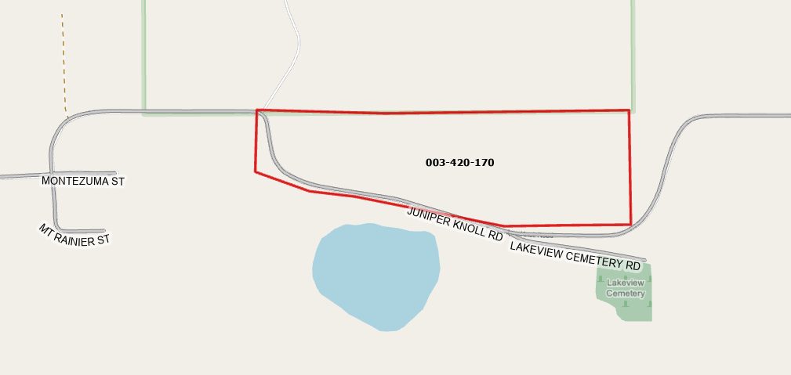
Map 1 of 2
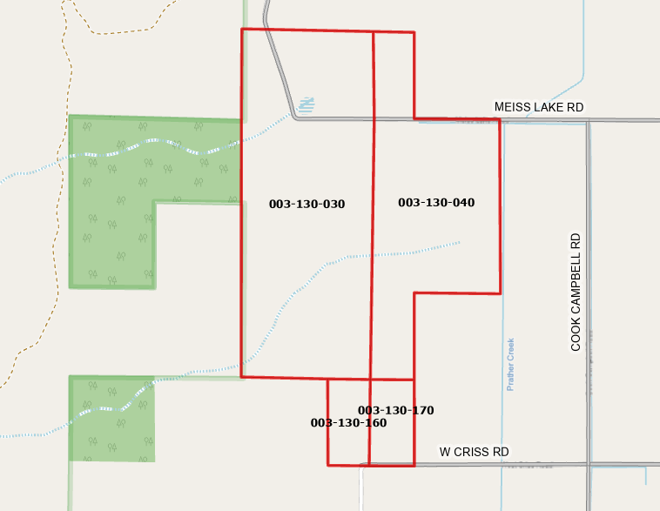
Map 2 of 2
Exhibit “B”
Land Conservation Contract APA-25-27
(W. Criss - Ranch)
Legal Description of Property to be Included

All that real property situate in the unincorporated area of the County of Siskiyou, State of California, described as follows:

[Insert Legal Description]

APN: 003-420-170, 003-130-030, 003-130-040, 003-130-160 and
003-130-170

