Staff Report
Meeting Date: March 3, 2026
To: Siskiyou County Board of Supervisors
From: Bernadette Cizin, Associate Planner
Subject: Proposed W Criss Williamson Act Rescission with Re-entry, Agricultural Preserve Amendment (APA-25-27) and CEQA Determination

Background and Discussion
On November 14, 2025, the County received an application from Wayne & Erin Criss for a Williamson Act Contract amendment to bring approximately 706 acres under two Williamson Act contracts, one with the Agricultural Use of intensive farming and the other with the use of livestock grazing, consisting solely of property under their ownerships. The property is currently under a Williamson Act contract which has multiple property owners.
Additionally, the existing Agricultural Preserve should be amended to remove the subject property and a new Agricultural Preserve created as the existing preserve consists of property that is not contiguous nor owned in common.
Agricultural Preserve Administrator Review
Staff prepared a detailed report (Exhibit C) for review and recommendation by the Agricultural Preserve Administrator. Based on the report, the Administrator found the applicant’s request is consistent with the County Rules for the Establishment and Administration of Agricultural Preserves and Williamson Act Contracts and recommends the Board rescind and reissue the contract as proposed and amend the existing preserve to remove the subject property and establish a new agricultural preserve.

Environmental Review
Staff is proposing that the proposed project be considered categorically exempt from the California Environmental Quality Act (CEQA) pursuant to CEQA Guidelines Section 15317, Open Space Easements or Contracts. A Categorical Exemption implies that the project will not result in any significant adverse environmental effects. CEQA Guidelines Section 15317 specifically exempts the making and renewing of open space contracts under the Williamson Act, which is applicable to the subject action.
The Board of Supervisors must consider the proposed CEQA exemption together with any comments received during the public review process. Further, the exemption can only be approved if the Board finds, based on the whole record before it, that there is not substantial evidence that the project will have a significant effect on the environment. Accordingly, a finding to this effect has been incorporated into both draft resolutions prepared for the Board’s consideration.
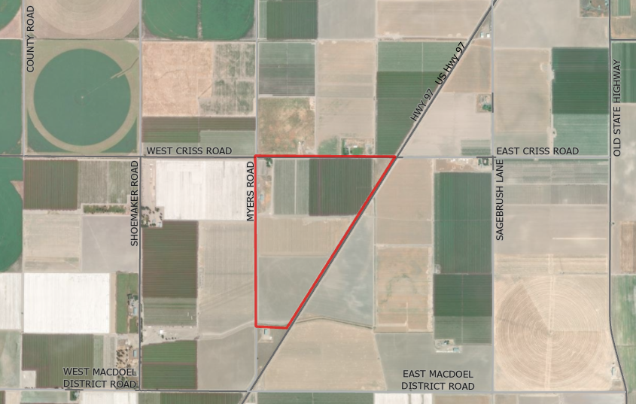
Figure 1: Subject Property – Farm
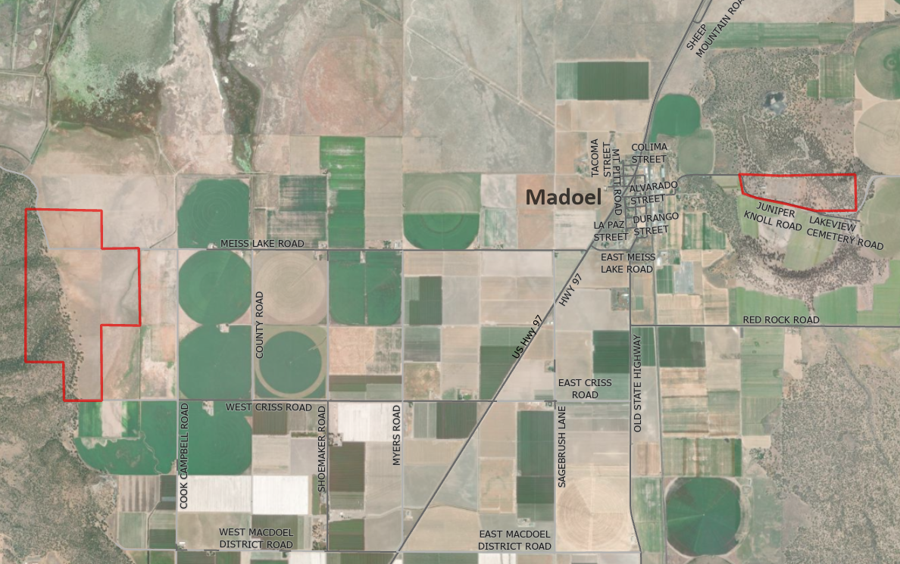
Figure 2: Subject Property – Ranch

Comments
Agency Comments

Siskiyou County Agricultural Commissioner – January 30, 2026
The commissioner commented that AG has no issues with this project (Exhibit D).
Planning Response: No Response necessary.

Siskiyou County Assessor – February 3, 2026
The Assessor’s office has provided estimated tax assessment values for the parcels included in this project (Exhibit D).
Planning Response: No Response necessary.
Public Comments
Notice of the project was published and posted as required prior to the Board of Supervisors meeting and no public comment was received as of the preparation of this staff report.

Recommended Action
Should the Board of Supervisors concur with staff’s analysis, staff recommends that the Board of Supervisors find that the proposed modifications to the Williamson Act contracts and Agricultural Preserves are exempt from CEQA and approve said modifications.
A draft motion to this effect is provided below.

Recommended Motions
I move to take the following actions:
- Determine the project exempt from CEQA in accordance with Section 15317, Open Space Easements or Contracts; and
- Adopt the attached resolution approving amendment to the existing Agricultural Preserve and establishment of a new preserve; and
- Adopt the attached resolution approving the rescission and reentry of the applicable Williamson Act contracts.

Exhibits to the Staff Report
- Draft Resolution amending the existing Agricultural Preserves and establishing a new preserve
- Draft Resolution Approving the Rescission of the subject property from the existing contracts and Reentry into two new Williamson Act Contracts
- Exhibit A within Draft Resolution: Williamson Act Contract Farm– Draft
- Exhibit B within Draft Resolution: Williamson Act Contract Ranch- Draft
- Agricultural Preserve Administrator Staff Report with Recommendation
- Comments

