Staff Report
Meeting Date: February 17, 2026
To: Siskiyou County Board of Supervisors
From: Bernadette Cizin, Associate Planner
Subject: Proposed Masson Williamson Act Rescission with Re-entry, Agricultural Preserve Amendment (APA-23-13) and CEQA Determination

Background and Discussion
On June 27, 2023, the County received an application for a Williamson Act Contract amendment to bring approximately 80.38 acres, owned by Dustin and Mireya Masson, under one Williamson Act contract consisting solely of property under their ownership with the Agricultural Use of livestock grazing and hay farming. The property is currently under a Williamson Act contract which has two property owners.
Additionally, the existing Agricultural Preserve should be amended to remove the subject property and a new Agricultural Preserve created as the existing preserve consists of property that is not contiguous nor owned in common. As the subject property alone does not meet the 100-acre minimum requirement, staff is recommending creating a preserve consisting of the subject property and adjacent property owned by the Shannons (Figure 2). This will not affect the Williamson Act Contract for the Shannon’s property.
This Agricultural Preserve amendment will leave approximately 74.9 acres owned by Sousa under the existing preserve. The Sousa property alone does not meet the 100-acre minimum requirement, so staff is recommending creating a second preserve consisting of the 74.9-acre Sousa owned property along with adjacent property owned by Hayden (Figure 3). This will not affect the Williamson Act Contract for the Hayden property.
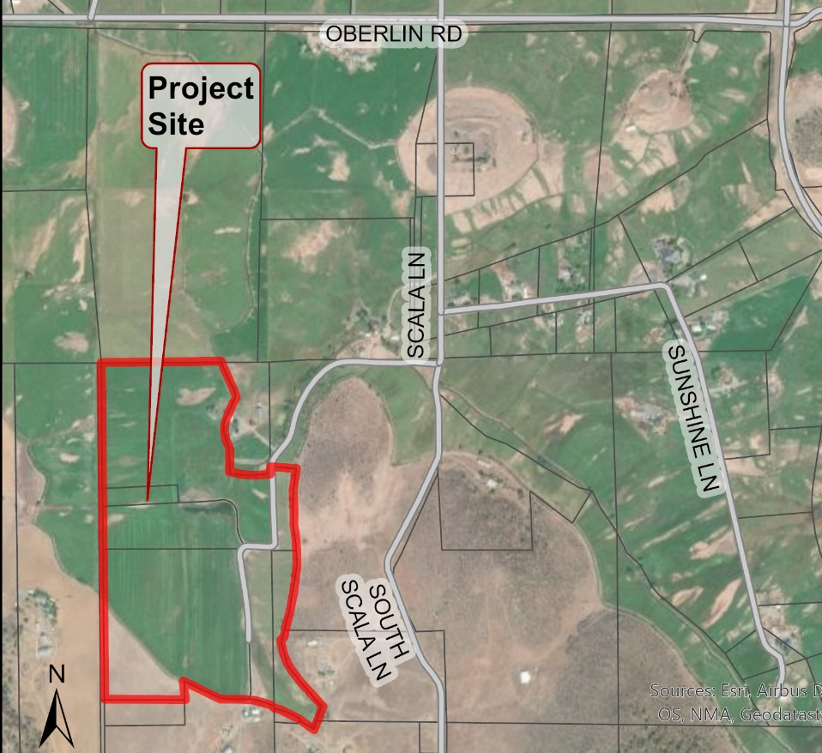
Figure 1: Subject Property
Agricultural Preserve Administrator Review
Staff prepared a detailed report (Exhibit C) for review and recommendation by the Agricultural Preserve Administrator. Based on the report, the Administrator found the applicant’s request is consistent with the County Rules for the Establishment and Administration of Agricultural Preserves and Williamson Act Contracts and recommends the Board rescind and reissue the contract as proposed and amend the existing preserve to remove the subject property and establish two new agricultural preserves.
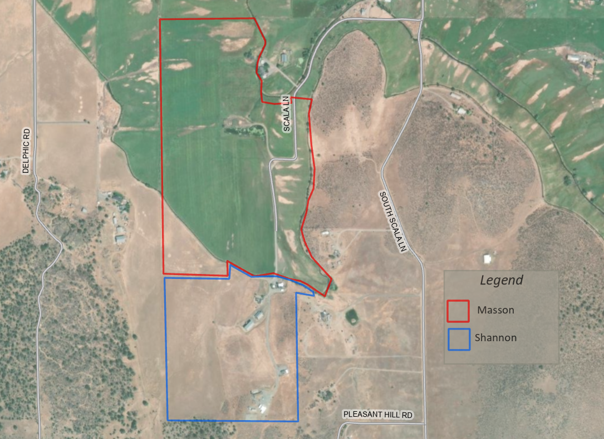
Figure 2: Proposed Agricultural Preserve (Masson & Shannon)
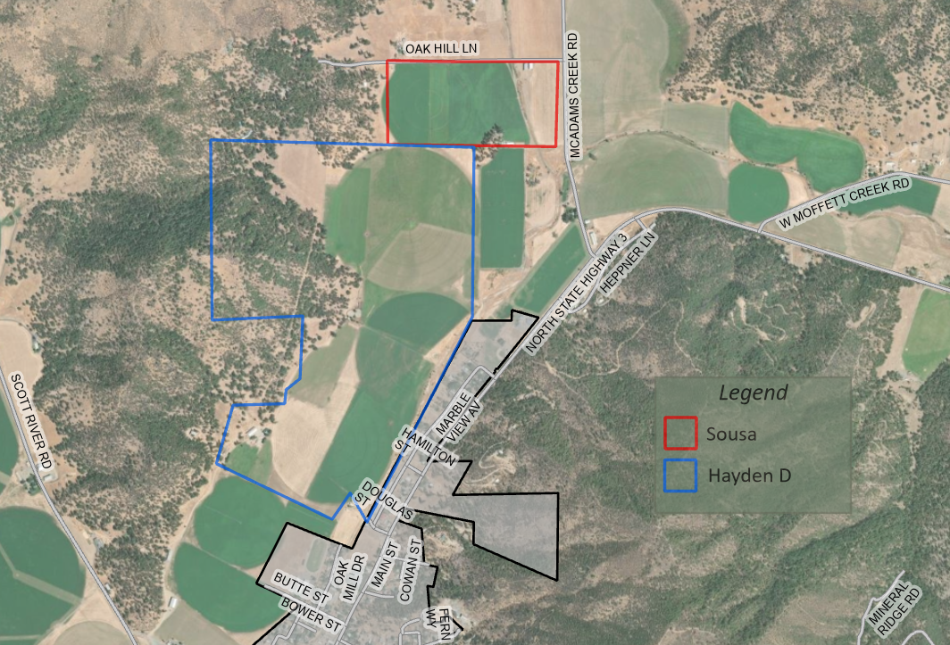
Figure 3: Proposed Agricultural Preserve (Sousa & Hayden)

Environmental Review
Staff is proposing that the proposed project be considered categorically exempt from the California Environmental Quality Act (CEQA) pursuant to CEQA Guidelines Section 15317, Open Space Easements or Contracts. A Categorical Exemption implies that the project will not result in any significant adverse environmental effects. CEQA Guidelines Section 15317 specifically exempts the making and renewing of open space contracts under the Williamson Act, which is applicable to the subject action.
The Board of Supervisors must consider the proposed CEQA exemption together with any comments received during the public review process. Further, the exemption can only be approved if the Board finds, based on the whole record before it, that there is not substantial evidence that the project will have a significant effect on the environment. Accordingly, a finding to this effect has been incorporated into both draft resolutions prepared for the Board’s consideration.

Comments
Agency Comments
A request for comment was sent to outside agencies on July 27, 2023. No agency comments were received.
Public Comments
Notice of the project was published and posted as required prior to the Board of Supervisors meeting and no public comment was received as of the preparation of this staff report.

Recommended Action
Should the Board of Supervisors concur with staff’s analysis, staff recommends that the Board of Supervisors find that the proposed modifications to the Williamson Act contract and Agricultural Preserve are exempt from CEQA and approve said modifications.
A draft motion to this effect is provided below.

Recommended Motions
I move to take the following actions:
- Determine the project exempt from CEQA in accordance with Section 15317, Open Space Easements or Contracts; and
- Adopt the attached resolution approving the amendment of the existing Agricultural Preserve and establish a new Agricultural Preserve consisting of the Masson and Shannon properties; and
- Adopt the attached resolution approving the amendment of the existing Agricultural Preserve and establish a new Agricultural Preserve consisting of the Sousa and Hayden properties; and
- Adopt the attached resolution approving the rescission and reentry of the applicable Williamson Act contract.

Exhibits to the Staff Report
- Draft Resolution amending the existing Agricultural Preserve and establishing a new preserve for the Masson and Shannon Properties.
- Draft Resolution amending the existing Agricultural Preserves and establishing a new preserve for the Sousa and Hayden properties.
- Draft Resolution Approving the Rescission of the subject property from the existing contract and Reentry into a new Williamson Act Contract
- Exhibit A within Draft Resolution: Williamson Act Contract – Draft
- Agricultural Preserve Administrator Staff Report with Recommendation

