STAFF REPORT
MEETING DATE: November 18, 2025
TO: Board of Supervisors
FROM: James Phelps, Senior Planner
SUBJECT: Determination of Public Convenience or Necessity (Form ABC-245) for a Type 21 (Off-Sale General) Alcoholic Beverage License for Grenada Shell Gas Station / 3J’s Deli & Mini Mart (Grenada Oil, Inc.)
RECOMMENDATION: Consider and adopt one of two alternative resolutions determining whether issuance of a Type 21 (Off-Sale General) license will serve Public Convenience or Necessity

I. BACKGROUND
The Applicant, Grenada Oil, Inc., doing business as Grenada Shell Gas Station/3J’s Deli & Mini Mart (Grenada Shell), has applied to the California Department of Alcoholic Beverage Control (ABC) for a Type 21 (Off-Sale General) license at 338 Highway A12, Grenada, CA 96038, APN 038-410-461. A Type 21 license allows for the off-premises sale of beer, wine, and distilled spirits.
ABC liquor licenses are issued by census tract. Grenada Shell is in Census Tract Number 7.01 which allows for seven (7) Off-Sale licenses. However, there are currently eight (8) existing licenses for this census tract. The Off-Sale license category includes both Type 20 (beer & wine only) and Type 21 (beer, wine, and distilled spirits).
Off-Sale Licenses in Census Tract Number 7.01
License Type | Owner | Business | Location
20 | Dollar Tree Inc | Dollar Tree 1251 | 1828 Fort Jones Road, Yreka
20 | Grenada Oil (Applicant) | 3J Truck Stop (Shell) | 338 Hwy A12, Grenada
20 | Mountain Silverado Inc | Easy Street Market | 1801 Fort Jones Road, Yreka
21 | Raleys | Raleys 247 | 1840 Fort Jones Road, Yreka
21 | Mountain Silverado Inc | Siskiyou Food Mart (Valero) | 1802 Fort Jones Road, Yreka
21 | Walmart Inc | Walmart Store #1630 | 1906 Fort Jones Road, Yreka
21 | SDSS One LLC | Liquor Expo | 9320 Old Hwy 99 S, Grenada
21 | Legend 295 Inc | Yreka Food Gas (Chevron) | 1801 Fort Jones Road, Yreka
Source: California Department of Alcoholic Beverage Control, License Query System, October 2025.
Six of the Off-Sale licenses within the census tract are located along Fort Jones Road/Highway 3, in Yreka, heading towards Walmart and Scott Valley. The remaining two Off-Sale licenses are located in Grenada.
When the number of existing licenses (8) exceeds the allowable threshold (7), ABC designates the area as having an undue concentration. In such cases, the Board of Supervisors must determine whether issuance of an additional license would serve Public Convenience or Necessity (PC or N) before ABC may issue another license.
Grenada Shell currently holds a Type 20 license (beer and wine) at the same location. Approval of a new Type 21 license (beer, wine, and distilled spirits) would allow broader product sales at the existing business. The Type 20 license would be surrendered for purposes of activation at this site but remains valid and transferable under ABC regulations. Because surrendered licenses can be reactivated elsewhere in California, issuance of the new Type 21 license would effectively increase the number of active Off-Sale licenses in Census Tract 7.01 from eight (8) to nine (9).
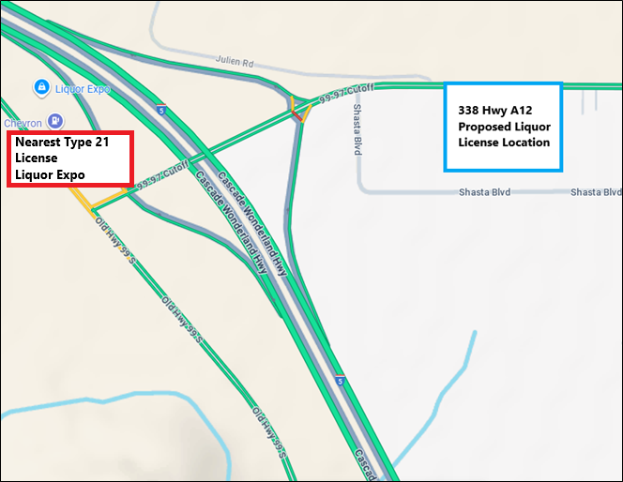
Figure 1: Location of Proposed Liquor License.
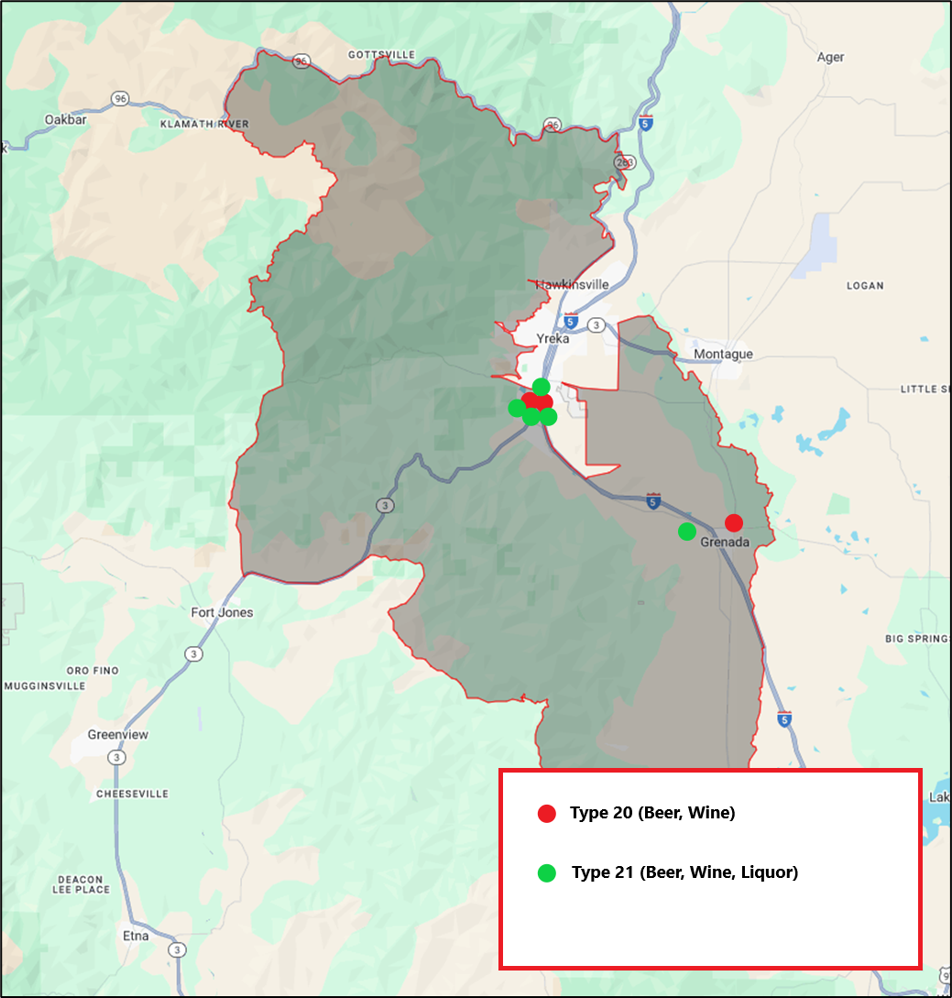
Figure 2: Census Tract # 7.01, Siskiyou County (Population 3,860 as of 2023).
ABC requires a local determination of PC or N whenever a new license is proposed in an area of undue concentration.
Siskiyou County has not adopted a local policy delegating PC or N determinations to a county department; therefore, this determination continues to be made by the Board on a case-by-case basis.
The PC or N determination is achieved by passing a Resolution finding that the issuance of the liquor license will serve Public Convenience or Necessity and by the Chair signing Part 3 of Form ABC-245 prior to submission to ABC.
The PC or N determination allows the Board to consider local context and community benefits that may not be reflected in ABC’s numeric analysis. While ABC evaluates concentration strictly by license ratios, the Board may recognize that a new license serves the public interest based on geographic need, economic development, or improved customer service to the surrounding community.
If the Board adopts a resolution finding that issuance of the license serves the public convenience or necessity, ABC may proceed with processing and issuing the license. If the Board determines that public convenience or necessity would not be served, ABC is prohibited from issuing the license.
Therefore, the PC or N process ensures that local officials, rather than the State alone, define what constitutes an appropriate and beneficial use in the context of community planning and service availability in Siskiyou County.
After being notified, the Board of Supervisors has 90 days to determine whether PC or N would be served by issuance of the Type 21 license. If the Board fails to act within 90 days, ABC may issue the license if the applicant demonstrates that PC or N would be served; ABC will not attribute any weight to the County’s failure to act within 90 days.

II. FISCAL IMPACT
There is no fiscal impact to the County associated with this action.

III. DISCUSSION
Planning staff reviewed the PC or N request and found:
- This request pertains to an existing commercial establishment serving the Grenada community and Interstate-5 corridor.
- No physical expansion or change in operations is proposed, and staff has identified no evidence of community opposition or adverse impacts.
- The business location is within the unincorporated area of Siskiyou County.
- The proposed use as a retail gas station selling beer, wine, and distilled spirits for off-site consumption is consistent with the zoning district Highway Commercial (C-H), and the County General Plan.
- There are no known code enforcement or zoning violations associated with the property.
- Adequate parking and site access are available, and no physical expansion or new construction is proposed.
- Determination of PC or N does not constitute a discretionary land use entitlement under County Code or CEQA; it is an administrative determination for ABC licensing purposes only.
Based on the information presented above, staff has prepared two alternative resolutions for the Board’s consideration to document its determination regarding public convenience or necessity.

IV. ENVIRONMENTAL REVIEW
The proposed action is not a “project” under the California Environmental Quality Act (CEQA), pursuant to CEQA Guidelines §15378(b)(5), as it constitutes an administrative activity of government that will not result in direct or reasonably foreseeable indirect physical changes to the environment.

V. RECOMMENDED MOTION
Staff recommends that the Board take one of the following actions:
Approval of Liquor License – (Alternative 1)
Finding that the license will serve Public Convenience or Necessity.
I move that the Board adopt the Resolution determining that issuance of a Type 21 license will serve Public Convenience or Necessity and authorize the Chair to complete and sign Part 3 of Form ABC-245 on behalf of the County of Siskiyou.
Denial of Liquor License – (Alternative 2)
Finding that the license will not serve Public Convenience or Necessity.
I move that the Board adopt the Resolution determining that issuance of a Type 21 license will not serve Public Convenience or Necessity and authorize the Chair to complete and sign Part 3 of Form ABC-245 on behalf of the County of Siskiyou.

VI. ATTACHMENTS
- Resolution Approving Public Convenience or Necessity.
- Resolution Denying Public Convenience or Necessity.
- Form ABC-245 (Received October 21, 2025).

