# Staff Report

Meeting Date: October 21, 2025

To: Siskiyou County Board of Supervisors

From: Bernadette Cizin, Associate Planner

Subject: AGN-25-03 - Intention to Serve Notice of Non-Renewal of property under Williamson Act Contracts 72030A, 72062, 76005D, 78025 and 93004 and CEQA Determination

## Background

There are approximately 510 individual Williamson Act contracts covering approximately 2,600 separate APNs in Siskiyou County. Pursuant to the rules and procedures for the Siskiyou County’s Williamson Act program, County Planning staff has surveyed and reviewed properties under Williamson Act contract to verify compliance and determine whether landowners are using their property for commercial agricultural operations. This review is conducted in order to assure that the intent of the program - commercial agricultural production is being carried out under these contracts.

The primary goal of the County’s Williamson Act contracts is not only the preservation of agricultural lands, but rather, the land is principally used for commercial agricultural production. With that in mind, staff continues to review survey responses, changes in property ownership and property boundaries.

## Discussion

In April of 2025, staff sent out surveys for each property under Williamson Act Contract. As five owners did not return a response, staff is unable to verify a commercial agricultural use is occurring on the property, which is in violation of the Siskiyou County Rules for the Establishment and Administration of Agricultural Preserves and Williamson Act Contracts (Guidelines).

Figure 1 – 72030 – Flannagan Property

Figure 2 – 72062 – Baird Property

Figure 3 – 76005D – Geib Property

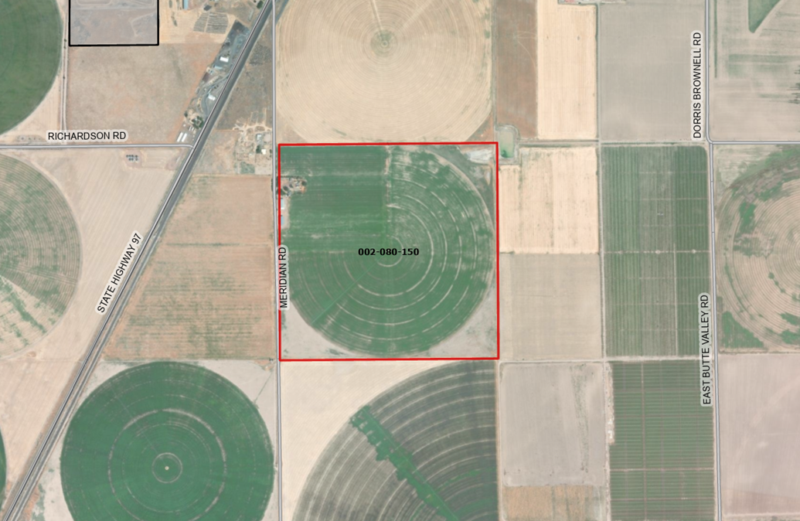

Figure 4 – 78025 – Blodgett Property

Figure 5 – 93004 – Jones Property

## Potential Next Steps

Should the Board agree with staff’s recommendation and authorize staff to issue the notices of non-renewal, the Planning Department will file a Notice of Non-Renewal of Williamson Act Contract with the Assessor’s Office. Under Government Code Section 51245**, *if a local government desires not to renew a Williamson Act contract, it shall serve written notice of non-renewal of the contract upon the contracted party(ies) in advance of the annual renewal date of the contract. A city or county shall serve written notice of non-renewal at least 60 days prior to the renewal date, which would require Siskiyou County to serve the Notice of Non-Renewal by no later than November 1, 2025.***

The recordation will trigger property tax reassessment of the affected parcels, and a nine-year period contract phase out will commence. Pursuant to Government Code Section 51246(a), development restrictions on non-renewed contracted parcels will remain in effect for the balance of the period remaining since the original execution or the last renewal of the contract.

Notice of the project was published and posted as required prior to the Board of Supervisors meeting and no public comments were received as of the preparation of this staff report.

## Environmental Review

Staff recommends the proposed issuance of a notice of non-renewal for a Williamson Act contract be determined categorically exempt from the California Environmental Quality Act (CEQA) pursuant to CEQA Guidelines Section 15317, Open Space Contracts or Easements. The Class 17 exemption applies as this project does not propose to alter or expand the existing Williamson Act contract, which will remain in effect for the nine-year roll out period. Additionally, staff further recommends also, therefore, also be exempt from CEQA pursuant to Guidelines Section 15061(b)(3), the “commonsense” exception, as no changes in current use of the properties are proposed.

The proposed CEQA exemptions must be considered together with any comments received during the public review process. Further, the exemptions can only be approved if the finding is made, based on the whole record before it, that there is not substantial evidence that there are unusual circumstances (including future activities) which might reasonably result in the project having a significant effect on the environment.

## Recommended Motion

I move to adopt the Resolutions Directing staff to Issue a Notice of Non-Renewal to Williamson Act Contract No. 72030A, 72062, 76005D, 78025 and 93004 which hereby taking the following actions:

1. The Board of Supervisors determine that the proposed issuance of Non-Renewals of Williamson Act contracts is categorically exempt under Sections 15317 and 15061(b)(3) of the CEQA Guidelines; and

## Authorize staff to process the Notice of Non-Renewals with any changes directed by the Board.

Exhibits to the Staff Report

A. Draft Resolution, a Resolution of the County of Siskiyou, State of California, Directing Staff to Issue a Notice of Non-Renewal for Contract No. 92015A, 92015B, 72025B and 71011.

* 1. Exhibit A-1 within Draft Resolution: List of recommended properties
  2. Exhibit A-2 within Draft Resolution: Notice of Non-Renewal - DRAFT

1. Agricultural Preserve Administrator Staff Report with Recommendation