Staff Report
Meeting Date: September 16, 2025
To: Siskiyou County Board of Supervisors
From: Bernadette Cizin, Associate Planner
Subject: Proposed Martin Williamson Act Rescission with Re-entry, Agricultural Preserve Amendment (APA-24-05) and CEQA Determination. Continued from August 5, 2025

Background and Discussion
J. T. Martin has requested that his 37.5 acres be removed from the existing Williamson Act contract which has two different property owners and is within an Agricultural Preserve which has property under several ownerships and is not contiguous.
This project was brought before the Board on August 5, 2025, with a recommendation not to approve the request and issue a notice of non-renewal for the subject property as it does not meet minimum acreage or soils requirements for a contract nor does it meet required acreage for a preserve.
The board directed staff to bring the project back to today’s meeting with additional options prepared.
Below Staff analyzes each requirement that has prevented staff from making a recommendation of approval of the applicant’s proposal and identified options.

- Government Code: 40-acre minimum parcel size
Government Code Section 51222 provides that it is in the public interest for local officials and landowners to retain agricultural lands which are subject to contracts in parcels large enough to sustain agricultural uses permitted in contracts. Agricultural land shall be presumed to be in parcels large enough to sustain their agricultural use if of least 10 acres in size in the case of prime agricultural land (NRCS mapped Class I or II soils) or at least 40 acres in size when the land is not prime agricultural land.
Because the Martin property does not meet any of the criteria in Government code section 51222 to be considered prime agricultural lands, it must meet the 40 acre non-prime acreage requirement.

- County Rules: Required 40-acres Class I or II equivalent soils
This acreage requirement in the County Rules ensures that when agricultural operations occur on lower production soils, there is a sufficient amount of acreage to maintain a legitimate commercial agricultural enterprise. For example, a 40-acre property of irrigated pasture consisting of Class III soils would have sufficient acreage, however a property dedicated to dryland grazing consisting of mainly unirrigated Class V soils would require much more acreage, upwards of 240 acres, to achieve the required equivalency of 40 acres of Class I or II soils under the County Rules.

The subject property consists of mainly Class III, IV & VI soils, only 24.25 acres of class I or II equivalent. This does not meet the minimum 40-acre equivalent soils requirement under the County rules
The County’s Rules provide an exception to the 40-acre minimum in Section III (B). This exception is for properties which have a concentrated Agricultural Enterprise limited to the growing of fruits, nuts or vines.
Because the Martin property has been used for and continues to be used for hay production and livestock grazing, this exception does not apply, and therefore the applicant does not have sufficient qualifying acreage under the County’s soil equivalency rules for a Williamson Act Contract with the County

Option: Should the Board wish to remove or modify the soil equivalency requirements in its Rules, which require in excess of 40 acres of nonprime agricultural land when soils do not meet the 40-acre Class I or II equivalent, then the Board has the option to continue this hearing to a future date pending revision of the County’s rules in a separate proceeding.

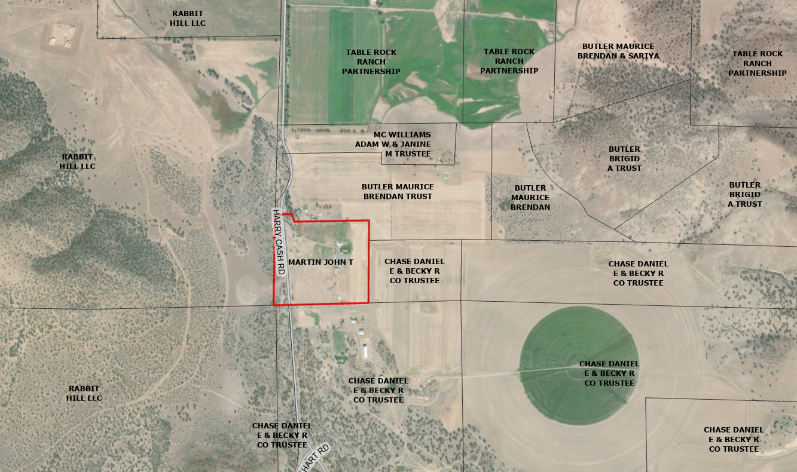
Figure 1: Subject Property

- Required 100-acre Agricultural Preserve
Government Code Section 51230 provides that a county may establish a preserve for the purposes of defining the boundaries of areas which the county would be willing to enter into Williamson Act Contracts. The preserve shall consist of no less than 100 acres. This requirement may be met by combining multiple parcels so long as they are contiguous or owned in common.
Preserves are established at the will of the county and can be altered by the county when they find it necessary. The county can adopt a resolution removing the subject property along with an adjacent property (For example, the adjacent Chase Ranch) and create a new preserve (Figure 2).
Option: Should the Board wish to proceed with approving the proposed contract, they must first address the issue of the preserve. Staff would recommend continuing the project to a future Board meeting as the project must be re-noticed to include the adjacent ranch that will be included in the newly established preserve.
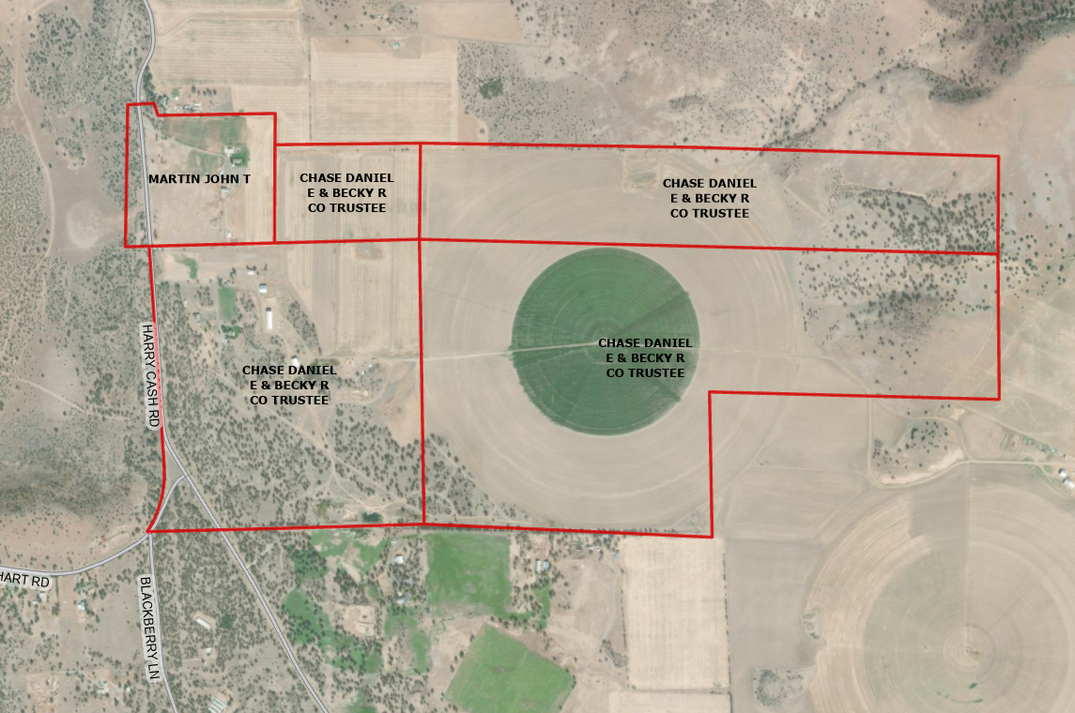Figure 2: Potential resultant Agricultural Preserve

Recommended Action
Option 1
Should the Board of Supervisors concur with staff’s analysis, staff recommends that the Board of Supervisors find that the issuance of the Notice of Non-Renewal for the Williamson Act contract is exempt from CEQA.
A draft motion to this effect is provided below.

Recommended Motion
Option 1
I move to take the following actions:
- Determine the issuance of a Notice of Non-Renewal exempt from CEQA in accordance with Section 15317, Open Space Easements or Contracts and Section 15061(b)(3) of the CEQA Guidelines; and
- Adopt the attached resolution directing staff to process the Notice of Non-Renewal for the subject property with any changes directed by the Board.

Alternative Motion
Option 2 (Please provide staff direction as to what the Board requires to take action on this proposal)
I move to take the following actions:
- Continue the public hearing to December 2, 2025, to allow staff to implement one or more of the options described in the body of this staff report as further directed by the Board.

Exhibits to the Staff Report
- Draft Resolution, a Resolution of the County of Siskiyou, State of California, Directing Staff to issue a Notice of Non-Renewal for 37.5-acres under Contract No. 75008
- Exhibit A-1 within Draft Resolution: Parcels, Map and Description of Property
- Exhibit A-2 within Draft Resolution: Notice of Non-Renewal – Draft

