Exhibit “A-1”
Land Conservation Contract APA-25-05
Notice of Non-Renewal
(Martin)

Assessor’s Parcels Numbers and Pre-rescission Contract Numbers listed below:

Assessor’s Parcel Number | Assessor Contract Number | Clerk Contract Reference | Recordation Number | Acreage
039-170-190 | 75008 | 245 | Vol. 727 Page 146 | 37.5

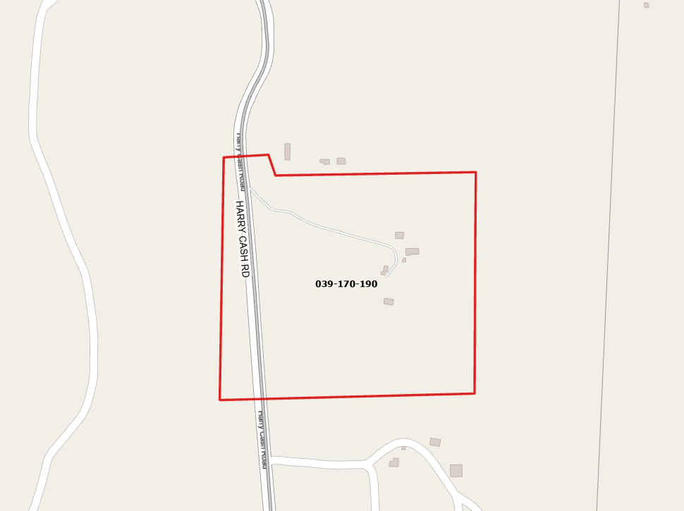
All that real property situate in the unincorporated area of the County of Siskiyou, State of California, described as follows:
[Insert Legal Description]

APN: 039-170-190

