Staff Report
Meeting Date: September 16, 2025
To: Siskiyou County Board of Supervisors
From: Bernadette Cizin, Associate Planner
Subject: Proposed Friden Williamson Act Rescission with Re-entry, Agricultural Preserve Amendment (APA-24-01) and CEQA Determination. Continued from August 5, 2025

Background and Discussion
Charles and Dianne Friden have requested that their 52.06 acres be removed from the existing Williamson Act contract which has six property owners and is within an Agricultural Preserve which has property under several ownerships and is not contiguous.
This project was brought before the Board on August 5, 2025, with a recommendation not to approve the request and issue a notice of non-renewal for the subject property as it does not 1) meet minimum soils requirements for a contract in the County’s Rules for the Establishment and Administration of Agricultural Preserves and Williamson Act Contracts, 2)nor on its own does the property meet minimum acreage requirements for an Agricultural Preserve .
The board directed staff to bring the project back to today’s meeting with additional options prepared.

Below staff analyzes each requirement that has prevented staff from making a recommendation to the Board to approve of the applicant’s proposal and provides alternative options.

- County Rule: Required 40-acres Class I or II equivalent soils
This acreage requirement is adopted by the Board in the County’s Rules for the Establishment and Administration of Agricultural Preserves and Williamson Act Contracts (“County Rules”). The purpose of this acreage requirement is to ensure that when agricultural operations occur on lower production soils, there is sufficient acreage to maintain a legitimate commercial agricultural enterprise. For example, under the equivalency calculations set forth in the County’s Rules, a 40-acre property of irrigated pasture consisting of Class III soils would have sufficient qualifying acreage, however a property dedicated to dryland grazing consisting of mainly unirrigated Class V soils would require much more acreage, upwards of 240 acres, to achieve the required equivalency of 40-acres of Class I or II soils under the County Rules

The subject property consists of mainly Class IV and VI Class soils, only 20.2 acres of Class I or II equivalent. This does not meet the minimum 40-acre equivalent soils requirement under the County rules.

The County’s Rules provide an exception to the 40-acre minimum in Section III (B). This exception is for properties which have a concentrated Agricultural Enterprise limited to the growing of fruits, nuts or vines.
Because the Friden property has been used for and continues to be used for livestock grazing, this exception does not apply and therefore the applicant does not have sufficient qualifying acreage under the county’s soil equivalency rules for a Williamson Act Contract with the County.
Option: Should the Board wish to remove or modify the soil equivalency requirements in its Rules, which require in excess of 40 acres of nonprime agricultural land when soils are classified between Class IV and VII, then the Board has the option to continue this hearing to a future date pending revision of the County’s rules in a separate proceeding.
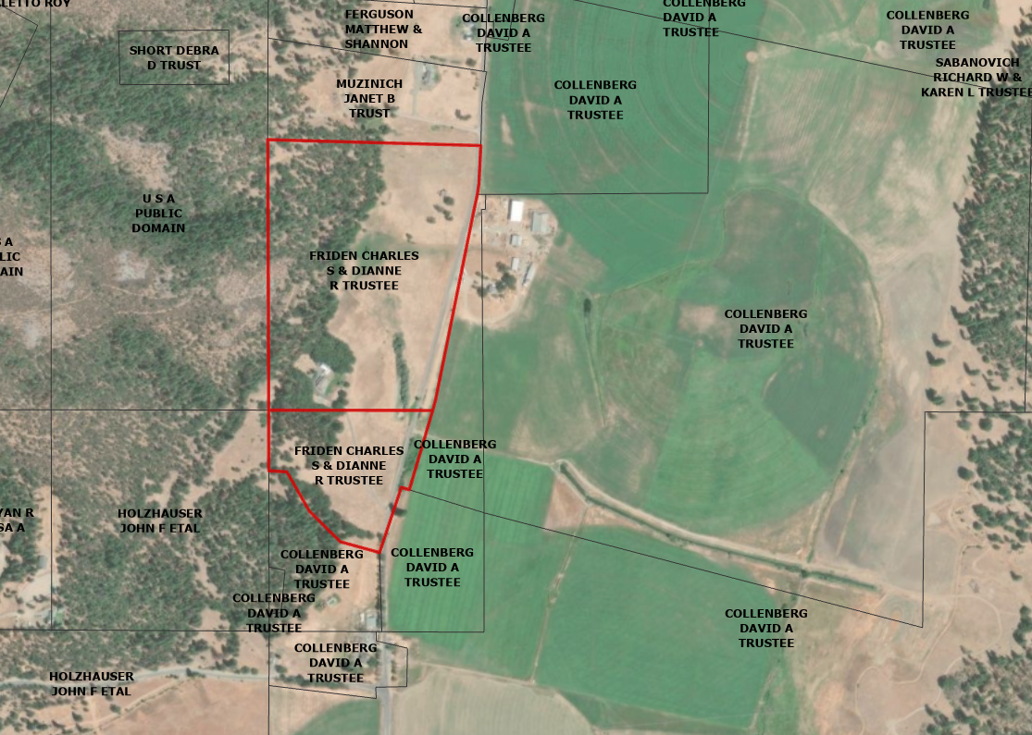
Figure 1: Subject Property
- Required 100-acre Agricultural Preserve
Government Code Section 51230 provides that a county may establish a preserve for the purposes of defining the boundaries of areas which the county would be willing to enter into Williamson Act Contracts. The preserve shall consist of no less than 100 acres. This requirement may be met by combining multiple parcels so long as they are contiguous or owned in common.
Preserves are established at the will of the county and can be altered by the county when they find it necessary. The County can adopt a resolution removing the subject property along with an adjacent property (for example, the adjacent Holzhauser Ranch) and create a new preserve (Figure 2).
Should the Board wish to proceed with approving the proposed contract, they must first address the issue of the preserve. Staff would recommend continuing the project to a future Board meeting as the project must be re-noticed to include the adjacent ranch that will be included in the newly established preserve (Figure 2).
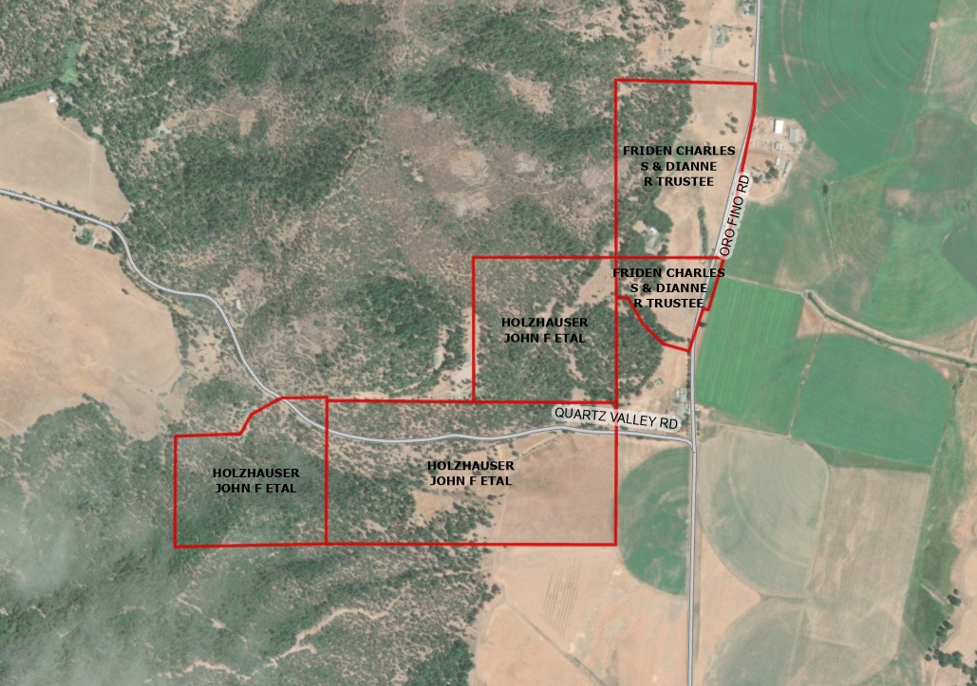
Figure 2: Example of potential resultant Agricultural Preserve

Recommended Action
Option 1
Should the Board of Supervisors concur with staff’s analysis; staff recommends that the Board of Supervisors find that the issuance of the Notice of Non-Renewal for the Williamson Act contract is exempt from CEQA.
A draft motion to this effect is provided below.

Recommended Motion
Option 1
I move to take the following actions:
- Determine the issuance of a Notice of Non-Renewal exempt from CEQA in accordance with Section 15317, Open Space Easements or Contracts and Section 15061(b)(3), of the CEQA Guidelines; and
- Adopt the attached resolution directing staff to process the Notice of Non-Renewal for the subject property with any changes directed by the Board.

Alternative Motion
Option 2
I move to take the following actions:
- Continue the public hearing to December 2, 2025, to allow staff to implement one or more of the options described in the body of this staff report as further directed by the Board.

Exhibits to the Staff Report
- Draft Resolution, a Resolution of the County of Siskiyou, State of California, Directing Staff to issue a Notice of Non-Renewal for 52.06-acres under Contract No. 71019
- Exhibit A-1 within Draft Resolution: Parcels, Map and Description of Property
- Exhibit A-2 within Draft Resolution: Notice of Non-Renewal – Draft

Under the Williamson Act itself, the Act allows for a presumption that a parcel that is 10 acres in size of prime agricultural land or 40 acres in size of non-prime agricultural land is of sufficient size for commercial agricultural use. This does not inhibit the County from rebutting that presumption through its rule making demonstrating either more or less non-prime agricultural land is needed to be sufficient size for commercial agricultural use. (Gov’t Code, § 51222.) The Act also allows the County’s contracts to provide for restrictions, terms, and conditions that are more restrictive or in addition to those required by the Act. (Gov’t Code, § 51240.)

