Exhibit “A-1”
Land Conservation Contract APA-25-01
Notice of Non-Renewal
(Friden)

Assessor’s Parcels Numbers and Pre-rescission Contract Numbers listed below:

Assessor’s Parcel Number | Assessor Contract Number | Clerk Contract Reference | Recordation Number | Acreage
022-400-060 | 20004 | 506 | Document 2000-15504 | 32.60
022-400-110 | 20004 | 506 | Document 2000-15504 | 8.70

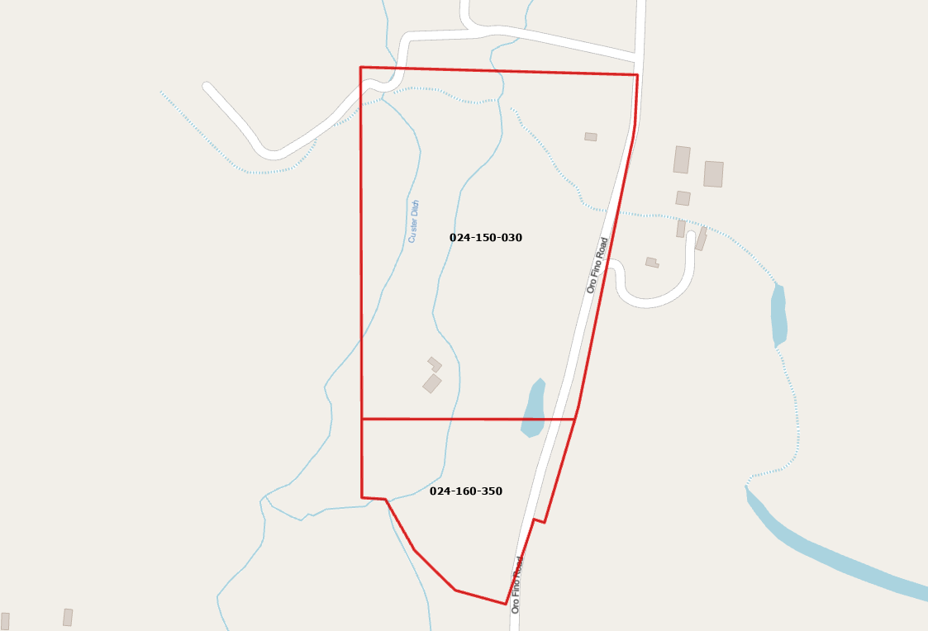
All that real property situate in the unincorporated area of the County of Siskiyou, State of California, described as follows:
[Insert Legal Description]

APNs: 024-160-350 and 024-150-030

