Staff Report
Meeting Date: August 5, 2025
To: Siskiyou County Board of Supervisors
From: Bernadette Cizin, Associate Planner
Subject: Proposed Friden Williamson Act Rescission with Re-entry, Agricultural Preserve Amendment (APA-24-01) and CEQA Determination

Background and Discussion
On February 13, 2025, the County received an application for a Williamson Act Contract amendment to bring approximately 52.06 acres, owned by Charles and Dianne Friden, under one Williamson Act contract consisting solely of property under their ownership with the Agricultural Use of rangeland and pasture for livestock production and forage. The property is currently under a Williamson Act contract which has six property owners.
Additionally, the existing Agricultural Preserve should be amended to remove the subject property and a new Agricultural Preserve created as the existing preserve consists of property that is not contiguous nor owned in common.
During the initial review, it was found that the subject property consists of 20.2 acres of Class I or II equivalent soils, not meeting the minimum 40-acre requirement.
Also, the subject property does not meet the 100-acre minimum required to establish an Agricultural Preserve.
Agricultural Preserve Administrator Review
Staff prepared a detailed report (Exhibit B) for review and recommendation by the Agricultural Preserve Administrator. Based on the report, the Administrator found the applicant’s request is not consistent with the County Rules for the Establishment and Administration of Agricultural Preserves and Williamson Act Contracts and recommends the Board not approve the request and direct staff to issue a Notice of Non-Renewal for the subject property.

Environmental Review
Staff would recommend the issuance of a Notice of Non-Renewal or the approval of the proposed project be considered categorically exempt from the California Environmental Quality Act (CEQA) pursuant to CEQA Guidelines Section 15317, Open Space Easements or Contracts. A Categorical Exemption implies that the project will not result in any significant adverse environmental effects. CEQA Guidelines Section 15317 specifically exempts the making and renewing of open space contracts under the Williamson Act, which is applicable to the proposed amendment or the non-renewal as it will not change the use of the property.
The Board of Supervisors must consider the proposed CEQA exemption together with any comments received during the public review process. Further, the exemption can only be approved if the Board finds, based on the whole record before it, that there is not substantial evidence that the project will have a significant effect on the environment. Accordingly, a finding to this effect has been incorporated into both draft resolutions prepared for the Board’s consideration.
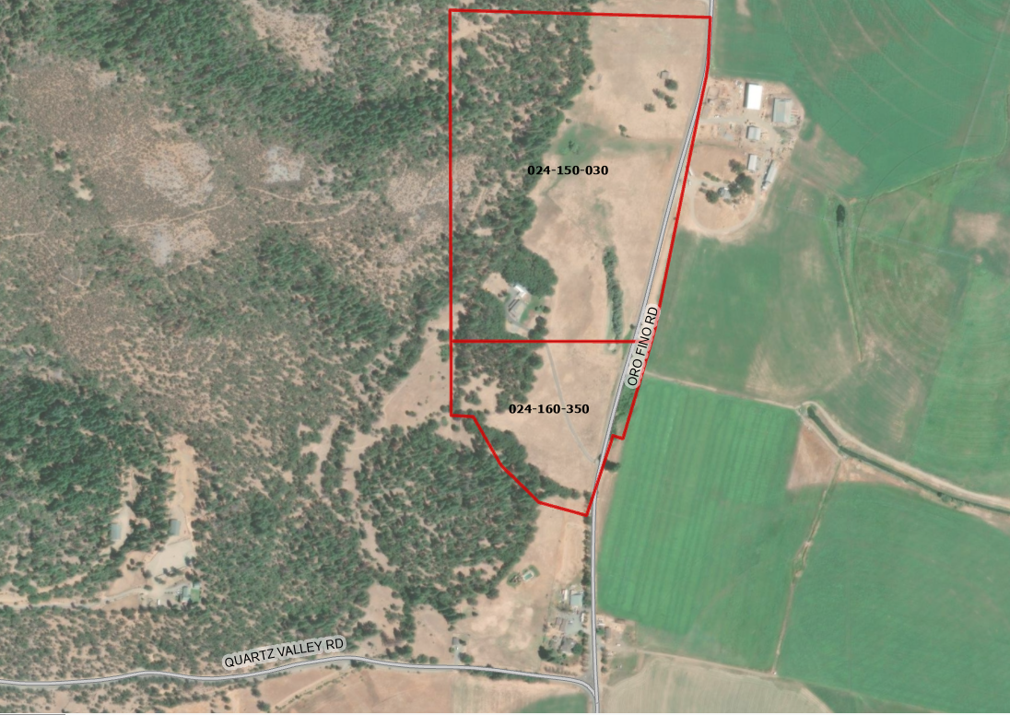Figure 1: Subject Property

Comments
Agency Comments

Siskiyou County Assessor – June 9, 2025
The Assessor’s office has provided estimated tax assessment values for the two parcels included in this project (Exhibit C).
Planning Response: No Response necessary.

Siskiyou County Agricultural Commissioner – April 9, 2025
The Ag Commissioner noted that their department has no issues with the proposal (Exhibit C).
Planning Response: No Response necessary.
Public Comments
Notice of the project was published and posted as required prior to the Board of Supervisors meeting and no public comment was received as of the preparation of this staff report.

Alternatives for Board Action
After consideration of this report and presentations by the applicant, the Board should consider choosing one of the following options:
Option 1: Direct staff to issue a Notice of Non-Renewal for the subject property
Option 2: Continue the hearing and direct staff to prepare resolutions approving the proposed Williamson Act Contract and Agricultural Preserve

Recommended Action
Option 1
Should the Board of Supervisors concur with staff’s analysis, staff recommends that the Board of Supervisors find that the issuance of the Notice of Non-Renewal for the Williamson Act contract is exempt from CEQA.
A draft motion to this effect is provided below.

Recommended Motions
I move to take the following actions:
- Determine the issuance of a Notice of Non-Renewal exempt from CEQA in accordance with Section 15317, Open Space Easements or Contracts; and
- Adopt the attached resolution directing staff to process the Notice of Non-Renewal for the subject property with any changes directed by the Board.

Exhibits to the Staff Report
- Draft Resolution, a Resolution of the County of Siskiyou, State of California, Directing Staff to issue a Notice of Non-Renewal for 52.06-acres under Contract No. 71019
- Exhibit A-1 within Draft Resolution: Parcels, Map and Description of Property
- Exhibit A-2 within Draft Resolution: Notice of Non-Renewal – Draft
- Agricultural Preserve Administrator Staff Report with Recommendation
- Comments

