Exhibit “A”
Land Conservation Contract APA-24-02
Notice of Non-Renewal
(Chase)

Assessor’s Parcels Numbers and Pre-rescission Contract Numbers listed below:

Assessor’s Parcel Number | Assessor Contract Number | Clerk Contract Reference | Recordation Number | Acreage
022-400-060 | 20004 | 506 | Document 2000-15504 | 32.60
022-400-110 | 20004 | 506 | Document 2000-15504 | 8.70
038-280-120  (portion) | 20004 | 506 | Document 2000-15504 | 14
022-190-020  (portion) | 74006 | 201 | Vol 704 Page 834 | 20
022-190-020  (portion) | 74006 | 201 | Vol 704 Page 834 | 3
022-190-110  (portion) | 74006 | 201 | Vol 704 Page 834 | 3
022-190-110  (portion) | 74006 | 201 | Vol 704 Page 834 | 25
022-190-120  (portion) | 74006 | 201 | Vol 704 Page 834 | 12
022-190-120  (portion) | 74006 | 201 | Vol 704 Page 834 | 30
038-240-010 | 74006 | 201 | Vol 704 Page 834 | 25.20
038-240-030  (portion) | 74006 | 201 | Vol 704 Page 834 | 27
038-240-040  (portion) | 74006 | 201 | Vol 704 Page 834 | 10
038-250-260  (portion) | 74006 | 201 | Vol 704 Page 834 | 7
038-270-040 | 74006 | 201 | Vol 704 Page 834 | 26.30
038-270-231  (portion) | 74006 | 201 | Vol 704 Page 834 | 20
038-270-231  (portion) | 74006 | 201 | Vol 704 Page 834 | 4
038-270-231  (portion) | 74006 | 201 | Vol 704 Page 834 | 4
038-280-090 | 74006 | 201 | Vol 704 Page 834 | 16.90
039-330-050 | 74006 | 201 | Vol 704 Page 834 | 9.00
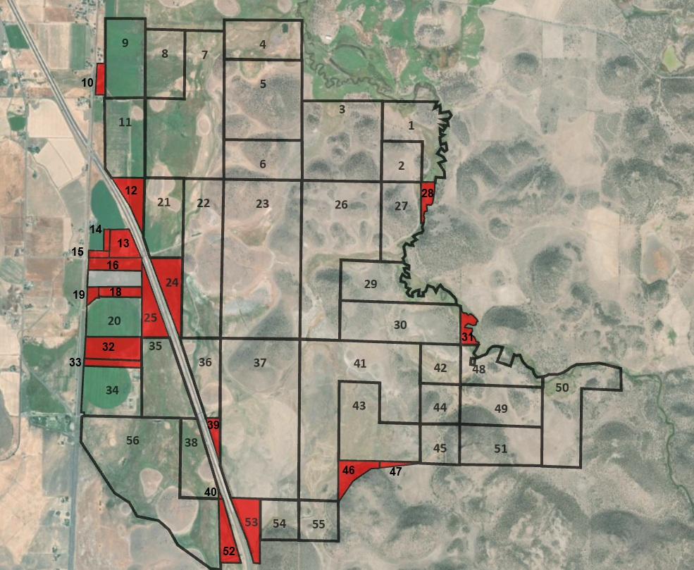
Substandard Parcels Identified as Parcels 10, 12, 13, 14, 15, 16, 18, 24, 25, 28, 31, 32, 33, 39, 40, 46, 47, 52 & 53 of Certificate of Compliance as recorded on October 2, 2018, in Siskiyou County records as Document No. 2018-0008084.

Parcel 10:
A portion of the Northeast One-quarter of Section 27, Township 44 North, Range 6 West, Mount Diablo Base and Meridian, in Siskiyou County, State of California, more particularly described as follows:
Parcel 1 as described in that certain Grant Deed as recorded in the Office of the Siskiyou County Recorder in Volume 421 of Official Records at Page 388.
Portion of APN: 038-250-260

Parcel 12:
The East One-half of the Northeast One-quarter of Section 34, Township 44 North, Range 6 West, Mount Diablo Base and Meridian, in Siskiyou County, State of California, excepting any portion located Southwesterly of the Northeasterly line of Interstate Route Number 5.
APN: 038-270-040

Parcel 13:
All that portion of the East One-half of the Northeast One-quarter of Section 34, Township 44 North, Range 6 West, Mount Diablo Base and Meridian, in Siskiyou County, State of California, located Southwesterly of the Southwesterly line of Interstate Route Number 5.
Excepting any portion located within Parcel 1 as shown on that certain map on file in the Office of the Siskiyou County Recorder in Book 10 of Parcel Maps at Page 145.
Also Excepting any portion located with that certain parcel of land as described in the Quit Claim Deed as recorded in the Office of the Siskiyou County Recorder in Volume 206 of Official Records at Page 474.
Portion of APN: 038-270-231

Parcel 14:
A portion of the East One-half of the Northeast One quarter of Section 34, Township 44 North, Range 6 West, Mount Diablo Base and Meridian, in Siskiyou County, State of California, described as follows:
That certain parcel of land as described in the Quit Claim Deed as recorded in the Office of the Siskiyou County Recorder in Volume 206 of Official Records at Page 474. Excepting any portion located within Parcel 1 as shown on that certain map on file in the Office of the Siskiyou County Recorder in Book 10 of Parcel Maps at Page 145.
Portion of APN: 038-270-231

Parcel 15:
All that portion of the Southwest One-quarter of the Northeast One-quarter of Section 34, Township 44 North, Range 6 West, Mount Diablo Base and Meridian, in Siskiyou County, State of California, lying East of the present right of way of the Southern Pacific Company as described in that certain parcel of land as described in the Grant Deed as recorded in the Office of the Siskiyou County Recorder in Volume 148 of Official Records at Page 145.
Excepting any portion located within Parcel 1 as shown on that certain map on file in the Office of the Siskiyou County Recorder in Book 10 of Parcel Maps at Page 145.
Also Excepting any portion with that certain parcel of land as described in the Quit Claim Deed as recorded in the Office of the Siskiyou County Recorder in Volume 206 of Official Records at Page 474.
Portion of APN: 038-270-231

Parcel 16:
All that portion of the Southeast One-quarter of Section 34, Township 44 North, Range 6 West, Mount Diablo Base and Meridian, in Siskiyou County, State of California, described as follows:
That certain parcel of land containing 18 acres, more or less, as described in the Grant Deed as recorded in the Office of the Siskiyou County Recorder in Volume 58 of Official Records at Page 449.
APN: 038-280-090

Parcel 18:
All that portion of the Southeast One-quarter of Section 34, Township 44 North, Range 6 West, Mount Diablo Base and Meridian, in Siskiyou County, State of California, described as follows:
That certain parcel of land comprising 17 acres, more or less, as described in the Grant Deed as recorded in the Office of the Siskiyou County Recorder in Volume 100 of Official Records at Page 1.
Excepting any portion of that certain parcel of land containing 4.18 acres, more or less, as described in the Grant Deed as recorded in the Office of the Siskiyou County Recorder in Volume 174 of Official Records at Page 373.
Portion of APN: 038-280-120

Parcel 24:
All that portion of the West One-half of the Southwest One-quarter of Section 35, Township 44 North, Range 6 West, Mount Diablo Base and Meridian, in Siskiyou County, State of California, lying Northeasterly of the Northeasterly line of Interstate Route Number 5.
Portion of APN: 038-240-030

Parcel 25:
All that portion of the West One-half of the Southwest One-quarter of Section 35, Township 44 North, Range 6 West, Mount Diablo Base and Meridian, in Siskiyou County, State of California, lying Southwesterly of the Southwesterly line of Interstate Route Number 5.
APN: 038-240-010

Parcel 28:
All that portion of the Northeast One-quarter of the Northeast One-quarter of Section 36, Township 44 North, Range 6 West, Mount Diablo Base and Meridian, in Siskiyou County, State of California, being located Westerly of the center line of the "Shasta River" as described in the Grant Deed as recorded in the Office of the Siskiyou County Recorder in Volume 202 of Official Records at Page 250.
Portion of APN: 038-240-040

Parcel 31:
All that portion of the Southwest One-quarter of the Southwest One-quarter of Section 31, Township 44 North, Range 5 West, Mount Diablo Base and Meridian, in Siskiyou County, State of California, being located Westerly of the center line of the "Shasta River" as described in the Grant Deed as recorded in the Office of the Siskiyou County Recorder in Volume 202 of Official Records at Page 250.
APN: 039-330-050

Parcel 32:
The Northeast One-quarter of Section 3, Township 43 North, Range 6 West, Mount Diablo Base and Meridian, in Siskiyou County, State of California, lying East of the East line of the Central Pacific Railroad Company right of way, as described in the said Grant Deed as recorded in the Office of the Siskiyou County Recorder in Volume 474 of Official Records at Page 27.
Excepting any portion of that certain parcel of land as described in the Grant Deed as recorded in the Office of the Siskiyou County Recorder in Volume 502 of Official Records at Page 612.
Also Excepting any portion of that certain parcel of land as described in the Grant Deed as recorded in the Office of the Siskiyou County Recorder in Volume 502 of Official Records at Page 615.
APN: 022-400-060

Parcel 33:
A portion of the Northeast One-quarter of Section 3, Township 43 North, Range 6 West, Mount Diablo Base and Meridian, in Siskiyou County, State of California, described as follows:
That certain parcel of land as described in the Grant Deed as recorded in the Office of the Siskiyou County Recorder in Volume 502 of Official Records at Page 612.
APN 022-400-110

Parcel 39:
All that portion of the East One-half of the Southwest One-quarter of Section 2, Township 43 North, Range 6 west, Mount Diablo Base and Meridian, in Siskiyou County, State of California, lying Easterly of the Easterly line of Interstate Route Number 5.
Portion of APN: 022-190-120

Parcel 40:
All that portion of the East One-half of Section 2, Township 43 North, Range 6 West, Mount Diablo Base and Meridian, in Siskiyou County, State of California, lying Westerly of the Westerly line of Interstate Route Number 5.
Portion of APN: 022-190-110

Parcel 46:
The Southeast One-quarter of the Southwest One-quarter of Section 1, Township 43 North, Range 6 West, Mount Diablo Base and Meridian, in Siskiyou County, State of California, excepting any portion of that certain parcel of land as described in the Grant Deed as recorded in the Office of the Siskiyou County Recorder in Volume 51 of Official Records at Page 325.
Portion of APN: 022-190-020

Parcel 47:
The Southwest One-quarter of the Southeast One-quarter of Section 1, Township 43 North, Range 6 West, Mount Diablo Base and Meridian, in Siskiyou County, State of California, excepting any portion of that certain parcel of land as described in the Grant Deed as recorded in the Office of the Siskiyou County Recorder in Volume 51 of Official Records at Page 325.
Portion of APN: 022-190-020

Parcel 52:
All that portion of the Northwest One-quarter of the Northeast One-quarter, and the North One-half of the Southwest One-quarter of the Northeast One-quarter of Section 11, Township 43 North, Range 6 West, Mount Diablo Base and Meridian, in Siskiyou County, State of California, lying Westerly of the Westerly line of Interstate Route Number 5.
APN: 022-190-110

Parcel 53:
All that portion of the Northwest One-quarter of the Northeast One-quarter, and the North One-half of the Southwest One-quarter of the Northeast One-quarter of Section 11, Township 43 North, Range 6 West, Mount Diablo Base and Meridian, in Siskiyou County, State of California, lying Easterly of the Easterly line of Interstate Route Number 5.
Portion of APN: 022-190-120

