# Staff Report

Meeting Date: June 3, 2025

To: Siskiyou County Board of Supervisors

From: Bernadette Cizin, Associate Planner

Subject: Proposed Lutz Agricultural Preserve Amendment, Williamson Act Rescission with Re-entry, Agricultural Preserve Amendment (APA-24-07) and CEQA Determination

## Background and Discussion

On May 31, 2024, the County received an application to adjust the boundary between two separate parcels, only one of which is encumbered by Williamson Act Contract.   
In order to complete the boundary line adjustment, we must first address the Agricultural Preserve boundary and Williamson Act Contract by amending them to reflect the proposed property boundary.

This project does propose to decrease the acreage of the existing agricultural preserve and contract by 0.57 acres. The acreage being transferred from Ag Preserve is developed with accessory structures incidental to the residence on the parcel that is not within Willimason Act contract, therefore having no effect on the existing agricultural uses.

**Agricultural Preserve Administrator Review**

Staff prepared a detailed report (Exhibit D) for review and recommendation by the Agricultural Preserve Administrator. Based on the report, the Administrator found the applicant’s request is consistent with the County Rules for the Establishment and Administration of Agricultural Preserves and Williamson Act Contracts and recommends the Board rescind and reissue the contract as proposed and amend the existing preserve to remove the subject property and establish a new agricultural preserve.

## Environmental Review

Staff is proposing that the proposed project be considered categorically exempt from the California Environmental Quality Act (CEQA) pursuant to CEQA Guidelines Section 15317, *Open Space Easements or Contracts.* A Categorical Exemption implies that the project will not result in any significant adverse environmental effects. CEQA Guidelines Section 15317 specifically exempts the making and renewing of open space contracts under the Williamson Act, which is applicable to the subject action of the recission and re-entry of the contracts and applies to the issuance of the non-renewal as the action would not cause a change in use and the contract will remain in effect for the balance of the time remaining since the last renewal.

The Board of Supervisors must consider the proposed CEQA exemption together with any comments received during the public review process. Further, the exemption can only be approved if the Board finds, based on the whole record before it, that there is not substantial evidence that the project will have a significant effect on the environment. Accordingly, a finding to this effect has been incorporated into both draft resolutions prepared for the Board’s consideration.

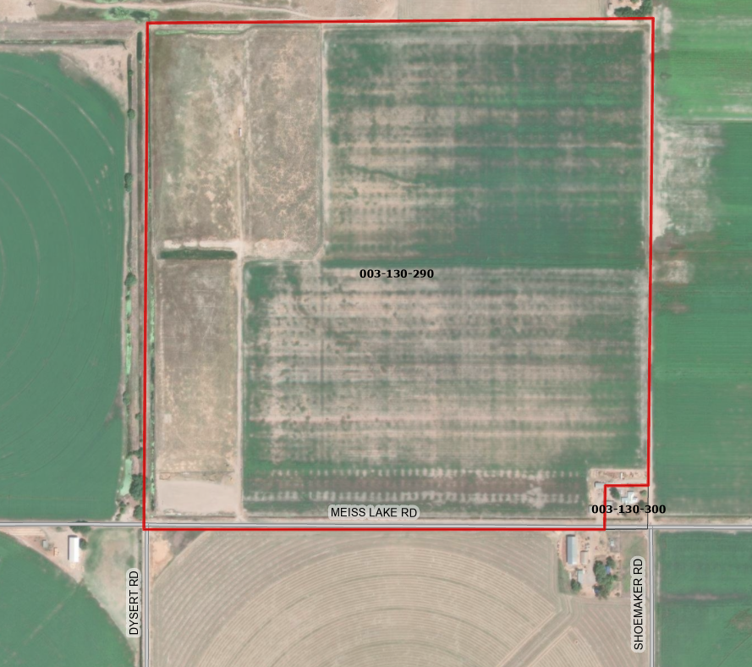   
Figure 1: Subject Property

## Comments

Agency Comments

Environmental Health, CAL FIRE and Public Works all commented specifically on the Boundary Line Adjustment proposal. No agency had any objections to the project as proposed.

Public Comments

Notice of the project was published and posted as required prior to the Board of Supervisors meeting and no public comment was received as of the preparation of this staff report.

## Recommended Action

Should the Board of Supervisors concur with staff’s analysis, staff recommends that the Board of Supervisors find that the proposed modifications to the Williamson Act contract and Agricultural Preserve amendments are exempt from CEQA and approve said modifications.

A draft motion to this effect is provided below.

## Recommended Motions

I move to take the following actions:

1. Determine the project exempt from CEQA in accordance with Section 15317, Open Space Easements or Contracts; and
2. Adopt the attached resolution approving amendment to the existing Agricultural Preserve and establishment of a new preserve; and
3. Adopt the attached resolution approving the rescission and reentry of the applicable Williamson Act contracts; and

## Exhibits to the Staff Report

1. Draft Resolution amending the existing Agricultural Preserve and establishing a new preserve
2. Draft Resolution Approving the Rescission of the subject property from the existing contracts and Reentry into new Williamson Act Contracts
3. Exhibit A within Draft Resolution: Williamson Act Contract Parcel A – Draft
4. Agricultural Preserve Administrator Staff Report with Recommendation