**Siskiyou County  
Planning Commission Staff Report  
December 18, 2024**

## Agenda Item Number 1 McDonagh Timberlands Zone Change (Z-24-01)

**Applicant:** John J. McDonagh  
Wolf Creek Tree Farm  
PO BOX 279  
McCloud, CA 96057

**Property Owner:** John J. and Claudia K. McDonagh  
PO BOX 279  
McCloud, CA 96057

**Project Summary** The project is a proposed zone change for approximately 323 acres from Rural Residential (R-R-B-40) to Timber Production (TPZ) in order to align the zoning with the current use of timber management.

**Location:** The project site is located five miles southwest of Highway 3 and the community of Callahan; APN 031-290-010; Township 39N, Range 8W, Section 7, MDB&M; 41.2606, -122.8277.

**General Plan:** Soils: Erosion Hazard; Building Foundation Limitations: High Shrink-Swell Behavior Soils; Slope; Wildfire Hazard; Woodland Productivity

**Zoning:** Rural Residential Agricultural, 40-acre minimum parcel size (R-R-B-40)

**Exhibits:** A. Draft Resolution PC 2024-028  
 A Resolution of the Planning Commission of the County of   
 Siskiyou, State of California, Recommending that the Board of   
 Supervisors Determine the Project Exempt from the California   
 Environmental Quality Act and Approve the McDonagh Zone   
 Change (Z-24-01)

A-1. Recommended Findings  
 A-2. Notations

B. Comments

C. California Cooperative Forest Management Plan

C-1. Revised Vegetation and Site Class Map

D. 1978 Resolution Adopting the Criteria for List “C” for Timber Preserve Zoning (4-11-1978)

## Background

### Current and Historical Conditions

The applicant is proposing to rezone 323 acres of real property from R-R-B-40 to TPZ to better align the site with the historic, existing, and future use of the property, namely the growing and harvesting of timber. Throughout the history of this parcel, timber production has been a regular source of income.

In 1993, the McKeen Mine Timber Harvest Plan (THP No. 2-93-00224-SIS) was filed for subsequent harvest and completed in 1995. It is estimated that 190 mbf (m=1000, bf=board feet) was harvested on the property, the majority of which was ponderosa pine and white fir.

In 2021, the River Complex Fire burned through the timber stand leaving approximately 30 unburned acres along the western boundary. The existing composition of timber includes white fir, ponderosa pine, Douglas fir, incense cedar, red fir and sugar pine.

In the Spring of 2022, bark beetles appeared and infected all the standing dead pine burned in the fire. An Emergency Timber Operation (2-22EM-00083-SIS) was conducted to salvage the fire kill timber from the remainder of the property. The insect population has since returned to endemic levels and the property currently has no disease problem. Conservation practices for the property follow the California Forest Practice Rules.

**Adjacent Parcels**

|  |  |  |  |
| --- | --- | --- | --- |
| **Direction** | **Acreage** | **Zoning** | **Uses** |
| West | 640 | RRB40 | Klamath National Forest |
| South | 323 | TPZ | Timber Management |
| East | 640 | RRB40 | Klamath National Forest |
| North | 34.4 | RRB40 | Klamath National Forest |

The project site is bordered by the Klamath National Forest to the north, east, and west. The 323-acre parcel directly south of the property is owned by the applicant and is zoned TPZ.

The property straddles two watersheds, the Lower Scott River and Fox Creek. Most of the property is located in the Lower Scott River watershed which contains West Boulder Creek and its tributary, Wolf Creek. Existing improvements on the site include private access dirt roads and the Callahan water diversion. The Callahan Water Company has a granted easement to divert water from Boulder Creek. The Callahan Water Diversion is located on Boulder Creek above the confluence of Wolf Creek. There are no buildings on the property. Many ditches remain from the mining era which have not been in use since the 1950’s.

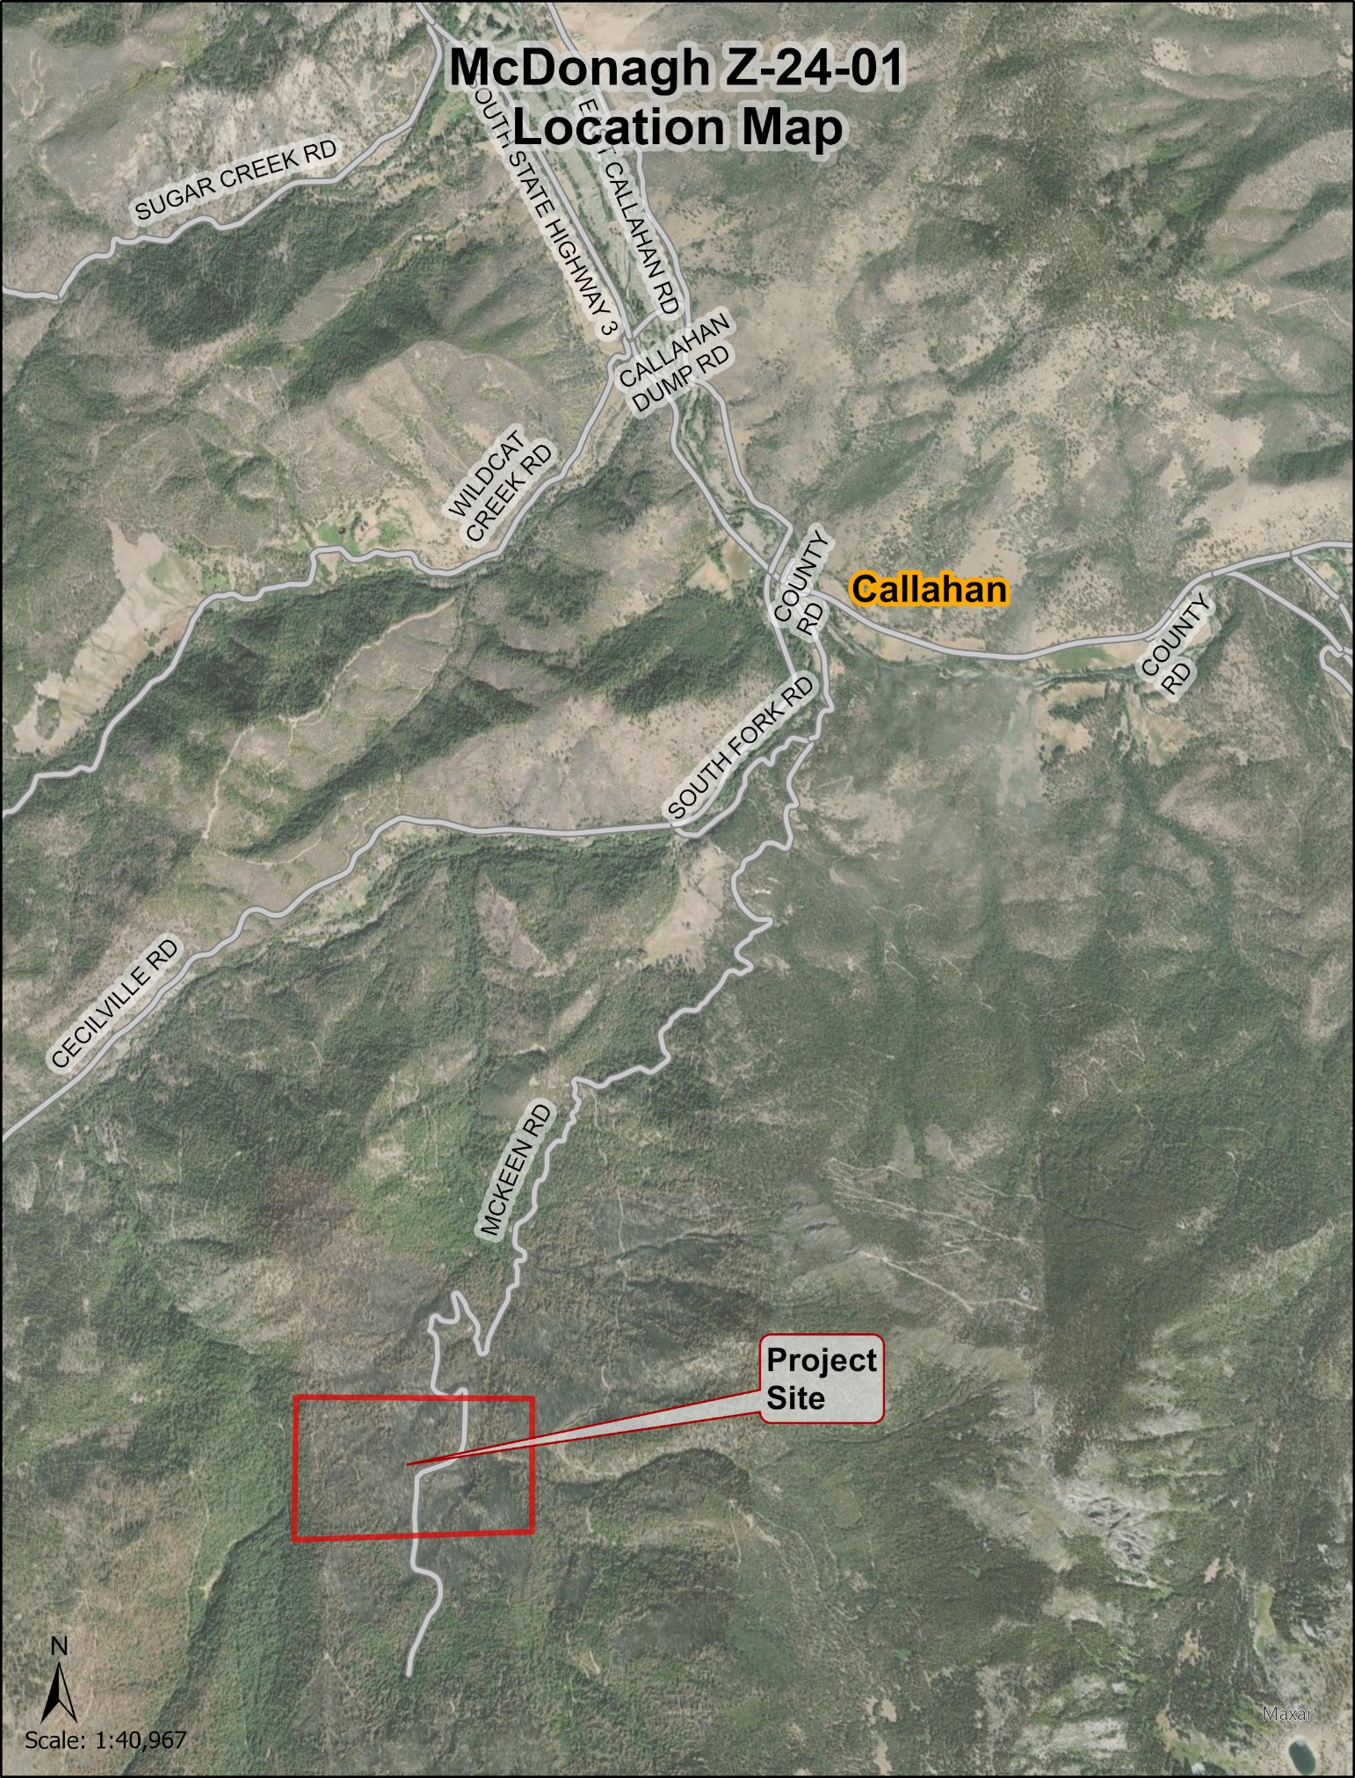

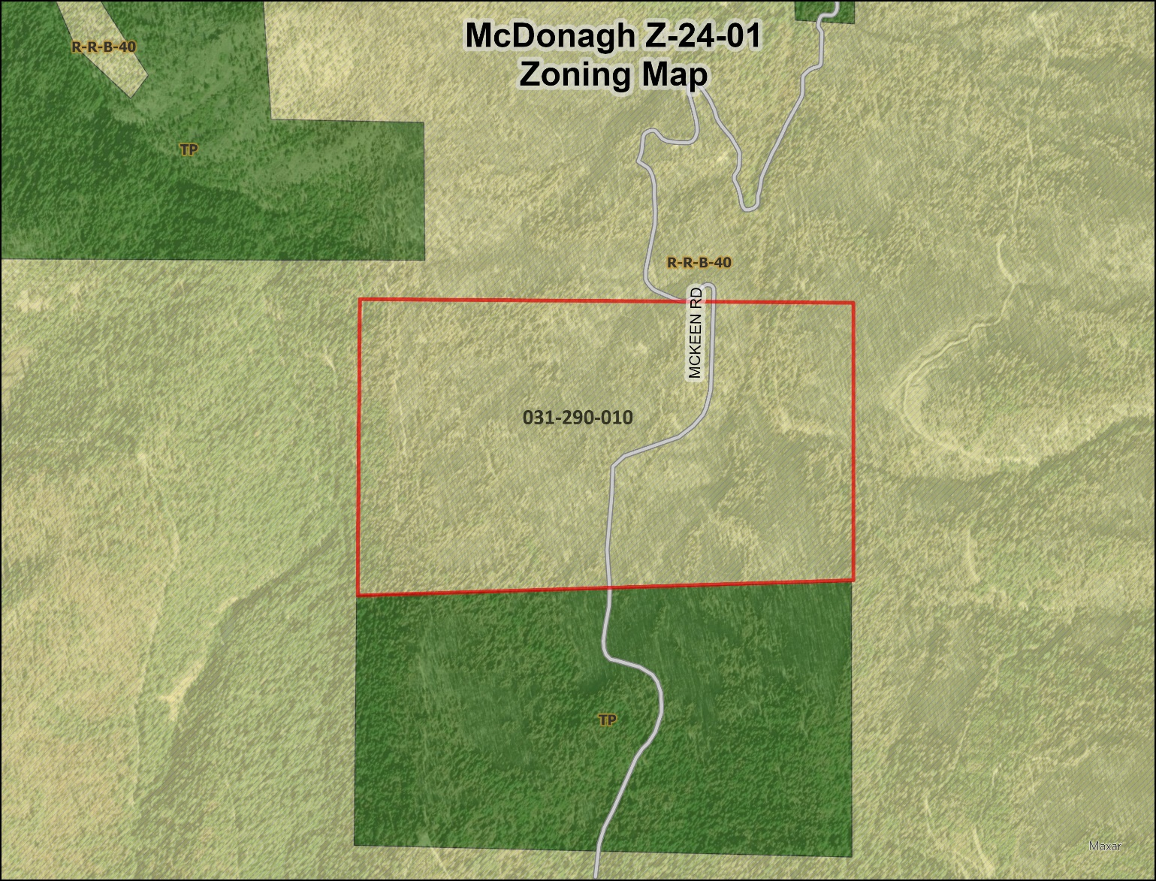

### Wildlife Species

Wildlife species that are known to occur or have potential habitat within the area are rainbow trout, which become anadromous steelhead, coho and chinook salmon, the Cascades frog, the western tailed frog, and salamanders. Also present are northern goshawk, mountain lion, black bear, mule deer, California grey and pine squirrel, jack and cottontail rabbit, chipmunk, northwest rattlesnake, lizards, pileated woodpecker, raven, red tail hawk, golden eagle, owl, falcon, vulture, crow, sap sucker, stellar blue jay, and songbirds. The Franklin’s bumble bee was federally listed as endangered in 2022. In 2006, one confirmed observation of Franklin’s bumble bee was made west of the property. Spotted owl activity areas are located both to the west and east of the property on Klamath National Forest land. The Sierra Nevada red fox is another threatened species possibly present in the area. In addition, there are two endangered species possibly present on the property, the grey wolf and bald eagle.

***Soil Conditions***  
The entire property’s soils are deep seated, averaging 5 feet in depth, drain water easily and are well suited for timber production. The property consists of two soil series: Gerle family – Entic Xerumbrepts association (24.8%), Gilligan – Chawanakee families association (75.2%).

### Site Classification The current site classification of the property is 80 acres classified as Site III (24.8% of the property) and 243 acres classified as high Site IV (75.2% of the property).

### As of December 2024, post fire reforestation efforts include 50,220 seedlings planted (155 seedlings per acre), consisting of ponderosa pine, Douglas fir, sugar pine, white fir and incense cedar. In the Spring of 2025, 3,000 riparian hardwoods will also be planted along the streams and permanent wet areas throughout the property, consisting of red alder, black cottonwood, and big leaf maple.

This reforestation effort is designed to increase the property’s site classification from high Site IV to a solid Site III. The estimated growth of the standing timber is 3.5 to 4 percent per year.

### Parcel Creation and Ownership History

The property was originally patented in 1896 and granted to the Central Pacific Railroad. On August 1, 1899, the NW ¼ of Section 7 was purchased by James McKeen and the Helena Mining Company from the Central Pacific Railroad. On September 1, 1901, the NE ¼ of Section 7 was purchased by James McKeen. On August 22, 1905, James McKeen sold his interest in the NE ¼ of Section 7 to the Helena Mining Company. On August 12, 1913, the North ½ of Section 7 was sold to the Shasta Mining Company. On July 8, 1915, the Shasta Mining Company sold to C.G. Strickland. On December 21, 1914, C.G. Strickland sold the property to Largent. On January 8, 1916, Largent sold to Oro Grande Mining. On June 7, 1963, Oro Grande Mining sold to Pool. On November 21, 1963, Pool sold to Walters. On May 3, 1965, Walters sold to Wilburn & Jenson. On October 24, 1968, Friden became the owner of the property. On May 22, 1973, Simonson Lumber Company purchased the property. On July 2, 1979, the Simonson Lumber Company became the Simpco Timber Lands Partnership. In 2020, the current owner, Wolf Creek Tree Farm, acquired the property from the Simpco Timber Lands Partnership.

## Analysis

### General Plan Consistency

The Land Use Element of the Siskiyou County General Plan identifies the project site as being within the mapped resource overlay areas for Soils: Erosion Hazard; Soils: Severe Septic Tank Limitations; Slope; Wildfire Hazard; and Woodland Productivity. Planning staff has identified that Composite Overall Policies 41.3(e), 41.3(f), 41.5, 41.6, 41.9, 41.12, 41.13, and 41.18 apply to the proposed project.

Staff has conducted a detailed analysis of each of the required findings and has found that the proposed project is consistent with the applicable General Plan policies governing the subject site. Additionally, the use would be compatible with surrounding land uses, would have adequate roadway access for transportation and public health and safety provisions, and would not create environmental impacts to on- or off-site resources. The recommended findings are detailed in the General Plan Consistency Findings section of Exhibit A-1 attached to this staff report and are submitted for the commissioners’ review, consideration, and approval.

### Zoning Consistency

The subject parcel is zoned Rural Residential 40-acre minimum parcel size (R-R-B-40). After the proposed zone change, the area would be rezoned to Timber Production Zone (TPZ).

Per Government Code 51104(f), “timberland” is defined as privately owned land which is devoted to and used for growing and harvesting of timber and which is capable of growing an average annual volume of wood fiber of at least 15 cubic feet per acre.

*The subject parcel meets the definition of “timberland”. Prior to the fire, the property was a fully stocked, mixed conifer forest with growth ranging from 175 to 320 bd ft. per acre per year, which converts to 14.58 cubic feet and 26.67 cubic feet per acre, respectively.*

Per Government Code 51113(c)(3)(A), the parcel shall meet the timber stocking standards set forth in Public Resources Code 4561 and the California Forest Practice Rules 2024. Per Siskiyou County Code 10-6.5102, permitted uses in the TPZ District include the growing and harvesting of timber.

*The property meets the stocking standards required by Public Resources Code 4561 and the forest practice rules as evidenced by the submitted California Cooperative Forest Management Plan. The property is currently being used for the growing and harvesting of timber. As such, a rezone of the property from R-R-B-40 to TPZ would be consistent with zoning requirements and existing uses already occurring on the property and neighboring parcels.*

Per Siskiyou County Code 10-6.5104, to be zoned TPZ, a parcel must be on List A or B as specified in the Z'berg-Warren-Keene-Collier Forest Taxation Reform Act of 1976 or, alternatively, meet the minimum standards adopted by the Board of Supervisors for inclusion under List C for the TPZ district. As the property is not shown on List A or B, it must meet the minimum standards for inclusion under List C.

*The property meets the minimum standards for inclusion under List C. The property is owned by a single entity (Wolf Creek Tree Farm). List C requires a minimum of 40 acres of Site III while the property contains 80 acres of Site III and 243 acres of high Site IV (which is equivalent to 121.5 acres of Site III). A California Cooperative Forest Management Plan was developed for the property by a Registered Professional Forester and the property meets the stocking standards of the forest practice rules (Article 6, Section 1080.1(a)(2)-(3), Stocking Standards for Substantially Damaged Timberlands). Where only dead, down, or dying trees were salvaged logged following the substantial damage, no restocking is required. No restocking requirements need be met on substantially damaged Timberlands on Sites IV and V after Timber Operations. In addition, from 2023 to 2024, 50,220 seedlings were planted (155 seedlings per acre) to replace what was lost during the 2021 fire.*

Based on staff’s analysis of the proposed use, staff believes that the necessary findings can be made for the approval of this application.

## Environmental Review

The proposed project (i.e., zone change to Timberland Production District) is statutorily exempt from the California Environmental Quality Act (CEQA) pursuant to CEQA Guidelines Section 15264, *Timberland Preserves*. Pursuant to this section, “local agencies are exempt from the requirement to prepare an EIR or negative declaration on the adoption of timberland preserve zones under Government Code Sections 51100 et seq. (Gov. Code, Sec 51119).”

## Comments

A Notice of Public Hearing was published in the Siskiyou Daily News on December 4, 2024, and mailed to property owners within 300 feet of the applicant’s property. No public comments have been received at the time this staff report was written.

A Preliminary Project Review was circulated to Siskiyou County Reviewing Agencies and State Responsible Agencies on June 20, 2024.

### California Department of Fish and Wildlife (CDFW) – July 2, 2024

Because the project only includes the rezoning of the parcel and does not include approval of future timber production or forest management activities CDFW has no comments at this time.

### Siskiyou County Environmental Health – June 4, 2024

Environmental Health has no objection to the proposed zone change.

## Planning Staff Recommendations

* Adopt Resolution PC 2024-028 taking the following actions:
  + Recommend the Board of Supervisors determine the project to be statutorily exempt from the California Environmental Quality Act (CEQA) in accordance with CEQA Guidelines Section 15264, *Timberland Preserves*; and
  + Recommend that the Board of Supervisors approve the Zone Change request based on the recommended findings in Exhibit A-1, attached hereto and incorporated herein.

## Suggested Motion

I move that we adopt Resolution PC 2024-028, a resolution of the Planning Commission of the County of Siskiyou, State of California, recommending that the Board of Supervisors determine the Project exempt from CEQA and approve the McDonagh Timberlands Zone Change Request (Z-24-01).

## Preparation

Prepared by the Siskiyou County Planning Division. For project specific information or to obtain copies for your review, please contact:

James Phelps, Planner  
Siskiyou County Planning Division  
806 S. Main Street  
Yreka, California 96097