## COUNTY AGREEMENT

### (Electronic Medical Records/Hardware/Software) (Medical Records Software at Co-Location Facility)

This Agreement (“**Agreement**”) is made and is effective this 1st day of May, 2023 (“Effective Date”), by and between CorEMR, L.C., a Utah limited liability company -- federal tax I.D. # 20-1999745 (**“CorEMR”**) with its principal office located at 430 West 200 North, P.O. Box 702. Midway, Utah 84049 and Siskiyou County, with its principal office address at 810 S. Main Street, Yreka, California 96097 (**“COUNTY”**). COUNTY and CorEMR are collectively referred to herein as the “Parties” and may singly be referred to herein as a “Party.”

## RECITALS:

1. Among other things, CorEMR is engaged in the business of providing computer hardware and software for electronic medical records.
2. Among other things COUNTY operates a correctional facility located at 315 South Oregon Street, Yreka, California 96097 (the “**FACILITY**”) and makes available, by separate contract or otherwise, medical services, including medical staff for the care and treatment of the inmates at the FACILITY.
3. COUNTY desires the services of CorEMR in providing offsite hosted electronic medical records software (the “**Medical Records Software**”) for it in connection with the provision of medical services for the inmates at the FACILITY. CorEMR is willing to provide offsite software for electronic medical records for COUNTY exclusively at the FACILITY.

**NOW THEREFORE**, in consideration of the mutual promises and covenants contained herein together with other good and valuable consideration, the receipt and legal sufficiency of which are hereby acknowledged, the Parties incorporate the Recitals herein and agree as follows:

* 1. **SCOPE OF COREMR SERVICES.** CorEMR agrees to provide COUNTY for its use exclusively at the FACILITY the following:
     1. Medical Records Software which can be accessed by the Facility via the Internet, which software is hosted on a non-exclusive server (the “**Server**”) owned or leased by CorEMR which is located at an offsite, independent and unrelated co-location facility selected by CorEMR (“**Co-Location Facility**”)1;
     2. Repair, maintenance and, if necessary, replacement of the Server within a reasonable time of the Facility’s notice to CorEMR of any problems therewith;
     3. Telephone and/or internet training on the operation, maintenance, and use of the Medical Records Software;
        1. A Software License Agreement to be executed concurrently herewith by the parties permitting the FACILITY access to and use of the Medical Records Software on CorEMR’s server at the Co-location Facility;
        2. On an on-going basis, reasonable telephone consultation and training for COUNTY’S information technology representative and, if requested by COUNTY, the information technology representative for the FACILITY regarding use of the Medical Records Software;

1 The present Co-location Facility selected by CorEMR at the inception of this Agreement is owned and operated by Fibernet Corp., a Utah corporation located at 1155 South 800 East, Orem, Utah 84097.

* + - 1. Periodic product updates and enhancements to the Medical Records Software for use by the COUNTY exclusively at the FACILITY during the term of this Agreement;
      2. Periodic information CorEMR has learned from the industry generally (not including any proprietary information) concerning current correctional FACILITY practices and procedures for electronic medical records creation, access, retention, storage and retrieval;
      3. At least annual telephonic consultation with the COUNTY’s information technology representative and the information technology representative and medical personnel at the FACILITY, if desired, to evaluate and improve electronic medical records creation, addition to, access, retention, storage and retrieval;
      4. Reasonable integration of the COUNTY/ FACILITY adaptable medical protocol forms, if any, into the Medical Records Software at the FACILITY; and
      5. Upon termination of this agreement and provided County is not in breach of this Agreement, a stand alone, read only program that allows the COUNTY/FACILITY to search for, view and print medical records, along with a data schema describing how data is stored.
  1. **COUNTY’S RESPONSIBILITIES.** In connection with the access to and use of the Medical Records Software, COUNTY shall:
     1. Be responsible for all access to the Medical Records Software utilized by the FACILITY via secure Internet access and for all aspects of the security of all of the Facilities medical records and data and medical records including, without limitation, in all instances providing appropriate user names, passwords, credentials, keys, encryptions, etc;
     2. Be responsible with the FACILITY for the acts and omissions of all users of the Medical Records Software at the Facilities and remote access by any one on behalf of or through FACILITY and/or the COUNTY to medical records stored on-site and/or off-site;
     3. Be responsible with the medical and billing staff at the FACILITY for the form, content, completeness and accuracy of all medical records, coding and billing;
     4. Be responsible with the FACILITY for all privacy pertaining to on-site and off-site medical records, whether stored electronically or otherwise, including state and federal privacy laws and including HIPAA and the HIPAA Security Rule;
     5. Be responsible with the medical staff at the FACILITY for all medical care including diagnosis, treatment and medication dispensing for all inmates at the FACILITY; and
     6. Enter into and fully comply with the terms and provisions of the accompanying Software License Agreement.
  2. **EXCLUSIONS**. CorEMR shall have no responsibility or obligation to the COUNTY, the FACILITY, any inmates at the FACILITY, or to any third persons or legal entities for or arising out of any of the COUNTY’S responsibilities and obligations as set forth in Section 2 above or for any failure to perform such responsibilities and obligations. Notwithstanding anything in this Agreement to the contrary, In as much as the Servers are at an independent co-location facility and access to them and the Medical Records Software will be via the Internet over which CorEMR has no control, CorEMR shall have no responsibility or liability of any kind or nature for any and all aspects of any and all of the following:
     1. Any and all aspects electrical power availability, backup, environmental controls including humidity and temperature, and/or all other physical aspects of the Server(s);
     2. The ability of the FACILITY to connect to the Servers or access the Medical Records Software via the Internet;
     3. The input, form, content, completeness and/or accuracy of any medical records, coding or billing;
     4. Security, access to and privacy of the applicable Medical Records Software utilized by the FACILITY, including, but not limited to, user names, passwords, credentials, keys, and encryption;
     5. Remote access for anyone on behalf of or through the COUNTY to the applicable Medical Records Software and the medical records stored thereon at the Co-location Facility;
     6. Maintaining privacy pertaining to on-site medical records, whether stored electronically or otherwise, including compliance with state and federal privacy laws and including HIPAA and the HIPAA Security Rule, if applicable; and
     7. The medical care including diagnosis, treatment and medication dispensing for any and all inmates at the FACILITIES.
  3. **PROPRIETARY PROTOCOL FORMS.** The COUNTY or the FACILITY may have

developed and own certain proprietary protocol forms for assisting the FACILITY ‘S medical staff in efficiently providing medical services to inmates in the FACILITY. At no additional cost, COREMR agrees to exercise reasonable efforts to integrate all COUNTY/ FACILITY adaptable protocol forms, if any, into the Medical Records Software used by COUNTY at the FACILITY. Attached hereto as Schedule 2 is a list of any protocol forms that COUNTY claims are proprietary and confidential (the “Confidential Protocol Forms”). Except as set forth below, CorEMR agrees to keep the Confidential Protocol Forms confidential and not use the same in connection with its Medical Records Software at any correctional FACILITY without COUNTY’s prior written consent. In addition, except as set forth below, CorEMR agrees to keep the Confidential Protocol Forms confidential and shall not disclose the same, in whole or in part, to any person or entity other than its representatives who need to know about such Confidential Protocol Forms in connection with the performance of CorEMR’s duties under this Agreement, except as otherwise consented to in writing by COUNTY. Notwithstanding the foregoing or anything herein to the contrary, the foregoing restrictions and limitations of CorEMR’s use or disclosure of the Confidential Protocol Forms shall not be applicable to protocol forms identified by the COUNTY on Schedule 1 as Confidential Protocol Forms which; (a) are already substantially or materially known to CorEMR at the time the Confidential Protocol Forms are disclosed to CorEMR; (b) have become substantially or materially generally known to the public through no wrongful act of CorEMR; (c) have been rightfully received by CorEMR from a third party without restriction on disclosure and without, to the knowledge of CorEMR, a breach of an obligation of confidentiality running directly or indirectly to the other party thereto; (d) have been approved for release by a written authorization by the COUNTY or the FACILITY; (e) have been disclosed pursuant to a requirement of a governmental agency or of law without similar restrictions or other protection against public disclosure, or is required to be disclosed by operation of law; (f) are independently developed by CorEMR without use, directly or indirectly, of the Confidential Protocol Forms received from the COUNTY or the FACILITY; (g) are furnished to a third party by the COUNTY or the FACILITY without restrictions on the third party’s right to disclose the Confidential Protocol Forms; or (h) are disclosed by CorEMR with the prior written permission of the COUNTY or the FACILITY.

* 1. **PAYMENT.** As consideration for the services listed in this Agreement, COUNTY agrees to pay CorEMR in proportion to services satisfactorily performed as specified in Exhibit “A”, CorEMR EMR Proposal, in an amount not to exceed ~~Twenty Four Thousand Fifty Dollars and No/Cents ($24,050.00)~~ for FY 22/23, for the Term of the this Agreement. Siskiyou County declines the additional CorEMR Services outlined in Schedule 2 of this Agreement.
     1. Invoices: CorEMR shall submit detailed invoices for all services being rendered and will Include a detailed description of charges based on work performed within Exhibit “A”.
  2. **~~TERM.~~** ~~The initial term (“Initial Term”) of this Agreement shall be for a period of One (1) year from the Effective Date,~~ unless sooner terminated as provided in Paragraph 8 below, with the option to renew **by written agreement by both parties**, on the same terms and provisions, for successive periods of one (1) year each (“Renewal Term(s)”), unless either Party gives written notice of termination to the other at least ninety (90) days prior to the expiration of the Initial Term or applicable Renewal Term. At the expiration or termination of this Agreement and at the written request of COUNTY, CorEMR shall remove all of COUNTY’s protocol forms from the Medical Records Software at the FACILITY and generally from CorEMR’s Medical Records Software wherever located, and shall not thereafter use the same except under the circumstances set forth in the last sentence of Paragraph 4 above. Effective immediately upon the expiration or termination of this Agreement, the accompanying Software License Agreement shall also automatically and without notice terminate arid expire, and the COUNTY and the FACILITY shall no longer use the Medical Records Software, or any component thereof, except the read- only software and COUNTY’S/ FACILITY’S protocol forms, if any, which have been installed thereon all of which shall be in a read-only format.

## INDEPENDENT CONTRACTOR.

* + 1. CorEMR is an independent contractor, holding itself out to the general public as an independent contractor for other work or contracts as it sees fit; it advertises its services as it sees fit to the general public, maintains its office separate from COUNTY, and this Agreement is not exclusive of other CorEMR agreements, contracts or opportunities.
    2. An independent contractor relationship is created by this Agreement. COUNTY is interested only in the results to be achieved, and the conduct and control of the service provided by CorEMR as set forth in paragraph 1 above will lie solely with CorEMR. CorEMR is not to be considered an agent or employee of COUNTY for any purpose, and the employees of CorEMR are not entitled to any of the benefits that COUNTY provides for COUNTY’s employees. COUNTY is not to be considered an agent or employee of CorEMR for any purpose, and the employees of COUNTY are not entitled to any of the benefits that CorEMR provides for CorEMR’s employees.
    3. Each Party shall comply with all laws regarding workers’ compensation insurance, as applicable and all other insurance, whether required by applicable law or otherwise. Neither Party shall have any authorization, express or implied, to bind the other to any agreement, settlement, liability, or understanding whatsoever, and agrees not to perform any acts as agent for the other except as expressly set forth herein. The compensation to be paid CorEMR as provided for herein shall be the total compensation payable hereunder to CorEMR by the COUNTY.
    4. Nothing herein shall be deemed to constitute COUNTY and CorEMR as partners or joint venturers. Each of the Parties is a separate legal entity. CorEMR is merely providing software to COUNTY as an independent contractor pursuant to this Agreement. Each of the Parties shall be solely and exclusively liable and responsible for its own negligent, reckless and/or intentional acts and omissions and for all of their respective costs and expenses.
    5. This Agreement does not confer any rights or benefits on any third person or legal entity.
  1. **DEFAULT.** In the event either Party hereto breaches any of the terms, provisions, covenants or obligations of this Agreement, the other Party shall give notice specifying such breach and give the breaching Party a thirty (30) day opportunity to cure the breach. In the event the breach is cured within this thirty (30) day period, this Agreement shall not be in default. In the event the breaching Party fails to cure the breach within this thirty (30) day period, such breaching Party shall be in default, and the other Party shall be entitled to terminate this Agreement at any time thereafter upon written notice to the other Party resulting in, among other things, an automatic termination of the accompanying Software License Agreement, and in addition shall be entitled to recover such out-of-pocket damages as actually and directly incurred as a direct result of a breach of this Agreement. Notwithstanding the foregoing, neither Party shall be liable to the other under any circumstances in the event of a default for any indirect, exemplary, punitive, general, special, statutory, incidental or consequential loss or damages of any kind or nature whatsoever.
  2. **INDEMNIFICATION**. The Parties agree to indemnify each other and all of their ~~of its~~ officers, directors, stockholders, employees, agents, consultants, independent contractors from any and all claims, losses, damages, or liabilities (including attorneys’ fees and costs) brought by any third person, including any inmate(s) at the FACILITY, arising out of the Parties’ performance or nonperformance of its obligations under this Agreement or arising from the use of any hardware or the Medical Records Software supplied by CorEMR, except as the same as may be the direct result of a breach of CorEMR’s obligations under this Agreement.
  3. **COMPLIANCE WITH LAW.** Each Party shall comply with all applicable local, state, and federal laws that may bear on their respective obligations under this Agreement.
  4. **NOTICES.** Any notice or other communication under this Agreement shall be in writing and shall be considered given when delivered personally, upon receipt by confirmed telefax, on delivery by a reputable overnight courier (receipt confirmed), certified mail, return receipt requested or four (4) days after the postmark date if mailed by United States First Class Mail, to the Parties at the addresses set forth below (or at such other address as a Party may specify by notice to the other):

If to CorEMR, to it at:

John J. Probst, Manager 430 West 200 North,

P.O. Box 702

Midway, Utah 84049 with a copy to:

STOEL RIVES LLP

201 Main Street, Suite 1100

Salt Lake City, Utah 84111- 4904 Attention: Scott F. Young

If to COUNTY, to it at:

Shelly R. Davis, Director Public Health Division Director of Correctional Health Services

810 S. Main Street Yreka, CA 96097

with a copy to:

Shelly R. Davis, Director Public Health Division Director of Correctional Health Services

810 S. Main Street Yreka, CA 96097

* 1. **TAXES**. In the event that any withholding, sales or use taxes or other taxes or government fees, assessments or charges are payable because of this License Agreement, or any license of the Software, or because of any payment by you, then the COUNTY shall pay such taxes, fees, assessments and charges in addition to all other payments.
  2. **ENTIRE AGREEMENT.** This Agreement, together with the accompanying Exhibits and Schedules, including Exhibit “B” County Software License Agreement, set forth the entire understanding and agreements between the Parties with respect to the subject matter hereof, and supersedes any and all prior understandings, representations and warranties, including, without limitation, any submittal or response to request for proposal (“RFP”) of any kind preceding the date of this Agreement and are not binding on either party except to the extent incorporated in this Agreement, the accompanying Schedules or Software License Agreement. This Agreement may only be Amended by and instrument in writing signed by the Parties. The invalidity of any provision or portion of a provision of this Agreement shall not affect the validity of any other provision of this Agreement or the remaining portion of the applicable provision.
  3. **ASSIGNMENT.** No Party may assign any of its rights or delegate any of its duties under this Agreement without the prior written consent of the other Party, which may be withheld for any reason or for no reason, except that any Party may assign its rights and delegate its duties to a successor to such Party’s entire business, membership interests or substantially all of its assets.
  4. **COUNTERPARTS.** This Agreement may be executed in one or more counterparts, which together shall constitute a single instrument. Facsimile delivery of an executed counterpart shall be valid and binding for all purposes.
  5. **INCORPORATION OF RECITALS AND FOOTNOTES.** The Recitals and Footnotes to this agreement are a part hereof and incorporated herein.
  6. **MODIFICATION/CONSTRUCTION.** This Agreement may not be modified or amended except with a writing signed by both Parties. No rule of strict construction shall apply against or in favor of either Party.
  7. **FORCE MAJEURE**. Neither CorEMR nor COUNTY shall be liable to the other or be deemed to be in breach of this Agreement for any failure or delay in rendering performance arising out of causes beyond its reasonable control and without its fault or negligence. Such causes may include, but are not limited to, acts of God or the public enemy, fires, floods, epidemics, quarantine restrictions, strikes, freight embargoes, unusually severe weather, and inability to access the Medical Records Software on the Server at the Co-location Facility for any reason including due to disruption of the internet or inability to connect to the Server via the internet.

IN WITNESS WHEREOF, County and CorEMR have executed this agreement on the dates set forth below, each signatory represents that they have the authority to execute this agreement and to bind the Party on whose behalf their execution is made.

Date: _4/11/2023

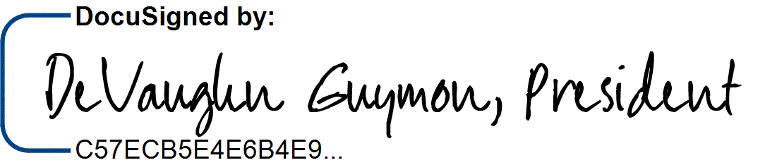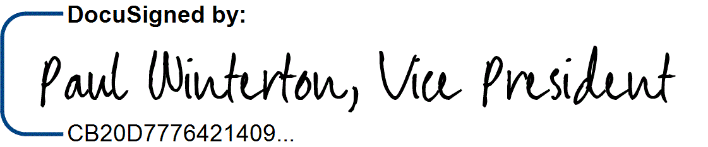

CONTRACTOR: CorEMR L.C.

DeVaughn Guymon, President CorEMR

Paul Winterton, VP of Operations

Date: 4/13/2023

License No.: N/A

(Licensed in accordance with an act providing for the registration of contractors)

Note to Contractor: For corporations, the contract must be signed by two officers. The first signature must be that of the chairman of the board, president or vice-president; the second signature must be that of the secretary, assistant secretary, chief financial officer or assistant treasurer. (Civ. Code, Sec. 1189 & 1190 and Corps. Code, Sec. 313.)

# TAXPAYER I.D. 20-1999745

COUNTY OF SISKIYOU

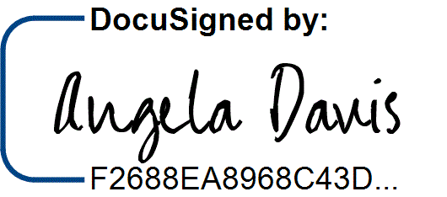4/20/2023

Angela Davis, County Administrator (Date)

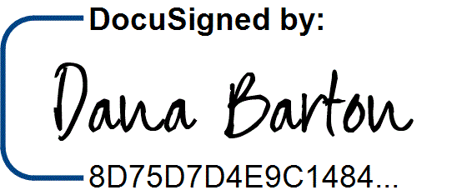

APPROVED AS TO LEGAL FORM:

4/13/2023

Edward J. Kiernan, County Counsel

(Date)

# APPROVED AS TO ACCOUNTING FORM:

Fund Org Account FY 22/23 FY 23/24 2162 401015 723000 ~~$24,050.00~~  ~~$0~~

If not to exceed, include amount not to exceed: ~~$24,050.00~~

Diane Olson, Auditor-Controller (Date)

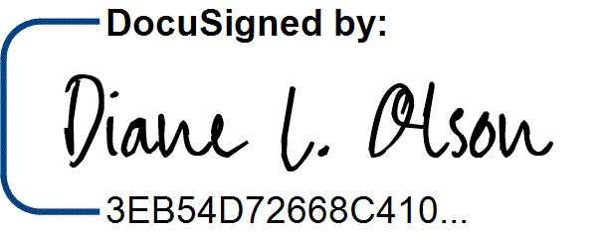

4/13/2023

# APPROVED AS TO INSURANCE REQUIREMENTS:

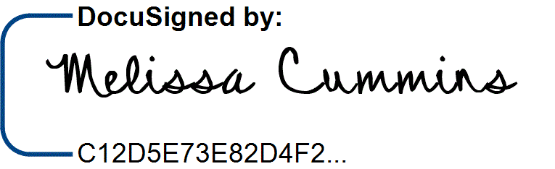

4/20/2023

Melissa Cummins, Risk Management

(Date)

## SCHEDULE 1

**LIST OF CONFIDENTIAL PROTOCOL FORMS**

NONE

## SISKIYOU COUNTY PUBLIC HEALTH DIVISION

Dated: 4/20/2023

By:

Angela Davis, County Administrator

## COREMR, L.C.

4/11/2023

Dated:

By:

DeVaughn Guymon, President



## ~~SCHEDULE 2~~

**~~COREMR ADDITIONAL SERVICES~~**

### ~~Siskiyou County declines these optional costs.~~

**~~Custom Programming Requests:~~** ~~If Siskiyou County requires custom programming, the fee will be $150/hour with a minimum of 1 hour per instance.~~

**~~System Integration Support:~~** ~~After the initial integration is established, if the FACILITY’s Inmate Management system, Pharmacy, or lab changes and~~ **~~CorEMR~~** ~~technical representative are required to edit/modify the integration,~~ **~~CorEMR~~** ~~will charge Siskiyou County $150 per hour with a minimum of 1 hour to re-establish communication between the two systems.~~

### ~~Optional On-site Support/Training (optional) - $1,500.00/day~~

~~Upon request, CorEMR will provide on-site training and/or support. The cost for this is $1,500 per CorEMR representative per day. Training days are to be consecutive.~~

### ~~Laboratory Results Interface (optional) - $1,500.00~~

~~This feature allows the receipt of Laboratory results from LabCorp, Quest, Garcia or BioReference.~~

### ~~Additional Integrations (optional) - $5,000.00~~

~~Any additional integration such as labs or x-ray will be an additional $5,000 per integration.~~

### ~~Drug Interaction Database (optional) - $2,500.00~~

~~This optional feature will allow for real time Drug to Drug and Drug to Allergy interaction checks while ordering medications. As a medication is being enter the software will perform checks in the background and list any potential interactions to other medications that an inmate is currently on or any allergies that the inmate may have recorded so the provider can make an informed decision.~~

## ~~SISKIYOU COUNTY PUBLIC HEALTH DIVISION~~

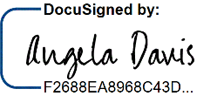

~~Angela Davis, County Administrator~~

~~Dated: 4/20/2023~~

~~By:~~

## ~~COREMR, L.C.~~

~~Dated: 4/11/2023~~

~~By:~~

~~DeVaughn Guymon, President~~

