# FIRST ADDENDUM TO COUNTY AGREEMENT BY INDEPENDENT CONTRACTOR

THIS ~~FIRST~~ ADDENDUM is to that County Agreement entered into on May 1, 2023, by and between the Siskiyou County (“County”) and CorEMR, L.C., a Utah limited liability company (“Contractor”) and is entered into on the date signed by all parties to it.

WHEREAS, the Agreement will expire on April 30, 2024, and services continued to be required after that date; and

WHEREAS, the parties desire to extend the term of the Agreement; and WHEREAS, the cost of services to be provided under the Agreement is expected

to exceed the amount provided in the Agreement; and

WHEREAS, the parties desire to increase the amount of compensation payable under the Agreement.

NOW, THEREFORE, THE PARTIES MUTUALLY AGREE AS FOLLOWS:

Paragraph 6 of the Agreement, Term, shall be amended to extend the term of the Agreement through June 30, 2028.

Paragraph 5 of the Agreement, Payment, shall be amended to add an additional ~~Twenty Five Thousand Two Hundred Fifty Dollars and No/100 Cents ($25,250.00),~~ to increase the compensation payable under the Agreement to an amount not to exceed ~~Forty Nine Thousand Three Hundred Dollars and No/100 ($49,300.00)~~.

All other terms and conditions of the Agreement shall remain in full force and effect.

# (SIGNATURES ON FOLLOWING PAGE)

IN WITNESS WHEREOF, County and Contractor have executed this First Addendum on the dates set forth below, each signatory represents that they have the authority to execute this agreement and to bind the Party on whose behalf their execution is made.

CONTRACTOR: CorEMR, L.C.

Date:12/18/2023

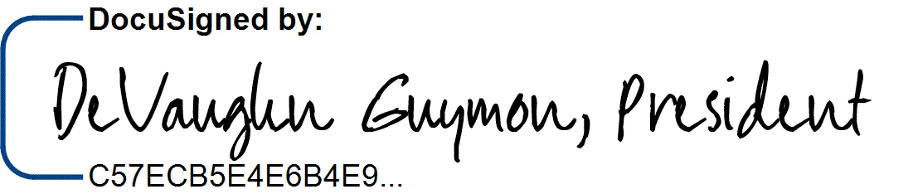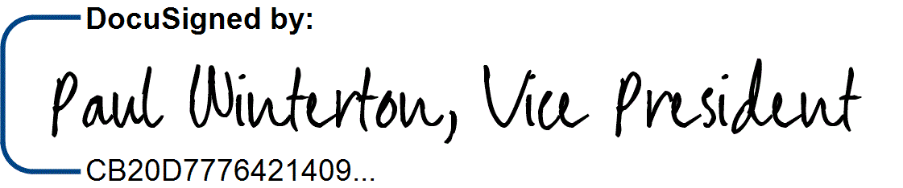

DeVaughn Guymon, President

Paul Winterton, VP of Operations

Date:1/16/2024

License No.: N/A

(Licensed in accordance with an act providing for the registration of contractors)

Note to Contractor: For corporations, the contract must be signed by two officers. The first signature must be that of the chairman of the board, president or vice-president; the second signature must be that of the secretary, assistant secretary, chief financial officer or assistant treasurer. (Civ. Code, Sec. 1189 & 1190 and Corps. Code, Sec. 313.)

TAXPAYER I.D. 20-1999745

Angela Davis, County Administrator (Date)

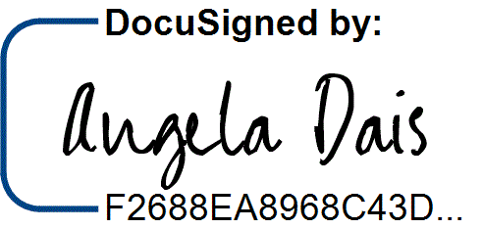

COUNTY OF SISKIYOU

1/19/2024

APPROVED AS TO LEGAL FORM:

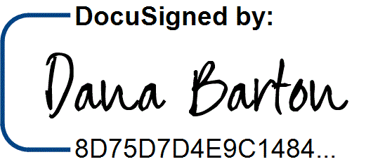

1/17/2024

Natalie E. Reed, County Counsel (Date)

APPROVED AS TO ACCOUNTING FORM:

Fund Org Account FY 22/23 FY 23/24 FY 24/25 FY 25/26 FY 26/27 FY 27/28

|  |  |  |  |  |  |  |  |
| --- | --- | --- | --- | --- | --- | --- | --- |
| 2162 | 401015 723000 | $~~24,050~~ | $0 | $0 | $0 | $0 | $0 |
| 2111 | 401081 723000 | $0 | $5,050 | $5,050 | $5,050 | $5,050 | $5,050 |

If not to exceed, include amount not to exceed: $~~49,300.00~~ Encumbrance number (if applicable): E2300535

Diane Olson, Auditor-Controller (Date)

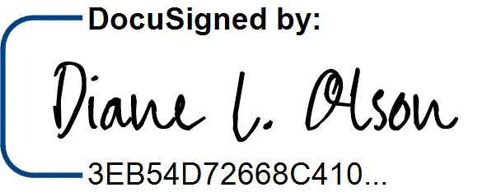

1/18/2024