Date of Hearing: August 15, 2024

ASSEMBLY COMMITTEE ON WATER, PARKS, AND WILDLIFE
Diane Papan, Chair

SJR 17
(Allen) – As Amended August 12, 2024
SENATE VOTE: 37-0
SUBJECT: The Sáttítla National Monument
SUMMARY: Urges the President to use the Antiquities Act of 1906 to establish the Sáttítla National Monument and makes findings regarding the history and value of the land that would be included in the Sáttítla National Monument.
EXISTING LAW:
- Declares that it is a national policy to preserve for public use historic sites, buildings, and objects of national significance for the inspiration and benefit of the people of the United States [54 United States Code (USC) § 320101].
- Authorizes the President to declare by public proclamation historic landmarks, historic and prehistoric structures, and other objects of historic or scientific interest that are situated on land owned or controlled by the Federal Government to be national monuments (54 USC § 320301).
- Directs the California Natural Resources Agency (CNRA) to combat the biodiversity and climate crisis by, among other things, establishing the California Biodiversity Collaborative and establishes a goal to conserve at least 30% of the state’s lands and coastal waters by 2030 (30x30) [Public Resources Code § 71450].
FISCAL EFFECT: Unknown. This resolution is keyed non-fiscal.
COMMENTS:
- Purpose of this bill. According to the author, “In order to reach our state’s 30x30 goals and ensure that future generations have access to California’s remarkable landscape, we must permanently protect the irreplaceable resource of our natural lands. The establishment of the Sáttítla National Monument will safeguard California’s endangered species and biodiversity, ecological sustainability, and rich cultural history. As national monuments, these lands will benefit from the same tribal stewardship that kept them pristine over the centuries.”
- Background. The Federal Antiquities Act, passed in 1906, seeks to preserve America’s archeological places and historical sites, including the information they contain, on federal lands. Among other things, this act authorizes the President to establish national monuments. Specifically, the act gives the President the authority to “declare by public proclamation historic landmarks, historic and prehistoric structures, and other objects of historic or scientific interest that are situated on land owned or controlled by the Federal Government to be national monuments” [54 USC § 320301(a)]. National monuments may be administered by the National Park Service (NPS), the U.S. Forest Service (USFS), the U.S. Fish and Wildlife Service, or the Bureau of Land Management (BLM). Since 1906, U.S. presidents have used their authority under the Antiquities Act to set aside land almost 300 times.
In California, there are at least 17 national monuments, including Berryessa Snow Mountain, Cabrillo, California Coastal, Carrizo Plain, Castle Mountains, César E. Chávez, Devils Postpile, Fort Ord, Giant Sequoia, Lava Beds, Mojave Trails, Muir Woods, Saint Francis Dam Disaster, Sand to Snow, San Gabriel Mountains, Santa Rosa and San Jacinto Mountains, and Tule Lake.
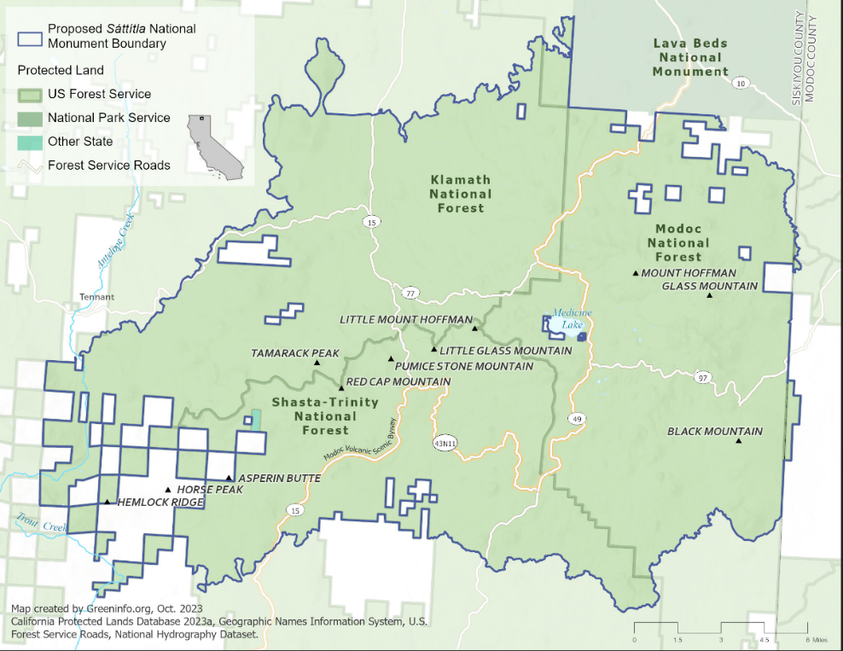
Sáttítla National Monument proposal. The Pit River Tribe and supporters are calling on President Biden to establish a national monument in Northern California to protect approximately 200,000 acres of land managed by the USFS and BLM in an area commonly known as the Medicine Lake Highlands, but designated as Sáttítla by Native Americans in the area (see map).

Located 30 miles northeast of Mount Shasta and nestled within the Shasta-Trinity, Klamath, and Modoc National Forests of northeastern California, Sáttítla is a culturally significant, geologically unique, water rich, and life sustaining region. The area’s mature forests help to sequester carbon and provide habitat for wildlife. It is home to bald eagles, osprey, goshawks, deer, elk, black bear, imperiled northern spotted owls, Sierra martens, Pacific fishers, rare bats, and sensitive plants. For thousands of years the forested lands and waters have been sacred to numerous tribes including the Pit River, Modoc, Shasta, Karuk, and Wintu. Sáttítla is a spiritual center for the Pit River and Modoc Tribes, who continue to use the area for religious activities, ceremonies, and gatherings.

Sáttítla is located in a headwater area of the state, which helps to provide water to the state’s residents, agriculture, and wildlife. The Medicine Lake Volcano is an enormous hydrological recharge and storage area for California’s water supply. It captures and discharges over 1.2 million acre-feet of snowmelt annually, emerging as the Fall River Springs, the largest spring system in the state, which sustains a trout fishery before it flows into Shasta Lake Reservoir and the Sacramento River, serving millions of residents downstream. The volcanically formed aquifers below the surface capture snow melt and are estimated to store 20 to 40 million acre-feet of water, which is on the same order of magnitude as California’s 200 largest surface reservoirs. A 2014 hydrogeological study pointed out the need to protect this groundwater resource for farms, cities, and people.

Connection to 30x30 initiative. In October 2020, Governor Newsom issued Executive Order N-82-20, which establishes a state goal of conserving 30% of California’s lands and coastal waters by 2030 – known as 30x30. The 30x30 goal is intended to help conserve state lands and coastal waters through voluntary, collaborative action with partners across the state to meet three objectives: conserve and restore biodiversity, expand access to nature, and mitigate and build resilience to climate change. The 30x30 goal was codified by SB 337 (Min), Chapter 392, Statutes of 2023.
As of May 2023, the state has conserved 24.4% of lands and 16.2% of coastal waters for 30x30. California’s strategy to conserve an additional six million acres of land and half a million acres of coastal waters is organized into ten pathways that are specific state actions that will help achieve 30x30.
According to CNRA, the proposed Sáttítla National Monument would add roughly 210,000 acres to the state’s 30x30 target. This numbers may change upon final designation.
- Arguments in support. The Pit River Nation (sponsors) write that Sáttítla is “culturally significant to the Pit River, Modoc, Shasta, Karuk, and Wintu peoples of northeastern California, and is a spiritual epicenter for the Pit River and Modoc Tribes who meet there for ceremonies and other important cultural activities.” They also indicate that the land is home to numerous threatened species and other singular geological and ecological resources.
- Related legislation. H.R.8031 (Ruiz, 2023–2024) and S.4132 (Padilla, 2023–2024) both, would establish the Chuckwalla National Monument, consisting of approximately 621,000 acres of federal land administered by the BLM. Further, the bill would amend the California Desert Protection Act of 1994 to add approximately 17,842 acres of land to Joshua Tree National Park. H.R.8031 is pending in the House Committee on Natural Resources. S.4132 is pending in the Senate Committee on Energy and Natural Resources.
SJR 10 (Dodd) of the current legislative session urges the President and Congress to expand the Berryessa Snow Mountain National Monument to include the Walker Ridge (Molok Luyuk) Addition. SJR 10 was held in this Committee by the request of the author in response to the Presidents proclamation on May 2, 2024 expanding the Berryessa Snow Mountain National Monument.
SJR 16 (Padilla) of the current legislative session urges the President to use the Antiquities Act of 1906 to establish the Chuckwalla, Joshua Tree, and Kw’tsán National Monuments. SJR 16 is set for hearing in this Committee.

AB 1183 (Ramos), Chapter 380, Statutes of 2021, establishes the California Desert Conservation Program at the Wildlife Conservation Board.
AJR 4 (Dodd), Res. Chapter 19, Statutes of 2015, urges the President to use his authority under the Antiquities Act to establish a federal monument in the region known as Berryessa Snow Mountain.
REGISTERED SUPPORT / OPPOSITION:
Support
Pit River Tribe (Sponsor)
Allensworth Progressive Association
CactusToClouds Institute
California Botanic Garden
California Environmental Voters
California Trout
Californians for Western Wilderness
CalWild
Central Valley Partnership
Coalition to Protect Americas National Parks
Conservation Lands Foundation
Council of Mexican Federations
Defenders of Wildlife
Endangered Habitats League
Environment California
Environmental Center of San Diego
Environmental Protection Information Center
Forests Forever
Forevergreen Forestry
Friends of Plumas Wilderness
Friends of The Amargosa Basin
Friends of The Inyo
Great Old Broads for Wilderness
Latino Outdoors
Legacy - the Landscape Connection
Mount Shasta Bioregional Ecology Center
Native American Land Conservancy
Resource Renewal Institute
Robert Redford Conservancy At Pitzer College
Santa Clara Valley Audubon Society
Save California Salmon
Sierra Business Council
Sierra Club California
Sierra Nevada Alliance
The Mountain PACT
The Wilderness Society
Trout Unlimited
Tuleyome
Vet Voice Foundation
Western Watersheds Project
Opposition
None on file
Analysis Prepared by: Stephanie Mitchell / W., P., & W. / (916) 319-2096

