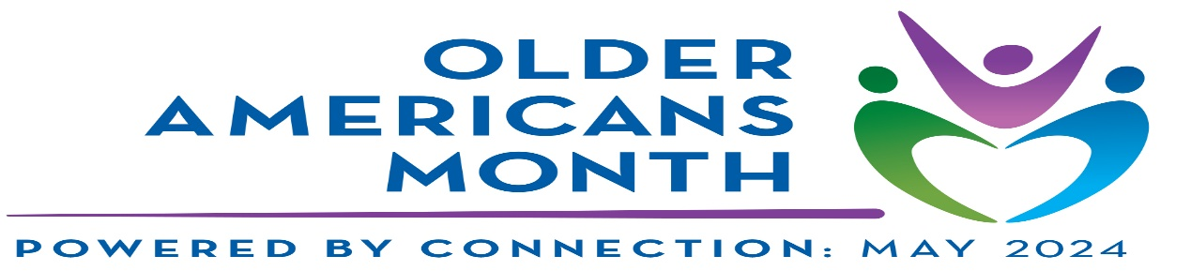

**Older Americans Month 2024**

A Proclamation

Whereas, May is Older Americans Month, a time for us to recognize and honor Siskiyou County older adults and their immense influence on every facet of American society; and

Whereas, through their wealth of life experience and wisdom, older adults guide our younger generations and carry forward abundant cultural and historical knowledge; and

Whereas, older Americans improve our communities through intergenerational relationships, community service, civic engagement, and many other activities; and

**Whereas**, communities benefit when people of all ages, abilities, and backgrounds have the opportunity to participate and live independently; and

Whereas, Siskiyou County must ensure that older Americans have the resources and support needed to stay involved in their communities — reflecting our commitment to inclusivity and connectedness; and

**Now, therefore,** Siskiyou County does hereby proclaim May 2024 as Older Americans Month. This year's theme, "Powered by Connection," emphasizes the profound impact of meaningful interactions and social connection on the well-being and health of older adults in our community.

We call upon all residents to join in recognizing the contributions of our older citizens and promoting programs and activities that foster connection, inclusion, and support for older adults.

On this date in the month of May, 2024

Supervisor Michael N. Kobseff

Chairman, Siskiyou County Board of Supervisors