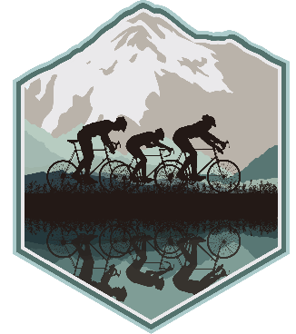
FOR IMMEDIATE RELEASE

Contact: Linda Woodley
Email: aoscentury@gmail.com

Date: February 6, 2024

ART OF SURVIVAL CENTURY BIKE RIDE
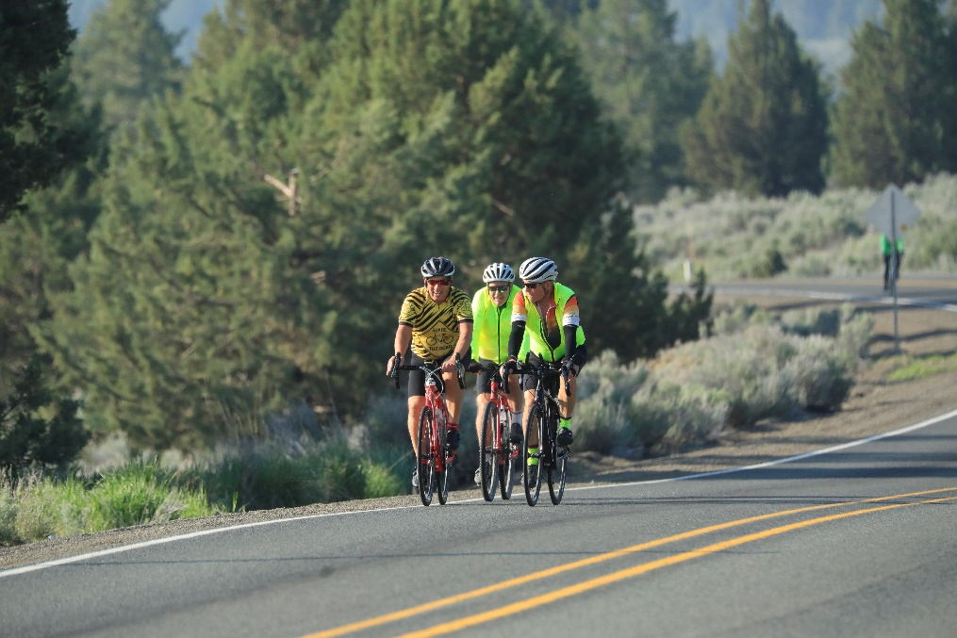
The 11th Annual Art of Survival Century Bicycle Ride and Gravel Grinder event isn't just about pedaling a road or mountain bike through beautiful stretches of the countryside. It's also an opportunity to learn about a region that includes Southern Oregon's Klamath Basin and Northern California’s Tulelake Basin and Butte Valley area. What is unique about this event—which is a ride, not a race—is that each rest stop offers an educational component highlighting the geology of the area, cultural history, geography, and environmental issues; along with providing fluids and nutritious snacks.
This year, the event highlights the Volcanic Legacy Scenic Byway, an awe-inspiring All-American Road winding through the captivating landscapes of Southern Oregon and Northern California. This extraordinary route, distinguished as one of only 42 in the United States for its unique qualities, offers a 500-mile expedition through the remarkable aftermath of geologic forces along the Pacific Rim of Fire.
Traverse this scenic masterpiece, where towering volcanic peaks, expansive lava flows, enchanting caves, bubbling mud pots, and steaming fumaroles paint a vivid picture of the Earth’s dynamic history. Immerse yourself in the natural wonders of Crater Lake National Park, Lava Beds National Monument, the alpine charm of Mount Shasta against a snow-capped backdrop, and the captivating beauty of Lassen Volcanic National Park.
As you navigate the byway, find yourself surrounded by majestic mountainous forests, expansive wetlands, crystal-clear streams, and picturesque farms and ranches. Beyond the captivating volcanic features, your journey unfolds with great roads, charming towns, and a tranquil pace of life—making every moment along this scenic byway a truly unforgettable experience.
Day 1, Saturday, May 25: Choose from four routes that begin and end at the Malin Community Park in Malin, OR - 100-mile Century, 62-mile Metric Century, 38-mile, and family friendly 14-mile road routes plus a 22-mile mountain gravel grinder route in the Medicine Lake Highlands.
Day 2, Sunday, May 26, is a Gravel Grinder Mix covering distances of 74 and 54 miles and a family friendly 13-mile route. All gravel routes begin and end at the Butte Valley Community Center in Dorris, CA. Participants will ride along the flatlands of Butte Valley, including the Butte Valley Wildlife Area, farms, ranches and up to beautiful Juanita Lake for breakfast.
Registration Fees Saturday: $80 for the Century and Metric Century, $60 for 38-mile and $25 for both the mountain bike and family friendly routes. Sunday: $80 for 74 and 54-mile, and $25 for 13-mile route. However, if riders register for both days, they will receive a discount. The cost for all routes will increase $10 after May 20. Fees include rest stop food and beverages, SAG, delicious post-ride meal both days and SWAG.
A pre-ride reception will be held Friday, May 24 from 4:00-6:30 p.m. at the Malin Broadway Theater in Malin, OR for cyclists to pick up their ride packets, which includes a free Volcanic Legacy Scenic Byway guidebook, enjoy light refreshments, discover new area activities, and learn more about the Volcanic Legacy Scenic Byway. The committee welcomes all to attend this reception and enjoy a visit with the locals.
Post-ride meals will be offered on both days and are included in the registration fees. The cost for non-riders is $18 both days. The Malin meal will likely feature locally grown, load-your-own baked potatoes while Dorris will offer yummy lasagna.
For more information and to register visit the website at www.survivalcentury.com.

NOTE: Photo by Larry Turner

