December 12, 2023

Ms. Angela Davis

Siskiyou County

1312 Fairlane Rd, Suite 1

Yreka, CA 96097

RE: 2024 GSFA MRB Programs

Dear Ms. Davis,

Thank you for your continued participation in Golden State Finance Authority (“GSFA”) housing programs.  Your participation and support enable the residents of Siskiyou County to take advantage of the housing programs developed by GSFA using Mortgage Revenue Bonds (“MRB”) and/or Mortgage Credit Certificates (“MCC”).

Each year the California Debt Limit Allocation Committee (“CDLAC”) allocates each County their per capita portion of private activity bonds.  In 2019, Siskiyou County assigned its allocation to GSFA to participate in the MCC Program (see attached letter). Unfortunately, CDLAC has not allocated any new funds since. We are hopeful CDLAC will allocate new funds for 2024. GSFA is requesting the assignment of the County’s 2024 allocation to participate in an upcoming MCC Program. Enclosed is the letter that needs to be placed on County letterhead as well as a Housing Elements Form (Attachment K) required by CDLAC. Please email Letter and Form to GSFA.

GSFA appreciates your continued participation in these programs and your interest in helping to further homeownership opportunities for low-to-moderate income Californians. Please feel free to contact myself or Peter Tran at 855-740-8422 if you have any questions.

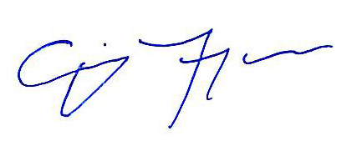

Sincerely,

Craig Ferguson

*Vice President*

GSFA

CC: Peter Tran, *Director of Operations*, GSFA