**ATTACHMENT “A”**

Proposal Prepared for

Siskiyou County Health Department

Attention:

Henry Schnedler, Administrator

January 18, 2022

# Prepared by:

David Smith

Senior Account Executive 100 Warren St., Suite 305

Mankato, MN 56001

507- 399- 0423 Direct Line

507-388-4141 Office

[david.smith@champsoftware.com](mailto:david.smith@champsoftware.com)

January 18, 2023

Champ Software, Inc. supports the Siskiyou County Health Department's mission. As a method of supporting services and efforts to help improve the well-being of individuals and communities, Champ Software is pleased to offer the following proposal for Nightingale Notes training and site licenses to Siskiyou County Health Department.

**Siskiyou County Health Department**

**GOLD Package** with 15 Named Users

# One-Time Training and Implementation - $8,700.00

**Annual Subscription -** $18,990.00

**Total First year costs**

27,690

(2,784) – Courtesy Discount (15%) on first year subscription

24,906

# Total Invoice Amount: $24,906.00 (Implementation/Training & 1st year Subscription)

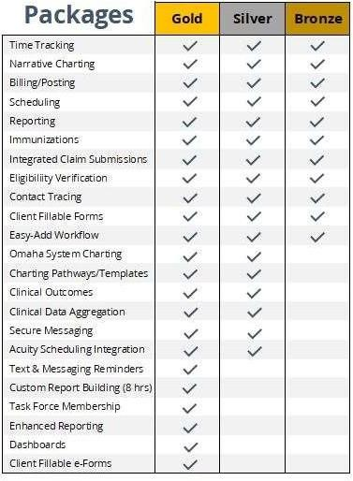

**Optional Annual Time Tracking (only) Licenses:** Time Tracking Licenses are available- minimum of 15 and in increments of 5 users.

*A standard license has access to the Time Tracking functionality/reporting. If your agency has employees that need to utilize the Time Tracking (only) functionality, and not use any other parts of the software, your agency may purchase a bundle of Time Tracking (only)