STATE OF JEFFERSON TRADE ROUTE

YREKA TO PACIFIC OCEAN (224 MILES)

O'BRIAN

SMITH RIVER
E
OREGON
CALIFORNIA

HAPPY CAMP
SEIAD VALLEY

SISKIYOU COUNTY

CITY OF YREKA
I

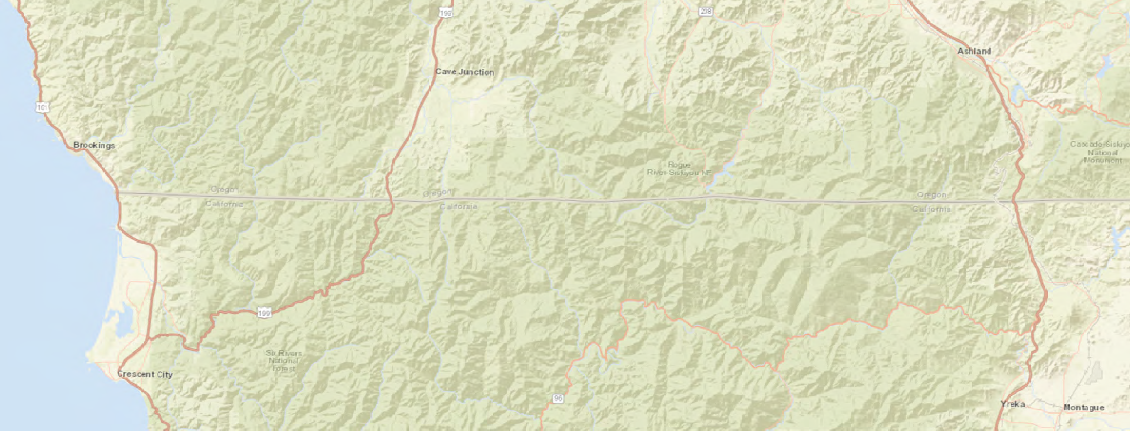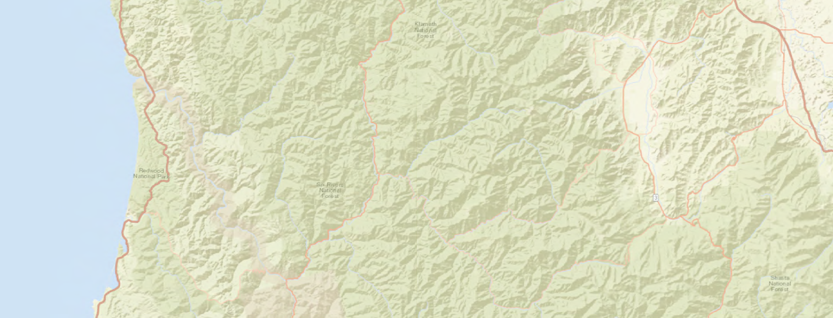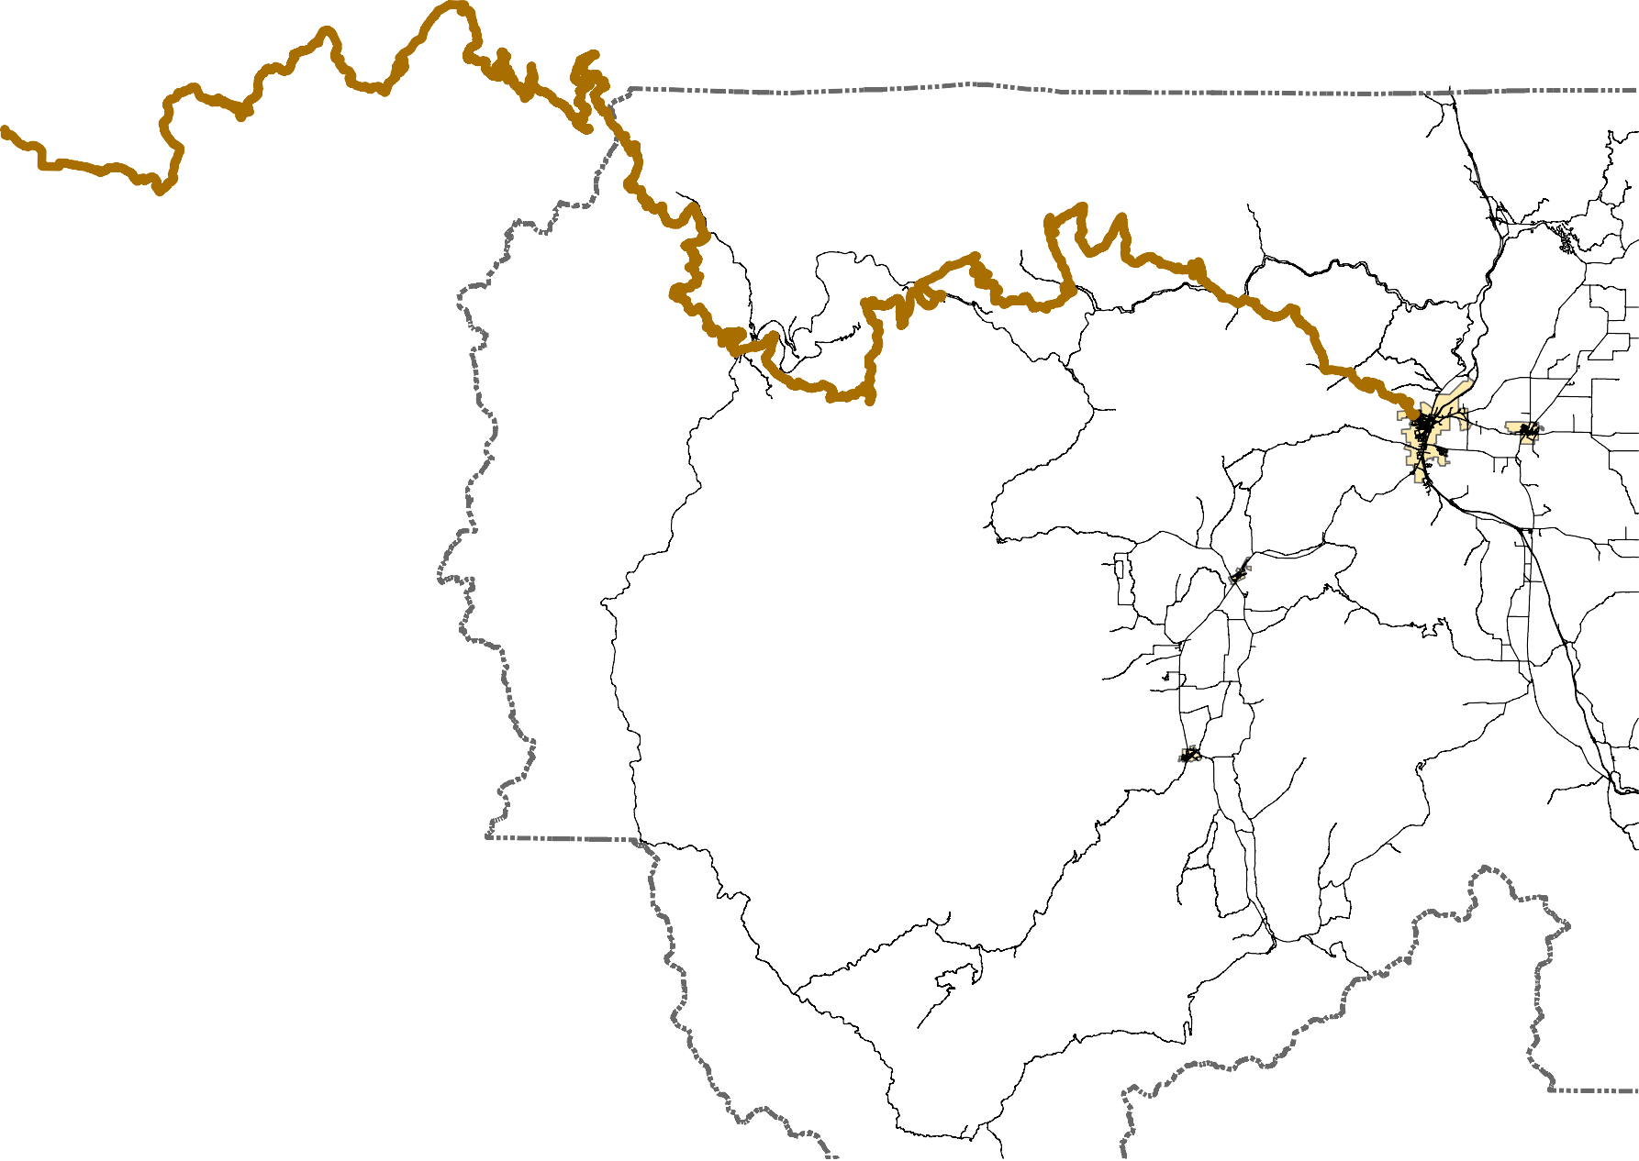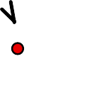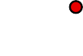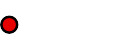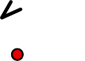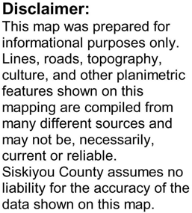
NGA, USGS, NPS
Page 1 of 12

0 2.5
Miles

5 10 15 20

Esri, HERE, Garmin,

TABLE 1
COUNTY ROADS PROPOSED TO BE DESIGNATED COMBINED-USE, REQUIRING CALIFORNIA HIGHWAY PATROL NOTIFICATION PER CVC § 38026
SEGMENT  NUMBER | MAP SHEET | PROPOSED  DESIGNATION | COUNTY ROAD NAME | COUNTY ROAD  NUMBER | BEGIN | END | UNSURFACED  (MILES) | SURFACED  (MILES) | NET LENGTH  (MILES) | JUSTIFICATIONS
SEGMENT #1 | FIGURE 1-1 | COMBINED-USE | HAWKINSVILLE HUMBUG ROAD | 7J002 | MILE POST 4.69 | CANAL GULCH ROAD (7J018) | 0.00 | 0.48 | 0.48 | ( 1 ) | *SJTR
SEGMENT #2 | FIGURE 1-2 | COMBINED-USE | WALKER ROAD | 8G004 | WALKER BRIDGE CONN ROAD (8G002) | KLAMATH RIVER ROAD (8J001) | 0.00 | 1.63 | 1.63 | ( 1 ) | *SJTR
SEGMENT #3 | FIGURE 1-2 | COMBINED-USE | WALKER BRIDGE CONN ROAD | 8G002 | WALKER ROAD (8G004) | STATE HIGHWAY 96 | 0.00 | 0.22 | 0.22 | ( 1 ) | *SJTR
SEGMENT #4 | FIGURE 1-3 | COMBINED-USE | WALKER CREEK ROAD | 8D006 | STATE HIGHWAY 96 | GRIDER CREEK ROAD (8D001) | 0.00 | 0.04 | 0.04 | ( 1 ) | *SJTR
SEGMENT #5 | FIGURE 1-3 | COMBINED-USE | GRIDER CREEK ROAD | 8D001 | WALKER CREEK ROAD (8D006) | MILE POST 2.41 ( USFS 46N66) | 0.00 | 2.41 | 2.41 | ( 1 ) | *SJTR
SEGMENT #6 | FIGURE 1-4 | COMBINED-USE | CHINA GRADE ROAD | 7C002 | ELK CREEK ROAD (7C001) | MILE POST 1.22 (USFS 45N85) | 0.00 | 1.22 | 1.22 | ( 1 ) | *SJTR
SEGMENT #7 | FIGURE 1-4 | COMBINED-USE | ELK CREEK ROAD | 7C001 | STATE HIGHWAY 96 | CURLY JACK ROAD (7C006) | 0.00 | 0.52 | 0.52 | ( 1 ) ( 2 ) *SJTR
SEGMENT #8 | FIGURE 1-4 | COMBINED-USE | CURLY JACK ROAD | 7C006 | ELK CREEK ROAD (7C001) | MILE POST 0.36 (CAMPGROUND) | 0.00 | 0.36 | 0.36 | ( 1 ) ( 3) *SJTR
SEGMENT #9 | FIGURE 1-4 | COMBINED-USE | LOWER AIRPORT ROAD | 7C035 | STATE HIGHWAY 96 | MILE POST 0.18 (USFS 16N30) | 0.00 | 0.18 | 0.18 | ( 1 ) ( 2 ) *SJTR
SEGMENT #10 | FIGURE 1-5 | COMBINED-USE | SOUTH FORK ROAD | 8C001 | MILE POST 0.15 (USFS 17N32) | MILE POST 0.57 (USFS 18N30) | 0.00 | 0.42 | 0.42 | ( 1 ) | *SJTR
JUSTIFICATIONS CVC § 38026:
Page 2 of 12

( 1 ) HIGHWAY SEGMENT IS LOCATED IN A MANNER THAT PROVIDES A CONNECTING LINK BETWEEN OFF-HIGHWAY MOTOR VEHICLE TRAIL SEGMENTS.

( 2 ) HIGHWAY SEGMENT IS LOCATED IN A MANNER THAT PROVIDES A CONNECTING LINK BETWEEN AN OFF-HIGHWAY MOTOR VEHICLE RECREATIONAL USE AREA AND NECESSARY SERVICE FACILITIES. ( 3 ) HIGHWAY SEGMENT IS LOCATED IN A MANNER THAT PROVIDES A CONNECTING LINK BETWEEN LODGING FACILITIES AND AN OFF-HIGHWAY MOTOR VEHICLE RECREATIONAL FACILITY.
* SJTR = STATE OF JEFFERSON TRADE ROUTE. ROAD SEGMENT PROVIDES CONNECTIVITY ALONG ROUTE.

FIGURE 1

SCALE: 1" = 3 MILES

HILT

West Branch Campground
Æ

Beaver Creek Campground
Æ

FIGURE 1-5
Æ

HAPPY CAMP

Fort Goff Campground

Grider Creek Campground
Æ

SEIAD

HORSE
WALKER BRIDGE CONN RD.

FIGURE 1-2

KLAMATH RIVER

HAWKINSVILLE HUMBUG ROAD
Tree of
Heaven Campground
Æ

Curly Jack Campground
Æ

FIGURE 1-4
FIGURE 1-3

Sara Totten Campground
Æ

HAMBURG
CREEK

ELIZA GULCH ROAD

Humbug OHV Area
Æ

SCOTT BAR

RD.
MILL CR.
MIDDLE FORK HUMBUG ROAD

YREKA

COMBINED-USE ROADS
COUNTY ROADS PROPOSED TO BE DESIGNATED COMBINED-USE PER CA CVC § 38026, SUBJECT TO REVIEW BY CALIFORNIA
HIGHWAY PATROL. SEE TABLE 1, AND FIGURES 1-1 THRU 1-5.

"NON-HIGHWAY" ROADS Æ
COUNTY ROADS PROPOSED TO BE DESIGNATED AS "NON-HIGHWAY" FOR THE
PURPOSES OF CA CVC § 38000 VIA. COUNTY BOARD OF SUPERVISORS RESOLUTION. SEE TABLE 2, AND FIGURES 2-1 THRU 2-5
Æ

Bridge Flat River Access

Indian Scotty
M
Campground
M
Æ

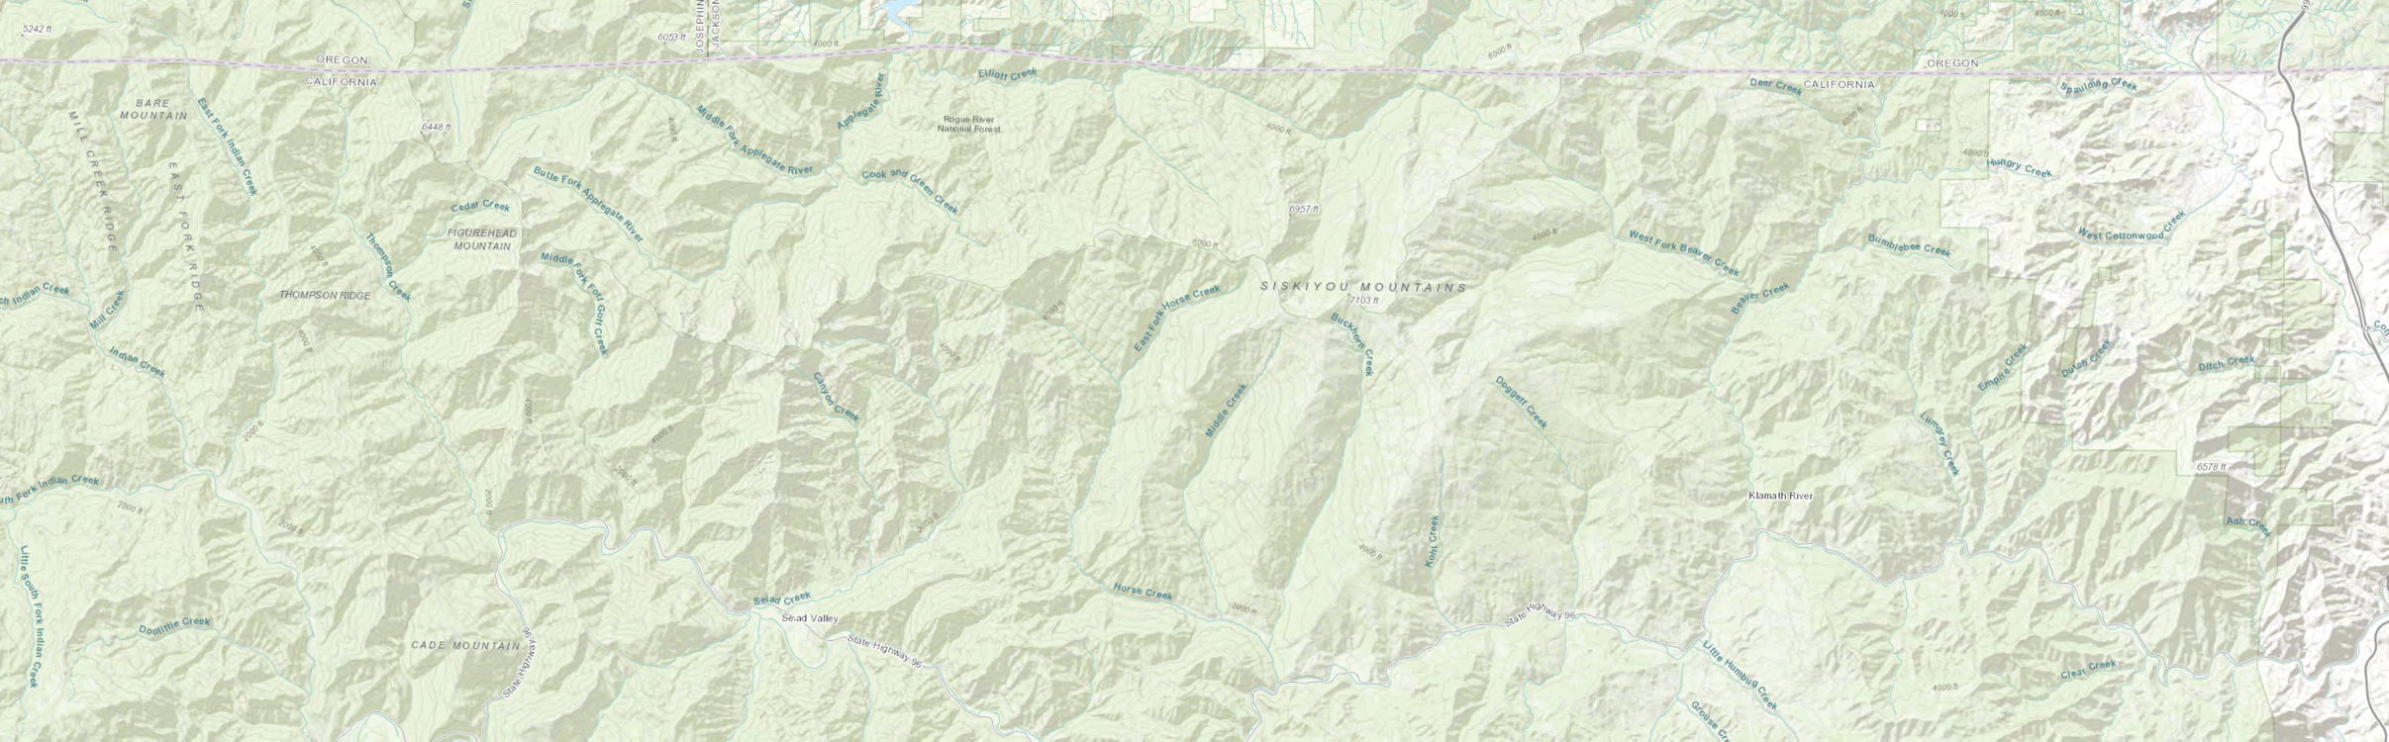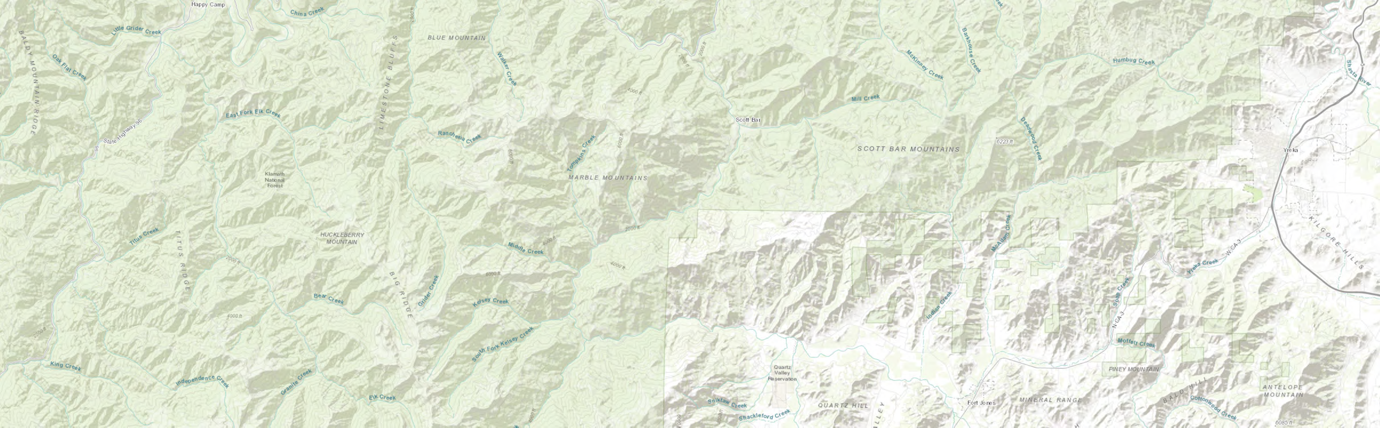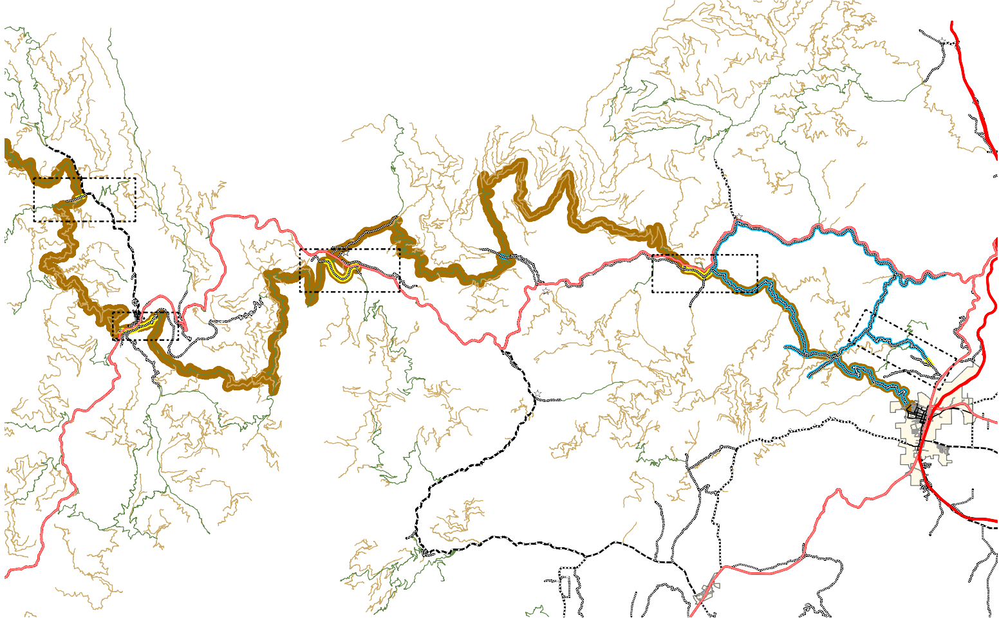USFS ROADS OPEN TO HIGHWAY LEGAL VEHICLES ONLY USFS ROADS OPEN TO ALL VEHICLES

STATE OF JEFFERSON TRADE ROUTE

MAPPING PREPARED BY SISKIYOU COUNTY PUBLIC WORKS AT THE DIRECTION OF THE SISKIYOU COUNTY BOARD OF SUÆPERVISORS.
Æ

Bureau of Land Management, State of Oregon, State of Oregon DOT, State of Oregon GEO, Esri Canada, Esri, HERE, Garmin, I
NCREMENT P, USGS, METI/ NASA, NGA, EPA, USDA

FORT
JONES

Page 3 of 12

8J

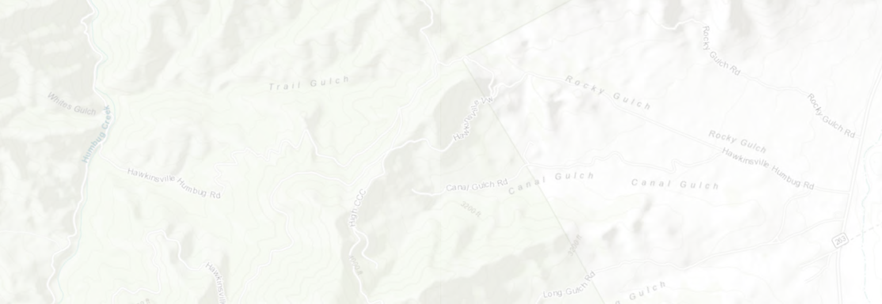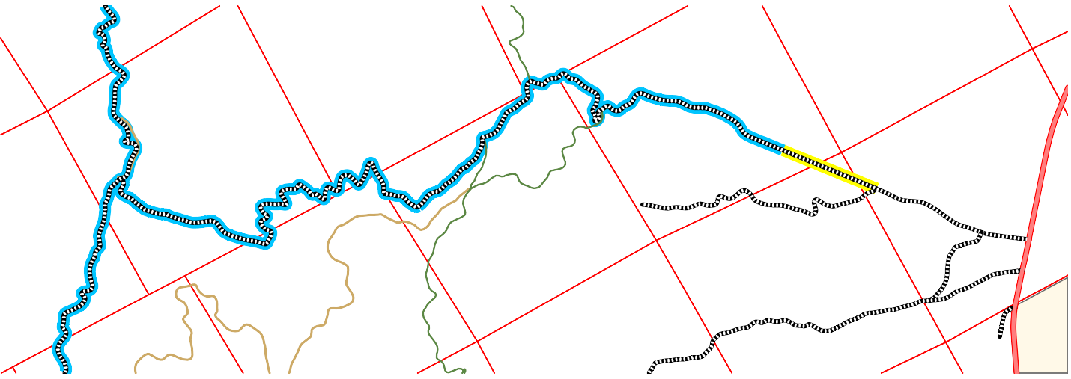COMMENCING AT THE INTERSECTION OF HUMBUG CREEK ROAD #8J002 AND HAWKINSVILLE HUMBUG ROAD #7J002, BEING LOCATED IN SECTION 3, TOWNSHIP 45 NORTH, RANGE 7 WEST, M.D.M., SAID ROADS BEING COUNTY MAINTAINED
45N07W 1
46N07W29
46N07W34
BEGIN SEGMENT 1
45N07W 3
45N07W 2
45N07W12
46N07W33
46N07W30
END SEGMENT 1
46N07W32
45N07W 4
45N07W11
46N07W31
45N07W 5
45N07W10
0
405.2N057W06.5
1 Miles
45N0B7uWrea9u of Land Management, Esri Canada, Esri, HERE, Garmin,
45N08W 1
SEGMENT NUMBER 1
45N07W 8
FIGURE 1-1
INCREMENT P, USGS, METI/NASA, EPA4,5UNS0D7AW14
45N07W15
State of Jefferson Trade Route
A
HIGHWAYS; THENCE SOUTHEASTERLY 4.69 MILES ALONG HAWKINSVILLE HUMBUG ROAD TO THE TRUE POINT OF BEGINNING; THENCE SOUTHEASTERLY 0.48 MILES ALONG HAWKISVILLE HUMBUG ROAD TO THE END OF "SEGMENT 1", SAID TERMINOUS POINT BEING LOCATED AT THE INTERSECTION OF CANAL GULCH ROAD #7J018.
NET LENGTH = 0.48 MILES
E

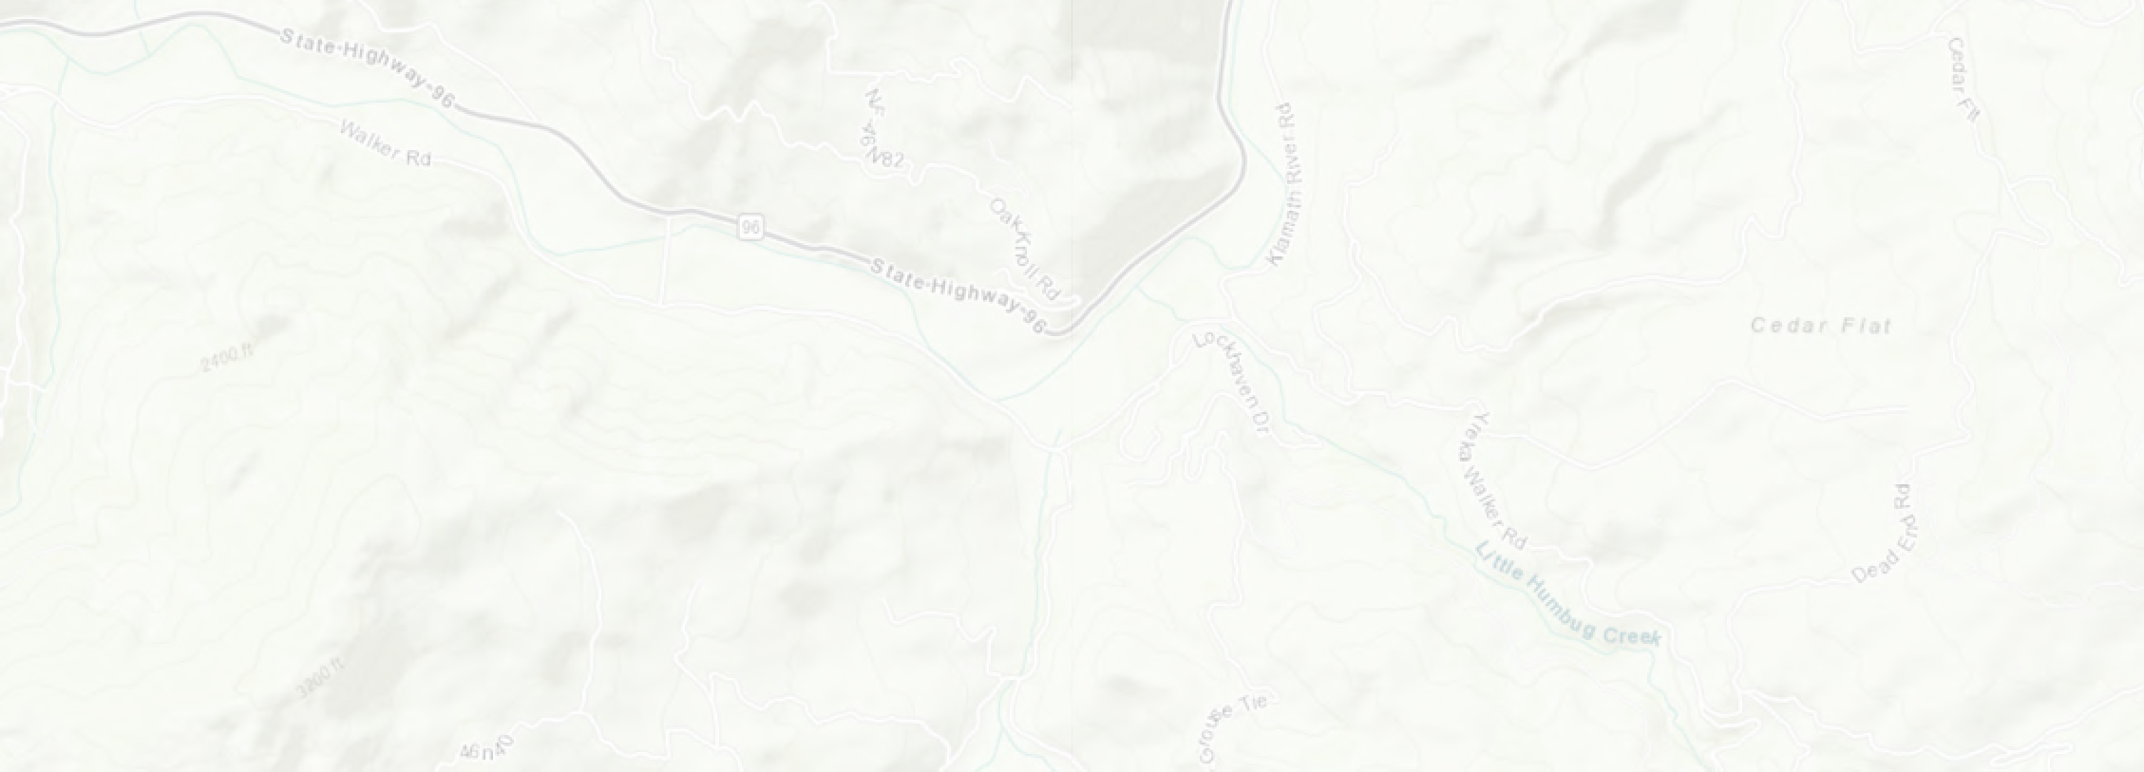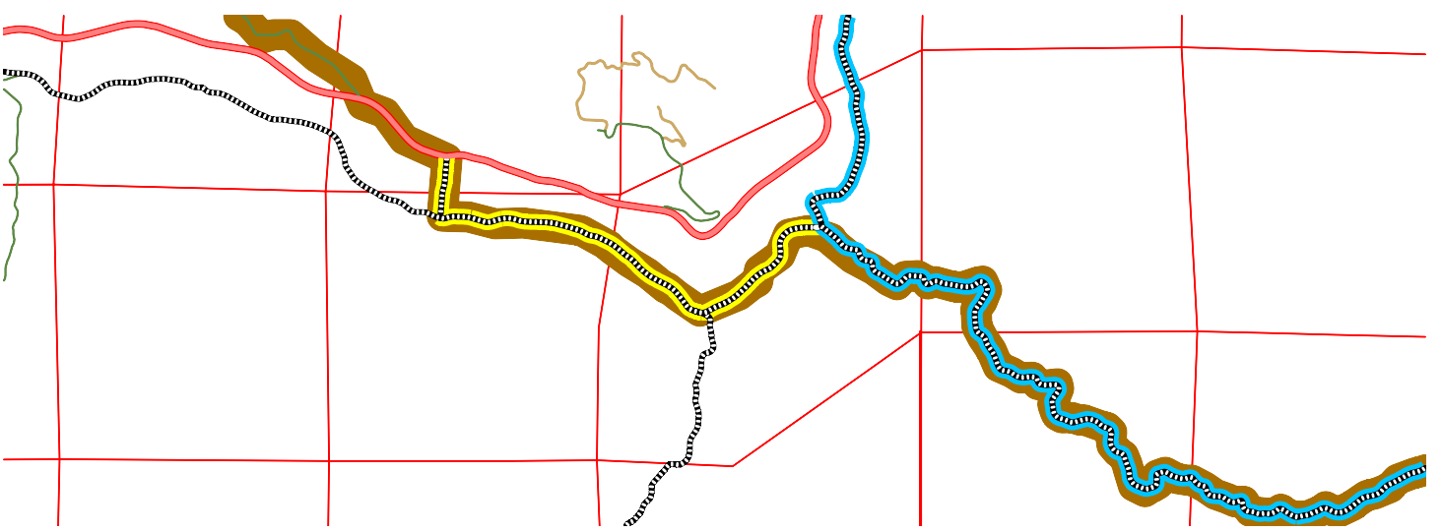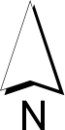BEGINNING AT THE INTERSECTION OF WALKER BRIDGE CONN ROAD #8G002 AND WALKER ROAD #8G004, BEING LOCATED IN SECTION 14, TOWNSHIP 46 NORTH, RANGE 9 WEST, M.D.M., SAID ROADS BEING COUNTY MAINTAINED HIGHWAYS; THENCE EASTERLY 1.63 MILES ALONG WALKER ROAD TO THE END OF "SEGMENT 2", SAID TERMINOUS POINT BEING LOCATED AT THE INTERSECTION OF YREKA WALKER ROAD #7J001.
46N09W 9
END SEGMENT 3
46N09W11
46N08W 7
46N08W 8
46N09W12
46N09W10
WALKER BRIDGE CONN ROAD 8G002
46N08W18
46N08W17
BEGIN SEGMENT 3
L
46N09W13
46N09W16
46N09W15
46N09W14
BEGIN
SEGMENT 2
46N09W21
0
0.25 0.5
46N09W22
1 Miles
46N09W23
END SEGMENT 2
Bureau of Land Manageme4n6tN, 0St8aWte1o9f Oregon, State of 4O6rNeg08oWn D20OT, Sta4te6No0f 9OWre2g4on GEO, Esri Canada, Esri, HERE, Garmin, INCREMENT P,
USGS, METI/NASA, EPA, USDA
SEGMENT NUMBER 2
FIGURE 1-2
State of Jefferson Trade Route
NET LENGTH = 1.63 MILES.

=============================================================================

SEGMENT NUMBER 3
BEGINNING AT THE INTERSECTION OF WALKER ROAD #8G004 AND WALKER BRIDGE CONN ROAD #8G002, BEING LOCATED IN SECTION 14, TOWNSHIP 46 NORTH, RANGE 9 WEST, M.D.M., SAID ROADS BEING COUNTY MAINTAINED HIGHWAYS; THENCE NORTHERLY 0.22 MILES ALONG WALKER BRIDGE CONN ROAD TO THE END OF "SEGMENT 3", SAID TERMINOUS POINT BEING LOCATED AT THE INTERSECTION OF STATE HIGHWAY 96 AT MILE POST SIS 84.054.
NET LENGTH = 0.22 MILES.

46N11W 9
46N11W 8

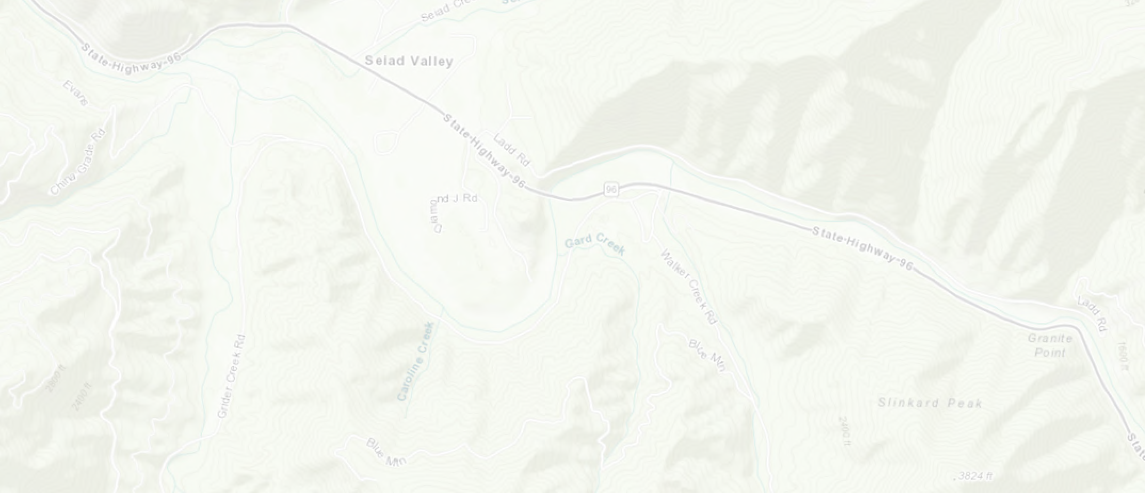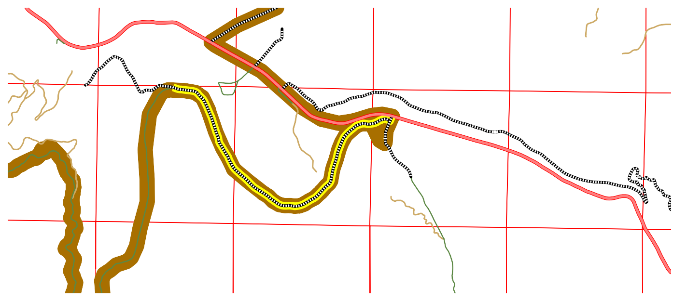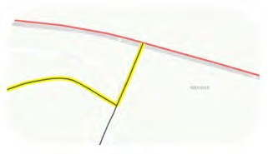BEGINNING AT THE INTERSECTION OF STATE HIGHWAY 96 AT MILE POST SIS 61.683 AND WALKER CREEK ROAD #8D006, BEING LOCATED IN SECTION 18, TOWNSHIP 46 NORTH, RANGE 11 WEST, M.D.M., WALKER CREEK ROAD BEING A COUNTY MAINTAINED HIGHWAY; THENCE SOUTHWESTERLY 0.04 MILES ALONG WALKER CREEK ROAD TO THE END OF "SEGMENT 4", SAID TERMINOUS POINT BEING LOCATED AT THE INTERSECTION OF GRIDER CREEK ROAD #8D001.
46N12W10
46N12W11
M.P. 2.41
46N12W12
END
46N11W 7 SEGMENT 4
BEGIN SEGMENT 4
N.T.S.
46N12W15 END 46N12W14
SEGMENT 5
46N12W13
46N11W18
46N11W17
46N11W16
BEGIN SEGMENT 5
8
46N12W22
0 0.25 0.5
46N12W23
1 Miles
46N12W24 Bureau of Land Management, State of Oregon, State of Oregon DOT, State of Oregon 4G6ENO1, 1EWsr1i C9anada, Esri, HERE, G4a6rNm1i1nW, IN20CREM4E6NNT1P1,W21
USGS, METI/NASA, EPA, USDA
SEGMENT NUMBER 4
FIGURE 1-3
State of Jefferson Trade Route
NET LENGTH = 0.04 MILES.

==============================================================================

SEGMENT NUMBER 5

BEGINNING AT THE INTERSECTION OF WALKER CREEK ROAD #8D006 AND GRIDER CREEK ROAD #8D001, BEING LOCATED IN SECTION 18, TOWNSHIP 46 NORTH, RANGE 11 WEST, M.D.M., SAID ROADS BEING COUNTY MAINTAINED HIGHWAYS; THENCE WESTERLY 2.41 MILES ALONG GRIDER CREEK ROAD TO THE END OF "SEGMENT 5", SAID TERMINOUS POINT BEING LOCATED AT THE INTERSECTION OF FOREST SERVICE ROAD #46N66.
NET LENGTH = 2.41 MILES

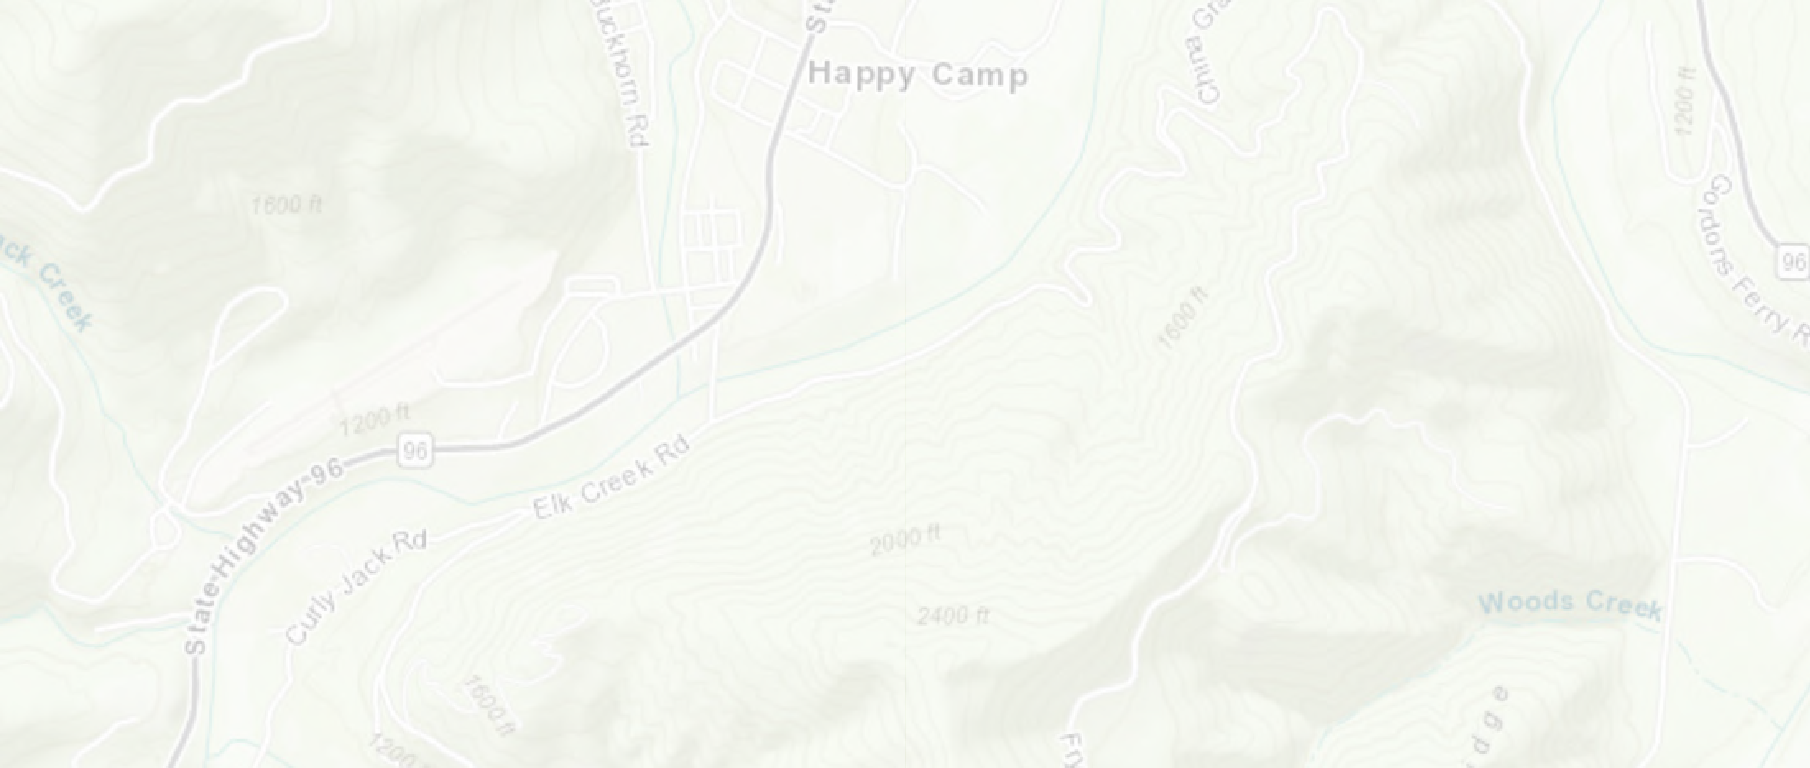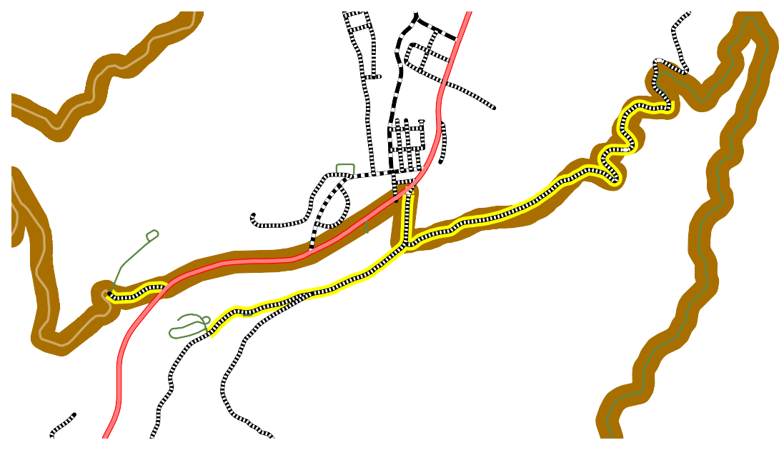les
16N08E 6
Curly Jack Campground
Æ
AIRPORT RD. 7C035
6
END SEGMENT 8
16N07E10 BEGIN SEGMENT 9
LOWER
0 0.1163N007.2E 53 0.5 Mi
16N07E 2

HAPPY CAMP

BEGIN SEGMENT 7

16N07E11
16N07E 1

END SEGMENT 6
M.P. 1.22

16N07E12

16N08E 7
8

END
SEGMENT 9 16N07E15

BEGIN SEGMENT 6
END SEGMENT 7 BEGIN SEG16MNE07NET148

Bureau of Land Management, State of Oregon, State of Oregon DOT, State of Oregon GEO, Esri Ca1n6aNd0a7, EE1sr3i, HERE, Garmin, INCRE1M6ENN08TEP1,8
Intermap, USGS, METI/NASA, EPA, USDA

SEGMENT NUMBER 6
FIGURE 1-4

State of Jefferson Trade Route

BEGINNING AT THE INTERSECTION OF ELK CREEK ROAD #7C001 AND CHINA GRADE ROAD #7C002, BEING LOCATED IN SECTION 11, TOWNSHIP 16 NORTH, RANGE 7 EAST, H.M., SAID ROADS BEING COUNTY MAINTAINED HIGHWAYS; THENCE NORTHEASTERLY 1.22 MILES ALONG CHINA GRADE ROAD TO THE END OF "SEGMENT 6", SAID TERMINOUS POINT BEING LOCATED AT THE INTERSECTION OF FOREST SERVICE ROAD #45N85.
NET LENGTH = 1.22 MILES.

=============================================================================

SEGMENT NUMBER 7
BEGINNING AT THE INTERSECTION OF STATE HIGHWAY 96 AT MILE POST SIS 41.165 AND ELK CREEK ROAD #7C001, BEING LOCATED IN SECTION 11, TOWNSHIP 16 NORTH, RANGE 7 EAST, H.M., ELK CREEK ROAD BEING A COUNTY MAINTAINED HIGHWAY; THENCE SOUTHWESTERLY 0.52 MILES ALONG ELK CREEK ROAD TO THE END OF "SEGMENT 7", SAID TERMINOUS POINT POINT BEING LOCATED AT THE INTERSECTION OF CURLY JACK ROAD #7C006.
NET LENGTH = 0.52 MILES.

=============================================================================

SEGMENT NUMBER 8
BEGINNING AT THE INTERSECTION OF ELK CREEK ROAD #7C001 AND CURLY JACK ROAD #7C006, BEING LOCATED IN SECTION 11, TOWNSHIP 16 NORTH, RANGE 7 EAST, H.M., SAID ROADS BEING COUNTY MAINTAINED HIGHWAYS; THENCE
SOUTHWESTERLY 0.36 MILES ALONG CURLY JACK ROAD TO THE END OF "SEGMENT 8", SAID TERMINOUS POINT BEING LOCATED AT THE CURLY JACK CAMPGOUND ENTRANCE.
NET LENGTH = 0.36 MILES.

=============================================================================

SEGMENT NUMBER 9
BEGINNING AT THE INTERSECTION OF STATE HIGHWAY 96 AT MILE POST SIS 40.285 AND LOWER AIRPORT ROAD #7C035, BEING LOCATED IN SECTION 10, TOWNSHIP 16 NORTH, RANGE 7 EAST, H.M., LOWER AIRPORT ROAD BEING A COUNTY MAINTAINED HIGHWAY; THENCE WESTERLY 0.18 MILES ALONG LOWER AIRPORT ROAD TO THE END OF SEGMENT 9, SAID TERMINOUS POINT BEING LOCATED AT THE BEGINNING OF FOREST SERVICE ROAD #16N30.
NET LENGTH = 0.18 MILES.

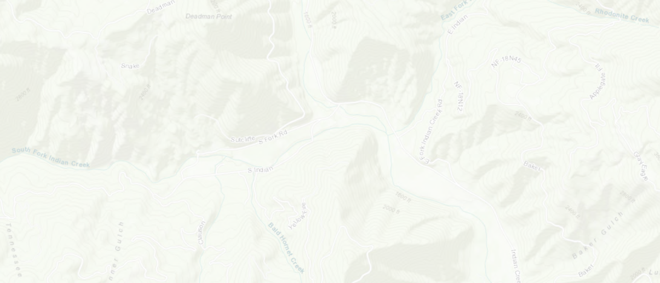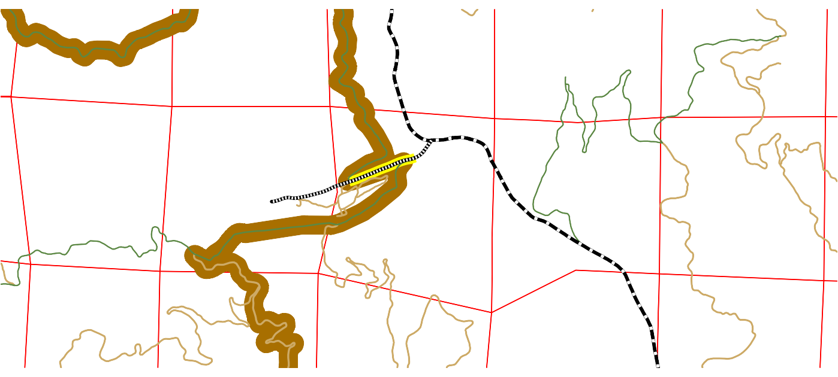COMMENCING AT THE INTERSECTION OF INDIAN CREEK ROAD #7C01 AND SOUTH FORK ROAD #8C001, BEING LOCATED IN SECTION 8, TOWNSHIP 17 NORTH, RANGE 7 EAST, H.M., SAID ROADS BEING COUNTY MAINTAINED HIGHWAYS; THENCE SOUTHWESTERLY 0.15 MILES ALONG SOUTH FORK ROAD TO THE TRUE POINT OF BEGINNING, SAID POINT BEING LOCATED AT THE INTERSECTION OF FOREST SERVICE ROAD #17N32; THENCE SOUTHWESTERLY 0.42 MILES ALONG SOUTH FORK ROAD TO THE END OF "SEGMENT 10", SAID TERMINOUS POINT BEING LOCATED AT THE INTERSECTION OF FOREST SERVICE
17N06E 2
17N06E 1
17N07E 6
17N07E 5
17N07E 4
17N07E 3 17N07E 2
END SEGMENT 10
17N06E12
17N07E 7
17N07E11
U
17N07E10
17N06E11
17N07E 8
BEGIN
SEGMENT 10
17N07E 9
17N06E14

17N06E13
0 0.25 0.5
17N07E18
1 Miles
Bureau of Land Management, State of Oregon, State of Oregon DOT,
17N07E17 State of Oregon GEO, E1s7riNC0a7nEa1d6a, Esri, HERE, Garm1in7,NIN07CER1E5ME1N7TNP07, E14
USGS, METI/NASA, EPA, USDA
SEGMENT NUMBER 10
FIGURE 1-5
State of Jefferson Trade Route
ROAD #18N30.
NET LENGTH = 0.42 MILES.

TABLE 2
COUNTY ROADS TO BE DESIGNATED BY THE BOARD OF SUPERVISORS AS "NON-HIGHWAY" FOR THE PURPOSES OF CVC § 38000
SEGMENT  NUMBER | MAP SHEET | PROPOSED  DESIGNATION | COUNTY ROAD NAME | COUNTY ROAD  NUMBER | BEGIN | END | UNSURFACED  (MILES) | SURFACED  (MILES) | NET LENGTH  (MILES)
SEGMENT 11 | FIGURE 2-1 | NON-HIGHWAY | HAWKINSVILLE HUMBUG ROAD | 7J002 | HUMBUG CREEK ROAD (8J002) | MILE POST 4.69 | 4.69 | 0.00 | 4.69
SEGMENT 12 | FIGURE 2-2 | NON-HIGHWAY | YREKA WALKER ROAD | 7J001 | KLAMATH RIVER ROAD (8J001) | YREKA CITY LIMITS (M.P. 17.92) | 17.70 | 0.22 | 17.92
SEGMENT 13 | FIGURE 2-3 | NON-HIGHWAY | HUMBUG CREEK ROAD | 8J002 | YREKA WALKER ROAD (7J001) | KLAMATH RIVER ROAD (8J001) | 6.69 | 0.00 | 6.69
SEGMENT 14 | FIGURE 2-3 | NON-HIGHWAY | MIDDLE FORK HUMBUG ROAD | 7H002 | YREKA WALKER ROAD (7J001) | MILE POST 1.80 (END) | 1.80 | 0.00 | 1.80
SEGMENT 15 | FIGURE 2-3 | NON-HIGHWAY | ELIZA GULCH ROAD | 7J031 | YREKA WALKER ROAD (7J001) | MILE POST 1.62 (END) | 1.62 | 0.00 | 1.62
SEGMENT 16 | FIGURE 2-4 | NON-HIGHWAY | KLAMATH RIVER ROAD | 8J001 | YREKA WALKER ROAD (7J001) | STATE HIGHWAY 96 | 16.00 | 0.82 | 16.82
SEGMENT 17 | FIGURE 2-5 | NON-HIGHWAY | HORSE CREEK ROAD | 8F001 | MILE POST 2.76 (USFS 12) | MILE POST 3.09 (USFS 46N60) | 0.33 | 0.00 | 0.33
Page 8 of 12

FIGURE 2

HORNBROOK

FIGURE 2-5

KLAMATH RIVER

FIGURE 2-4

SCALE: 1" = 2 MILES

Tree of Heaven Campground
Æ

HORSE CREEK

Sara Totten Campground
Æ

HAMBURG

Humbug OHV Area
Æ
T

SCOTT BAR
.

MILL CREEK

ROAD

YREKA

COMBINED-USE ROADS
COUNTY ROADS PROPOSED TO BE DESIGNATED COMBINED-USE PER CA CVC § 38026, SUBJECT TO REVIEW BY CALIFORNIA
HIGHWAY PATROL. SEE TABLE 1, AND FIGURES 1-1 THRU 1-5.

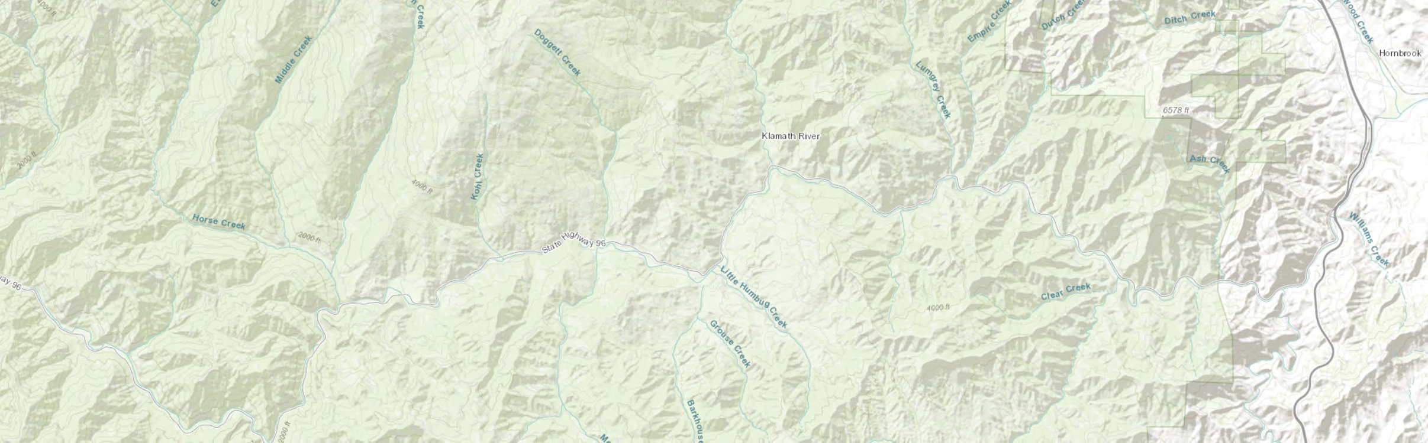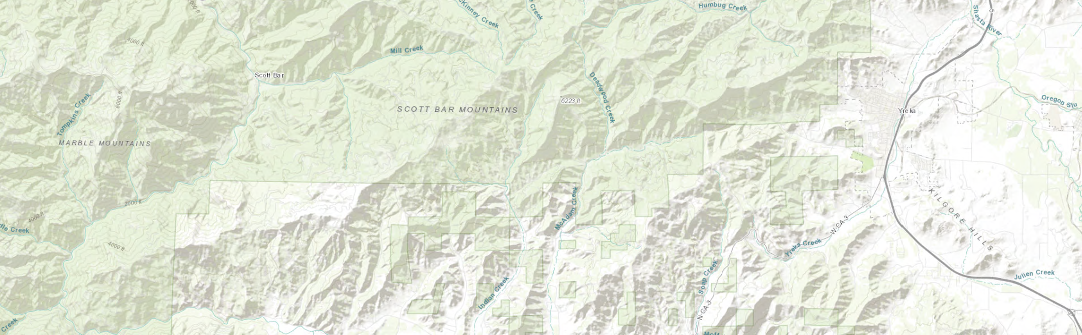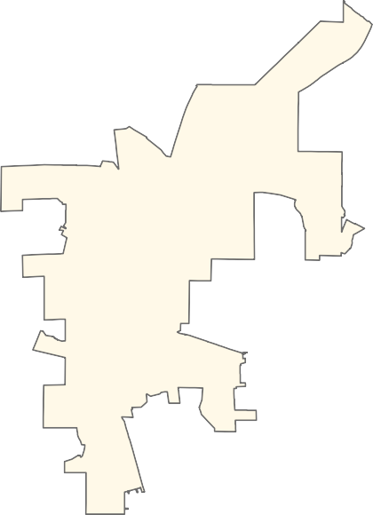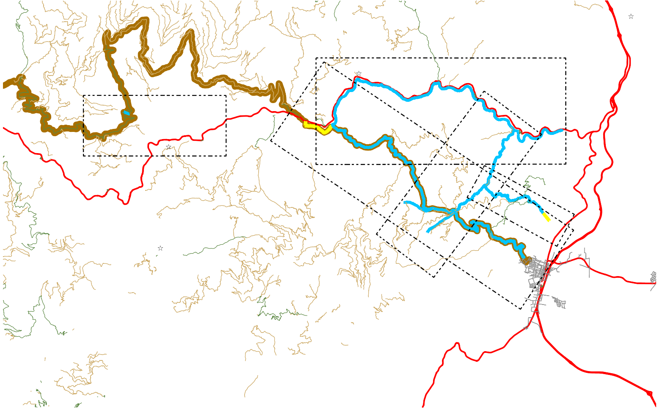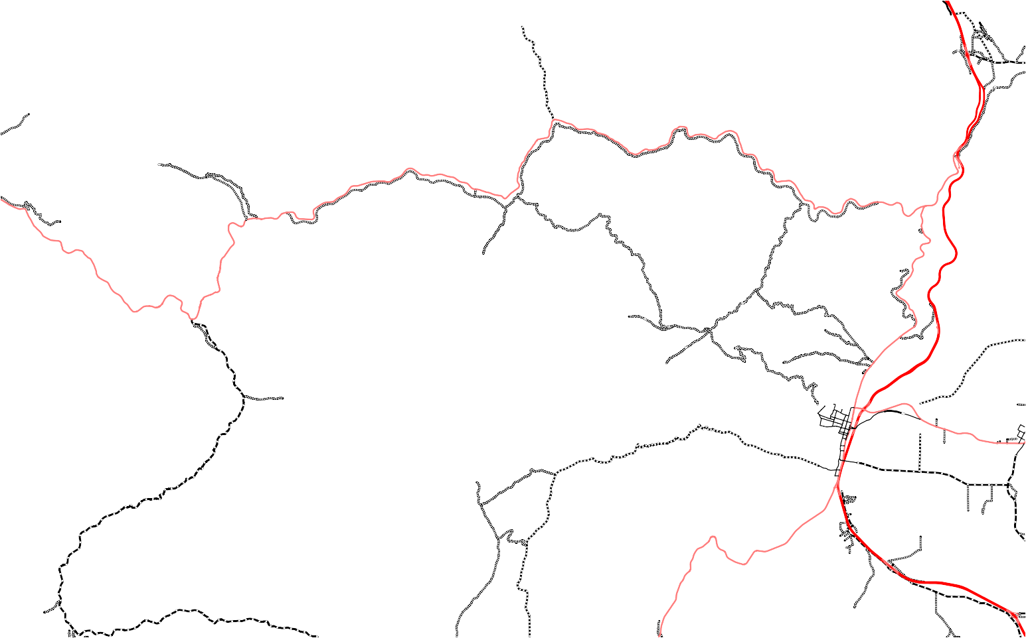"NON-HIGHWAY" ROADS
COUNTY ROADS PROPOSED TO BE DESIGNATED AS "NON-HIGHWAY" FOR THE PURPOSES OF CA CVC § 38000 VIA. COUNTY BOARD
OF SUPERVISORS RESOLUTION. SEE TABLE 2, AND FIGURES 2-1 THRU 2-5
USFS ROADS OPEN TO HIGHWAY LEGAL VEHICLES ONLY USFS ROADS OPEN TO ALL VEHICLES

Æ
STATE OF JEFFERSON TRADE ROUTE

Æ

MAPPING PREPARED BY SISKIYOU COUNTY PUBLIC WORKS AT THE DIRECTION OF THE SISKIYOU COUNTY BOARD OF SUPERVISORS.

Bureau of Land Management, Esri Canada, Esri, HERE, Garmin, INCREMENT P, USG
S, METI/NASA, EPA, USDA

8J

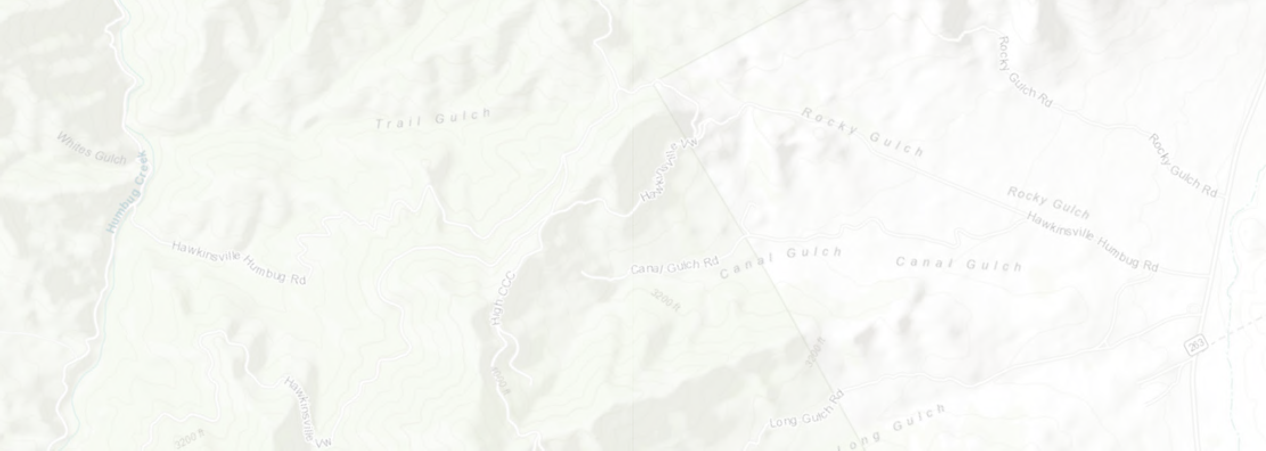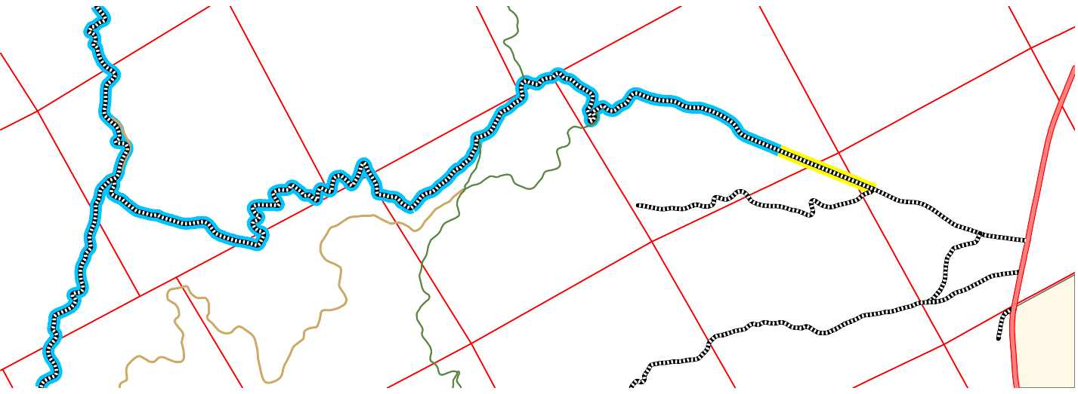SEGMENT NUMBER 11 FIGURE 2-1
46N07W34
46N07W29
45N07W 1

45N07W12
46N07W33
END SEGMENT451N107W 2
45N07W 3
46N07W30
BEGIN SEGMENT 11
46N07W32
45N07W11
46N07W31
45N07W 4
N
45N07W 5
45N07W10
45N07W 9
45N08W 0
1
450N.2075W 60.5
1 Miles
Bureau of Land Management, Esri Canada, Esri, HERE, 4G5aNrm07inW, 14
45N07W 8
INCREMENT P, USGS, METI/NASA, EPA, USDA
45N07W15
BEGINNING AT THE INTERSECTION OF HUMBUG CREEK ROAD #8J002 AND HAWKINSVILLE HUMBUG ROAD #7J002,
BEING LOCATED IN SECTION 32, TOWNSHIP 46 NORTH, RANGE 7 WEST, M.D.M., SAID ROADS BEING COUNTY MAINTAINED HIGHWAYS; THENCE SOUTHEASTERLY 4.69 MILES ALONG HAWKINSVILLE HUMBUG ROAD TO THE END OF "SEGMENT 11". NET LENGTH = 4.69 MILES.

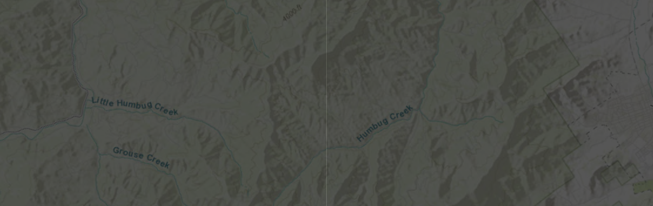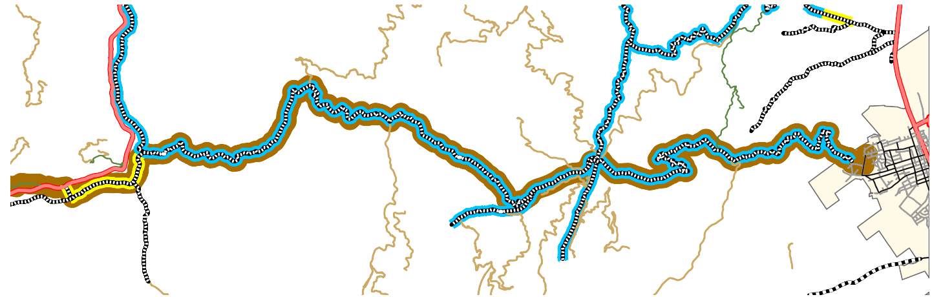BEGINNING AT THE INTERSECTION OF KLAMATH RIVER ROAD #8J001 AND YREKA WALKER ROAD #7J001, BEING LOCATED IN SECTION 13, TOWNSHIP 46 NORTH, RANGE 9 WEST, M.D.M., SAID ROADS BEING COUNTY MAINTAINED HIGHWAYS; THENCE SOUTHEASTERLY 17.92 MILES MORE OR LESS ALONG YREKA WALKER ROAD TO THE END OF "SEGMENT 12", SAID TERMINOUS POINT BEING LOCATED AT THE YREKA CITY LIMITS.
Humbug OHV Area
YREKA
BEGIN SEGMENT 12
0 0.5 1
2 Miles
END SEGMENT 12 YREKA CITY LIMITS
Bureau of Land Management, State of Oregon, State of Oregon DOT,
State of Oregon GEO, Esri Canada, Esri, HERE, Garmin, USGS, NGA, EPA,
USDA, NPS
SEGMENT NUMBER 12
FIGURE 2-2
State of Jefferson Trade Route
NET LENGTH = 17.92 MILES.

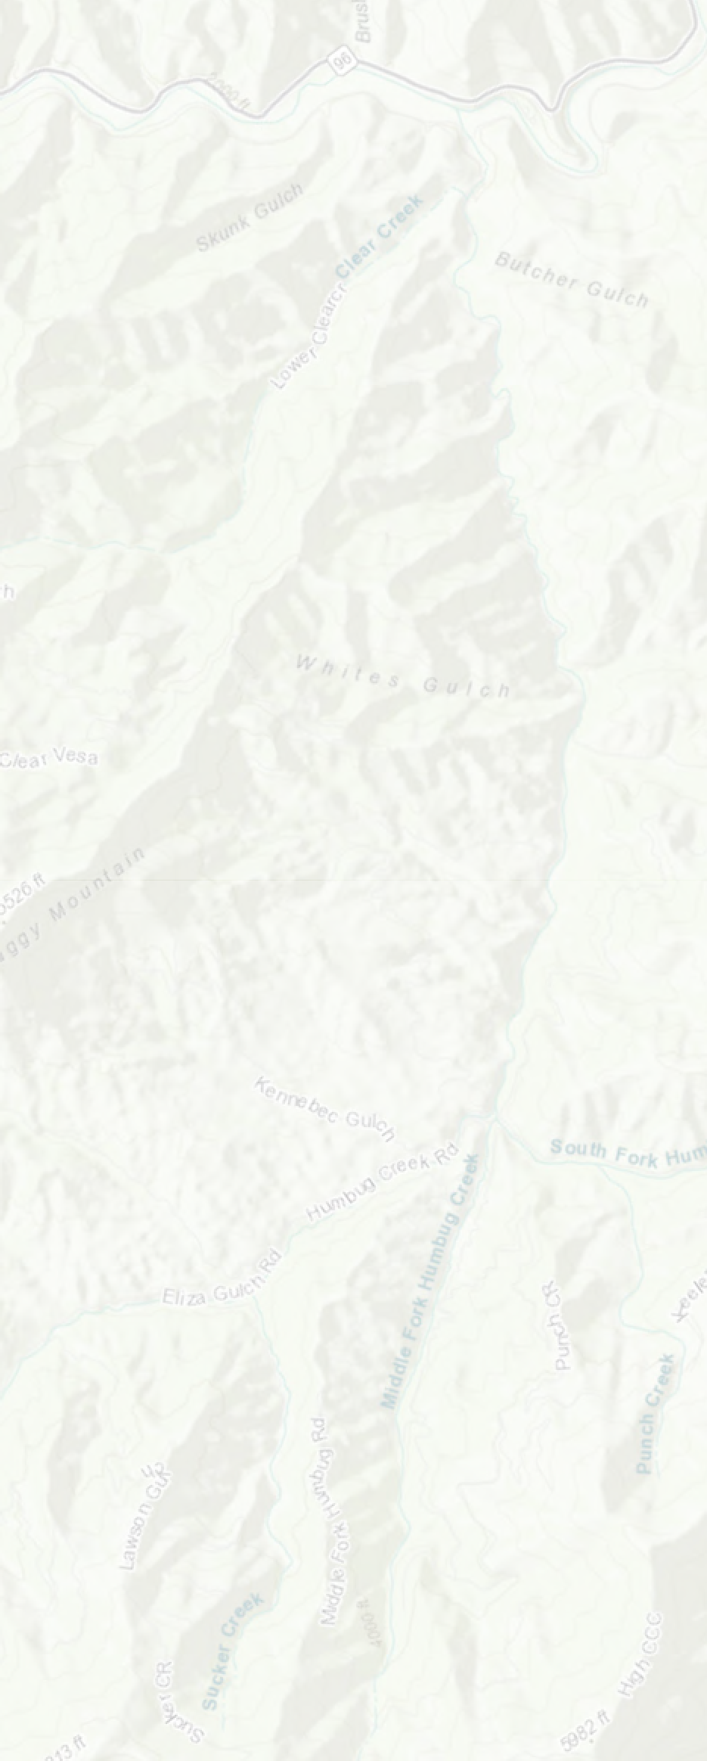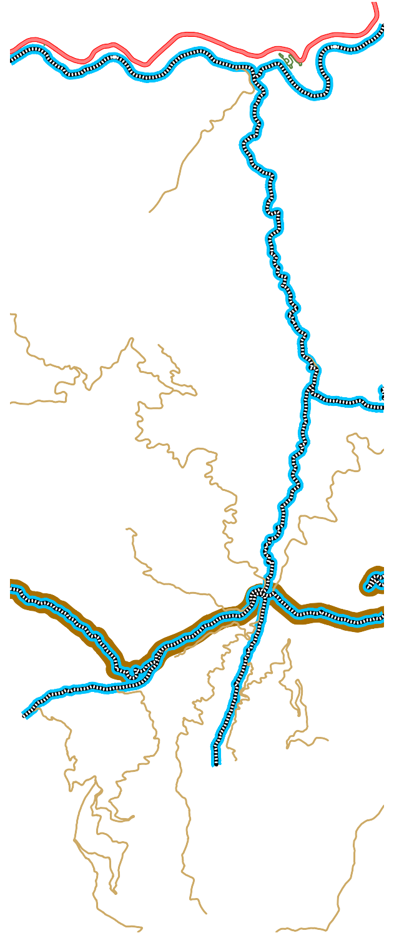SEGMENT NUMBER 13
Tree of Heaven Campground
END SEGMENT 13
YREKA WALKER ROAD 7J001
BEGIN SEGMENT 13

Humbug OHV Area
BEGIN SEGMENT 14
END SEGMENT 15
BEGIN SEGMENT 15
END SEGMENT 14
0
0.5
1
Bureau of Land Management, State of Oregon, State of Oregon DOT, State of Oregon GEO, Esri Canada, Esri, HERE, Garmin, INCREMENT P, USGS, METI/N2ASMA, iNleGsA, EPA, USDA
BEGINNING AT THE INTERSECTION OF YREKA WALKER ROAD #7J001 AND HUMBUG CREEK ROAD #8J002, BEING LOCATED IN SECTION 1, TOWNSHIP 45 NORTH, RANGE 8 WEST, M.D.M.,SAID ROADS BEING COUNTY MAINTAINED HIGHWAYS; THENCE NORTHEASTERLY 6.69 MILES ALONG HUMBUG CREEK ROAD TO THE END OF "SEGMENT 13", SAID TERMINOUS POINT BEING LOCATED AT THE INTERSECTION OF KLAMATH RIVER ROAD #8J001.
NET LENGTH = 6.69 MILES

============================================
D

SEGMENT NUMBER 14
BEGINNING AT THE INTERSECTION OF YREKA WALKER ROAD #7J001 AND MIDDLE FORK HUMGUB ROAD #7H002, BEING LOCATED IN SECTION 1, TOWNSHIP 45 NORTH, RANGE 8 WEST, M.D.M., SAID ROADS BEING COUNTY MAINTAINED HIGHWAYS; THENCE SOUTHWESTERLY 1.80 MILES ALONG MIDDLE FORK HUMBUG ROAD TO THE END OF "SEGMENT 14", SAID TERMINOUS POINT BEING LOCATED AT THE END OF THE COUNTY MAINTAINED ROAD.
NET LENGTH = 1.80 MILES

============================================

SEGMENT NUMBER 15
BEGINNING AT THE INTERSECTION OF YREKA WALKER ROAD #7J001 AND ELIZA GULCH ROAD #7J031, BEING LOCATED IN SECTION 2, TOWNSHIP 45 NORTH, RANGE 8 WEST, M.D.M., SAID ROADS BEING COUNTY MAINTAINED HIGHWAYS; THENCE NORTHWESTERLY 1.62 MILES ALONG ELIZA GULCH ROAD TO THE END OF "SEGMENT 15", SAID TERMINOUS POINT BEING LOCATED AT THE END OF THE COUNTY MAINTAINED
H
ROAD.
NET LENGTH = 1.62 MILES

============================================
I

FIGURE 2-3

State of Jefferson Trade Route

0

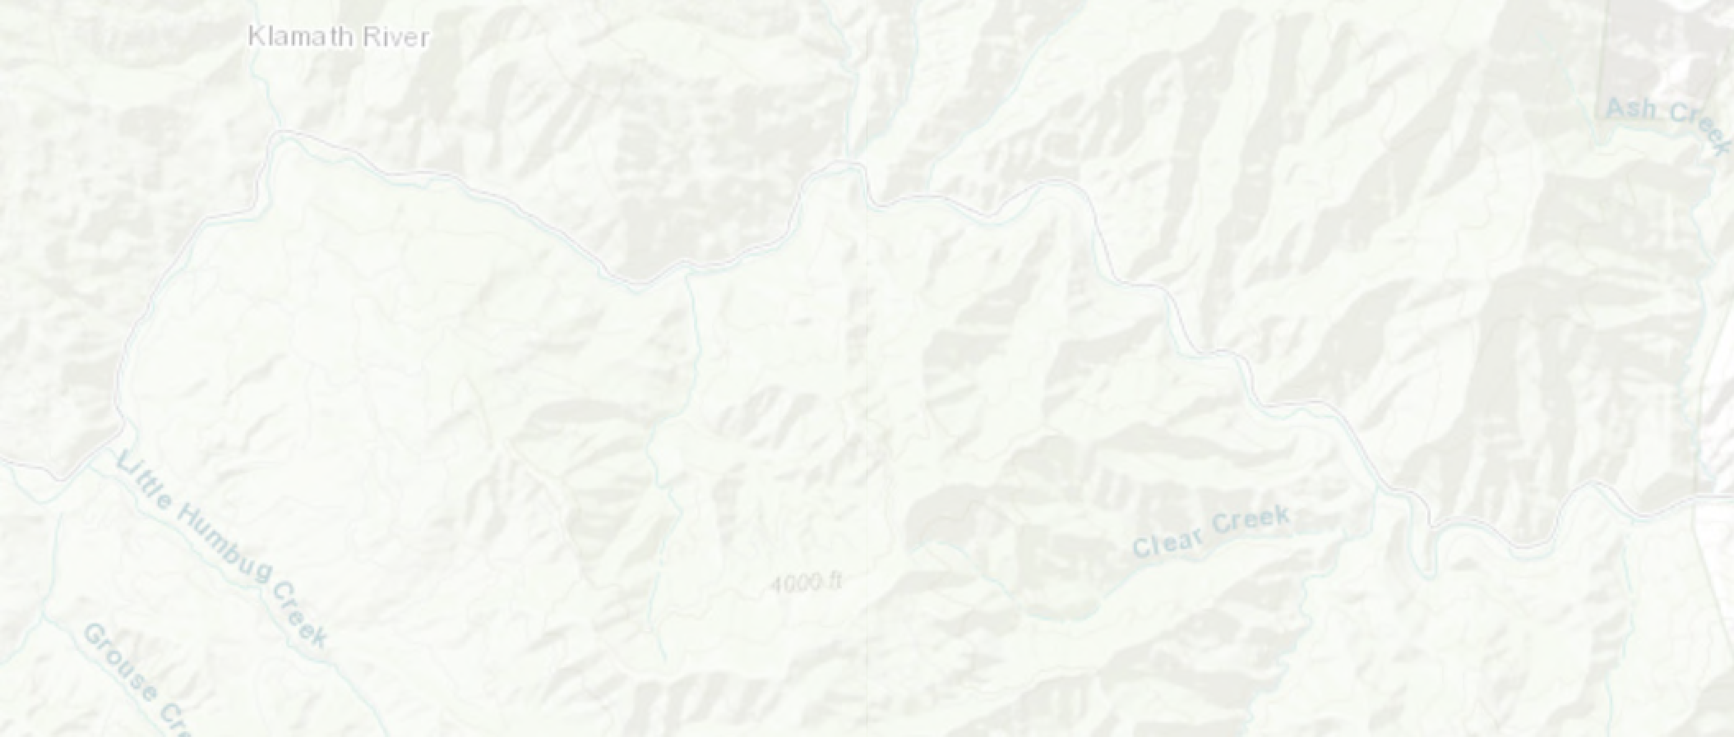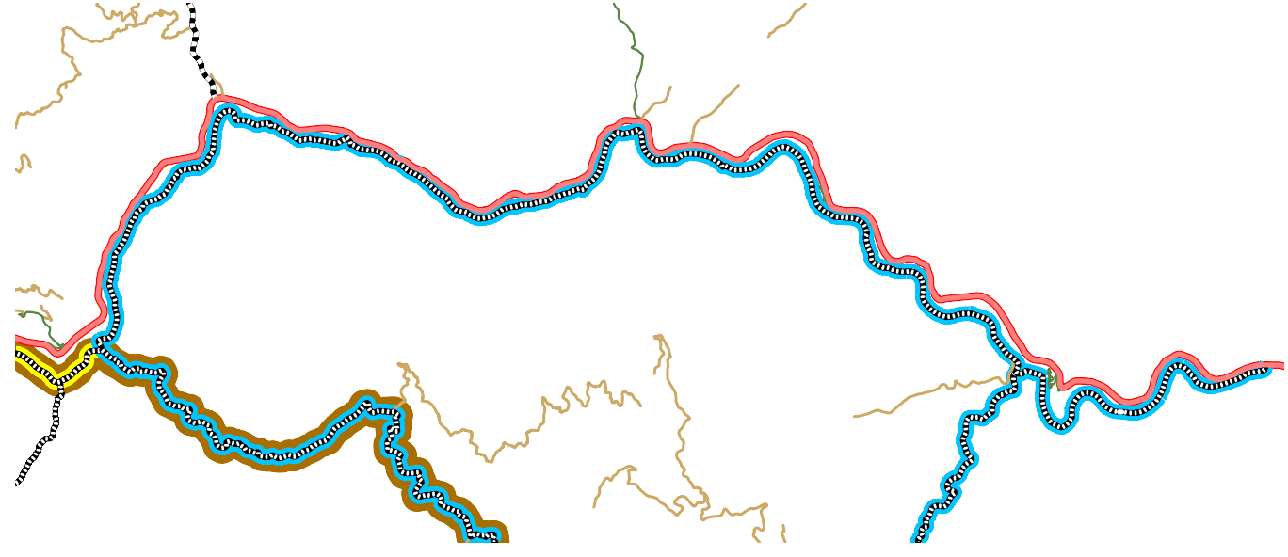BEGINNING AT THE INTERSECTION OF YREKA WALKER ROAD #7J001 AND KLAMATH RIVER ROAD #8J001, BEING LOCATED IN SECTION 13, TOWNSHIP 46 NORTH, RANGE 9 WEST, M.D.M., SAID ROADS BEING COUNTY MAINTAINED HIGHWAYS; THENCE EASTERLY 16.82 MILES ALONG KLAMATH RIVER ROAD TO THE END OF "SEGMENT 16", SAID TERMINOUS POINT BEING LOCATED AT THE INTERSECTION OF STATE HIGHWAY 96.
BEGIN SEGMENT 16
END SEGMENT 16
Tree of Heaven Campground
Æ
0 0.5 1
R
2 Miles
Bureau of Land Management, State of Oregon, State of Oregon DOT, State of Oregon GEO, Esri Canada, Esri, HERE, Garmin, INCREMENT P, USGS, METI/NASA, EPA, USDA
SEGMENT NUMBER 16
FIGURE 2-4
State of Jefferson Trade Route
0
NET LENGTH = 16.82 MILES.

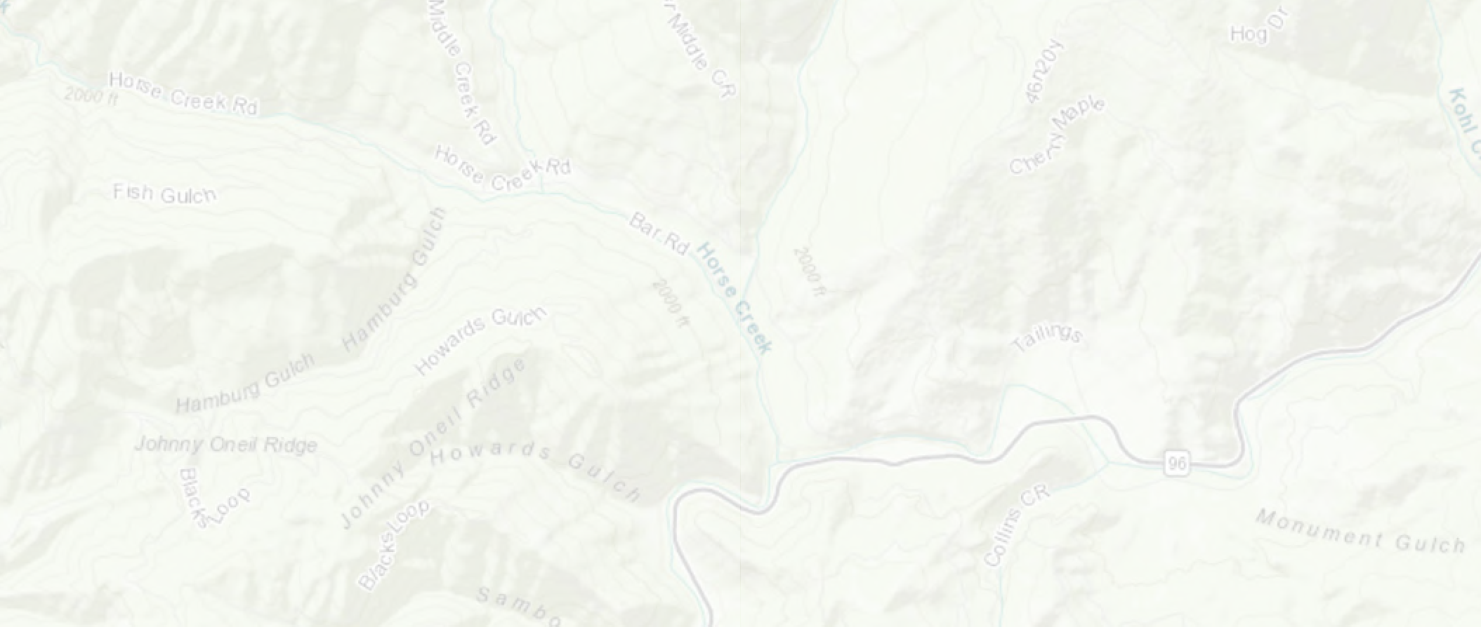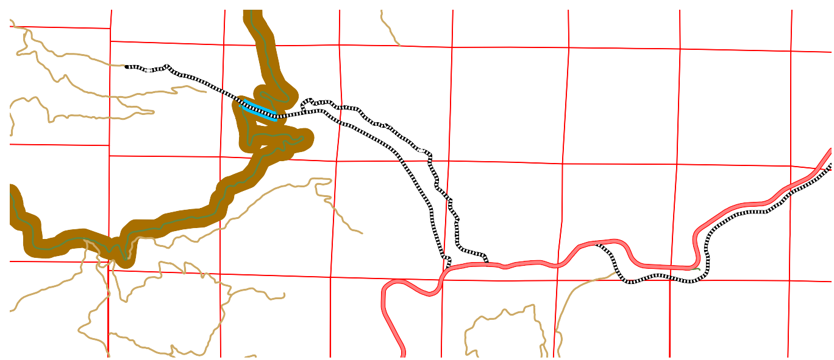COMMENCING AT THE INTERSECTION OF BAR ROAD #8F003 AND HORSE CREEK ROAD #8F001, BEING LOCATED IN SECTION 8, TOWNSHIP 46 NORTH, RANGE 10 WEST, M.D.M., SAID ROADS BEING COUNTY MAINTAINED HIGHWAYS; THENCE NORTHWESTERLY
46N11W 1
46N10W 6
46N10W 5
BEGIN
46N10W 4
46N10W 3
46N10W 2
46N10W 1
SEGMENT 17
46N11W12
46N09W 6
46N09W 7
46N10W 7

END SEGMENT 17
46N10W 8
46N10W 9
46N10W10
46N10W11
46N10W12
46N11W13
46N09W18
46N10W18
46N10W17
46N10W16
46N10W15
46N10W14
46N10W13
46N11W24
0 0.25 0.5
46N10W19
1 Miles
46N10W20
Bureau of Land Management, State of Oregon, State of Oregon
46N10W21
4D6ONT1,0SWta2te2 of Orego4n6GNE1O0W, E2s3ri Canada4,6ENs1ri0, WHE2R4E, G4a6rmN0in9,W19
INCREMENT P, USGS, METI/NASA, NGA, EPA, USDA
SEGMENT NUMBER 17
FIGURE 2-5
State of Jefferson Trade Route
H
0.25 MILES ALONG HORSE CREEK ROAD TO THE TRUE POINT OF BEGINNING, SAID POINT BEING THE INTERSECTION OF FOREST SERVICE ROAD #12; THENCE CONTINUING NORTHWESTERLY 0.33 MILES ALONG HORSE CREEK ROAD TO THE END OF "SEGMENT 17", SAID TERMINOUS POINT BEING LOCATED AT THE INTERSECTION OF FOREST SERVICE ROAD #46N60.
NET LENGTH = 0.33 MILES.

