**2023 Community Project Funding Requests**

**(original submission)**

**Recipient:** Siskiyou County Sheriff’s Office

**Address:** 305 Butte Street, Yreka CA 96097

**Website:** <https://www.co.siskiyou.ca.us/sheriff>

**Department Contact:** Courtney K. Greenley

**Contact Email:** [cgreenley@co.siskiyou.ca.us](mailto:cgreenley@co.siskiyou.ca.us)

**Contact Phone/Fax:** 530-842-8326 / 530-842-8356

The Siskiyou County Sheriff’s Office is requesting funding for law enforcement equipment; this project includes various items that either have a high cost to initiate, complete, or would not normally allow us the ability distribute to other agencies within the County. Please review the following requests, this project totals **$959,560.00** We appreciate the opportunity this funding offers.

_____________________________________________________________________________________

**Item #1:** Siskiyou County Sheriff & Jail Bullet Proof Vests Replacements

The Siskiyou County Sheriff’s Office is responsible for outfitting all peace-officer personnel in Bullet Proof Vests. Vests expire every 5 years and it has been the intent of the department to stay up to date on their expiration. Due to increased turnover, we have fallen behind in the ability to fund new purchases and have exhausted our spare vests. The State also recently allocated funding for an additional 5 Deputy positions to cover the needs of our new Courthouse which we plan to add to our position allocation list by September 2022.

Our request would fund vests for those we hire to fill anticipated and current vacancies allocated to the Sheriff’s Office, Jail, and outfit the new Courthouse positions. In total we are asking for 32 vests. The vest quoted has been tested by a few staff members to compare with the vests we used to use. Although they are a little more expensive, we have found they are much easier to maneuver in.

**Project Funding and Costs:**

* 1. Total Project Cost: $37,617.68
  2. Total Funding Requested: **$37,650.00**
* If request is granted, no additional funding be necessary to complete the project. Everyone has been measured recently. Ideally, we would place the order at the cost quoted before any cost increases could occur.
* We have an account with the Patrick Lely Bullet Proof Vest Grant but it only covers partial reimbursement. Due to the large amount we need, it is not possible to get them all up to date as soon as needed.
* This project has not received any other funding or requests for funding through State, Federal, local, corporate, non-profit, other Senators or Congressman.
* This project should be a priority because it is life-saving for the staff that protects the public and patrols our Jail. It is also a requirement that we keep them in unexpired vests for liability of injury.
* Taxpayers assume and expect our responding deputies to be fully equipped for this kind of threat. Being in unexpired equipment provides additional confidence to deputies and correctional officers. We should be able to provide them updated safety equipment as needed to effectively fulfill the requests of the public.
* At this time, our agency has received support from the Siskiyou County Board of Supervisors and the Mayors from the City of Dorris and the City of Montague. Both cities are within Siskiyou County. If needed, we could also post a Public Notice and request comments if requested of us.

**Supporting Documentation:** Quote from Vendor & Cost Spreadsheet

**Item #2:** Fire Resistant Uniforms

For the last few years, the Siskiyou County Sheriff’s Office has responded to multiple fires throughout the year. We take responsibility for executing safe evacuations from the public among other duties. We are often close to fire lines or burning infrastructure and our daily patrol uniforms are not adequate protection from embers. We would like to be able to have various sizes available to whoever on our staff is available to assist with emergencies such as these. We used MSRP prices for our request total.

**Project Funding and Costs:**

* 1. Total Project Cost: $28,686.82
  2. Total Funding Requested: **$28,700.00**
* No additional funding will be needed to complete this project if this funding is provided, there have not been other attempts to acquire funds. Due to how many people require outfitting, we wouldn’t be able to provide this prior to fire season.
* This project has not received any other funding or requests for funding through State, Federal, local, corporate, non-profit, other Senators or Congressman.
* This project should be a priority because of our inability to control environmental elements that have these kinds of impacts on our County but it is required of our staff to patrol activities and keep the public safe.
* We believe taxpayers would be supportive of safety equipment being provide to those putting themselves in harm’s way, be able to bring the public to safety, and they would also be easily identifiable. Law enforcement will be more appropriately outfitted in the event we need to get somewhere unsafe during an emergency such as a fire which we are seeing more of every year.
* At this time, our agency has received support from the Siskiyou County Board of Supervisors and the Mayors from the City of Dorris and the City of Montague. Both cities are within Siskiyou County. If needed, we could also post a Public Notice and request comments if requested of us.

**Supporting Documentation:** Quote from Vendor’s Website & Cost Spreadsheet

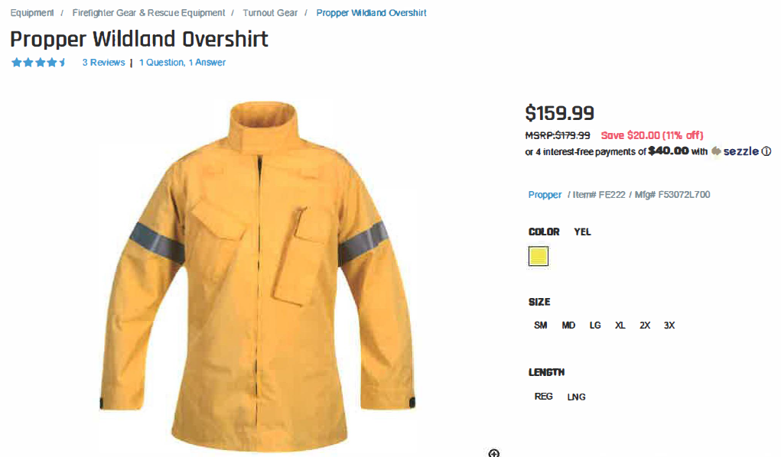

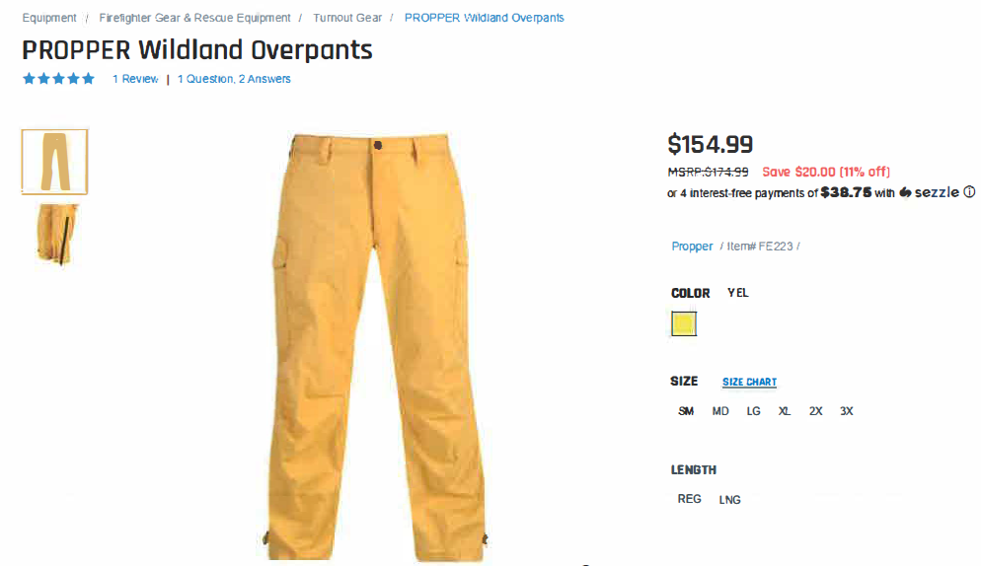

**Item #3**: Radios

Siskiyou County is moving to a vehicle lease model with Enterprise beginning in 2022. We have ordered 10 Ford Responders and plan to upfit them upon arrival. We are hopeful for an arrival of these vehicles by Spring 2023. Some equipment may be transferrable from existing vehicles, but we need newer radios and we do not currently have any spares. We would like to secure 15 units of the Motorola APX 8500. This covers the 10 leased trucks, the 2 we recently purchased and the 5 in this project. The most recent vendor quote received provided us a subtotal of $7,009.53 (pre tax) each. Our total funding requested includes the tax (7.75%). Upon the recycle of our leased vehicles it is our understanding that any equipment we own will be transferred into the replacement vehicle. Since October 2021 to April 2022 they have increased by almost $1,000.00

**Project Funding and Costs:**

* 1. Total Project Cost: $142,747.33
  2. Total Funding Requested: **$143,000.00**
* At this time, we have not explored other funding opportunities. We are looking into grants available but have not applied for any. Due to rising vendor costs this request includes a 5% buffer.
* We are concerned this project cannot be completed without additional funding. We anticipate the issue we face is paying the vendor up front vs being able to make payments. We cannot use the vehicles without radios.
* This project has not received any other funding or requests for funding through State, Federal, local, corporate, non-profit, other Senators or Congressman.
* This project is a priority because it guarantees law enforcement communication increases the safety of both our staff and the public.
* We believe taxpayers would be supportive of radio purchases if it meant they would have deputies patrolling. Our future aim is to offer more coverage. The community relies on dispatch to be able to communicate to deputies in the field who then rely on each other for backup to situations they may face. It is important that we take care of our own as well as any threats the public may face depending on the nature of the situation.
* At this time, our agency has received support from the Siskiyou County Board of Supervisors and the Mayors from the City of Dorris and the City of Montague. Both cities are within Siskiyou County. If needed, we could also post a Public Notice and request comments if requested of us.

**Supporting Documentation:** Vendor Quote from Day Wireless & Cost Spreadsheet

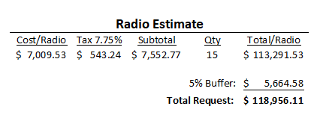

**Item #4:** Patrol Vehicles

The Siskiyou County Sheriff’s Office is responsible for reporting to various types of calls. These include incidents and public events where we need patrol rated vehicles as well as trucks capable of towing or hauling our trailers and equipment. Not only are we struggling to secure newer vehicles, but we currently do not have enough trucks vs the amount of trailers we would like to utilize in a major event.

The County Yard maintains our current weathered fleet but cannot turn them around fast enough for the number of repairs needed. We have coordinated with Enterprise for a vehicle lease starting as early as Spring 2023 for 10 F150 Responders. We went this route when securing purchases paid in full was not an option. As of recent, a Sourcewell vendor has announced Ford is opening up the ordering window and we hope to secure 3 more Responders. The majority of these will be assigned to outlying areas where mountainous terrain is more than a car or SUV can handle. This request includes the cost for 1 year of the 4-year lease with Enterprise. We have included the cost quoted to us for upfit and radios.

**Project Funding and Costs:**

* 1. Total Project Cost: $188,624.54
  2. Total Funding Requested: **$189,000.00**
* If request is granted, no will additional funding be necessary to complete the project. We added 10% on the vehicles total for tax and other fees incurred, excluding the leased trucks. No other funding sources have been received.
* This project has not received any other funding or requests for funding through State, Federal, local, corporate, non-profit, other Senators or Congressman.
* This project is a priority because without the appropriate vehicles we cannot execute our orders. Having versatile vehicles within the Sheriff’s Office inventory is beneficial to all special teams. We cannot always foresee when a vehicle will break down or need repairs during crucial times and with limited inventory of trucks we know this will be utilized year-round. We also live in a county with mountainous terrain and weather including snow where a truck would be beneficial.
* We believe taxpayers would be supportive of us being able to get off road vehicles and boats where they need to be to enforce laws and regulations without worrying about terrain or snow. We would be able to access all areas of the county for public safety.
* At this time, our agency has received support from the Siskiyou County Board of Supervisors and the Mayors from the City of Dorris and the City of Montague. Both cities are within Siskiyou County. If needed, we could also post a Public Notice and request comments if requested of us.

**Supporting Documentation:** Quote from Sourcewell Dealer, Cost Spreadsheet

**Item #5:** Restoration of the Special Response Team (SRT)

The Siskiyou County Sheriff’s Office is rebuilding our Special Response Team and the equipment required to support their activities. SRT is a group of tactically trained law enforcement officers who enter high-risk scenarios, conduct criminal investigations, and arrest criminals considered highly violent. The Siskiyou County Sheriff’s Office is responsible for providing law enforcement coverage in our unincorporated areas of Siskiyou County. This includes areas that do not have city police departments including but not limited to: Dorris, Hornbrook, Happy Camp, Big Springs, Hilt, Henley, Callahan, Scott Bar, Hawkinsville, and Sawyers Bar. The attached spreadsheet provided is a supply & equipment list of what we currently lack. If fully funded the department will cover the cost of training the staff who will be assigned to the team.

**Project Funding and Costs:**

* 1. Total Project Cost: $183,924.44
  2. Total Funding Requested: **$184,000.00**
* If request is granted, no additional funding be necessary to complete the project.
* Our most recent attempt for additional funds was through a recent grant award from the NRA to cover non-lethal training ammunition costs. Other than that, we do not have any additional funding outside our general funded budget to expend on this program. It would take years to accumulate the needed supplies to be up and running effectively.
* We have already started the overall project of acquiring needed equipment, but we have been looking for additional funding to expedite the start-up timeline. SRT is called out and needs the training and equipment to support their activities.
* The only outside source of funding has been through the NRA grant as mentioned above, those items being funded are not included in this request.
* This project has not received any other funding or requests for funding through State, Federal, local, corporate, non-profit, other Senators or Congressman.
* This project is a priority because having an equipped SRT Team supports local law enforcement agencies and increases the safety and overall outcome of the situations SRT would be responding to.
* We believe taxpayers would be at ease knowing our agency had the ability to go above and beyond the normal call of duty. SRT responds to situations beyond the scope of regular patrol; including but not limited to critical incidents, barricaded suspects, hostage situations, arrests of armed and dangerous subjects and offer support for riot control. The SRT will participate in regular trainings to stay current on all relative techniques and skills related to dynamic entry, searches, lesser lethal weapon deployment, active shooter response, and hostage rescue. In the event a situation occurs where SRT is needed, they have expanded knowledge and skills to preserve the life of others that may not be the result without their specialized knowledge and equipment.
* At this time, our agency has received support from the Siskiyou County Board of Supervisors and the Mayors from the City of Dorris and the City of Montague. Both cities are within Siskiyou County. If needed, we could also post a Public Notice and request comments if requested of us.

**Supporting Documentation:** Cost Spreadsheet

**Item #5:** Tactical Medical Life Saving Program

This project would outfit all law enforcement personnel in the County of Siskiyou with gunshot kits to be used in critical incidents and the training needed to implement the kits in an emergency. The county currently has older kits that have long since expired and the equipment in most kits most be replaced to be current. Our county currently employees approximately 144 law enforcement personnel between 9 agencies.

**Project Funding and Costs:**

* 1. Total Project Cost: $28,208.76
  2. Total Funding Requested: **$28,210.00**
* If request is granted, no additional funding be necessary to complete the project.
* We have not attempted to acquire additional funds for this request.
* This project overall cannot be completed without external funding. We would not be able to make normal purchases through the Sheriff’s Office’s budget since the agencies we included are not employees of the County. Our hope is to provide this to all that participate as peace officers in Siskiyou County.
* This project has not received any other funding or requests for funding through State, Federal, local, corporate, non-profit, other Senators or Congressman.
* This project is a priority because it is vital to all public safety members, to ensure first responders have the equipment needed in the event a gunshot wound. The equipment requested is perishable, expires and degrades overtime from being stored in a vehicle.
* These are items that all first responders should have and would most likely be included in general funded budgets, therefore they would still require or be eligible for taxpayer funding.
* At this time, our agency has received support from the Siskiyou County Board of Supervisors and the Mayors from the City of Dorris and the City of Montague. Both cities are within Siskiyou County. If needed, we could also post a Public Notice and request comments if requested of us.

**Supporting Documentation:** Product Snapshots & Cost Spreadsheet

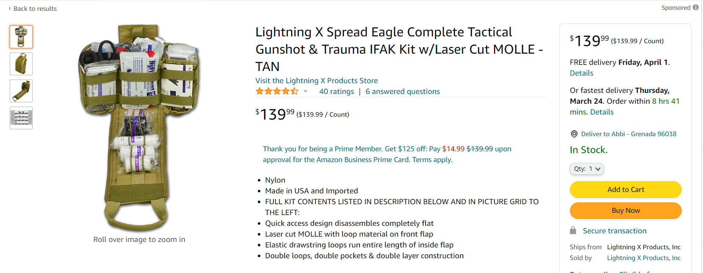

**Item #6:** Vehicle Upfitting

Siskiyou County is switching the majority of our vehicles to a lease program with Enterprise. The Sheriff’s Office is new to this method, but it ensures us the availability of the newest and most reliable versions of patrol vehicles. Our current orders placed with Enterprise is for 10 Ford Responders, 2 F150 Responders purchased separately are arriving by December 2022, and this project requests includes 3 additional also needing upfit. A total of 15 vehicles. We will be required to upfit them upon being received and most, to all, of our equipment is extremely outdated or not the correct fit for the new Ford model. Our equipment coordinator was able to attend shows and conferences within the last year to scope out different options and equipment offered to law enforcement. As of now, the department has selected Day Wireless as our planned vendor. They can customize each vehicle based on need, but the attached quote is a general upfit including tax, shipping and installation costs. Since the Sheriff’s Office will own and maintain the upfitted equipment and materials, we will also be recycling the same equipment into any replaced vehicles once each lease expires and a new vehicle takes its place.

**Project Funding and Costs:**

* 1. Total Project Cost: $372,847.70
  2. Total Funding Requested: **$373,000.00**
* If request is granted, we do not foresee needing additional funding to complete the project. Due to rising vendor costs, our request for total funding has a 5% buffer. Having them all generally upfitted is a huge step in getting them ready for patrol activities.
* No additional funds have been applied for yet. We are looking for different avenues of funding and payment options but this project being funded would take a lot of pressure off of the Sheriff’s general fund budget.
* This project has not received any other funding or requests for funding through State, Federal, local, corporate, non-profit, other Senators or Congressman.
* This is a priority because having law enforcement in reliable vehicles ensures effective policing.
* We want our deputies to successfully navigate through all types of weather and terrain to police and assist the public. Siskiyou County includes various unpaved roads and mountains that create the need for us to switch from cars and SUV’s to trucks. There have been instances in the past where we have been called to assist community members trapped by heavy snow up an unpaved road, and we cannot get to due to the available vehicles we currently have. The public, taxpayers, needs to be confident that we can respond to any call any time of year.
* At this time, our agency has received support from the Siskiyou County Board of Supervisors and the Mayors from the City of Dorris and the City of Montague. Both cities are within Siskiyou County. If needed, we could also post a Public Notice and request comments if requested of us.

**Supporting Documentation:** Quote for Upfit from Day Wireless & Cost Spreadsheet

