INTERGOVERNMENTAL AGREEMENT REGARDING  
 TRANSFER OF PUBLIC FUNDS

This Agreement is entered into between the CALIFORNIA DEPARTMENT OF HEALTH CARE SERVICES (“DHCS”) and the SISKIYOU COUNTY HEALTH AND HUMAN SERVICES AGENCY (“GOVERNMENTAL FUNDING ENTITY”) with respect to the matters set forth below.

The parties agree as follows:

AGREEMENT

1. Transfer of Public Funds

1.1 The GOVERNMENTAL FUNDING ENTITY agrees to make a transfer of funds to DHCS pursuant to sections 14164 and 14301.4 of the Welfare and Institutions Code. The amount transferred shall be based on the sum of the applicable rate category per member per month (“PMPM”) contribution increments multiplied by member months, as reflected in Exhibit 1. The GOVERNMENTAL FUNDING ENTITY agrees to initially transfer amounts that are calculated using the Estimated Member Months in Exhibit 1, which will be reconciled to actual enrollment for the service period of January 1, 2021 through December 31, 2021 in accordance with Sub-Section 1.3 of this Agreement. The funds transferred shall be used as described in Sub-Section 2.2 of this Agreement. The funds shall be transferred in accordance with the terms and conditions, including schedule and amount, established by DHCS.

1.2 The GOVERNMENTAL FUNDING ENTITY shall certify that the funds transferred qualify for Federal Financial Participation pursuant to 42 C.F.R. part 433, subpart B, and are not derived from impermissible sources such as recycled Medicaid payments, Federal money excluded from use as State match, impermissible taxes, and non-bona fide provider-related donations. Impermissible sources do not include patient care or other revenue received from programs such as Medicare or Medicaid to the extent that the program revenue is not obligated to the State as the source of funding.

1.3 DHCS shall reconcile the “Estimated Member Months,” in Exhibit 1, to actual enrollment in HEALTH PLAN(S) for the service period of January 1, 2021 through December 31, 2021 using actual enrollment figures taken from DHCS records. Enrollment reconciliation will occur on an ongoing basis as updated enrollment figures become available. Actual enrollment figures will be considered final two years after December 31, 2021. If reconciliation results in an increase to the total amount necessary to fund the nonfederal share of the payments described in Sub-Section 2.2, the GOVERNMENTAL FUNDING ENTITY agrees to transfer any additional funds necessary to cover the difference. If reconciliation results in a decrease to the total amount necessary to fund the nonfederal share of the payments described in Sub-Section 2.2, DHCS agrees to return the unexpended funds to the GOVERNMENTAL FUNDING ENTITY. If DHCS and the GOVERNMENTAL FUNDING ENTITY mutually agree, amounts due to or owed by the GOVERNMENTAL FUNDING ENTITY may be offset against future transfers.

2. Acceptance and Use of Transferred Funds

2.1 DHCS shall exercise its authority under section 14164 of the Welfare and Institutions Code to accept funds transferred by the GOVERNMENTAL FUNDING ENTITY pursuant to this Agreement as IGTs, to use for the purpose set forth in Sub-Section 2.2.

2.2 The funds transferred by the GOVERNMENTAL FUNDING ENTITY pursuant to Section 1 and Exhibit 1 of this Agreement shall be used to fund the non-federal share of Medi-Cal Managed Care actuarially sound capitation rates described in section 14301.4(b)(4) of the Welfare and Institutions Code as reflected in the contribution PMPM and rate categories reflected in Exhibit 1. The funds transferred shall be paid, together with the related Federal Financial Participation, by DHCS to HEALTH PLAN(S) as part of HEALTH PLAN(S)’ capitation rates for the service period of January 1, 2021 through December 31, 2021, in accordance with section 14301.4 of the Welfare and Institutions Code.

2.3 DHCS shall seek Federal Financial Participation for the capitation rates specified in Sub-Section 2.2 to the full extent permitted by federal law.

2.4 The parties acknowledge that DHCS will obtain any necessary approvals from the Centers for Medicare and Medicaid Services.

2.5 DHCS shall not direct HEALTH PLAN(S)’ expenditure of the payments received pursuant to Sub-Section 2.2.

3. Assessment Fee

3.1 DHCS shall exercise its authority under section 14301.4 of the Welfare and Institutions Code to assess a 20 percent fee related to the amounts transferred pursuant to Section 1 of this Agreement, except as provided in Sub-Section 3.2. GOVERNMENTAL FUNDING ENTITY agrees to pay the full amount of that assessment in addition to the funds transferred pursuant to Section 1 of this Agreement.

3.2 The 20-percent assessment fee shall not be applied to any portion of funds transferred pursuant to Section 1 that are exempt in accordance with sections 14301.4(d) or 14301.5(b)(4) of the Welfare and Institutions Code. DHCS shall have sole discretion to determine the amount of the funds transferred pursuant to Section 1 that will not be subject to a 20 percent fee. DHCS has determined that $0.00 of the transfer amounts will not be assessed a 20 percent fee, subject to Sub-Section 3.3.

3.3 The 20-percent assessment fee pursuant to this Agreement is non-refundable and shall be wired to DHCS simultaneously with the transfer amounts made under Section 1 of this Agreement. If at the time of the reconciliation performed pursuant to Sub-Section 1.3 of this Agreement, there is a change in the amount transferred that is subject to the 20-percent assessment in accordance with Sub-Section 3.1, then a proportional adjustment to the assessment fee will be made.

4. Amendments

4.1 No amendment or modification to this Agreement shall be binding on either party unless made in writing and executed by both parties.

4.2 The parties shall negotiate in good faith to amend this Agreement as necessary and appropriate to implement the requirements set forth in Section 2 of this Agreement.

5. Notices. Any and all notices required, permitted, or desired to be given hereunder by one party to the other shall either be sent via secure email or submitted in writing to the other party personally or by United States First Class, Certified or Registered mail with postage prepaid, addressed to the other party at the address as set forth below:

* Any required signature(s) on any documents must be in compliance with California Government Code section 16.5 and any other applicable state or federal regulations.

To the GOVERNMENTAL FUNDING ENTITY:

Sarah Collard, Ph.D., HHSA Director

Siskiyou County Health & Human Services Agency

818 S. Main Street

Yreka, CA 96097

[scollard@co.siskiyou.ca.us](mailto:scollard@co.siskiyou.ca.us)

With copies to:

Dawn Walton, Program Manager

Siskiyou County Health & Human Services Agency

810 S. Main Street

Yreka, CA 96097

[dwalton@co.siskiyou.ca.us](mailto:dwalton@co.siskiyou.ca.us)

Rose Bullock, Deputy Director Administrative Services

Siskiyou County Health & Human Services Agency

818 S. Main Street

Yreka, CA 96097

[rbullock@co.siskiyou.ca.us](mailto:rbullock@co.siskiyou.ca.us)

Shelly Davis, Director Public Health Division

Siskiyou County Health & Human Services Agency

810 S. Main Street

Yreka, CA 96097

[sdavis@co.siskiyou.ca.us](mailto:sdavis@co.siskiyou.ca.us)

To DHCS:

Vivian Beeck

California Department of Health Care Services

Capitated Rates Development Division  
1501 Capitol Ave., MS 4413

Sacramento, CA 95814

[Vivian.Beeck@dhcs.ca.gov](mailto:Sandra.Dixon@dhcs.ca.gov)

6. Other Provisions

6.1 This Agreement contains the entire Agreement between the parties with respect to the Medi-Cal payments described in Sub-Section 2.2 of this Agreement that are funded by the GOVERNMENTAL FUNDING ENTITY, and supersedes any previous or contemporaneous oral or written proposals, statements, discussions, negotiations or other agreements between the GOVERNMENTAL FUNDING ENTITY and DHCS relating to the subject matter of this Agreement. This Agreement is not, however, intended to be the sole agreement between the parties on matters relating to the funding and administration of the Medi-Cal program. This Agreement shall not modify the terms of any other agreement, existing or entered into in the future, between the parties.

6.2 The non-enforcement or other waiver of any provision of this Agreement shall not be construed as a continuing waiver or as a waiver of any other provision of this Agreement.

6.3 Sections 2 and 3 of this Agreement shall survive the expiration or termination of this Agreement.

6.4 Nothing in this Agreement is intended to confer any rights or remedies on any third party, including, without limitation, any provider(s) or groups of providers, or any right to medical services for any individual(s) or groups of individuals. Accordingly, there shall be no third party beneficiary of this Agreement.

6.5 Time is of the essence in this Agreement.

6.6 Each party hereby represents that the person(s) executing this Agreement on its behalf is duly authorized to do so.

7. State Authority. Except as expressly provided herein, nothing in this Agreement shall be construed to limit, restrict, or modify the DHCS’ powers, authorities, and duties under Federal and State law and regulations.

8. Approval. This Agreement is of no force and effect until signed by the parties.

9. Term. This Agreement shall be effective as of January 1, 2021 and shall expire as of June 30, 2024 unless terminated earlier by mutual agreement of the parties.

SIGNATURES

IN WITNESS WHEREOF, the parties hereto have executed this Agreement, on the date of the last signature below.

THE SISKIYOU COUNTY HEALTH AND HUMAN SERVICES AGENCY:

By: Date: _______________________

Ed Valenzuela, Chair, Board of Supervisors

County of Siskiyou, State of California

ATTEST:

LAURA BYNUM

Clerk, Board of Supervisors

By: ___________________________________________

Wendy Winningham, Deputy County Clerk

ACCOUNTING: Fund: 2121 Organization: 401015 Account: 752500

THE STATE OF CALIFORNIA, DEPARTMENT OF HEALTH CARE SERVICES:

By: Date: _______________________

Rafael Davtian, Deputy Director, Health Care Financing

Exhibit 1

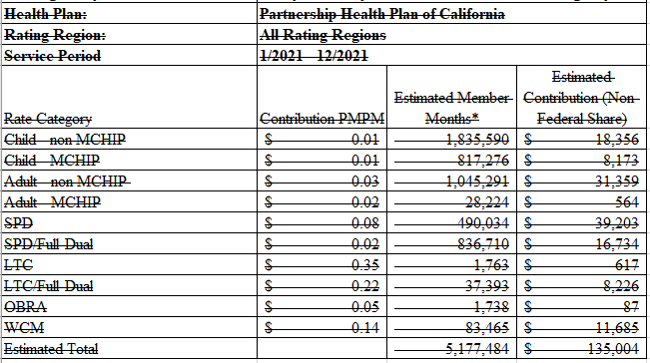

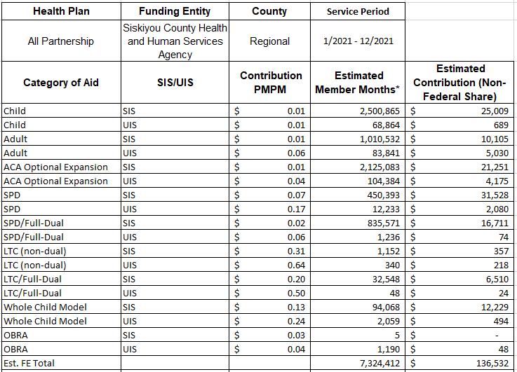

* Note that Estimated Member Months are subject to variation, and the actual total Contribution (Non-Federal Share) may differ from the amount listed here.

* FMAP is a weighted blend of multiple FMAPs.