Responses to Claims in Petition for Rulemaking to Set Minimum Flows on the Scott River
Submitted by: GSA Technical Team
- Flows at the Fort Jones USGS stream gage:
Petition at page 3, lines 2-3 and 16-18
Response: The statement is incorrect. In the three wettest years of the last 20 years, the water year’s lowest flows at the Ft. Jones USGS stream gage varied from 35 cfs (9/1/2017), 37 cfs (9/1/2006), to 54 cfs (9/1/2011). In contrast, the lowest flows in dry years of a half century and more ago, at a time of limited groundwater pumping, were measurably lower:
- from August 9 to September 24, 1973: 22 cfs to 25 cfs,
- in September 1970: 29 cfs,
- in late July, late August, and late October 1968: 28-29 cfs,
- between August 25 and September 12, 1967: 24-26 cfs,
- from September 8 to 17, 1959: 27-28 cfs,
- and in late July and from August 26 to September 17, 1955: 22-28 cfs.

- Recharge from flood irrigation:
Petition at page 3, line 16
Response: On about half of the irrigated acreage in Scott Valley, growers in the 1970s also stopped to employ “inefficient” flood irrigation between April and July/August, which provided significant artificial recharge to the groundwater basin and delayed, artificial return flows to the stream during May through September (a smaller-scale managed aquifer recharge example and its effects on streamflow are documented in Tolley et al., 20xx and the “MAR-ILR” scenario results in the Scott Valley GSP, Appendix 4A “Scott Valley Management Scenario Analysis”).

- Factors Contributing to Streamflow Reduction:
Petition at page 3, line 18
Response: Climate contributes significantly – but not exclusively - to the current flow situation. In July-August, agricultural pumping and diversion have the largest impact on streamflow reduction, whereas September flow reductions are dominated by climate change drivers, see page 14, line 9 and analysis by Drake et al (2000), VanKirk et al. (2008)

- Reference:
Petition at Page 4, line 1
Response: No scientific references provided to support this argument.

- Flow in Scott River:
Petition at page 4, Line 11
Response: When looking at flows in Scott River, there is the need to look at supply and demand: the precipitation plot in the 2022 annual report shows how the precipitation changed since 1970s. The GSP showed that even removing all agriculture, with the current precipitation it is not possible to reach the prescribed minimum flows (as included in the modelled scenarios without agriculture included in the Appendix 4 of the GSP).

- Livestock water use:
Petition at page 4, Line 20
Response: CDFW is providing funding for a study that will look into “inefficient” livestock water use and will consider options depending on time of the year and locations. In some locations, leaky ditch infiltration might be critical to support baseflow later in the fall and this study is collecting all the data necessary to demonstrate this benefit.

- References:
Petition at page 4, Lines 21-22
Response: No scientific references provided to support this argument.

- Streamflow measurements at the USGS Fort Jones Gage:
Petition at page 4, Line 26
Response: Daily streamflow measurements for the USGS Fort Jones gage on the Scott River are available since 1942. Prior to the 1970s, little groundwater pumping occurred in Scott Valley while flood irrigation throughout the valley led to significantly higher summer and fall groundwater return flows into the Scott River than after the 1970s. In their Minimum Interim Stream Flow Requirements, CDFW (2017) selected water years 1942 – 1971 as an “unimpaired” flow period. However, June through December daily mean flows did not meet the CDFW Minimum Interim Stream Flow Requirements of >165 cfs (June, July), >134 cfs (July, second half), >77 cfs (August), > 62 cfs (September), > 134 cfs (October), > 266 cf (November), or >337 cfs (December) in each year for some period in the summer and/or fall. The below list identifies periods of at least five days during the 30-year “unimpaired” period 1942-1971 that did not meet these criteria (for monthly average flow exceedances see Petition Table 1, Figure 1, and Figure 2):

- 10/1 – 11/30 of 1941
- 7/27 – 7/31, 8/25 – 8/31, 9/29 – 11/14 of 1942
- 9/18 – 12/31 of 1943 except on 6 days
- 7/2 – 7/31, 8/12 – 12/21 of 1944 except on 6 days
- 7/7 – 7/31, 8/9 – 11/24 of 1945 except on 6 days
- 7/18 – 7.22, 8/26 – 8/31, 9/20 – 11/18 of 1946
- 6/24 – 10/15, 10/26 – 12/31 of 1947
- 7/20 – 7/31, 10/1 – 12/7 of 1948
- 6/30 – 12/31 of 1949 except on 1 day
- 7/11 – 10/27 of 1950 except on 6 days
- 8/8 – 11/27 of 1951 except on 10 days
- 10/1 – 12/28 of 1952 except on 8 days
- 10/1 – 11/13 of 1953 except on 6 days
- 7/20 – 7/31, 10/1 – 12/31 of 1954 except on 11 days
- 6/28 – 11/18 of 1955
- 10/1 – 10/25, 11/20 – 12/11 of 1956
- 7/7 – 7/31, 8/15 – 10/8 of 1957 except on 7 days
- 10/1 – 12/31 of 1958 except on 3 days
- 6/28 – 12/31 of 1959
- 7/3 – 11/24 of 1960
- 7/9 – 9/15, 10/1 – 12/19 of 1961 except on 1 day
- 7/8 – 10/8 of 1962 except on 4 days
- 7/11 – 9/21, 10/1 – 11/ of 1963 except on 5 days
- 7/7 – 11/28 of 1964 except on 3 days
- 7/10 – 7/31, 8/10 – 8/17, 10/1 – 11/13, 12/1 – 12/31 of 1965 except on 2 days
- 6/29 – 11/14 of 1966 except on 1 day
- 8/23 – 9/23, 10/1 – 12/31 of 1967
- 6/24 – 11/17, 11/26 – 12/9 of 1968
- 7/20 – 9/18, 10/1 – 12/11 of 1969
- 7/8 – 11/7 of 1970 except on 6 days
- 8/19 – 8/30, 10/1 – 11/26 of 1971 except on 1 day
The list below lists periods between water years 1942 and 1971 when flow did not exceed 62 cfs (regardless of month):
- 9/29 – 10/9 of 1942
- 9/18 – 10/20 of 1943
- 8/21 – 11/3 of 1944
- 8/22 – 10/30 of 1945
- 9/20 – 10/20 of 1946, except on 5 days
- 8/7 – 10/15 of 1947
- 8/15 – 11/9 of 1949
- 8/25 – 10/5 of 1950
- 9/6 – 10/22 of 1951
- 8/4 – 11/12 of 1955
- 8/20 – 9/26 of 1957
- 7/26 – 12/22 of 1959
- 8/15 – 10/9 of 1960, except on 2 days and 10/27 – 11/2
- 8/13 – 9/15 of 1961
- 8/25 – 9/27 of 1962, except on 2 days
- 8/20 – 9/21 of 1963
- 8/11 – 11/7 of 1964, except on 4 days
- 9/14 – 9/18 of 1965
- 8/3 – 10/4 of 1966, except on 1 day
- 8/23 – 9/23 of 1967, except on 4 days
- 7/17 – 11/1 of 1968, except on 4 days
- 8/19 – 9/17 of 1969, except on 1 day
- 8/4 – 10/22 of 1970, except on 4 days
- 8/20 – 8/26 of 1971

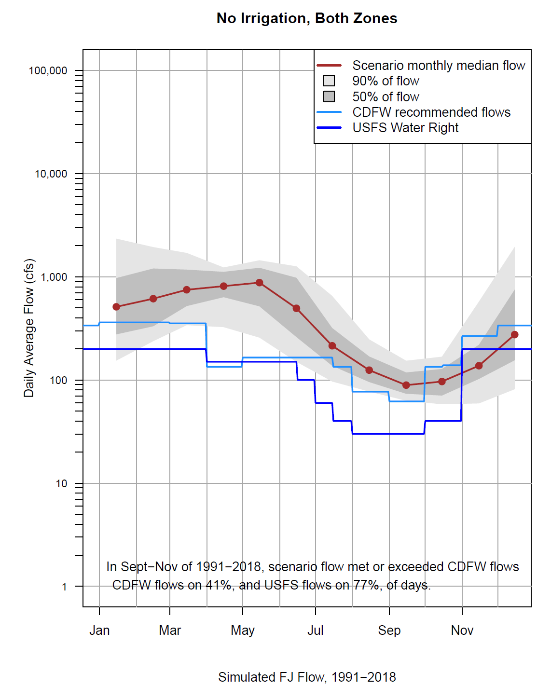
Figure 1: SVIHM 1991-2018 scenario flows, assuming that no irrigation occurs in Scott Valley (no surface water diversion, no groundwater pumping), either inside or outside the adjudicated zone, and that vegetation may deplete root zone soil moisture, but is not able to tap into groundwater and that no groundwater wicking into the root zone occurs. i.e., there is no groundwater-dependent ecosystem at any time.
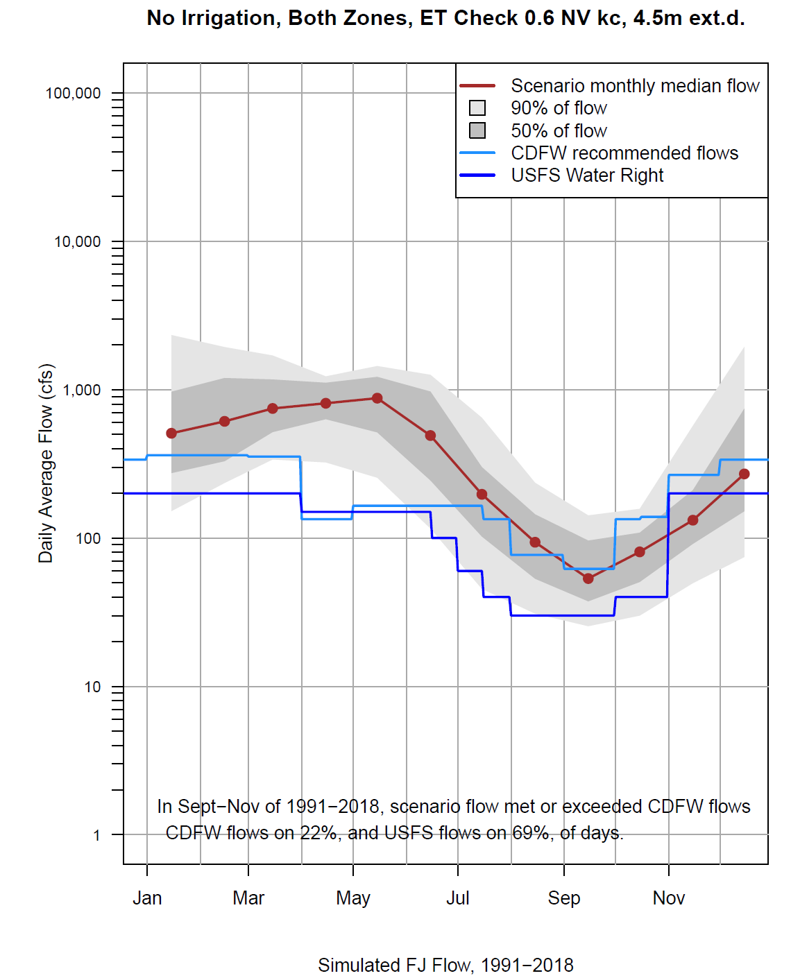
Figure 2: SVIHM 1991-2018 scenario flows, assuming that no irrigation occurs in Scott Valley (no surface water diversion, no groundwater pumping), and that natural vegetation (bunch grasses, clover, scattered trees, riparian vegetation), is able to tap into groundwater to meet it’s ET demand. For the scenario shown, potential ET of natural vegetation is assumed to be at most 60% of reference ET. Actual ET is limited by soil moisture availability and by access to groundwater. Actual ET from groundwater is water table dependent and linearly decreases from 100% of potential ET when the water table is near the land surface to zero, when the water table falls below 4.5 m (15 ft) below the land surface.
- Minimum Flows:
Petition at page 5, Line 3-4
Response: There is a need for a serious biological study: the current minimum flows are not calibrated for Scott valley and there is need to have measures of flow and temperature in different stretches of the river, not just at Fort Jones.

- Streamflow measurements at the USGS Fort Jones Gage:
Petition at page 8, Line 16
Response: What is the reasonable and useful minimum streamflow? There is need a science-based assessment with consideration for recent precipitation trends, as displayed in the Annual Report for WY 2022.

- Minimum instream flows:
Petition at page 11, Line 5
Response: The minimum streamflow is still “interim”, they have never been finalized. The table needs to be combined with the precipitation pattern: 1977 was the first very dry year and introduced a generally drier pattern.

- Causes of decline of flows in Scott River:
Petition at page 14, Line 7
Response: We should acknowledge a combination of different causes.

- Connection between surface water and groundwater:
Petition at page 14, Line 18-19
Response: Not sure what is meant with this statement regarding the model: there is always a connection between surface water and groundwater.

- Flow value:
Petition at page 20, Lines 4-6
Response: Statement is very vague, 16 cfs where and when?

- Soil water budget:
Petition at page 20, Lines 9-10
Response: The increase in agricultural groundwater pumping reported since 2019, relative to earlier years, does not reflect a change in groundwater pumping, rather it reflects updated outputs from the soil water budget module of the Scott Valley Integrated Hydrologic Model (Foglia et al., 2018; Tolley et al., 2019).

- GSP reference:
Petition at page 20, Line 26, reference 74
Response: The Scott Valley GSP (page 209) continues to state “However, current Basin conditions indicate a need to improve conditions for fish. The GSP furthers that goal. Reversal of stream depletion is one action that can help achieve that goal.”

- Groundwater use estimates in Annual Reports:
Petition at page 20, Line 26
Response: The GSP technical team is discussing options with DWR to distinguish in annual reports between changes in water use that merely reflect model improvements from water use report changes that reflect actual changes in water use, across the entire basin, including the adjudicated zone. The team envisions that updated models / model assumptions may generate revised time series of annual water use (groundwater or surface water or both) going back to the beginning of the reporting time series (typically: 2015). Both, original and updated values may be reported.

- Scott Valley Groundwater Model:
Petition at page 23, Line 3
Response: This discussion is referencing the old SS Papadopoulos model: it would be better to use the updated version developed for SGMA.
- Monitoring results:
Petition at page 25, Line 10
Response: Even with the emergency regulations in place, the monitoring by the State Water Board was not very coordinated and results may not be available out of the data collected last summer.

- Interconnected Surface Waters Undesirable Results:
Petition at page 25, Line 13
Response: The GSP states that undesirable results are already occurring for the interconnected surface waters sustainability indicator. For this reason, we set a metric (reverse depletion) that is expected to improve year by year through implementation of different projects. The plan was approved by DWR in April 2023 and the implementation is starting now.

- Management Scenario Results- Irrigation:
Petition at page 25, Lines 21-22
Response: In Appendix 4 of the GSP, we show results of scenarios where agriculture is completely removed and monthly median flows were still below the CDFW recommended interim instream flows during late fall and early winter (see Figure 1 above).

- Conditions prior to 2015:
Petition at page 26, Lines 1-3 and Lines 8-12
Response: It is incorrect to state that the Scott Valley GSP is based on a “refusal to address conditions prior to 2015.” And it is incorrect that “The Scott Valley GSP also relies on SGMA to consider all stream depletions that occurred before January 1, 2015 as not being ‘undesirable results.’”. It is incorrect that “The GSP concludes that it need only address depletions that are more severe than those occurring on that date – despite this date falling several years into one of the worst droughts California has ever seen” Quite to the contrary, the GSP’s sustainable management criteria [SMC[ for interconnected surface water [ISW] reflect an unprecedented, unparalleled, and significant effort at reversing stream depletion that already existed prior to 2015. Among all of the state’s GSPs, the Scott Valley GSP is the only plan that goes beyond simply maintaining conditions during the baseline period (in most GSPs a period from the 1990s to 2015), and that explicitly set minimum thresholds that will reverse streamflow depletion that already existed during the 1991-2018 baseline period and therefore will measurably improve streamflow condition. No other California GSP has set its ISW SMC more stringent than baseline period conditions. This unique effort of the Scott Valley GSP reflects the fact that “The GSA designed this ISW SMC to be consistent with the requirements of SGMA and [emphasis added by the author] the programmatic structure of the NCRWQCB Basin Plan (including the TMDL Action Plan), ESA [Endangered Species Act], and PTD [Public Trust Doctrine].” (Scott Valley GSP, page 209). The GSP specifically states: “In the context of assessing MT’s for the ISW SMC, the GSA has determined that it is reasonable to hold groundwater producers outside the adjudicated zone (regulated by the GSP) to a modest percentage of stream depletion reversal.” (Scott Valley GSP, page 210).

- Jurisdictional Areas of the GSA:
Petition at page 26, Line 4
Response: The GSA can work in adjudicated areas but has no jurisdiction over this area. This is clearly stated in Chapter 2 of the GSA, under Section 2.1.1.1 Jurisdictional Areas, “There are two areas within the Basin that are not required to form GSAs or develop GSPs under SGMA: the interconnected zone covered by a groundwater adjudication… outside of the jurisdiction of the GSA…” .

- Stream depletion undesirable results:
Petition at page 26, Lines 8-9
Response: This is incorrect.

- Depletion reversal:
Petition at page 26, Lines 14-15
Response: Depletion reversal cannot happen suddenly, and projects need to run for some time to show benefits.

- Minimum streamflow:
Petition at page 26, Line 20
Response: Defining minimum streamflow is not expected in the SGMA regulations.

- Irrigation ditches and groundwater recharge:
Petition at page 27, Line 15
Response: Leaky ditches can be beneficial in restoring groundwater levels over the wintertime when flows are in excess. CDFW just funded a project to study the potential benefits of the ditches on the west side. In Shasta Valley, large declines of spring groundwater levels prior to irrigation were noted due to dry ditches. See the Shasta Annual Report and Gazelle area data.

- Emergency regulation impact data:
Petition at page 28, Lines 15-21
Response: This needs to be demonstrated: does the State Water Board has a report from last year?

- Salmonids:
Petition at page 32, Lines 8-10
Response: But there was the option to look into solution and this is why they have now the frost protection ponds.

- Acreage:
Petition at page 36, Line 17
Response: The GSP does not have any increase in acreage.

- Instream flows:
Petition at page 35, Lines 18-21
Response: “Routinely” above 62 cfs and “rarely” below 62 cfs is an interpretive misrepresentation: According to table 1 (page 11 of the Petition) and figures 1 and 2 (page 15 of the Petition), monthly mean flows exceeded Minimum Interim Stream Flow Recommendations in approximately one third of the thirty years 1942 – 1971 (11 of 30 years for August and in 12 of 30 years for September 1942-1971). In 2021 and 2022, the State Water Board issued curtailments based on daily average flows, not based on monthly average flows. Per list in comment (VIII.) above, daily average flows at the Fort Jones USGS flow gage dropped below the Minimum Interim Stream Flow Recommendation for extended periods of time in each of the 30 years of “unimpaired” flow 1942-1971 and dropped to 62 cfs or lower in all but 6 years, that is, in 80% of the 30 years between 1942 and 1971.

- Water extractions:
Petition at page 37, Line 7
Response: Our modeling does not indicate that water extractions have increased year over year, let alone over a period of decades (Foglia et al, 2018, Tolley et al., 2018). Between 1991 and 2018, water extractions have varied, with higher extractions in drier years and lower extractions in wetter years.

- Water extractions:
Petition at page 43, Lines 8-9
Response: Scenario results using 1991 – 2018 climate conditions, presented in the Scott Valley GSP (Appendix 4A, copied below) demonstrate that flows during the critical fall flow regime will not meet the CDFW Minimum Interim Stream Flow Recommendation in over 75% of water years, even under the extreme scenario with no irrigation (i.e., no surface water diversions and no groundwater pumping) and a desert like, zero-ET landscape. After accounting for consumptive water use by naturally occurring groundwater-dependent ecosystems that would be in place instead of irrigated agriculture (unimpaired flow simulation scenario), no only do 75% of fall flows not meet the CDFW Minimum Interim Stream Flow Recommendation, in about half of water years, summer flows would not meet the Minimum Interim Stream Flow Recommendation (see second graph below). The UC Davis Scott Valley Integrated Hydrologic Simulation Model team is currently updating the model for further analysis of future scenario outcomes.

https://waterdata.usgs.gov/nwis/inventory/?site_no=11519500
Scott GSP Appendix 4: https://www.co.siskiyou.ca.us/sites/default/files/fileattachments/natural_resources/page/28347/appendix_4-a._management_scenario_results.pdf
Drake et al. 2000. “Analysis shows climate-caused decreases in Scott River fall flows.” California Agriculture 54(6):46-49. https://doi.org/10.3733/ca.v054n06p46
Van Kirk, Robert W., and Seth W. Naman. 2008. “Relative effects of climate and water use on base-flow trends in the lower Klamath Basin.” Journal of American Water Resources Association 44(4): 1035-52. https://onlinelibrary.wiley.com/doi/10.1111/j.1752-1688.2008.00212.x
Available: https://sgma.water.ca.gov/portal/gspar/preview/178
Scott GSP Appendix 4: https://www.co.siskiyou.ca.us/sites/default/files/fileattachments/natural_resources/page/28347/appendix_4-a._management_scenario_results.pdf
Available: https://sgma.water.ca.gov/portal/gspar/preview/178
Foglia, L., J. Neuman, D.G. Tolley, S.B. Orloff, R.L. Snyder, and T. Harter, 2018. Modeling guides groundwater management in a basin with river-aquifer interactions. California Agriculture 72:1, 84-95. Tolley, D., L. Foglia, T. Harter, 2019. Sensitivity analysis and calibration of an integrated hydrologic model in an irrigated agricultural basin with a groundwater-dependent ecosystem. Water Resources Research, 55, 7876– 7901. https://doi.org/10.1029/2018WR024209.
https://www.co.siskiyou.ca.us/sites/default/files/fileattachments/natural_resources/page/28347/appendix_4-a._management_scenario_results.pdf
Available: https://sgma.water.ca.gov/portal/gspar/preview/177
Foglia, Laura, Jakob Neumann, Douglas G. Tolley, Steve Orloff, Richard L. Snyder, and Thomas Harter. 2018. “Modelling guides groundwater management in a basin with river-aquifer interactions.” California Agriculture 72 (1): 84-95.
Tolley, Douglas G., Laura Foglia, and Thomas Harter. 2019. “Sensitivity Analysis and Calibration of an Integrated Hydrologic Model in an Irrigation Agricultural Basin with a Groundwater-Dependent Ecosystem.” Water Resources Research 55(8). https://doi.org/10.1029/2018WR024209.

