**Resolution No. ________**

**A Resolution of the Board of Supervisors of the County of Siskiyou,**

**State of California, Naming an Unnamed Private Road as “Lilly Loop”**

**Whereas**, Section 10-9.02, of the Siskiyou County Code, states that “road” shall mean any road, highway, street, avenue, boulevard, easement, or right-of-way, either public or private, used for vehicular traffic; and

**Whereas**, Section 10-9.04(c) of the Siskiyou County Code, states that a petition to change road names may be submitted by a resident property owner, accompanied by a fee set by the Board; and

**Whereas**, the County of Siskiyou has been petitioned by a resident property owner to name an unnamed private road as “Lilly Loop” (Application RN-22-03) and any fee has been paid; and

**Whereas**, the Planning Division presented its written staff report on Road Name RN-22-03 at a regular meeting of the Board of Supervisors on April 4, 2023, and

**Whereas**, on April 4, 2023 the Board of Supervisors adopted Resolution No. 23-71 pursuant to section 10-9.04(d) of the Siskiyou County Code, declaring their intent to name an unnamed private road as “Lilly Loop” pursuant to Road Name application RN-22-03, which road is located in Township 41 North, Range 9 West, Section 29, south of the city of Etna, extending off Homestead Lane in a loop approximately +/- 813 feet, (as depicted on Exhibit A attached hereto), and setting the matter for public hearing on May 2; 2023 and

**Whereas,** public notice of the hearing has been provided by law; and

**Whereas**, on May 2, 2023, the Chair of the Board of Supervisors opened the duly noticed public hearing on Road Name RN-22-03 to receive testimony, both oral and written from any interested person,following which the Chair closed the public hearing; and

**Whereas**, the Planning Division recommends Road Name (RN-22-03) not to be considered a project pursuant to CEQA as defined in California Environmental Quality Act (CEQA) Guidelines Section 15378, and is therefore not subject to CEQA pursuant to Section 15060(c)(3); and

**Now, therefore,** the Board of Supervisors hereby resolves as follows:

1. The naming of an unnamed road is not considered a project as defined in CEQA Guidelines Section 15378 and is therefore not subject to CEQA pursuant to Section 15060(c)(3).

2. The Board of Supervisors determines that the proposed name of “Lilly Loop” is appropriate

3. The Board of Supervisors hereby designates that the official name of the above-described unnamed private road shall immediately and henceforth be “Lilly Loop”.

Passed and adopted this 2nd day of May 2023 at a regular meeting of the Board of Supervisors by the following vote:

Ayes:

Noes:

Absent:

Abstain:

________________________________

Ed Valenzuela, Chair

Siskiyou County Board of Supervisors

Attest:

Laura Bynum, Clerk,

Board of Supervisors

By _______________________

Deputy

Attachments:

Exhibit A : Map Titled Proposed Road Name, Lilly Loop.

Exhibit A

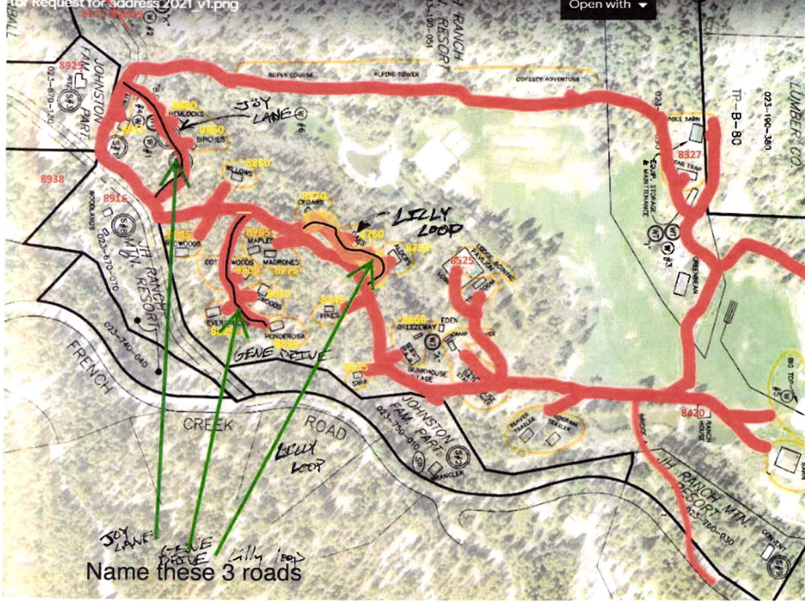

Homestead Lane

**Joy Place**

**JH Ranch**

**APN 023-190-510**

**Proposed Road Name Changes**

**Gene Court**

**Lilly Loop**