Staff Report
Meeting Date: April 4, 2023
To: Siskiyou County Board of Supervisors
From: Bernadette Cizin, Assistant Planner
Subject: Proposed Costello Williamson Act Rescission and Re-entry (APA-22-06) and CEQA Determination

Background and Discussion
On June 28, 2022, the County received an application for a Williamson Act Contract amendment to bring approximately 190.39 acres owned by Aiden Costello, under one Williamson Act contract consisting solely of property under their ownership with the Agricultural Use of timber production. The property is currently under a Williamson Act contract with five separate property owners and the Agricultural Use of Ranching.
During the initial review of the project, it was found that one of the subject parcels, APN 014-210-160 is substandard in size (under the 40-acre minimum requirement). The applicant was notified that because this parcel is only 33.12 acres, it does not meet the minimum parcel size requirement and would be recommended for non-renewal. It was also explained that the owner did have the option to apply to adjust the property boundary to increase the size of this parcel to over 40- acres or merge the two parcels. As of the preparation of this staff report, the owner has not applied for a boundary line adjustment.
This project does not propose to remove or add property to the existing agricultural preserves. It would simply revise the existing contract to remove the property owned by the applicant and reissue one Contract consisting of property solely under his ownership.
Agricultural Preserve Administrator Review
Staff prepared a detailed report for review and recommendation by the Agricultural Preserve Administrator. Based on the report, the Administrator found the applicants request is consistent with the County Rules for the Establishment and Administration of Agricultural Preserves and Williamson Act Contracts and recommends the Board rescind and reissue the contract as proposed. The Administrator also recommends that the Board direct staff to issue a Notice of Non-Renewal for the 33.12-acre parcel that is substandard in size.

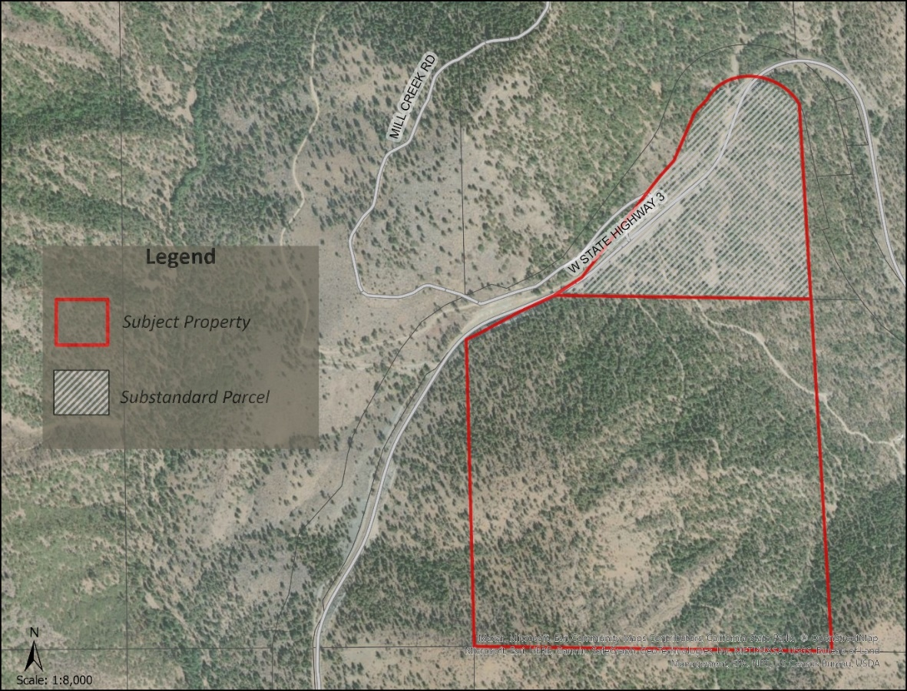
Figure 1: Subject Parcels

Environmental Review
Staff is proposing that the proposed project be considered categorically exempt from the California Environmental Quality Act (CEQA) pursuant to CEQA Guidelines Section 15317, Open Space Easements or Contracts. A Categorical Exemption implies that the project will not result in any significant adverse environmental effects. CEQA Guidelines Section 15317 specifically exempts the making and renewing of open space contracts under the Williamson Act, which is applicable to the subject action.
The Board of Supervisors must consider the proposed CEQA exemption together with any comments received during the public review process. Further, the exemption can only be approved if the Board finds, based on the whole record before it, that there is not substantial evidence that the project will have a significant effect on the environment. Accordingly, a finding to this effect has been incorporated into both draft resolutions prepared for the Board’s consideration.

Comments
Agency Comments
No agency comments were received.
Public Comments
Notice of the project was published and posted as required prior to the Board of Supervisors meeting and no public comment was received as of the preparation of this staff report.

Recommended Action
Should the Board of Supervisors concur with staff’s analysis, staff recommends that the Board of Supervisors find that the proposed modifications to the Williamson Act contract are exempt from CEQA and approve said modifications.
A draft motion to this effect is provided below.

Recommended Motions
I move to take the following actions:
- Determine the project exempt from CEQA in accordance with Section 15317, Open Space Easements or Contracts; and
- Adopt the attached resolution approving the rescission and reentry of the applicable Williamson Act contract; and
- Direct staff to bring back the 33.12-acre, substandard parcel with a recommendation for issuance of a Notice of Non-Renewal no later than September 2023, should the owner not amend the boundaries making the parcel meet the 40-acre minimum.

Exhibits to the Staff Report
- Draft Resolution Approving the Rescission of the subject property from the existing contract and Reentry into a new Williamson Act Contract
- Exhibit A-1 within Draft Resolution: Williamson Act Contract - Draft
- Agricultural Preserve Administrator Staff Report with Recommendation

