McKinley Scott Fuel Reduction Project

20-FH-SKU-010

Project revision proposal due to fire effects of the McKinney Fire

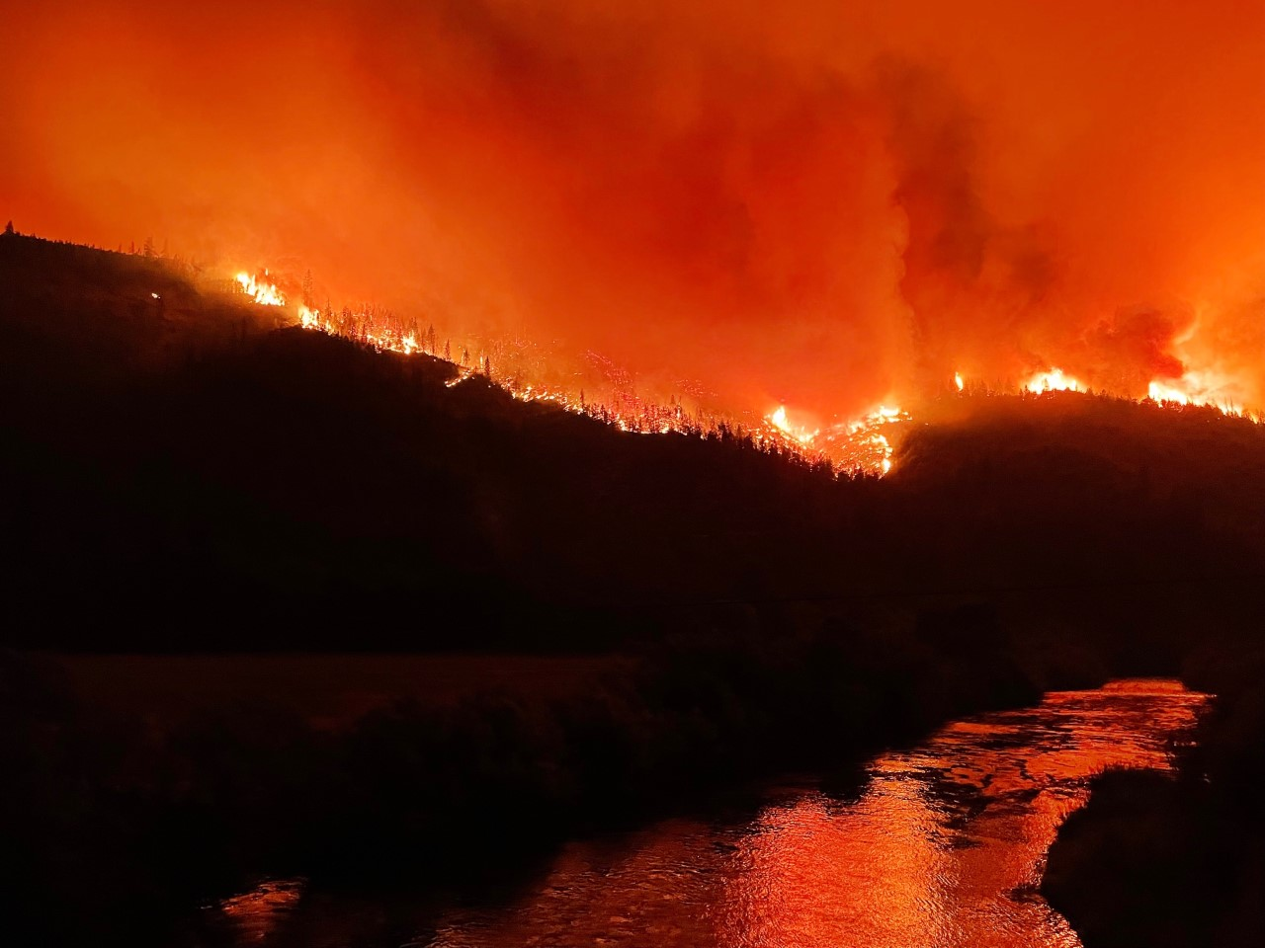

*McKinney Fire during the first night*

The McKinley Scott Fuel Reduction project was partially burned during the McKinney Fire last summer that burned about 60,000 acres, much of which was at a high vegetation severity (see attached maps). Stands included in the original proposal which burned at high severity were removed from this revised proposal due to the much different needs and objectives of those stands. Those stands account for 175 acres of the original 2,477 acre footprint.

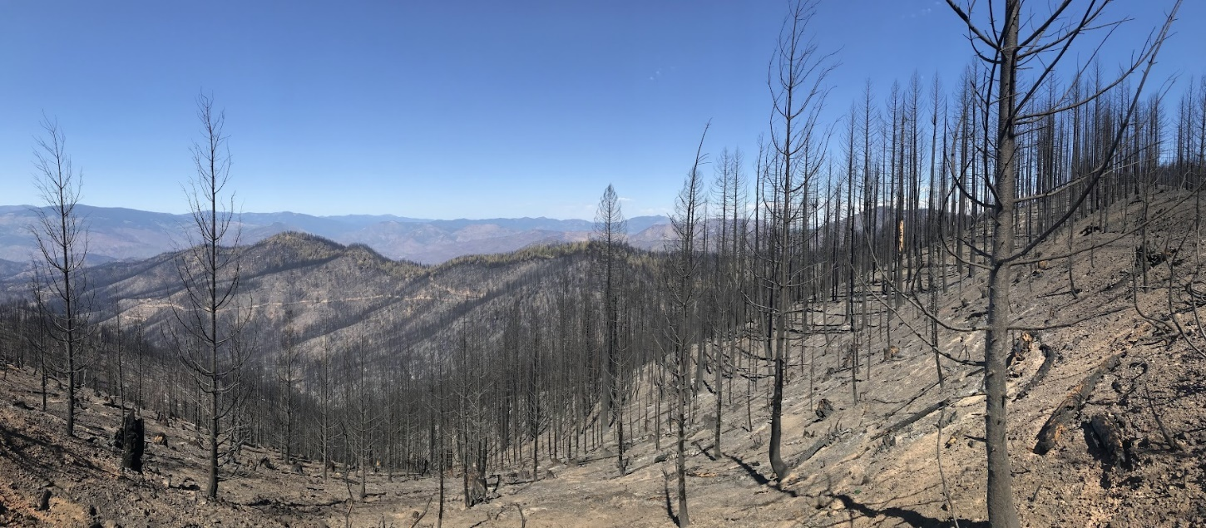

The McKinney Fire also allowed local land managers to assess the efficacy of the treatments that had been accomplished previous to the fire and to create better prescriptions for treatments that may mitigate future fire activity in these landscapes. Fire Ecologists for the Klamath NF and fire experts for the Siskiyou CalFire unit reviewed the fire effects and have come up with recommendations for fuel break construction in the Klamath Mountains using local fire weather and seeing how the different existing fuel breaks reacted to the fire. In general, the effective fuel breaks were wider, had better crown separation, addressed ground fuels better as well as ladder fuels.

The Klamath NF had completed a project along portions of the same strategic ridge line in this cross boundary “All Lands” project area. The stands had been logged to separate crowns, leaving the largest and most fire resilient trees. Ladder fuels had been removed and the ground fuels treated by understory burning. The McKinney fire burned hot up to these ridge stands but was not able to burn through the stands due to complete and effective treatments. These stands showed little or no mortality. The fire did pass around the treated stands which shows a need to complete the fuel break treatments on all lands and not have the fuel breaks start and stop along a ridge like a dashed line of morse code.

It was felt by the McKinley Scott partnership after reviewing that information and putting in pre-treatment plots in the stands, that the previously planned treatments could be strengthened by including more treatment of ground and ladder fuels and separating the tree crowns further. These treatments will increase the cost and therefore reduce the footprint acres. However, the total acres of treatment will stay relatively similar to the original proposal. The original proposal was to treat 2,477 footprint acres with 3,632 acres of treatments (multiple treatments on some acres). The revised proposal treats a reduced footprint of 1,859 acres with 3,713 acres of treatments. To achieve the more complete treatments, an additional 443 acres of unburned stands were removed from the project based upon the need to stay within the original $5 million budget. We are still including those stands in the exemption in case we are able to secure additional funds to treat those acres.

We feel that these more complete treatments will create more effective treatments on the landscape and should reduce the fire effects and allow fire suppression forces to be more successful in the future. For example, the original treatment may have been to hand thin the stand, pile slash, and burn the piles. While these treatments may treat the ladder fuels, it may not address existing ground fuels or crown separation. In this case we may decide to add a biomass removal to the stand or increase the hand thinning cost to address the ground fuels.

The original project description is still the same as stated below:

*The McKinley Scott Fuel Reduction project occurs in central Siskiyou County on Scott Bar Mtn. and adjoining ridges above the Mill Creek watershed, between the Scott and Klamath Rivers approximately 10 miles west of Yreka, CA. It will use understory burning, herbicide application, mastication, thinning and chipping to create shaded fuel breaks extending the existing Craggy project along a strategic ridge system. The project goals include community protection, forest health and resilience, and wildlife habitat maintenance.*

We have revised the Forest Health project budget workbook and are providing new maps of the treatments and the shape files associate with those. The Exemption has been updated and will be sent to Andrea Williams for review with this update. We expect that if these revisions are approved that we can get started with the contracting and treatments this summer.

Treatments already accomplished are installation of the pre-treatment plots and the first year of the wildlife monitoring by Oregon State University. While some of the wildlife monitoring stations were lost during the McKinney Fire, the University has been able to adapt to the changed conditions and revise their research study design to meet the objectives of the Fisher research. The pre-treatment plots were essential in helping the partners design the new treatment regimes.

Thank you for your consideration of this revised proposal for the McKinley Scott Fuel Reduction Project.

This project revision was approved by the Siskiyou County Board of Supervisors on April 4, 2023, by the following vote:

AYES:

NOES:

ABSENT:

ABSTAIN:

Sincerely,

Ed Valenzuela, Chair,

Board of Supervisors