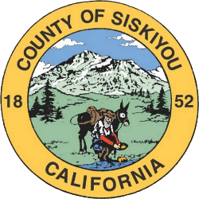**Resolution No. ____**

## Resolution of the Board of Directors of the Siskiyou County Flood Control and Water Conservation District, County of Siskiyou, State of California

**Whereas**, the Siskiyou County Flood Control and Water Conservation District owns approximately 2,000 acres of forested property surrounding Lake Siskiyou; and

**Whereas,** the property includes the Lake Siskiyou Camp Resort, which is operated by concessionaire Reynolds Resorts pursuant to a lease agreement; and

**Whereas**,the lease agreement requires Reynolds Resorts to obtain the prior approval of the Board of Directors of the Siskiyou County Flood Control District prior to implementing any new fees or increasing existing fees; and

**Whereas**, Reynolds Resorts is requesting to increase certain fees at the Lake Siskiyou Camp Resort.

**Now, Therefore, Be It Resolved** that the Board of Directors of the Siskiyou County Flood Control and Water Conservation District Approves the identified Base Rate Increases for the identified Sites and Units as set forth in the attached LAKE SISKIYOU CAMPGROUND RESORT RATE ADJUSTMENT FEES.

**Passed and Adopted** by the Board of Directors of the Siskiyou County Flood Control and Water Conservation District at a regular meeting of said Board, held on the 21st day of February, 2023 by the following vote:

AYES:

NOES:

ABSENT:

ABSTAIN:

________________________________________  
 Ed Valenzuela, Chair  
Board of Directors, Siskiyou County

Flood Control and Water Conservation District

ATTEST:

Laura Bynum,  
County Clerk

By _________________________________  
 Deputy, Wendy Winningham