Staff Report
Meeting Date: January 17, 2023
To: Siskiyou County Board of Supervisors
From: Bernadette Cizin, Assistant Planner
Subject: Proposed Crawford Williamson Act Rescission and Re-entry (APA-22-12) and CEQA Determination

Background and Discussion
On August 16, 2022, the County received an application for a Williamson Act Contract amendment to bring approximately 480 acres (shown in Blue, Figure 1), owned by John and Susan Crawford, under one Williamson Act contract consisting solely of property under their ownership with the Agricultural Use of livestock grazing. The property is currently under one Williamson Act contract, which has several separate property owners. They have also proposed to add 222.78 acres (Shown in Red, Figure 1) to the Agricultural Preserve and new contract. In order to accomplish this, the existing Agricultural Preserve would need to be amended to include the 222.78 acres and the 480 acres rescinded from the existing contract and a new contract issued for the 702.78 acres.

Agricultural Preserve Administrator Review
Staff prepared a detailed report (Exhibit D) for review and recommendation by the Agricultural Preserve Administrator. Based on the report, the Administrator found the applicants request is consistent with the County Rules for the Establishment and Administration of Agricultural Preserves and Williamson Act Contracts, with the exception of the addition of 222.78 acres and recommends the Board rescind the 480 acres and reissue the contract for the 480 acres only.

Environmental Review
Staff is proposing that the proposed project be considered categorically exempt from the California Environmental Quality Act (CEQA) pursuant to CEQA Guidelines Section 15317, Open Space Easements or Contracts. A Categorical Exemption implies that the project will not result in any significant adverse environmental effects. CEQA Guidelines Section 15317 specifically exempts the making and renewing of open space contracts under the Williamson Act, which is applicable to the subject action.
The Board of Supervisors must consider the proposed CEQA exemption together with any comments received during the public review process. Further, the exemption can only be approved if the Board finds, based on the whole record before it, that there is not substantial evidence that the project will have a significant effect on the environment. Accordingly, a finding to this effect has been incorporated into both draft resolutions prepared for the Board’s consideration.

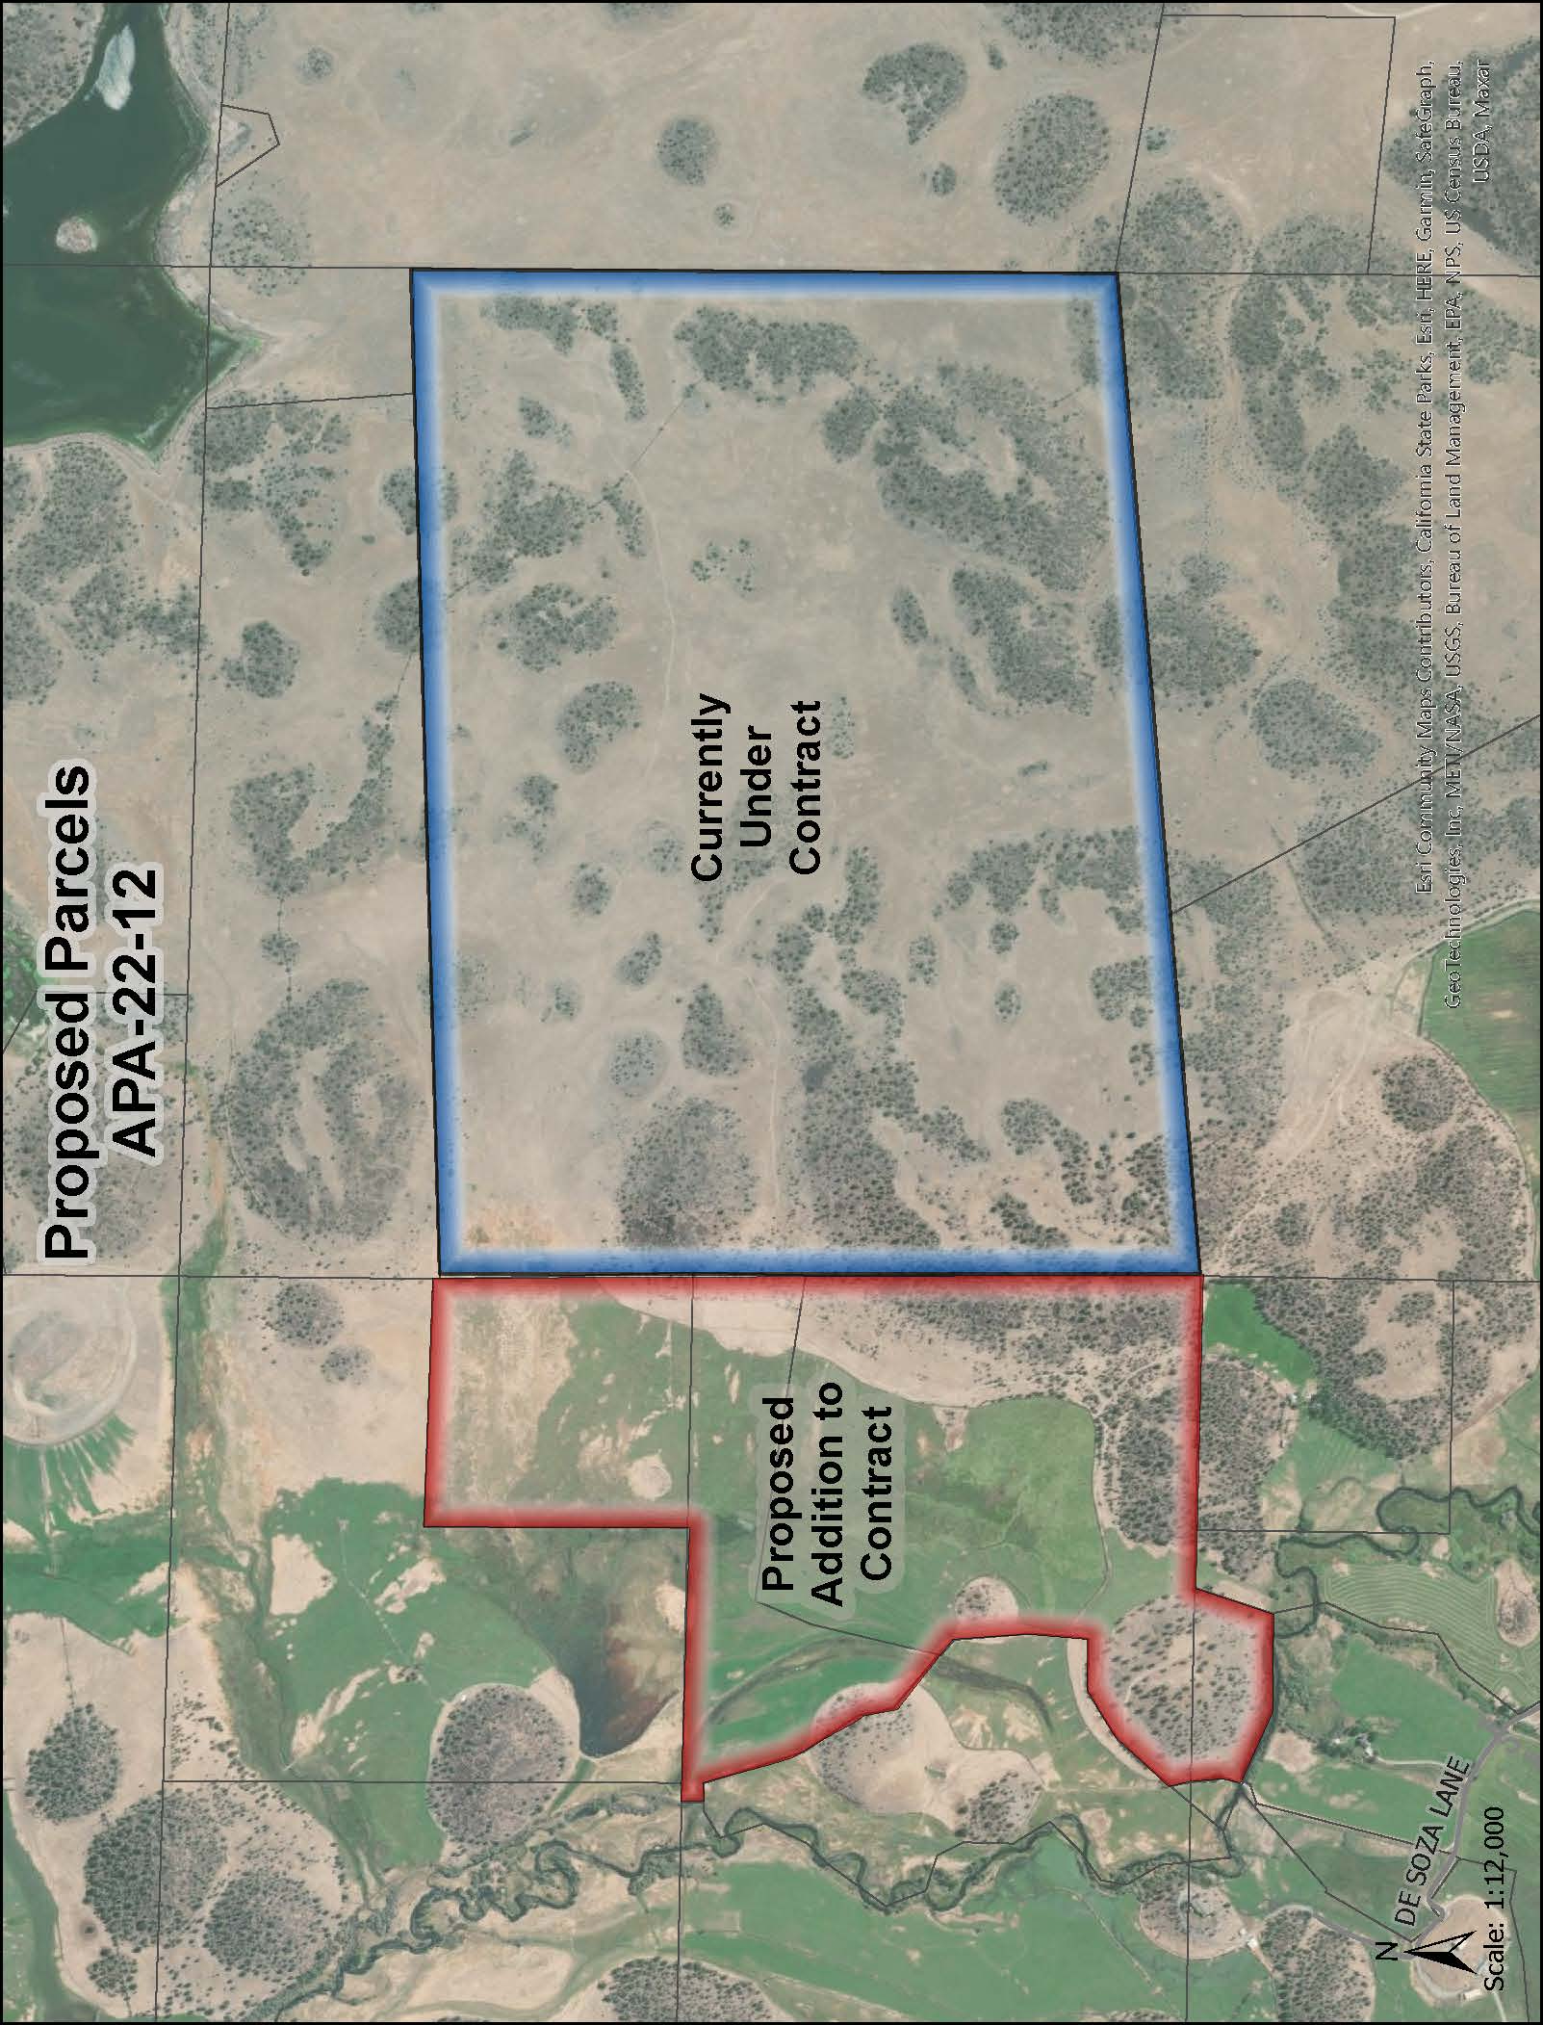
Figure 1: Subject Parcels

Comments
Agency Comments
Siskiyou County Agricultural Commissioner
The Agricultural Commissioner provided comment via phone call on January 4, 2023, they have no issue with the rescission and reentry of the 480-acres and were in support of applying the policy to not increase this Agricultural Preserve by 222.78 acres.
Public Comments
Notice of the project was published and posted as required prior to the Board of Supervisors meeting and no public comment was received as of the preparation of this staff report.

Recommended Action
Should the Board of Supervisors concur with staff’s analysis, staff recommends that the Board of Supervisors find that the proposed modifications to the Williamson Act contract are exempt from CEQA and approve said modifications.
A draft motion to this effect is provided below.

Recommended Motions
I move to take the following actions:
- Determine the project exempt from CEQA in accordance with Section 15317, Open Space Easements or Contracts; and
- Adopt the attached resolution approving the rescission and reentry of the applicable Williamson Act contract; and

Exhibits to the Staff Report
- Draft Resolution Approving the Rescission of the subject property from the existing contracts and Reentry into a new Williamson Act Contract
- Draft Williamson Act Contract
- Agricultural Preserve Administrator Staff Report with Recommendation

