# Supplemental Staff Report

Meeting Date: October 4, 2022

To: Siskiyou County Board of Supervisors

From: Bernadette Cizin, Assistant Planner

Subject: Proposed Matthew & Audrey Parsons Trust Agricultural Preserve Amendment, Williamson Act Rescission and Re-entry (APA-22-02) and CEQA Determination

## Background and Discussion

On June 14, 2022, staff brought before the Board a proposed Agricultural Preserve amendment to bring approximately 525 acres, owned by Matthew & Audrey Parsons Trust, under one individual preserve and a single Williamson Act contract. Staff recommended that the board not approve the request as there is an open code compliance case on one of the subject parcels. After Board discussion and comment by the applicant, the public hearing was continued to August 2, 2022.

At the August hearing, staff provided the board with different options for the owners that would allow them to continue their business, which is not allowed by the current County Rules. These options included varied greatly from removing the subject property from the Williamson Act program to moving the business completely from the property, none of which the property owners considered to be feasible.

Staff also discussed updates that could be made to the Board adopted Rules for the Establishment and Administration of Agricultural Preserves and Williamson Act Contracts in order to allow for additional compatible uses on Contracted Land.

After Board discussion and comment by the applicant, the public hearing was continued to today’s date, with direction from the Board for staff to provide the cost of the most efficient and cost-effective solution for the applicant to continue the business on their property and provide proposed updates including the addition of an additional compatible use within the Rules.

**Potential Solution**  
Planning staff met to discuss options for the property owners to continue their business where it currently resides and to keep the property in the Williamson Act program. It was confirmed that, as adopted, the current Rules do not allow for the wood processing, storage and sales of commercially produced wood pellets on contracted property.

Should the Board update the Rules to include a compatible use which would allow this operation, the owners would then have a path forward, in which they could apply for to rezone the entire parcel to Non-Prime Agricultural (AG-2) and for a Use Permit. Staff determined this to be the least costly route as this would not require structures utilized for the business to be relocated nor does it require a survey of the property, two major cost concerns expressed by the property owners.

For this particular project, the cost would include the following:

* $4100.00 - Application/Processing fees and CEQA determination to county agencies
* $92.00 – Recording Fee (+ $3 per page for additional pages)

It should be noted that this is based on staff’s preliminary evaluation of the property, projected use based on the current use and the anticipation that a CEQA exemption may apply.

**Contracts**

APNs 010-010-630 and 010-010-660 are under Contract #73020. Even though there is an active code compliance case, staff would not recommend the issuance of a Notice of Non-Renewal as the owners are actively working to remedy the compliance issues.

APN’s 010-010-550 and 002-170-270 are currently in the Non-Renewal process under Contract #76033NR due to the non-compliance of a separate property owner under the same contract.

**Agricultural Preserve**  
The subject parcels are located within two different Agricultural Preserves.

If the code enforcement issue were resolved and should the Board approve the applicant’s request, the Parsons Trust will own all of the property under one particular agricultural preserve as shown in Figure 1 of this report.

**Williamson Act Contract Rescission and Re-entry**  
APN 010-010-660 and a portion of 010-010-660 is under contract No. 73020 as recorded in the Siskiyou County Official Records as Document No 05-0001313 on January 24, 2005. The remainder of 010-010-660 was later included in Contract No. 73020 by Agricultural Preserve Contract Amendment APA-00-06.

APN 002-170-270 and 010-010-550 are under contract recorded in the Siskiyou County Official Records at Volume 750 Page 283 on February 17, 1976.

If the code enforcement issue were resolved and should the Board approve the applicant’s request, the Parsons Trust will own all of the property under one particular Williamson Act Contract as shown in Figure 1 of this report.

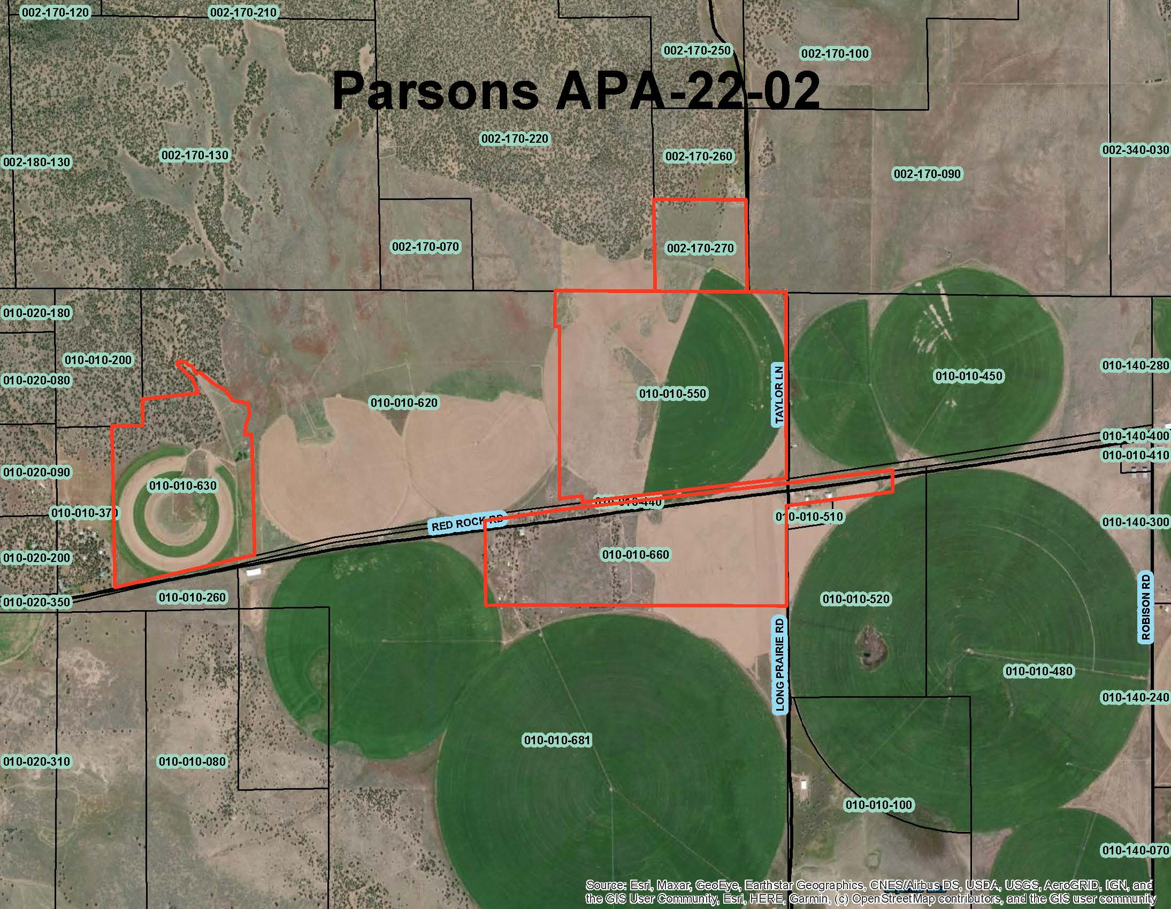  
Figure 1: Subject Parcels

## Comments

Notice of the project was published and posted as required prior to the Board of Supervisors meeting and no public comment was received as of the preparation of this staff report.

## Recommended Action

Should the Board of Supervisors concur with staff’s analysis, staff recommends that the Board of Supervisors continue the public hearing to give the property owners additional time to return the property to compliance with County Code and the adopted Rules for the Establishment and Administration of Agricultural Preserves and Williamson Act Contracts.

## Recommended Motions

I move to take the following actions:

1. Continue the Public Hearing to December 13, 2022, to give the applicants time to return to compliance with Siskiyou County code and the “Rules for the Establishment and Administration of Agricultural Preserves and Williamson Act Contracts”.