# Staff Report

Meeting Date: December 6, 2022

To: Siskiyou County Board of Supervisors

From: Bernadette Cizin, Assistant Planner

Subject: Proposed Woodson Williamson Act Rescission and Re-entry (APA-22-03) and CEQA Determination

## Background and Discussion

On May 13, 2022, the County received an application for a Williamson Act Contract amendment to bring approximately 2720 acres (Figure 1), owned by the Woodson’s, under one Williamson Act contract consisting solely of property under their ownership with the Agricultural Use of livestock grazing. The property is currently under three separate Williamson Act contracts, with 280 acres not currently within an agricultural preserve.

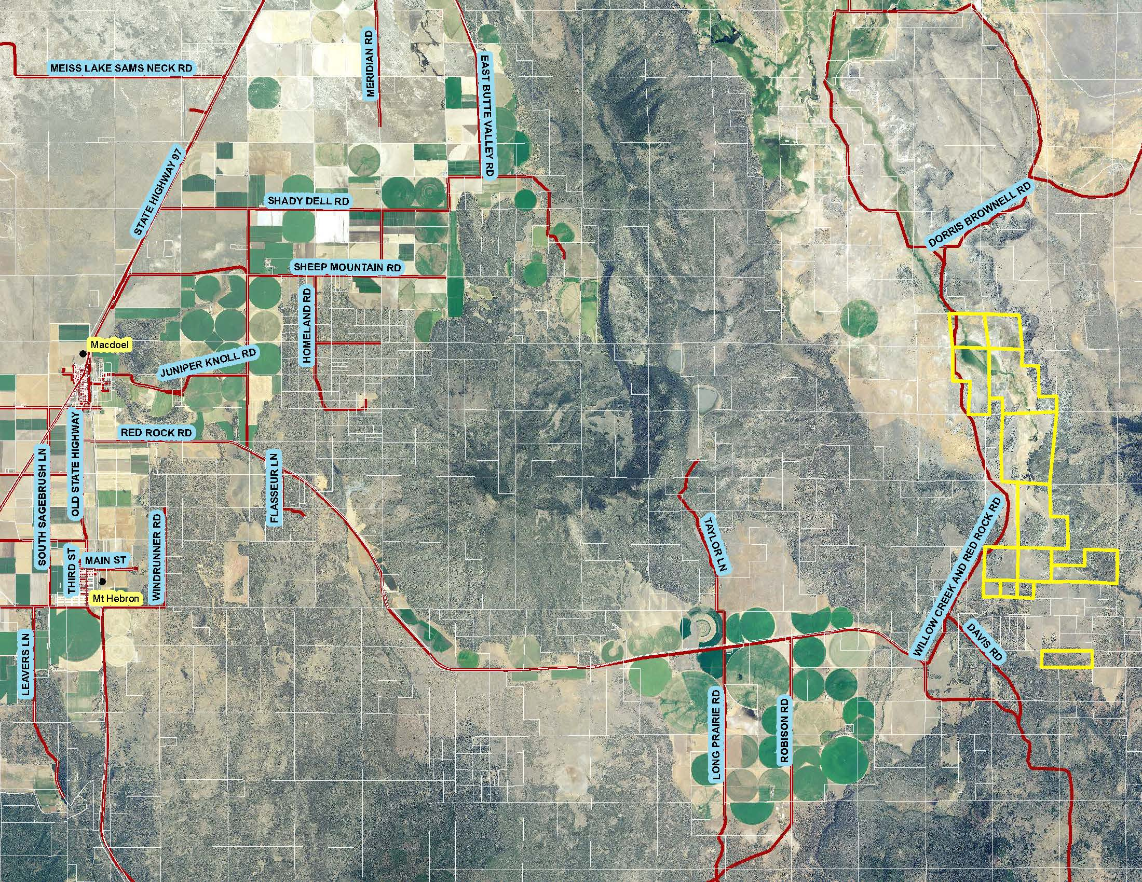  
Figure 1: Subject Parcels

**Agricultural Preserve Administrator Review**

Staff prepared a detailed report (Exhibit D) for review and recommendation by the Agricultural Preserve Administrator. During the preparation of this report, it was found that one 120-acre parcel was not legally created and should not be included in the new agricultural preserve and contract. The Administrator found the applicants request, apart from the 120-acre illegally created parcel, is consistent with the County Rules for the Establishment and Administration of Agricultural Preserves and Williamson Act Contracts and recommends the Board rescind and reissue the contract as proposed.

## Environmental Review

Staff is proposing that the proposed project be considered categorically exempt from the California Environmental Quality Act (CEQA) pursuant to CEQA Guidelines Section 15317, *Open Space Easements or Contracts.* A Categorical Exemption implies that the project will not result in any significant adverse environmental effects. CEQA Guidelines Section 15317 specifically exempts the making and renewing of open space contracts under the Williamson Act, which is applicable to the subject action.

The Board of Supervisors must consider the proposed CEQA exemption together with any comments received during the public review process. Further, the exemption can only be approved if the Board finds, based on the whole record before it, that there is not substantial evidence that the project will have a significant effect on the environment. Accordingly, a finding to this effect has been incorporated into both draft resolutions prepared for the Board’s consideration.

## Comments

Agency Comments

***Siskiyou County Agricultural Commissioner***The Agricultural Commissioner provided comment that they had no objection to the proposal.

***Siskiyou County Treasurer/Tax Collector***The Treasurer noted that several parcels have an open payment plan, and the current fiscal year taxes are owing.

Public Comments

***Property Owner***The owner sent a letter regarding the current and historical use of the land along with an explanation of how the inclusion of the additional 280 acres would benefit their operation.

Notice of the project was published and posted as required prior to the Board of Supervisors meeting and no public comment was received as of the preparation of this staff report.

## Recommended Action

Should the Board of Supervisors concur with staff’s analysis, staff recommends that the Board of Supervisors find that the proposed modifications to the Williamson Act contract are exempt from CEQA and approve said modifications.

A draft motion to this effect is provided below.

## Recommended Motions

I move to take the following actions:

1. Determine the project exempt from CEQA in accordance with Section 15317, Open Space Easements or Contracts; and
2. Adopt the attached resolution approving the rescission and reentry of the applicable Williamson Act contract; and
3. Adopt the attached resolution approving amendment to the existing Agricultural Preserves and establishment of a new preserve.

Exhibits to the Staff Report

1. Draft Resolution Approving the Rescission of the subject property from the existing contracts and Reentry into a new Williamson Act Contract
2. Draft Resolution amending the existing Agricultural Preserves and establishing a new preserve
3. Draft Williamson Act Contract
4. Agricultural Preserve Administrator Staff Report with Recommendation
5. Comments