Initial Study/Mitigated Negative Declaration

Custom Crushing Industries, Inc. Concrete and Asphalt Recycling Facility

(Goodwin Zone Change and Use Permit)

APNs 013-120-320 and 013-120-330
Project Title | Crushing Industries, Inc., Concrete and Asphalt Recycling Facility
Lead Agency | Siskiyou County
Contact Person | Hailey Lang, Deputy Director of Planning
Project Location | The project site is located approximately 2 miles east of the City of Yreka, California, along East Oberlin Road, on Siskiyou County Assessor's Parcel Nos. (APN) 013-120-320 and 013-120-330.
Applicant | Paul and Clara Goodwin  2409 East Oberlin Road  Yreka, California 96097  ccicrush4u@yahoo.com  530-842-5544 (office)
Consultant | VESTRA Resources, Inc.  5300 Aviation Drive  Redding, California 96002  530-223-2585 (office)
Zoning | Prime Agricultural (AG-1) with proposed change to Heavy Industrial (M-H) and Light Industrial (M-M)

Introduction

California Environmental Quality Act (CEQA) Compliance
CEQA, a statewide environmental law contained in California Public Resources Code (PRC) Sections 21000–21177, applies to most public agency decisions to carry out, authorize, or approve actions that have the potential to adversely affect the environment (PRC Section 21000 et seq.). The overarching goal of CEQA is to protect the physical environment. To achieve that goal, CEQA requires that public agencies identify the environmental consequences of their discretionary actions and consider alternatives and mitigation measures that could avoid or reduce significant adverse impacts when avoidance or reduction is feasible. It also gives other public agencies and the public an opportunity to comment on the project. If significant adverse impacts cannot be avoided, reduced, or mitigated to below a level of significance, the public agency is required to prepare an Environmental Impact Report (EIR) and balance the project’s environmental concerns with other goals and benefits in a statement of overriding considerations.
In accordance with the CEQA Guidelines, the County, as the lead agency, has prepared an Initial Study (IS) to evaluate potential environmental effects and to determine whether an EIR, a Negative Declaration, or a Mitigated Negative Declaration (MND) should be prepared for the project. CEQA Guidelines Section 15070(b) provides that an MND should be prepared for a project when the IS has identified potentially significant environmental impacts associated with the project, but (1) revisions to the project’s plans or proposals made or agreed to by the applicant before release of an MND for public review would avoid or mitigate environmental effects to a point where no significant effect on the environment would occur and (2) there is no substantial evidence in the record before the public agency that the project, as revised, may have a significant effect on the environment. The IS determined that implementation of the project would result in no impacts or less than significant impacts with incorporation of mitigation. Therefore, the County has prepared an MND for the project.
VESTRA Resources Inc., prepared the project’s Initial Study per CEQA Guidelines Sections 15063–15065. The CEQA Guidelines include a suggested checklist to indicate whether a project would have an adverse impact on the environment. The IS can be found in Appendix A, Initial Study Checklist.
For this IS/MND, one of the following four responses is possible for each environmental issue area:
- Potentially Significant Impact
- Less than Significant Impact with Mitigation Incorporated
- Less than Significant Impact
- No Impact
This project does not have any known environmental impact areas that have a potentially significant impact.

Project Summary:
The request is for approval of a conditional use permit to develop and operate a recycling facility associated with rezoning of APNs 013-120-320 and 013-120-330. The facility would operate on the southeastern portion of APN 013-120-330. The facility would receive construction waste. Construction waste would be mechanically separated, crushed, and screened into aggregate bases. General site location is shown on Figure 1.
The project site is located approximately 2.3 miles east of the City of Yreka along East Oberlin Road. Access to the site would be from East Oberlin Road and/ or South Phillipe Lane.
The project is located on a relatively flat valley plain. One single-family residence is located approximately 0.56 miles north of the site on APN 013- 110-340. To the east, the site borders undeveloped land. An existing solid waste and recycling facility is located south of the property. To the west, parcels are developed as equipment yards and industrial areas. Adjacent properties are shown on Figure 4.
The project may require review and/ or discretionary approvals and permits from the below-listed agencies:
- State Water Resources Control Board, Industrial General Permit and Stormwater Pollution Prevention Plan
- Siskiyou County Community Development Department, Solid Waste Facility Permit
- Siskiyou County Air Quality Management District, Authority to Construct
- Siskiyou County Air Quality Management District, Permit to Operate

CEQA Environmental Checklist

Project Description and Background
Project Title: Goodwin Zone Change and Use Permit Project (Z-21-02 and UP-21-06)
Lead agency name: County of Siskiyou Address: 806 S. Main Street
Contact person: Hailey Lang Phone number: 530-841-2100
Project Applicant’s name: Paul and Clara Goodwin
Address: 2409 E. Oberlin Road, Yreka, CA 96097
Project Location: 2409 E. Oberlin Road, Yreka, CA 96097
General plan description: AG-1
Zoning: AG-1 to M-H and M-M
Description of project:
The Project site is located in an unincorporated part of Siskiyou County approximately 2.3 miles east of the City of Yreka along Oberlin Road. The APNs associated with this project are 013-120-320 and 013-120-330. The project is proposing to change the zoning of APN 013-120-230 from Prime Agricultural (AG-1) to Light Industrial (M-M) and change the zoning of APN 013-120-330 from Prime Agricultural (AG-1) to Heavy Industrial (M-H). The proposed project plans to develop a recycling facility on the property and to expand an existing gravel parking lot. The facility would receive construction waste, which would be mechanically separated, crushed, and screened into aggregate base. The concrete and asphalt recycling facility would be located on the southeastern portion of APN 013-120-330. The expanded parking lot would be located on the western portion of APN 013-120-320. The facility will function Monday through Friday with no night, weekend, or holiday operations. Hours of operation will be 7:00 a.m. to 5:00 p.m., with eight (8) hours of operation expected per day. The operations at this site will vary based on time of year and type of construction projects within the area producing construction waste.
Surrounding land uses and setting:
The project is located on a relatively flat valley plain approximately 1.75 miles northeast of Kilgore Hills West. One single-family residence is located approximately 0.56 miles north of the site on APN 013-110-340. To the east, the site borders undeveloped land. The existing solid waste and recycling facility is located south of the property. To the west, parcels are developed for industrial uses. The parcels surrounding the project site and a list of the corresponding landowners are shown on Figure 4.
Other public agencies whose approval may be required (e.g. permits, financial approval, or participation agreements):
- State Water Resources Control Board, Industrial General Permit and Stormwater Pollution Prevention Plan
- Siskiyou County Community Development Department, Solid Waste Facility Permit
- Siskiyou County Air Quality Management District, Authority to Construct
- Siskiyou County Air Quality Management District, Permit to Operate

Native American Consultation
Have California Native American tribes traditionally and culturally affiliated with the project area requested consultation pursuant to Public Resources Code (PRC) section 21080.3.1? Yes No
If yes, ensure that consultation and heritage resource confidentiality follow PRC sections 21080.3.1 and 21080.3.2 and California Government Code 65352.4
Note: Conducting consultation early in the CEQA process allows tribal governments, lead agencies, and project proponents to discuss the level of environmental review, identify and address potential adverse impacts to tribal cultural resources, and reduce the potential for delay and conflict in the environmental review process. (See Public Resources Code section 21080.3.2.) Information may also be available from the California Native American Heritage Commission’s Sacred Lands File per Public Resources Code section 5097.96 and the California Historical Resources Information System administered by the California Office of Historic Preservation. Please also note that Public Resources Code section 21082.3(c) contains provisions specific to confidentiality.

ENVIRONMENTAL FACTORS POTENTIALLY AFFECTED:
The environmental factors checked below would be potentially affected by this project. Please see the checklist beginning on page 4 for additional information.
Aesthetics Agriculture and Forestry
Air Quality Biological Resources
Cultural Resources Energy
Geology/Soils Greenhouse Gas Emissions
Hazards and Hazardous Materials Hydrology/Water Quality
Land Use/Planning Mineral Resources
Noise Population/Housing
Public Services Recreation
Transportation Tribal Cultural Resources
Utilities/Service Systems Wildfire
Mandatory Findings of Significance

Determination
On the basis of this initial evaluation (choose one):
I find that the proposed project COULD NOT have a significant effect on the environment, and a NEGATIVE DECLARATION will be prepared.
I find that although the proposed project could have a significant effect on the environment, there will not be a significant effect in this case because revisions in the project have been made by or agreed to by the project proponent. A MITIGATED NEGATIVE DECLARATION will be prepared.
I find that the proposed project MAY have a significant effect on the environment, and an ENVIRONMENTAL IMPACT REPORT is required.
I find that the proposed project MAY have a "potentially significant impact" or "potentially significant unless mitigated" impact on the environment, but at least one effect 1) has been adequately analyzed in an earlier document pursuant to applicable legal standards, and 2) has been addressed by mitigation measures based on the earlier analysis as described on attached sheets. An ENVIRONMENTAL IMPACT REPORT is required, but it must analyze only the effects that remain to be addressed.
I find that although the proposed project could have a significant effect on the environment, because all potentially significant effects (a) have been analyzed adequately in an earlier EIR or NEGATIVE DECLARATION pursuant to applicable standards, and (b) have been avoided or mitigated pursuant to that earlier EIR or NEGATIVE DECLARATION, including revisions or mitigation measures that are imposed upon the proposed project, nothing further is required.
Hailey Lang |  | Signature on File |  | 9-7-2022
Print Name |  | Signature |  | Date

Project Information

Project Description
The project site is located approximately 2.3 miles east of the City of Yreka along East Oberlin Road. Access to both sites would be from East Oberlin Road, and a secondary entrance with an approved encroachment permit is at the northeastern end of the north parcel from South Phillipe Lane. An encroachment permit was obtained in 2019 from the Siskiyou County Road Department. The southern parcel, APN 013-120-330, is 61 acres in size and the northern parcel, APN 013-120-320, is approximately 16.5 acres in size. The property owner proposes to develop and operate a construction waste recycling facility and expand an existing gravel parking lot (see Figure 3).
The concrete and asphalt recycling facility would be located on the southeastern portion of APN 013-120-330 (south parcel). The main entrance to the plant (south parcel) is off of East Oberlin Road, approximately 190 feet west of South Phillipe Lane. The maximum size of the recycling plant would be approximately 3 acres. The parking lot expansion of approximately 2 acres would take place on the western portion of APN 013-120-320 (north parcel). This expansion would include installment of a truck scale (75 feet by 10 feet) for company use. This parcel is currently developed on the western side as a gravel parking area with portable buildings and equipment storage. The main entrance to the expansion area is from the existing development on the northern side of East Oberlin Road. A secondary entrance lies to the west of South Phillipe Lane on the eastern side of the property. The entrance from South Phillipe Lane is accessed by a driveway with a culvert protecting the ephemeral drainage.
Hours of operation will be 7:00 a.m. to 5:00 p.m., with eight (8) hours of operation expected per day. The operations at this site will vary based on time of year and type of construction projects within the area producing construction waste. The facility will function Monday through Friday with no night, weekend, or holiday operations. Construction waste will be recycled into aggregate bases. The proposed project will generate a maximum of 40 truck and ten employee trips per day when in operation. By providing a local recycling facility, the project will likely result in reduced emissions from transportation of construction waste. Facility operations will require one to five employees onsite at any given time. Employees will park in existing lots at the developed facility away from the project area. A portable toilet(s) will be provided for employee use from Big Valley Septic and serviced regularly. Bottled water will be provided for employee use. Waste will not be generated at the site with the exception of household garbage from employees. This waste will be gathered and taken to the dumpster stationed on the northern side of the south parcel and removed by Yreka Transfer on a weekly basis.
Inbound materials will arrive by truck with up to 40 loads (totaling 1,000 tons) anticipated per day. Construction waste will include used concrete, concrete asphalt, and asphalt which will be recycled into aggregate bases. Materials will be mechanically separated and non-usable materials, if found, will be removed and properly disposed of. Materials will be mixed, crushed, and screened onsite at APN 013-120-330. No additives, amendments, or bulking agents will be added to the materials during processing. Unloading, processing, storage, and loading will take place onsite in the plant area. If additional process materials are anticipated in the future (e.g., green waste) then the appropriate permits will be obtained at that time. The initial recycled base may be utilized to build up the recycling pad for a 300-foot by 300-foot dimension to a maximum of 3 acres in size if necessary to withstand a substantial amount of material being processed or stockpiled when the plant is operating. The recycled aggregate base will then be sold as base rock for residential driveways, and other similar uses.
Processing equipment onsite will include dump trucks, trailers, forklifts, loaders, crushing, screening and mixing equipment, and other similar diesel-powered heavy machinery. Diesel-powered generators may be used onsite if necessary. The equipment will be stored on the northern parcel in the expansion area, while operating equipment will be moved to the southern parcel as needed. Equipment will be maintained in good working order to reduce air quality impacts and noise generation. Fuel will be obtained from mobile carriers when in the field onsite. Haul trucks will fuel in town at a service station or card-lock facility. Projected work at the site will be solely based on the presence of large or a group of smaller projects in the local area. There will not be regular activity at the site because trucks will haul in spoils of projects on an as-needed basis. This could mean months or years with no activity at this project site. The first recycling period will begin after receiving a sufficient amount of material such as 10,000 tons, which is able to be recycled in approximately two weeks. Equipment will be on site, when necessary, not on a consistent basis; most machines will be moved off-site when not in use. The goal is to provide a close, convenient place to legally accept and process construction spoil material in this region.

Site Background Information

Existing Land Use

Project Site
The Custom Crushing Industries Concrete and Asphalt Recycling Facility project site is zoned AG-1, Prime Agricultural; however, neighboring properties to the west and south are zoned and operated for industrial purposes. An application for rezoning has been submitted to Siskiyou County. The proposed zoning change would result in APN 013-120-320, currently zoned AG-1, being rezoned to M-M, Light Industrial. This parcel is currently developed on the western side as a gravel parking area with portable buildings, equipment storage, an access driveway and a culvert to protect the ephemeral drainage. The proposed project includes an expansion site of approximately two acres for vehicle and equipment parking. A haul truck scale (75 feet by 10 feet) will be installed for company haul trucks. The proposed zoning change would result also in APN 013-120-330, currently zoned AG-1, being rezoned to M-H, Heavy Industrial. This parcel is currently undeveloped with the exception of an access driveway with a culvert. The proposed project would include installing a recycling plant of approximately a 300-foot by 300- foot pad on the southeastern portion of the parcel (APN 013-120-330). The proposed zoning is consistent with surrounding land uses.

General Plan and Zone Information
The Siskiyou County General Plan Land Use Element designates the project area as " Prime Agricultural." The project site is zoned Prime Agricultural " but rezoning for industrial uses is being proposed (Figure 2B).

Mineral Resource Zone Classification
Sections 2761 (a) and (b) and 2790 of the Surface Mining and Reclamation Act of 1975 (SMARA) provide for a mineral lands inventory process termed classification-designation. Mineral resource areas are classified by the State Geologist on the basis of geologic factors, without regard to existing land use and land ownership. The areas are categorized into four mineral resource zones (MRZ-1 through MRZ-4). The MRZ-2 classification adopted by the State Mining and Geology Board (SMGB) is defined as an area where adequate information indicates that significant mineral deposits are present or where it is judged that a high likelihood exists for their presence. The project site is not within any mineral resource zone.

Surrounding Land Use
The project is located on a relatively flat valley plain approximately 1.75 miles northeast of Kilgore Hills West. One single-family residence is located approximately 0.56 miles north of the site on APN 013-110-340. To the east, the site borders undeveloped land. The existing solid waste and recycling facility is located south of the property. To the west, parcels are developed for industrial uses. The parcels surrounding the project site are shown on Figure 4.

Aesthetics
Except as provided in Public Resources Code Section 21099, would the project:
Question | CEQA Determination
a) Have a substantial adverse effect on a scenic vista? | No Impact
b) Substantially damage scenic resources, including, but not limited to, trees, rock outcroppings, and historic buildings within a state scenic highway? | Less Than Significant Impact
c) In non-urbanized areas, substantially degrade the existing visual character or quality of public views of the site and its surroundings? (Public views are those that are experienced from a publicly accessible vantage point). If the project is in an urbanized area, would the project conflict with applicable zoning and other regulations governing scenic quality? | Less Than Significant Impact
d) Create a new source of substantial light or glare which would adversely affect day or nighttime views in the area? | Less Than Significant Impact

Setting
The existing visual character of the site is that of an open agricultural field. The area is vegetated with annual grasses and a few juniper trees. The proposed expansion will take place on the northwestern side of parcel APN 013-120-320. The proposed recycling plant would take place on the southeastern portion of parcel APN 013-120-330. The site is relatively flat with few trees present. Fencing will surround the operating area. A locked gate has been installed at the project entrance to prevent public entry. All vehicle areas have been or will be rocked for dust control. If necessary, a company water truck will be used to mitigate dust emissions. Site development may include removing some juniper trees which are less than 5 feet tall as necessary.

Discussion
- The entrance is the only visible portion of the project site that is visible from East Oberlin Road. The site is currently zoned AG-1, Prime Agricultural. The north parcel (APN 013-120-320) would be rezoned to M-M, Light Industrial, the same designation as the adjoining parcel to the west. The western portion of the parcel is currently used as an equipment storage yard with portable buildings. Concrete dividers and gravel were put in to protect the drainages and represent the boundary of the graveled yard. No ephemeral drainage will be affected on the northern parcel. The southern parcel (APN 013-120-330) would be rezoned from AG-1 to M-H, Heavy Industrial The adjoining parcel to the west is currently zoned M-H, Heavy Industrial and will be developed and used as such. A construction waste recycling facility would be developed on the southern portion of APN 013-120-330. This type of activity is common in the area and consistent with industrial zoning of adjoining parcels. There will be no impact.
- The project would not substantially damage any scenic resource. Few trees are present on the property. Some smaller (less than 5 feet tall) juniper trees may be removed during project development. Estimated impact to existing trees is 50 percent or less. No historic buildings exist on the property. There will be less than significant impact.
- The adjoining parcels to the west of the project site are zoned M-M, Light Industrial, and M-H, Heavy Industrial, respectively. An equipment yard is operated on the parcel zoned M-M. Equipment yards and industrial sites are operated on the parcels zoned M-H. The proposed project would be used for similar operations (see Figure 4). Equipment and material stockpiles could be visible from adjacent properties and roadways. This type of activity is common in the area and consistent with the industrial zoning. The impact is considered less than significant due to surrounding land use.
- No night operations are planned. The project would not create a new source of substantial light or glare which would adversely affect day or nighttime views in the area. There will be no impact.

Agriculture and Forest Resources
In determining whether impacts to agricultural resources are significant environmental effects, lead agencies may refer to the California Agricultural Land Evaluation and Site Assessment Model (1997) prepared by the California Department of Conservation as an optional model to use in assessing impacts on agriculture and farmland. In determining whether impacts to forest resources, including timberland, are significant environmental effects, lead agencies may refer to information compiled by the California Department of Forestry and Fire Protection regarding the state’s inventory of forest land, including the Forest and Range Assessment Project and the Forest Legacy Assessment Project; and the forest carbon measurement methodology provided in Forest Protocols adopted by the California Air Resources Board.
Would the project:
Question | CEQA Determination
a) Convert Prime Farmland, Unique Farmland, or Farmland of Statewide Importance (Farmland), as shown on the maps prepared pursuant to the Farmland Mapping and Monitoring Program of the California Resources Agency, to non-agricultural use? | No Impact
b) Conflict with existing zoning for agricultural use, or a Williamson Act contract? | Less Than Significant Impact
c) Conflict with existing zoning for, or cause rezoning of, forest land (as defined in Public Resources Code section 12220(g)), timberland (as defined by Public Resources Code section 4526), or timberland zoned Timberland Production (as defined by Government Code section 51104(g))? | No Impact
d) Result in the loss of forest land or conversion of forest land to non-forest use? | No Impact
e) Involve other changes in the existing environment which, due to their location or nature, could result in conversion of Farmland, to non-agricultural use or conversion of forest land to non-forest use? | Less Than Significant Impact

Discussion
The California Department of Conservation Farmland Mapping and Monitoring Program (FMMP) defines and classifies Prime Farmland and Farmland of Statewide Importance. In order to be considered Prime Farmland, property must have " ... been used for irrigated agricultural production at some time during the four years prior to the Important Farmland Map date" and, ''the soil must meet the physical and chemical criteria for Prime Farmland or Farmland of Statewide Importance as determined by the US Department of Agriculture (USDA) Natural Resources Conservation Service (NRCS)."
Under the Siskiyou County General Plan Land Use and Circulation Element, "all Class I, II and III soils, and the soils that become Class III under irrigation, with the exception of Class III soils determined to be non-irrigable, are defined as prime agricultural land." The minimum parcel size for prime agricultural land is 40 acres under the General Plan. However, it is important to note that FMMP does not consider either parcel to be Prime Farmland or Farmland of Statewide Importance.
Many factors are considered in qualifying soils as Prime Farmland including Natural Resource Conservation Service (NRCS) soil data and USDA Land-Capability Classification information. The land-capability classification system divides soils into capability classes and subclasses based on agricultural usability. Land-capability classes are ranked I through VIII based on soil quality, with limitations increasing with each successive ranking. Land-capability subclasses are ranked 'e', 'w', 's', and 'c', representing the following (USDA, 1961):
- 'e' ranking - soils prone to erosion
- 'w' ranking - soils prone to excessive wetness
- 's' ranking - soils prone to root-zone limitations
- 'c' ranking - soils with climatic limitations to use
NRCS soil data and USDA land-capability rankings were used to characterize the soils on APNs 013-120-320 and 013-120-330. The following addresses the farmland status of each parcel individually.

APN 013-120-320
Parcel 013-120-320 is approximately 16 acres in size and is currently undeveloped except for a small gravel parking area. No irrigation is available on this property. The topography is relatively flat. Two northeast-flowing ephemeral drainages transect the property. The drainages form a confluence north of the property and become a tributary of the Shasta River. NRCS data divide the soils on this parcel into two mapping units, 219 and 220. Unit 219 consists of Salisbury gravelly clay loam with 0 to 5 percent slopes. Unit 220 is Salisbury gravelly clay loam with 5 to 9 percent slopes. The land-capability classification for these soils is Ille. These soils have severe limitations to crop production and are prone to erosion. This parcel is 16 acres and, therefore, does not qualify as prime agricultural land under the General Plan. The parcel does not meet the conditions required for classification as Prime Farmland or Farmland of Statewide Importance by the FMMP.

APN 013-120-330
Parcel 013-120-330 is approximately 61 acres in size and currently has an access road and culvert to the proposed plant area. No irrigation is available on this property. The topography is relatively flat. Three northeast-flowing ephemeral drainages transect the property. The main drainage going through the property no longer carries water. The flow has been impeded by a blockage on the property to the south. The drainages form a confluence north of the property and become a tributary of the Shasta River. NRCS data divide the soils on this parcel into four mapping units, 158, 206, 219 and 220. Unit 158 consists of hilt-rock outcrop complex with 2 to 50 percent slopes. Unit 206 consists of Pit clay. Unit 219 consists of Salisbury gravelly clay loam with 0 to 5 percent slopes. Unit 220 is Salisbury gravelly clay loam with 5 to 9 percent slopes (NRCS, 2016).
Parcel 013-120-330 is currently considered prime agricultural land under the Siskiyou County General Plan based on the presence of Class III soils, although no irrigation is present. The soils on this parcel have severe limitations on crop cultivation. They are prone to poor drainage, are often wet, and are easily impacted by erosion. The USDA states that,
“…many of the wet, slowly permeable but nearly level soils in class III require drainage and a cropping system that maintains or improves the structure and tilth of the soil. To prevent puddling and to improve permeability it is commonly necessary to supply organic material… and to avoid working them when they are wet (1961).
Salisbury gravelly clay loam is classified as Ille. Soils in the Ille category have 'severe limitations that reduce the choice of plants or require special conservation practices, or both' and are 'where the susceptibility and past erosion damage are the major soil factors for placing soils in this subclass'. A typical soil profile is gravelly clay loam from 0 to 4 inches, gravelly clay, gravelly clay loam from 4 to 24 inches, indurated soil from 4 to 24 inches, and stratified sand to stony sand from 24 to 32 inches in depth. The indurated layer forms duripan at 20 to 40 inches in depth, restricting vertical water movement. Deep ripping may improve drainage from the pit clay soil, but ripping would alter the local hydrologic system and would influence the ephemeral drainages found onsite. This is the only soil type found on parcel 013-120-320. Approximately 59 percent (36.4 acres) of parcel 013-120-330 falls into this classification.
Pit clay is classified as IIIw. These soils have 'severe limitations that reduce the choice of plants or require special conservation practices, or both,' and are known for having 'excess water [as] the dominant hazard or limitation to their use. Poor soil drainage, wetness, high water table, and overflow are the criteria for determining which soils belong in this subclass.' A typical soil profile is clay from 0 to 38 inches and silty clay loam or clay loam from 38 to 61 inches in depth. While the restrictive feature may be more than 80 inches below the surface, the water table may be only 24 to 36 inches below the surface of this soil. Deep ripping is not expected to improve soil drainage. Approximately 40 percent (25.3 acres) of parcel 013-120-330 falls into this classification.
The Hilt-Rock outcrop complex falls into land capability classes, VIe and VIIIs. Covering a small portion of the parcel, areas classified as VIe have 'severe limitations that make them generally unsuited to cultivation and limit their use' and are prone to erosion. Stony sandy loam, loam, sandy clay loam, and weathered and un-weathered bedrock are characteristic of these areas. Areas classified as VIIIs 'have limitations that preclude their use for commercial plant production and restrict their use to recreation, wildlife, or water supply or to esthetic purposes.' Soils in the VIIIs classification are known for being shallow and rocky with low fertility. Hilt-Rock outcrop comprises approximately 1 percent (0.8 acres) of parcel 013-120-330.
Parcels 013-120-320 and 013-120-330 do not meet the requirements of Prime Farmland or Farmland of Statewide Importance. Rather, the FMMP considers both of the parcels to be Farmland of Local Importance (FMMP, 2016). The soils on the property are known for "severe limitations that reduce its usability for crop production" (USDA, 1961). Much of the soil on the property is prone to erosion and, where clay is present, poor drainage and excess water present cultivation challenges.
In order for property to be considered Prime Farmland or Farmland of Statewide Importance, irrigated crops must have been grown on the property within the four years prior to the most recent Important Farmland Map update (FMMP, 2016(2)). The last update in the area was published in the Siskiyou County Important Farmland 2014 map, published in December 2016 (FMMP, 2016). No irrigated crops were grown on either of the parcels in the four years prior to soil mapping.
An evaluation of the local water table height has also been completed. The California Department of Water Resources (DWR) monitors six wells within five miles of the two parcels (DWR, 2017). Groundwater level shows seasonal variation but is stable over time at all six locations. The average depth to water at these six sites ranges from 3.6 to 27.9 feet below ground surface. The height of the local water table likely contributes to poor soil drainage in the area. Table 1 summarizes the six DWR-monitored wells. The height of the local water table likely contributes to the poor drainage of soils on these parcels.
Table 1: DWR Well Information
Site Code ID | Distance from Site | Use | Status | Total Depth (feet) | Depth to Water (feet) | Years of Record
417220N1225928W001 | 0.9 | Residential | Active | 105 | 12.30 | 1990-2017
417262N1225917\V001 | 1.2 | Irrigation | Inactive | 170 | 3.63 | 2000-2008
417096N1225453W001 | 2.7 | Residential | Active | 178 | 27.95 | 2013-2017
417258N1225337W001 | 3.4 | Residential | Active | 45 | 5.05 | 1990-2017
416774N1225301W001 | 4.0 | - | Inactive | 113 | 23.53 | 1953-2017
417258N1225083W001 | 4.7 | Residential | Active | 70 | 19.98 | 2004-2017

- The subject property is identified as Farmland of Local Importance by the California Department of Conservation Farmland Mapping and Monitoring Program (FMMP). The property is not Prime Farmland, Unique Farmland, or Farmland of Statewide Importance (FMMP, 2010; FMMP, 2014). The project would convert Farmland of Local Importance to industrial uses consistent with adjacent parcel uses to the west (Figure 4, Figure 5). There will be no impact to Prime Farmland, Unique Farmland, or Farmland of Statewide Importance.
- The proposed project is on property zoned " Prime Agricultural " under the Siskiyou County General Plan (Siskiyou County, 1973). The subject property would be rezoned for industrial use. This is consistent with adjoining properties to the west and south which are zoned and developed for industrial uses. The site is not under a Williamson Act contract. There will be less than significant impact.
- The proposed project will not conflict with existing zoning for, or cause rezoning of, forestland, timberland, or timberland zoned Timberland Production. The project site is not zoned for forestland or timberland, nor is it adjacent to land that is zoned for forestland or timberland (Siskiyou County, 1973; FMMP, 2014). There will be no impact.
- Forestland is defined in Public Resources Code section 12220(g) as land that can support 10 percent native tree cover of any species, including hardwoods, under natural conditions, and that allows for management of one or more forest resources, including timber, aesthetics, fish and wildlife, biodiversity, water quality, recreation, and other public benefits. This project will not result in the loss of forestland as the project site does not contain forestland. There will be no impact.
- The project would result in the conversion of Farmland of Local Importance to non­agricultural uses consistent with those taking place on adjoining parcels to the west and south which are zoned and developed for industrial uses. Soils on the property are known for severe limitations that reduce its usability for crop production (SCS, 1961; NRCS, 2012). On both parcels, soil quality is poor, and no irrigation is available. There will be less than significant impact.

Air Quality
Where available, the significance criteria established by the applicable air quality management district or air pollution control district may be relied upon to make the following determinations.
Would the project:
Question | CEQA Determination
a) Conflict with or obstruct implementation of the applicable air quality plan? | Less Than Significant Impact
b) Result in a cumulatively considerable net increase of any criteria pollutant for which the project region is non- attainment under an applicable federal or state ambient air quality standard? | Less Than Significant Impact
c) Expose sensitive receptors to substantial pollutant concentrations? | No Impact
d) Result in other emissions (such as those leading to odors) adversely affecting a substantial number of people? | No Impact

Discussion
The project is located in the Siskiyou County Air Pollution Control District (SCAPCD). The SCAPCD has jurisdiction over air quality issues throughout Siskiyou County.
The California Air Resources Board (CARB) has established ambient air quality standards for common pollutants. These ambient air quality standards represent safe levels of contaminants that avoid specific adverse health effects associated with each pollutant. The federal and California state ambient air quality standards are summarized in Table 2. Federal and state ambient standards were developed independently, and, as a result, the standards differ in some cases. In general, the California state standards are more stringent.
Table 2: Federal and State Ambient Air Quality Standards
Pollutant | Averaging Time | Federal Primary Standard | State Standard
Ozone | 1-Hour  8-Hour | -  0.070 ppm | 0.09 ppm  0.070 ppm
Carbon Monoxide | 8-Hour  1-Hour | 9.0 ppm  35.0 ppm | 9.0 ppm  20.0 ppm
Nitrogen Dioxide | Annual  24-Hour  1-Hour | 0.053 ppm  0.100 ppm | 0.030 ppm  0.18 ppm
Sulfur Dioxide | Annual  24-Hour | 0.03 ppm  0.14ppm  - | -  0.04 ppm  0.25 ppm
PM10 | Annual  24-Hour | -  150 ug/m3 | 20 ug/m3  50 ug/m3
PM23 | Annual  24-Hour | 15 ug/m3  35 ug/m3 | 12 ug/m3  -
Sulfates | 24-Hour | - | 25 ug/m3
Lead | 30-Day Avg.  3-Month Avg. | -  15 ug/m3 | 1.5 ug/m3  -
Hydrogen Sulfide | 1-Hour |  | 0.03 ppm
Sources: California Ambient Air Quality Standards, CARB, 2009; National Ambient Air Quality Standards, US EPA, 2011. Notes: ppm= parts per million; ug/m3=micrograms per cubic meter
In accordance with the California Clean Air Act (CCAA), the CARB is required to designate areas of the state as "attainment," "nonattainment," or "unclassified" with respect to applicable standards. An "attainment" designation for an area signifies that pollutant concentrations did not violate the applicable standard in that area. A "nonattainment" designation indicates that a pollutant concentration violated the applicable standard at least once, excluding those occasions when a violation was caused by an exceptional event, as defined in the criteria.
The U.S. Environmental Protection Agency (EPA) has classified Siskiyou County as an unclassified/ attainment area for the 8-hour ozone, CO, PM 10, and PM 2.5 under both state and federal air quality standards (EPA, 2011).
The CARB Air Quality Planning Branch (AQPB) has classified Siskiyou County as an attainment area for the state 1-hour ozone standard, the PM 2.5 and PM 10 standards, nitrogen dioxide, sulfur dioxide, sulfates, and lead. The County is unclassified for carbon monoxide, hydrogen sulfide, and visibility-reducing particles under CARB standards (CARB AQPB, 2015). Siskiyou County's attainment status for each of these pollutants relative to the NAAQS and CAAQS is summarized in Table 3.
Table 3: Federal and State Attainment Status for Siskiyou
Criteria Pollutants | State Designation | National Designation
1-Hour Ozone | Attainment | -
1-Hour Ozone | - | Unclassified/ Attainment
PM 10 | Attainment
PM 23 | Attainment | Unclassified/ Attainment
Carbon Monoxide | Unclassified | Unclassified/ Attainment
Nitrogen Dioxide | Attainment | Unclassified/ Attainment
Sulfur Dioxide | Attainment | Unclassified
Sulfates | Attainment | -
Lead | Attainment | Unclassified/ Attainment
Hydrogen Sulfide | Unclassified | -
Visibility-Reducing Particles | Unclassified | -
Source: California Air Resources Board, 2015

The SCAPCD operates an air quality monitoring station in Yreka. The Foothill Drive monitoring station is the closest air quality monitoring station to the proposed site. Data from the station are summarized in Table 4.

Table 4: Ambient Air Quality Monitoring Data
Yreka-Foothill
Pollutant | California | Federal | Year | Maximum Yearly Average Concentration | Days (Samples) State/Fed Standard Exceeded
Ozone (03)  (1-Hour) | 0.09 ppm  for 1 hour | NA | 2018  2019  2020 | 0.039  0.045  0.046 | 0/*  0/*  0/*
Ozone (03) | 0.07ppm  for 8 hours | 0.097 ppm  for 8 hours | 2018  2019  2020 | 0.039  0.033  0.038 | 0/0  0/0  0/0
Particulate Matter (PM10) | 50 ug/m3  for 24 hours | 150 ug/m3  for 24 hours | 2018  2019  2020 | NA
Fine Particulate Matter (PM23) | No 24-hour  State Standard | 35 ug/m3  for 24 hours | 2018  2019  2020 | 36.25  16.10  11.63 | 39  4  0
Source: California Air Resources Board CARB) Air Pollution Summaries

- The proposed project may create dust emissions. Potential sources of dust include material loading and unloading, crushing, chipping, grinding, mixing, and screening, as well as operation of site equipment. Dust from vehicle traffic will be limited due to the short distance to paved county roadways. The proposed project will use diesel-powered equipment and trucks to haul and process material. Siskiyou County is in attainment for PM10. All vehicle areas are or will be rocked to reduce dust emissions, and a company water truck will be utilized on an as-needed basis. Processing equipment will be maintained in good working order to reduce air quality impacts. There will be less than significant impact with project-defined controls.
- Siskiyou County is in attainment or unclassified for all state and federal standards for air pollutants (CARB AQPB, 2015). All vehicle areas have been or will be rocked to reduce dust emissions, and processing equipment will be maintained in good working order to reduce air quality impacts. There will not be regular activity at this site producing on an annual basis. The vehicle areas will be utilized, when necessary, based on construction and work being completed in the area. There will be less than significant impact.
- The property owner has submitted a zoning change application requesting that the subject property be rezoned from AG-1, Prime Agricultural, to M-M, Light Industrial (APN 013-120-320) and M-H, Heavy Industrial (APN 013-120-330, where the proposed facility will operate). Adjoining properties to the west are zoned M-M and M-H and used for industrial purposes. Industrial zoning implies increased diesel truck traffic. There are several sources of diesel truck traffic currently in the area. Air pollutants will be generated by vehicle emissions from diesels trucks transporting material to and from the site as well as heavy equipment operating onsite and employee vehicle traffic. The proposed project will generate a maximum of 40 truck and 10 employee trips per day. By providing a local recycling facility, the project will likely result in reduced emissions from transportation of construction waste.
A single-family residence is located 0.56 miles north of the project site. The nearest school is approximately 1.4 miles west of the site. The project will not expose sensitive receptors to substantial pollutant concentrations. Therefore, there will be no impact.
- The project would not cause air emissions which would create objectionable odors affecting a substantial number of people. Wind patterns are generally north-south in the area (Figure 6). There will be no impact.

Biological Resources
Would the project:
Question | CEQA Determination
a) Have a substantial adverse effect, either directly or through habitat modifications, on any species identified as a candidate, sensitive, or special status species in local or regional plans, policies, or regulations, or by the California Department of Fish and Wildlife, U.S. Fish and Wildlife Service, or NOAA Fisheries? | Less Than Significant with Mitigation Incorporated
b) Have a substantial adverse effect on any riparian habitat or other sensitive natural community identified in local or regional plans, policies, regulations or by the California Department of Fish and Wildlife or U.S. Fish and Wildlife Service? | Less Than Significant Impact
c) Have a substantial adverse effect on state or federally protected wetlands (including, but not limited to, marsh, vernal pool, coastal, etc.) through direct removal, filling, hydrological interruption, or other means? | No Impact
d) Interfere substantially with the movement of any native resident or migratory fish or wildlife species or with established native resident or migratory wildlife corridors, or impede the use of native wildlife nursery sites? | No Impact
e) Conflict with any local policies or ordinances protecting biological resources, such as a tree preservation policy or ordinance? | Less Than Significant Impact
f) Conflict with the provisions of an adopted Habitat Conservation Plan, Natural Community Conservation Plan, or other approved local, regional, or state habitat conservation plan? | No Impact

Discussion
- A review of the California Natural Diversity Database (CNDDB), the California Native Plant Society's (CNPS) Inventory of Rare and Endangered Plants, and the U.S. Fish and Wildlife Critical Habitat inventory was conducted to determine if any special status species are located within a 1-mile and 5-mile radius of the project site (Figure 7).
Special-status species considered here meet one or more of the following criteria:
- Federally listed as threatened or endangered
- State listed as threatened or endangered
- Identified as a California Species of Special Concern
- California Rare Plant Rank of 1 or 2 as determined by CNPS
A summary of special-status wildlife and plant species with the potential to occur within a 5-mile radius of the project site is given in Table 5A and 5B, respectively. Although certain species may have the potential to occur within the search area, no potential may occur within or adjacent to the project area due to site-specific habitat suitability.

No species listed as Endangered on the Federal, and California lists of endangered species are found within a 1-mile radius of the project site. One Federally listed endangered species, the plant Yreka phlox (Phlox hirsuta), is found within a 5-mile radius of the site. Greater sandhill crane, a California threatened species, has potential habitat within a 5-mile radius of the project site. However, the species has a low potential for occurrence at the project site due to previous land disturbance and the presence of only ephemeral drainages and lack of year-round surface water access.
Table 5A: Potentially Occurring Special-Status Wildlife Species
Common and Scientific Names | Status Fed/State | Distribution | Preferred Habitats | Known and Potential Occurrence in Project Area
Birds
Prairie falcon  Falco mexicanus | —/CDFW  Watch List | Western North America. In California from southeastern deserts northwest  throughout Central Valley and along inner Coast Ranges and Sierra Nevada. | Grasslands, savannahs, rangeland, desert scrubs, and some agricultural  areas. Nests on cliffs or bluffs. | Low potential for occurrence of  foraging birds. No potential for nesting birds due to lack of suitable nesting habitat.
Greater sandhill crane  Gras Canadensis tabida | -/CT | Winters in southern U.S. states and Mexico, breeds mostly in Canada, with some pockets of breeding in western and  northern U.S. | Marshes, swamps, meadows, seeps,  and wetlands. | Low potential to occur due to  lack of suitable wetland habitat.
Invertebrates
Crotch bumble bee  (Bombas crotchii) | -/CSC | This species occurs primarily in  California, including the Mediterranean  region, Pacific Coast, Western Desert, Great Valley, and adjacent foothills  through most of southwestern California  (IUCN, 2015). | Inhabits grassland and scrub habitats.  Nesting occurs underground (IUCN,  2015). | Unlikely to occur; possibly extinct in the area (IUCN, 2015). Also, a lack of nesting and floral  habitat.
Morrison bumble bee  Bombas morrisoni | IUCN  Vulnerable | This species occurs throughout the Mountain West from California east of the Sierra-Cascade Ranges to southern  British Columbia and east to New Mexico and elsewhere (IUCN, 2014). | Inhabits open dry scrub. Nests  underground or in structures and  grass hummocks (IUCN, 2014). | Unlikely to occur; possibly  extinct in the area (IUCN, 2014).  Also, a lack of nesting and floral  habitat.
Franklin’s bumble bee  Bombasfranklini | IUCN Critically  Endangered | Occurs only from southern Oregon to northern California between the Coastal  and Cascade Ranges. | Open areas with abundant floral  resources and abandoned rodent  burrows. | Unlikely to occur due to lack of  nesting and floral habitat.
Western pond turtle  Emys marmorata | -/CSC | Native to west coast from Baja California, Mexico north through Klickitat County, Washington (Nachman, 2008). | Inhabits aquatic and terrestrial  habitats; rivers, lakes, ponds,  wetlands, vernal pools, ephemeral  creeks. Prefers areas with cover and basking sites (Nachman, 2008). | Low potential to occur due to ephemeral drainages onsite.
Key: Federally Endangered (TK), Threatened (FT); California Endangered (CE); California Threatened (CT); California Fully Protected (CFP); California Species of Special Concern by CDFW (CSC)

Table 5B: Potentially Occurring Special-Status Plant Species
Common and Scientific Names | Status Fed/State | Distribution | Preferred Habitats | Known and Potential Occurrence in Project Area
Pendulous bulrush  Scirpus pendulus | --/--/2B.2 | Throughout western U.S. | Marshes, swamps, meadows and seeps, and wetlands. | No potential to occur due to lack of  suitable habitat.
Oregon polemonium  Polemonium cameum | --/--/2B.2 | California, Washington, and Oregon | Coastal prairie, coastal scrub, and lower montane coniferous forest. | Low potential for occurrence due to  previous land disturbances.
Woolly balsamroot Balsamorhiza lanata | --/--/1B.2 | Oregon and California | Volcanic substrates in cismontane woodland. | Low potential for occurrence due to  previous land disturbances
Woolly meadowfoam Limnanthese floccose ssp. floccose | --/--/1B.2 | Oregon and California | Meadows, wetlands. | Low potential for occurrence due to lack of suitable habitat.
Single-flowered mariposa lily Calochortus monanthus | --/--/lA | Endemic to California | Riparian meadow. | No potential for occurrence due to lack of suitable habitat; presumed extirpated - known only from one locality along Shasta River.
Siskiyou clover Trifolium siskivouense | --/--/1B.1 | Oregon and California | Meadows and seeps, sometimes streambanks. | No potential for occurrence due to lack of suitable habitat.
Shasta orthocarpus Orthocapus pachystachyus | --/--/1B.1 | Endemic to California | Great Basin scrub, meadow and seep, and valley and foothill grassland. | Low potential for occurrence to due previous land disturbances; presumed extirpated in the project area  (Calflora, 2017).
Peck's lomatium Lomatium peckianum | --/--/2B.2 | Oregon and California | Chaparral, cismontane woodland, lower montane coniferous forest, pinyon and juniper woodland. | No potential for occurrence due to lack of suitable habitat.
Yreka phlox  Phlox hirsute | FE/CE/lB.2 | Endemic to California | Serpentine gravel in montane coniferous forests. | No potential for occurrence due to lack of suitable habitat.
Alkali hymenoxys Hymenoxys lemmonii | --/--/2B.2 | Western U.S. | Great Basin scrub, lower montane coniferous forest, and subalkaline soils in meadows and seeps. | Low potential for occurrence to due previous land disturbances.
Key: Federally Endangered (FE), Threatened (FT); California Endangered (CE); California Threatened (Cr); California Fully Protected (CFP); California Species of Special Concern by CDFW (CSC)

Several other special-status species are found outside the 1-mile radius but within a 5-mile radius of the project site. Figure 7 shows the locations of candidate, sensitive, and special-status species found within the search radius. Habitat types are summarized on Figure 8.
Based on the previous site surveys, it has been determined that the northern parcel of the project does not contain additional species of concern that have not been discussed due to heavy previous ground disturbance. Portions of existing operations are in close proximity to the expansion area; therefore, noise levels will not be a significant issue. 1bis portion of the project area does not present suitable wildlife habitat and will not require an additional biological resources survey.
The following is a brief summary of each special-status species identified as potentially occurring within a 5-mile radius of the project site. Species with no potential for occurrence at this site are not discussed further.

Prairie falcon (Falco mexicanus)
California Species of Special Concern
Prairie falcons occur in western North America. Habitat includes open hills, plains, prairies, and deserts as well as open country above the tree line in high mountains. In winter, they are often found in farmland around lakes and reservoirs and may regularly winter in some western cities. Nest sites are typically on a ledge of a cliff, in a recessed site, protected by an overhang of rock (Audubon, 2017). There are no suitable nesting sites for prairie falcons in the project vicinity; however, the grassland adjacent to the project site could provide foraging habitat. There is a low potential for occurrence of this species at the project site.

Greater sandhill crane (Grus Canadensis tabida)
California Threatened Species
The greater sandhill crane winters in California's Central Valley and nests in six northeastern counties. The bird inhabits meadows and marshy habitat and undisturbed wetlands, foraging and nesting in these areas. Agricultural crops are known to support foraging cranes during winter months, although agricultural practices threaten the species when nesting habitat is converted into farmland. Breeding pairs are found in Siskiyou County and the species has been reported within a 5-mile radius of the project site (CDFW, 1994). This species has a low potential for occurrence at the project site. The presence of only ephemeral drainages and lack of year-round surface water access makes the habitat of this species unlikely.

Western pond turtle (Emys mannorata)
California Threatened Species
This species ranges from the San Francisco Bay area north into Oregon and southern Washington. The turtle is found in lakes, ponds, rivers, streams, creeks, marshes, irrigation ditches, and ephemeral drainages. Areas with cover and basking sites are preferred (Nachman, 2008). There is a low potential for occurrence in the ephemeral drainages on the project site.

Wooly meadowfoam (Limnanthes floccosa ssp. floccose)
CNPS4.2 Species
Woolly meadowfoam is found in Oregon and California. The species inhabits chaparral, cismontane woodland, valley and foothill grasslands, and vernal pools (Calflora, 2017). It has been reported in Yreka and other areas within a 5-mile radius of the project site and has a low potential for occurrence in the project area due to previous land disturbances of dry land farming in 2017.

Oregon polemonium (Polemonium cameum)
CNPS2B.2 Species
Oregon polemonium occurs in Oregon, Washington, and California. The species inhabits coastal prairie and scrub, and lower montane coniferous forest. It has been reported in Yreka (Calflora, 20171. There is a low potential for occurrence of this species at the project site due to previous land disturbances of dry land farming in 2017.

Woolly balsamroot (Balsamorhiza Janata)
CNPS 1B.2 Species
Woolly balsamroot is found in Oregon and California. The species inhabits rocky volcanic areas and cismontane woodlands and is endangered in California and elsewhere. In California, it is found only in the Shasta and Scott valleys. The species has been reported within 1 mile of the project site (Calflora, 20173). There is a low potential for occurrence of this species at the project site due to previous land disturbances of dry land farming in 2017.

Shasta orthocarpus (Orthocarpus pachystachyus)
CNP S 1 B.1 Species
The Shasta orthocarpus is endemic to California and was believed to be extinct until rediscovered in 1996. It is now known from two collections but is presumed extirpated in the project area. The species inhabits Great Basin scrub, meadows and seeps, and valley and foothill grasslands (Calflora, 20174). There is a low potential for occurrence of this species at the project site due to previous land disturbances of dry land farming in 2017.

Alkali hymenoxyes (Hymenoxys Jemmonii)
CNPS 2B.2 Species
The alkali hymenoxyes occurs in Arizona, Idaho, Nevada, Oregon, Utah, and California. It is endangered in California but common elsewhere. The species inhabits Great Basin scrub, lower montane coniferous forest, and meadows and seeps with subalkaline soils. The species has been reported in Yreka, several miles from the project site (Calflora, 20175). There is a low potential for occurrence of this species at the project site due to previous land disturbances of dry land farming in 2017.

Morrison bumble bee (Bombus morrisoni)
Federal status: none; State status: none; IUCN Red List Vulnerable
The Morrison bumble bee occurs from southern British Columbia to California, as well as other areas of the country, but is possibly extinct in the project area. The species colonizes dry scrub and grass hummocks as well as abandoned animal burrows, bird nests, and rock piles. Food sources include Asclepias, Astragalus, Chrysothamnus, Cirsium, Cleome, Ericameria, Helianthus, Melilotus, and Senecio. This species is unlikely to occur at the project site due to previous land disturbance at the site and lack of food sources and habitat.

Franklin bumble bee (Bombus franklini)
Federal status: none; State status: none; IUCN Red List Criticalfy Endangered
The Franklin bumble bee is limited in distribution from northern California to southern Oregon between the Coast and Sierra-Cascade Ranges. This species lives in areas with floral resources including Lupinus, Eschscholzja, Agastache, Monardella and Vicia. Abandoned animal burrows and grassy hummocks serve as nesting areas for this species (IUCN, 2008). This species is unlikely to occur at the project site due to previous land disturbance and lack of habitat and food sources.

Crotch bumble bee (Bombus crotchii)
Federal status: none; State status: none; IUCN Red List Endangered
The Crotch bumble bee is limited in distribution to southwestern North America. It occurs primarily in California including the Mediterranean region, Pacific Coast, Western Desert, Great Valley, and adjacent foothills through most of southwestern California. This species inhabits open grassland and scrub habitats. Nests are often located underground in abandoned rodent nests, or aboveground in tufts of grass, old bird nests, rock piles, or cavities in dead trees (Hatfield et al., 2015). This species is unlikely to occur at the site due to previous land disturbance, lack of habitat and food sources.
Based on the analysis provided above, it is concluded that the proposed project will have a less than significant impact with mitigation pedestrian biological survey on biological resources. A pedestrian survey was conducted on January 18, 2022. The survey covered the two project parcels as well as adjacent areas where development could impact resources onsite. A Trimble Geo XT Explorer 6000, Nikon P530 camera, and binoculars were used during the survey to observe and document site characteristics and species presence. Mitigation measures were developed and implemented for these species if necessary.
- The project will not have a substantial adverse effect on any riparian habitat or other sensitive natural community. Three unnamed ephemeral drainages transect the property. The main ephemeral drainage going through the property is no longer flowing, due to a blockage from the southern property impeding the flow. These drainages converge approximately 0.4 miles northeast of the site and flow into the Shasta River approximately 2.2 miles northeast of the property. These drainages will not be disturbed. The subject property is zoned for agricultural uses and will be rezoned for industrial uses.
Soils at the site are generally poorly drained. No surface material will be removed from the site. No deep ripping will be performed. Surface grading may take place on the northwestern portion where the expansion area lies, and the southeastern portion of APN 013-120-330 proposed as the work area. The graded work area and access road are rocked to mitigate dust emissions. Rocked areas may result in increased runoff in some areas. Graded and rocked areas will be designed to minimize the impact of surface runoff. A SWPPP will be implemented to protect the surrounding habitat and natural communities from impacts due to the project. This impact will be less than significant.
- Three ephemeral drainages transect the site; these drainages will not be affected. An encroachment permit was obtained as part of the planned access road from East Oberlin Road just west of South Phillipe Lane onto the subject property. The access road has a culvert to protect the ephemeral drainage. No impact.
- The project would not interfere with the movement of any native resident or migratory fish or wildlife species, nor impede the use of native wildlife nursery sites. There will be no impact.
- The Siskiyou County General Plan Land Use and Conservation Element Conservation Plan requires that natural vegetation, natural resources, agricultural land, and other resources be considered prior to property development. The project is underlain by clay-rich soils with poor drainage (SCS, 1961; NRCS, 2012). The project will not remove surface soil from the site or disturb the subsurface hydrology. Rock work on the access road and work area may affect surface hydrology by redirecting flow from the work area into the surrounding soils. Rocked areas will be designed to reduce the chance of runoff flows causing erosion. This impact will be less than significant.
- No habitat conservation plans, or other similar plans have been adopted for the project site. There will be no impact.

Mitigation
Mitigation Measure BIO-1 (Wetland Buffer):
- Any ground-disturbing activities would be restricted to areas outside of a buffer zone around any water courses onsite. Typically, ephemeral drainages require a 50-foot setback.
Mitigation Measure BIO-2 (Nesting Birds):
- Vegetation removal and other ground-disturbance activities associated with construction shall occur between September 1 and January 31, when birds are not nesting; or
- If vegetation removal or ground disturbance activities occur during the nesting season, a pre-construction nesting bird survey shall be conducted by a qualified biologist to identify active nests in and adjacent to the Project area.
Surveys shall begin prior to sunrise and continue until vegetation and nests have been
sufficiently observed. The survey shall consider acoustic impacts and line-of sight disturbances occurring as a result of the Project to determine a sufficient survey radius to maximize observations of nesting birds. A nesting bird survey report should be prepared and at a minimum, the report should include a description of the area surveyed, date and time of the survey, ambient conditions, bird species observed, a description of any active nests observed, any evidence of breeding behaviors (e.g., courtship, carrying nest materials or food, etc.), and a description of any outstanding conditions that may have impacted the survey results (e.g., weather conditions, excess noise, the presence of predators, etc.).
If an active nest is located during the preconstruction surveys, a non-disturbance buffer shall be established around the nest by a qualified biologist in consultation with the Department and U.S. Fish and Wildlife Service to comply with FGC sections 3503 and 3503.5 and the Migratory Bird Treaty Act. Compliance measures may include, but are not limited to, exclusion buffers, sound-attenuation measures, seasonal work closures based on the known biology and life history of the species identified in the survey, as well as ongoing monitoring by biologists.
Mitigation Measure BIO-2 (Rare Plant Survey):
- If ground disturbance is proposed within the annual grassland community onsite, a protocol-level pre-construction survey will be completed for the following botanical species:
- Peck’s lomatium (Lomatium peckianum)
- Woolly balsamroot (Balsamorhiza lanata)
- Shasta orthocarpus (Orthocarpus pachystachyus)
- Alkali hymenoxys (Hymenoxys lemmonii)

Cultural Resources
Would the project:
Question | CEQA Determination
a) Cause a substantial adverse change in the significance of a historical resource pursuant to in §15064.5? | Less Than Significant with Mitigation Incorporated
b) Cause a substantial adverse change in the significance of an archaeological resource pursuant to §15064.5? | Less Than Significant with Mitigation Incorporated
c) Disturb any human remains, including those interred outside of dedicated cemeteries? | Less Than Significant with Mitigation Incorporated

Discussion
Cultural resources in California are protected by a number of federal, state, and local regulations, statutes, and ordinances. Management of cultural resources in the state is guided in large part by the National Historic Preservation Act (NHPA) of 1966 and the provisions of CEQA.
Section 106 (36 Code of Federal Regulations [CFR] Part 800) of the NHPA does not apply to this proposed project because there is no known federal agency approval or oversight involved and there is no federal funding or federal permitting required.
Cultural resources are defined as buildings, sites, structures, or objects, each of which may have historic, architectural, archaeological, cultural, or scientific importance. Under the State CEQA Guidelines, an impact on a cultural resource is considered significant if a project would result in an effect that may change the significance of the resource (Public Resources Code [PRC] Section 21084.1). Demolition, replacement, substantial alteration, and relocation of historic properties are actions that would change the significance of an historic resource (14 California Code of Regulations [CCR] 15064.5). Before the level of significance of impacts can be determined and appropriate mitigation measures developed, the significance of cultural resources must be determined.
The following steps are normally part of a cultural resources investigation to comply with CEQA:
- Identify cultural resources.
- Evaluate the significance of the cultural resources based on established thresholds of significance.
- Evaluate the effects of a project on all cultural resources.
- Develop and implement measures to mitigate the effects of the project on significant cultural resources.
Because the proposed project is located on nonfederal land in California, it is also necessary to comply with state laws pertaining to the inadvertent discovery of human remains of Native American origin.
The Conservation Element of the Siskiyou County General Plan is dated 1973. The archaeology section of the Conservation Element states that Siskiyou County “has a wealth of archaeological history within its borders” and the County shall “preserve, protect, and develop the County’s Archaeological, Paleontological, and Historic as well as Geologic sites.” The County will strictly enforce state laws which prohibit unauthorized excavation on all lands under its jurisdiction and encourage scientific excavation, with all projects directed to the Siskiyou County Museum or Historical Society for guidance to assure that the proper procedures are followed which will ensure the validity and authenticity of any and all finds.
- There are no known areas of historical significance pursuant to 15064.5 in the area of the proposed project. The project would not cause a substantial adverse change in the significance of an historical resource. There will be less than significant impact with mitigation incorporation.
- There are no known areas of archeological resource significance pursuant to 15064.5 in the area of the proposed project (Siskiyou County, 1973; Siskiyou County, 1996). There will be less than significant impact with mitigation incorporation.
- No excavation is planned at the site. Surface grading may be undertaken prior to rocking the work area. The project site is not on or adjacent to any known cemetery or burial area (Siskiyou County, 1973, 1996). Therefore, there is no evidence to suggest that the project would disturb any human remains. In the event that human remains are encountered during or subsequent to ground-disturbing activities, work will cease immediately near the area and not resume until applicable regulations have been followed, including, but not limited to, immediately contacting the County Coroner's office and requesting consultation with the responsible agencies. There will be less than significant impact with mitigation incorporation.

Mitigation
Mitigation Measure CR-1 (Cultural Resources):
There is potential to disturb or destroy any known or unknown cultural resource through ground disturbing activities associated with construction and operation.
The following measures are generally included on all project plans in the County and shall be adhered to throughout project site work.
- If any cultural resources i.e., human bone or burnt animal bone, midden soils, projectile points, humanly modified lithics, historic artifacts, etc.) are encountered during any phase of construction, all earth-disturbing work shall stop within 100 feet of the find. The Siskiyou County Planning Department shall be notified, and a qualified archaeologist shall make an assessment of the discovery and recommend/implement mitigation measures as necessary. Siskiyou County shall consider mitigation recommendations presented by a qualified archaeologist that meets the Secretary of the Interior's Professional Qualification Standards in prehistoric or historical archaeology for any unanticipated discoveries. The County and the project applicant shall consult and agree upon implementation of a measure or measures that the County and project applicant deem feasible and appropriate. Such measures may include avoidance, preservation in place, excavation, documentation, curation, data recovery, or other appropriate measures. The project applicant shall be required to implement any mitigation necessary for the protection of cultural resources.
- If human remains are discovered, all work shall be halted immediately within 50 meters (165 feet) of the discovery and the Siskiyou County Planning Department and the County Coroner shall be notified, according to Section 5097.98 of the State Public Resources Code and Section 7050.5 of California's Health and Safety Code. If the remains are determined to be Native American, the coroner will notify the Native American Heritage Commission, and the procedures outlined in CEQA Section 15064.5(d) and (e) shall be followed.
- In the event that project plans change to include areas not included in the original project plan, additional reconnaissance shall be required prior to any earth disturbing activities to identify any potential cultural or paleontological resources or human remains. If any cultural resources are identified, Siskiyou County shall consider mitigation recommendations presented by a qualified archaeologist that meets the Secretary of the Interior's Professional Qualification Standards in prehistoric or historical archaeology for any unanticipated discoveries. The County and the project applicant shall consult and agree upon implementation of a measure or measures that the County and project applicant deem feasible and appropriate. Such measures may include avoidance, preservation in place, excavation, documentation, curation, data recovery, or other appropriate measures. The project applicant shall be required to implement any mitigation necessary for the protection of cultural resources.
The available data suggests that the project would not cause a substantial adverse change in the significance of an historical resource. The northern parcel is not a known area of historical significance or is known to have archaeological resources. Historically, these parcels have been disturbed.

Energy
Would the project:
Question | CEQA Determination
a) Result in potentially significant environmental impact due to wasteful, inefficient, or unnecessary consumption of energy resources, during project construction or operation? | No Impact
b) Conflict with or obstruct a state or local plan for renewable energy or energy efficiency? | No Impact

Discussion
The Siskiyou County General Plan discusses the need for efficiency of energy use, and this has been locally prioritized and implemented. This project aligns with Siskiyou County energy efficient goals of less imported supplies, using less non-renewable resources, direct energy cost savings and fewer environmental impacts from non-renewable sources and greater local employment. This recycling center for construction materials would help local resources be reused or recycled as well as creating more jobs. With recycling materials there would be less impact on the environment for having to dispose of possible waste from construction sites as well as being able to reuse the materials.
- This proposed project would be using Pacific Power of Yreka for future power on the property. Power hook-ups are available on the property. Because this project would require little energy to operate, at the initial start of the project Custom Crushing will be using a generator and portably powered equipment that is CARB permitted. The project uses mostly diesel-powered trucks and equipment. The project will utilize diesel fuel to power the equipment onsite as well as haul trucks transporting recycled materials to and from the site. The project will potentially decrease fuel consumption by allowing recycling for nearby construction projects. Compliance with state, federal, and local regulations (limiting engine idling times, etc.) will reduce and/ or minimize energy demand during the project to the extent feasible and will not result in wasteful or inefficient use of energy. No impact.
- The project will not result in a substantial increase in energy consumption. The first few years, power will come from portable sources because the energy demand is very low. Portable sources will include generators or portably powered equipment that is CARB permitted. The project will not conflict or obstruct plans related to renewable energy or energy efficiency. No impact.

Geology and Soils
Would the project:
Question | CEQA Determination
a) Directly or indirectly cause potential substantial adverse effects, including the risk of loss, injury, or death involving:  i) Rupture of a known earthquake fault, as delineated on the most recent Alquist-Priolo Earthquake Fault Zoning Map issued by the State Geologist for the area or based on other substantial evidence of a known fault? Refer to Division of Mines and Geology Special Publication 42. | No Impact
ii) Strong seismic ground shaking? | No Impact
iii) Seismic-related ground failure, including liquefaction? | No Impact
iv) Landslides? | No Impact
b) Result in substantial soil erosion or the loss of topsoil? | No Impact
c) Be located on a geologic unit or soil that is unstable, or that would become unstable as a result of the project, and potentially result in on- or off-site landslide, lateral spreading, subsidence, liquefaction or collapse? | No Impact
d) Be located on expansive soil, as defined in Table 18-1-B of the Uniform Building Code (1994), creating substantial direct or indirect risks to life or property? | No Impact
e) Have soils incapable of adequately supporting the use of septic tanks or alternative wastewater disposal systems where sewers are not available for the disposal of waste water? | No Impact
f) Directly or indirectly destroy a unique paleontological resource or site or unique geologic feature? | No Impact

Discussion
Based on the related documents listed in the Initial Study Checklist, and staff review of the project and observations on the project site and in the vicinity, the following findings can be made:
- Would the project expose people or structures to potential substantial adverse effects, including the risk of loss, injury, or death involving:
  - Rupture of a known earthquake fault, as delineated on the most recent Alquist­Priolo Earthquake Fault Zoning Map issued by the State Geologist for the area or based on other substantial evidence of a known fault?
Refer to Division of Mines and Geology Special Publication 42.
  - Strong seismic ground shaking?
According to the General Plan, Siskiyou County is an area of generally low seismic activity (Siskiyou County, 1973). The nearest Alquist-Priolo Special Studies Zone is approximately 23 miles east of the subject property (CGS, 2007). Based on California Geological Survey mapping, the nearest pre-Quaternary fault is approximately one quarter of a mile south of the subject property. The nearest Quaternary fault is Yellow Butte Fault, approximately 14 miles southeast of the subject property (CGS, 2010).

The County’s General Plan Seismic Safety and Safety Element was written in 1975. The Plan discusses historic earthquakes for all of northeastern California but makes no references to events specifically in Siskiyou County aside from one event in 1866 which caused the Klamath River to change course, and one event in 1956 in which plaster cracked on a home near Manzanita Lake. The General Plan notes that the event may have been a landslide that took place without an earthquake event. The magnitude and intensity of these events is not reported. The most recent earthquake recorded by the United States Geological Survey (USGS) within two miles of the site was a magnitude 1.9 event at 13.2 km depth that was recorded in November 1992 (USGS, 2017). In general, Siskiyou County has had very little seismic activity (Siskiyou County, 1973).
According to the General Plan, the highest historic intensity rating for an earthquake affecting northeastern California was VII as measured by the Modified Mercalli Intensity Scale. The International Building Code (IBC) establishes standards for structures to survive earthquakes of an intensity of VII with little or no damage. The IBC also classifies the entire county as being within a Seismic Design Category D0. A Seismic Risk Zone D0 requires that special precautions be taken, in accordance with the IBC, during construction to avoid or minimize earthquake damage (IBC, 2015). All structures shall be constructed in accordance with seismic requirements of the currently adopted International Building Code and other applicable standards and regulations. There will be no impact.
  - Seismic-related ground failure, including liquefaction?
Due to the lack of seismic activity in the western portion of the County, it is unlikely that liquefaction or other ground failure of this type would occur. Liquefaction generally occurs in low-lying areas with saturated soils and its effects are commonly observed near waterbodies. Soils with a loose structure, such as sand, are more susceptible to liquefaction when saturated. The project site consists of the following soil type as shown on Figure 9 (NRCS, 2012):
- 219 - "hdrl" - Salisbury gravelly clay loam, 0 to 5 percent slopes
- 220 - "hdrm" - Salisbury gravelly clay loam, 5 to 9 percent slopes
- 158 - "hdpm"- Hilt-Rock outcrop complex, 2 to SO percent slopes
- 206 - "hdrS" - Pit Clay
Depending on the level of saturation, these soil types are unlikely to be subject to liquefaction during strong shaking in a seismic event. The Earthquake Shaking Potential for California map indicates that Siskiyou County is in an area that will only experience lower levels of ground shaking (CGS, 2016). It is concluded that there will be no impact. Also, see VI a) i-ii above.
  - Landslides
Landslides include phenomena that involve the downslope displacement and movement of material, either triggered by static (gravity) or dynamic (earthquake) forces. Areas susceptible to landslides are typically characterized by steep, unstable slopes in weak soil or bedrock units. The topography of the project site and surrounding area is relatively flat; subsequently, it is not susceptible to slope failures and landslides. Digital elevation model (DEM) contours are shown on Figure 10. Therefore, it is concluded that there will be no impact. Also see Section VII. a) i) above.
- Soils will not be removed from the site. Soils within the project area fall into land capability classifications Ille, Illw, Vie, and Vllls (NRCS, 2012). Salisbury gravelly clay loam covers almost 70 percent of the subject property. This soil's land capability classification is Ille, meaning the soil has 'susceptibility and past erosion damage' as a major soil classification factor (SCS, 1961). Severe erosion typically occurs on moderate slopes of sand and steep slopes of clay subjected to concentrated water runoff. The project site is flat, reducing the chances of erosion. Areas of active operation are or will be rocked to protect the surface from erosion. There will be no impact.
- This project is not located on geologic units or soils that are unstable or that would become unstable as a result of the project. The project will not result in on-or off-site landslide, lateral spreading, subsidence, liquefaction or collapse. There will be no impact.
- The project is not located on expansive soils. Expansive soils are those that shrink or swell with the change in moisture content. The volume of change is influenced by the quantity of moisture, by the kind and amount of clay in the soil, and by the original porosity of the soil. California Building Code compliance reduces potential impacts from expansive soils. There will be no impact.
- The project site will not rely on the use of septic tanks for the disposal of wastewater. Portable sanitation units with an approved sewage hauler contracted for sanitary disposal will be used at the facility. There will be no impact.
- There are no known paleontological resources or unique geologic features listed in the Energy Element or Conservation Element of the Siskiyou County General Plan for this area (Siskiyou County, 1973, 1996). There is no evidence to suggest that the project would directly or indirectly destroy a unique paleontological resource or site or unique geologic feature. There will be no impact.

Greenhouse Gas Emissions
Would the project:
Question | CEQA Determination
a) Generate greenhouse gas emissions, either directly or indirectly, that may have a significant impact on the environment? | Less Than Significant Impact
b) Conflict with an applicable plan, policy or regulation adopted for the purpose of reducing the emissions of greenhouse gases? | Less Than Significant Impact

Discussion
The Governor of California signed Executive Order S-3-05 (EO) in June 2005 which established statewide reduction targets for greenhouse gases. The EO states that emissions shall be reduced to year 2000 levels by 2010, to 1990 levels by 2020, and by 2050 reduced to 80 percent of the 1990 levels. Assembly Bill 32, the California Global Warming Solutions Act, 2006 (AB 32), was signed into law in September 2006. AB 32 finds that global warming poses a serious threat to the economic wellbeing, public health, natural resources, and the California environment. It establishes a state goal of reducing greenhouse gas emissions to 1990 levels by the year 2020, which would be a 25 percent reduction from forecasted emission levels.
- Greenhouse gases (GHGs), as defined by Health and Safe Code, include but are not limited to water vapor, carbon dioxide (CO2), methane (CH4), nitrous oxide (N20), ozone (03), and chlorofluorocarbons (CFCs) (Health and Safety Code §38500 et seq.). These gases all act as effective global insulators, reflecting back to earth visible light and infrared radiation.
The project cannot generate enough GHG emissions to influence global climate change on its own. The project participates in potential climate change by its incremental contribution (positive or negative) of GHG emissions that, when combined with the cumulative increase of all other natural and anthropogenic sources of GHGs, impact global climate change. Therefore, global climate change is a type of cumulative impact and the project's participation in this cumulative impact is through its incremental contribution of GHG emissions. The primary source of GHG emissions associated with the project results from the transportation of materials to and from the facility and equipment operated onsite.
The project will rely on diesel-powered heavy equipment for delivery of inbound materials, materials processing, and shipment of finished product. Process equipment will include dump trucks, trailers, forklifts, crushing, screening, and mixing equipment and other similar diesel-powered heavy machinery. Estimated maximum truck traffic will be 40 trips per day. Estimated maximum employee trips per day are 10. The project is anticipated to generate emissions which would contribute to the cumulative increase of greenhouse gas emissions; however, because the air quality in the region is good and the relative size of the project is small, the potential increase in emissions is individually limited. In addition, by providing a local recycling facility, the project will likely result in reduced emissions from transportation of construction waste to other, likely further away, facilities. With the relatively minor volume of vehicle trips that would be added to the area by the project and the overall good air quality in the region, potential impacts are less than significant. Based on the analysis provided above, it is concluded that the proposed project will have a less than significant impact on emissions of GHGs.
- See discussion in Section VIII a) above. The project is consistent with the AB 32 goal of reducing GHG emissions and is not in conflict with existing guidelines or standards. The project will divert substantial material out of the landfill and solid waste disposal train. By providing a local recycling facility, the project will likely result in reduced emissions from transportation of construction waste. Therefore, impacts associated with this issue will be less than significant.

Hazards and Hazardous Materials
Would the project:
Question | CEQA Determination
a) Create a significant hazard to the public or the environment through the routine transport, use, or disposal of hazardous materials? | No Impact
b) Create a significant hazard to the public or the environment through reasonably foreseeable upset and accident conditions involving the release of hazardous materials into the environment? | No Impact
c) Emit hazardous emissions or handle hazardous or acutely hazardous materials, substances, or waste within one-quarter mile of an existing or proposed school? | No Impact
d) Be located on a site which is included on a list of hazardous materials sites compiled pursuant to Government Code Section 65962.5 and, as a result, would it create a significant hazard to the public or the environment? | No Impact
e) For a project located within an airport land use plan or, where such a plan has not been adopted, within two miles of a public airport or public use airport, would the project result in a safety hazard or excessive noise for people residing or working in the project area? | No Impact
f) Impair implementation of or physically interfere with an adopted emergency response plan or emergency evacuation plan? | No Impact
g) Expose people or structures, either directly or indirectly, to a significant risk of loss, injury or death involving wildland fires? | No Impact

Discussion
Based on the related documents listed in the Initial Study Checklist and staff review of the project and observations on the project site and vicinity, the following findings can be made:
- The project will require the use of petroleum-based products for onsite equipment. None of these products will be kept onsite. The office is located across the street on the north side of East Oberlin Road; the products will be kept at the current office location. Motor vehicles and equipment used for operating the facility will be maintained onsite if necessary. Operating equipment will be refueled onsite via mobile carrier. Equipment will be kept in good repair to prevent leakage of petroleum products and antifreeze. Any waste spills will be cleaned up immediately and comply with applicable laws and regulations in place.
Materials supplied to the recycling facility are considered non-hazardous. If hazardous materials are identified in the inbound materials, they will be properly sorted, contained, stored, and disposed of based on applicable law. Therefore, it is concluded that there will be no impact.
- Refer to subsection IX a) above. No hazardous materials will be stored onsite. Therefore, it is concluded that there will be no impact.
- The proposed project would not emit hazardous emissions or handle hazardous or acutely hazardous materials, substances, or waste within one-quarter mile of an existing or proposed school. Public facilities near the project site are shown on Figure 11. There are no schools located within one-quarter mile of the project site. Therefore, it is concluded that there will be no impact.
- The project site is not in an area included on a list of hazardous materials sites compiled pursuant to California Government Code §65962.5 (Figure 12). According to the database of cleanup sites provided through the California Department of Toxic Substances Control, there are other sites located both north and west of the site that are in voluntary cleanup or evaluation phases. The project will not affect these efforts. The project would not create a significant hazard to the public or environment. It is concluded that there will be no impact.
- The project site is located approximately 3 miles southwest of the Montague-Yreka Airport (see Figure 11). This airport is the closest airport to the project site. The project site is not located within the airport land use planning boundary for this airport. This airport would have no impact on the project site and would not create a significant hazard for people residing or working in the project area. Therefore, it is concluded that there will be no impact.
- The project would not interfere with an adopted emergency response or evacuation plan. All roads in the area would remain open. The project site is located on private property with adequate access to county roads. The project will not interfere with adjacent roadways that may be used for emergency response or evacuation. The proposed project does not pose a unique or unusual use or activity that would impair the effective and efficient implementation of an adopted emergency response or evacuation plan. Therefore, it is concluded that there will be no impact.
- The proposed project would not expose people, agricultural lands, or structures to a significant risk of loss, injury, or death involving wildland fires surrounding the project site. The project site is located within a State Responsibility Area managed by the California Department of Forestry and Fire Protection (CAL FIRE). CAL FIRE ranks the site as an area of moderate fire hazard severity, shown on Figure 13 (CAL FIRE, 2007). The site is served by the CAL FIRE Siskiyou Unit (see Figure 14). It is concluded that there will be no impact to people or structures due to wildfire.

Hydrology and Water Quality
Would the project:
Question | CEQA Determination
a) Violate any water quality standards or waste discharge requirements or otherwise substantially degrade surface or ground water quality? | Less Than Significant Impact
b) Substantially decrease groundwater supplies or interfere substantially with groundwater recharge such the project may impede sustainable groundwater management of the basin? | No Impact
c) Substantially alter the existing drainage pattern of the site or area, including through the alteration of the course of a stream or river or through the addition of impervious surfaces, in a manner which would:  (i) result in substantial erosion or siltation on- or off-site; | No Impact
(ii) substantially increase the rate or amount of surface runoff in a manner which would result in flooding on- or offsite; | No Impact
(iii) create or contribute runoff water which would exceed the capacity of existing or planned stormwater drainage systems or provide substantial additional sources of polluted runoff; or | No Impact
(iv) impede or redirect flood flows? | No Impact
d) In flood hazard, tsunami, or seiche zones, risk release of pollutants due to project inundation? | No Impact
e) Conflict with or obstruct implementation of a water quality control plan or sustainable groundwater management plan? | No Impact

Discussion
- Three ephemeral drainage channels exist on the south parcel of the project site. The main ephemeral drainage on the southern parcel is no longer carrying water; the flow has been impeded by a blockage from the property to the south. The project will not violate any water quality standards or waste discharge requirements. The project will not be subject to waste discharge requirements. The surface hydrology in the vicinity of the site is shown on Figure 15.
Order WQ-2015-0121-DWQ requires the operator to obtain coverage under the General National Pollutant Discharge Elimination System (NPDES) Permit for Industrial Activities (IGP) and submit a Stormwater Pollution Prevention Plan (SWPPP) to the Regional Board prior to operation.
Facilities requiring coverage under the IGP are summarized in Attachment A of the IGP. Coverage is a function of being specifically listed in Attachment A, including facilities subject to effluent limitation guidelines under 40 CFR Subchapter N, Landfills; under Subtitle D of RCRA, Hazardous Waste Treatment Facilities; under RCRA Subtitle C, Power Generation Facilities and Wastewater Treatment Plants; or based on Standard Industrial Classification (SIC) code.
40 CFR § 122.26(b) (14) provides that facilities are considered to be engaging in "industrial activity" if they are "classified as" any one of a number of specified SIC codes. The SIC defines an establishment as "an economic unit, generally at a single physical location, where business is conducted or where services or industrial operations are performed." However, "for activities such as construction, transportation, communications, electric, gas, and sanitary services, and similar physically dispersed operations, establishments are represented by those relatively permanent main or branch offices, terminals, station, etc. that are either (1) directly responsible for supervising such activities, or (2) the base from which personnel operate to carry out these activities."
The site would be classified by SIC Code 5093: Scrap and Waste Materials and be required to obtain coverage under the IGP. Specifically, SIC Code 5093 includes:
5093 Scrap and Waste Materials. Establishments primarily engaged in assembling, breaking up, sorting, and wholesale distribution of scrap and waste materials.
- Scrap and waste materials- wholesale
- Junk and scrap, general line- wholesale
The SWPPP for the facility will contain best management practices (BMPs) implemented to reduce or prevent pollutants in the industrial stormwater discharge. The permit and agency oversight will mitigate potential impacts to a less than significant level. Therefore, there will be less than significant impact.
- The proposed project would not substantially deplete groundwater supplies or interfere substantially with groundwater recharge. Water supply wells in the vicinity are shown on Figure 16. There are six DWR-monitored groundwater wells within 5 miles of the site. Information on the wells is included in Table 1. Hydrographs from these six sites are shown on Figures 17 A-F. Groundwater levels vary over short time periods but are stable at all six locations. The project will not utilize groundwater. If water is needed for dust mitigation, it will be purchased elsewhere and transported to the site. Bottled drinking water will be supplied for employee consumption. There will be no impact.
- The project will not alter any naturally existing drainage pattern. An encroachment permit was obtained in 2019 to access the site. There will be no impact.
  - The project will not result in substantial erosion or siltation on or off site with continued implementation of the seasonal erosion control measures are included in the SWPPP. There will not be any alterations to the drainage patterns of the site. There will be no impact.
  - This project will not substantially increase the rate or amount of surface runoff in a manner which will result in flooding on or off site. Three ephemeral drainage channels exist on the property; these drainages will not be affected by the proposed area for the recycling center. The access road into the work area has been rocked to reduce dust emissions. This is not expected to substantially increase the rate or amount of surface runoff in a manner that would result in flooding on- or off-site. A culvert was put in the northern parcel before the road was added. The drainage was not affected. There will be a less than significant impact.

  - The project would not result in a substantial amount of runoff. There are no stormwater drainage systems in the project vicinity. There will be no impact.
  - This project will not impede or redirect flood flows. See above. There will be no impact.
- The project is not located within a flood hazard, tsunami or seiche zone and does not risk release of pollutants due to project inundation. There would be no impact on the project site from inundation by seiche or tsunami because the project area is not located near large bodies of water that would pose a seiche or tsunami hazard. There will be no impact.
- The project will not conflict with any water quality control plan or sustainable groundwater management plan. There will be no impact.

Land Use Planning
Would the project:
Question | CEQA Determination
a) Physically divide an established community? | No Impact
b) Cause a significant environmental impact due to a conflict with any land use plan, policy, or regulation adopted for the purpose of avoiding or mitigating an environmental effect? | Less Than Significant Impact

Discussion
- The proposed project is located between the City of Yreka and City of Montague in an agricultural and industrial area and would not physically divide an established community. The area consists of agricultural and industrial uses and is not part of a developed community. There will be no impact.
- The General Plan land use designation for the site is "Prime Agricultural." Rezoning to industrial designations M-M, Light Industrial, and M-H, Heavy Industrial, is proposed as part of this project. The project would be developed consistent with the General Plan land use goals for industrial areas and no significant land use impacts will occur. There will be a less than significant impact.

Mineral Resource
Would the project:
Question | CEQA Determination
a) Result in the loss of availability of a known mineral resource that would be of value to the region and the residents of the state? | No Impact
b) Result in the loss of availability of a locally important mineral resource recovery site delineated on a local general plan, specific plan or other land use plan? | No Impact

Discussion
- No mineral resources of value are known on the property. The area is not part of a mineral resource zone as defined by the California Division of Mines and Geology. The project is located on shallow soils that overlie the alluvium of Shasta Valley. Below the alluvium are the Upper Cretaceous (66 to 100 Ma) marine sedimentary rocks of the Hornbook Formation. In the project area, the Hornbook Formation unconformably overlies serpentinite and the Schulmeyer Gulch sequence, an informally named heterogeneous unit comprised of beds and lenses of quartz arenite, chert, and discontinuous limestone bodies (Hotz, 1977). The project will not remove surface material from the project site. There will be no impact.
- The Siskiyou County General Plan does not designate the site as a locally important mineral resource recovery site. The area is not part of a mineral resource zone as defined by the California Division of Mines and Geology. The proposed project would have no impact on oil, gas, and geothermal resources according to the Oil, Gas, and Geothermal Fields in California, 2001 map by the Department of Conservation. There will be no impact.

Noise
Would the project result in:
Question | CEQA Determination
a) Generation of a substantial temporary or permanent increase in ambient noise levels in the vicinity of the project in excess of standards established in the local general plan or noise ordinance, or applicable standards of other agencies? | Less Than Significant Impact
b) Generation of excessive groundborne vibration or groundborne noise levels? | No Impact
c) For a project located within the vicinity of a private airstrip or an airport land use plan or, where such a plan has not been adopted, within two miles of a public airport or public use airport, would the project expose people residing or working in the project area to excessive noise levels? | No Impact

Discussion
- Existing noise sources in the project vicinity include traffic noise from East Oberlin Road and Sanitary Landfill Road. The existing solid waste landfill and recycling facility and equipment yard to the south and west of the project site generate noise locally. The location of the recycling yard is all the way at the southeastern portion of the property limiting the noise impact to surrounding parcels.
- The Siskiyou County General Plan Noise Element includes criteria for addressing whether or not noise from a proposed project is acceptable. In heavy industrial areas, the day-night average sound level (Ldn) noise standard is 65 dB.
Noise would be generated during preparation of the project site as well as by project operations. Once in operation, the primary source of noise from the project would be from crushing and screening equipment. Noise will also be generated by dump trucks, loaders, and other heavy machinery operated onsite as well as project-related traffic. This will not be a consistent noise disturbance due to the operations at the site being based on large local construction activities. The nearest residential receptor to the site is a single-family residence located approximately 0.56 miles north of the proposed project on APN 013-110-340 (Figure 4). The closest large residential area to the project site is the City of Yreka, approximately 1 mile west of the site (Figure 1). At this distance from the project site, it is not anticipated that noise levels from the project would exceed 65 dB Ldn at the nearest residential land uses. Noise generated from project operations would be consistent with adjacent industrial land uses. In addition, the project would only operate between the hours of 7:00 a.m. and 5:00 p.m., Monday through Friday. No night, weekend, or holiday operations are planned. Based on the aforementioned information, it is concluded that there is a less than significant impact from project generated noise.
- The equipment operated onsite will not generate excessive groundborne vibration. The project would not result in excessive groundborne vibration or groundborne noise levels. It is concluded that there will be no impact.

- The project site is located approximately three miles southwest of the Siskiyou County Airport. This airport is the closest public use airport to the project site and would not expose people in the project area to excessive noise levels. Therefore, there will be no impact on people working or residing in the project area.

Population and Housing
Would the project:
Question | CEQA Determination
a) Induce substantial unplanned population growth in an area, either directly (for example, by proposing new homes and businesses) or indirectly (for example, through extension of roads or other infrastructure)? | No Impact
b) Displace substantial numbers of existing people or housing, necessitating the construction of replacement housing elsewhere? | No Impact

Discussion
- No new residences are being proposed. No road extensions or other infrastructure is being proposed. The addition of employees will not have a substantial impact on population growth. There will be no impact.
- The project will not displace substantial numbers of people requiring the construction of replacement housing elsewhere. No displacement of existing housing will occur due to the project. There will be no impact.

Public Services
Would the project result in substantial adverse physical impacts associated with the provision of new or physically altered governmental facilities, need for new or physically altered governmental facilities, the construction of which could cause significant environmental impacts, in order to maintain acceptable service ratios, response times or other performance objectives for any of the following public services:
Question | CEQA Determination
a) Fire protection? | No Impact
b) Police protection? | No Impact
c) Schools? | No Impact
d) Parks? | No Impact
e) Other public facilities? | No Impact

Discussion
- Fire protection?
The project area is within the State responsibility area and is serviced by CAL FIRE Siskiyou Unit. Fire responsibility area boundaries are shown on Figure 14. The nearest fire station is the Siskiyou Unit station, located 3.3 miles to the east of the site. County roads provide adequate transportation routes for the fire department to reach the project site in the event of a fire. Response time would not be affected by the proposed project. There will be no impact.
- Police protection?
The proposed project would have a less-than-significant impact on law enforcement services provided by the Siskiyou County Sheriff's Department. There is a Sheriff's Office located in the City of Yreka. Transportation routes to the project site are adequate for law enforcement to reach the area in the event of an emergency. Response time would not be affected by the proposed project. This project will not require the staffing of additional peace officers or the purchase of additional equipment to support law enforcement activities. There will be no impact.
- Schools?
The project will not result in an increase in demand on the public school system. The nearest school is located approximately 1.2 miles from the site to the southwest (see Figure 11). There are no activities which would require or impact the services of the School District. There will be no impact.
- Parks?
Parks in the vicinity are shown on Figure 11. No park facilities are located within the immediate vicinity of the project site. No activities are proposed which would require additional parks or impact existing park facilities. There will be no impact.
- Other public facilities?
There are no public facilities in the area or in other parts of the county that would be impacted by this project. There will be no impact.

Recreation
Would the project:
Question | CEQA Determination
a) Would the project increase the use of existing neighborhood and regional parks or other recreational facilities such that substantial physical deterioration of the facility would occur or be accelerated? | No Impact
b) Does the project include recreational facilities or require the construction or expansion of recreational facilities which might have an adverse physical effect on the environment? | No Impact

Siskiyou County is rich in recreation. Siskiyou County encompasses parts of Shasta-Trinity National Forest and Kamath National Forest, many parks and historical water ways such as Sacramento River, Shasta River, McCloud River, Salmon River, Scott River and Klamath River. Siskiyou County has at least 272 named lakes. Some of the most popular lakes include Castle Lake, Lake Siskiyou, Lake Shastina, and Heart Lake. Some recreation activities in these areas include camping, hunting, fishing, boating, kayaking, rafting, hiking, wildlife viewing, horseback riding, scenic drives, winter sports, water activities, bicycling, climbing, historic lodges and gold mining. Siskiyou County also has a parks and recreation center full of activities and facilities for every age. This area is a destination spot for many tourists looking for outdoor activities. This project located within Siskiyou County is not located within the vicinity of any of these recreation areas.

Discussion
- The project will have no impact on recreation. No new demand will be generated for the use of the existing area parks. The project does not include recreation facilities or require the construction or expansion of recreational facilities that might have an adverse physical effect on the environment. There will be no impact.
- Approval of this project would not increase the use of existing regional parks and other recreational facilities and no substantial physical deterioration of these facilities would occur or be accelerated. There are no park facilities within the area of the project. The project does not include uses that will attract additional residents to the area; therefore, there will be no need to build additional recreational facilities or expand existing facilities. See a). There will be no impact.

Transportation/Traffic
Would the project:
Question | CEQA Determination
a) Conflict with a program, plan, ordinance, or policy addressing the circulation system, including transit, roadway, bicycle and pedestrian facilities? | Less Than Significant Impact
b) Would the project conflict or be inconsistent with CEQA Guidelines section 15064.3, subdivision (b)? | Less Than Significant Impact
c) Substantially increase hazards due to a geometric design feature (e.g., sharp curves or dangerous intersections) or incompatible uses (e.g., farm equipment)? | No Impact
d) Result in inadequate emergency access? | No Impact

Discussion
- The project will not conflict with an applicable plan, ordinance, or policy establishing measures of effectiveness for performance of the circulation system. Level of service (LOS) is used to grade road conditions from a designation of "A" to that of "F." The Siskiyou County General Plan states that the County will strive to maintain a roadway level of service of C or better. However, SB 743 requires local government to evaluate traffic impacts based on vehicle miles traveled (VMT), and not LOS.
As shown in Table 6, daily traffic from the site will not exceed a maximum of 40 truck trips and 10 employee vehicle trips per day over an 8-hour workday. These traffic projections represent a level of service "A." The additional vehicle trips per day would not have a significant impact on current access roads or nearby connecting roads. The increase is not substantial based on roadway capacity. The increase in traffic will not exceed applicable County standards and guidelines for Level of Service on streets near the site.
Table 6: Vehicle Miles Traveled
Description | Average Daily Trips | Maximum Daily Trips | Average Vehicle Miles Traveled Daily Length (miles) | Maximum Vehicle Miles Traveled Daily Length (miles) | Average Total | Maximum Total
Employee Vehicles | 10 | 20 | 32 | 60 | 320 | 1,200
Aggregate Exporting Trucks | 20 | 40 | 30 | 100 | 600 | 4,000
Empty Trucks | 20 | 40 | 30 | 100 | 600 | 4,000
Total | 50 | 100 | 122 | 260 | 1,520 | 9,200

The project site is adjacent to Sanitary Landfill Road and East Oberlin Road. Traffic in the area of the project is generally industrial and residential, with truck traffic generated from industrial areas to the west and south of the site. The truck traffic for this proposed project will be from East Oberlin Road and then to Interstate Highway 5. The intersection at Sanitary Landfill Road and East Oberlin Road is uncontrolled. Roads into East Oberlin Road include Mill Road, Fairlane Road from I-5, and South Main Street from the west side of I-5. Two Caltrans traffic studies were conducted https://gisdata-caltrans.opendata.arcgis.com/ within the last six months, the first near mile post L48.164 off of South Main Street and East Oberlin Road and the second off of I-5 near Fairlane Road mile post R45.62. The study recorded the Average Daily Traffic. The first study near R45.62 recorded 18,300 vehicles a day and truck traffic were recorded at 4,837 trucks per day. The second study near L48.62 recorded 6,900 vehicles and 252 trucks per day.
With the proposed project bringing in 40 truck trips per day and 10 employee vehicles per day, it would not have a significant impact on the traffic numbers each day. Additional vehicle traffic as a result of this project may impact the level of service for the East Oberlin Road intersection. The impact is not expected to be substantial, and the project is not anticipated to impact the East Oberlin Road level of service beyond a "C" rating. Additionally, the site will not operate on a consistent basis. It is heavily dependent on construction being done in the local area, therefore will vary on a monthly and/ or annual basis. There will be a less than significant impact.
- Many local agencies have developed screening thresholds to indicate when detailed analysis is needed. Absent substantial evidence indicating that a project would generate a potentially significant level of VMT, or inconsistently with a Sustainable Communities Strategy (SCS) or general plan, projects that generate or attract fewer than 110 trips per day generally many be assumed to cause a less than significant transportation impact (OPR, 2017).
Section 15064.3 was recently added to the CEQA Guidelines and states that "vehicle miles traveled" (VMT) is the preferred method for evaluating transportation impacts. Traffic is also studied with Vehicle Miles Traveled (VMT). The VMT in the project region is dependent upon the total trip generations and the length of the vehicle trips. This new recycling facility would allow local projects to use this site as opposed to driving to other recycling facilities to haul construction waste and materials from projects. The projected VMT is approximately 30 miles for each haul truck. This depends on the workload in the area. See Table 6 for VMT. Less than significant impact.
- The proposed project would not substantially increase traffic hazards due to a design feature or incompatible uses. The project does not include potentially hazardous design features such as sharp curves or dangerous intersections. The project does not handle hazardous materials that would be delivered on trucks. The project will not render existing features of nearby roadways hazardous. The project will be compatible with other uses of nearby roadways. This project does not involve changes to existing access roads. The increase in traffic along access roads will not be significant and should not create conflicts with agricultural equipment in the area. The project proposes to have all parking, loading, and unloading conducted onsite. There will be no impact.
- The project would not result in inadequate emergency access because East Oberlin Road provides adequate access to the site. Baseline traffic and projected operational traffic volumes and will not hinder emergency response time. There will be no impact.

Tribal Cultural Resources
Would the project cause a substantial adverse change in the significance of a tribal cultural resource, defined in Public Resources Code section 21074 as either a site, feature, place, cultural landscape that is geographically defined in terms of the size and scope of the landscape, sacred place, or object with cultural value to a California Native American tribe, and that is:
Question | CEQA Determination
a) Listed or eligible for listing in the California Register of Historical Resources, or in a local register of historical resources as defined in Public Resources Code section 5020.1(k), or | No Impact
b) A resource determined by the lead agency, in its discretion and supported by substantial evidence, to be significant pursuant to criteria set forth in subdivision (c) of Public Resources Code Section 5024.1. In applying the criteria set forth in subdivision (c) of Public Resource Code Section 5024.1, the lead agency shall consider the significance of the resource to a California Native American tribe. | No Impact

Discussion
AB 52 was enacted on July 1, 2015, and establishes that "a project with an effect that may cause a substantial adverse change in the significance of a tribal cultural resource is a project that may have a significant effect on the environment". (Public Resources Code Section 21084.2). It further states that the lead agency shall establish measures to avoid impacts that would alter the significant characteristics of a tribal cultural resource when feasible (PRC Section 21084.3).
Public Resources Code Section 21074 (a)(l)(A) and (B) defines tribal cultural resources as "sites, features, places, cultural landscapes, sacred places, and objects with cultural value to a California Native American tribe" and meets either of the following criteria:
- Listed or eligible for listing in the California Register of Historical Resources, or in a local register of historical resources as defined in Public Resources Code section 5020.1 (k), or
- A resource determined by the lead agency, in its discretion and supported by substantial evidence, to be significant pursuant to criteria set forth in subdivision (c) of Public Resources Code Section 5024.1. In applying these criteria, the lead agency shall consider the significance of the resource to a California Native American tribe.
AB 52 also establishes a formal consultation process for California cities, counties, and tribes regarding tribal cultural resources. Under AB 52, lead agencies are required to "begin consultation with a California Native American tribe that is traditionally and culturally affiliated with the geographic area of the proposed project." Native American tribes to be included in the process are those that have requested notice of projects proposed within the jurisdiction of the lead agency.
The Conservation Element of the Siskiyou County General Plan is dated 1973. The archaeology section of the Conservation Element states that Siskiyou County “has a wealth of archaeological history within its borders” and the County shall “preserve, protect, and develop the County’s Archaeological, Paleontological, and Historic as well as Geologic sites.” The County will strictly enforce state laws which prohibit unauthorized excavation on all lands under its jurisdiction and encourage scientific excavation, with all projects directed to the Siskiyou County Museum or Historical Society for guidance to assure that the proper procedures are followed which will ensure the validity and authenticity of any and all finds.
- i-ii There is no evidence of historical resources at the site that are listed or eligible for listing in the California Register of Historical Resources, or in a local register of historical resources, or a resource determined by the lead agency, in its discretion and supported by substantial evidence, to be significant pursuant to criteria set forth in subdivision (c) of Public Resources Code. Pursuant to AB 52, project notifications were mailed by Siskiyou County to all tribes that have requested notice of projects proposed within the County to invite consultation and avoid potential impacts to tribal cultural resources. At this time, no known resources were identified during the consultation process. There will be no impact.

Utilities and Service Systems
Would the project:
Question | CEQA Determination
a) Require or result in the relocation or construction of new or expanded water, wastewater treatment or storm water drainage, electric power, natural gas, or telecommunications facilities, the construction or relocation of which could cause significant environmental effects? | No Impact
b) Have sufficient water supplies available to serve the project and reasonably foreseeable future development during normal, dry and multiple dry years? | No Impact
c) Result in a determination by the wastewater treatment provider which serves or may serve the project that it has adequate capacity to serve the project’s projected demand in addition to the provider’s existing commitments? | No Impact
d) Generate solid waste in excess of State or local standards, or in excess of the capacity of local infrastructure, or otherwise impair the attainment of solid waste reduction goals? | No Impact
e) Comply with federal, state, and local management and reduction statutes and regulations related to solid waste? | No Impact

Discussion
- The project will not require the services of a wastewater treatment provider. All onsite wastewater will be by use of a portable sanitation unit. An approved and licensed sanitation hauler will dispose of wastewater. No wastewater treatment facilities will need to be constructed or expanded. The project will not require or result in new or expanded utility facilities which could cause significant environmental effects. There will be no impact.
- The project does not require new or expanded entitlements for water supplies. Water for dust suppression will be purchased offsite and transported to the facility via company water truck. Bottled water will be brought onsite for human consumption. No additional wells are proposed with this project. The project will have sufficient water supplies to serve the project. There will be no impact.
- There is no municipal wastewater treatment provider for the area. All onsite wastewater will be by use of a portable sanitation unit. An approved and licensed sanitation hauler will dispose of wastewater. No wastewater treatment facilities will need to be constructed or expanded. There will be no impact.
- Large quantities of solid waste will not be generated by the project. Small quantities of solid waste generated by the project will be bagged, removed from the site, and transported to the neighboring landfill. No impact.
- Overall, the project site will generate small quantities of solid waste. The project will operate in compliance with all federal, state, and local statutes governing solid waste. As a result, there will be no impact on solid waste regulations.

Wildfire
If located in or near state responsibility areas or lands classified as very high fire hazard severity zones, would the project:
Question | CEQA Determination
a) Substantially impair an adopted emergency response plan or emergency evacuation plan? | No Impact
b) Due to slope, prevailing winds, and other factors, exacerbate wildfire risks, and thereby expose project occupants to, pollutant concentrations from a wildfire or the uncontrolled spread of a wildfire? | No Impact
c) Require the installation or maintenance of associated infrastructure (such as roads, fuel breaks, emergency water sources, power lines or other utilities) that may exacerbate fire risk or that may result in temporary or ongoing impacts to the environment? | No Impact
d) Expose people or structures to significant risks, including downslope or downstream flooding or landslides, as a result of runoff, post-fire slope instability, or drainage changes? | No Impact

Discussion
- The proposed project would not expose people, agricultural lands, or structures to a significant risk of loss, injury, or death involving wildland fires surrounding the project site. The project site is located within a State Responsibility Area managed by the California Department of Forestry and Fire Protection (CAL FIRE). CAL FIRE ranks the site as an area of very high fire hazard severity, shown on Figure 13 (CAL FIRE, 2007). The site is served by the CAL FIRE Siskiyou Unit (see Figure 14). The project is located on a public road and will not impair an adopted emergency response plan or emergency evacuation plan. There will be no impact.
- The project does not include any change to slope or prevailing winds or other factors in operations at the site that may exacerbate or spread wildfire risks. There will be no impact.
- The project does not include installation of additional maintenance of infrastructure. The project does not include new infrastructure or maintenance that may exacerbate fire risks or result in temporary or ongoing impacts to the environment. There will be no impact.
- The project does not include the construction of any additional structures. Workers will not be exposed to downslope or downstream flood or landslides as a result of runoff, post-fire slope instability, or drainage changes. There will be no impact.

Mandatory Significance of Findings
Question | CEQA Determination
a) Does the project have the potential to substantially degrade the quality of the environment, substantially reduce the habitat of a fish or wildlife species, cause a fish or wildlife population to drop below self-sustaining levels, threaten to eliminate a plant or animal community, substantially reduce the number or restrict the range of a rare or endangered plant or animal or eliminate important examples of the major periods of California history or prehistory? | Less Than Significant with Mitigation Incorporated
b) Does the project have impacts that are individually limited, but cumulatively considerable? ("Cumulatively considerable" means that the incremental effects of a project are considerable when viewed in connection with the effects of past projects, the effects of other current projects, and the effects of probable future projects)? | Less Than Significant Impact
c) Does the project have environmental effects which will cause substantial adverse effects on human beings, either directly or indirectly? | No Impact

Discussion
- All impacts associated with the project have been fully identified in this document. Impacts to Biological Resources and Cultural Resources are discussed in this document. Mitigation measures are included to reduce any potentially significant impacts to biological and cultural resources to a less than significant level. Implementation of the mitigation measures will ensure the project does not have an impact as such to degrade any quality of the environment, substantially reduce the habitat of fish or wildlife species, causing fish or wildlife population to drop below self-sustaining levels, threaten to eliminate plant or animal communities, substantially reduce the number or restrict the range of a rare or endangered plant or animal or eliminate important examples of the major periods of California history or prehistory. There will be less than significant impact with mitigation.
- The project will not have cumulative impacts on air quality, greenhouse gas emissions, hydrology, water quality, noise, and transportation and traffic; Impacts will be reduced either through adopted best practices, or implementation of applicable federal, state, and county standards, no mitigations included. Therefore, there will be less than significant impact.
- The project would not have environmental effects which will cause substantial adverse effects on human beings. Dust and other air pollutants will be minimized by implementation of BMPs for dust control and equipment maintenance. Therefore, there will be no impact.

Appendix A: Maps

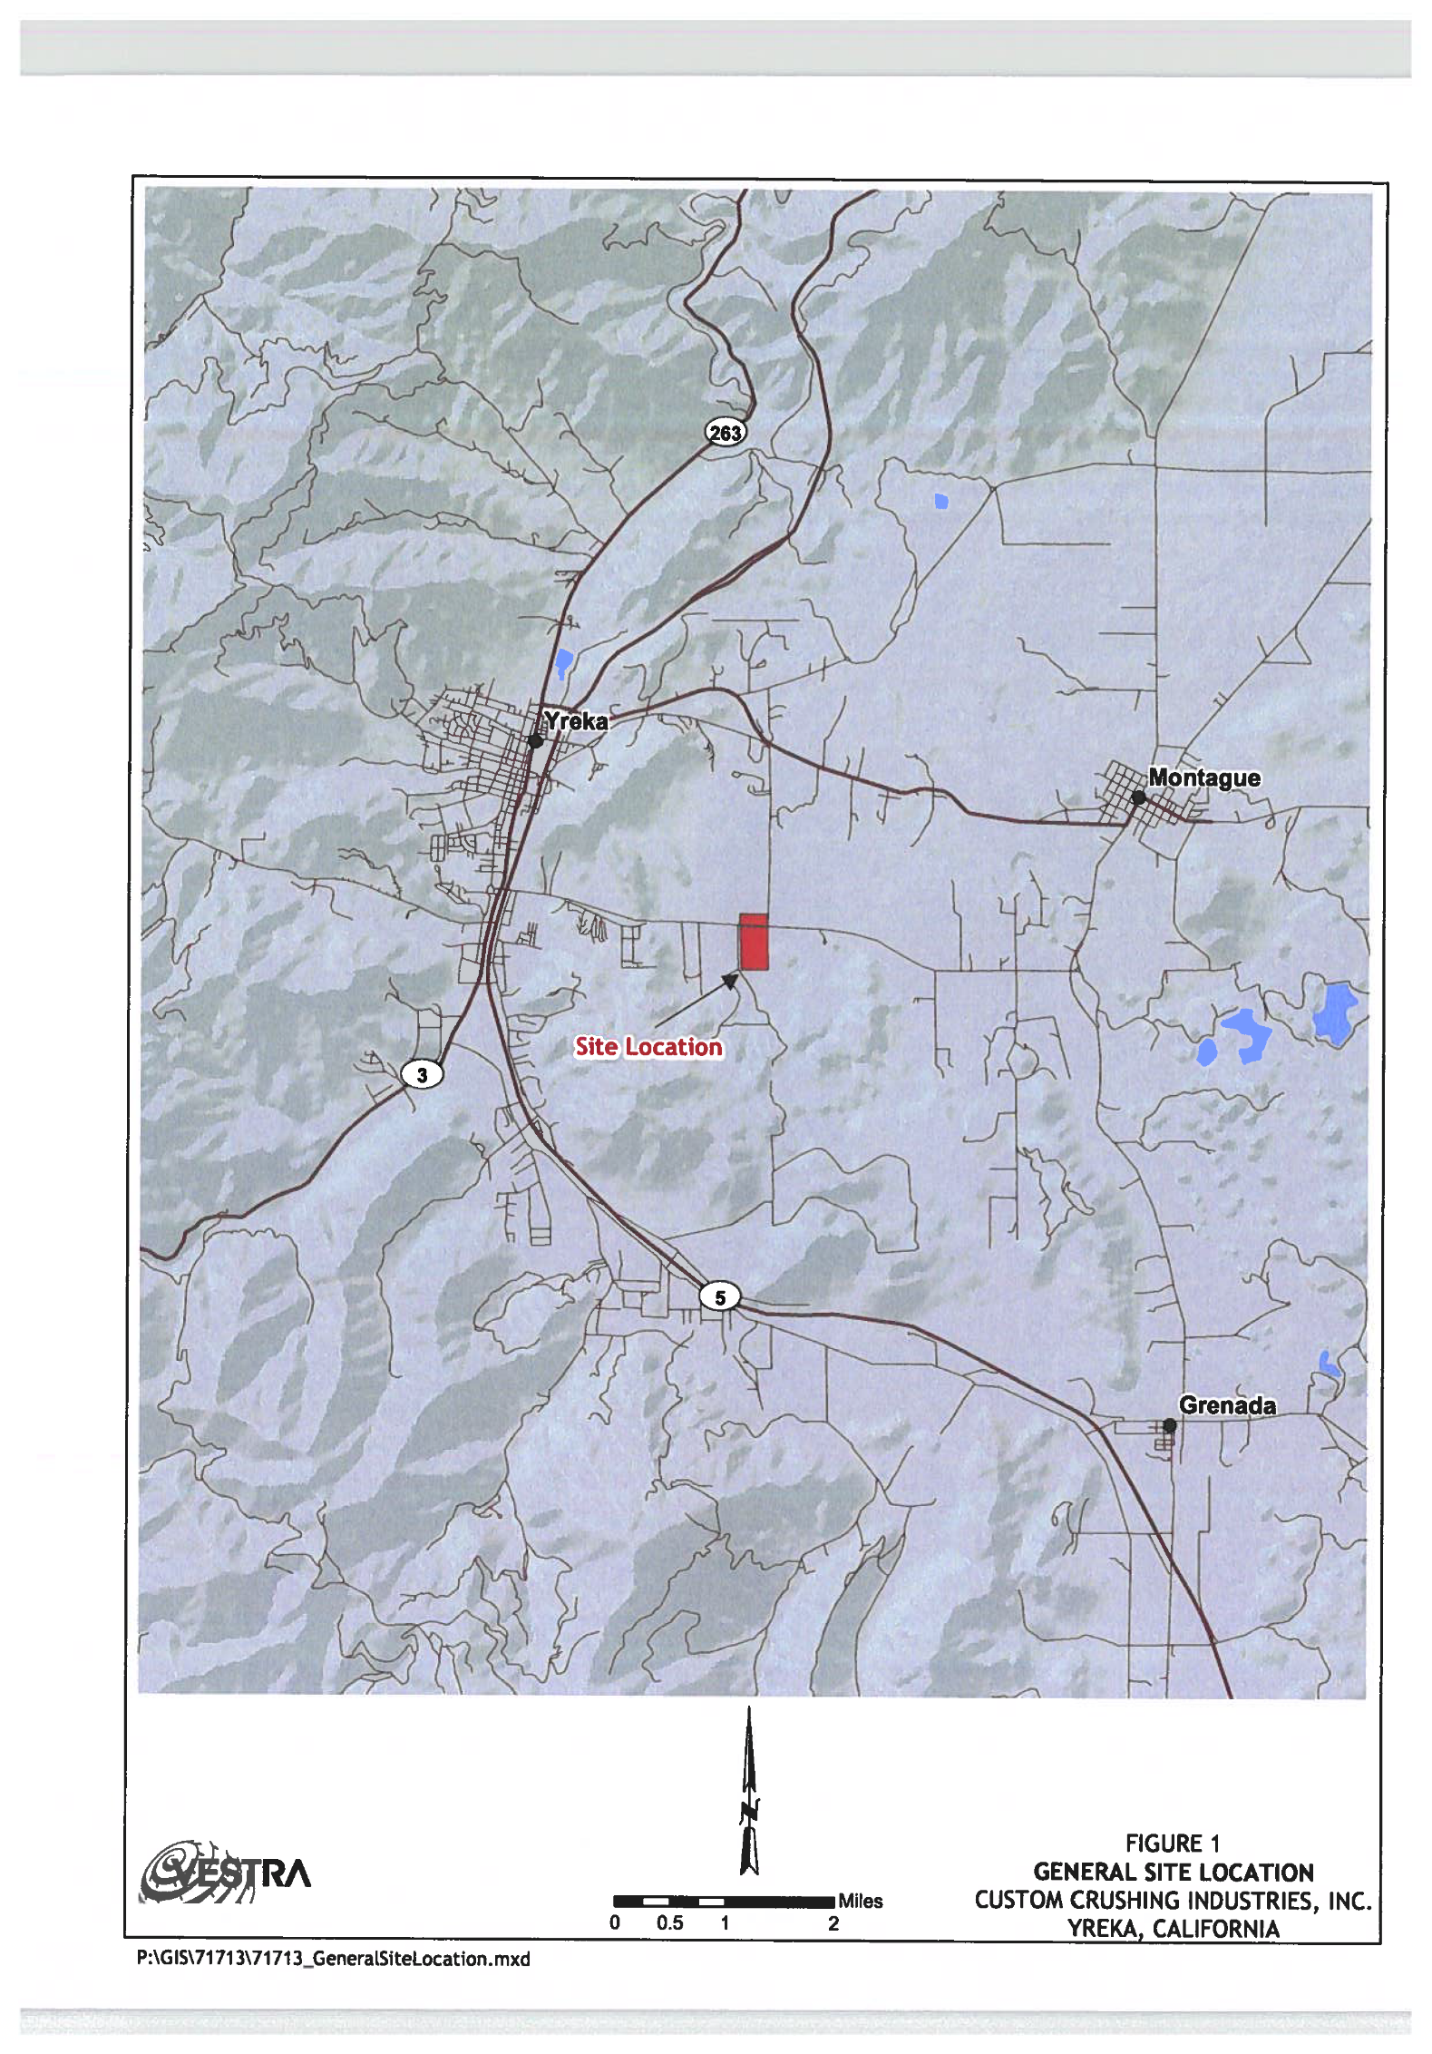
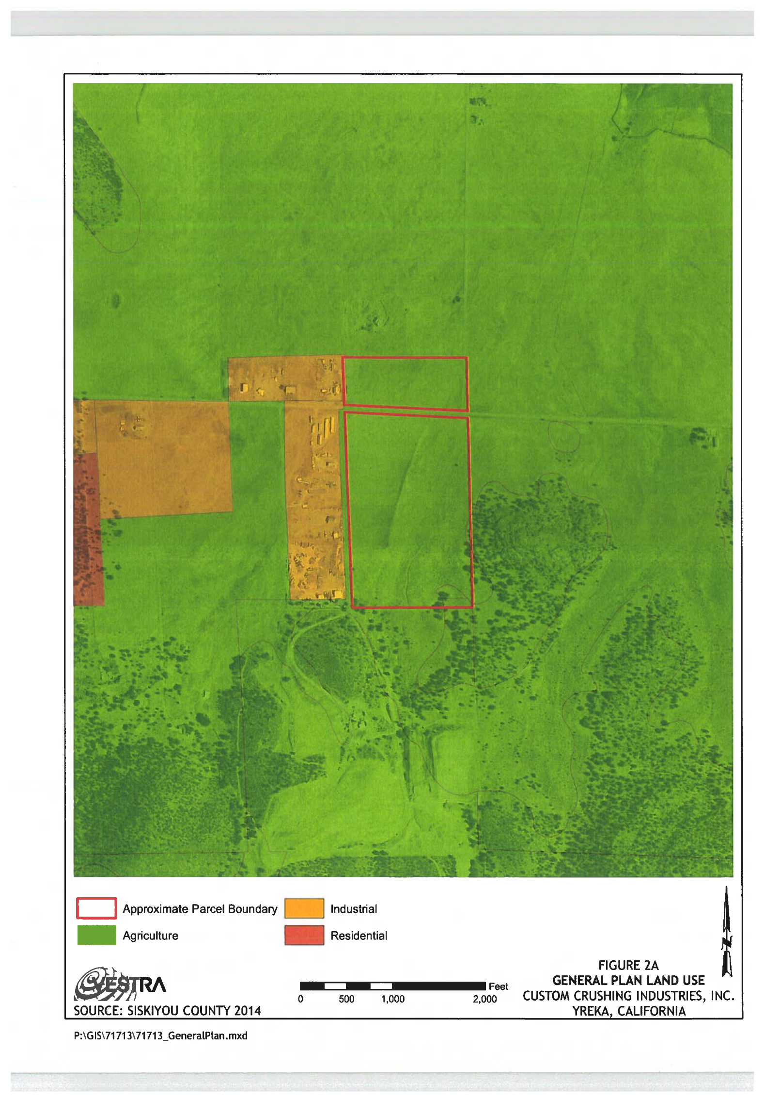
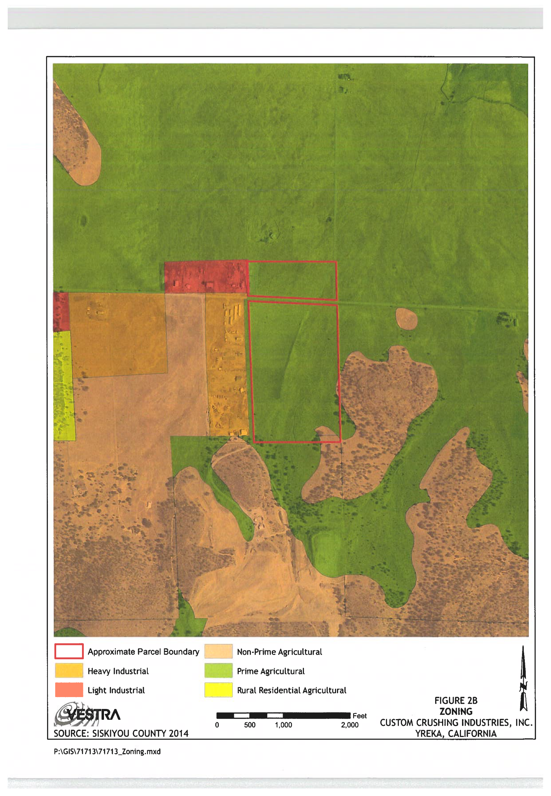
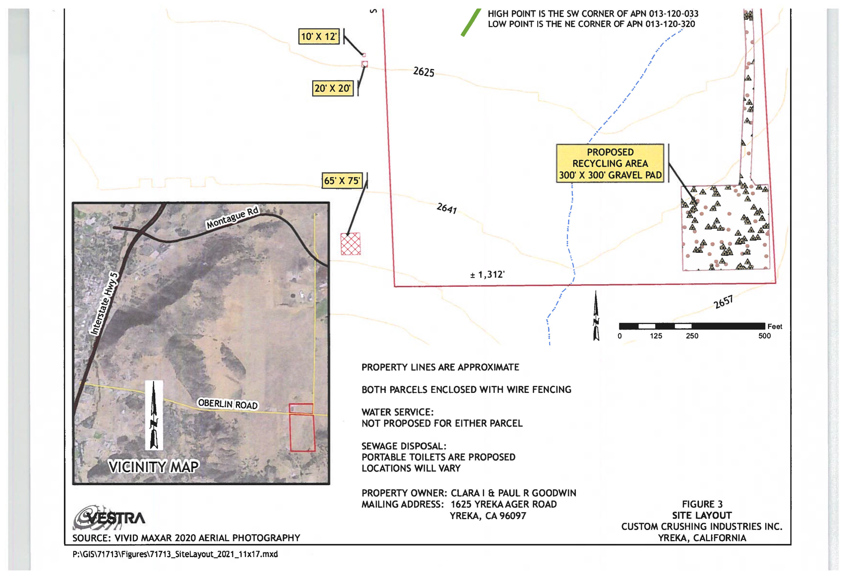
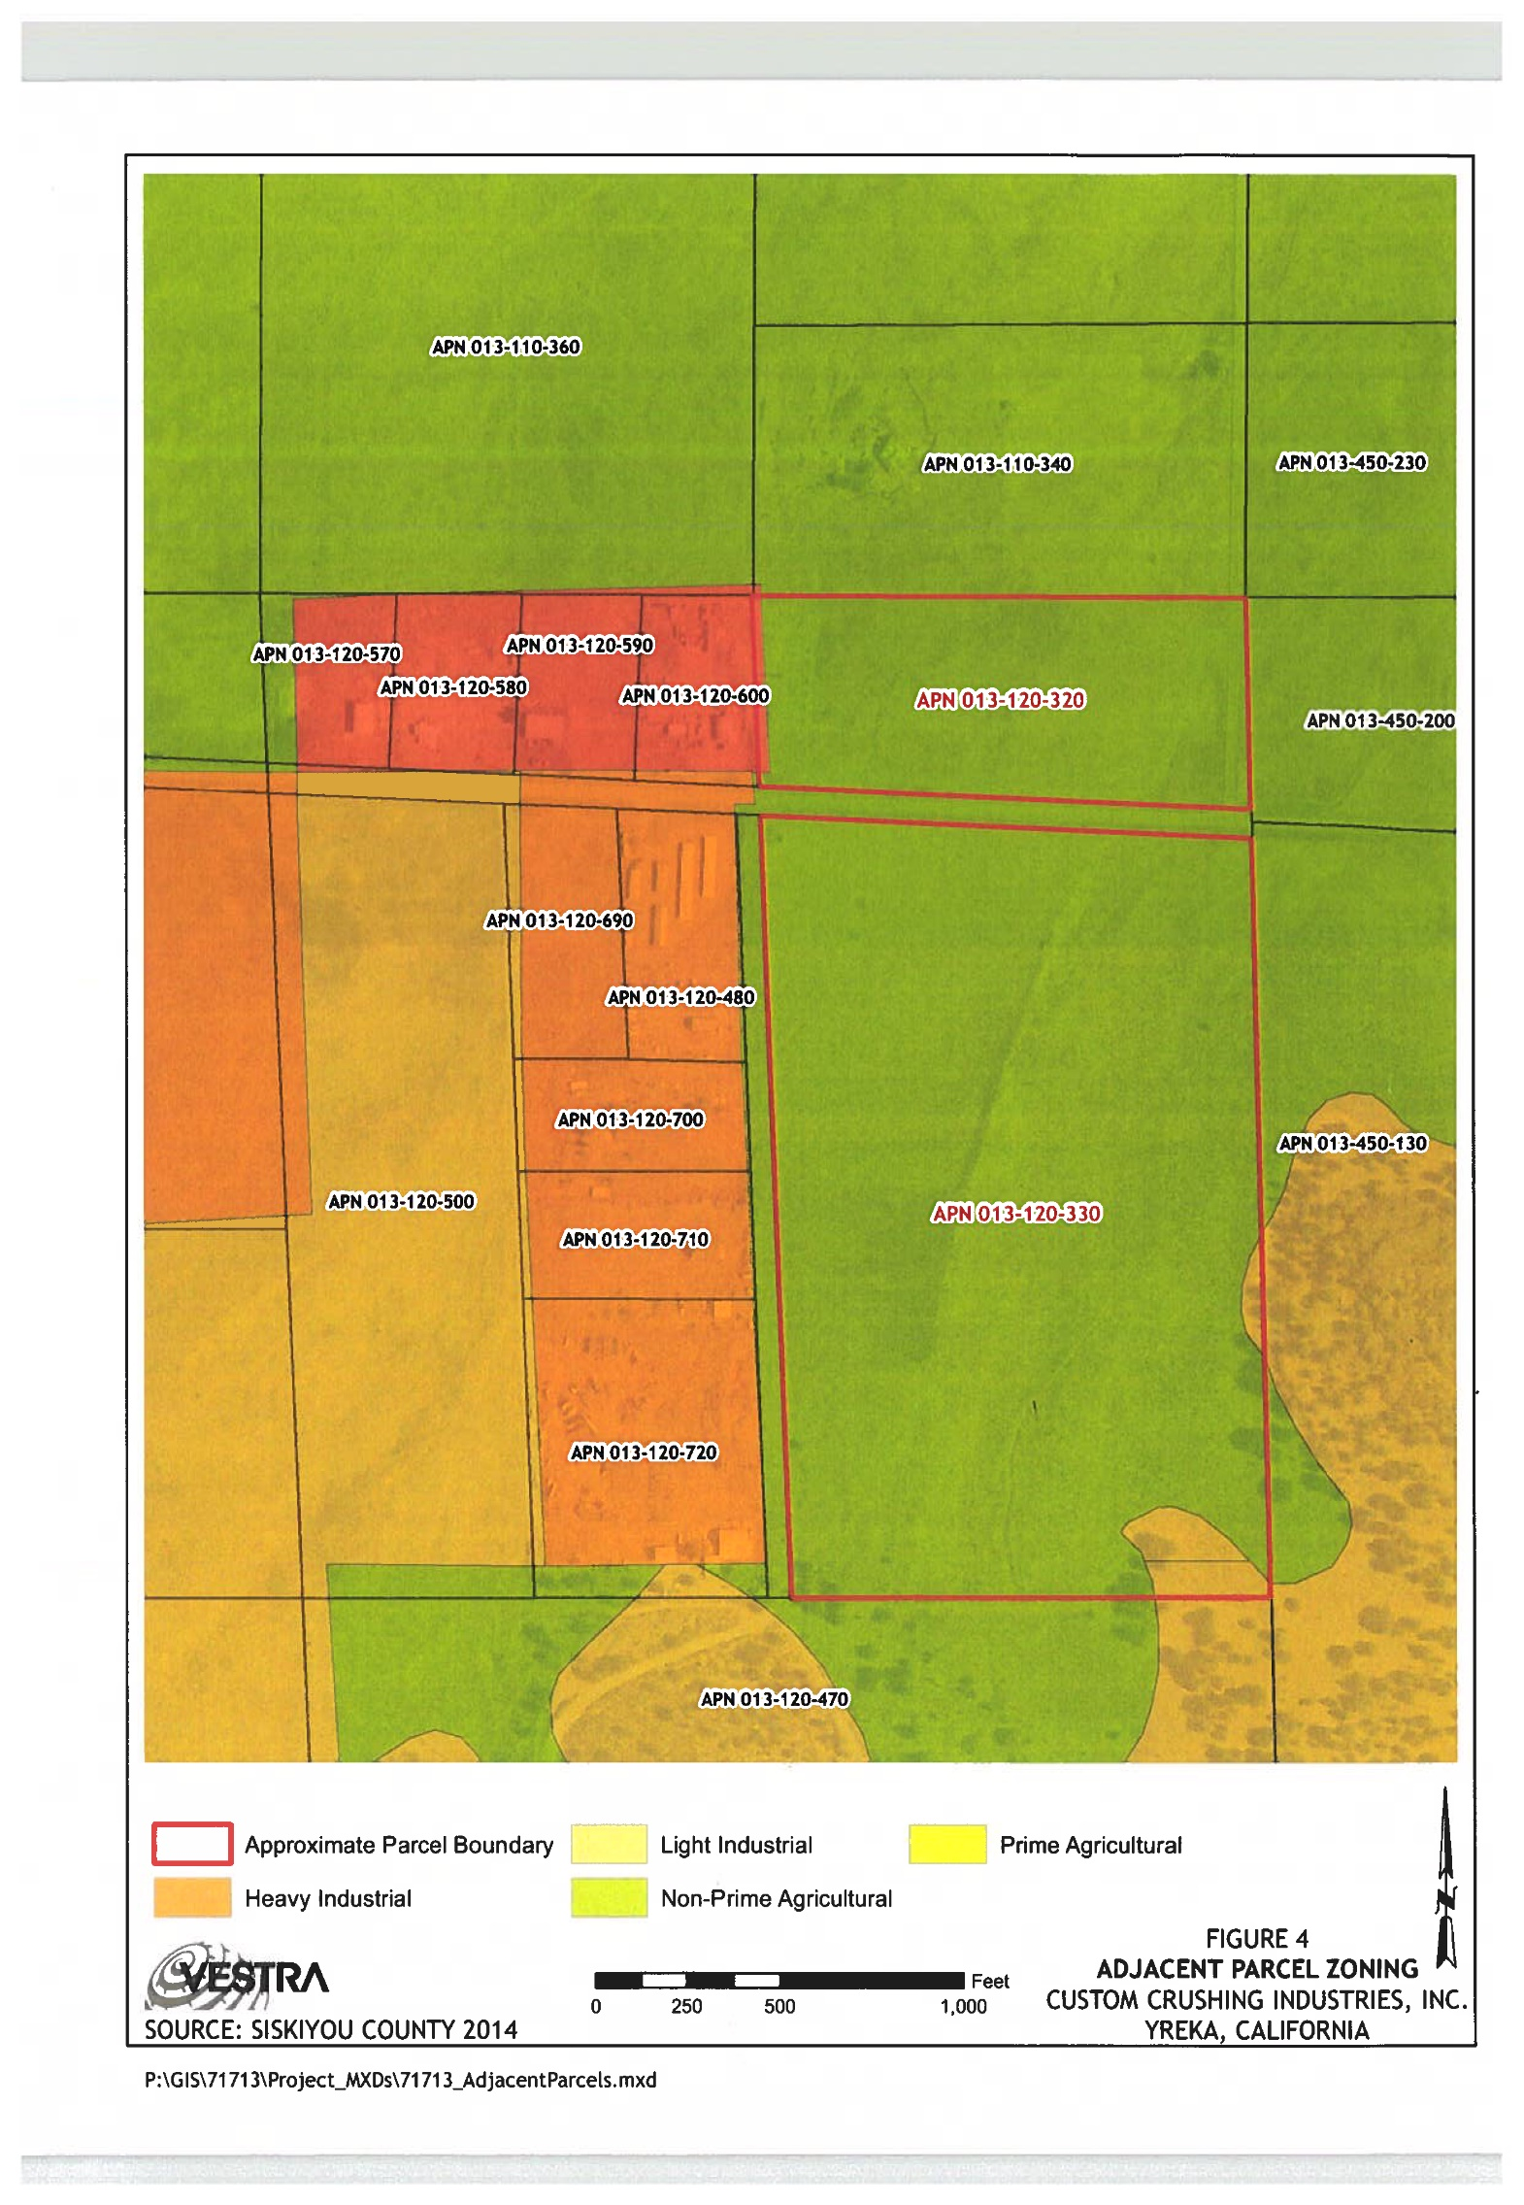

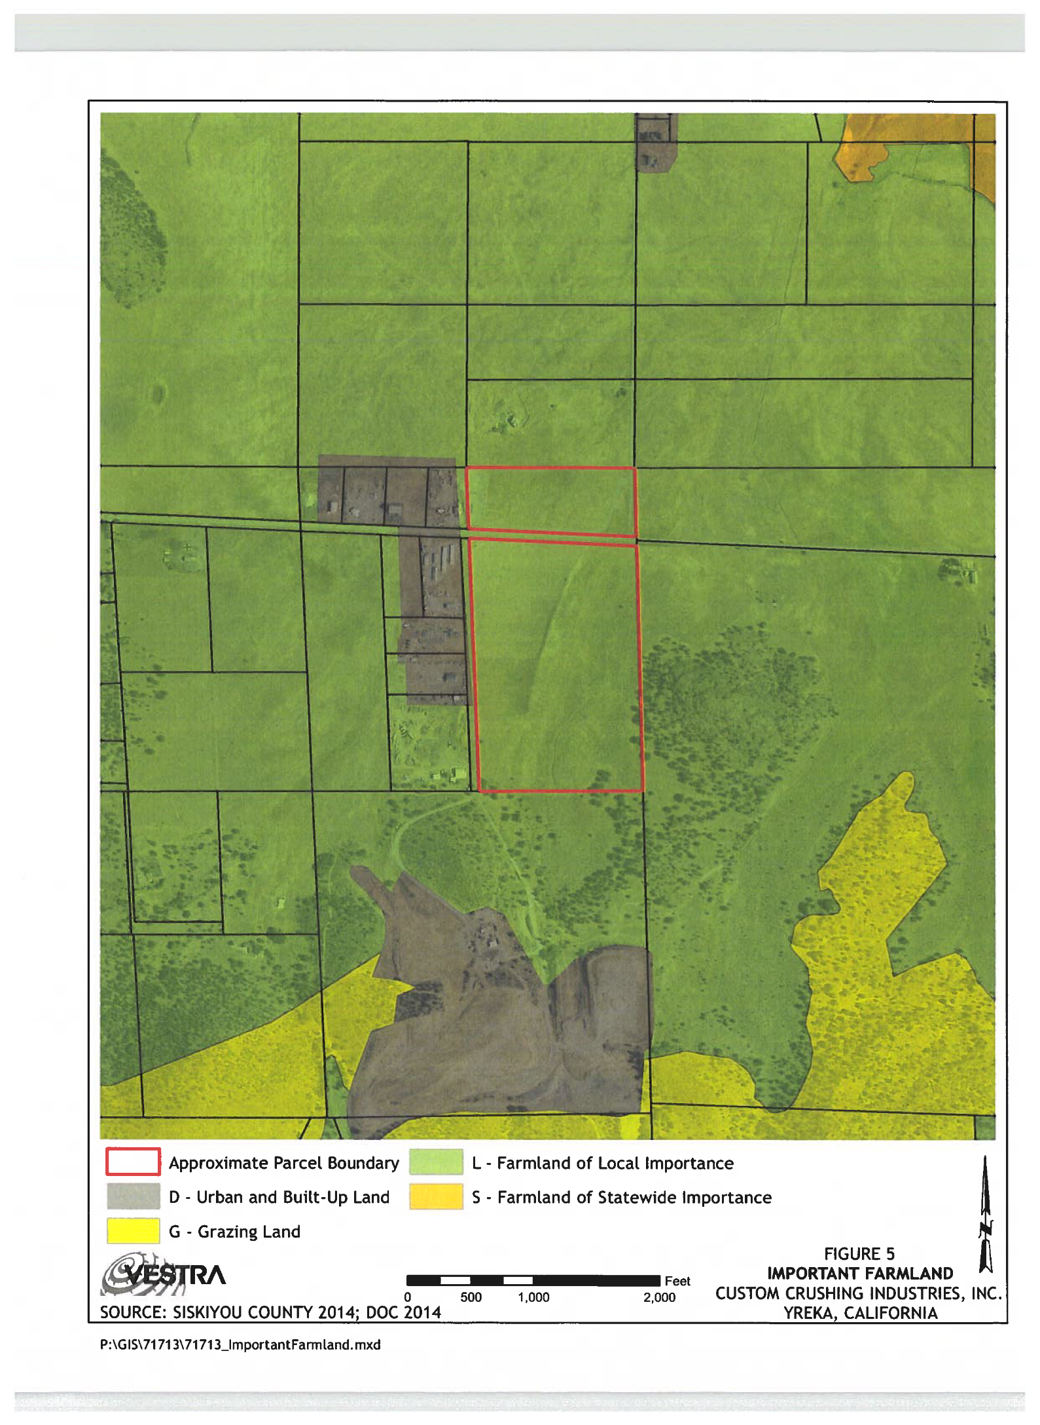
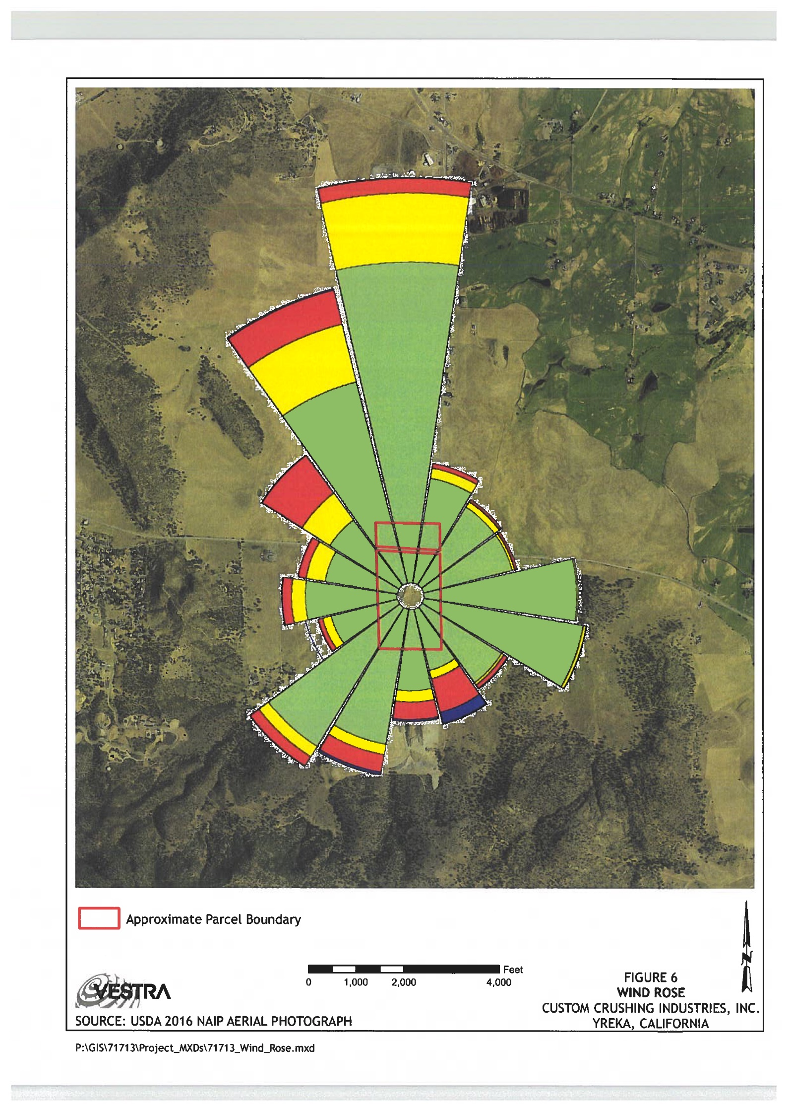

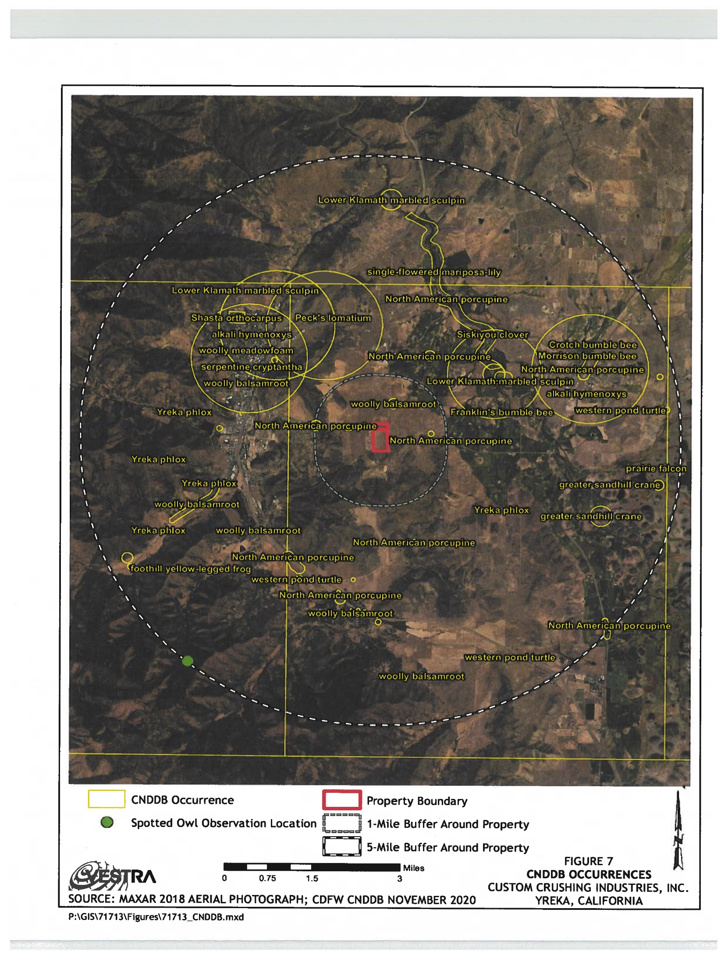
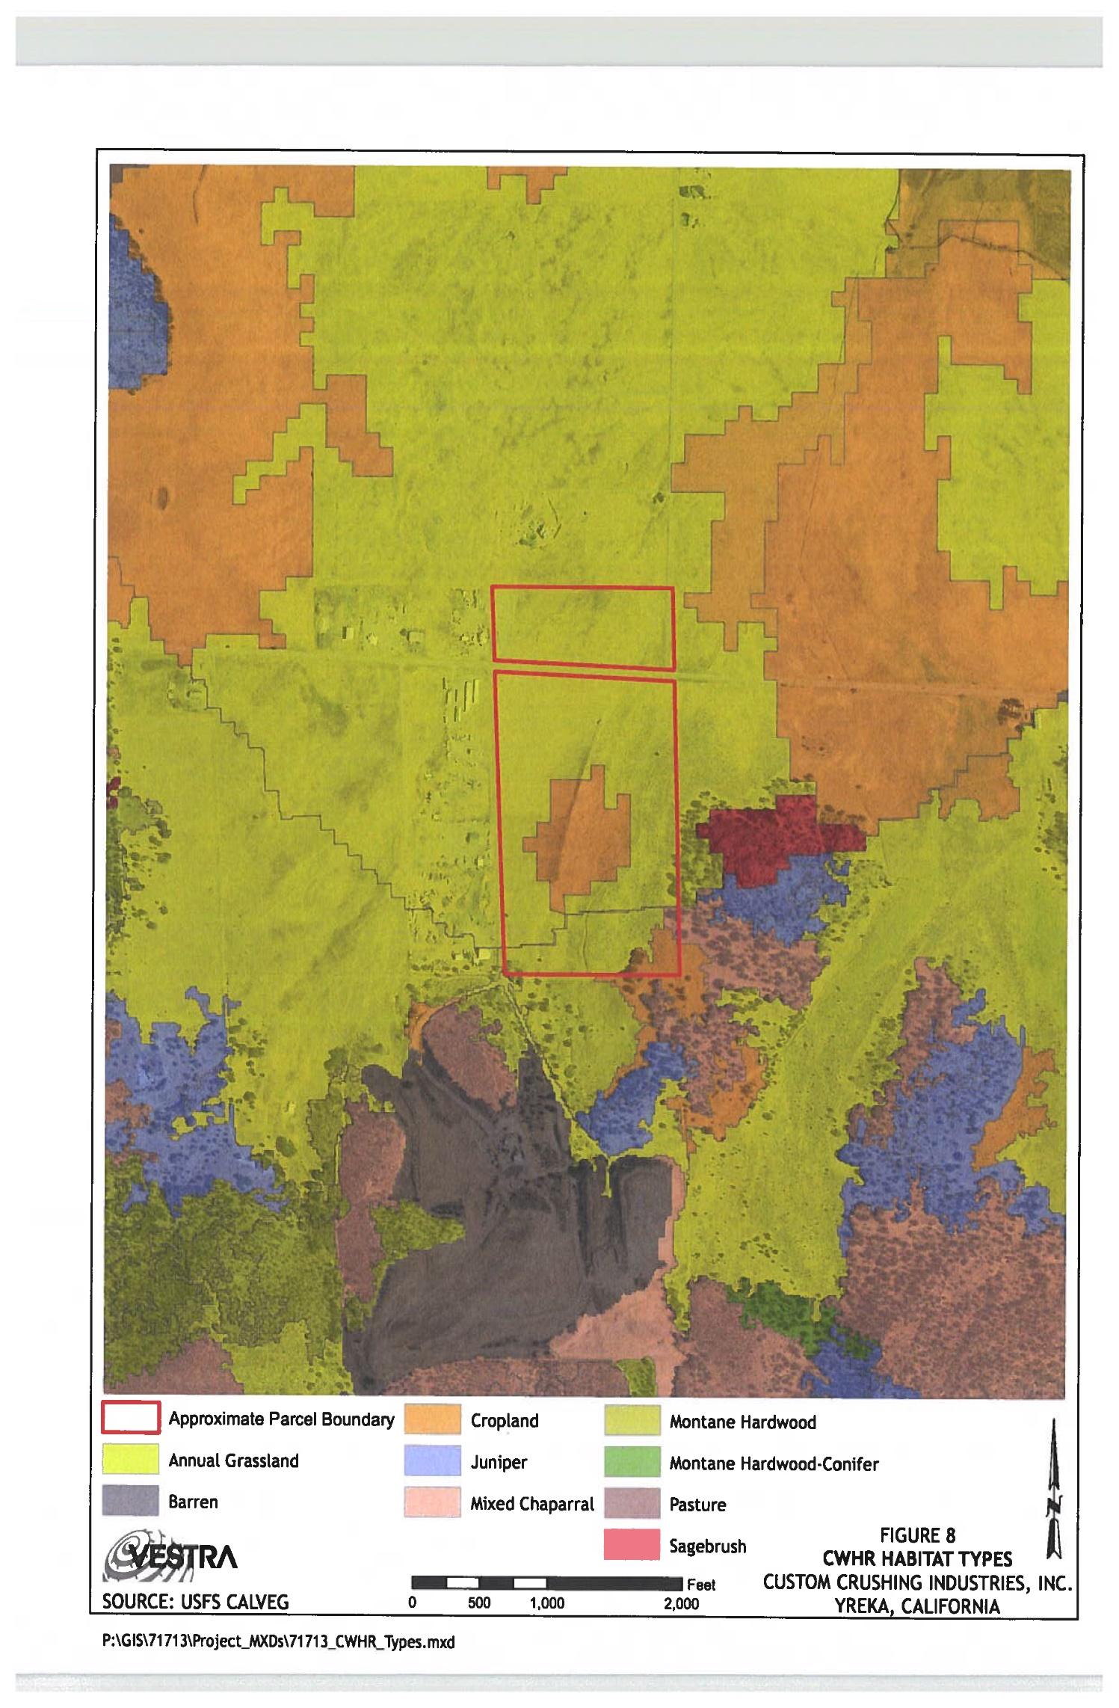
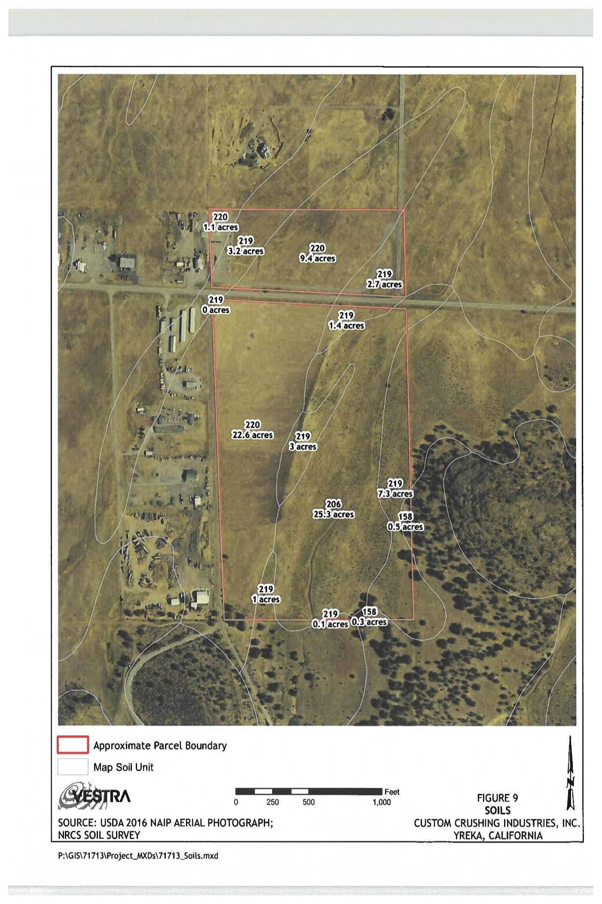

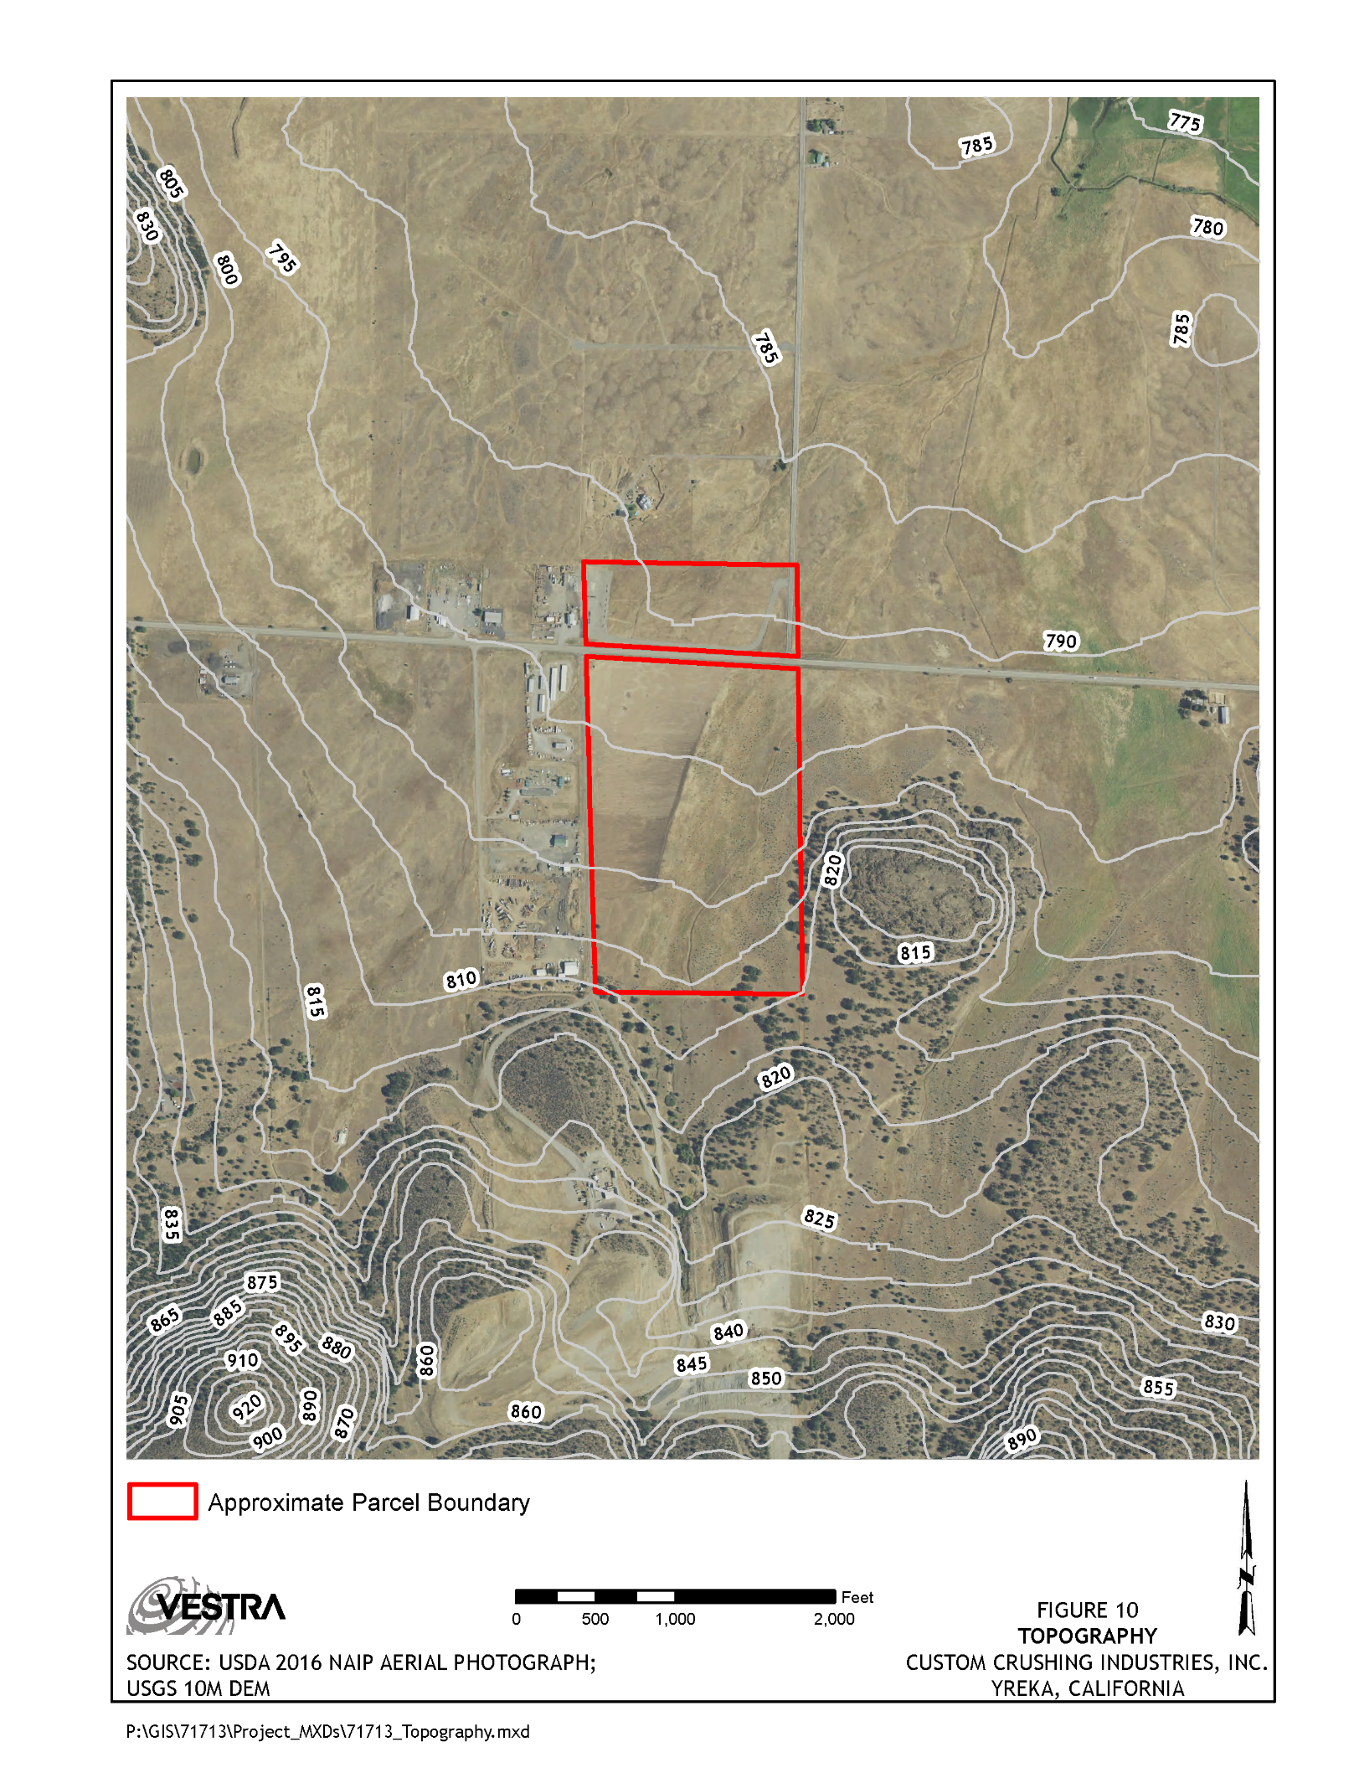
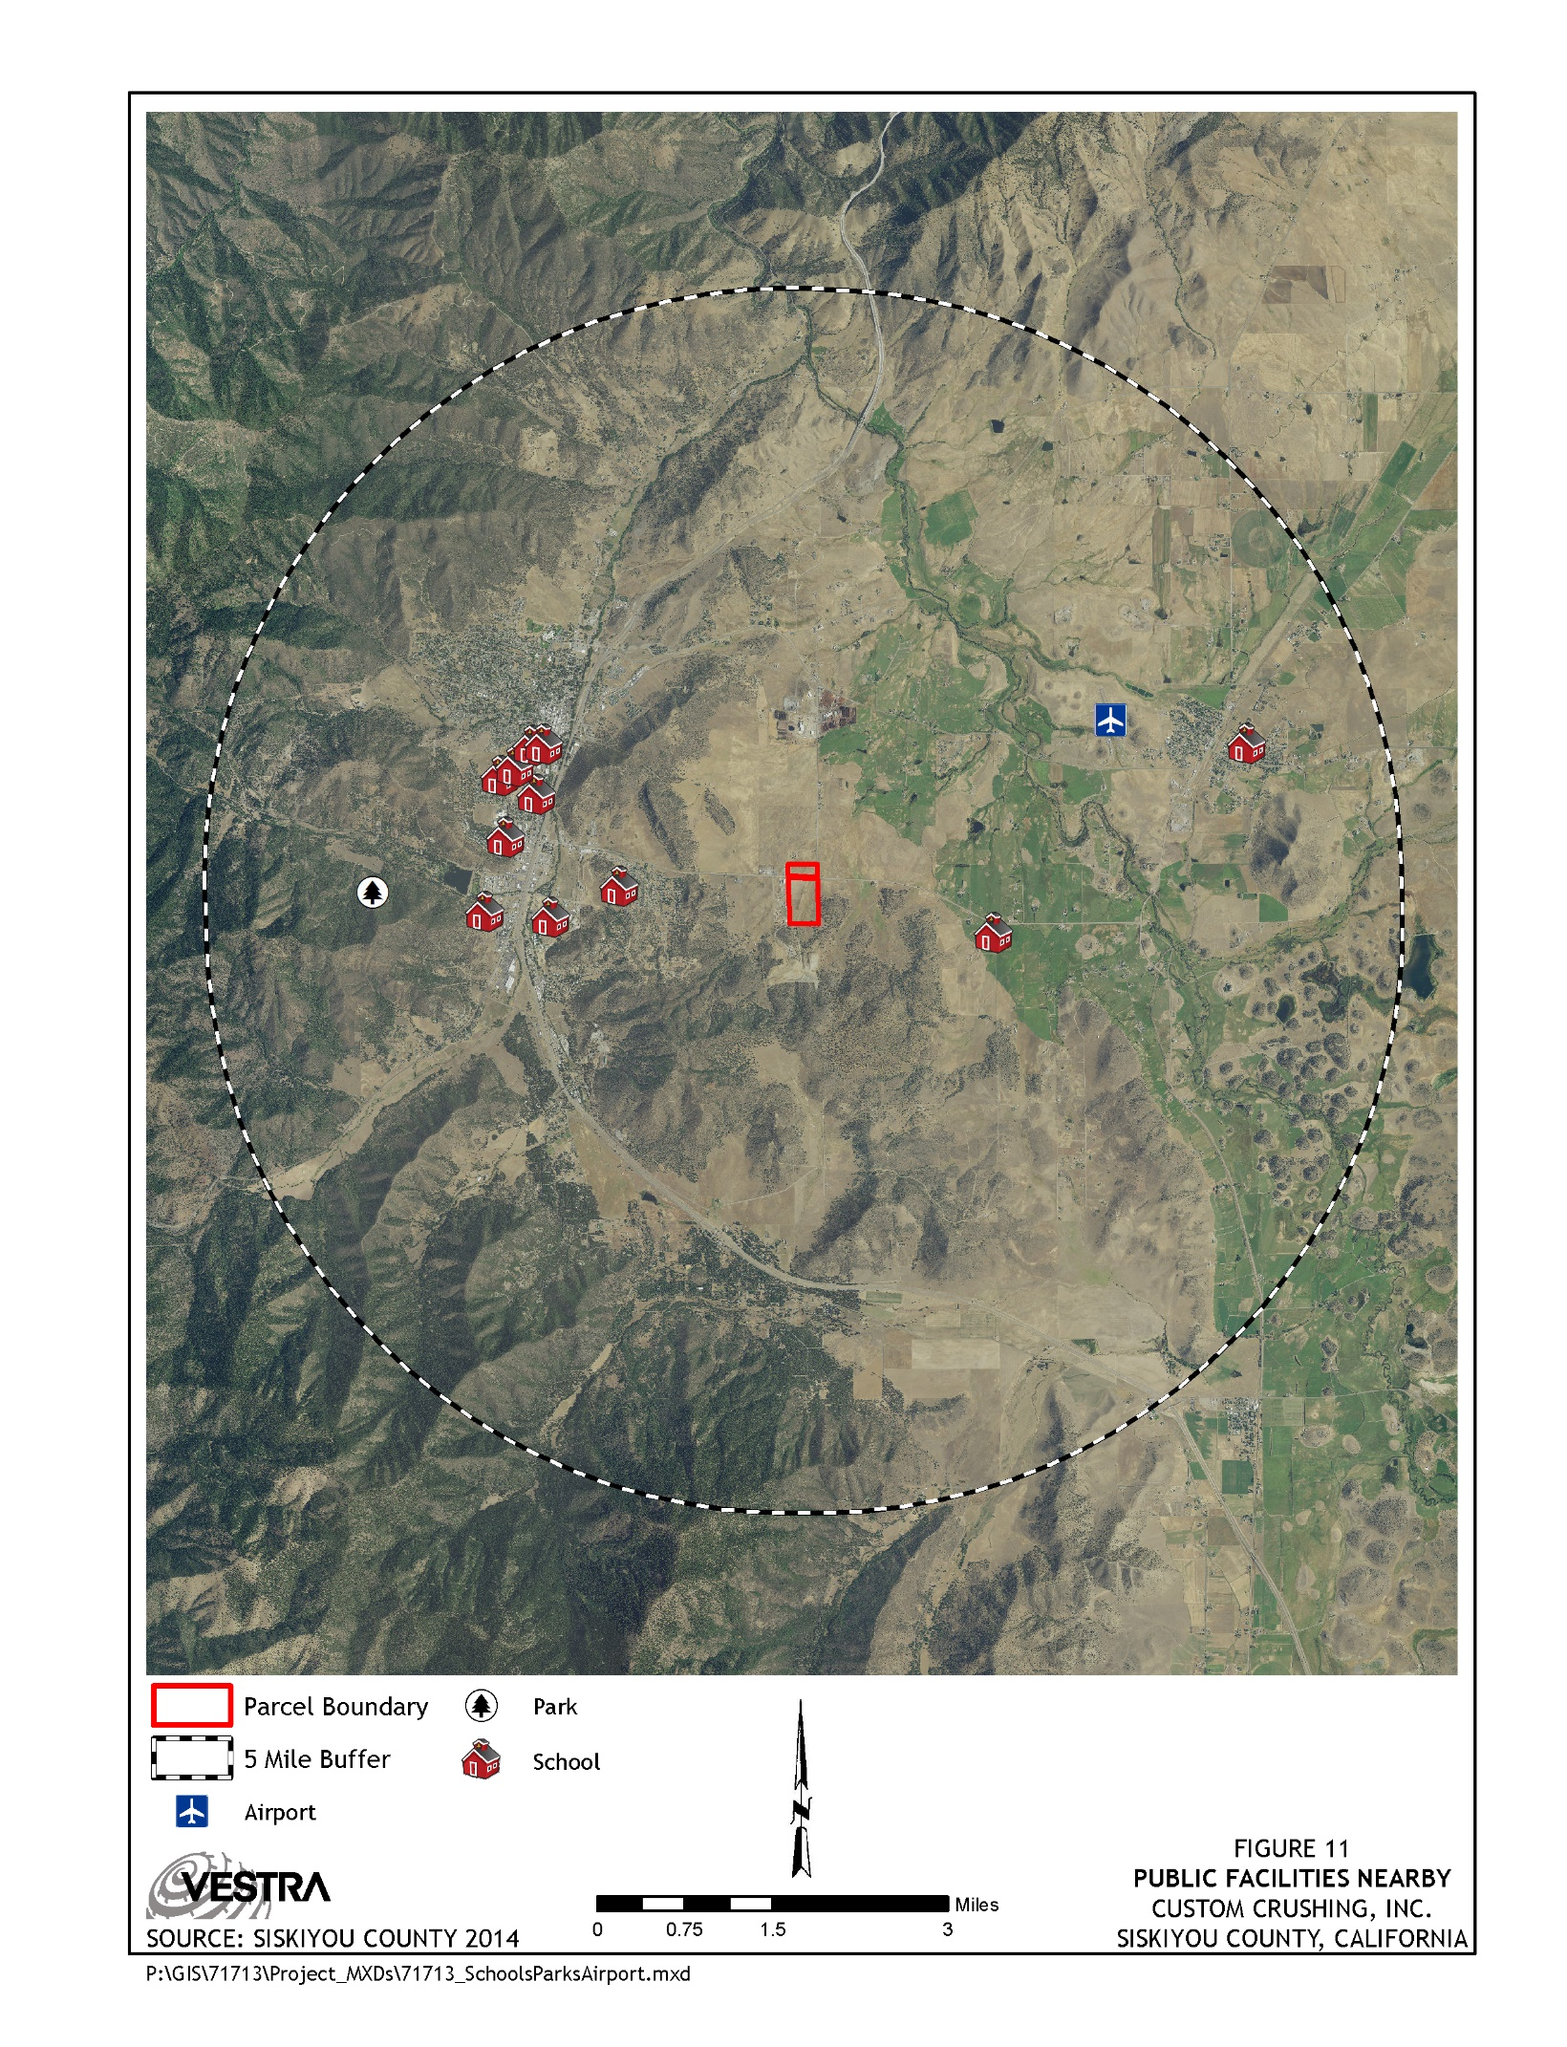
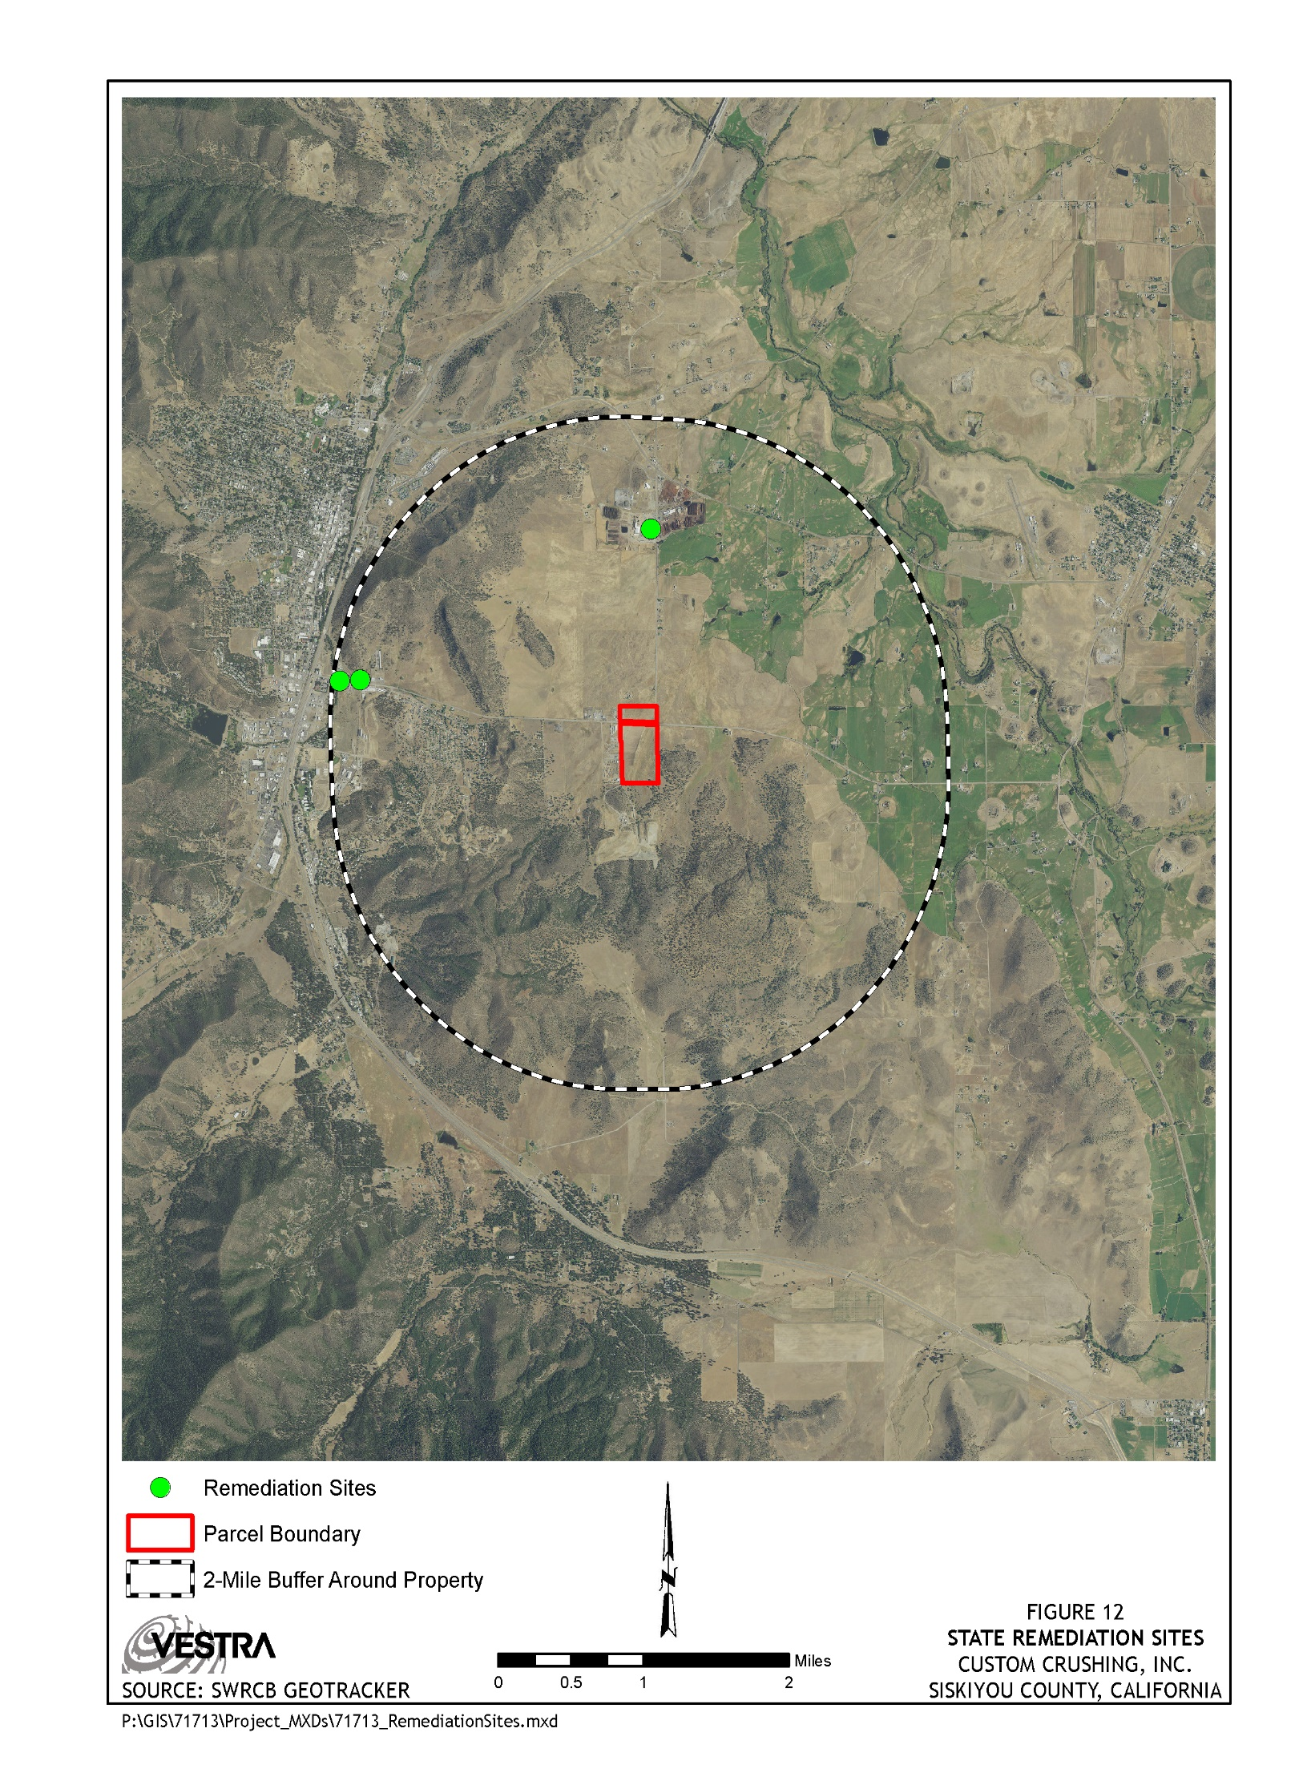
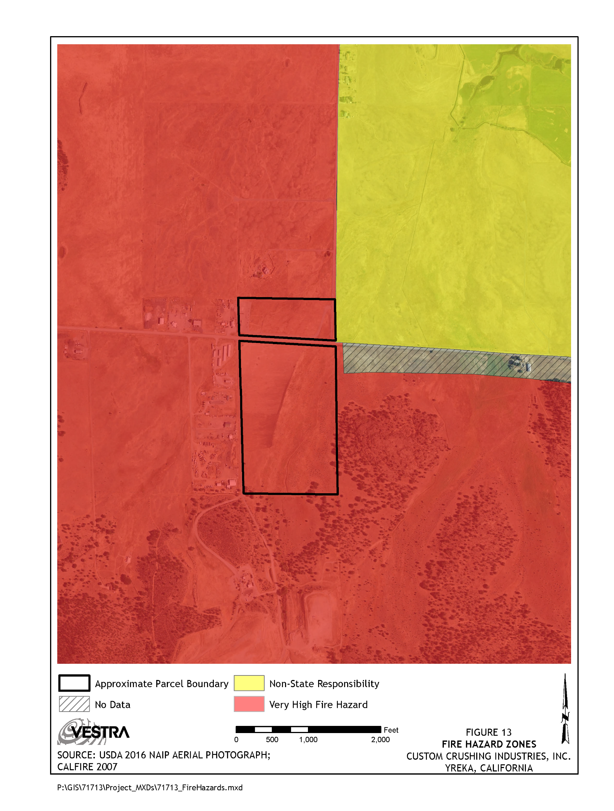
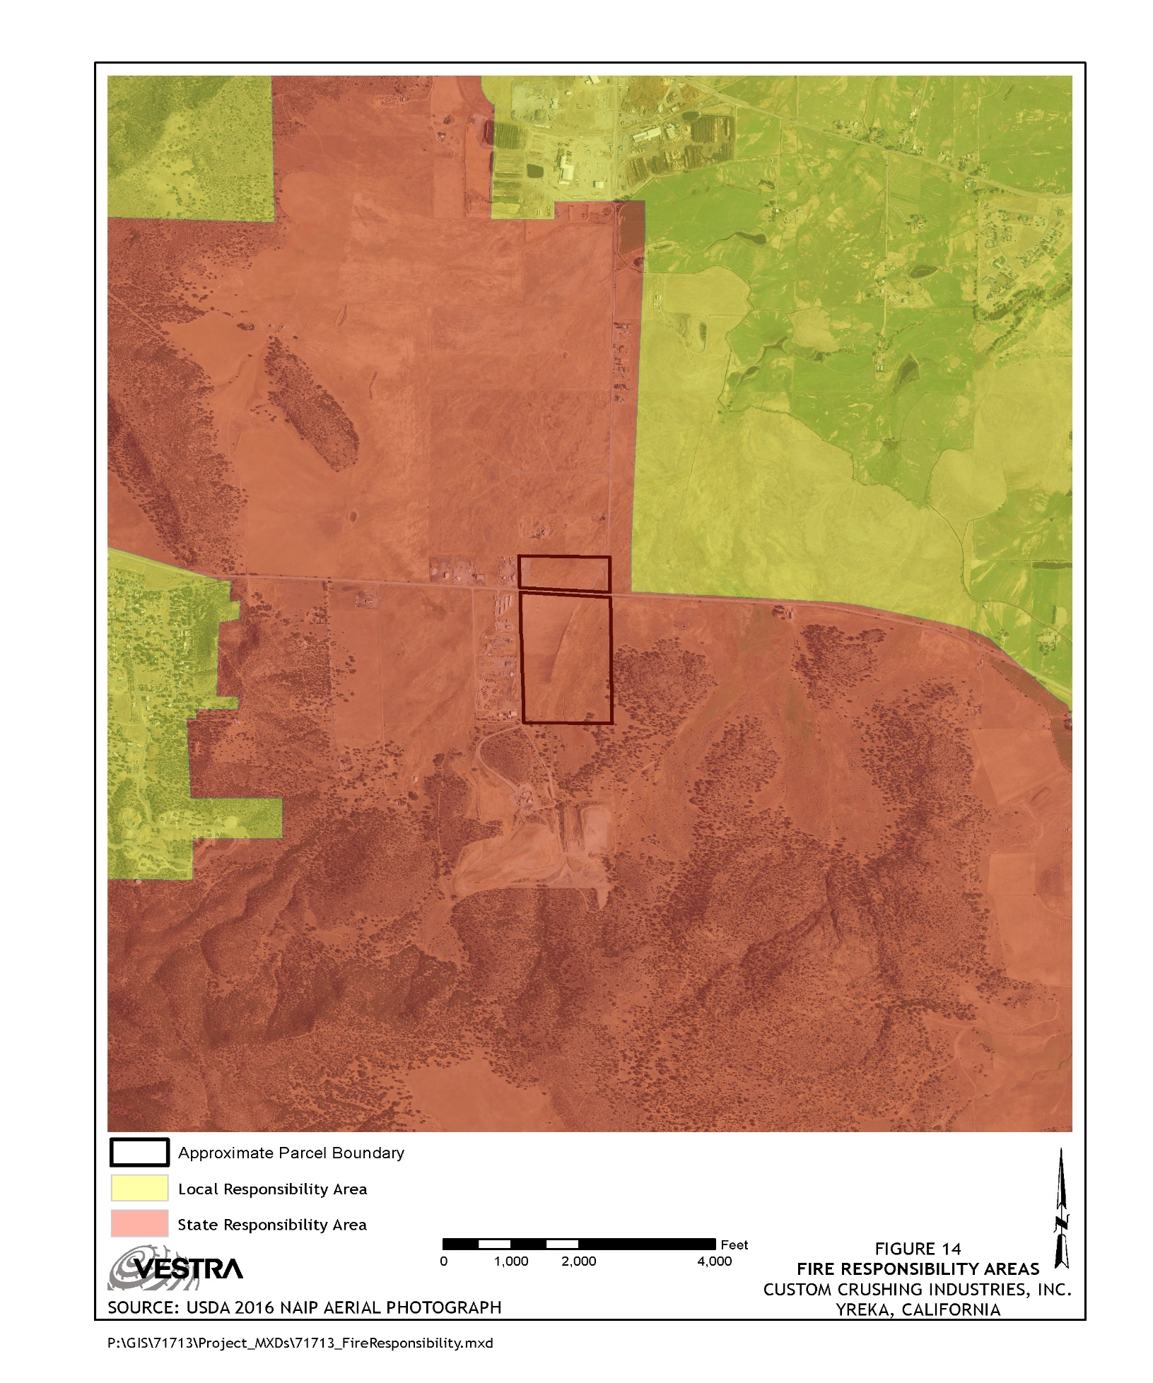

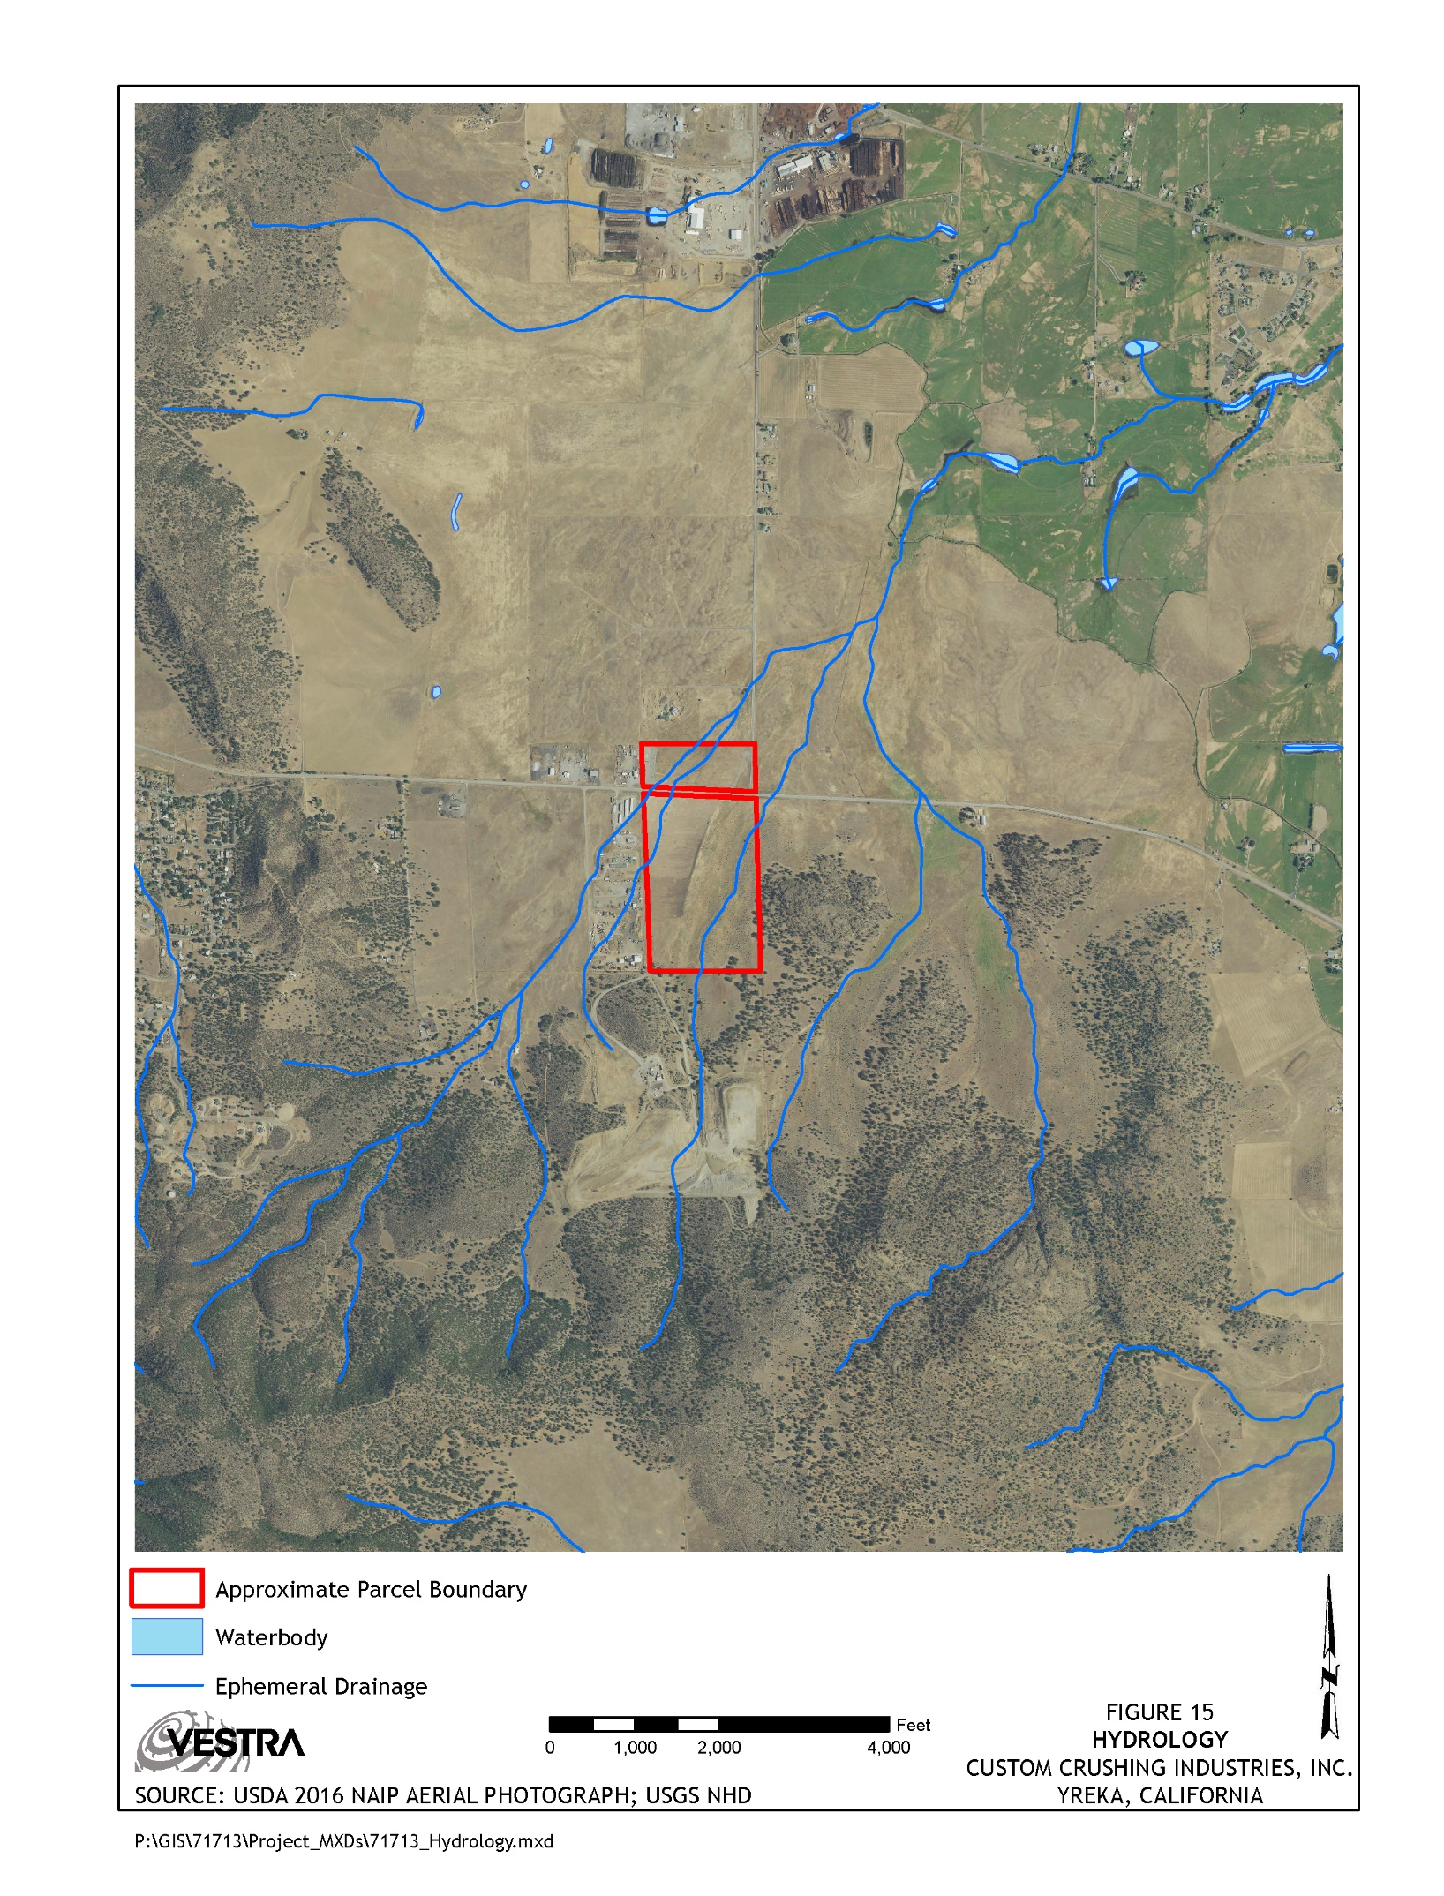
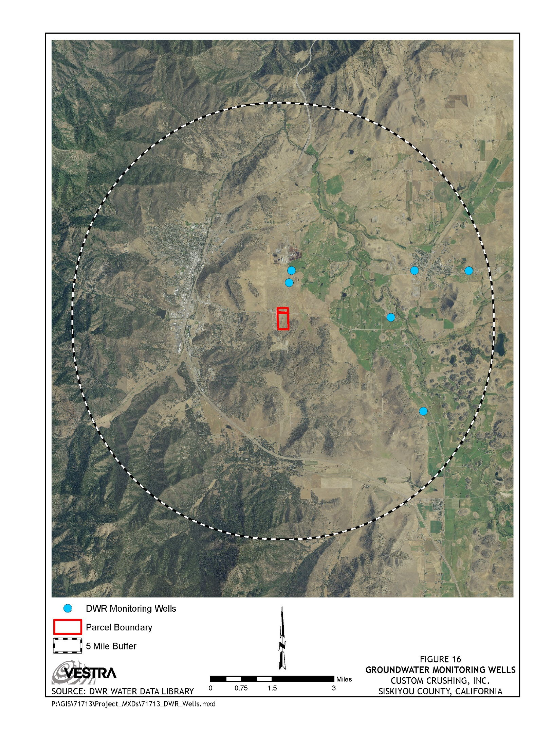

References
California Department of Conservation Farmland Mapping and Monitoring Program (FMMP). 2010. Soil Candidate Listing for Prime Farmland and Farmland of Statewide Importance.
California Department of Conservation Division of Oil, Gas, and Geothermal Resources. 2001. Oil, Gas, and Geothermal Fields in California. Division of Oil, Gas, and Geothermal Resources Map S-1.
California Air Resources Board Air Quality Planning Branch (CARB AQPB). 2015³. Area Designations for State Ambient Air Quality Standards PM10. December, 2015.
California Department of Forestry and Fire Protection (CAL FIRE), 2007. Fire Hazard Severity Zones in SRA. Adopted by CAL FIRE November 7, 2007.
California Air Resources Board Air Quality Planning Branch (CARB AQPB). 2015¹. Area Designations for State Ambient Air Quality Standards Ozone. December, 2015.
California Air Resources Board Air Quality Planning Branch (CARB AQPB). 2015². Area Designations for State Ambient Air Quality Standards PM2.5. December, 2015.
California Geological Survey (CGS). 2007. Fault-Rupture Hazard Zones in California. California Geological Survey Special Publication 42 Interim Revision 2007.
California Geological Survey (CGS). 2016. Earthquake Shaking Potential for California, 2016. California Geological Survey Map Sheet 48, revised 2016.
California Geological Survey (CGS). 2010. Fault Activity map of California (2010). Fault Activity map of California (2010). Accessed May 10, 2017.
California Department of Conservation Division of Land Resource Protection Farmland Mapping and Monitoring Program (FMMP). April, 2014. California Farmland Conversion Report 2008-2010.
California Department of Fish and Game (CDFW). 1994. 5-Year Status Review: Greater Sandhill Crane (Grus Canadensis tabida).
California Native Plant Society (Calflora¹). 2017. Woolly meadowfoam. Accessed May 30, 2017.
California Native Plant Society (Calflora²). 2017. Oregon polemonium. Accessed May 30, 2017.
California Native Plant Society (Calflora³). 2017. Woolly balsamroot. Accessed May 30, 2017.
California Native Plant Society (Calflora⁴). 2017. Shasta Orthocarpus. Accessed May 30, 2017.

California Native Plant Society (Calflora5). 2017. Alkali hymenoxys. Accessed May 30, 2017.
California Office of Planning and Research (OPR). 2017 Technical Advisory on Evaluating
Transportation Impacts in CEQA. November 2017.
Hotz, P.E. 1977. Geology of the Yreka Quadrangle, Siskiyou County, California. Geological Survey bulletin 1436.
International Union for Conservation of Nature (IUCN). 2014. Bombus morrisoni. Accessed May 26, 2017.
International Union for Conservation of Nature (IUCN). 2015. Bombus crotchi. Accessed May 26, 2017.
International Union for Conservation of Nature (IUCN). 2008. Bombus franklini. Accessed May 30, 2017.
Nachman, J. 2008. Emys marmorata (online). Accessed May 26, 2017.
United States Geological Survey (USGS). 2017. Earthquake Catalog; accessed May 25, 2017.
Natural Resources Conservation Service (NRCS), 2012. Custom Soil Resource Report for Siskiyou County, California, Central Part.
International Building Code. 2015. United States Seismic Zones Map.
Siskiyou County Local Transportation Commission, 2010. 2010 Regional Transportation Plan. April 2011.
Siskiyou County. 1996. Siskiyou County Comprehensive Land and Resource Management Plan. February 1996.
Siskiyou County. 1973. Siskiyou County General Plan. Siskiyou County, California.
Soil Conservation Service (SCS), 1961. Land-Capability Classification. US Department of Agriculture. Agriculture Handbook No. 210.
Townsend, T.G. 1998. Leaching Characteristics of Asphalt Road Waste. Florida Center for Solid and Hazardous Waste Management Report No. 98-2. June 15, 1998.
United States Environmental Protection Agency (EPA), 2011. National Ambient Air Quality Standards (NAAQS) Table; accessed May 10, 2017.

