# Staff Report

Meeting Date: June 14, 2022

To: Siskiyou County Board of Supervisors

From: Bernadette Cizin, Assistant Planner

Subject: Proposed Matthew & Audrey Parsons Trust Agricultural Preserve Amendment, Williamson Act Rescission and Re-entry (APA-22-02) and CEQA Determination

Exhibits: A. Existing Agricultural Preserve and Williamson Act Contracts

B. Williamson Act Contract Amendment Questionnaire

C. Code Enforcement Case CR-21-0242

## Background and Discussion

On March 10, 2022, the County received an application for an Agricultural Preserve amendment to bring approximately 525 acres, owned by Matthew & Audrey Parsons Trust, under one individual preserve and a single Williamson Act contract. The property is primarily used for row and field crops and uses such as the residence of the property owners, farm employee housing and accessory structures.

This project does not propose to remove or add property to the existing agricultural preserves. It would simply modify the boundaries of the existing agricultural preserves and revise contracts to consolidate all property owned by the Parsons Trust under one single Contract and one agricultural preserve.

**Parcel History  
Parcels contained within Contract No. 73020**On February 8, 1973, eleven parcels owned by Lewis A. Parsons totaling approximately 1,640 acres were approved to be an agricultural preserve under Williamson Act Contract No. 73020, as recorded in the Siskiyou County Records in Book 709 at Page 321. APNs 010-010-630 and 010-010-660 have been modified by Boundary Line Adjustment BLA-90-30 as recorded in the Siskiyou County Official Records as Document No. 91-0005047 on April 30, 1991. Later, APN 010-010-630 was again modified by Boundary Line Adjustment (BLA-00-21) as recorded in the Siskiyou County Official Records as Document Number 01-0014765 on October 12, 2001. Subsequently, Agricultural Preserve Contract Amendment APA-00-06 was administratively approved, transferring 40 acres from Contract No. 76033 to 73020, in alignment with BLA-00-21. Another Boundary Line Adjust (BLA-04-38) modifying APN 010-010-630 was recorded in the Siskiyou County Official Records as Document No. 05-000821 on January 14, 2005, with a Williamson Act Contract Amendment APA-04-08 concurrently recorded creating a contract for the resultant Parsons Parcel of BLA-04-38. Both APNs 010-010-630 and 010-010-660 are currently owned by the Parson’s Trust and all remaining parcels under the original contract are now under other property ownership.

**Parcels contained within Contract No. 76033**  
On February 10, 1976, eight parcels owned by Esther Taylor were approved to be an agricultural preserve under Williamson Act Contract No. 76033, as recorded in the Siskiyou County Records in Book 750 at Page 283. APNs 002-170-270 and 010-010-550 were modified by Boundary Line Adjustment (BLA-99-19) as recorded in the Siskiyou County Official Records as Document Number 00-0002156 on February 24, 2000 and are currently owned by the Parson’s Trust. All remaining parcels under the original contract are under other property ownership.

A Notice of Non-Renewal of land under Contract 76033 was Recorded for APN’s 010-010-550 and 002-170-270 as Document No. 2021-0010938 on October 14, 2021. This was a County initiated non-renewal due to the non-compliance of a separate property owner under the contract.

**Agricultural Preserve**  
The subject parcels are located within two different Agricultural Preserves.

Approximately 300 acres of this proposed project was placed in an agricultural preserve through Board Resolution No. 119, Book 5 on February 9, 1973 (Contract No. 73020).

Approximately 225 acres of this proposed project was placed in an agricultural preserve through Board Resolution No. 30, Book 7 on February 10, 1976 (Contract No. 76033).

Should the Board approve the applicant’s request, the Parsons Trust will own all of the property under one particular agricultural preserve as shown in Figure 1 of this report.

**Williamson Act Contract Rescission and Re-entry**  
APN 010-010-660 and a portion of 010-010-660 is under contract No. 73020 as recorded in the Siskiyou County Official Records as Document No 05-0001313 on January 24, 2005. The remainder of 010-010-660 was later included in Contract No. 73020 by Agricultural Preserve Contract Amendment APA-00-06.

APN 002-170-270 and 010-010-550 are under contract recorded in the Siskiyou County Official Records at Volume 750 Page 283 on February 17, 1976.

Should the Board approve the applicant’s request, the Parsons Trust will own all of the property under one particular Williamson Act Contract as shown in Figure 1 of this report.

**Code Enforcement Case**  
The Code Enforcement Division received a complaint from a representative of the US Forest Service on November 16, 2021, regarding an unpermitted commercial firewood operation.

After review of the Business website which showed commercial sales of firewood and wood pellets, Code Enforcement issued a Notice to Comply to the property owners that the business Pro Grass Sod and Firewood is operating without a business license nor a use permit and in violation of County Code Section 10-6.4903 (G), which allows for the processing, storage or sale of agricultural products and supplies with a Conditional Use Permit.

In January 2022, Code Enforcement Officers visited the site and found that the processing of imported logs into firewood and the storage for sales of firewood and Golden Fire Brand wood pellets was occurring at 11700 Red Rock Road on APN 010-010-660. After further research of the subject site, it was found that the area being utilized for the firewood and wood pellet business was in Prime Agricultural Zoning which does not allow for processing and sales on site. The subject property is also in Agricultural Preserve and encumbered by a Williamson Act Contract which does not allow for processing facilities of imported timber as an agricultural production use or compatible use.

Staff and the property owners have had several discussions on how they can continue the wood processing and firewood sales. As all of the Parson’s property is in Williamson Act contract, which they wish to remain under, they have been actively looking for an alternative site.

The owners continue to work on removing the firewood processing business. They also continue to work towards the removal of the stored wood pellets. They anticipate having the commercial wood pellets, firewood processing and storage off of the site in February of 2023.

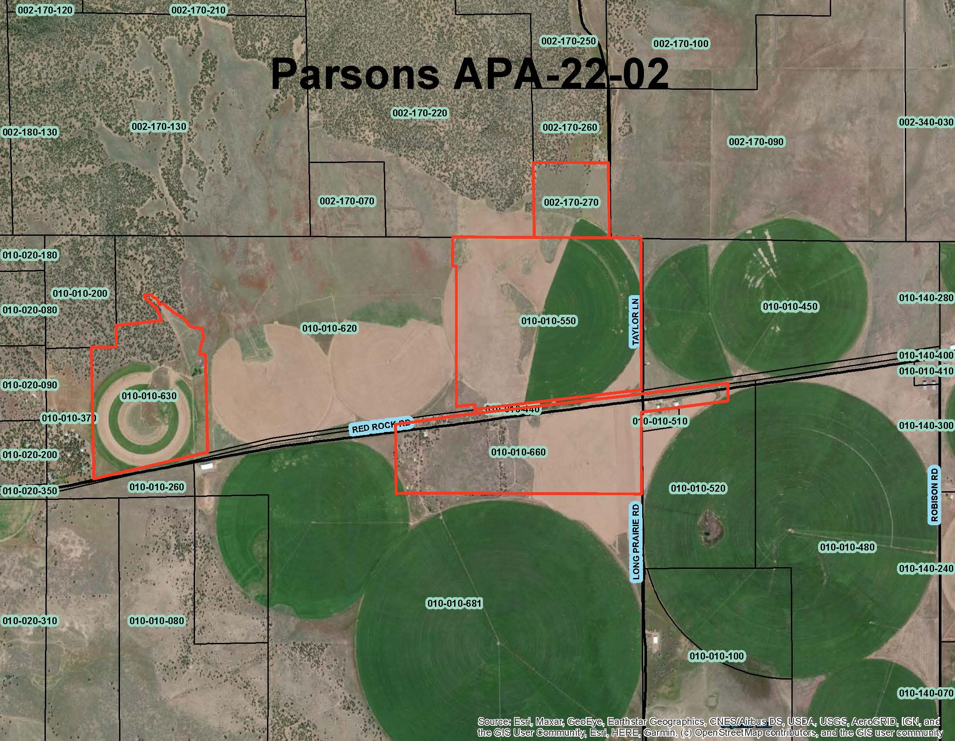  
Figure 1: Subject Parcels

## Environmental Review

Staff is proposing that the proposed project be considered categorically exempt from the California Environmental Quality Act (CEQA) pursuant to CEQA Guidelines Section 15317, *Open Space Easements or Contracts.* A Categorical Exemption implies that the project will not result in any significant adverse environmental effects. CEQA Guidelines Section 15317 specifically exempts the making and renewing of open space contracts under the Williamson Act, which is applicable to the subject action.

The Board of Supervisors must consider the proposed CEQA exemption together with any comments received during the public review process. Further, the exemption can only be approved if the Board finds, based on the whole record before it, that there is not substantial evidence that the project will have a significant effect on the environment. Accordingly, a finding to this effect has been incorporated into both draft resolutions prepared for the Board’s consideration.

## Comments

Notice of the project was published and posted as required prior to the Board of Supervisors meeting and no public comment was received as of the preparation of this staff report.

## Recommended Action

Should the Board of Supervisors concur with staff’s analysis, staff recommends that the Board of Supervisors continue the public hearing to a date uncertain, giving the property owners the opportunity to return the property to compliance with County Code and the Rules for the Establishment and Administration of Agricultural Preserves and Williamson Act Contracts.

## Recommended Motions

I move to take the following actions:

1. Direct staff to bring the proposed project to the board for consideration upon compliance with Siskiyou County code and the “Rules for the Establishment and Administration of Agricultural Preserves and Williamson Act Contracts”.